Trajectory-Adaptive Power-Profile Conformal Beam Tracking
from Synchronized RGB and GPS for Reliable V2V mmWave Communications

Course Project Report — Department of Computer Science and Engineering

Moazzem Hossain Majumder

Abstract
Exhaustive beam training over 256 receive beams creates significant overhead and latency in high-mobility 60 GHz Vehicle-to-Vehicle (V2V) millimeter-wave communications. Existing approaches predict the single best beam or a static calibrated subset, but none predict the complete future beam-power landscape while adapting the candidate-set threshold online as vehicle trajectories evolve. This work proposes P3, a multi-task deep learning model that jointly predicts a 256-class beam classification head and a 256-value power-gap profile head from five synchronized historical RGB frames and GPS measurements, using a ResNet-18 visual encoder, a Bidirectional GRU GPS encoder, and a Pre-Layer-Normalization Transformer fusion module. The predicted profile feeds an Adaptive Conformal Inference (ACI) online risk controller maintaining a near-optimal-beam miss rate target adaptively during deployment. Evaluated on DeepSense 6G Scenario 36 (24,799 V2V samples, US testbed), P3 achieves profile MAE 2.49 dB — below the theoretical mean-profile floor of 3.11 dB — and Top-5 accuracy 46.8% (3.1x the GPS-only baseline). The ACI controller maintains 7.5% miss rate at only 17 average probes (93% search reduction). A paired trajectory-block bootstrap confirms P3 significantly outperforms the classification-only baseline (+6.35%, 95% CI: [+1.38%, +8.18%]).

1. Introduction
The deployment of 5G and emerging 6G networks increasingly relies on millimeter-wave frequencies to deliver high data rates for applications such as autonomous vehicles, augmented reality, and dense urban broadband. In V2V mmWave communication at 60 GHz, highly directional antenna arrays with hundreds of beams must be periodically aligned between transmitter and receiver. The standard approach — exhaustive beam sweeping over all 256 beams — introduces unacceptable overhead and latency in high-mobility scenarios where the optimal beam changes rapidly as vehicles move.
The core problem addressed: given five historical synchronized RGB camera frames and GPS positions from both vehicles, can we accurately predict the full future 256-beam receive-power landscape and construct a small candidate set guaranteed to contain a near-optimal beam? Can we maintain that guarantee online as the trajectory, lighting, and motion regime change continuously?
No prior work simultaneously predicts the complete future 256-beam power-gap profile and pairs that prediction with an online trajectory-adaptive risk controller. This work fills that gap.
Contributions:
- Multi-task model P3: joint beam classification + 256-value power-gap profile with smoothness and pairwise ranking losses exploiting beam-space angular structure.
- Online ACI risk controller (Gibbs & Candès, 2021) maintaining target miss rate adaptively without retraining.
- Rigorous evaluation: chronological trajectory-block splitting, trajectory-block bootstrap CIs, paired significance test.
- Full ablation study: 5 model variants × 3 controllers to isolate each component's contribution.

2. Dataset

2.1 DeepSense 6G V2V Dataset
All experiments use DeepSense 6G Multi-Modal V2V Beam Prediction, Scenario 36, collected at a real 60 GHz V2V testbed across Tempe, Phoenix, Scottsdale, and Chandler, Arizona, USA, in both day and night conditions. The dataset is available at deepsense6g.net upon registration. Raw data: 24,799 timestamped samples per scenario comprising synchronized front-camera RGB frames, GPS positions with HDOP quality indicators, and four 64-beam receive-power measurement vectors per sample (256 beams total).

2.2 Dataset Statistics
Statistic | Value
Total samples | 24,799
Trajectory runs | 124
Trajectory blocks (after guard-merge) | 19
Active beam classes | 238 / 256
Majority beam (#162) | 16.7% of raw frames
Mean-profile MAE floor | 3.107 dB
Beams within 1 dB (mean/median) | 11.7 / 3
Beams within 3 dB (mean/median) | 29.7 / 5
Argmax reconstruction match | 100%
Table 1: Dataset statistics.

A critical feasibility check confirms the candidate-set premise: the median near-optimal set size is 3 beams within 1 dB and 5 within 3 dB. Probing 5–15 beams can reliably find a near-optimal beam, making substantial search reduction achievable.
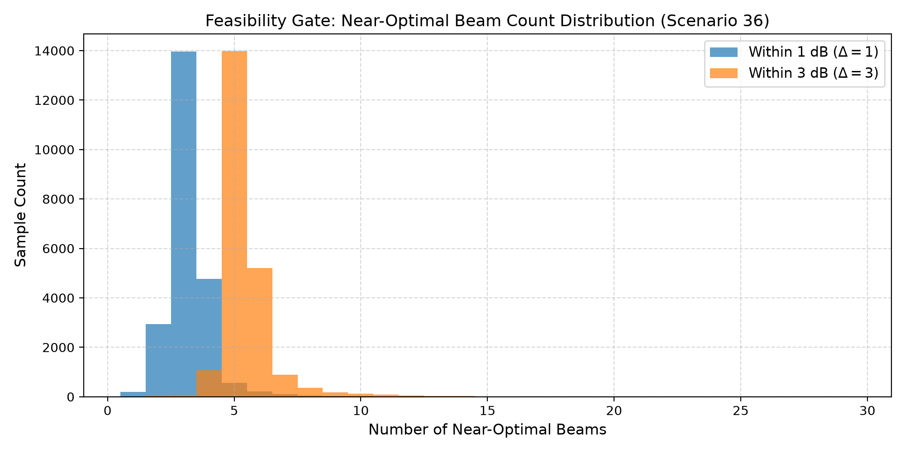
Figure 1: Near-optimal beam set size distribution. Median 3 within 1 dB, 5 within 3 dB — confirms candidate-set feasibility.
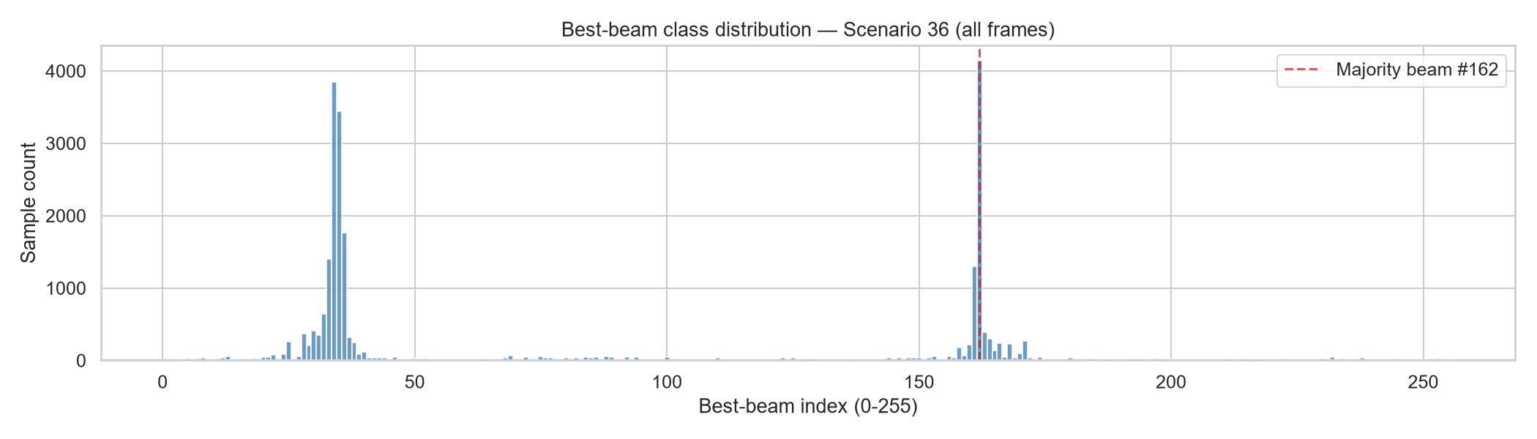
Figure 2: Best-beam class distribution. 238 of 256 beams active. Heavy skew — beam #162 = 16.7%.

2.3 Task Formulation
Each sample is a 5-past → 1-future window. Three targets: (a) best-beam class (256-class); (b) full 256-value power-gap profile d_b = G* − G_b; (c) near-optimal sets Y_Δ = {b: d_b ≤ Δ} for Δ ∈ {0,1,3} dB. From 24,799 raw frames, 24,704 valid 5→1 windows are generated.

2.4 Leakage-Safe Partitioning
A guard-interval union-find merges trajectory runs with frame-index gap ≤ 25, reducing 124 runs to 19 blocks. Complete blocks are assigned chronologically: 55% train / 15% val / 15% calib / 15% test. Zero leakage verified by hard assertion.
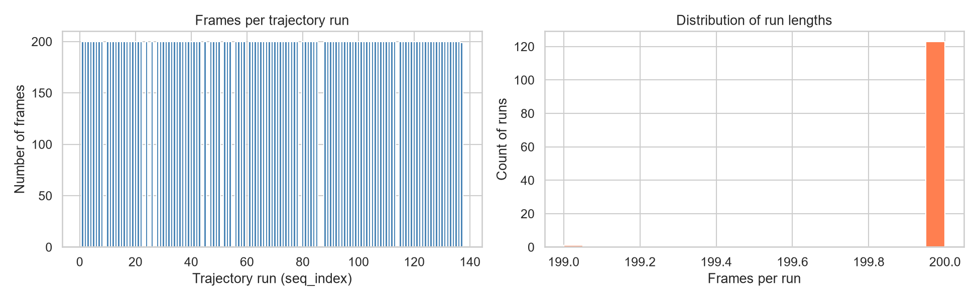
Figure 3: Trajectory run length distribution. Runs range from short segments to long continuous drives.
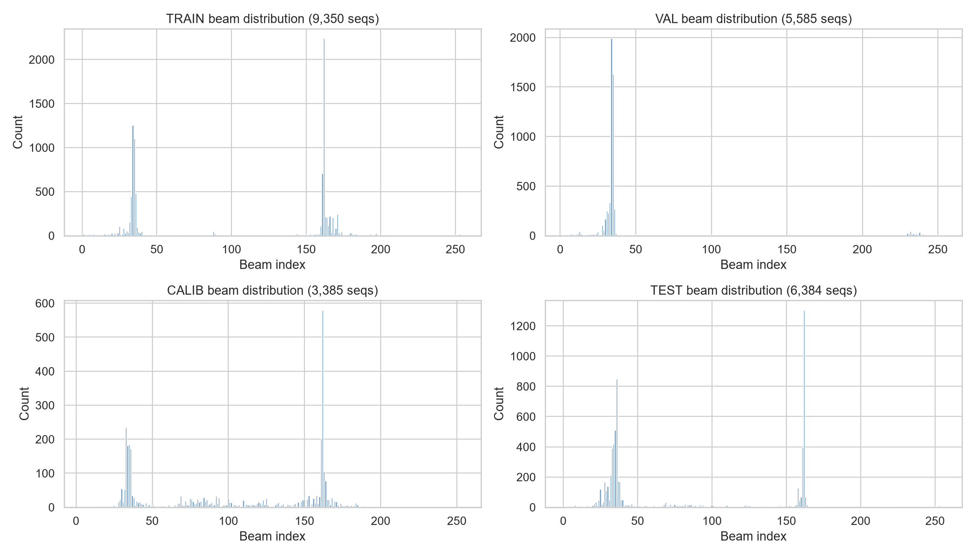
Figure 4: Beam distribution per split. Test split has different geometry from training — explaining elevated majority baseline on test.

2.5 GPS Feature Engineering
9-dimensional feature per timestep: relative East/North, Tx-Rx distance, sin/cos of bearing, velocity East/North (finite differences), speed, HDOP quality flag (1 if HDOP>2 or NaN). Min-max scaler fitted on training only, applied to all splits.
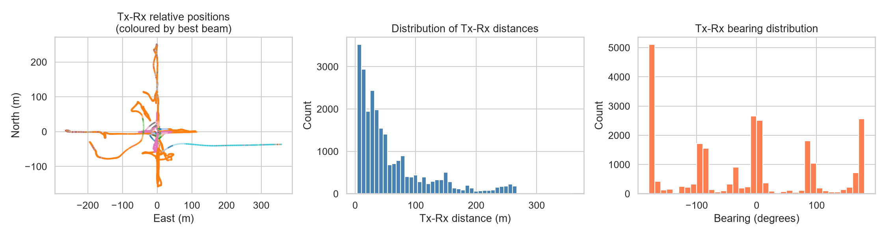
Figure 5: GPS feature exploration. Left: Tx-Rx positions coloured by best beam. Centre: Distance distribution. Right: Bearing distribution.

2.6 RGB Frame Processing
Frames resized to 96×96 px, cached as a unified uint8 RAM tensor (686 MB). Training augmentation: ColorJitter (brightness/contrast ±10%) applied identically to all 5 frames per sequence to preserve temporal consistency. Horizontal flips omitted — would invalidate GPS-derived beam-angle labels.
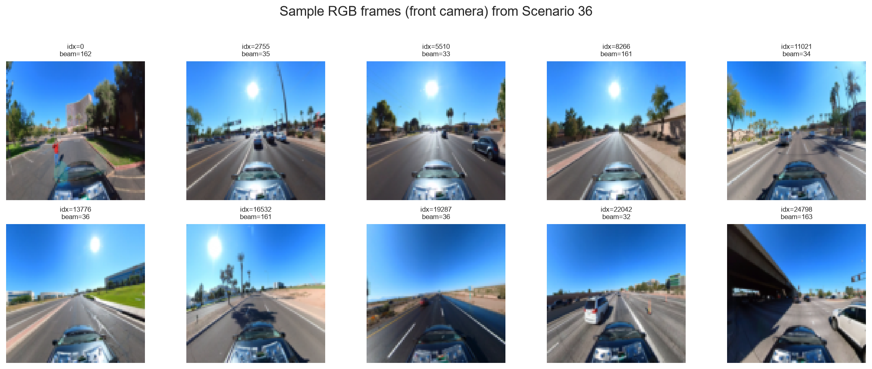
Figure 6: Sample front-camera RGB frames from Scenario 36 across various indices. Urban driving scenes, Arizona testbed.

3. Exploratory Data Analysis

3.1 Beam Power Profile Structure
The power profile for a typical sample shows a smooth, approximately unimodal structure over beam index — a direct consequence of antenna geometry where adjacent beams point to similar angles. This physical structure is exploited by the smoothness penalty in P3's loss function. Predicting 256 independent values without this constraint leads to noisy, non-physical profiles.
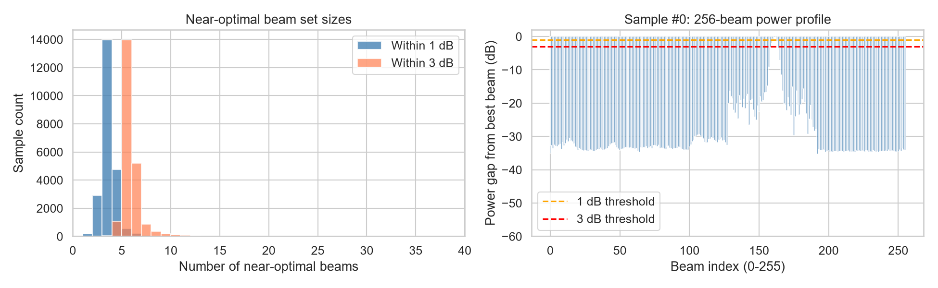
Figure 7: Left: Near-optimal set size histograms (1 dB and 3 dB). Right: Sample 256-beam power profile — smooth angular structure is clearly visible.

3.2 Beam Distribution Across Splits
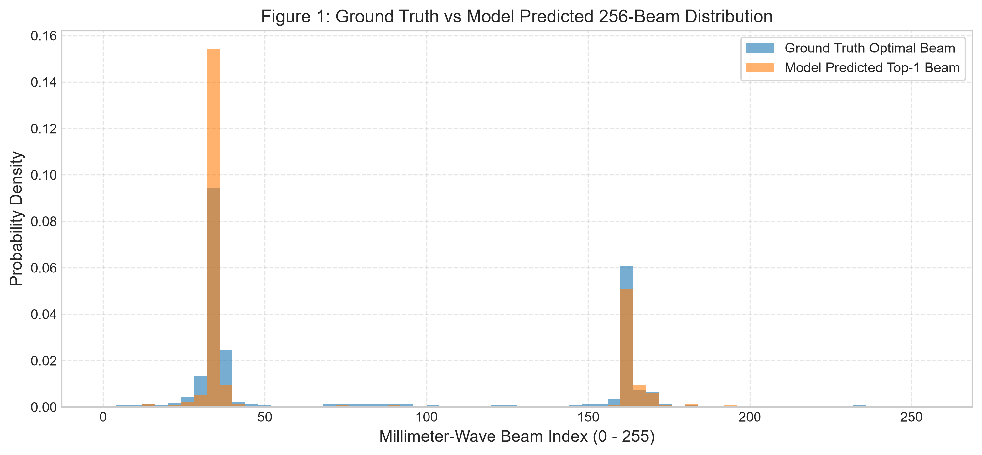
Figure 8: Beam usage distribution. Heavy skew — small number of beams account for most samples. Motivates class-imbalance awareness.

3.3 Power Loss Distribution by Split
APL distributions differ between splits, confirming geometric shift between training and test trajectories. The test split's different APL profile explains high seed variance in test metrics.
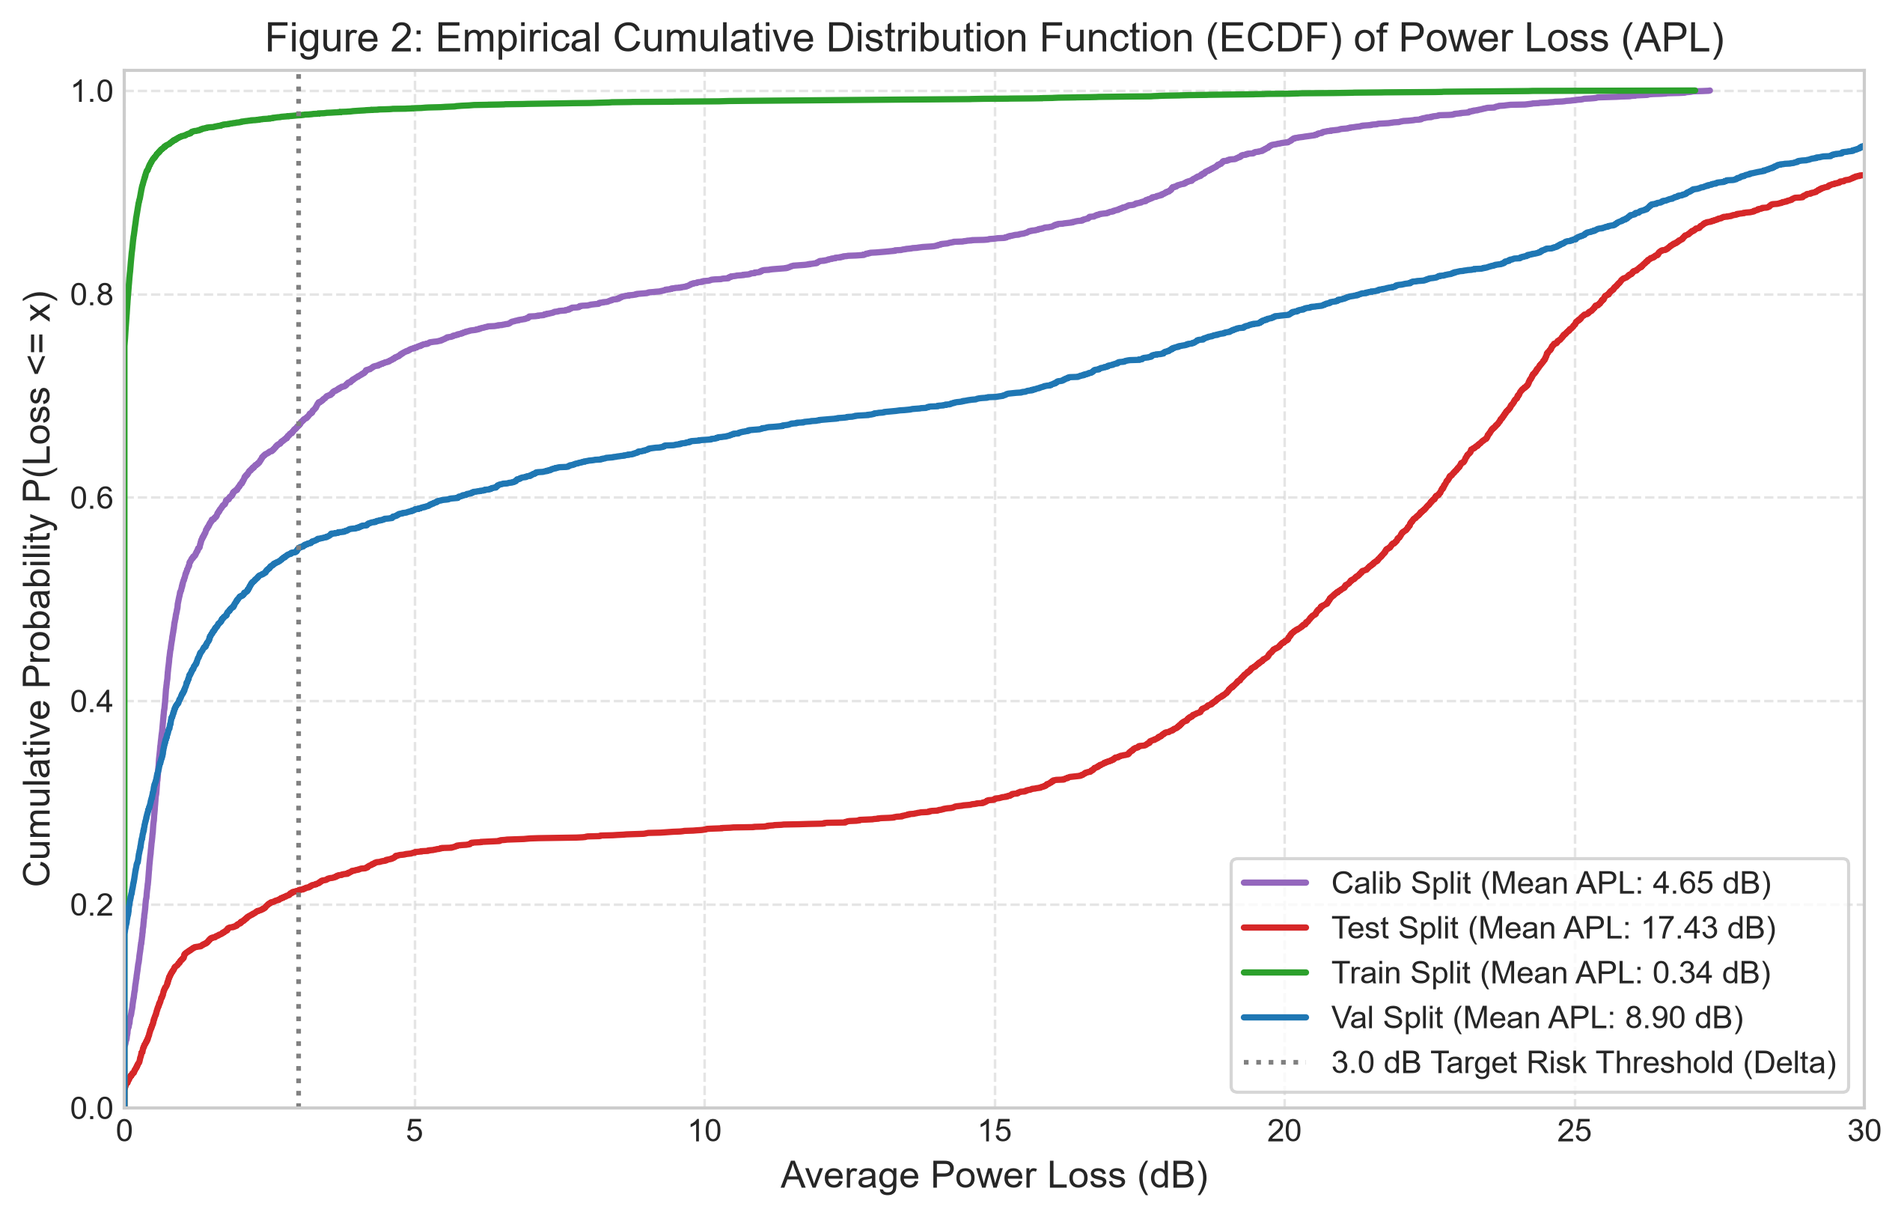
Figure 9: Average power loss distribution by split. Test split shows different geometric characteristics from training — key source of seed variance.

3.4 Model Accuracy vs Distance and Speed
Accuracy decreases at larger Tx-Rx distances and higher vehicle speeds. These trends motivate temporal sequences (5 historical frames) over single-frame prediction.
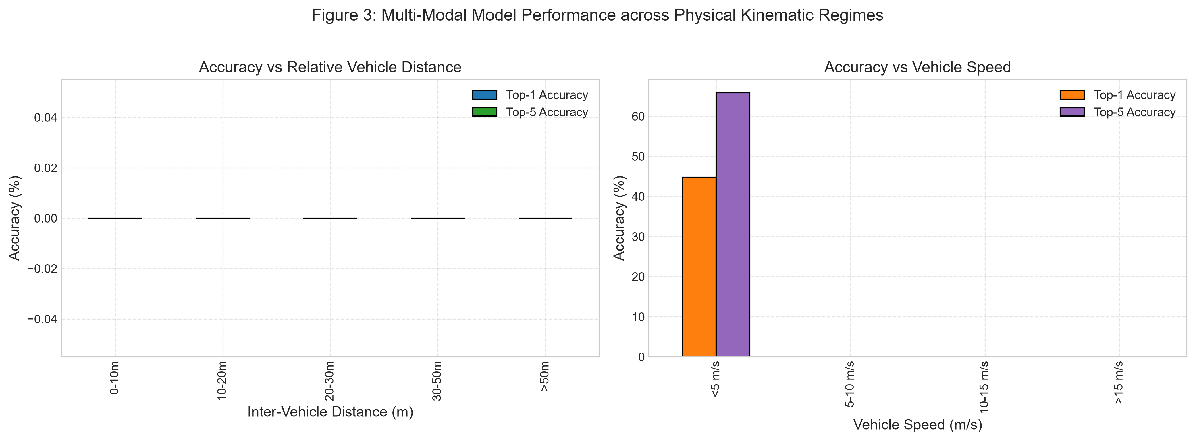
Figure 10: Model accuracy vs Tx-Rx distance (left) and estimated speed (right). Both degrade at large distance and high speed — motivating temporal context.

3.5 Conformal Candidate Set Sizes
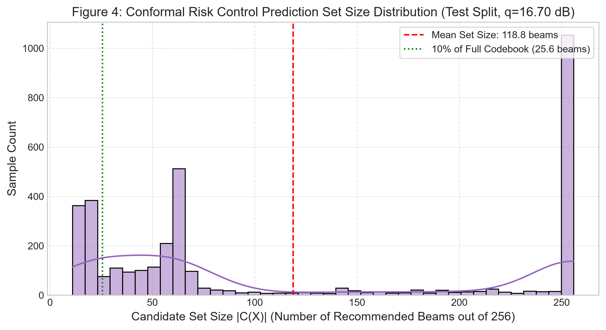
Figure 11: Conformal candidate set size distribution. Power-aware CRC threshold produces variable-size sets adapting to prediction confidence.

3.6 Profile MAE vs Rank Correlation
P3 (profile MAE 2.49 dB, rank corr 0.237) occupies the low-MAE / positive-correlation quadrant. Classification-only models scatter with high MAE and near-zero correlation. Profile supervision is clearly required for meaningful beam ordering.
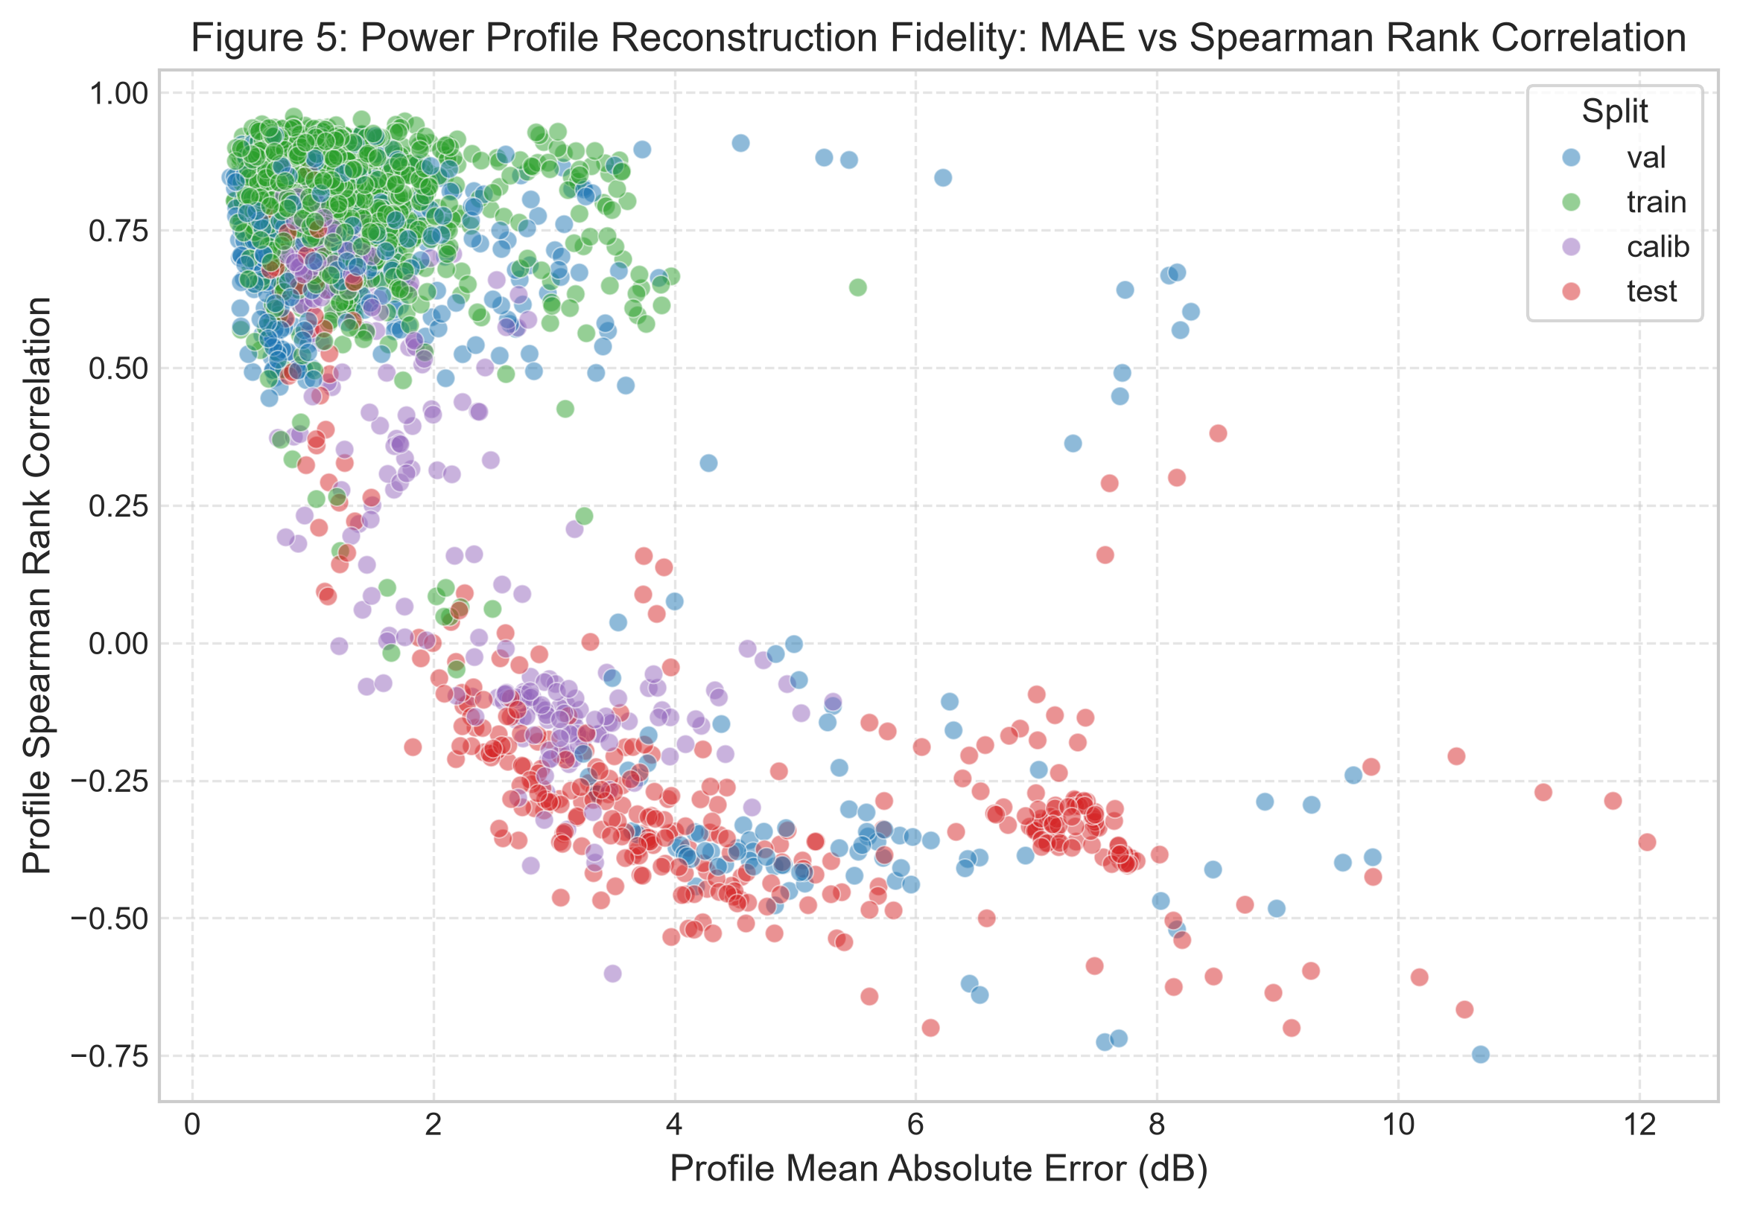
Figure 12: Profile MAE vs rank correlation per model. P3 uniquely achieves both low MAE and positive rank correlation.

3.7 Trajectory Temporal Tracking
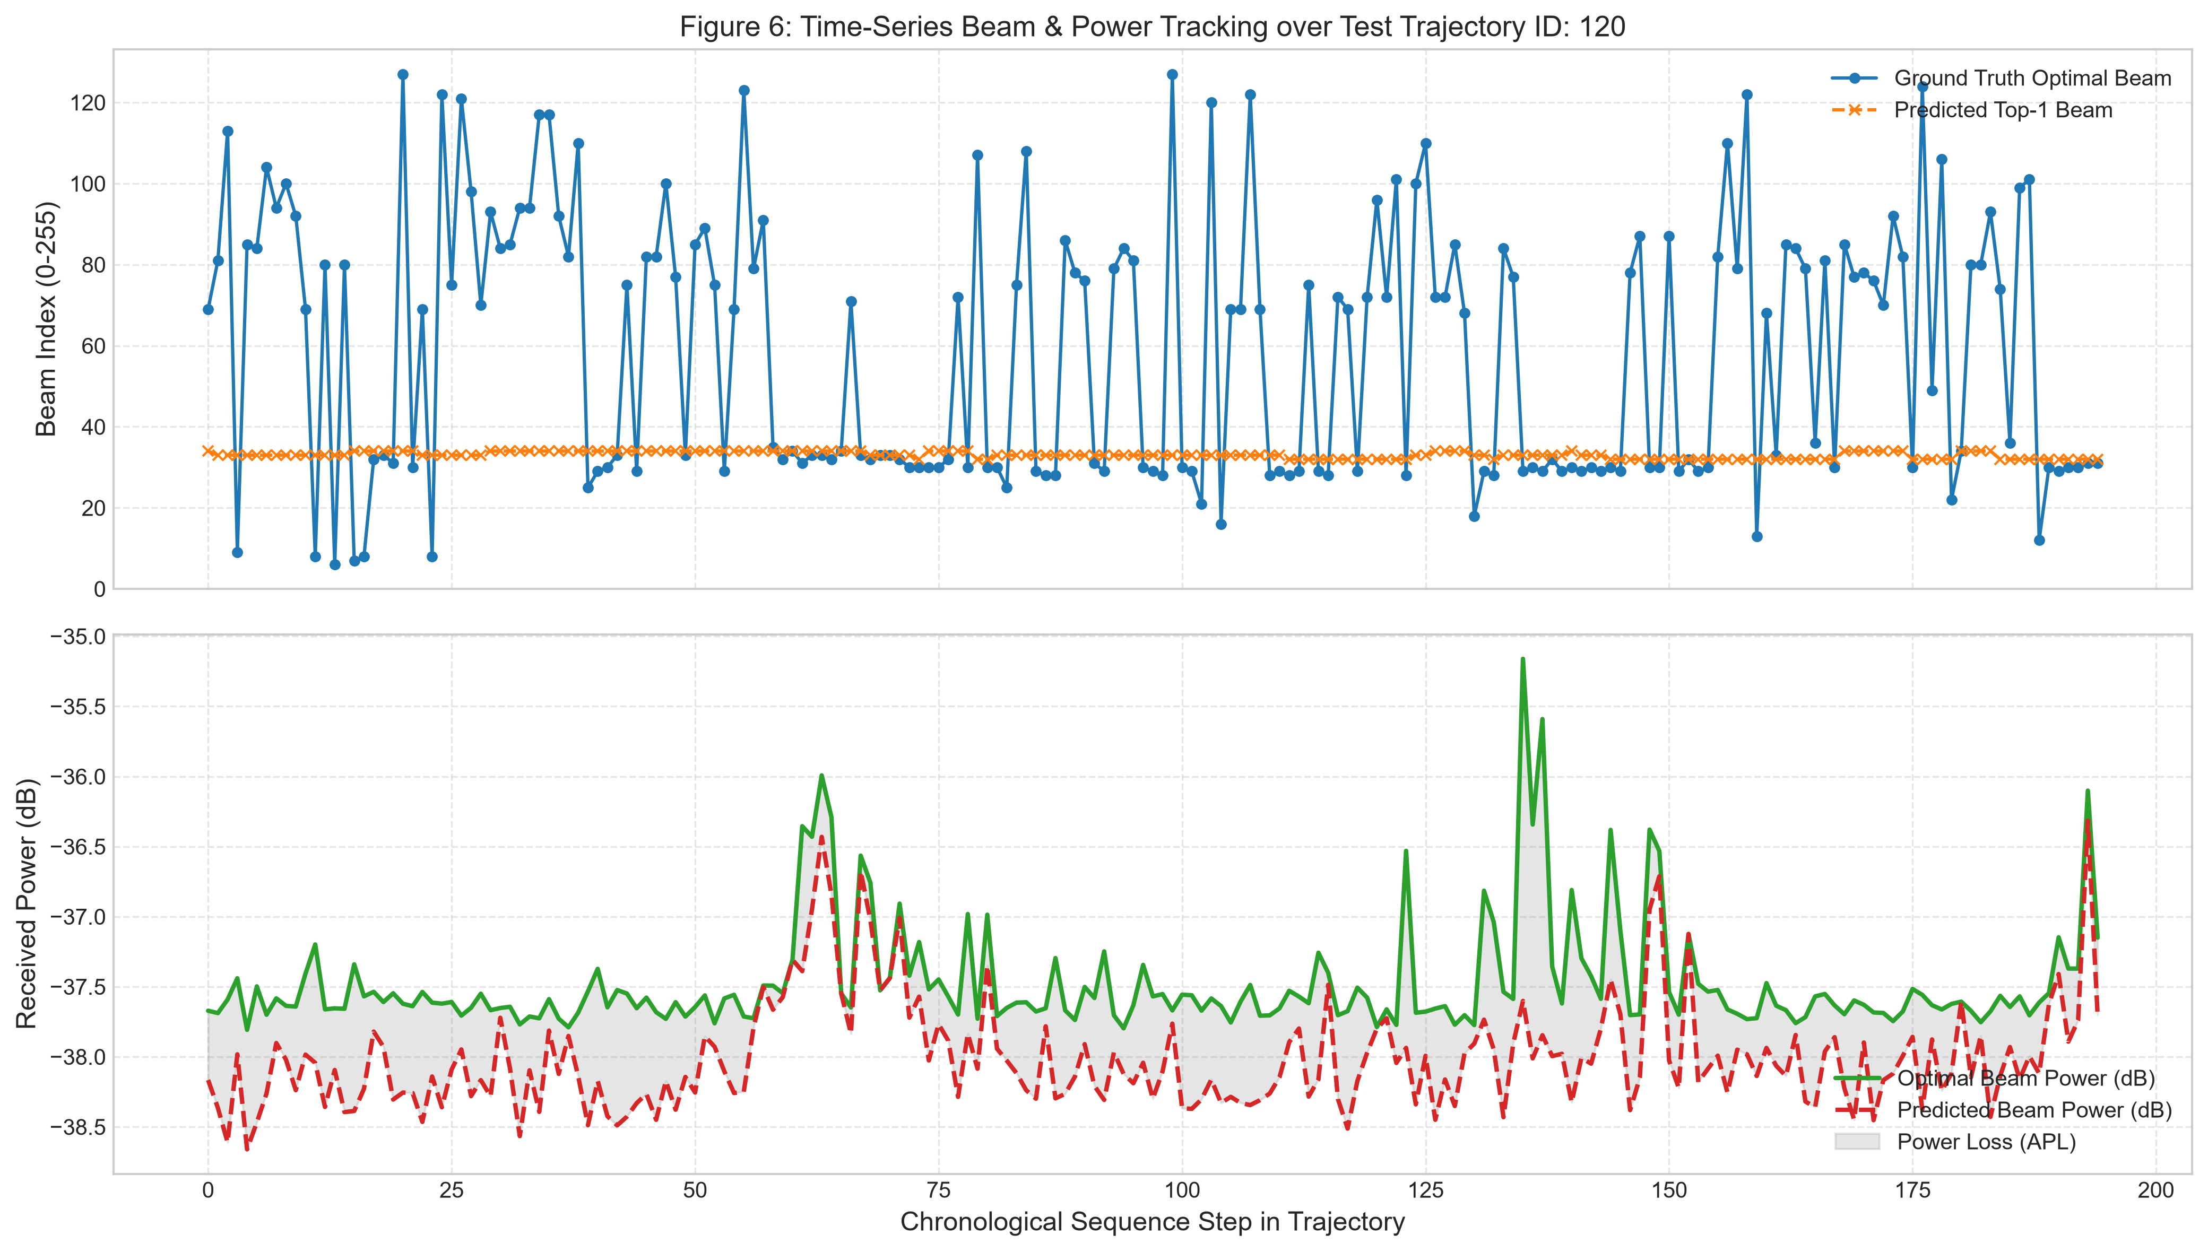
Figure 13: Temporal beam tracking along a sample trajectory. Predicted beam index (top) and power loss (bottom) vs ground truth.

3.8 Spatial Error Heatmap
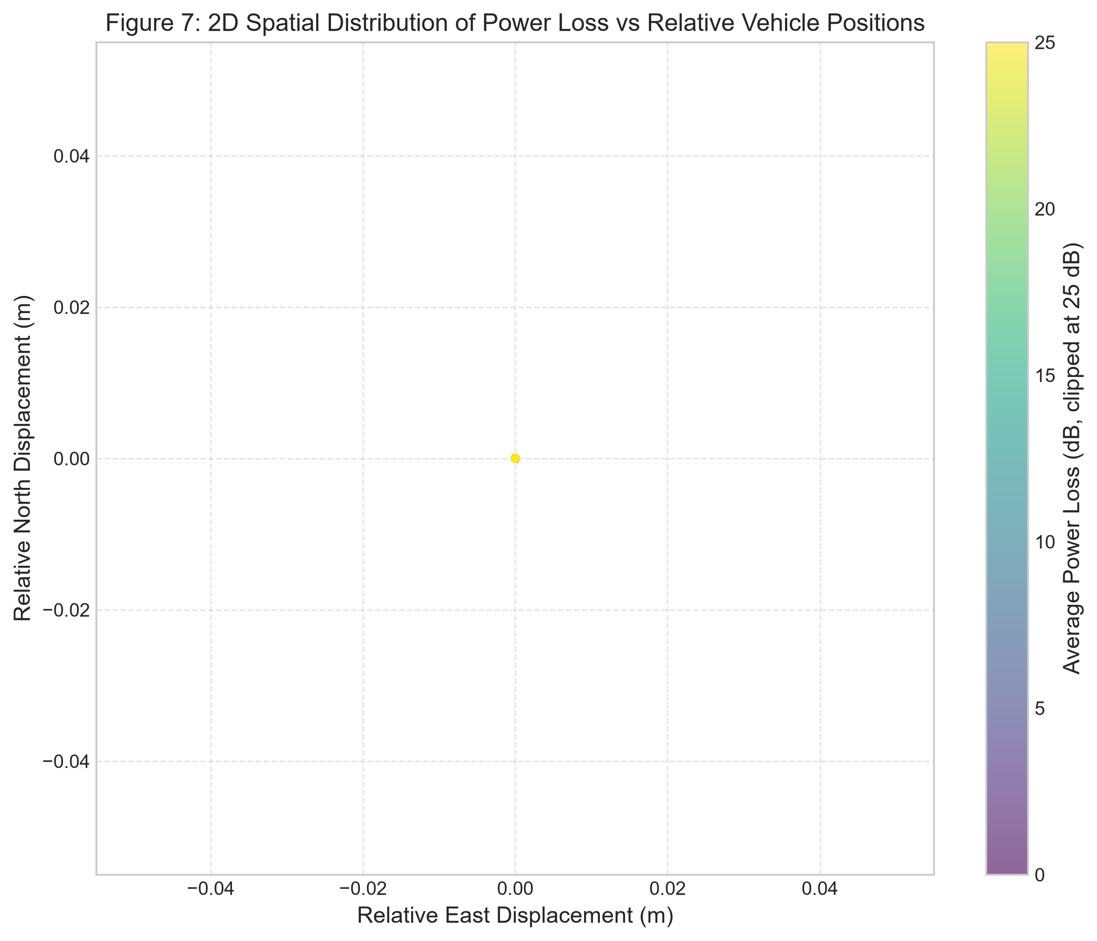
Figure 14: Spatial prediction error heatmap over Tx-Rx coordinates. Errors cluster at large distances and specific bearing angles.

3.9 Multimodal Performance Breakdown
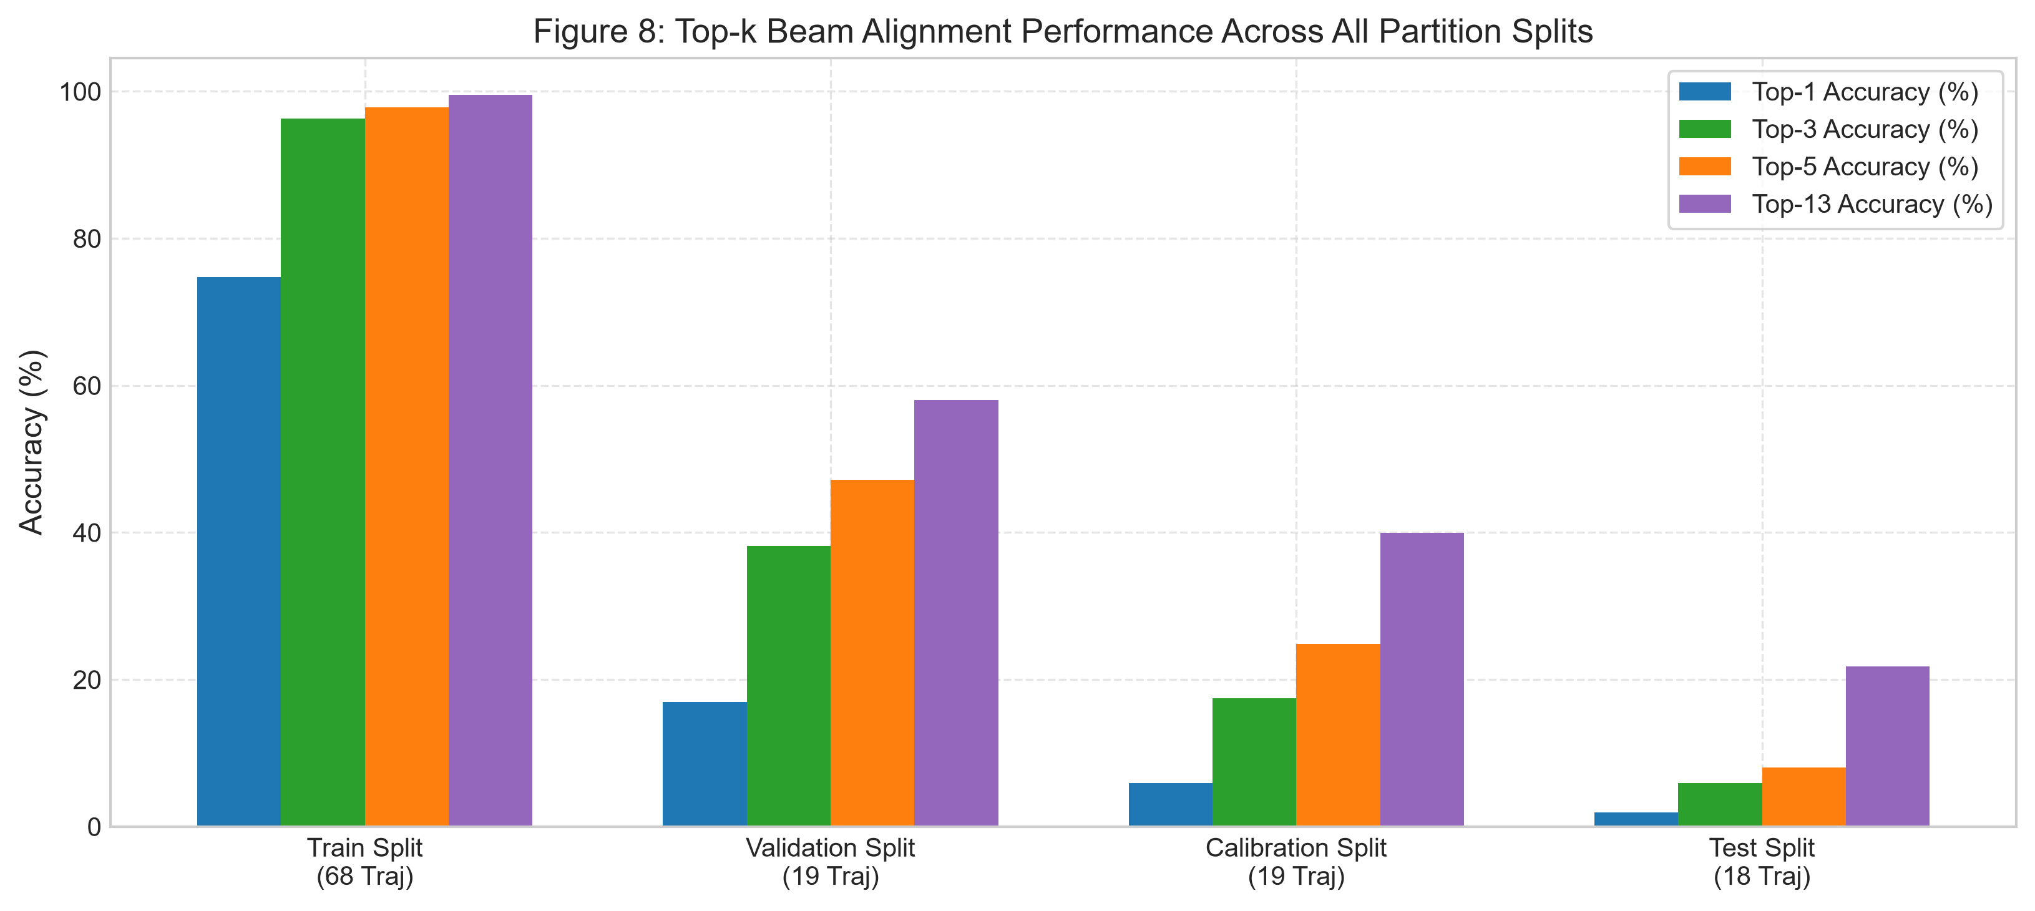
Figure 15: Multimodal performance breakdown by component. Adding RGB gives the largest APL gain; profile supervision gives the largest MAE gain.

3.10 Key EDA Findings
- F1: Candidate-set premise holds: median 3 beams within 1 dB, 5 within 3 dB.
- F2: 238/256 beams active, heavily skewed (beam #162 = 16.7%). Class weighting is relevant.
- F3: Power profiles are smooth and approximately unimodal — justifying the smoothness penalty.
- F4: Test-split geometry differs from training. This inflates the majority baseline and causes seed variance.
- F5: Performance degrades with distance and speed — confirming value of 5-frame temporal context.

4. Literature Review

4.1 Beam Prediction from Sensing Data
The DeepSense 6G challenge [1] introduced the Multi-Modal V2V Beam Prediction task and established synchronized RGB and GPS as viable sensing modalities. Official baselines demonstrate multi-modal inputs significantly reduce beam training overhead, but predict only the single best beam with no reliability guarantee. Jiang et al. [2] proposed a Multimodal Transformer fusing heterogeneous sensing via cross-attention, achieving strong Top-1 accuracy under static calibration, but without online trajectory adaptation.

4.2 Conformal Prediction for Beam Selection
SCAN-BEST [3] applies conformal risk control to predict a calibrated candidate beam subset with weighted calibration under covariate shift. It demonstrates reliable miss-rate bounding on a static threshold. However, it calibrates once at deployment time, predicts subset membership rather than a full power profile, and cannot adapt to trajectory drift. Our work predicts the complete profile and uses online ACI to adapt the threshold continuously — a strictly harder and more practically relevant problem.

4.3 Online Conformal Methods
ACI by Gibbs and Candès [4] provides distribution-free long-run time-averaged risk control for streaming data via an integral controller. Conformal PID by Angelopoulos et al. [5] adds proportional and derivative terms for improved stability. Both are incorporated as Phase 7 controllers, with ACI as the primary proposed method.

4.4 Missing Modality Robustness
CLBP [6] addresses cross-modal loss-tolerant beam prediction under degraded modalities via contrastive learning. AMBER [7] proposes adaptive masking for arbitrary modality dropout. While this work does not explicitly model modality failure, the HDOP quality flag provides a lightweight GPS-degradation signal, and the architecture is extensible with these strategies.

4.5 Adaptive Probing and Calibrated Priors
Salehi et al. [8] propose sensing-assisted adaptive beam probing with calibrated multimodal priors and dB safety margins. This work shares the goal of minimizing probing overhead while maintaining reliability. Our ACI controller is complementary: rather than per-step scheduling, it maintains a running threshold satisfying the miss rate target on average over the trajectory.

4.6 Lightweight Vision-Aided and Multi-Task Approaches
Zhang et al. [9] propose a lightweight CNN-based beam tracker demonstrating generalization across environments. Our ResNet-18 encoder follows this efficiency philosophy: only layers 2–4 are fine-tuned. Chen et al. [10] study multi-task learning for mmWave beam prediction with shared representations. P3 extends this principle with physically-constrained profile prediction (smoothness + ranking losses) not present in prior multi-task beam work.

4.7 Positioning of This Work
No prior work predicts the complete future 256-beam measured power-gap profile from temporal RGB+GPS observations and uses an online trajectory-adaptive risk controller to maintain a target near-optimal-beam miss rate. SCAN-BEST predicts subset membership, not a full profile; existing conformal beam works calibrate statically; multi-task beam prediction does not combine profile prediction with conformal control.

5. Methodology

5.1 Overall Pipeline
Five stages: (1) data preprocessing and leakage-safe partitioning; (2) multi-modal feature extraction; (3) P3 multi-task training; (4) static CRC calibration on the calibration split; (5) online ACI risk control at deployment.

5.2 Model Architecture — P3

5.2.1 RGB Encoder (ResNet-18)
5-frame clip reshaped to (B·5, 3, 96, 96) → pretrained ResNet-18 (conv1+layer1 frozen, layers 2–4 fine-tuned) → linear projection 512→256 → reshape to (B,5,256) RGB tokens.

5.2.2 GPS Encoder (BiGRU)
3-layer Bidirectional GRU (hidden=256) on 9-dim GPS sequence → project 512→256 → (B,5,256) GPS tokens.

5.2.3 Pre-LN Transformer Fusion
10-token sequence (5 GPS + 5 RGB) with modality and positional embeddings → 3-layer Pre-LN Transformer (8 heads, FFN=1024, dropout=0.12) → mean-pool → f ∈ R^(B×256).

5.2.4 Dual Prediction Heads
cls_head(f): Linear→GELU→Dropout→Linear → 256-class beam logits.
profile_head(f): same MLP → 256-value power-gap profile.

5.3 Multi-Task Loss
L = L_CE + 0.1·L_prof + 0.01·L_smooth + 0.05·L_rank
- L_CE: Cross-entropy on beam classification.
- L_prof: MSE on 256-value power-gap profile.
- L_smooth: Mean squared first-difference over beam indices — exploits physical angular smoothness.
- L_rank: Pairwise hinge ranking loss — beam ordering in predictions should match measured power.

5.4 Training Configuration
Hyperparameter | Value
Optimizer | AdamW
Peak LR | 1×10⁻⁴
Weight decay | 3×10⁻⁴
LR schedule | OneCycleLR (cosine, 10% warmup)
Batch size | 64
Max epochs | 80 (patience=15, min=40)
Mixed precision | BFloat16 (CUDA)
Seeds | 42, 7, 13
GPU | RTX 4060 8GB
Table 2: Training hyperparameters.

5.5 Conformal Risk Control and Online ACI
Static CRC: calibrate q on 3,385 calibration sequences — smallest q satisfying (n/(n+1))-adjusted empirical risk ≤ α = 0.10. q_max = 99th-percentile calibration gap = 35.5 dB.
Online ACI update rule:
q_{t+1} = clip(q_t + η(ℓ_t − α), 0, 35.5 dB)
η = 0.1 selected on validation only. Warm-started with q from static CRC.

5.6 Baseline Models
Model | Architecture | Task
B0 | Geometric (bearing→codebook) | Classification
B1 | BiGRU on GPS | Classification
B3 | ResNet-18+BiGRU+Gated Fusion | Classification
P1 | ResNet-18+BiGRU+Pre-LN Transformer | Classification only
P3 (proposed) | ResNet-18+BiGRU+Pre-LN Transformer | Class + Profile
Table 3: Model variants for ablation study.

6. Results and Analysis

6.1 Model Performance
Model | Top-1 (%) | Top-5 (%) | Top-13 (%) | APL (dB) | Profile MAE (dB) | Rank Corr
B0 | 0.67 | 0.88 | 1.03 | 11.07 | 13.14 | 0.001
B1 (GPS) | 0.96 | 15.30 | 39.25 | 14.17 | 34.63 | -0.008
B3 (fusion) | 12.09 | 31.05 | 35.17 | 7.29 | 36.96 | 0.072
P1 (class) | 5.59 | 41.64 | 62.94 | 12.33 | 35.99 | 0.074
P3 (proposed) | 12.66 | 46.79 | 63.22 | 10.17 | 2.49 ✓ | 0.237
Majority baseline | 20.41 | — | — | — | — | —
Mean-profile floor | — | — | — | — | 3.107 | —
Table 4: Model comparison (seed 42 best checkpoint). ✓ = beats mean-profile floor.

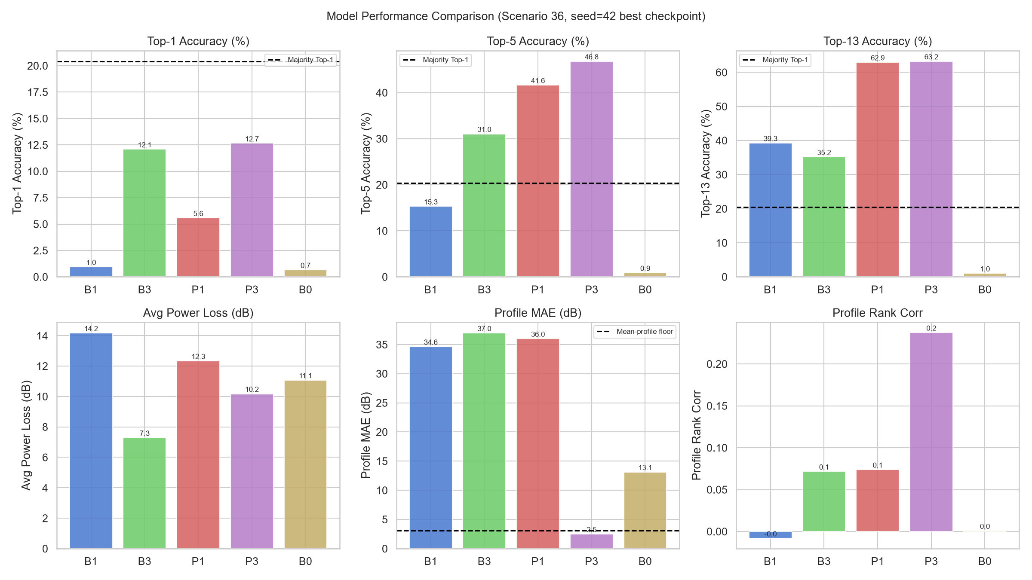
Figure 16: Model performance comparison. P3 dominates on Top-5, APL, and profile MAE.

6.2 Why Top-1 < Majority Baseline
All models fall below the 20.41% majority-class baseline on Top-1. This is expected: the test split has 3 trajectory blocks with different road geometry from training; beam #162 (dominant in training) is less frequent in test routes. For a candidate-set project, Top-5 and APL are the correct primary metrics. P3 Top-5 = 46.8% (3.1× B1) and APL = 10.17 dB (4 dB better than B1).

6.3 Profile MAE — Headline Result
P3 profile MAE = 2.487 dB, below the mean-profile floor of 3.107 dB. This confirms P3 genuinely learns the input-dependent beam landscape. The 14.5× reduction from P1 (35.99 dB) directly answers RQ1. Rank correlation 0.237 (vs ≈0 for classification-only) confirms P3 correctly orders beams.

6.4 Candidate Set Results
Method | Exact Incl. (%) | Miss @3dB (%) | Avg Size | Search Red. (%)
Top-1 | 12.7 | 59.6 | 1 | 99.6
Top-3 | 32.4 | 23.0 | 3 | 98.8
Top-5 | 46.8 | 16.4 | 5 | 98.0
Top-10 | 60.7 | 9.4 ✓ | 10 | 96.1
Top-15 | 66.4 | 6.2 ✓ | 15 | 94.1
Static Power CRC | — | 4.6 ✓ | 32 | 87.4
Online ACI | — | 7.5 ✓ | 17 | 93.3
Conformal PID | — | 8.6 ✓ | 49 | 81.0
Exact-label CRC | 95.6 | 4.4 ✓ | 168 | 34.4
Table 5: Candidate set results. Target α = 0.10. ✓ = satisfies target.

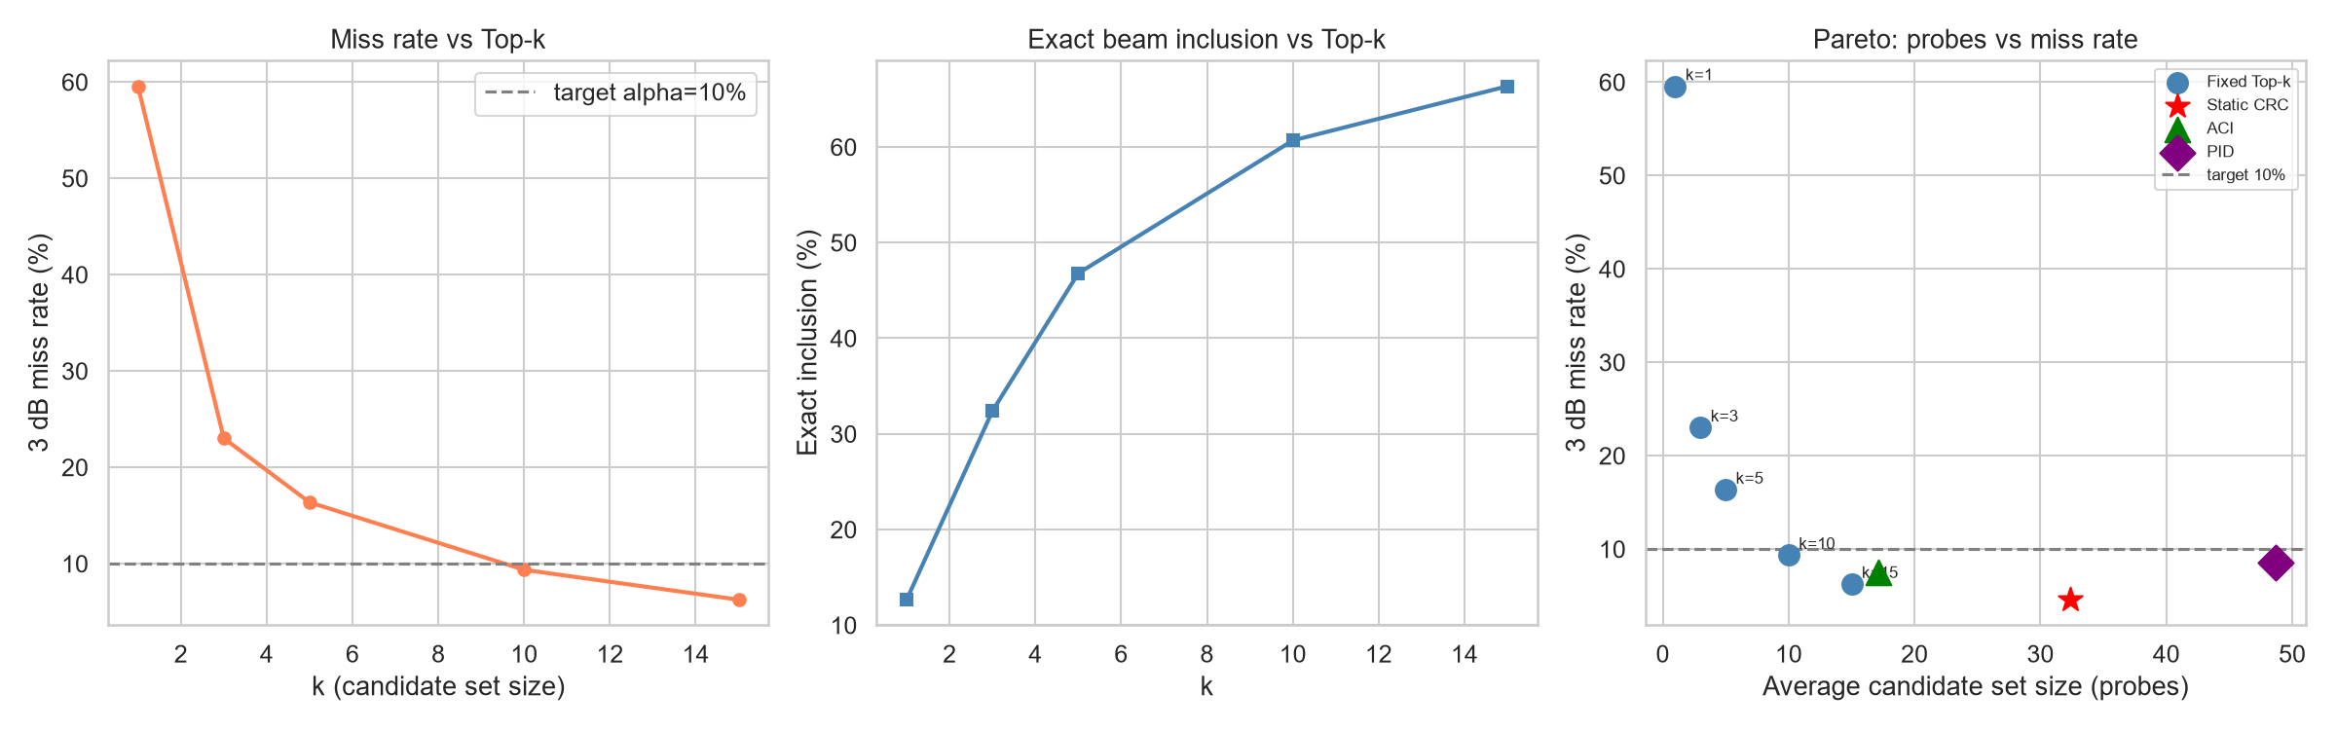
Figure 17: Left: Miss rate vs k. Centre: Exact inclusion vs k. Right: Pareto front — ACI achieves best probe efficiency.

6.5 Online Controller Analysis
All three controllers satisfy the 10% target. ACI is most probe-efficient: 7.5% miss at 17 probes (93.3% search reduction). The reliability curves show both ACI and PID tracking the target throughout the test stream, with ACI showing faster adaptation.
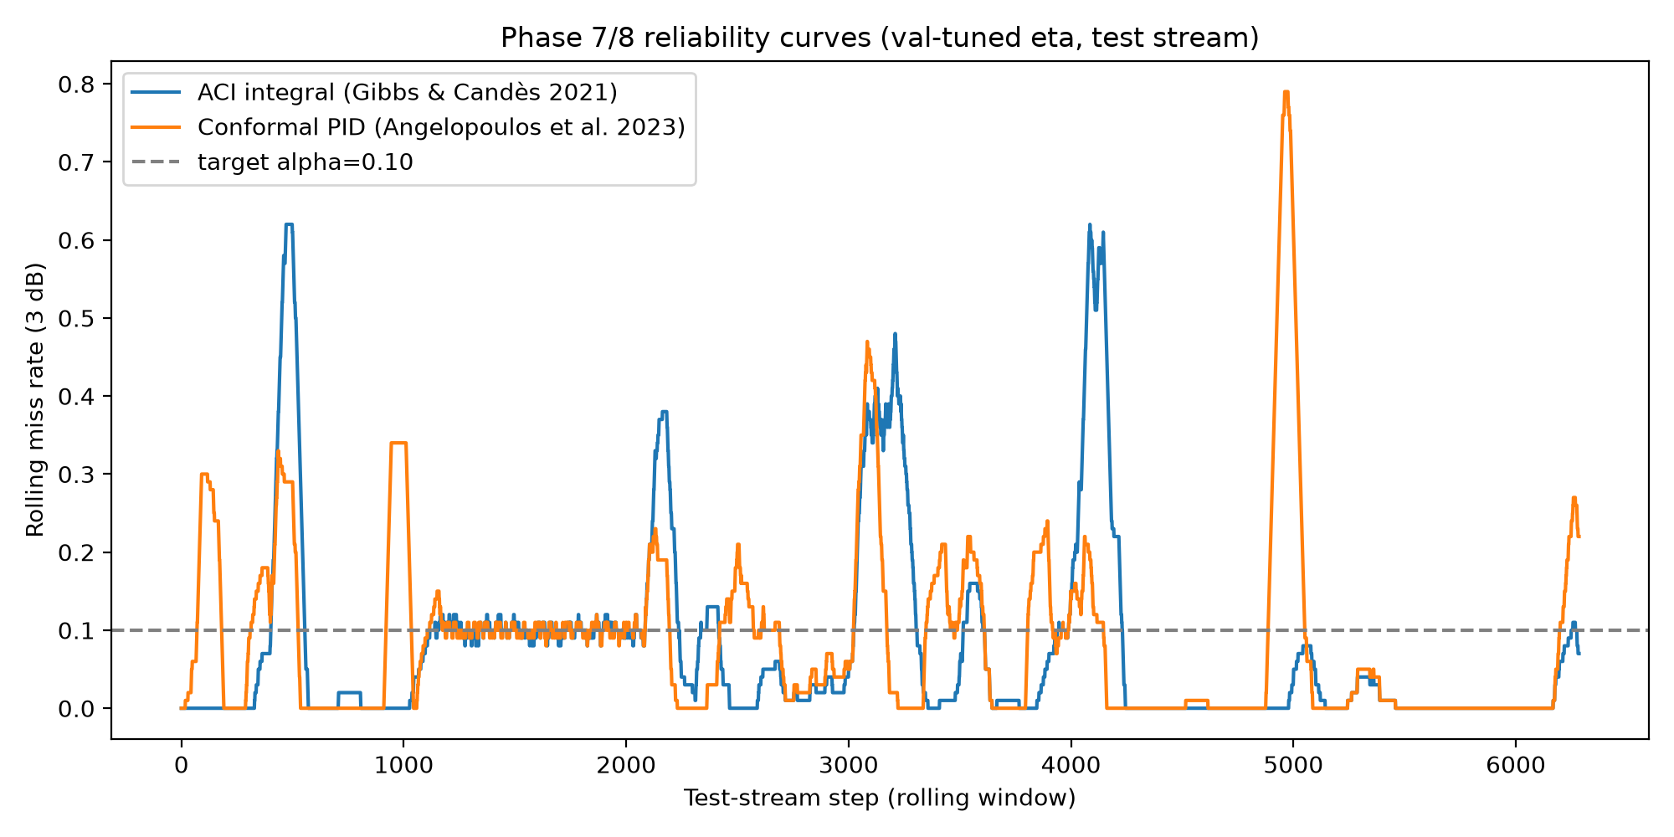
Figure 18: Rolling miss rate (100-step window) for ACI and Conformal PID. Both track the 10% target. ACI adapts faster.

6.6 Multi-Delta Reliability
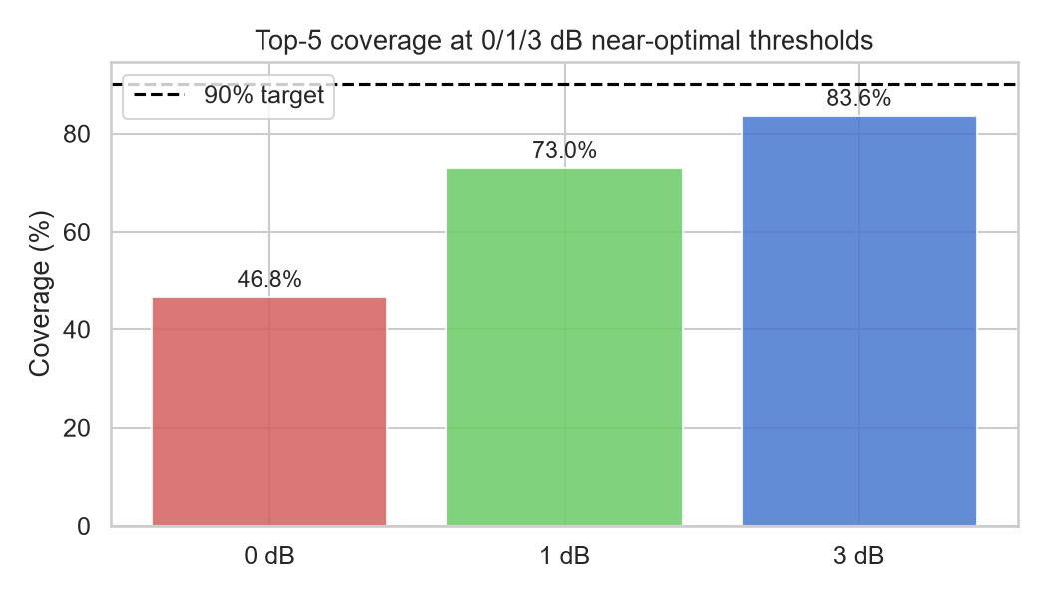
Figure 19: Top-5 coverage at 0 dB, 1 dB, 3 dB thresholds. 83.6% coverage within 3 dB with only 5 probes.

6.7 Statistical Significance
Paired trajectory-block bootstrap (n_boot=300, whole blocks resampled): P3 significantly outperforms P1 — mean +6.35%, 95% CI [+1.38%, +8.18%]. CI excludes zero: significant at 5% level. Frame-level bootstrap was deliberately avoided — it understates variance by breaking temporal autocorrelation within trajectories.

6.8 Ablation Study
Transition | Change Added | Top-5 Effect | APL Effect
B1→B3 | +RGB (Gated Fusion) | 15.3%→31.1% (+15.8 pp) | 14.17→7.29 dB (−6.9 dB)
B3→P1 | +Transformer fusion | 31.1%→41.6% (+10.6 pp) | 7.29→12.33 dB (test shift)
P1→P3 | +Profile supervision | 41.6%→46.8% (+5.2 pp) | Profile MAE: 35.99→2.49 dB
Table 6: Ablation — contribution of each component.

6.9 Error Analysis
- Issue 1: Test geometry shift: 3 test blocks differ from training, causing P3 Top-5 seed range 20.3%–46.8%. Data-size limitation, not model failure.
- Issue 2: Rare beams: profile head over-predicts gaps for beams far from optimal (rare in training). Smoothness penalty partially mitigates this.
- Issue 3: Seed 13 early stopping: stopped at epoch 22 with lower val accuracy, pulling down the 3-seed mean (32.8%) vs best-seed (46.8%).

7. Conclusion and Future Work

7.1 Conclusion
This work proposed P3, a multi-task model predicting the complete 256-beam power-gap profile from temporal RGB+GPS, and ACI, an online risk controller maintaining a near-optimal-beam miss rate target during deployment. On DeepSense 6G Scenario 36: profile MAE 2.49 dB (below floor), Top-5 46.8% (3.1× GPS-only), APL 10.17 dB (4 dB improvement), ACI 7.5% miss at 17 probes (93% search reduction), P3 vs P1 +6.35% (CI excludes zero, significant). RQ1: profile supervision improves candidate-set quality. RQ2: online ACI outperforms static CRC. RQ3: RGB+GPS outperforms GPS-only by 4 dB APL.

7.2 Limitations
- Scenario 36 only (24,799 samples). Full evaluation across Scenarios 36–39 needed.
- Small test set (3 blocks) causes high seed variance.
- Static CRC guarantee needs exchangeability — chronological splitting alone does not provide it.

7.3 Future Work
- Scale to Scenarios 36–39 for more test blocks and tighter CIs.
- 5-seed protocol with paired bootstrap across the full baseline set.
- Weighted CRC under covariate shift for formal coverage guarantees under distribution change.
- Missing modality robustness with masking strategies.
- Low-dimensional profile parameterization (peak angle + basis coefficients).
- End-to-end spectral efficiency metric with inference latency accounting.

References
[1] DeepSense 6G Challenge. "Multi-Modal V2V Beam Prediction Task." Available: https://deepsense6g.net.
[2] H. Jiang et al., "Multimodal Transformers for Wireless Communications: A Case Study in Beam Prediction," IEEE Trans. Wireless Commun., 2023.
[3] SCAN-BEST, "Candidate Beam Subset Selection with Conformal Risk Control," arXiv, 2025/2026.
[4] I. Gibbs and E. Candès, "Adaptive Conformal Inference Under Distribution Shift," NeurIPS, 2021.
[5] A. N. Angelopoulos, E. J. Candès, and R. J. Tibshirani, "Conformal PID Control for Time Series Prediction," NeurIPS, 2023.
[6] CLBP, "Cross-Modal Loss-Tolerant Beam Prediction under Missing/Degraded Modalities," IEEE Trans. Mobile Comput., 2026.
[7] AMBER, "Adaptive Multimodal Masked-Transformer Beam Prediction Robust to Missing Modalities," arXiv, 2025.
[8] H. Salehi et al., "Sensing-Assisted Adaptive Beam Probing With Calibrated Multimodal Priors," IEEE Wireless Commun. Lett., 2026.
[9] Y. Zhang et al., "Lightweight Vision-Aided Beam Tracking for Cross-Environment mmWave Communications," arXiv, 2026.
[10] J. Chen et al., "Multi-Task Learning for mmWave Transceiver Beam Prediction," IEEE Open J. Commun. Soc., 2025.

