**MAPD713 Enterprise Technologies for Mobile Platforms**

**Project: Patient Data REST API**

**Descriptions**

You are asked to help design REST API Service for a Patient Clinical Data management application for the health care providers (i.e. nurses and doctors) in hospital.

* REST API Service shall allow health care providers to view patient data to track and monitor patient records.
* REST API Service shall allow health care providers to view the detailed clinical data for an individual patient.
* REST API Service shall allow health care providers to find out any patients in critical condition.
* The clinical data can include the following information:
  + Date/time, Type of Data, Reading/Value
  + Data Type:
    - Blood Pressure
    - Respiratory Rate
    - Blood Oxygen Level
    - Heart Beat Rate

**Milestones & Evaluation Schema**

|  |  |  |  |
| --- | --- | --- | --- |
| Project - milestones | Deliverables | Evaluation Mark | Due Date |
| Milestone 1  Mockups and requirements analysis | Document containing:  - Title Page which includes team member names  - Project description  - Use cases / Functionality   * Add Patient * View Patient * List all Patients * Add Patient Record * View Patient Records * Etc.   - Sequence Diagrams for all use-cases  - Documents should be uploaded to e.centennial in the format: <TeamName>_m1.zip (e.g. Nexus_m1.zip) | 10 | Oct 10, 2018 |
| Milestone 2  Prototype,  interface implementation, implementing selected functionality | - Web Server with Implementation of at least 3 use-cases  - Demonstration of functionality (e.g. using Postman) | 15 | Oct 31, 2017 |
| Milestone 3  Client – server integration | - Web Server with Implementation of all of use-cases  - Integration with Mobile App (at least one use case – e.g. List All Patients)  - Demonstration of integration using Android App (using test server with sample data or your own service) | 15 | Nov 14, 2018 |
| Milestone 4  Integration, testing, and beta application | - Unit tests / Integration tests  - Service Deployed to Heroku/OpenShift platform  - Integration with Mobile App (at least 3 use cases)  - Demonstration of integration using Android App (using test server with sample data or your own service)  - Source Code should be uploaded to e.centennial in the format: <TeamName>_m4.zip (e.g. Nexus_m4.zip) | 10 | Dec 5, 2018 |
| Presentation  Final Submission and Presentation | - In-class Presentation (10 min max), each team member must participate in the presentation to earn the mark  - All code and all documents should be uploaded to e.centennial  in the format: <TeamName>_m_final.zip (e.g. Nexus_m_ final.zip) | 20 | Dec 12, 2017 |
|  | TOTAL | 70 |  |

**Server with Sample Data**

<http://ehealth-zvbox.rhcloud.com/patient>s - get all patients

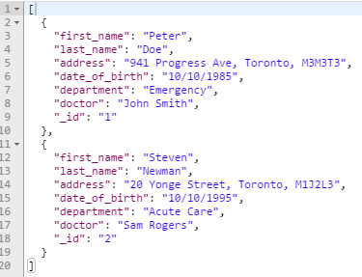

<http://ehealth-zvbox.rhcloud.com/patients/1> - get patient with id=1

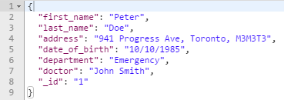

<http://ehealth-zvbox.rhcloud.com/patients/1/record>s - get records of patient with id=1

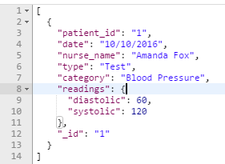

**Diagram Example**

**Client - Server Communication Diagram**

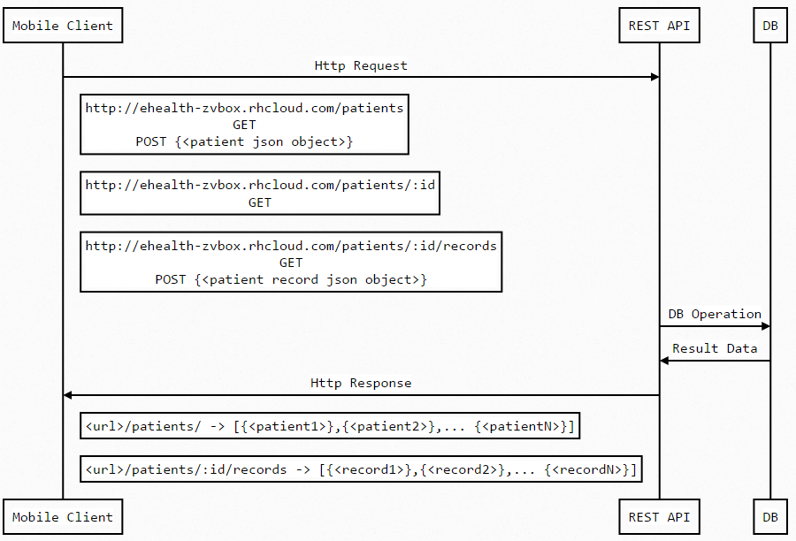

**Diagram Source Code**

Mobile Client->REST API: Http Request

Note right of Mobile Client: http://ehealth-zvbox.rhcloud.com/patients\nGET\nPOST {<patient json object>}

Note right of Mobile Client: http://ehealth-zvbox.rhcloud.com/patients/:id\nGET

Note right of Mobile Client: http://ehealth-zvbox.rhcloud.com/patients/:id/records\nGET\nPOST {<patient record json object>}

REST API->DB: DB Operation

DB->REST API: Result Data

REST API->Mobile Client: Http Response

Note right of Mobile Client: <url>/patients/ -> [{<patient1>},{<patient2>},... {<patientN>}]\n

Note right of Mobile Client: <url>/patients/:id/records -> [{<record1>},{<record2>},... {<recordN>}]\n