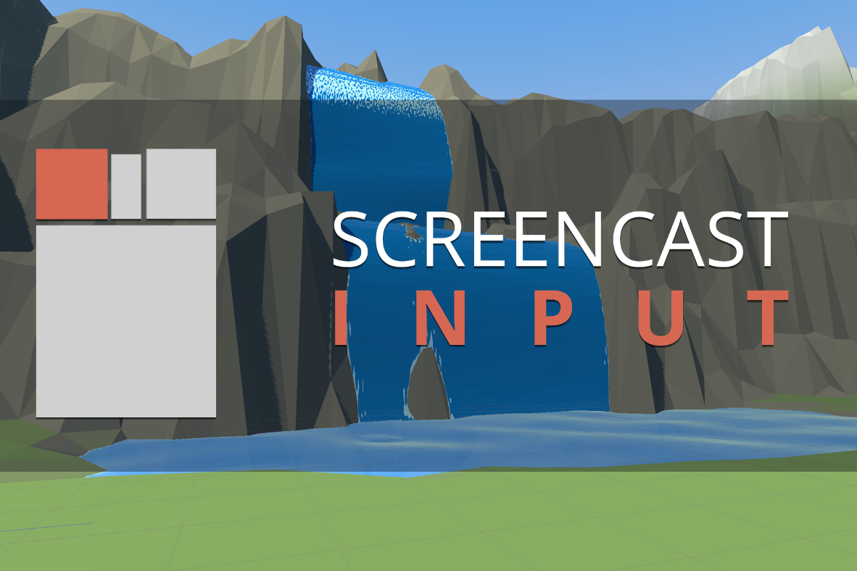

README | Release 1.0 | Unity 2020.2.1f1

© Over One Studio LLC

# Foreword

Thank you for purchasing **Screencast Input**, a small library to visualize user input while your game is played. The codebase included with **Screencast Input** is documented. Take some time to read through it if you are interested in how it works.

You will be happy to know **Screencast Input** supports Unity’s old and new input systems without any configuration on your part. Simply follow the installation step below in a new or existing project. We also made sure Unity keeps code for the un-used input system out of your compiled project.

**Screencast Input** currently supports Mouse and Keyboard. Let us know if you would like to see support for other devices through our support channel below!

# Installation

Download and import **Screencast Input** using the *Unity Package Manager*. Make sure that all items are selected before clicking the import button.

**Screencast Input** uses **Text Mesh Pro**. Make sure to add its essential resources to your project by clicking **Window/Text Mesh Pro/Import TMP Essential Resources**.

# Quick Start

After installation is completed add the **Screencast Input** prefab to your scene.

You can either

* Drag and drop the **Screencast Input** prefab from the */prefabs* directory into your scene.

**or**

* Click **UI/Screencast Input** in the *Create Menu* of the Hierarchy window.

# Logging

**Screencast Input** has built-in logging support which can be toggled on/off in the *Screencast Input Text Settings* asset. Logging captures a rolling log of timestamp and input information.

When enabled a log file will be created at **Assets/ScreencastInput/Logs**. You can compare inputs captured in the log to timestamps in video recordings to help see when input was captured relative to actions in your recordings. Check out the example log file below.

[Screencast Input] 0

[Screencast Input] 5.434587 Left Button

[Screencast Input] 6.715996 Left Button x 2

[Screencast Input] 6.762367 Left Button + Right Button

[Screencast Input] 9.98532

# Support

If you require assistance, want to submit a feature request, or are looking for custom development, kindly send an email to [**ScreencastInput@over-one.studio**](mailto:ScreencastInput@over-one.studio).