Insider Threat Detection for AP Transactions
Rule-Based Audit Automation (ACL) + Machine Learning Validation + Dashboard

Prepared by: Abdelrhman Qandil, Mohammad Bader, Tareq Abu Gazaleh, Ramez Karadsheh, Jehad Ghunaim
Environment: Diligent HighBond / Analytics (ACL Robots) + Google Colab
Phases covered: Phase 2, Phase 3, Phase 4

Part 1 — Executive Summary
Objective
- Detect and prioritize insider-threat indicators in AP transactions using ACL rule-based testing, ML validation in Colab, and a management dashboard.
Key Results (Final)
- Illegal transactions: 0.44% | Legal transactions: 99.56%
- Total illegal invoice amount: 84.69M
- ACL Phase 2 outputs: Suspicious_Weekends = 5,250 | Conflict_Breaches = 1 | mismatch_legalty = 0
- Best ML model: Random Forest (RF) | Confusion Matrix: [[3637, 0], [0, 16]]

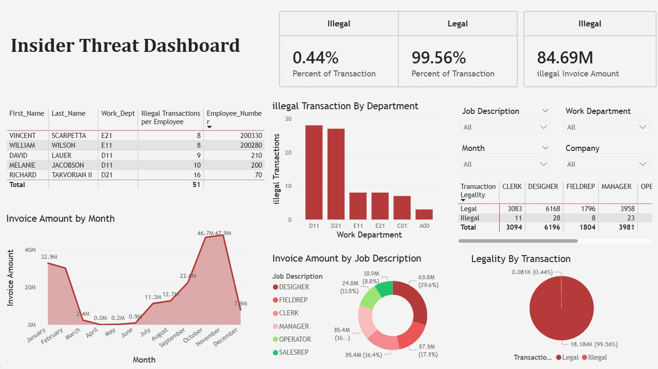
Figure 1. Insider Threat Dashboard (KPIs & Summary)

Part 2 — Data Overview & Assumptions
Key Fields Used
- Transactional: API_COMPANY, API_VENDOR_ID, API_INVOICE_ID, API_INV_CURRENCY, API_CREATE_DATE, API_INVOICE_DATE, API_BASE_INV_AMT, API_PO_NUMBER, API_PO_CODE, API_DESCRIPTION
- Employee/Org: Matched_Employee_ID, Employee_Number, Work_Dept_, Job_Description, Salary, First_Name, Last_Name, Country_Code
- Flags/Label: Flag_Weekend, Flag_Self_Approval, Flag_High_Value, Transaction_Legality
Key Assumptions
- Flags exist in the unified labeled dataset (Phase 1 preparation assumed completed).
- Day_of_Week reflects creation timing and supports weekend detection.
- Salary_Ratio (Invoice/Salary) provides a normalized risk indicator for ML.

Part 3 — Phase 2 Methodology (Rule-Based Audit Automation)
Implemented Rules
- Weekend transactions: Flag_Weekend = 1 → Suspicious_Weekends
- Self-approval conflicts: Flag_Self_Approval = 1 → Conflict_Breaches
- Label QA check: Transaction_Legality <> check_legaly → mismatch_legalty
Label QA Logic (check_legaly)
- Illegal if Flag_Self_Approval = 1
- Illegal if Flag_Weekend = 1 AND Flag_High_Value = 1
- Else Legal

Part 4 — Phase 2 Results (Key Outputs)
Output Summary
- Suspicious_Weekends: 5,250 records
- Conflict_Breaches: 1 record
- mismatch_legalty: 0 records
- Total Invoice:
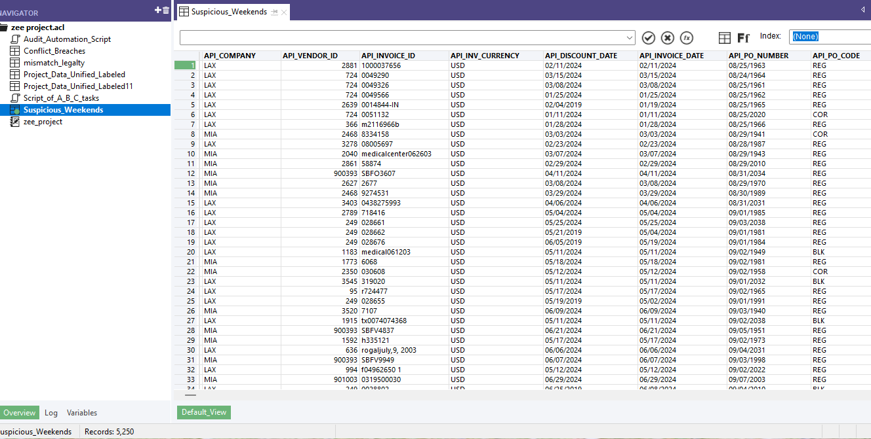
Figure 4. Suspicious_Weekends output showing total records (5,250)
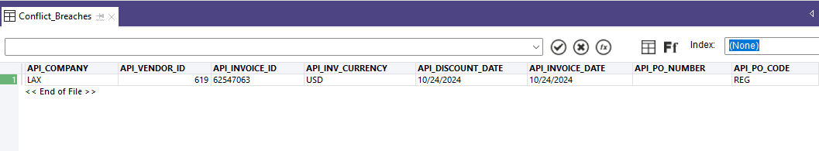
Figure 5. Conflict_Breaches output showing extracted record (1)
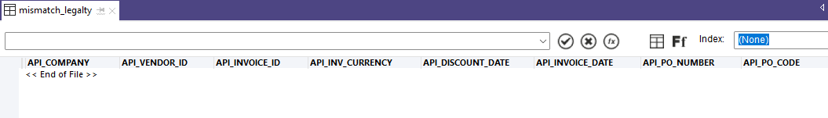
Figure 6. mismatch_legalty output showing 0 mismatches
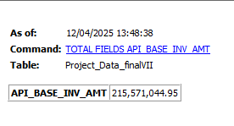
Figure 7. Total invoice

Part 5 — Phase 3 Methodology (Machine Learning)
Features (X) and Target (y)
- Features: API_BASE_INV_AMT, Day_of_Week, Department_ID (from Work_Dept_), Salary_Ratio
- Target: Transaction_Legality (Legal=0, Illegal=1)
- Models: LogReg, LinearSVC, RF, GB, KNN, GNB
- Validation: stratified train/test split + 5-fold StratifiedKFold CV; selection by F1-macro
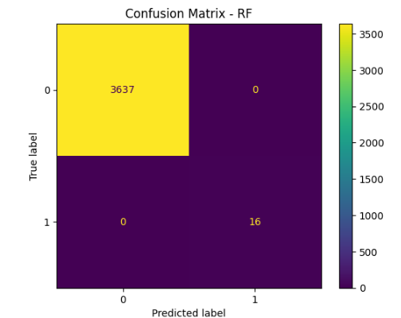
Figure 7. Cross-validation F1-macro comparison (6 classifiers)

Part 6 — Phase 3 Results (Best Model + Evaluation)
Best Model: Random Forest (RF)
Test-set Confusion Matrix (counts): TN=3637, FP=0, FN=0, TP=16.
Audit note: validate again with a time-based split to reduce leakage risk.
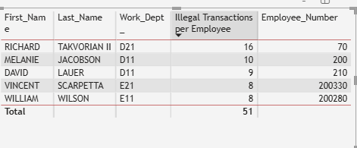
Figure 8. Confusion Matrix — Random Forest (Counts)

Part 7 — Phase 4 Dashboard Summary (Management View)
KPI Highlights
- Illegal transactions: 0.44% | Legal transactions: 99.56%
- Total illegal invoice amount: 84.69M
- Illegal activity concentrates in departments such as D11 and D21 (dashboard).
Top Employees by Illegal Transactions (Total = 51)
- Richard Takvorian II (D21) — 16
- Melanie Jacobson (D11) — 10
- David Lauer (D11) — 9
- Vincent Scarpetti (E21) — 8
- William Wilson (E11) — 8
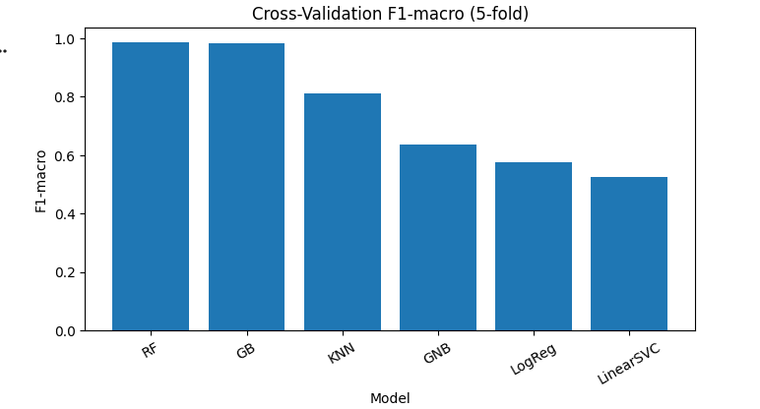
Figure 10. Top employees by illegal transactions (Total = 51)

Part 8 — Conclusions & Recommendations
Conclusions
- Rule-based automation produced explainable exception outputs and validated label consistency (0 mismatches).
- ML validation ranked Random Forest best, with perfect classification on the provided test split.
- Dashboard provides executive-ready KPIs and investigation prioritization by department and employee.
Recommendations
- Investigate top employees and departments responsible for illegal counts and amounts.
- Review the self-approval breach case in detail and document root cause.
- Enforce maker-checker separation (operator ≠ approver) and add controls for weekend/high-value approvals.
- Harden ML evaluation using time-based splits and periodic drift monitorin

Appendix A — Phase 2 Fi

nal ACL Script (Verbatim)
COMMENT
//ANALYTIC TYPE IMPORT Audit_Automation_Script.acl
//RESULT LOG
END
SET SAFETY OFF
OPEN Project_Data_Unified_Labeled
SET FILTER
SET FILTER TO Flag_Weekend = 1
EXTRACT FIELDS API_COMPANY API_VENDOR_ID API_INVOICE_ID API_INV_CURRENCY API_DISCOUNT_DATE API_INVOICE_DATE API_PO_NUMBER API_PO_CODE API_DESCRIPTION API_BASE_INV_AMT API_DISCOUNT_RATE API_DUE_DATE API_INVOICE_STATUS API_CREATE_DATE API_OPERATOR API_APPRV_OPERATOR API_APPROVED_FLAG API_TERMS_CD API_INVOICE_TYPE Matched_Employee_ID Employee_Number Work_Dept_ Job_Description Salary First_Name Last_Name Country_Code Day_of_Week Flag_Weekend Flag_Self_Approval Flag_High_Value Transaction_Legality TO "Suspicious_Weekends." OPEN
OPEN Project_Data_Unified_Labeled
SET FILTER
SET FILTER TO Flag_Self_Approval = 1
EXTRACT FIELDS API_COMPANY API_VENDOR_ID API_INVOICE_ID API_INV_CURRENCY API_DISCOUNT_DATE API_INVOICE_DATE API_PO_NUMBER API_PO_CODE API_DESCRIPTION API_BASE_INV_AMT API_DISCOUNT_RATE API_DUE_DATE API_INVOICE_STATUS API_CREATE_DATE API_OPERATOR API_APPRV_OPERATOR API_APPROVED_FLAG API_TERMS_CD API_INVOICE_TYPE Matched_Employee_ID Employee_Number Work_Dept_ Job_Description Salary First_Name Last_Name Country_Code Day_of_Week Flag_Weekend Flag_Self_Approval Flag_High_Value Transaction_Legality TO "Conflict_Breaches" OPEN
DEFINE FIELD check_legaly COMPUTED
AS "check legaly"
"Illegal" IF Flag_Self_Approval = 1
"Illegal" IF Flag_Weekend=1 AND Flag_High_Value=1
"Legal"
SET FILTER TO Transaction_Legality <> check_legaly
EXTRACT FIELDS API_COMPANY API_VENDOR_ID API_INVOICE_ID API_INV_CURRENCY API_DISCOUNT_DATE API_INVOICE_DATE API_PO_NUMBER API_PO_CODE API_DESCRIPTION API_BASE_INV_AMT API_DISCOUNT_RATE API_DUE_DATE API_INVOICE_STATUS API_CREATE_DATE API_OPERATOR API_APPRV_OPERATOR API_APPROVED_FLAG API_TERMS_CD API_INVOICE_TYPE Matched_Employee_ID Employee_Number Work_Dept_ Job_Description Salary First_Name Last_Name Country_Code Day_of_Week Flag_Weekend Flag_Self_Approval Flag_High_Value Transaction_Legality check_legaly TO "mismatch legalty" OPEN
OPEN Project_Data_Unified_Labeled
SET SAFETY ON

