LAN WLAN Switcher

# Configuration

Change the following parameters in both bat files:

1. YOUR_LAN_IP

Run ipconfig in cmd, this IP can be found under local Ethernet

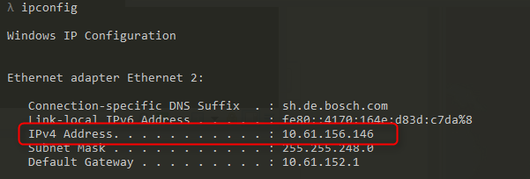

1. YOUR_TEAM_WLAN_NAME

Open Wi-Fi, this is your Wlan name

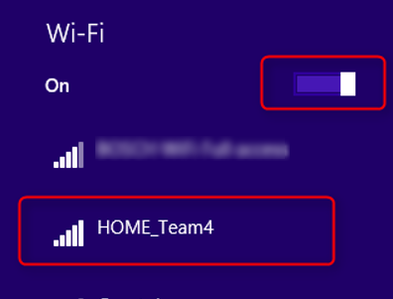

1. YOUR_INTERFACE_LAN_NAME
2. YOUR_INTERFACE_WLAN_NAME

The LAN and WLAN name can be found under **Control Panel\Network and Internet\Network Connections**

Notice: You LAN and WLAN name could be others (Maybe Ethernet 3 or Ethernet), not exact as the image displayed

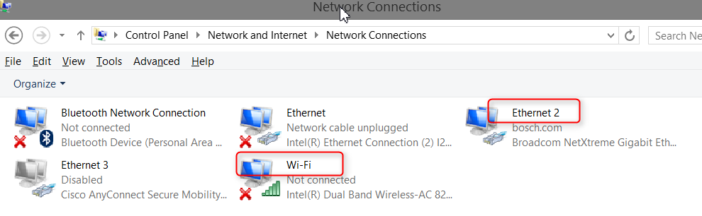

# Run

1. Keep you WI-FI **ON**

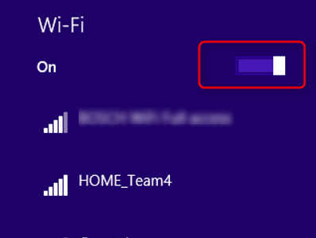

1. Cmder is recommend to execute the bat scripts.

Please run script directly or Cmder as Administrator

Otherwise you will see exception:



1. In Test scenario, lan_wifi_switch.bat will switch from LAN TO WLAN, or WLAN to LAN automatically.

Enable WLAN, and disable LAN

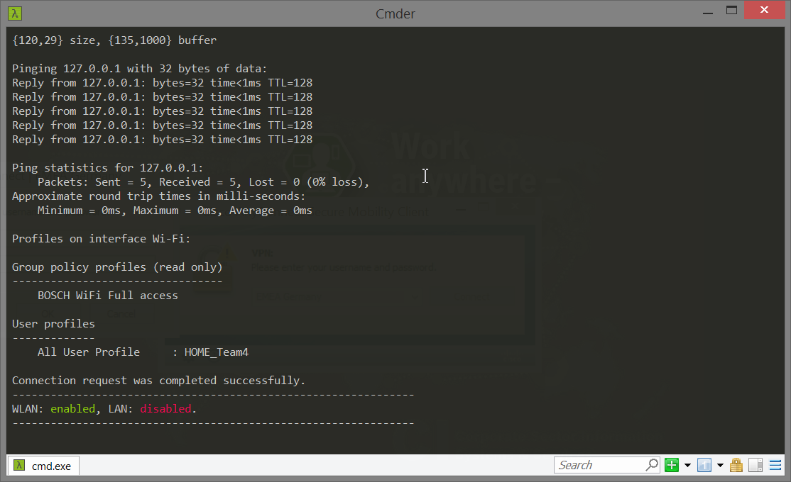

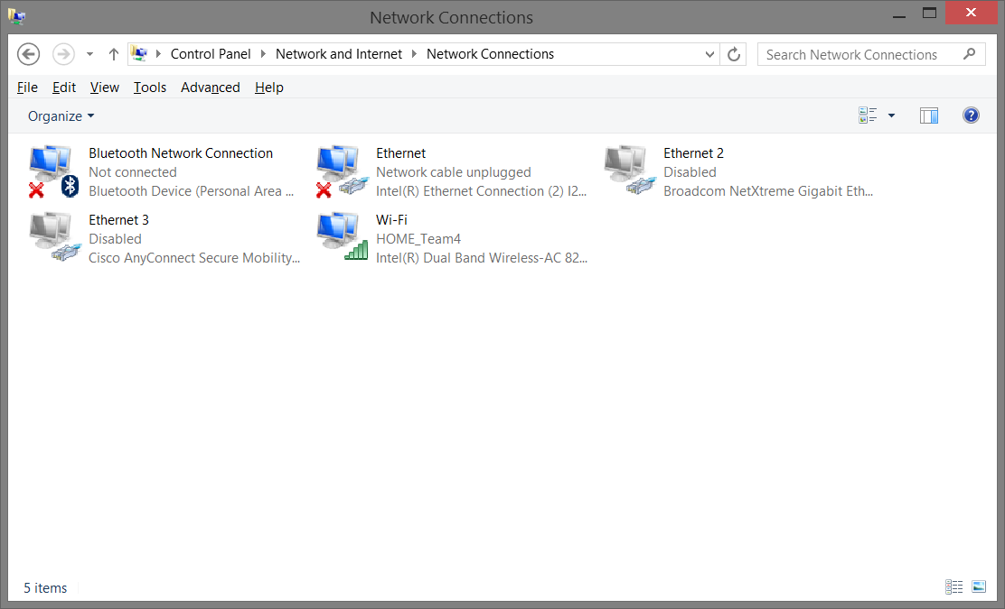

Disable WLAN, and enable LAN

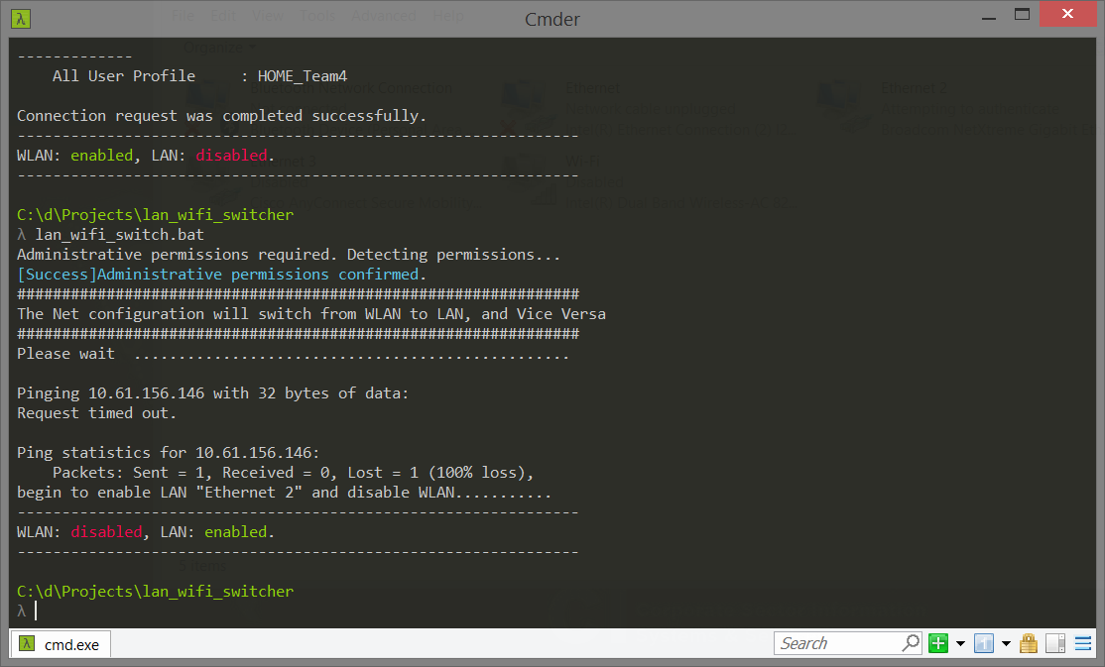

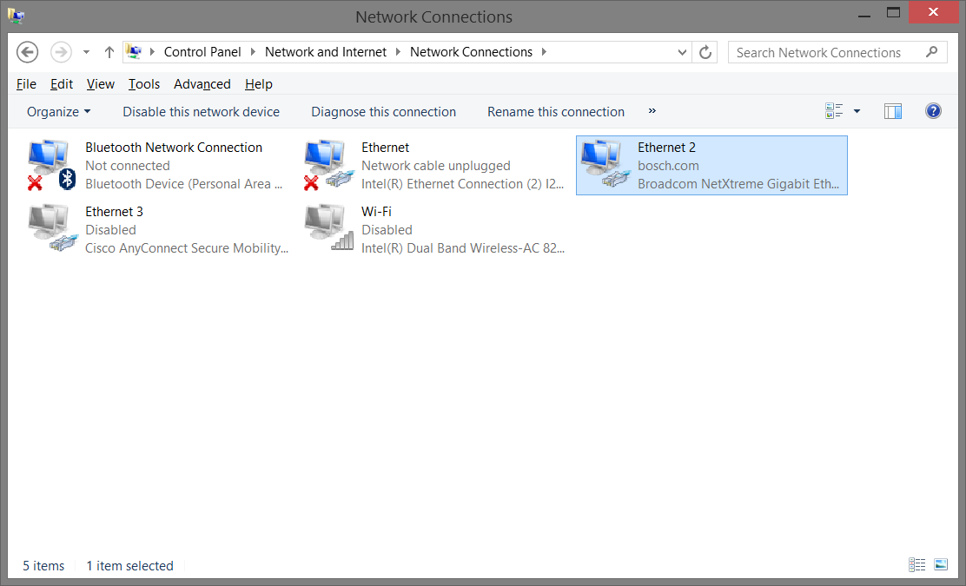

1. After Test scenario, run lan_wifi_both_enable.bat to active both LAN and WLAN

