飞机控制逻辑说明文档

1.1 项目结构
1.1.1 项目总体结构
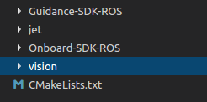
飞机控制部分
视觉部分
1.1.2 飞机控制部分项目结构
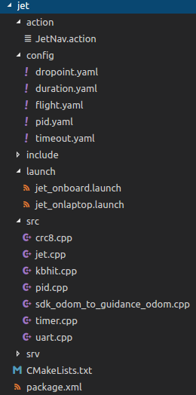
actionlib导航
空投点配置
过渡时间配置
飞行参数配置
PID闭环参数配置
超时配置
在板子上跑
在笔记本上跑（仿真）
PID算法
CRC8校验算法
飞机控制主逻辑实现
定时器
串口读写
把飞控的里程计转换成guidance里程计（调试用）
jet/action/JetNav.action: actionlib导航
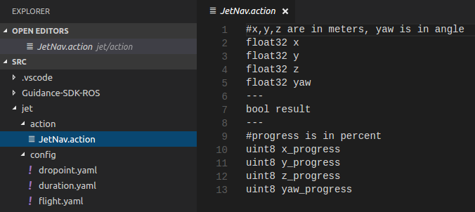
jet/config/dropoint.yaml: 空投点配置
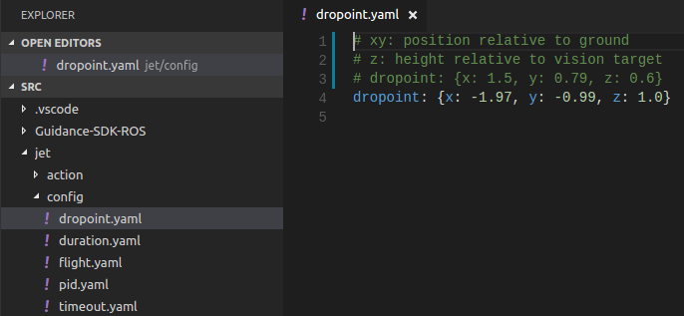
jet/config/duration.yaml: 过渡时间配置
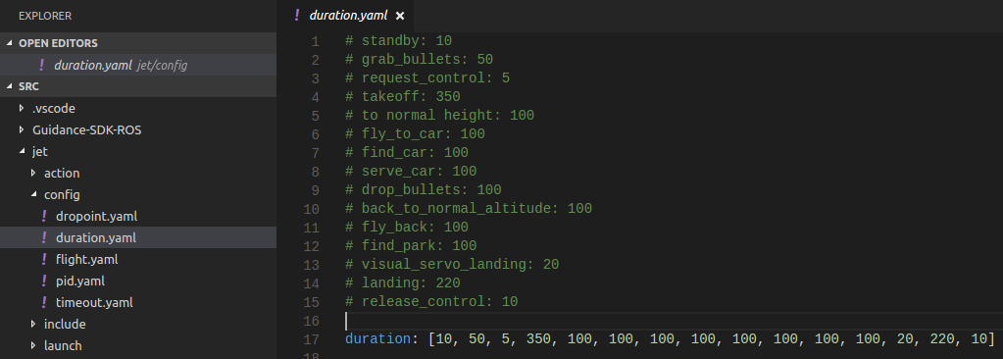
jet/config/flight.yaml: 飞行参数配置

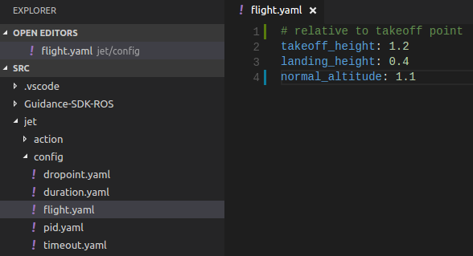
jet/config/pid.yaml: PID闭环控制参数配置
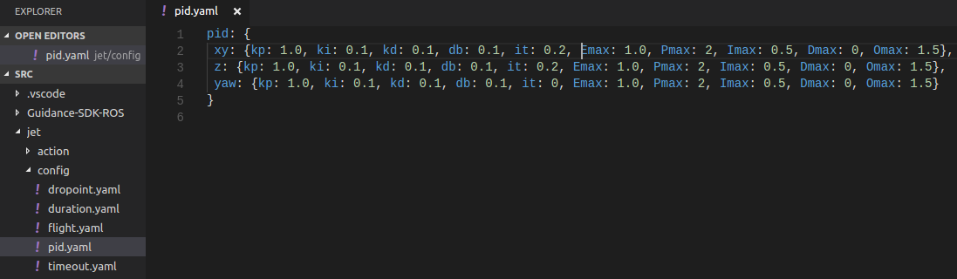
jet/config/timeout.yaml: 超时配置
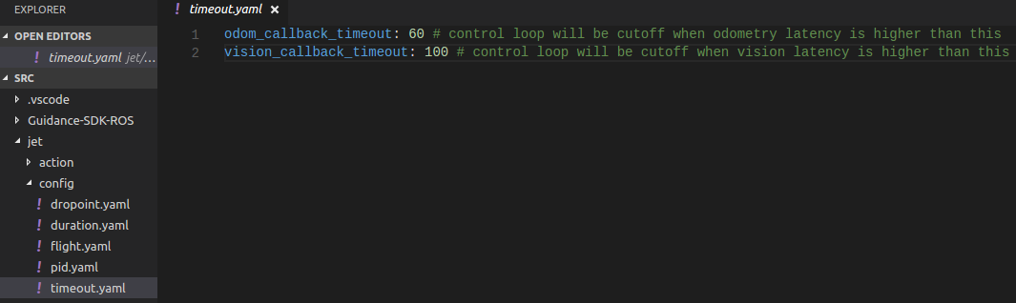

1.1.3 视觉部分项目结构

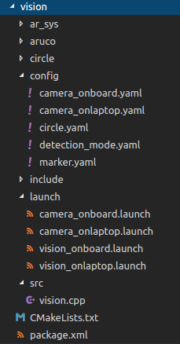
圆形（停机坪）检测
AR工具
aruco库
配置文件
板载相机参数
笔记本相机参数
圆（停机坪）参数
检测模式配置
二维码参数配置
板载相机启动文件
笔记本相机启动文件
板载视觉启动文件
笔记本视觉（调试）启动文件

vsion/config/camera_*.yaml: 相机参数配置
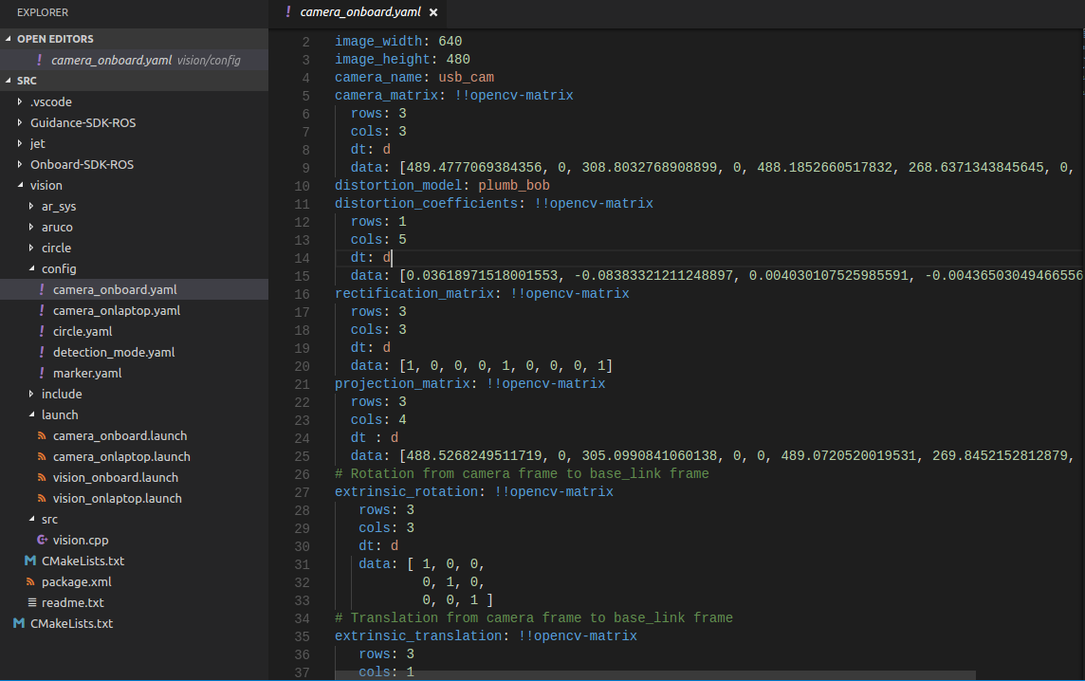
vision/config/circle.yaml: 圆（停机坪）参数配置
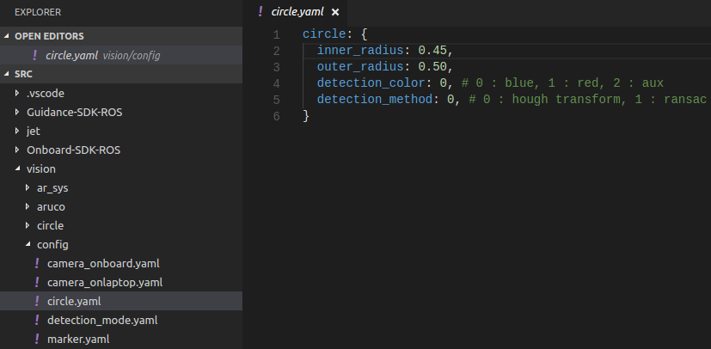
vision/config/detection_mode.yaml: 检测模式配置

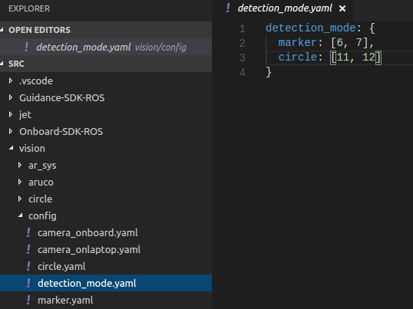
vision/config/marker.yaml: 二维码参数配置

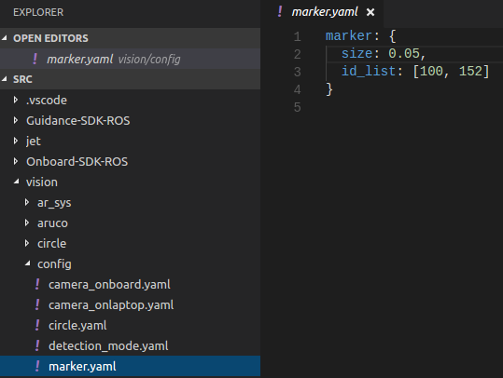

> 以上所有配置文件均可在运行时动态加载（调用相关的service），调参十分方便。

1.2 状态机
1.2.1 主逻辑
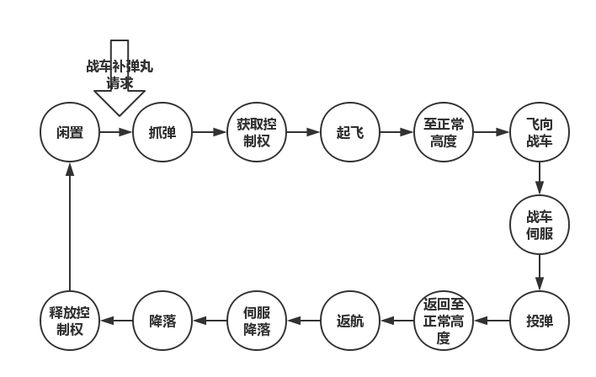
1.2.2 状态/命令类型枚举
typedef enum
{
STAND_BY,
GRAB_BULLETS,
REQUEST_CONTROL,
TAKE_OFF,
TO_NORMAL_ALTITUDE,
FLY_TO_CAR,
FIND_CAR,
SERVE_CAR,
DROP_BULLETS,
BACK_TO_NORMAL_ALTITUDE,
FLY_BACK,
FIND_PARK,
VISUAL_SERVO_LANDING,
LANDING,
RELEASE_CONTROL,
} JetCmd_e;

1.2.3 状态机执行流程
void Jet::stateMachine()
{
static bool success = false;
static uint32_t tick = 0;
switch (jet_state)
{
case STAND_BY:
if (!success)
{
success = doStandby();
std::cout << "stateMachine: " << "Standby" << std::endl;
}
else if (tick < duration[STAND_BY])
{
tick++;
std::cout << "stateMachine: " << "Standby@Tick: " << tick << std::endl;
}
else
{
tick = 0;
success = false;
jet_state = GRAB_BULLETS;
std::cout << "stateMachine: " << "Standby->Grab Bullets" << tick << std::endl;
}
break;

case GRAB_BULLETS:
if (!success)
{
success = doGrabBullets();
std::cout << "stateMachine: " << "Grab Bullets" << std::endl;
}
else if (tick < duration[GRAB_BULLETS])
{
tick++;
std::cout << "stateMachine: " << "Grab Bullets@Tick: " << tick << std::endl;
}
else
{
tick = 0;
success = false;
jet_state = REQUEST_CONTROL;
std::cout << "stateMachine: " << "Grab Bullets->Request Control" << tick << std::endl;
}
break;

case REQUEST_CONTROL:
if (!success)
{
success = doRequestControl();
std::cout << "stateMachine: " << "Request Control" << std::endl;
}
else if (tick < duration[REQUEST_CONTROL])
{
tick++;
std::cout << "stateMachine: " << "Request Control@Tick: " << tick << std::endl;
}
else
{
tick = 0;
success = false;
jet_state = TAKE_OFF;
std::cout << "stateMachine: " << "Request Control->Takeoff" << tick << std::endl;
}
break;

case TAKE_OFF:
if (!success)
{
success = doTakeoff();
std::cout << "stateMachine: " << "Takeoff" << std::endl;
}
else if (tick < duration[TAKE_OFF])
{
tick++;
std::cout << "stateMachine: " << "Takeoff@Tick: " << tick << std::endl;
}
else
{
tick = 0;
success = false;
jet_state = TO_NORMAL_ALTITUDE;
std::cout << "stateMachine: " << "Takeoff->To Normal Altitude" << tick << std::endl;
}
break;

case TO_NORMAL_ALTITUDE:
if (!success)
{
success = doToNormalAltitude();
std::cout << "stateMachine: " << "To Normal Altitude" << std::endl;
}
else if (tick < duration[TO_NORMAL_ALTITUDE])
{
tick++;
std::cout << "stateMachine: " << "To Normal Altitude@Tick: " << tick << std::endl;
}
else
{
tick = 0;
success = false;
jet_state = FLY_TO_CAR;
std::cout << "stateMachine: " << "To Normal Altitude->Fly to Car" << tick << std::endl;
}
break;

case FLY_TO_CAR:
if (!success)
{
success = doFlyToCar();
std::cout << "stateMachine: " << "Fly to Car" << std::endl;
}
else if (tick < duration[FLY_TO_CAR])
{
tick++;
std::cout << "stateMachine: " << "Fly to Car@Tick: " << tick << std::endl;
}
else
{
tick = 0;
success = false;
jet_state = FIND_CAR;
std::cout << "stateMachine: " << "Fly to Car->Find Car" << tick << std::endl;
}
break;

case FIND_CAR:
if (!success)
{
success = doFindCar();
std::cout << "stateMachine: " << "Find Car" << std::endl;
}
else if (tick < duration[FIND_CAR])
{
tick++;
std::cout << "stateMachine: " << "Find Car@Tick: " << tick << std::endl;
}
else
{
tick = 0;
success = false;
jet_state = SERVE_CAR;
std::cout << "stateMachine: " << "Find Car->Serve Car" << tick << std::endl;
}
break;

case SERVE_CAR:
if (!success)
{
success = doServeCar();
std::cout << "stateMachine: " << "Serve Car" << std::endl;
}
else if (tick < duration[SERVE_CAR])
{
tick++;
std::cout << "stateMachine: " << "Serve Car@Tick: " << tick << std::endl;
}
else
{
tick = 0;
success = false;
jet_state = DROP_BULLETS;
std::cout << "stateMachine: " << "Serve Car->Drop Bullets" << tick << std::endl;
}
break;

case DROP_BULLETS:
if (!success)
{
success = doDropBullets();
std::cout << "stateMachine: " << "Drop Bullets" << std::endl;
}
else if (tick < duration[DROP_BULLETS])
{
tick++;
std::cout << "stateMachine: " << "Drop Bullets@Tick: " << tick << std::endl;
}
else
{
tick = 0;
success = false;
jet_state = BACK_TO_NORMAL_ALTITUDE;
std::cout << "stateMachine: " << "Drop Bullets->Back to Normal Altitude" << tick << std::endl;
}
break;

case BACK_TO_NORMAL_ALTITUDE:
if (!success)
{
success = doBackToNormalAltitude();
std::cout << "stateMachine: " << "Back to Normal Altitude" << std::endl;
}
else if (tick < duration[BACK_TO_NORMAL_ALTITUDE])
{
tick++;
std::cout << "stateMachine: " << "Back to Normal Altitude@Tick: " << tick << std::endl;
}
else
{
tick = 0;
success = false;
jet_state = FLY_BACK;
std::cout << "stateMachine: " << "Back to Normal Altitude->Fly Back" << tick << std::endl;
}
break;

case FLY_BACK:
if (!success)
{
success = doFlyBack();
std::cout << "stateMachine: " << "Fly Back" << std::endl;
}
else if (tick < duration[FLY_BACK])
{
tick++;
std::cout << "stateMachine: " << "Fly Back@Tick: " << tick << std::endl;
}
else
{
tick = 0;
success = false;
jet_state = FIND_PARK;
std::cout << "stateMachine: " << "Fly Back->Find Park" << tick << std::endl;
}
break;

case FIND_PARK:
if (!success)
{
success = doFindPark();
std::cout << "stateMachine: " << "Find Park" << std::endl;
}
else if (tick < duration[FIND_PARK])
{
tick++;
std::cout << "stateMachine: " << "Find Park@Tick: " << tick << std::endl;
}
else
{
tick = 0;
success = false;
jet_state = VISUAL_SERVO_LANDING;
std::cout << "stateMachine: " << "Find Park->Visual Servo Landing" << tick << std::endl;
}
break;

case VISUAL_SERVO_LANDING:
if (!success)
{
success = doVisualServoLanding();
std::cout << "stateMachine: " << "Visual Servo Landing" << std::endl;
}
else if (tick < duration[VISUAL_SERVO_LANDING])
{
tick++;
std::cout << "stateMachine: " << "Visual Servo Landing@Tick: " << tick << std::endl;
}
else
{
tick = 0;
success = false;
jet_state = LANDING;
std::cout << "stateMachine: " << "Visual Servo Landing->Landing" << tick << std::endl;
}
break;

case LANDING:
if (!success)
{
success = doLanding();
std::cout << "stateMachine: " << "Landing" << std::endl;
}
else if (tick < duration[LANDING])
{
tick++;
std::cout << "stateMachine: " << "Landing@Tick: " << tick << std::endl;
}
else
{
tick = 0;
success = false;
jet_state = RELEASE_CONTROL;
std::cout << "stateMachine: " << "Landing->Standby" << tick << std::endl;

calied = false; // re-calibrate odom
}
break;

case RELEASE_CONTROL:
if (!success)
{
success = doReleaseControl();
std::cout << "stateMachine: " << "Release Control" << std::endl;
}
else if (tick < duration[RELEASE_CONTROL])
{
tick++;
std::cout << "stateMachine: " << "Release Control@Tick: " << tick << std::endl;
}
else
{
tick = 0;
success = false;
jet_state = STAND_BY;
std::cout << "stateMachine: " << "Release Control->Standby" << tick << std::endl;
if (freestyle)
{
freestyle = false; // clear freestyle flag
std::cout << "+---------------------Jetbang Free Style Done----------------------+" << std::endl;
help();
}
}
break;

default:
jet_state = STAND_BY;
break;
}
}

1.4 启动
1.4.1 仿真
1）首先准备两台电脑，一台windows，一台ubuntu，windows用来跑DJI Simulator，ubuntu跑控制程序；
2）用mini-USB线连接windows电脑和飞控，用USB转串口线连接ubuntu电脑和飞机UART-CAN2，windows电脑上打开DJI Assistant，启用API控制，打开模拟器；下面在ubuntu电脑上操作：
3）cd到jet_ros文件夹，在此文件夹下打开两个terminal，分别source devel/setup.bash之后，在一个terminal运行roslaunch dji_sdk sdk_linux.launch，在另一个terminal运行roslaunch jet jet_onlaptop.launch；在运行后者的窗口出现以下界面，可进行单元测试，也可运行全自动测试（Jetbang Free Style)，如想从某一项目开始测试，可先进入该项目后选择[h] Resume Free Style. 自动运行过程中可中断（[g] Pause Free Style），也可停止（[i] Cutoff Free Style）。
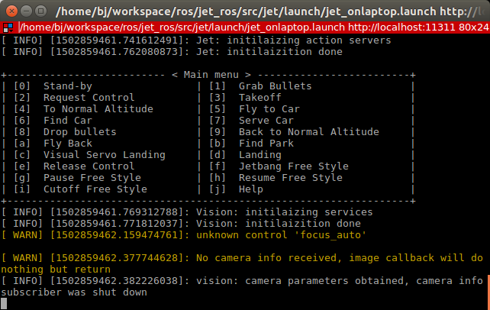
1.4.2 真机运行
launch相应的启动文件即可（roslaunch jet jet_onboard.launch)
PS: 仿真环境下里程计用的是飞控的模拟数据，坐标为北东天，程序里面的飞行控制也用的是北东天，而guidance为北东地，实际飞行的时候jet_onboard.launch 里面的use_guidance属性一定要为true，否则坐标系不对，会炸机！！！

1.4.3 节点关系图与tf树

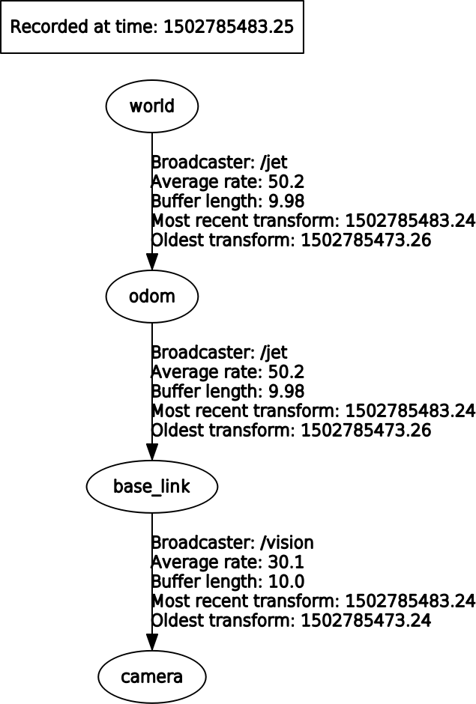
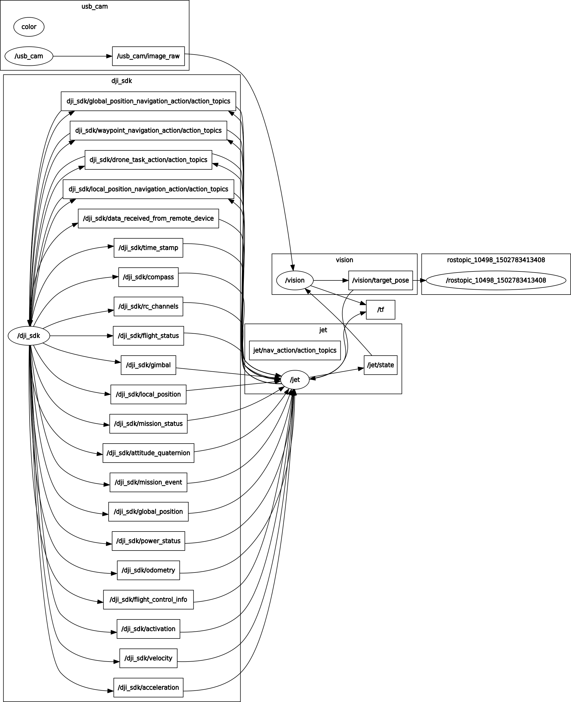

1.4.4 Topics与Services
rostopic list:
/jet/nav_action/cancel
/jet/nav_action/feedback
/jet/nav_action/goal
/jet/nav_action/result
/jet/nav_action/status
/jet/pose_calied
/jet/state
/tf
/vision/detection_mode
/vision/result
/vision/target_pose

rosservice list:
/jet/charge
/jet/grabber/cmd
/jet/grabber/stat
/jet/reload_dropoint_param
/jet/reload_duration_param
/jet/reload_flight_param
/jet/reload_pid_param
/usb_cam/set_camera_info
/usb_cam/start_capture
/usb_cam/stop_capture
/vision/reload_camera_param
/vision/reload_circle_param
/vision/reload_detmod_param
/vision/reload_marker_param

