Indian Institute of Technology Kharagpur
Department of Civil Engineering
3D Numerical Digital Twin for Cold Storage Facilities
The Coupled Numerical Model: Formulation, Implementation and Verification
Undergraduate researcher: Mobashshir Zainuddin
Supervisor: Prof. Mohammad Saud Afzal
Nature of work: Bachelor's Thesis Project (BTP) — technical progress report
Project website: https://coldstoragetwin.onrender.com/
Repository: https://github.com/mobashshir-ubn-zainuddin/ColdStorageTwin
Date: September 2026

Contents
Summary 3
1. Scope and objectives 3
2. Starting point: the diffusion prototype 4
3. Computational domain and mesh (Module 1) 4
4. Psychrometric engine (Module 3) 5
4.1 Saturation vapour pressure 5
4.2 Derived state 5
5. Initial conditions (Module 2) 6
6. Governing equations (Modules 4, 5 and 7) 6
6.1 Low-Mach continuity with a lumped room density 6
6.2 Momentum 6
6.3 Energy 6
6.4 Moisture 7
7. Room pressure and opening flows 7
8. Source and boundary models (Modules 8–12) 7
8.1 Air injection (Module 8) 7
8.2 Leakage (Module 9) 8
8.3 Door-opening events (Module 10) 8
8.4 Walls, floor and ceiling (Module 11) 8
8.5 Internal sources and stored product (Module 12) 8
8.6 Refrigeration unit coolers 8
9. Condensation, frost and evaporation (Module 6) 9
10. Numerical method 9
10.1 Scalar transport 9
10.2 Momentum and pressure projection 9
10.3 Time-step control 10
10.4 Solution sequence per time step 10
11. Verification 10
11.1 Analytical diffusion solution and grid convergence 10
11.2 Conservation audit 11
11.3 Physical-behaviour tests 11
12. Demonstration: pull-down with a door opening 11
13. Software implementation and web platform 14
14. Assumptions and limitations 15
15. Next steps 15
References 15

Summary
This report documents the numerical model of the cold-storage digital twin and the work completed so far. The project began as an explicit finite-difference solver for coupled heat and moisture diffusion in still air, with fixed wall temperatures (the model described in the April 2026 BTP proposal). It has now been extended into a transient, three-dimensional, coupled finite-volume model. The model solves for airflow, pressure, temperature and humidity in the room, together with condensation and frost. It also represents the external and internal mechanisms that drive a real cold store: air injection, pressure-driven leakage, door openings, conduction through insulated walls, internal heat and moisture sources, stored product, and thermostat-controlled unit coolers.
The solver advances the primary state Q = [T, P, u, v, w, ω] in every cell. A psychrometric engine derives the complete moist-air state from T, P and ω: relative humidity, vapour and saturation pressures, dew and wet-bulb temperatures, enthalpy, densities, specific volume, and sensible, latent and total energy. The model is therefore available at every cell and every saved time. The numerics use a staggered (MAC) grid, a pressure-projection method and a lumped, implicitly solved room-pressure node. Together these make the discrete mass, water and energy budgets close to round-off: the measured ledger errors are of order 10⁻¹² %. Against an analytical diffusion solution, the scheme shows the expected second-order spatial convergence (observed order p ≈ 2.0–2.2).
The model is deployed in a browser dashboard. Users can place sources anywhere in the room and follow any of 30 fields in space and time. They can probe any point for its full psychrometric state and history, and review heat loads, condensation and conservation diagnostics. The scope is strictly numerical modelling; no machine-learning components are used.

1. Scope and objectives
The central question the model answers is: given the geometry, initial conditions, wall construction, air-injection and leakage conditions, heat loads and refrigeration of a cold-storage room, how do temperature, pressure, airflow, moisture, humidity, energy and condensation evolve at every location as a function of time?
The implementation followed the phased plan: psychrometrics → heat and moisture → pressure and airflow → injection and leakage → full coupling → dashboard → verification. Each phase was verified before the next was built on it, so that the dashboard visualises a complete and tested physical model rather than an approximation.
Table 1. Implementation status by module.
Module | Content | Status
1 Geometry & mesh | Cartesian finite-volume mesh, faces, volumes, boundary patches, point location, interpolation, source distributions, obstacles | Complete
2 Initial conditions | Uniform, stratified or zoned T and humidity; five moisture input modes; validity checks | Complete
3 Psychrometric engine | Hyland–Wexler saturation (water/ice), full derived state, dew/wet bulb by root solving, mixing | Complete
4 Heat transfer | Energy equation with advection, diffusion, sources and latent heat; energy fields | Complete
5 Moisture transport | Conservative ω transport with advection, diffusion and sources | Complete
6 Condensation | Bulk and wall-surface condensation/frost, evaporation, inventories, latent coupling | Complete
7 Airflow & pressure | Navier–Stokes (MAC), eddy viscosity, buoyancy, projection, lumped room pressure | Complete
8 Air injection | Face or interior jets; flow, moisture and thermal specification modes; schedules | Complete
9 Leakage | Orifice/crack power laws with stack effect; envelope leakage; direction from ΔP | Complete
10 Door events | Scheduled openings, net flow plus Gosney–Olama exchange, strip curtains | Complete
11 Wall heat transfer | Multilayer U-value, sol-air temperature, diurnal swing, ground floor | Complete
12 Internal sources | People, lighting, motors, equipment; product blocks with respiration | Complete
Refrigeration | Unit coolers with thermostat, capacity limit, dehumidification, fan heat | Complete
Dashboard & API | 3-D/slice fields, time slider, point probe, psychrometric chart, analytics, REST API | Complete
Verification | Analytical diffusion, grid convergence, conservation audit, 23 unit tests | Complete
Experimental validation | Comparison with sensor data from a pilot chamber | Planned

2. Starting point: the diffusion prototype
The first version (still available at /dashboard as a reference baseline) solves two coupled diffusion equations with forward-Euler time stepping and the seven-point Laplacian:
ρ c_{p} ∂T/∂t = k ∇²T + L_{v} ∂w/∂t, ∂w/∂t = D_{m} ∇²w (1)
It is stable when the diffusion numbers satisfy r_{T} = αΔt/Δx² ≤ 1/6 and r_{W} = D_{m}Δt/Δx² ≤ 1/6 (Von Neumann analysis). All six walls are held at fixed temperatures. This prototype established the numerical approach and the web platform. However, it cannot represent air movement, pressure, openings, realistic walls or refrigeration, and air diffuses heat far too slowly for diffusion alone to describe a real room. The work reported below removes each of those limitations.

3. Computational domain and mesh (Module 1)
The room is the box Ω = [0, L_{x}] × [0, L_{y}] × [0, L_{z}] with z vertical. It is divided into N_{x} × N_{y} × N_{z} finite volumes of uniform size:
Δx = L_{x}/N_{x}, Δy = L_{y}/N_{y}, Δz = L_{z}/N_{z}, V_{cell} = ΔxΔyΔz (2)
Cell centres lie at x_{i} = (i − ½)Δx (similarly for y, z). Face areas are A_{E,W} = ΔyΔz, A_{N,S} = ΔxΔz and A_{T,B} = ΔxΔy. The six boundaries are named W (x = 0), E (x = L_{x}), S (y = 0), N (y = L_{y}), B (floor) and T (ceiling). The mesh module also provides the following:
- Staggered storage. Scalars (T, ω, pressure) are stored at cell centres; the velocity components u, v, w are stored on the x-, y- and z-faces respectively (Marker-and-Cell arrangement). This avoids pressure checkerboarding and makes the discrete divergence used for continuity identical to the one used for scalar transport.
- Opening patches. An opening on a wall is given by its face, centre and width × height. It is mapped to the set of boundary faces whose centres fall inside the rectangle. Openings smaller than a cell map to the nearest face.
- Point location and trilinear interpolation. Used for dashboard point queries: φ(x) = Σ N_{abc} φ_{abc}, with N₀₀₀ = (1−ξ)(1−η)(1−ζ), etc.
- Discrete Gaussian source distribution for interior (sub-grid) sources: G_{i} ∝ exp(−r_{i}²/2σ²), truncated at 3σ and normalised so that Σ G_{i} = 1 exactly. Every source is therefore exactly conservative on the mesh.
- Obstacles. Product blocks are flagged as solid cells. Their faces carry no flow, and the pressure operator treats them with zero-gradient conditions.
- Quality checks: volume closure |ΣV_{cell} − V_{room}|/V_{room}, maximum aspect ratio, characteristic size h = (ΔxΔyΔz)^{1/3}.

4. Psychrometric engine (Module 3)
The solver transports only T, P and ω. Every other moist-air property is derived by a single, vectorised state operator 𝒫 = F(T, P, ω), which is applied to whole 3-D fields at every saved time. No property such as RH or dew point is ever transported as an independent field.

4.1 Saturation vapour pressure
The simple Magnus formula of the prototype was replaced by the Hyland–Wexler formulation used by the ASHRAE Handbook of Fundamentals. Below 0 °C, saturation over ice is used, which is essential in freezer stores. With T_{K} = T + 273.15:
ln p_{ws} = C₁/T_{K} + C₂ + C₃T_{K} + C₄T_{K}² + C₅T_{K}³ + C₆T_{K}⁴ + C₇ ln T_{K} (ice, T < 0 °C) (3)
ln p_{ws} = C₈/T_{K} + C₉ + C₁₀T_{K} + C₁₁T_{K}² + C₁₂T_{K}³ + C₁₃ ln T_{K} (water, T ≥ 0 °C) (4)
Table 2. Hyland–Wexler coefficients (p_{ws} in Pa).
Ice | Value | Water | Value
C₁ | −5.6745359 × 10³ | C₈ | −5.8002206 × 10³
C₂ | 6.3925247 | C₉ | 1.3914993
C₃ | −9.6778430 × 10⁻³ | C₁₀ | −4.8640239 × 10⁻²
C₄ | 6.2215701 × 10⁻⁷ | C₁₁ | 4.1764768 × 10⁻⁵
C₅ | 2.0747825 × 10⁻⁹ | C₁₂ | −1.4452093 × 10⁻⁸
C₆ | −9.4840240 × 10⁻¹³ | C₁₃ | 6.5459673
C₇ | 4.1635019

4.2 Derived state
With the molar-mass ratio ε = 0.621945, R_{da} = 287.058 J/(kg·K) and R_{v} = 461.495 J/(kg·K):
p_{v} = ωP/(ε + ω), p_{da} = P − p_{v}, RH = 100 p_{v}/p_{ws}(T) (5)
ω_{s} = ε p_{ws}/(P − p_{ws}), q = ω/(1 + ω) (6)
h = 1.006 T + ω(2501 + 1.86 T) [kJ/kg dry air] (7)
v = R_{da}T_{K}(1 + 1.6078ω)/P, ρ_{da} = 1/v, ρ_{ma} = ρ_{da}(1 + ω), ρ_{v} = p_{v}/(R_{v}T_{K}) (8)
Dew/frost point T_{dp} solves p_{ws}(T_{dp}) = p_{v}. It is found by Newton iteration on ln p_{ws}, starting from the Magnus inverse. Wet-bulb (ice-bulb) temperature T_{wb} solves the ASHRAE psychrometric relation below by vectorised bisection between −100 °C and T:
ω = [(2501 − 2.326T_{wb})ω_{s}(T_{wb}) − 1.006(T − T_{wb})] / (2501 + 1.86T − 4.186T_{wb}) (T_{wb} ≥ 0) (9)
ω = [(2830 − 0.24T_{wb})ω_{s}(T_{wb}) − 1.006(T − T_{wb})] / (2830 + 1.86T − 2.1T_{wb}) (T_{wb} < 0) (10)
The engine also returns the moisture deficit ω_{s} − ω, the condensation-risk index CRI = (ω − ω_{s})/ω_{s}, the saturation state (unsaturated/saturated/supersaturated), and pressure relative to the outside air at the same height. It also provides conversions from every supported moisture input (RH, ω, dew point, vapour pressure, specific humidity, vapour density) to ω, and adiabatic mixing of two streams. Reference checks against ASHRAE tables: p_{ws}(20 °C) = 2338.8 Pa, p_{ws}(−20 °C, ice) = 103.26 Pa, and at 30 °C / 50 % RH, T_{wb} = 22.0 °C and T_{dp} = 18.45 °C.

5. Initial conditions (Module 2)
The t = 0 state is built from T₀, P₀ and one moisture specification, with zero initial velocity. The main chain is:
(T₀, P₀, RH₀) → p_{v,0} = (RH₀/100) p_{ws}(T₀) → ω₀ = ε p_{v,0}/(P₀ − p_{v,0}) → complete state (11)
Optional refinements are a linear vertical gradient T₀(z) = T_{bottom} + (T_{top} − T_{bottom}) z/L_{z} and any number of box-shaped zones with their own T and RH. Product blocks start at their own temperature. The initial state is checked for physical validity (P > 0, 0 ≤ p_{v} < P, ω ≥ 0), and a warning is issued if it is supersaturated.

6. Governing equations (Modules 4, 5 and 7)

6.1 Low-Mach continuity with a lumped room density
Air speeds in a cold room are far below the speed of sound, so pressure waves need not be resolved. The in-room air uses a spatially uniform dry-air density ρ̄(t) = M_{da}/V, where the dry-air mass M_{da} comes from the room-pressure model (Section 7). Local density variations enter only through buoyancy (Boussinesq approximation). Continuity then becomes a divergence constraint that accounts for point sources q_{src} [1/s] and for compression or expansion of the room air:
∇·u = q_{src} − (1/ρ̄) dρ̄/dt (12)

6.2 Momentum
∂u/∂t + (u·∇)u = −(1/ρ̄)∇p + ∇·[(ν + ν_{t})∇u] − g (ρ_{ma} − ρ_{ref})/ρ_{ref} ẑ + S_{u} (13)
The buoyancy term uses the local moist-air density ρ_{ma}(T, P, ω) from the psychrometric engine. It therefore captures both thermal buoyancy (warm door air rising, cold coil air sinking) and the small humidity effect. The reference ρ_{ref} is the room mean, so the hydrostatic part is absorbed into the pressure. Turbulent mixing is modelled with the Smagorinsky eddy viscosity (constant and laminar options are also available):
ν_{t} = (C_{s}Δ)² |S|, |S| = √(2S_{ij}S_{ij}), C_{s} = 0.17, Δ = (ΔxΔyΔz)^{1/3} (14)

6.3 Energy
∂(ρ̄ c_{p} T)/∂t + ∇·(ρ̄ c_{p} u T) = ∇·(k_{eff} ∇T) + S_{Q} + S_{latent} (15)
Here k_{eff} = k + ρ̄ c_{p} ν_{t}/Pr_{t} (Pr_{t} = 0.85). The source S_{Q} collects the wall heat flux, internal loads and air–product exchange. Air streams carry their enthalpy through the boundary fluxes (inflowing T and ω). Latent heat therefore appears explicitly only for phase change, S_{latent} = L(S_{cond} − S_{evap}). This avoids the double counting warned about in the plan.

6.4 Moisture
∂(ρ̄ω)/∂t + ∇·(ρ̄ u ω) = ∇·(ρ̄ D_{eff} ∇ω) + S_{ω} + S_{evap} − S_{cond} (16)
Here D_{eff} = D_{m} + ν_{t}/Sc_{t} (D_{m} = 2.2 × 10⁻⁵ m²/s, Sc_{t} = 0.7). The source S_{ω} includes injected and infiltrated vapour, moisture released by people and product transpiration.

7. Room pressure and opening flows
The room pressure P_{room}(t) (absolute, at floor level) is a lumped node, as in multizone airflow models. Every opening exchanges air with the outside according to the pressure difference at its own height, including the hydrostatic columns of the inside and outside air (the stack effect):
ΔP(z) = (P_{out} − ρ_{out} g z) − (P_{room} − ρ_{room} g z) (17)
Flows follow the power law (orifice for n = 0.5, cracks and envelope leakage for n ≈ 0.65):
ṁ = sign(ΔP) ρ_{up} C_{d} A √(2/ρ_{up}) ΔP_{ref}^{0.5−n} |ΔP|^{n} → ṁ = sign(ΔP) C_{d} A √(2ρ|ΔP|) for n = 0.5 (18)
The upwind density is the outside density for inflow and the room density for outflow. Each time step, P_{room} is found implicitly (Brent root-finding) from the dry-air mass balance of the room, with M_{da}(P) from the ideal-gas law:
[M_{da}(P) − M_{da}^{n}]/Δt = Σ_{i} ṁ_{da,i}(P), M_{da}(P) = P V / [R_{da} T̄_{K} (1 + 1.6078 ω̄)] (19)
This single equation reproduces several effects. A room with a relief path equilibrates at the pressure that balances its flows. A sealed room pressurises under injection, following the ideal-gas law. A cooling room draws air in because M_{da}(P) rises as T̄ falls. With the room pressure known, each opening flow is fixed, and ρ̄^{n+1} = M_{da}^{n+1}/V sets the dilatation in Eq. (12).

8. Source and boundary models (Modules 8–12)

8.1 Air injection (Module 8)
An injection is either a real opening on a boundary face (preferred) or an interior sub-grid jet distributed with the Gaussian G(x). The user specifies one quantity from each group, and the rest are derived:
Table 3. Injection specification modes.
Group | Options | Derived relations
Flow | velocity U, volumetric flow V̇, mass flow ṁ, supply pressure P_{s} | V̇ = AU, ṁ = ρ_{in}V̇, ṁ = C_{d}A√(2ρ_{in}(P_{s} − P_{room}))
Moisture | RH, ω, dew point, vapour pressure, specific humidity, vapour density | ω_{in} = ε p_{v,in}/(P_{in} − p_{v,in})
Thermal | temperature T_{in}, or sensible heat Q_{s} relative to the room, plus optional heater power | T_{in} = T_{room} + Q_{s}/(ṁ_{da} c_{p})
Timing | start/end times, repeating on/off cycles, sinusoidal modulation | active(t), factor(t)

For a boundary opening, the patch face velocity carries the exact volume flow V̇ = ṁ_{da}/ρ̄. When the physical grille is smaller than the patch, the missing jet momentum ṁ(U_{jet} − U_{face}) is added to the first interior face so that jets penetrate realistically. For reporting, each stream carries dry-air and vapour flows ṁ_{da} = ṁ/(1 + ω_{in}) and ṁ_{v} = ṁ_{da}ω_{in}, and three heat rates relative to room air:
Q̇_{s} = ṁ_{da} c_{p}(T_{in} − T_{room}), Q̇_{l} = ṁ_{da}(ω_{in} − ω_{room})L_{v}, Q̇_{total} = ṁ_{da}(h_{in} − h_{room}) (20)

8.2 Leakage (Module 9)
Leakage paths are openings with the power-law flow of Eq. (18), driven by the ΔP(z) of Eq. (17). Direction follows the sign of ΔP: infiltration brings in outside T and ω, while exfiltration removes room air. Background envelope leakage is specified as an effective leakage area per m² of surface. It is split between a low and a high crack so that the stack effect acts on the envelope, as observed in practice: cold rooms exfiltrate near the floor and infiltrate near the ceiling.

8.3 Door-opening events (Module 10)
A door is a scheduled large opening with A_{open}(t) = f_{open} W H during [t_{open}, t_{close}), optionally repeating. Besides the net pressure-driven flow, an open cold-room door carries a buoyancy-driven two-way exchange with zero net mass. The warm, light air enters at the top and the cold, heavy air spills out at the bottom. This exchange is modelled with the Gosney–Olama correlation (ASHRAE Refrigeration Handbook), reduced by the effectiveness E of a strip or air curtain:
V̇_{ex} = 0.221 A √(g H (1 − ρ_{light}/ρ_{heavy})) F_{m} (1 − E), F_{m} = [2/(1 + (ρ_{heavy}/ρ_{light})^{1/3})]^{1.5} (21)
On the mesh, V̇_{ex} is imposed as inflow on the upper half of the door patch and equal outflow on the lower half. If the door spans a single cell row, it is imposed as a zero-net-mass source/sink pair. For a 2 × 2.5 m door between a −18 °C room and 30 °C outside air, V̇_{ex} ≈ 2 m³/s.

8.4 Walls, floor and ceiling (Module 11)
Each surface is a panel of layers (thickness L_{j}, conductivity k_{j}) between inside and outside films:
1/U = 1/h_{i} + Σ L_{j}/k_{j} + Σ R_{c} + 1/h_{o}, q″ = U (T_{sol-air} − T_{air}), T_{sol-air} = T_{out} + α_{s} I_{s}/h_{o} (22)
The flux is applied to every boundary cell not occupied by an opening. The outside temperature may follow a diurnal swing. The default floor is a slab on ground at 10 °C, and fixed-temperature (legacy Dirichlet) or adiabatic surfaces are also available. For the default 150 mm PU panel (k = 0.022 W/m·K), U = 0.143 W/m²K. The inside surface temperature T_{si} = T_{air} + q″/h_{i} drives the surface-frost model of Section 9.

8.5 Internal sources and stored product (Module 12)
Heat sources (equipment, lighting, motors, forklifts, custom) release Q̇(t) distributed as S_{Q} = Q̇ G(x) or uniformly over a box. People follow the ASHRAE cold-room relation q = 272 − 6T W/person and release about 50 g/h of vapour each. Product blocks (pallets, racks) are solid cells that block the airflow. Each has thermal mass m c_{p} and exchanges heat with the air through its exposed faces, Q = h A (T_{p} − T_{air}). Each also releases respiration heat q_{resp} = q_{ref} Q10^{T/10} [W/kg] and, optionally, transpired moisture.

8.6 Refrigeration unit coolers
A unit cooler recirculates room air, drawing through a return opening and discharging through a supply opening, with zero net mass exchange. A thermostat with a deadband switches the coil on and off based on the return-air temperature. When the coil is on, the supply leaves at the coil-leaving temperature and is dehumidified to saturation; the removed water accumulates as coil frost:
T_{sup} = T_{coil}, ω_{sup} = min(ω_{ret}, ω_{s}(T_{sup})), Q̇_{coil} = ṁ_{da} c_{p}(T_{ret} − T_{sup}) + ṁ_{w}(L_{v} + L_{f}) (23)
If Q̇_{coil} exceeds the installed capacity, the duty is scaled down, so the leaving air is warmer and wetter. Fan power is added to the supply-air temperature.

9. Condensation, frost and evaporation (Module 6)
Three phase-change mechanisms are modelled. The latent heat depends on phase: L_{v} = 2.501 × 10⁶ J/kg for condensation to liquid (T ≥ 0 °C), and L_{s} = L_{v} + L_{f} = 2.835 × 10⁶ J/kg for deposition to frost (T < 0 °C).
- Bulk (airborne) condensation. Where air becomes supersaturated (for example where humid door air mixes with cold air), the excess vapour relaxes towards saturation at rate k_{cond}. The deposited water or ice is stored per cell.
S_{cond} = ρ̄ k_{cond} max(0, ω − ω_{s}), Δω = −min(1, k_{cond}Δt)(ω − ω_{s}) (24)
- Evaporation/sublimation of deposits where the air is subsaturated, limited by the available inventory:
S_{evap} = min[ρ̄ k_{evap}(ω_{s} − ω), M_{l}/(V Δt)] (25)
- Wall-surface condensation and frost where the inside surface is below the dew point. The mass-transfer coefficient comes from the Chilton–Colburn (Lewis) analogy:
ṁ″ = h_{m}(ρ_{v,air} − ρ_{v,s}(T_{si})), h_{m} = h_{i}/(ρ c_{p} Le^{2/3}), Le = 0.85 (26)
Each process releases or absorbs L Δm in the energy equation of the adjacent cell. The water inventories (airborne deposits, wall frost/condensate, coil frost) are tracked separately, so the total water balance closes exactly (Section 11).

10. Numerical method

10.1 Scalar transport
The scalar equations are integrated over each control volume. Upwind face values give robust, bounded advection; central differences with harmonic-mean face coefficients give diffusion. The face volume flows are V̇_{f} = u_{f}A_{f}, and at an inflow boundary face the upwind value is the stream value (T_{in}, ω_{in}). For a scalar φ the update is:
ρ̄^{n+1}φ_{P}^{n+1}V = ρ̄^{n}φ_{P}^{n}V − Δt ρ̄^{n} Σ_{f} V̇_{f}φ_{f} + Δt ρ̄^{n} Σ_{f} Γ_{f}A_{f}(φ_{N} − φ_{P})/d + Δt ρ̄^{n} q_{src}Vφ_{src} + Δt S_{φ}V (27)
Because the velocity field satisfies the discrete form of Eq. (12) exactly, a uniform φ stays uniform, and the sum over all cells reduces to boundary fluxes plus sources. This is the property that makes the conservation ledgers close to round-off.

10.2 Momentum and pressure projection
The staggered velocity components are advanced by a Chorin projection:
- Predictor. Explicit upwind advection, eddy-viscosity diffusion (no-slip walls), buoyancy, interior-jet momentum and the inlet-momentum correction give u*.
- Pressure Poisson equation for the kinematic pressure φ, with zero-gradient conditions on walls and obstacles (openings carry prescribed velocity):
∇²φ = [∇·u* − q_{src} − q_{dil}]/Δt, q_{dil} = −(ρ̄^{n+1} − ρ̄^{n})/(Δt ρ̄^{n}) (28)
- Correction. u^{n+1} = u* − Δt∇φ on every open face, which satisfies Eq. (12) to machine precision. The dynamic pressure is p = ρ̄φ, and the absolute pressure field is P(x,t) = P_{room} − ρ̄ g z + p.
The Poisson operator is assembled once as a sparse matrix, with one pinned cell per connected fluid region to remove the constant null space. It is then factorised by sparse LU decomposition (SuperLU), so each time step needs only one cheap back-substitution.

10.3 Time-step control
The explicit scheme is conditionally stable. The step is chosen every iteration from a combined advection–diffusion criterion, together with limits for the stiff wall and product exchange terms:
Δt ≤ C / [max_{cells}(|u|/Δx + |v|/Δy + |w|/Δz) + 2Γ_{max}(1/Δx² + 1/Δy² + 1/Δz²)] (29)
This generalises the r ≤ 1/6 criterion of the prototype to unequal spacing and to advection. It includes the flows that openings are about to impose, so the step shrinks automatically when a door opens. Steps are shortened to land exactly on output times and schedule events. In fixed-Δt mode, the run stops with a diagnostic as soon as the chosen step exceeds the stability limit.

10.4 Solution sequence per time step
- Evaluate schedules; unit-cooler thermostats read the return air and compute coil duty and supply state.
- Solve the implicit room-pressure balance, Eq. (19); evaluate every injection, leak and door flow.
- Impose opening velocities and inflow T, ω on boundary faces; build interior source terms.
- Momentum predictor, pressure Poisson solve and projection.
- Transport T and ω with wall, internal, product and injection sources; update product temperatures.
- Bulk condensation/evaporation and wall frost with latent heat.
- Update the dry-air, water and energy ledgers; store time series and snapshots.

11. Verification

11.1 Analytical diffusion solution and grid convergence
A sealed, adiabatic box with still air is given an initial cosine perturbation in T and ω. With buoyancy and turbulence switched off, the model reduces to pure diffusion, whose exact solution decays as A exp(−Γπ²t/L²). The amplitude after 600 s was compared on three meshes with refinement ratio 2:
Table 4. Relative amplitude error after 600 s and observed order of accuracy.
Cells along L | Δx [m] | Error in T | Error in ω | Observed order p (T / ω)
8 | 0.125 | 1.21 × 10⁻³ | 1.45 × 10⁻³ | —
16 | 0.0625 | 2.96 × 10⁻⁴ | 3.55 × 10⁻⁴ | 2.03 / 2.03
32 | 0.03125 | 6.79 × 10⁻⁵ | 7.94 × 10⁻⁵ | 2.13 / 2.16

The observed order approaches 2 for both fields, confirming that the finite-volume diffusion operator is implemented correctly and is second-order accurate in space. The grid-convergence study proposed in §6.1 of the BTP proposal is available as a reusable routine (validation/convergence.py).

11.2 Conservation audit
For every run the solver keeps independent ledgers of total dry air, total water (vapour + airborne deposits + wall frost + liquid) and total energy (sensible + latent − fusion energy of ice + product heat). It compares each with its initial value plus the cumulative boundary and source exchanges. With every mechanism active (injection, door, leaks, people, product, unit cooler), the largest errors over the run were of order 10⁻¹² % for all three quantities. The discrete continuity residual stayed at round-off (≈ 10⁻¹⁶ s⁻¹).

11.3 Physical-behaviour tests
The automated suite (tests/test_full_model.py, 23 tests) includes the following checks:
- ASHRAE reference values for saturation pressure, dew point and wet bulb; round trips between moisture specifications; vectorised field evaluation.
- A still, isothermal room remains exactly at rest. A horizontal temperature contrast develops a gravity current whose velocity field stays divergence-free.
- A sealed room pressurises under a fixed mass injection exactly as the ideal-gas law predicts.
- An open door warms the room, raises its moisture content, and shows inflow through the upper and outflow through the lower half of the doorway.
- A supersaturated room condenses to saturation and warms by the released latent heat, with energy conserved.
- A warm pallet cools while the unit cooler removes heat; the capacity limit, dehumidification and thermostat work as specified.
- An unstable fixed time step is detected and rejected; the REST API round trip works end to end.

12. Demonstration: pull-down with a door opening
The default scenario is a 10 × 8 × 4 m frozen-food store (320 m³) on a 20 × 16 × 8 mesh (2,560 cells, 0.5 m spacing). It starts at −18 °C and 85 % RH, with outside air at 30 °C and 60 % RH. It contains a row of pallets that enter at −12 °C, 400 W of lighting and a 12 kW unit cooler (2 m³/s, set-point −20 °C) on the east wall. A forklift (3 kW) works between 600 s and 900 s, and the 2 × 2.5 m loading door opens from 600 s to 630 s behind a strip curtain with effectiveness 0.6. Twenty minutes were simulated in 7,514 adaptive steps (about 23 s of computing time).
Table 5. Key results of the demonstration run (t = 1200 s).
Quantity | Value
Room-mean temperature (final) | −17.8 °C (range −22.2 to −9.6 °C)
Room-mean temperature shortly after the door closes (t ≈ 700 s) | −13.9 °C
Peak infiltration heat load (door open) | ≈ 89 kW
Heat gained through walls / infiltration / internal loads | 2.37 / 3.58 / 1.38 MJ
Heat removed by the unit cooler | 9.73 MJ
Airborne deposits + wall frost / coil frost | 0.40 kg / 0.38 kg
Air infiltrated / exfiltrated (doors + leaks) | 51.2 / 56.8 kg
Maximum |conservation error| (mass / water / energy) | 2.7 × 10⁻¹³ / 6.7 × 10⁻¹³ / 8.7 × 10⁻¹⁴ %

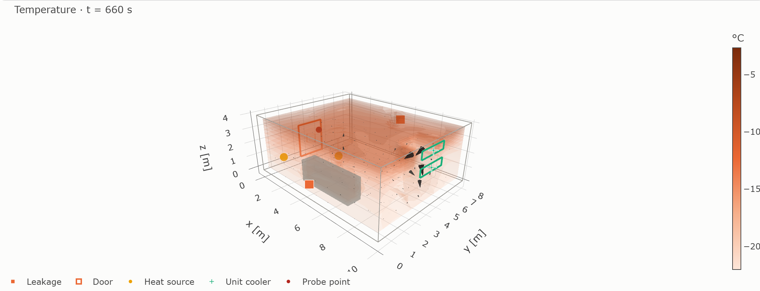
Figure 1. 3-D temperature field at t = 660 s. The volume rendering shows the warm plume from the loading door (W wall, orange outline), the pallet row (grey), the unit-cooler supply and return openings (green outlines), heat sources, leakage paths and velocity cones.
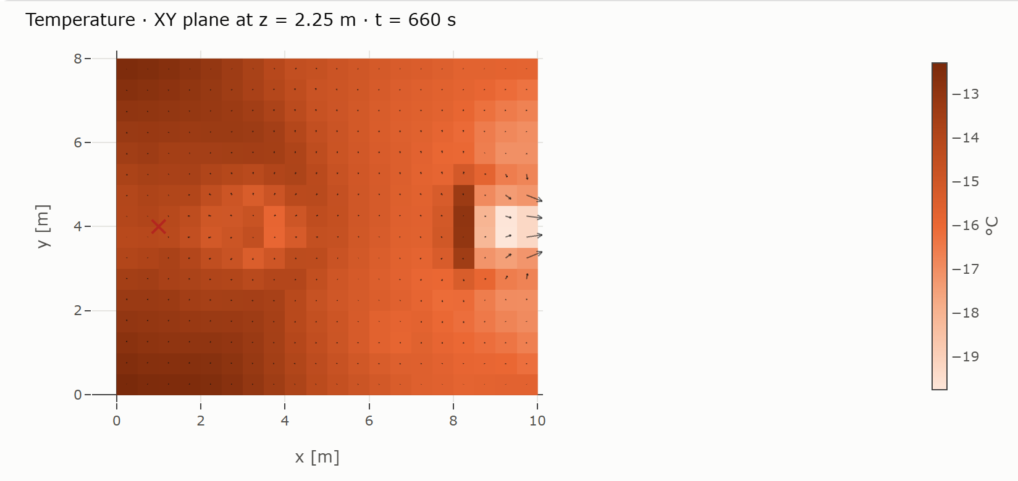
Figure 2. Horizontal temperature slice at z = 2.25 m, t = 660 s, with in-plane velocity vectors. The cold jet of the unit cooler enters from the east wall, while the air on the door side remains warmer after the opening.
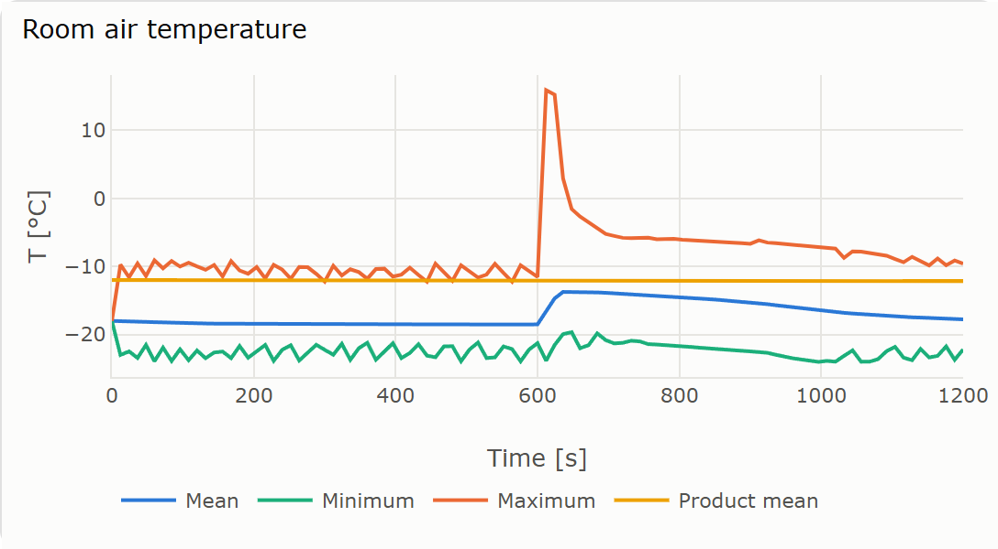
Figure 3. Room-air temperature (mean, minimum, maximum) and mean product temperature. Note the jump when the door opens at 600 s and the recovery under the unit cooler.
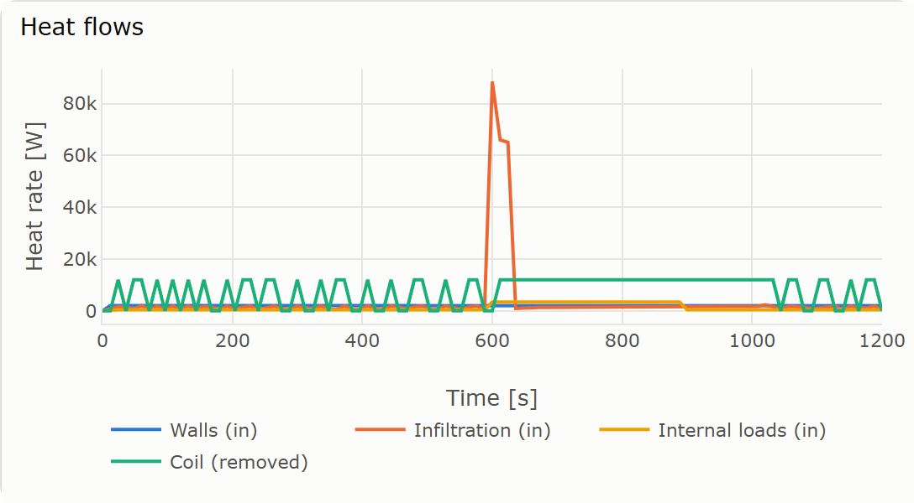
Figure 4. Heat flows: wall gains, infiltration (dominated by the door event), internal loads and heat removed by the coil (cycling under thermostat control).
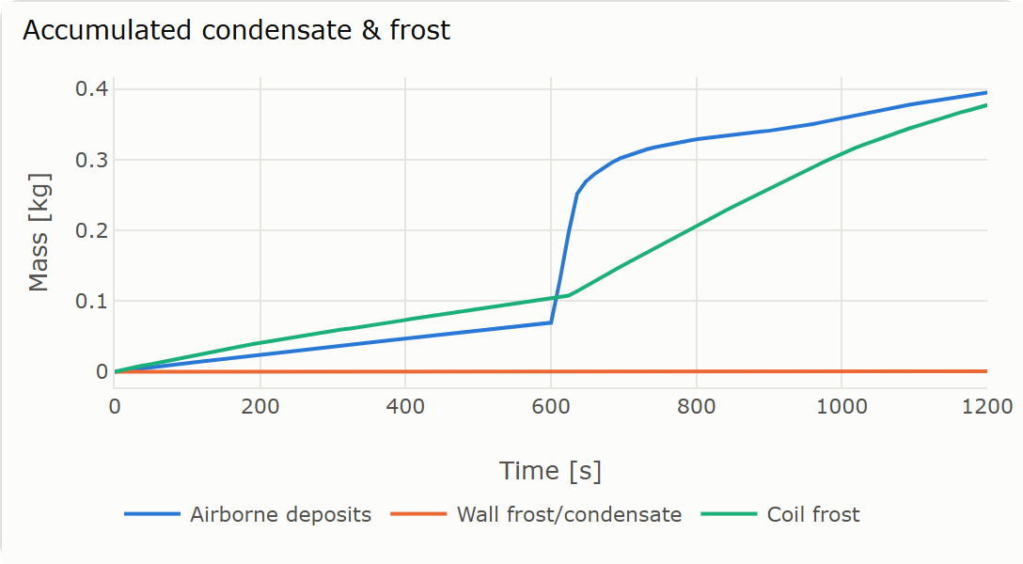
Figure 5. Accumulated airborne deposits, wall frost and coil frost.
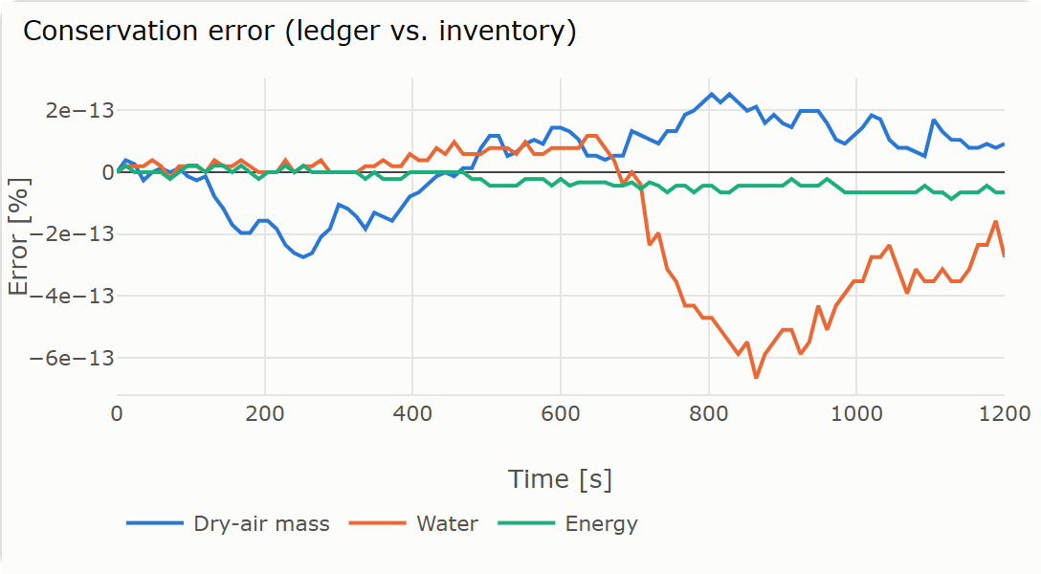
Figure 6. Conservation errors of the dry-air, water and energy ledgers over the run: all of order 10⁻¹³ %.
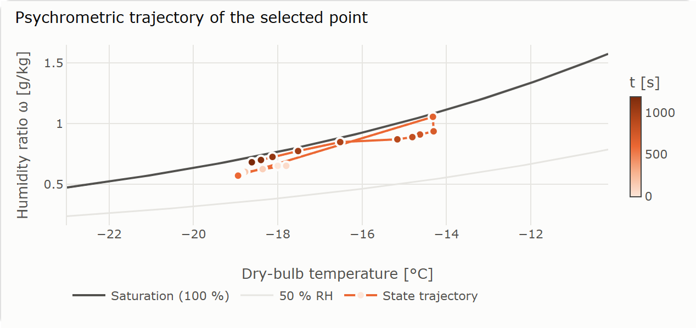
Figure 7. Psychrometric trajectory (dry-bulb temperature vs humidity ratio) of a probed point near the door. Markers are coloured by time; the saturation line bounds the moist-air region.
The results reproduce the expected physics of a cold store. The door opening dominates the heat and moisture load despite lasting only 30 s. Warm, humid air rises from the door along the ceiling. Where it mixes with cold air it becomes supersaturated, and it deposits frost in the air and on the walls. The unit cooler recovers the room over the following minutes while accumulating coil frost. Throughout, the stack effect makes the room exfiltrate near the floor and infiltrate near the ceiling.

13. Software implementation and web platform
The model is written in Python (NumPy, SciPy) and served by a Flask web application. The code is organised as the plan recommended:
Table 6. Code organisation.
Location | Content
geometry/mesh.py | Mesh, patches, interpolation, Gaussian sources, obstacles, quality checks
physics/psychrometrics.py | Psychrometric engine (Section 4)
physics/injection.py, leakage.py, walls.py, internal_sources.py, cooling_unit.py, schedules.py | Source and boundary models (Section 8)
solver/coupled_solver.py | Coupled transient finite-volume solver (Sections 6, 7, 9, 10)
solver/fdm_solver.py | Legacy diffusion prototype (Section 2)
simulation/scenario.py, results.py, jobs.py | Scenario definition and presets; result storage, derived fields, point queries, slices, indicators; background jobs
validation/diffusion.py, convergence.py, conservation.py | Verification routines (Section 11)
api/routes.py | REST API
templates/twin.html | Full-model dashboard
tests/ | Automated test suite (python run_tests.py)

The dashboard (/twin) is organised in five sections, following the plan:
- A. Simulation setup: geometry and mesh, initial conditions, walls and outside climate, numerics, and a raw scenario JSON editor. Two presets are provided, including the plan’s §59 example.
- B. Sources: add any number of injections, leakages, door events, heat sources, product blocks and unit coolers. Each is specified with the input modes of Table 3.
- C. Fields in space and time: 30 fields as horizontal/vertical slices or 3-D volume renderings, with a time slider and animation, velocity vectors, source markers with properties, and a per-source table of flows and heat rates at each time.
- D. Point analysis: click any cell (or type coordinates) to obtain the complete psychrometric state (27 quantities), its time history, and its trajectory on a psychrometric chart.
- E. Analytics: time series of temperature, RH, heat flows, room pressure, condensate/frost and conservation errors; stability numbers; CSV export.
Simulations run in a background thread, and the page polls their progress. To run locally: python -m venv .venv, activate it, pip install -r requirements.txt, then python app.py, and open http://localhost:10000/twin. In production the server must run as a single process, because jobs are held in memory (gunicorn -w 1 --threads 8 app:app).

14. Assumptions and limitations
- Turbulence uses a zero-equation (Smagorinsky) model on coarse meshes. Jets smaller than a cell are represented by their exact volume flow and a momentum correction rather than resolved.
- In-room air uses a spatially uniform dry-air density (low-Mach/Boussinesq); local density enters through buoyancy only. The specific heat is taken as that of dry air in the transport equation.
- First-order upwind advection is robust but numerically diffusive; results on coarse meshes smear sharp plumes.
- Walls are quasi-steady (U-value); the transient heat capacity of the insulation is not yet modelled. Deposited condensate is stationary, and existing liquid does not later freeze. Defrost cycles are not modelled.
- The model has been verified (it solves its equations correctly) but not yet validated against measurements from a real cold room.

15. Next steps
- Experimental validation against distributed temperature and RH sensors in a pilot chamber during pull-down and door events (proposal §6.2).
- Sensor-driven boundary conditions: drive outside climate, door schedules and coil states from logged data.
- Numerical extensions: implicit or semi-implicit time integration for longer simulations, higher-order bounded advection (TVD), a two-equation turbulence model, and non-uniform meshes refined near inlets and doors.
- Physics extensions: transient conduction inside walls, freezing of existing condensate, defrost cycles, and product freezing/thawing.

References
[1] ASHRAE (2017). ASHRAE Handbook — Fundamentals, Chapter 1: Psychrometrics. Atlanta: ASHRAE.
[2] ASHRAE (2018). ASHRAE Handbook — Refrigeration, Chapter 24: Refrigerated-Facility Loads. Atlanta: ASHRAE.
[3] Hyland, R. W., and Wexler, A. (1983). Formulations for the thermodynamic properties of the saturated phases of H₂O from 173.15 K to 473.15 K. ASHRAE Transactions, 89(2A), 500–519.
[4] Gosney, W. B., and Olama, H. A. L. (1975). Heat and enthalpy gains through cold room doorways. Proceedings of the Institute of Refrigeration, 72, 31–41.
[5] Chorin, A. J. (1968). Numerical solution of the Navier–Stokes equations. Mathematics of Computation, 22, 745–762.
[6] Harlow, F. H., and Welch, J. E. (1965). Numerical calculation of time-dependent viscous incompressible flow of fluid with free surface. Physics of Fluids, 8, 2182–2189.
[7] Smagorinsky, J. (1963). General circulation experiments with the primitive equations. Monthly Weather Review, 91, 99–164.
[8] Patankar, S. V. (1980). Numerical Heat Transfer and Fluid Flow. Hemisphere, New York.
[9] Walton, G. N., and Dols, W. S. (2013). CONTAM User Guide and Program Documentation. NIST Technical Note 1887.
[10] Alduchov, O. A., and Eskridge, R. E. (1996). Improved Magnus form approximation of saturation vapor pressure. Journal of Applied Meteorology, 35(4), 601–609.
[11] Smith, G. D. (1985). Numerical Solution of Partial Differential Equations: Finite Difference Methods, 3rd ed. Oxford University Press.

