**Business Requirements Document (BRD)**

**Project Title:** Design Insight Tracker

**1. Project Overview**

Design teams in creative agencies or organizations find it difficult to track the performance of their designs. They lack the ability to gather data on how their designs are perceived by users or clients and have no clear insights into what aspects of a design work well or need improvement. A tool is required to analyse design feedback, track performance metrics, and provide actionable insights, helping teams refine their design process based on data-driven decisions.

**2. Business Objectives**

* **Enhance User Engagement**: Enable end users to easily submit feedback via Excel sheets, improving participation in the design evaluation process.
* **Data-Driven Insights**: Provide designers and users with analytical reports generated from user feedback, facilitating data-driven design decisions.
* **Streamline Design Management**: Allow designers to upload and showcase new designs, enhancing visibility and accessibility.
* **Visual Analytics**: Offer interactive data visualizations to make insights more accessible and actionable.

**3. Stakeholders**

* **Design Team:** Creates and refines design assets.
* **Clients:** Provide feedback on designs, critical for assessing the effectiveness of designs and overall satisfaction, downloads the reports.
* **Team Managers**: Oversees the development process ,relying on insights from the tracker for strategic decision-making.

**4. Functional Requirements**

**4.1 User Management**

* User Registration/Login: Users can register and log in.
* Role Management: Different access levels for end users and designers.

**4.2 Excel Data Upload**

* Upload Feedback: Users can upload Excel files containing feedback.
* Validation: System validates the format of the uploaded file.

**4.3 Analytics Engine**

* Process Feedback: Extract attributes from the uploaded Excel data.
* Generate Reports: Create detailed analytics reports based on feedback.

**4.4 Data Visualization**

* Interactive Charts: Provide various charts and graphs to represent analytical insights.
* Download Options: Allow users to download reports in PDF format.

**4.5 Design Management**

* Upload Designs: Designers can post new designs.
* View Latest Designs: End users can view the latest designs.

**5. Non-Functional Requirements**

**5.1** **Performance**

* The system should handle requests for thousands of users with minimal latency.
* Multiple designers should be able to access real-time feedback data simultaneously.

**5.2** **Scalability**

* The system should automatically scale its resources up or down based on user demand, particularly during high-traffic periods such as design launches or client reviews.
* Design components of the application to be independently scalable.

**5.3** **Security**

* Ensure that all user data, including feedback and personal information, is encrypted to protect against data breaches.
* Enforce strict authorization policies based on user roles.

**5.4** **Usability**

* The user interface should be intuitive and easy for users to navigate.
* Ensure that the application is fully functional on various devices, allowing users to access feedback and analytics on the go.

**5.5 Interoperability**

* **API Integration:** The system will expose RESTful APIs for integration with other services.
* **Modular Design:** The architecture will support modular components for easy integration of new features.

**6. API routes:**

**6.1 User Management API Routes**

* POST /api/users: Register a new user.
* GET /api/users/{id}: Retrieve user details.

**6.2 Excel Data Upload API Routes**

* POST /api/feedback/upload: Upload Excel file for feedback processing.

**6.3 Analytics API Routes**

* GET /api/analytics/report: Retrieve the generated analytics report.

**6.4 Design Management API Routes**

* POST /api/designs: Upload a new design.
* GET /api/designs/latest: Retrieve the latest designs.

**7. User Stories**

**User Story 1: End User**

* As an end user, I want to upload my feedback through an Excel sheet so that I can easily contribute to the design evaluation process.
* **As an end user**, I want to view the latest designs so that I can stay updated with new projects.

**User Story 2: Designer**

* **As a designer**, I want to view analytical reports based on user feedback so that I can make informed design decisions.
* **As a designer**, I want to upload new designs to the platform so that users can provide feedback and engage with my work.
* As a designer, I want to access real-time performance metrics (like views and click-through rates) for my designs, so that I can evaluate their effectiveness.

**8. Schema Design**

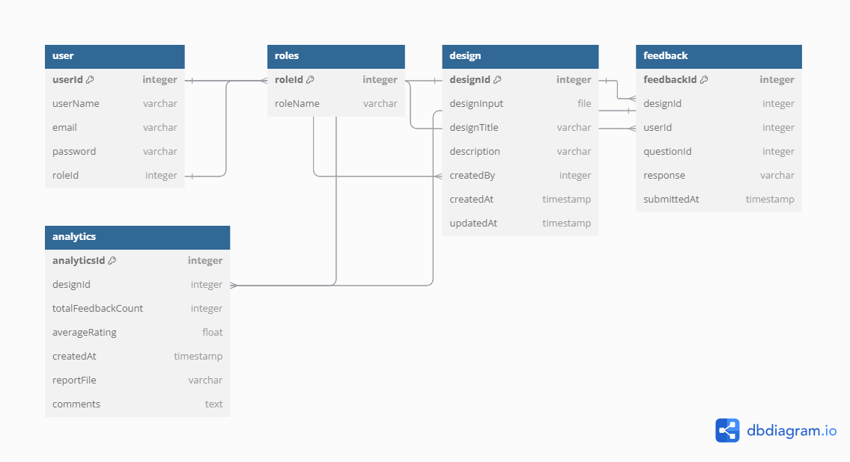

**9. UML Diagram**

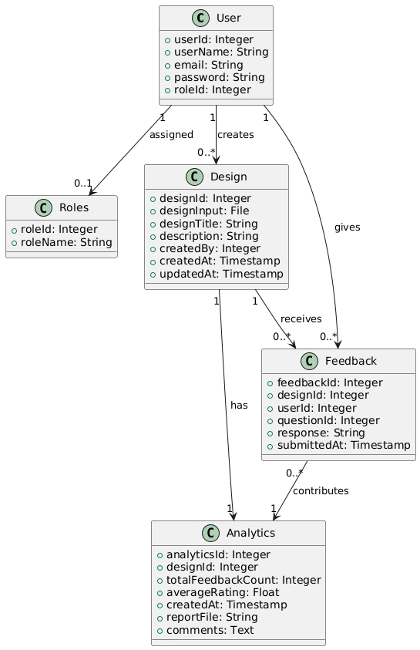

**10. Wireframing using Figma**

<https://www.figma.com/design/KDdZ1mnl9jFzzxP07l4WkU/Untitled?node-id=14-2&t=sLEKlSFJA3NTDcgb-1>