//to form connection in between git bash and online/remote git run the below commands:

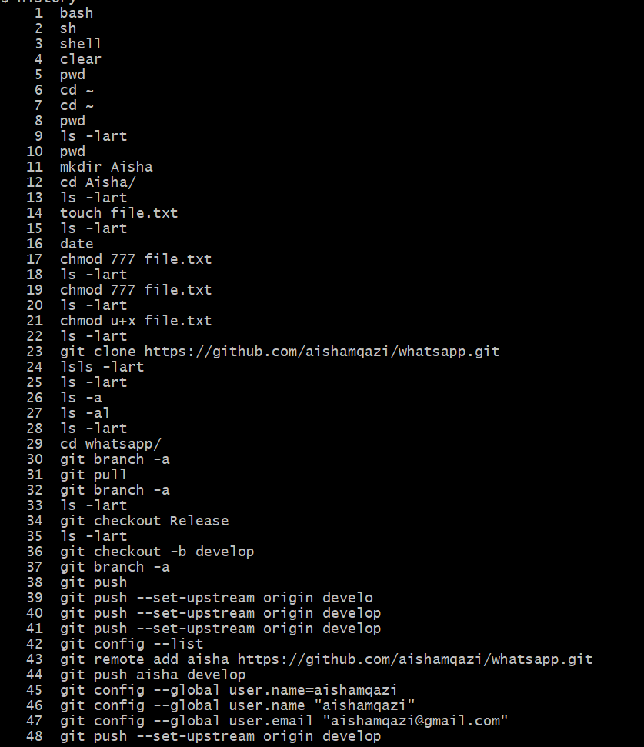

//In GitHub create a new REPO with name test

Add a readme.MD + gitignore (AL) file in it

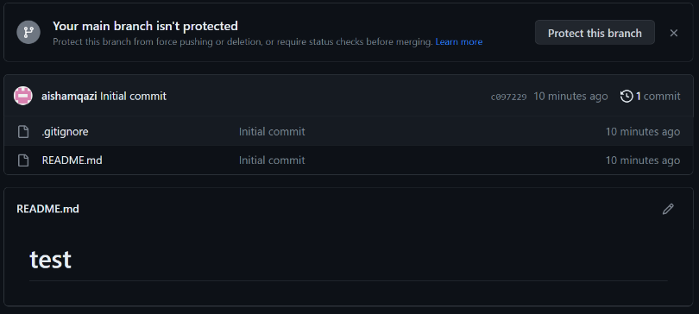

//Create another branch with name release from main

Add a release.txt file from

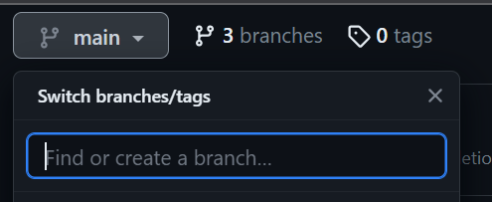

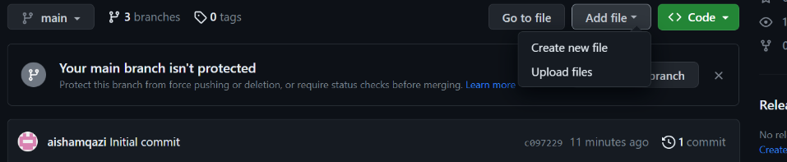

//Create another branch with name develop from main

Add a develop.txt file from

//Open Gitbash

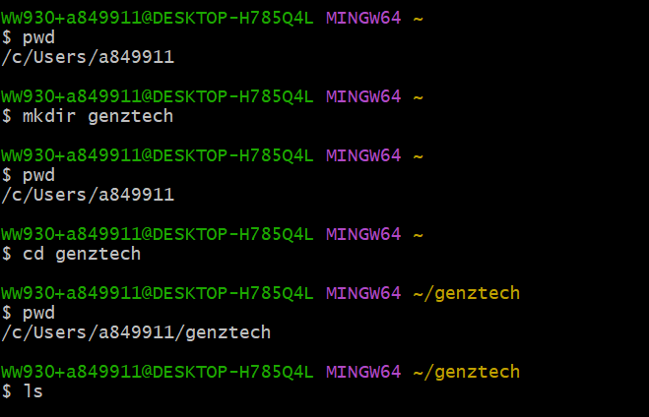

You will have created a folder in present working directory as below:

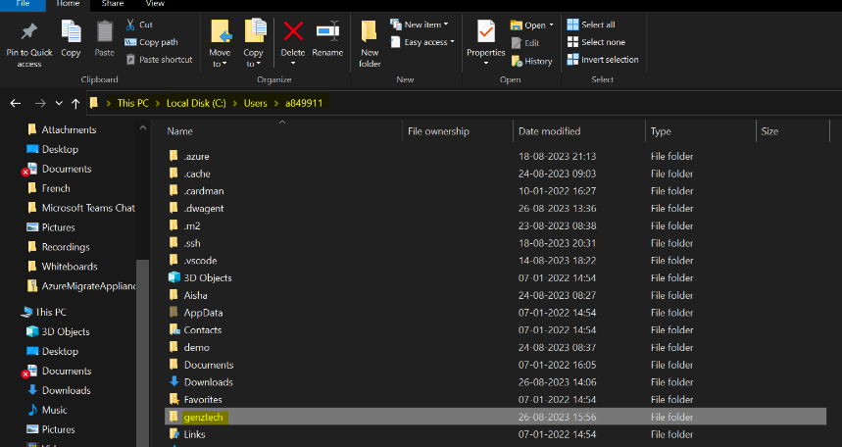

//Now clone the entire online repo to your local machine in the created folder:

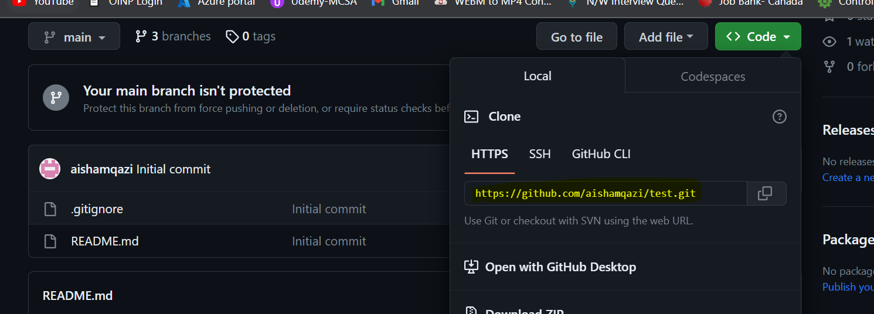

Use the below command in git bash:

Git clone <URL of HTTPS>

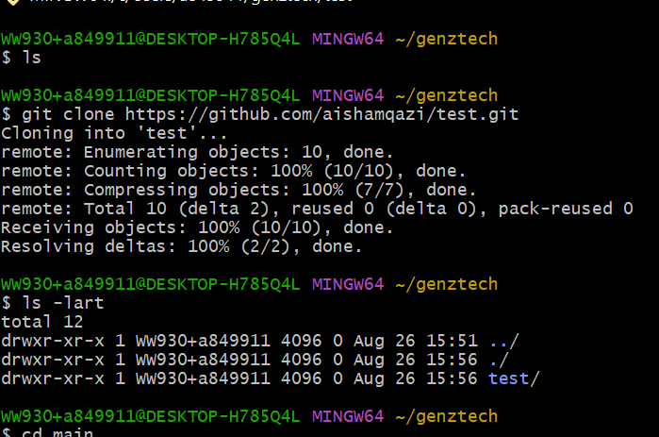

Git branch -a //list of all available branches in remote repo

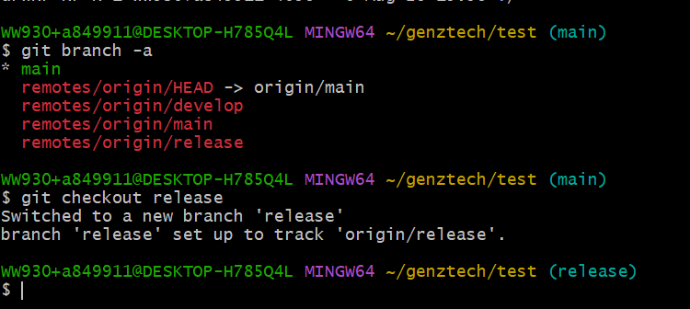

Git checkout <branchname> //To switch to branch

//to create a branch from main through gitbash: make sure you are in main branch

Git checkout -b feature //to create a new branch

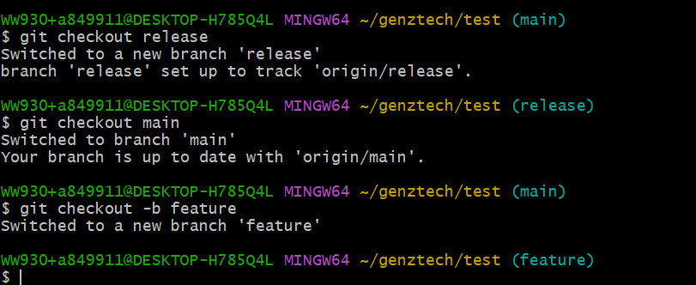

//to create a file in the branch in gitbash //we are using Unix commands;

Echo "new feature" >> feature.txt

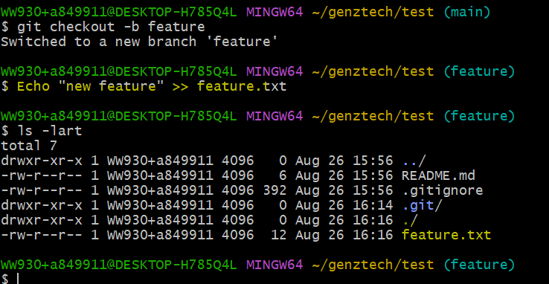

Git log //shows which all commit id's are in remote git

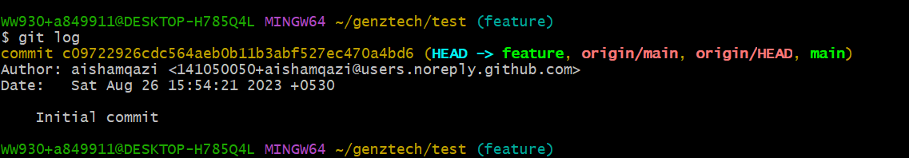

Git status //

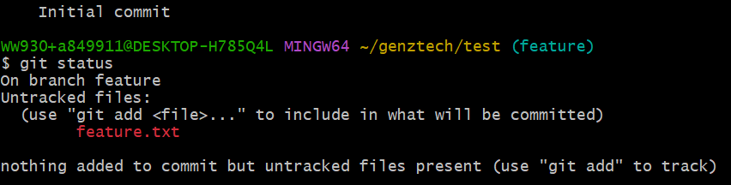

Git add .

Git commit -m "<any message>"

Git push

//Upstream is your remote repo

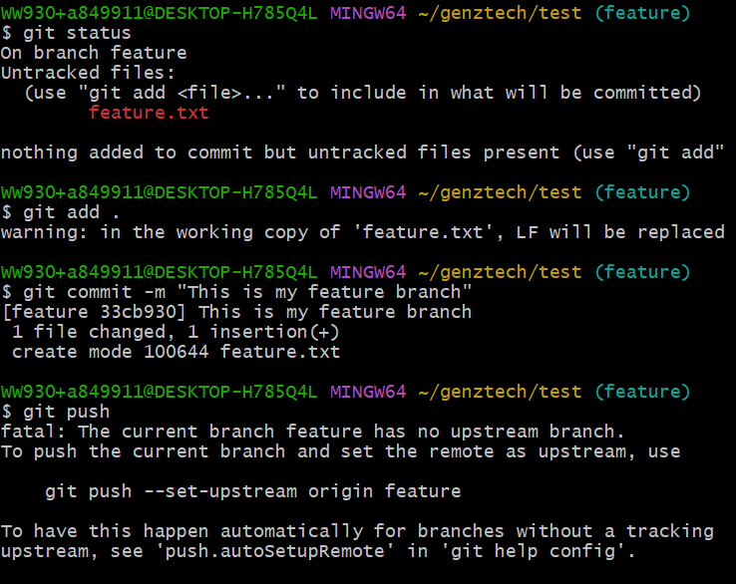

//it is asking to set the upstream to do the required pushes

git config --list | grep origin

//the above command shows all configuration files and grep ( to search) origin is for searching origin from config

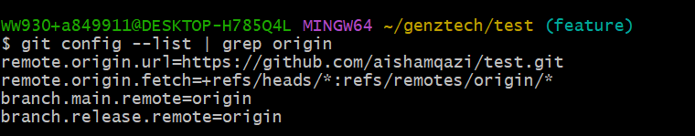

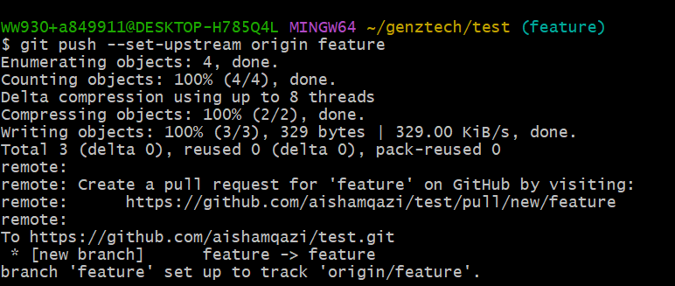

//upstream has all feature added

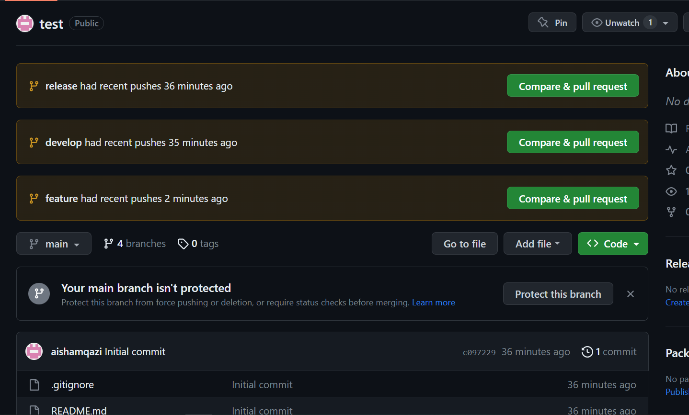

//touch is used to create an empty file in UNIX

Touch feature1.txt

git add feature1.txt

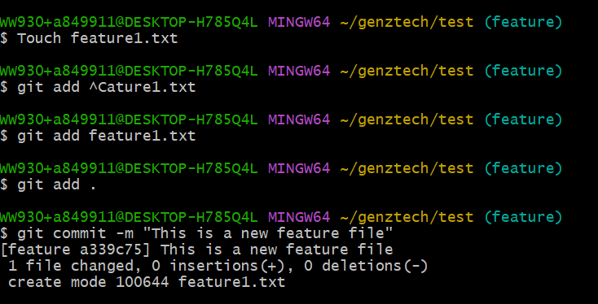

//pushing the same on remote repo

Git log //whatever commits done on log will be shown:

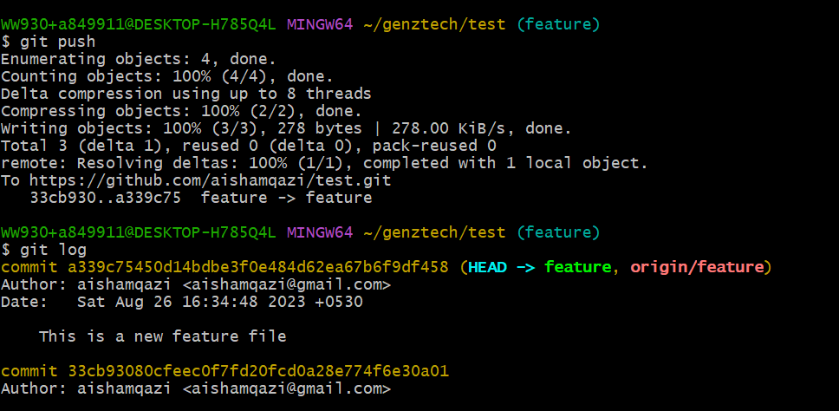

//the one which followed by commit is a SHA ID which is a commit ID

//to check the commit ID on remote repo: Go to File>History>commit ID as in SS below:

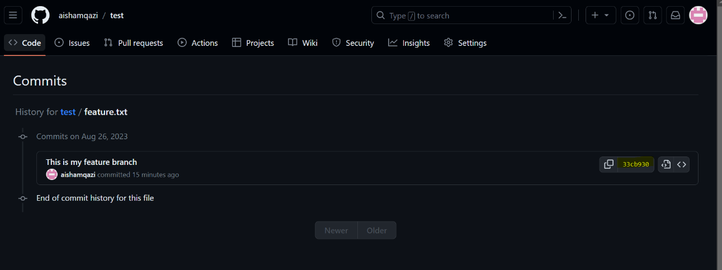

//Repeat the steps of creating file in a different branch as below:

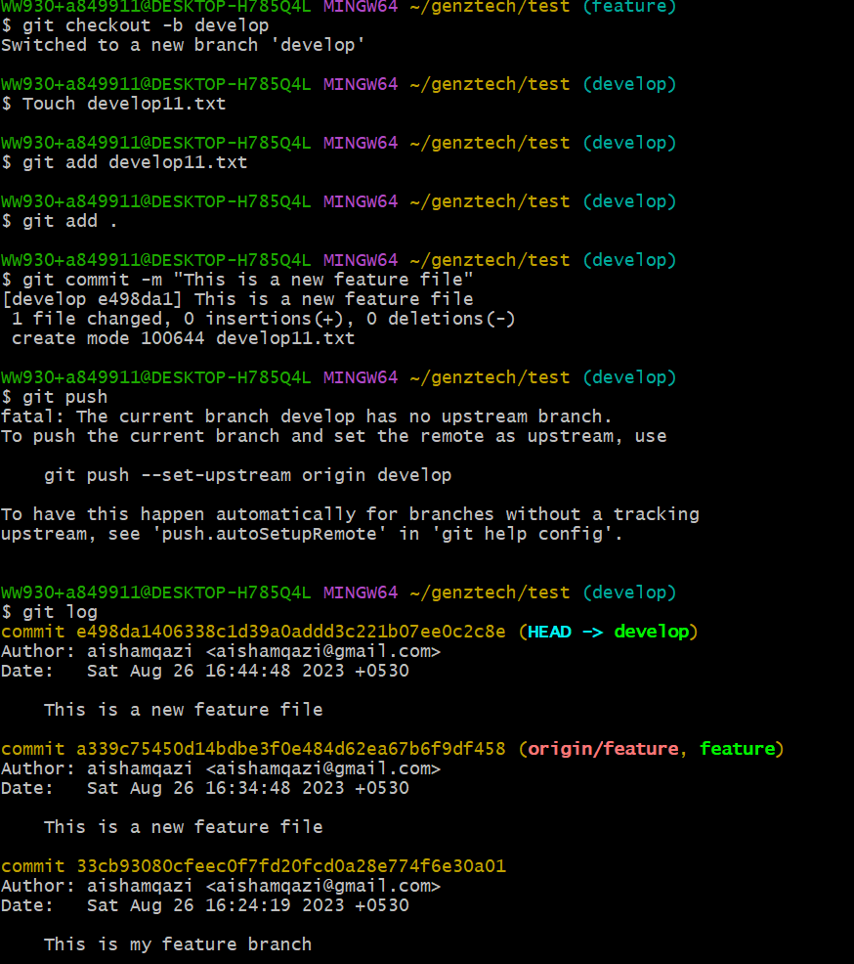

//if created a file in Git remote in feature branch as deleteme.exe

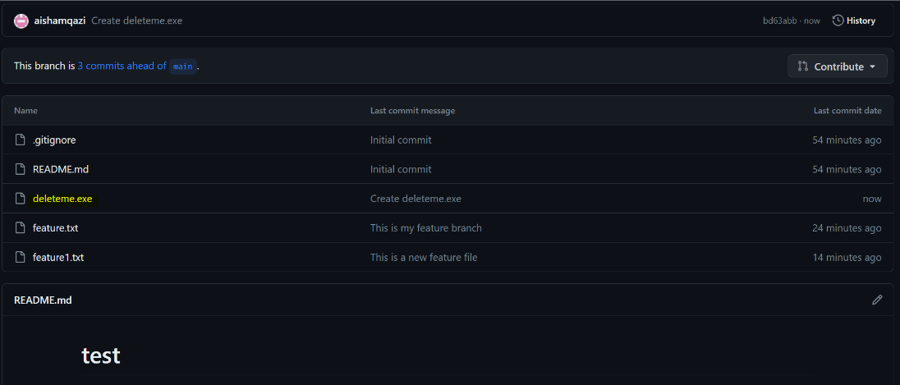

The above is not visible in local repo:

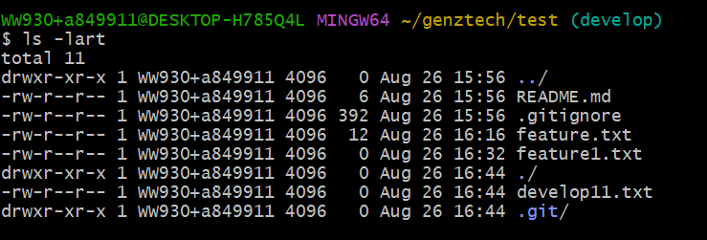

To pull the data from our online repo to our local repo we use the command: Git pull

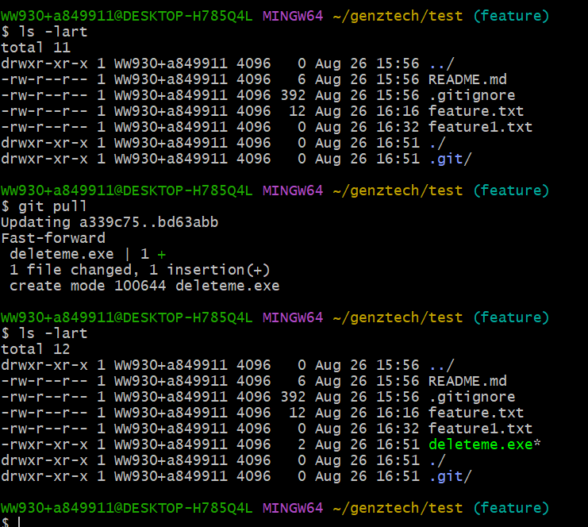

<https://github.com/mobeenh/test11.git>

//need to get a file in your local repo from above:

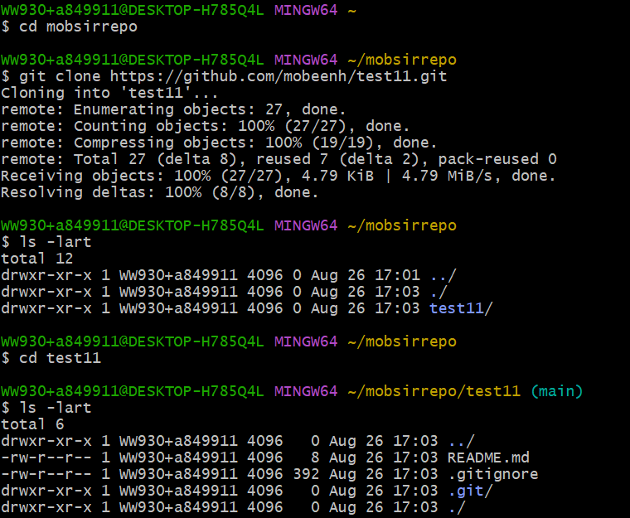

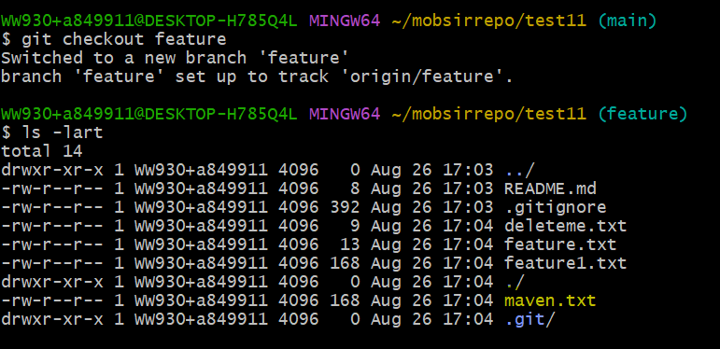

//Now create a file and push to Sir's repo:

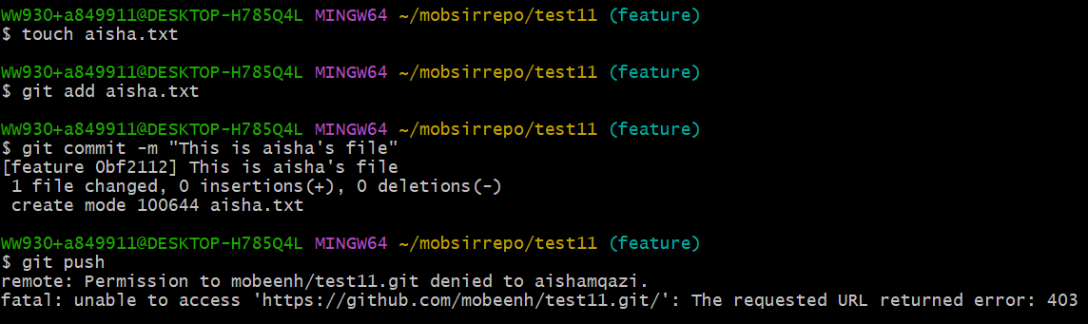

//Asked Sir to add me as a collaborator

Accept the invitation from your gmail:



Once accepted push again but fails with below error:

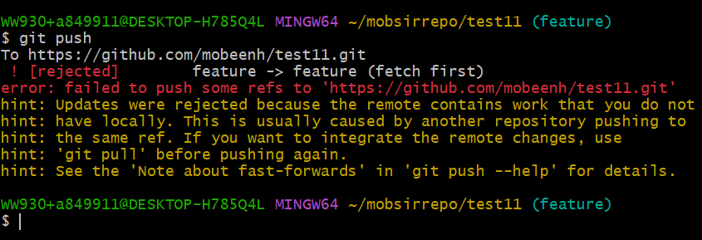

The above error occurs because there are changes and editions in repo. Hence run a git pull first and rerun a git push:

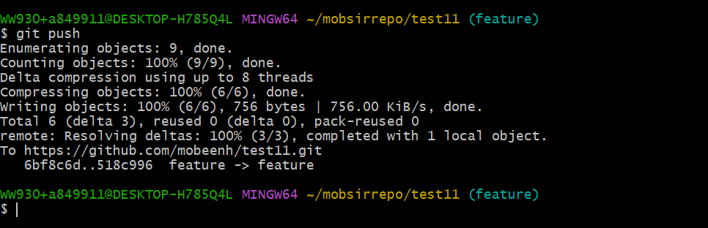

//to check if any changes made by Sir run a git pull again:

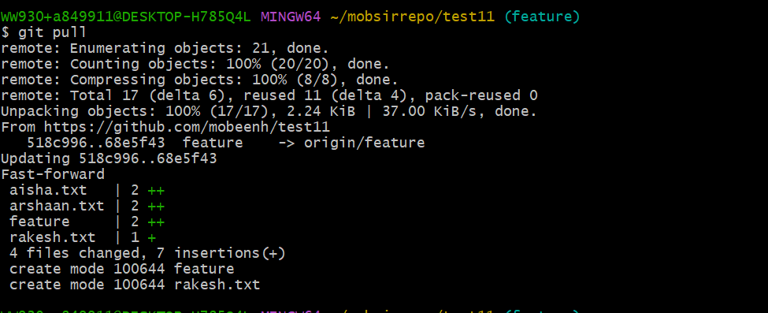

Who has done changes will reflect too on git online portal to the owner and collaborator

The owner can edit permissions as well