UNFI PROMO PLANNER
Detailed Product, Business Flow and Design Review
Consolidated from four prototype walkthrough recordings
Product discovery deliverable | 13 September 2026

Purpose and evidence standard
This report reconstructs the UNFI Promo Planner product concept from four walkthrough recordings. It is intended to support product alignment, requirements elaboration, UX refinement, technical design and QA planning. It documents the visible workflows, implied business operating model, information architecture, data needs, controls and unresolved decisions.
Evidence note: Confirmed observations are based on visible behavior in the recordings. Interpretations and implementation recommendations are identified as inferred. No separate written transcript was supplied, so exact spoken wording is not presented as verbatim; visible screens are the primary evidence source.

Recording | Duration | Primary contribution
Update Aug 18 | 5:54 | Landing page, Create new promo, Promotion details and submission confirmation
Aug 19 | 9:42 | Submission queues, promotion detail, product context and comments
Aug 20 | 5:56 | Category-manager review perspective and detail iteration
Scenario Early Draft | 9:14 | Analytical scenario grid, base / selected cases and commercial variables

Executive summary
- The product combines a promotion work queue, planning calendar, guided creation, collaborative review and an analytical scenario workspace.
- The apparent lifecycle begins with planning or scenario exploration, continues through structured promo entry and submission, and then moves through review, attention and approval states.
- The landing page is a control centre with status counts such as new submissions, needs attention and approved, plus a prominent Add promo action.
- The promotion detail page is the shared review record, combining promotion identity, item / supplier context, economics, comments and workflow actions.
- The scenario draft indicates a more advanced capability to compare pricing, cases, funding and outcomes before committing values to the governed promotion record.
- Key decisions remain around workflow states, approvals, formulas, data sources, permissions, post-approval amendments and scenario-to-promotion transfer.

1. Product framing and business intent
The concept appears designed to replace fragmented promotion planning with one governed workflow. Category and promotion users can understand workload, create or review proposals, collaborate on exceptions, assess commercial viability and monitor decisions. The scenario workspace moves evaluation earlier in the process by helping users compare assumptions before formal submission.

Likely user groups
User | Responsibilities | Primary needs
UNFI category manager | Own category promotion decisions and coordinate proposals | Portfolio visibility, scenario evaluation, review feedback, status clarity
Supplier / vendor collaborator | Provide promotion, product, funding and offer inputs | Simple submission, eligibility clarity, response to feedback
Reviewer / approver | Assess completeness, policy and economics | Attention queue, transparent calculations, comments, approve / return
Promo operations / admin | Maintain workflow quality and resolve exceptions | Cross-category visibility, audit history, configuration and correction
Finance / analyst | Evaluate margin, sales, volume and funding impact | Trusted baseline, formula definitions, scenario comparison

Visible or implied modules
- Promo Planner landing dashboard
- Calendar and list-based promotion discovery
- Guided Create New Promo flow
- Promotion detail and review workspace
- Comments / collaboration panel
- Submission and state management
- Scenario planning and commercial analysis workspace

Core product object
The governed object should be a uniquely identified promotion with event and date context, responsible owner, supplier / brand, one or more eligible items, offer mechanics, economics, workflow state, comments, versions and audit history. A scenario should remain a related analytical object until explicitly applied to a draft promotion.

2. Information architecture
Area | Purpose | Required behavior
Header / context | Identify application, user and business scope | Persist retailer / category context and provide reliable return navigation
Calendar | Understand promotional activity over time | Navigate periods, select events, show overlaps and retain filters
List / queues | Manage operational work | Search, sort, filter, open detail and preserve queue position
Status counters | Summarize workload and outcomes | Clickable counts open matching records using defined, non-overlapping logic
Add promo | Primary creation entry | Launch guided flow without losing prior context
Promo detail | Single source for one promotion | Show identity, dates, items, economics, state, comments and actions
Scenario workspace | Compare commercial alternatives | Save assumptions, recalculate, compare and explicitly transfer a selected case

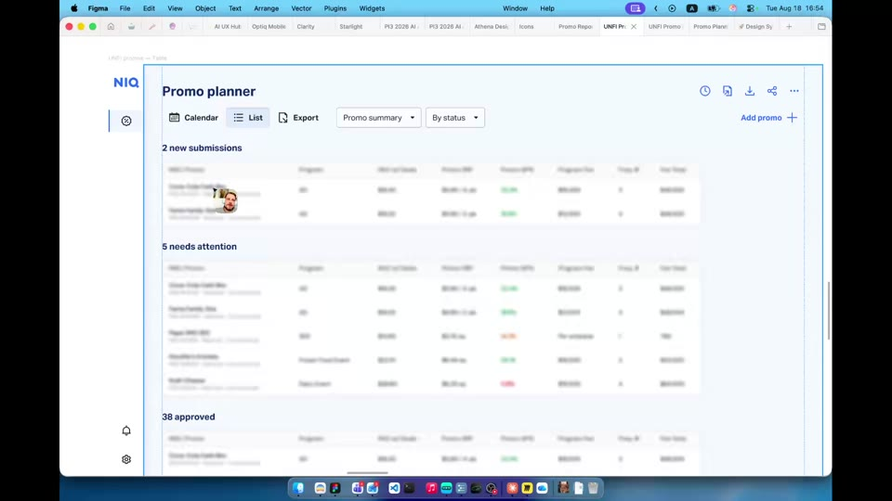
Figure 1. Promo Planner operational view with visible status counters and Add promo action.

3. End-to-end business flow
- Enter Promo Planner and review active work, events and status counts.
- Find an existing promotion through calendar, list or status queue, or choose Add promo.
- For a new record, select the event and dates, supplier / brand, products and offer mechanics.
- Enter commercial assumptions such as price, cost, funding and case volume as applicable.
- Review calculated outputs, warnings and missing-field validation.
- Save a draft or submit the promotion. The system confirms the transaction and establishes the next workflow state.
- A reviewer opens the shared detail page, evaluates context and economics, and uses comments to request clarification or document a decision.
- The record progresses through states such as new submission, needs attention and approved.
- If scenario planning is used, users compare alternatives and explicitly apply a preferred case to the draft promotion.
- Approved records remain governed, discoverable and auditable; controlled changes may trigger re-approval.
Inferred control: The formal promotion must remain the governed record. Applying a scenario must preview changes and must not silently overwrite submitted or approved values.

Proposed lifecycle for validation
State | Meaning | Primary actions | Exit
Draft | Created but not submitted | Edit, save, delete, run scenario | Completeness rules pass
New submission | Submitted and awaiting triage | Assign, open, comment | Review begins
Needs attention | Issue or missing information identified | Edit, reply, resubmit | Issue resolved
In review | Decision activity underway | Compare, comment, approve or return | Decision recorded
Approved | Authorized decision completed | View, export, controlled amendment | Execution / amendment
Rejected / cancelled | Will not proceed | View reason, clone if allowed | Closed

Open decision: Confirm the canonical states, transition owners, SLA timers, rejection versus cancellation, and re-approval behavior.

4. Landing page and work management
- The landing page operates as a control centre rather than a passive list.
- New submissions, needs attention and approved are visible summary categories and should have explicit definitions.
- Status counters should drill into filtered records and remain synchronized with list and calendar filters.
- Add promo is visually prominent and should remain accessible from both calendar and list contexts.
- Returning from detail should preserve filters, sort order, date range and scroll position.

Required discovery capabilities
- Search by promotion name, identifier, supplier, brand, item and UPC.
- Filter by event, date range, category, owner, supplier and status.
- Sort by submission date, start date, status age and commercial importance.
- Provide deliberate empty, loading, error and no-permission states.
- Support pagination or virtualization for large portfolios and retain user preferences.

5. Create New Promo workflow
The August 18 recording visibly demonstrates a guided Create new promo experience with a Promotion details stage and a successful submission confirmation. The workflow should progressively disclose required inputs, preserve partially entered work and adapt validation to promotion type and mechanic.
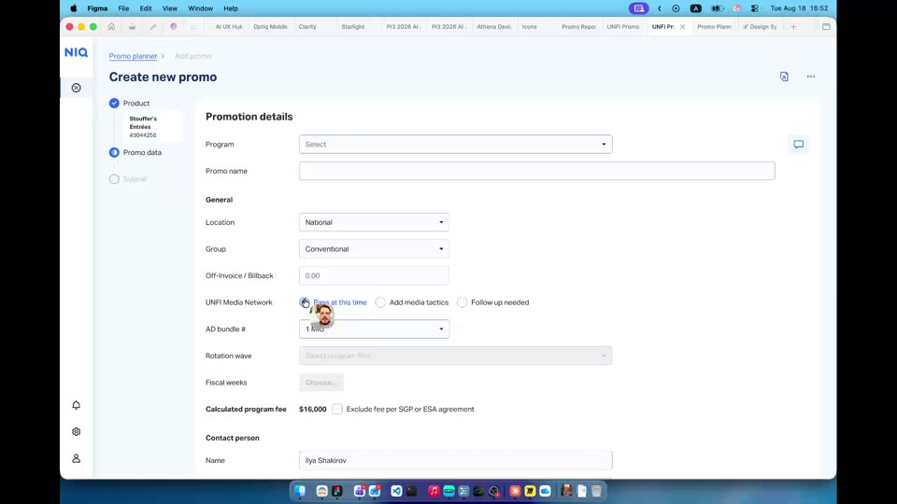
Figure 2. Create new promo experience with Promotion details as a central stage.

Data groups
Group | Representative information | Validation
Identity | Promotion name, event / program, description | Unique within scope; event required where applicable
Timing | Start, end and planning period | End on / after start; inside valid event and cutoff window
Organization | Retailer / banner, category, owner | Authorized values; derive from context where possible
Supplier / brand | Supplier, brand, contact | Valid active master-data relationships
Products | UPC / item, pack, size, description | Active, eligible, no duplicates
Mechanics | Offer type, promo price, discount, display / ad | Mechanic-specific fields and range checks
Volume | Base cases, selected / forecast cases | Non-negative values and explicit unit
Economics | Cost, SRP, funding, margin / profit | Currency, unit basis, rounding and formula consistency
Evidence | Rationale, notes, attachments | File controls, security scan and audit history

Interaction requirements
- Display a step indicator showing completed, current and remaining stages.
- Support Save as draft, safe exit and a warning before discarding unsaved changes.
- Use immediate field validation where reliable and repeat authoritative validation at submission.
- Show errors next to fields and present a short submission-level summary.
- Preserve valid values after errors or network failure.
- Prevent duplicate clicks and make submission retry idempotent.
- On success, show the promotion identifier, resulting status and next action.
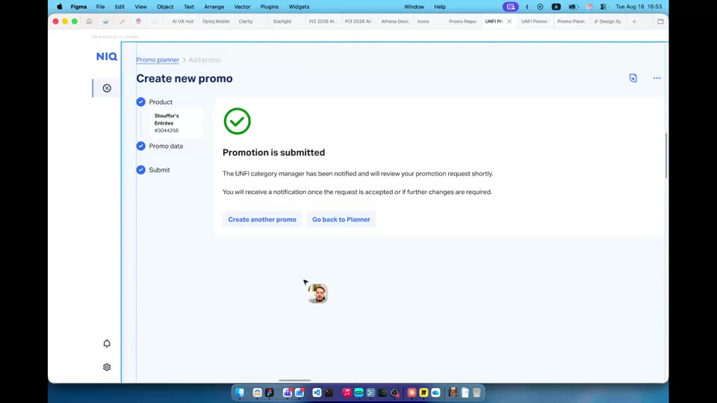
Figure 3. Successful submission confirmation at the end of the guided workflow.

6. Promotion detail and review workspace
The August 19 and 20 recordings demonstrate a promotion detail record for a seasonal event and branded product context. This screen appears to be the shared workspace after submission and should consolidate all information needed for a decision without forcing reviewers to reconstruct context across systems.
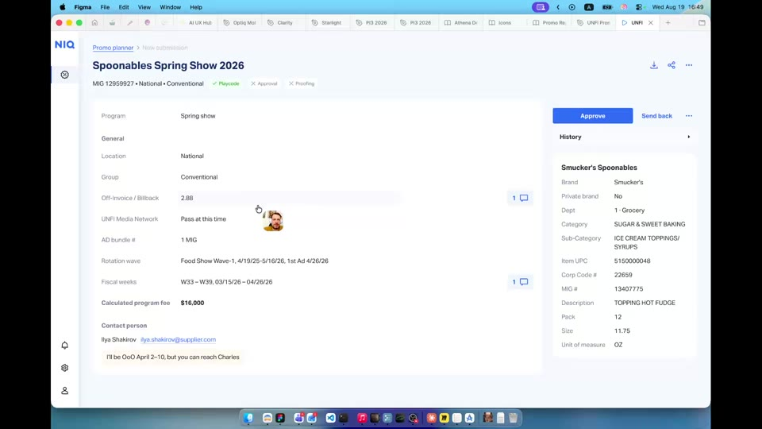
Figure 4. Promotion detail screen showing event and product / brand context.

Recommended hierarchy
- Header: promotion title, identifier, state, event, dates, category, owner and primary actions.
- Commercial summary: supplier, brand, promoted items, mechanics and headline economics.
- Detailed inputs: item-level prices, costs, funding, cases, assumptions and calculated outputs.
- Exceptions: missing data, policy warnings, invalid values and unresolved requests.
- Collaboration and audit: comments, mentions, attachments, state history and revisions.

Review principles
- Show previous and current values where a submission was amended.
- Explain warnings without hiding the underlying input or formula.
- Separate editable fields from read-only sourced information and calculated outputs.
- Require a return reason when placing a record into needs attention.
- Require decision identity, timestamp and optional / mandatory rationale according to policy.

7. Comments and collaboration
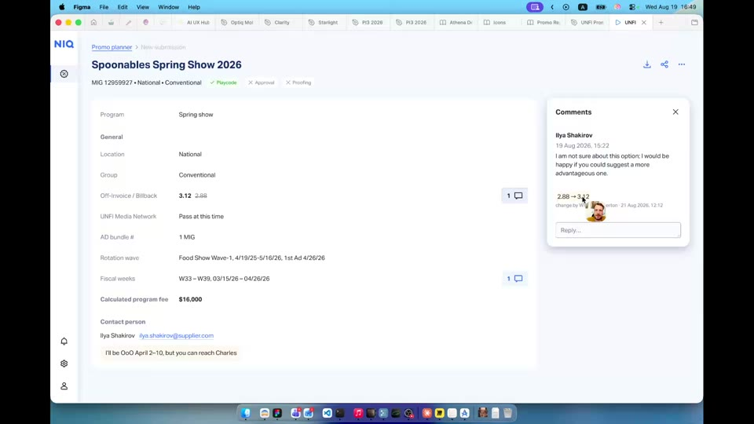
Figure 5. Comments area embedded in the promotion review experience.
- Comments are workflow evidence and must remain tied to the promotion.
- Capture author, timestamp, text, visibility and resolution status.
- Support contextual comments attached to a field or item when possible.
- Distinguish user comments from system events such as submission, value change and approval.
- Mentions and notifications should deep-link to the promotion and thread.
- Editing or deleting comments should be controlled and auditable.
Open decision: Determine whether unresolved comments block approval, whether needs attention requires a comment, and which threads external suppliers may see.

8. Scenario planning concept
The Scenario Early Draft shows a dense grid-oriented workspace with concepts such as base cases, selected cases, SRP and commercial variables. The likely objective is to let users evaluate alternative price, volume, funding and profitability assumptions before finalizing a promotion.
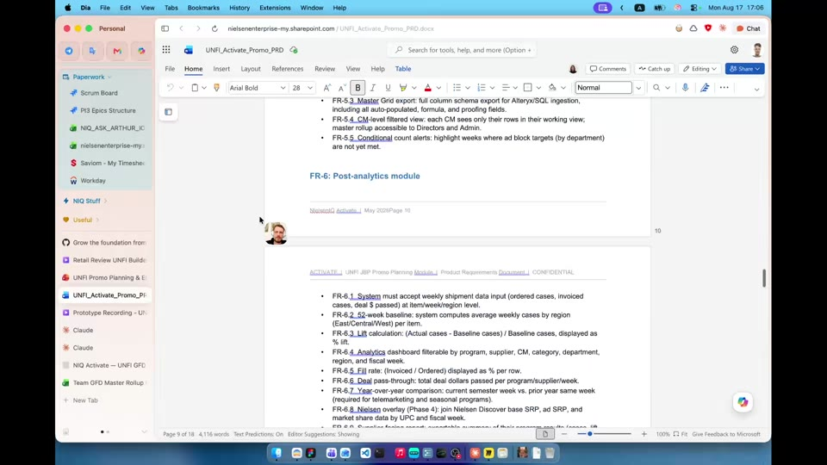
Figure 6. Early scenario workspace with case and pricing-oriented inputs.

Scenario jobs to be done
- Load a trusted baseline and make its source / freshness visible.
- Change selected assumptions without altering source values.
- Recalculate outcomes consistently and quickly.
- Compare alternatives using identical metric definitions, time windows and units.
- Name and save scenarios with creator, timestamp and version.
- Choose a preferred alternative and preserve the selection rationale.
- Preview and confirm the values transferred to a draft promotion.

Design and governance principles
Principle | Requirement
Baseline integrity | Source values are visually distinguished and protected from accidental edits.
Assumption clarity | User inputs, sourced values and calculated outputs use distinct treatments.
Unit transparency | Currency, unit / case basis, quantity units and rounding are always visible.
Comparison consistency | All scenarios use the same metrics, baseline and period.
Explainability | Users can access formula definitions and dependent inputs for key outcomes.
Version control | Scenario versions retain author, timestamp and changes.
Governed transfer | Applying a scenario previews each changed value and requires confirmation.

9. Metrics and calculation governance
Commercial trust depends on consistent, explainable calculations. Each measure requires a documented name, definition, grain, business perspective, unit, rounding rule, dependencies, source and accountable owner.
Family | Illustrative measures | Questions
Price | Regular SRP, promo price, discount | Shelf or transaction basis? Tax included? Weighted across items?
Volume | Base, forecast / selected and incremental cases | Baseline window? Case-pack conversion? Cannibalization?
Cost / funding | List cost, net cost, vendor funding, allowance | Per unit or case? Effective date? Multiple funding types?
Sales | Baseline, promo and incremental sales | Gross or net? Retail or wholesale perspective?
Margin / profit | Gross margin dollars / rate, incremental profit | Whose margin? Funding treatment? Execution cost?
Lift / ROI | Volume lift, sales lift, return | Compared with which baseline and investment?

Critical requirement: Do not label a value simply as margin, sales, cost or ROI. The interface and data dictionary must expose its exact business perspective and definition.

10. Business rules and controls
Rule area | Decision to define
Eligibility | Which events, suppliers, categories and items can participate?
Timing | Lead times, cutoffs, blackout periods and amendment windows?
Completeness | Required fields by promotion type, event and mechanic?
Thresholds | Which financial values produce warnings versus hard stops?
Overlap | Can an item participate in overlapping promotions?
Approval | Approver selection by category, value, funding or exception?
Amendment | Which changes trigger re-approval?
Cancellation | Who can cancel, and what reason / notification is required?
Retention | How long are drafts, comments, versions and files retained?

11. Data and integration requirements
- Item master: UPC / item, description, pack, size, status, category hierarchy, supplier and brand.
- Pricing and cost: regular price, cost basis, effective dates and location / banner scope.
- Event calendar: event identity, eligibility, planning window and execution dates.
- Promotion history: prior mechanics, approved assumptions and outcomes where available.
- Identity and access: organization, category entitlement, role and approval authority.
- Workflow services: assignment, comments, reminders, notifications and escalation.
- Downstream publishing: approved values delivered to execution, merchandising, finance and reporting systems.

Data-quality behavior
- Expose freshness and source for critical values.
- Handle stale or missing data explicitly; never default silently.
- Revalidate sourced data at submission and approval.
- Persist source-system identifiers for reconciliation.
- Provide an operational queue for failed integrations and retries.

12. Roles and permissions
Capability | Creator | Category manager | Approver | Admin
Create / edit draft | Yes | Yes | Optional | Yes
Submit | Yes | Yes | No | Yes
Comment | Yes | Yes | Yes | Yes
Return for attention | No | Optional | Yes | Yes
Approve | No | Policy-based | Yes | Yes
Edit approved values | No | Controlled | Controlled | Controlled
Configure workflow | No | No | No | Yes

Inferred control: Self-approval should be prohibited unless an explicit low-risk policy permits it. Authorization must be enforced server-side, not only through hidden UI actions.

13. UX, accessibility and non-functional requirements

UX and accessibility
- Communicate status with text and color, never color alone.
- Support keyboard operation for forms, grids, dialogs and comments.
- Provide visible focus, accessible icon names, labels, errors and table headers.
- For scenario grids, freeze identifiers and provide understandable row / column context.
- Use confirmation for approval, cancellation and scenario application.
- Use unambiguous dates and disclose timezone / business-calendar assumptions.
- Localize loading and error states to avoid losing the entire page context.

Non-functional expectations
Area | Direction
Performance | Fast landing and detail load; near-immediate common scenario recalculation.
Reliability | Idempotent submission / approval and recovery after interruption.
Auditability | Actor, timestamp, old value, new value, reason and state transition.
Security | Least privilege, organizational isolation, encryption and secure attachments.
Scalability | Large item portfolios, many concurrent promotions and dense scenario grids.
Observability | Monitor latency, API errors, workflow failures, calculation exceptions and abandonment.
Privacy | Limit personal data in comments, exports and notifications.

14. Prioritized functional requirements
ID | Requirement
PP-001 | Provide calendar and list views using a shared filter context.
PP-002 | Show actionable counts for new submissions, needs attention and approved.
PP-003 | Open the underlying filtered records when a status count is selected.
PP-004 | Allow authorized users to create, save and resume a draft promotion.
PP-005 | Apply promotion-type-aware required fields and validation.
PP-006 | Support multiple eligible items and prevent duplicates.
PP-007 | Recalculate dependent economics when an input changes.
PP-008 | Distinguish sourced inputs, user assumptions and calculated outputs.
PP-009 | Validate submission and return actionable field-level errors.
PP-010 | Record submission as an immutable activity event.
PP-011 | Allow reviewers to comment, return and approve according to permission.
PP-012 | Retain comment author, timestamp, visibility and resolution.
PP-013 | Keep governed value changes in version history.
PP-014 | Trigger re-approval when configured approved fields change.
PP-015 | Create, name, compare and retain multiple scenarios.
PP-016 | Apply a preferred scenario only through preview and confirmation.
PP-017 | Expose metric definitions, units and rounding behavior.
PP-018 | Enforce a configured state-transition model.
PP-019 | Retain source identifiers and freshness metadata.
PP-020 | Export a promotion summary with state and version information.

15. QA acceptance themes
- Happy path from landing through creation, submission and queue update.
- Save and resume at every creation stage.
- Field, cross-field and server-side validation.
- Duplicate clicks, retries and interrupted network requests.
- Creator, reviewer, approver and unauthorized-user permissions.
- Correct counter updates after transitions and concurrent changes.
- Comment visibility, notification, resolution and audit history.
- Scenario reproducibility and controlled transfer to a draft.
- Post-approval amendment and re-approval.
- Large item sets, long labels, keyboard navigation and screen-reader behavior.

16. Open questions
Topic | Decision required
Workflow | Authoritative statuses, transitions, owners and SLAs?
Users | Do suppliers use the product directly or provide inputs outside it?
Scope | Does approval publish execution instructions downstream?
Grain | Is a promotion one event, supplier, brand, item set or another unit?
Calculations | Exact formulas and business perspective for sales, margin, funding and ROI?
Scenario | Mandatory, optional or limited to certain promotion types?
Baseline | Source and method for base cases / sales?
Approval | Rules based on category, value, funding or exceptions?
Collaboration | Which comments and attachments are supplier-visible?
Dates | How order, ship, event and retail dates relate?
Change control | Which amendments require re-approval and version comparison?
Outputs | Required exports and downstream feeds after approval?

17. Recommended next steps
- Validate the reconstructed flow with category management, promo operations, finance, suppliers and approvers.
- Define the promotion entity, item grain and canonical state machine.
- Create a calculation dictionary with owners and worked examples.
- Map every field to source, edit owner, validation and downstream consumer.
- Confirm the role / permission matrix and supplier visibility model.
- Convert creation, review, comments, approval and scenario flows into prioritized stories and acceptance criteria.
- Prototype exception paths: missing master data, ineligible item, overlap, failed integration and approved amendment.
- Instrument completion, time in state, rework, approval cycle time and scenario adoption.

Appendix A. Recording-by-recording capture
Recording | Visible contribution
Update Aug 18 | Operational landing experience; guided Create new promo; Promotion details; successful submission; return to work queues.
Aug 19 | Status queues; seasonal promotion detail; product / brand context; comments and review activity.
Aug 20 | Category-manager-oriented revisit of detail and collaboration behavior.
Scenario Early Draft | Grid-based analytical concept using base / selected cases, pricing and related commercial assumptions.

Appendix B. Limitations
This is a product and design reconstruction from prototype video. Some labels are small, the scenario is explicitly an early draft, and not all states or exceptions are demonstrated. Inferred requirements are implementation recommendations, not claims that the prototype already supports them. Exact business definitions and spoken statements should be validated against product-owner notes or supplied transcripts before requirements baseline approval.

