# **SARSA**

## **Problem Statement**

Solve the cliff walking environment using SARSA.

### **Environment**

Cliff walking is a two dimensional board game.

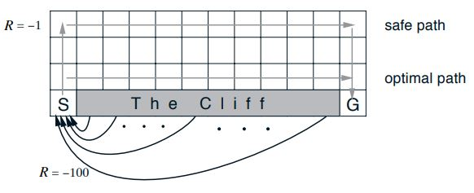

* The environment has episodic tasks.
* Agent starts at the state **S** and traverses through the environment to reach goal **G**.
* Agent can move up, down, right, and left.
* Agent receives a reward of -1 for every movement except for the cliff and goal.
* Agent falling into the cliff attracts a reward of -100 and is sent back to the state **S**.

**Dependency:**

Cliffwalking: <https://drive.google.com/file/d/1PpffxVlbLIYPnVhS1l_3s53Y395uj7Up/view?usp=sharing>