# Android Material Design Codelab Setup

Duration: 0:45

Environment: Web

Published Version: <https://docs.google.com/a/google.com/document/d/1xPJeRFPcgcpWOHk2S3UzSP8518aa6t1GuW-H4Pv2o0c/pub>

1. Download [Android Studio](https://developer.android.com/sdk/installing/studio.html).
2. Install [SDK packages](https://developer.android.com/sdk/installing/adding-packages.html).
3. Create a new Project in Android Studio
   1. Open Android Studio.
   2. Select “Start a new Android Studio project”.

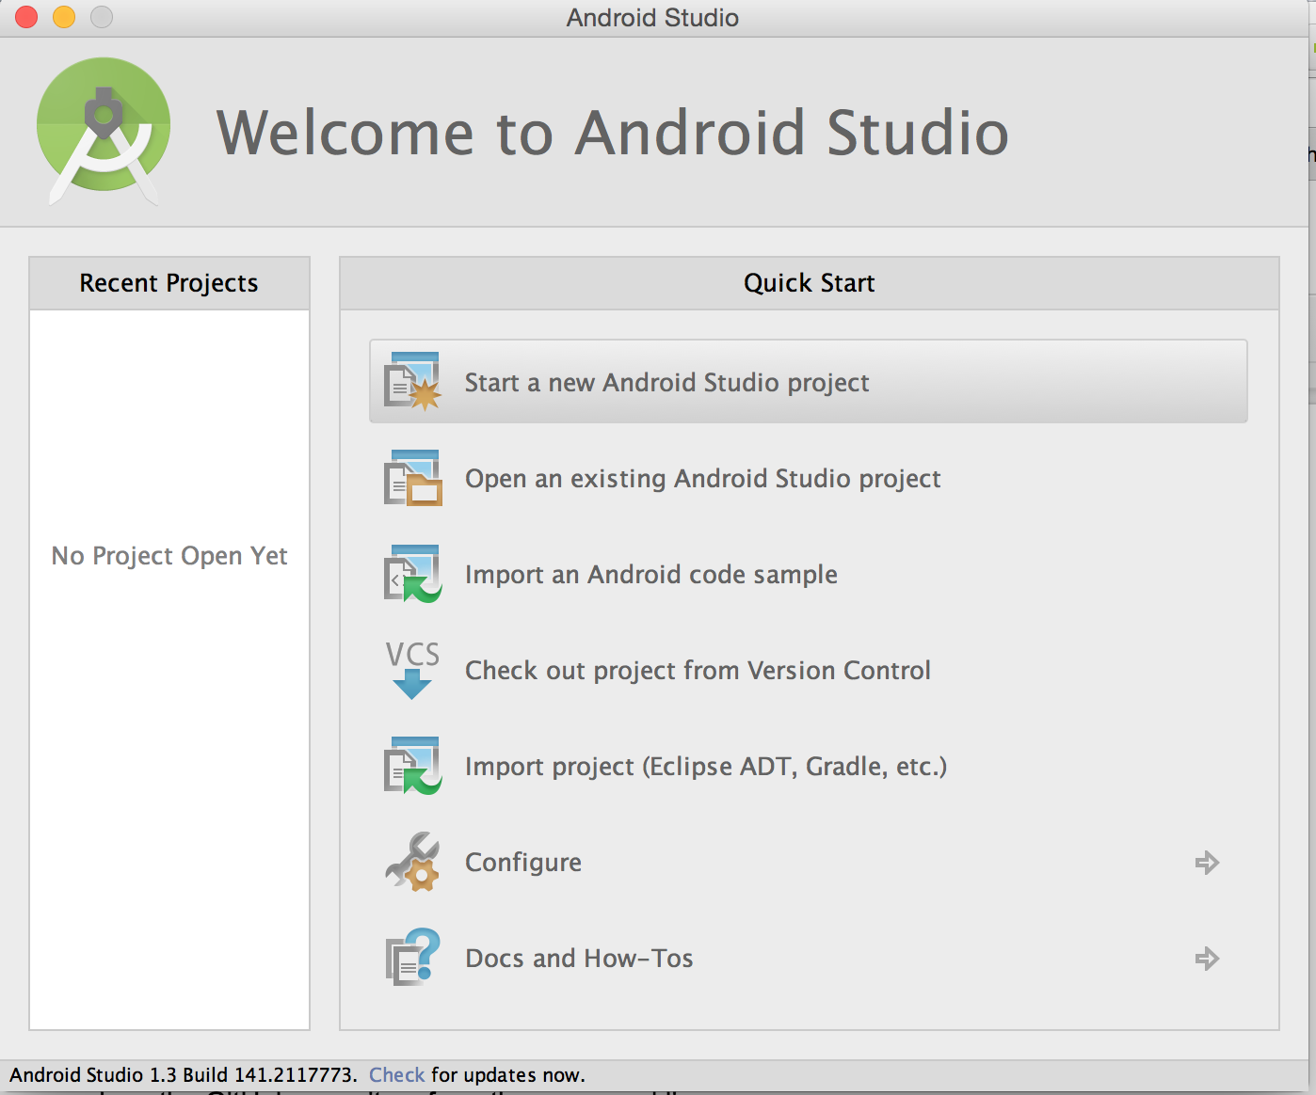

* 1. Fill out the “Configure your new project” form and click “Next”.

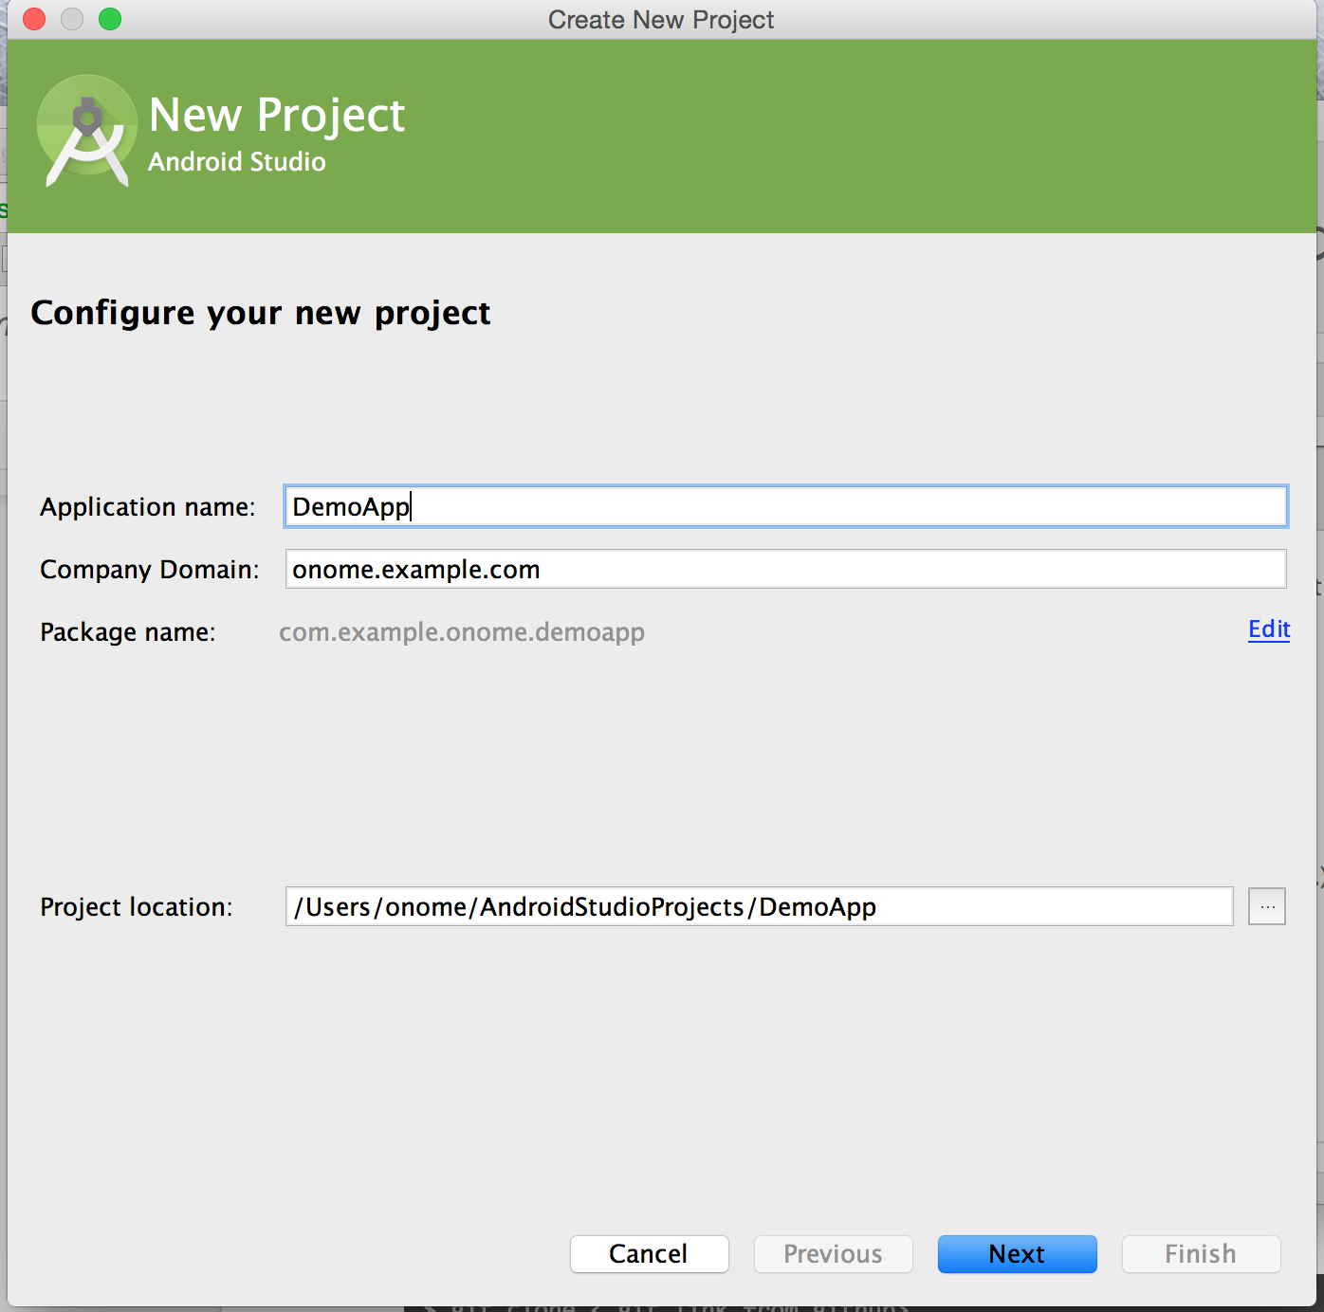

* 1. Select the form factors your app will run
     1. Select the “Phone and Tablet” checkbox.
     2. Set Minimum SDK to API 21: Android 5.0 (Lollipop) or higher.
     3. Click “Next”

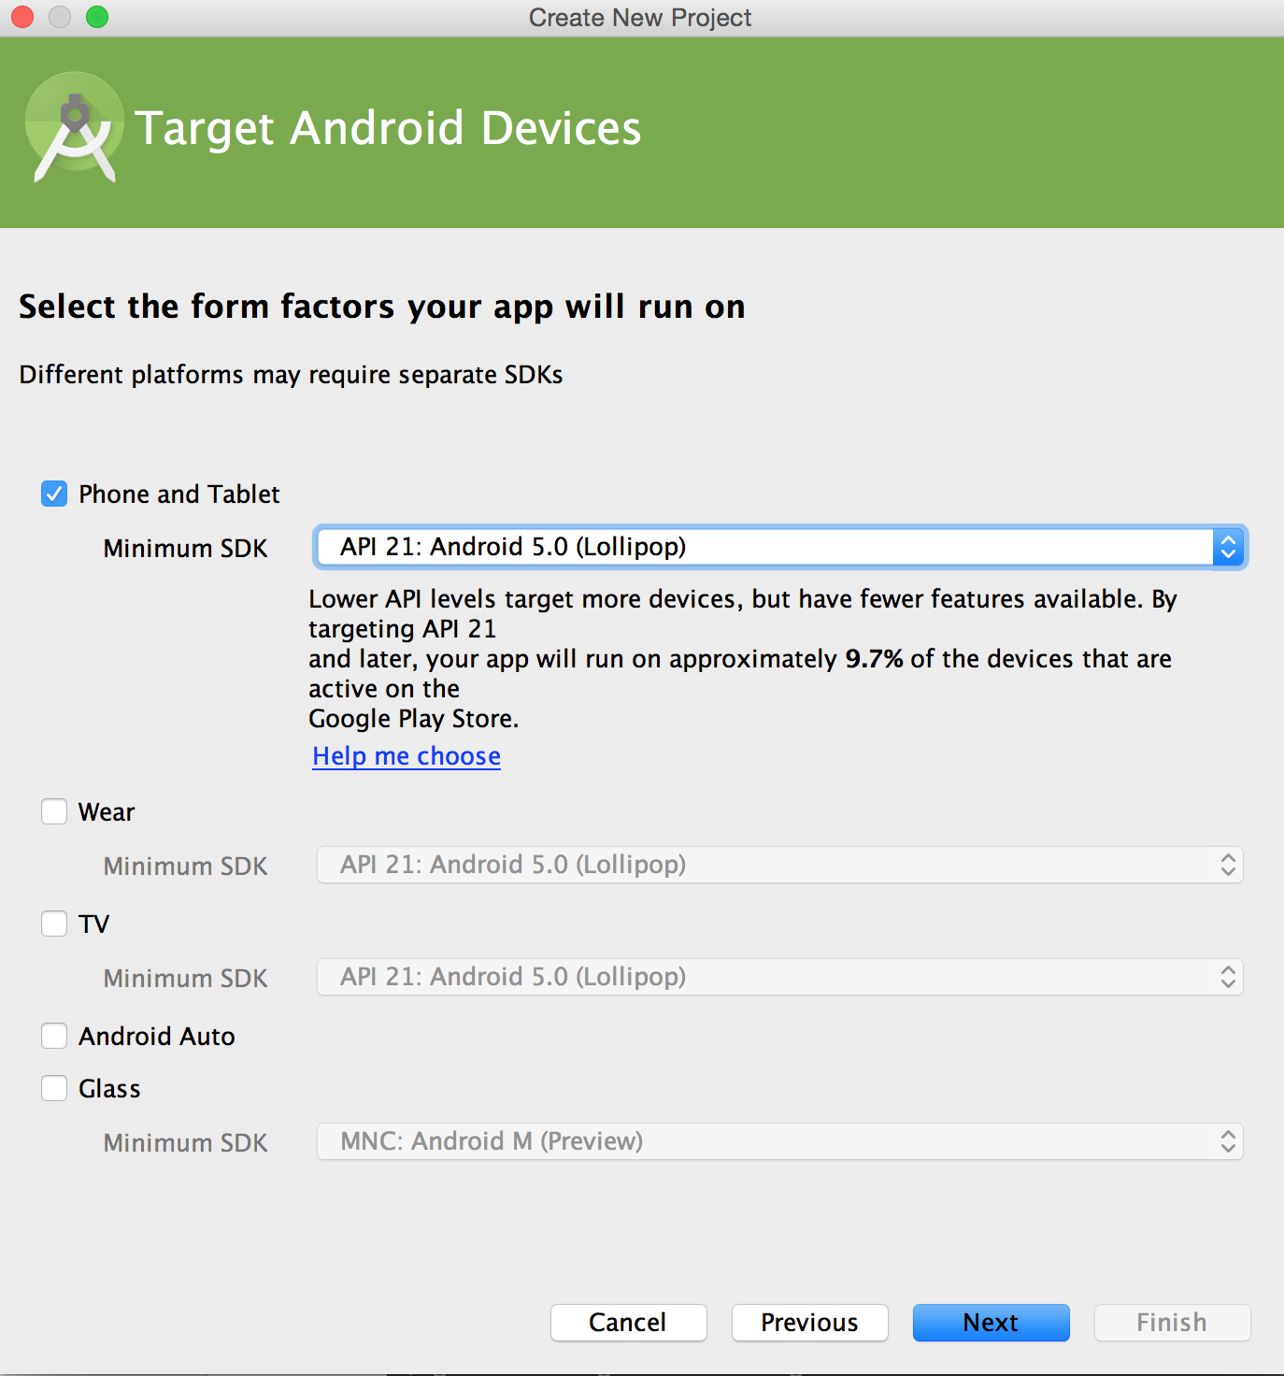

* 1. Add “Blank Activity” to mobile and customize the names as needed after clicking “Next”.

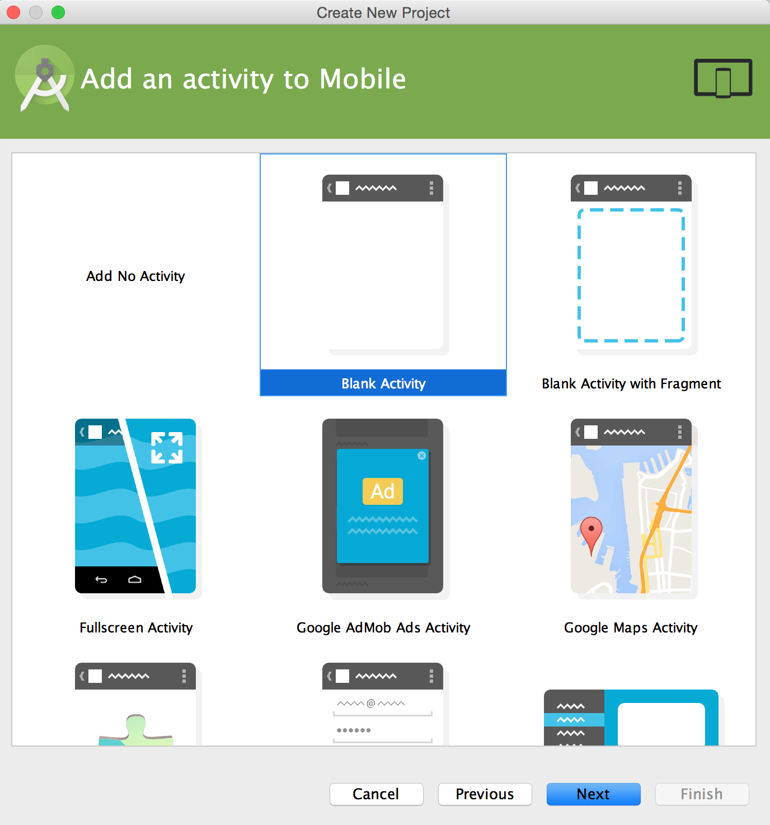

* 1. Click “Finish”.
  2. Resolve any build errors in the Intellij IDE that opens up.
  3. Update [build.gradle](https://drive.google.com/a/google.com/file/d/0B8fmn9WHMkHYckd5bC0tTFF1R0E/view) file to use v22 SDK and Android Design Support Library.
  4. Sync and run your project:
     1. Click **Run**  from the toolbar.
     2. In the “Choose Device” menu, select “Launch emulator” and set “Android virtual device” to “Nexus 5 API 22 x86” (the one installed in step #2).
     3. Click “OK” to run.
     4. Ensure that emulator starts up correctly and that there are no error in the IDE log.
  5. Congrats! You’re done with the setup and now ready to begin the codelab.