USER MANUAL

Welcome Page:

When you first open the webpage, you will be greeted with a welcome page showing you what this website is about. Here you can navigate to the register page when you can make your account and join the skills build player base or if you are an existing user, you can navigate to the log on page.

Figure 1- shows the welcome page

Register and log on:

The user here can register as a new user to join the skills build community. On the register page the user can decide a user name and create a password and once done will be redirected to the log on page.

Figure 2- shows the register page with user "Moksh" registering

On the log on page the user must enter their specific user name and password In order to access the rest of the website.

Figure 3- shows the log on page

Dashboard:

Once logged on the user is directed to the dashboard page. This serves as the main page on the website where you can access all the other pages shown in the navigation bar under the “IBM SKILLSBUILD COURSES” logo. The user can see a list of available courses to start and their specific category.

Figure 4- shows the dashboard with available courses

The user can also sort the list of courses in alphabetical order, reverse alphabetical order and by category to make it as simple as possible to find the course they want to start.

Figure 5- shows the courses sorted by category

Start Courses:

Active Courses Section:

* The page displays a list of active courses along with their elapsed time.
* Users can see the list of active courses in an ordered list, where each course is

displayed within a list item.

Start Session Form:

* Users can start a new course session by filling out the form.
* The form includes an input field for the course name.
* The user needs to enter the course name, and upon submitting the form.

Pause Session Form:

* Users can pause an active course session by choosing a course from the drop-

down list and submitting the form.

* This form includes a drop-down list which has the available courses.

Resume Session Form:

* Users can resume a paused course session by choosing a course from the drop-

down list and submitting the form.

* Like the “Pause Session” form, this form includes a drop-down list populated with available courses.

Footer Section:

* The footer includes social media links to IBM’s Instagram and Facebook pages.

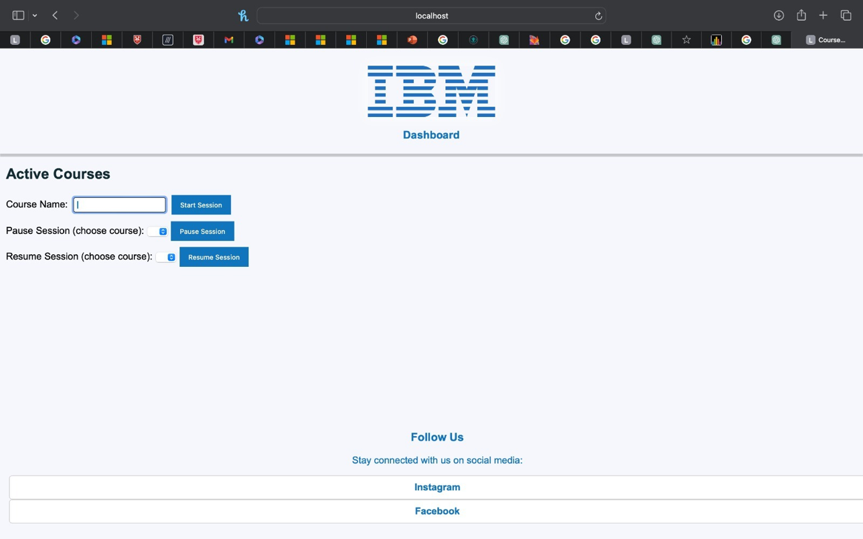

Figure 6- shows what the page looks like.

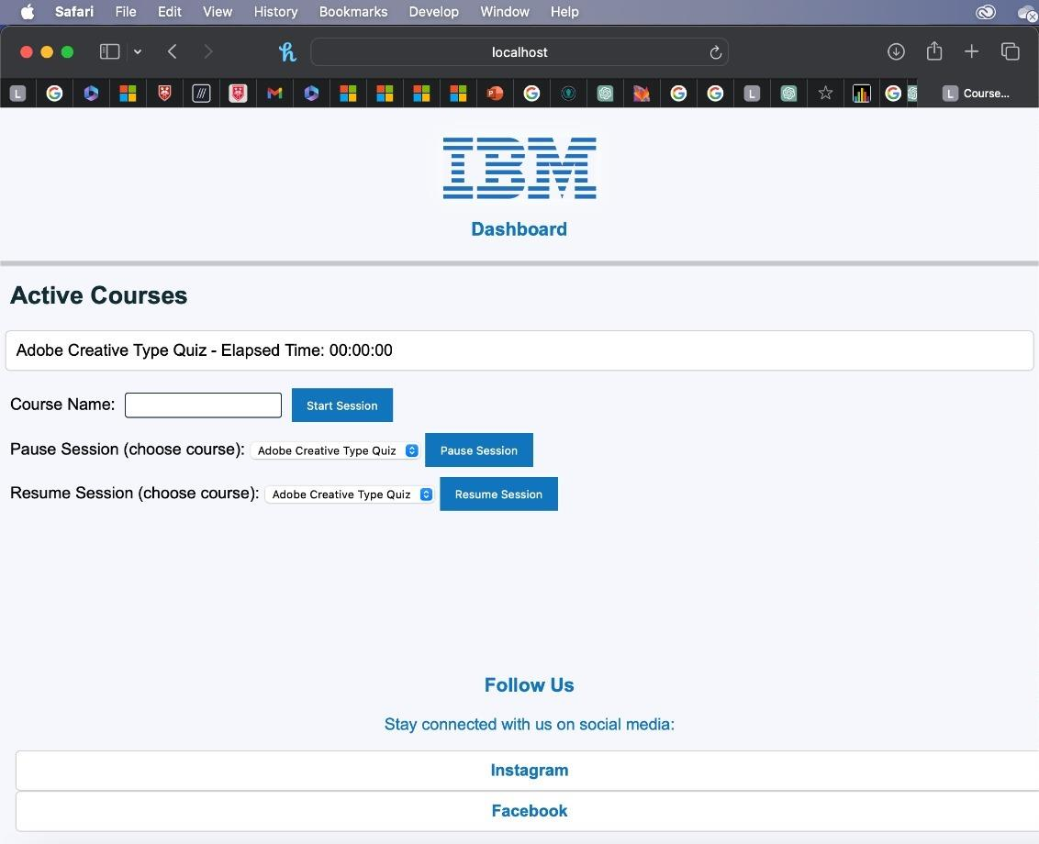

Figure 7- shows what happens when the user type in a course name and click the “Start Session”.

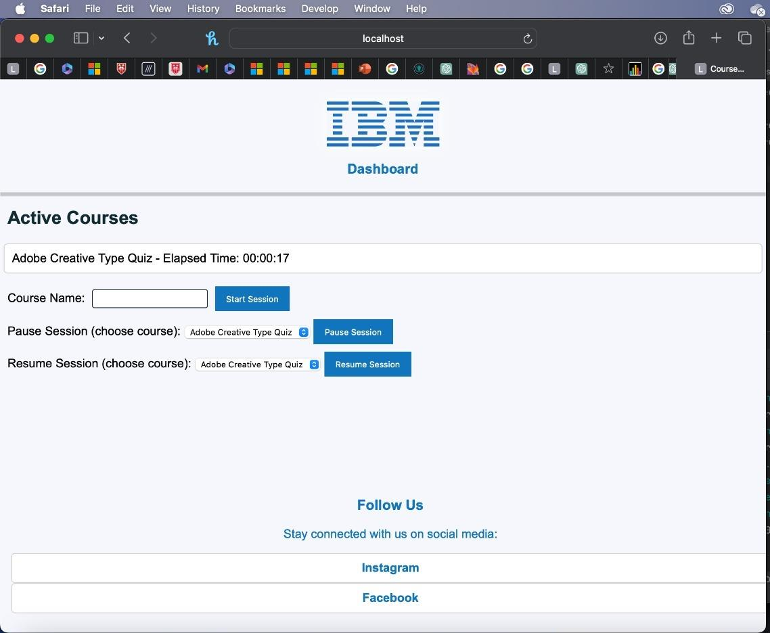

Figure 8- shows what happens after the user click the ‘Pause session’ button, it shows the timer going off and shows how much time it’s been.

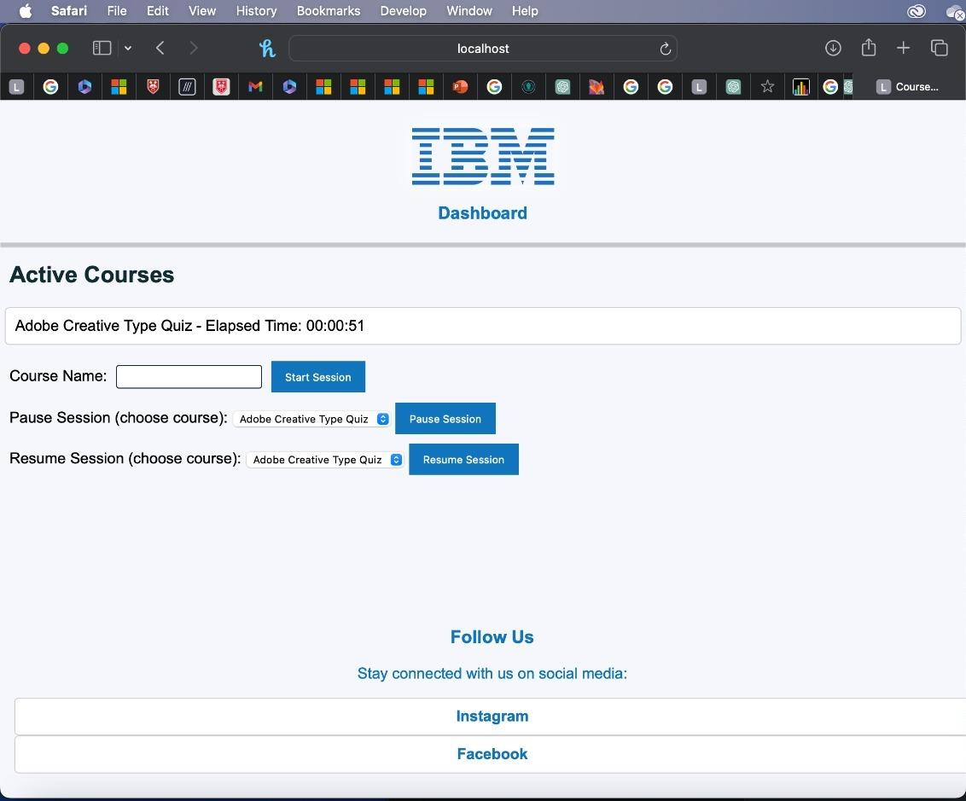

Figure 9- shows what happens when the user clicks the ‘Resume Session’ button

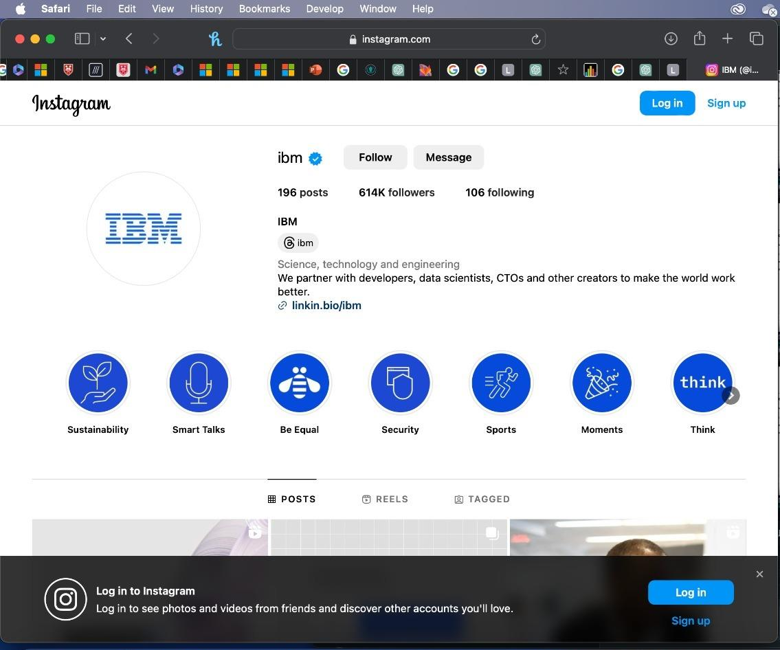

Figure 10- shows what happens when the user clicks on the Instagram link in the footer.

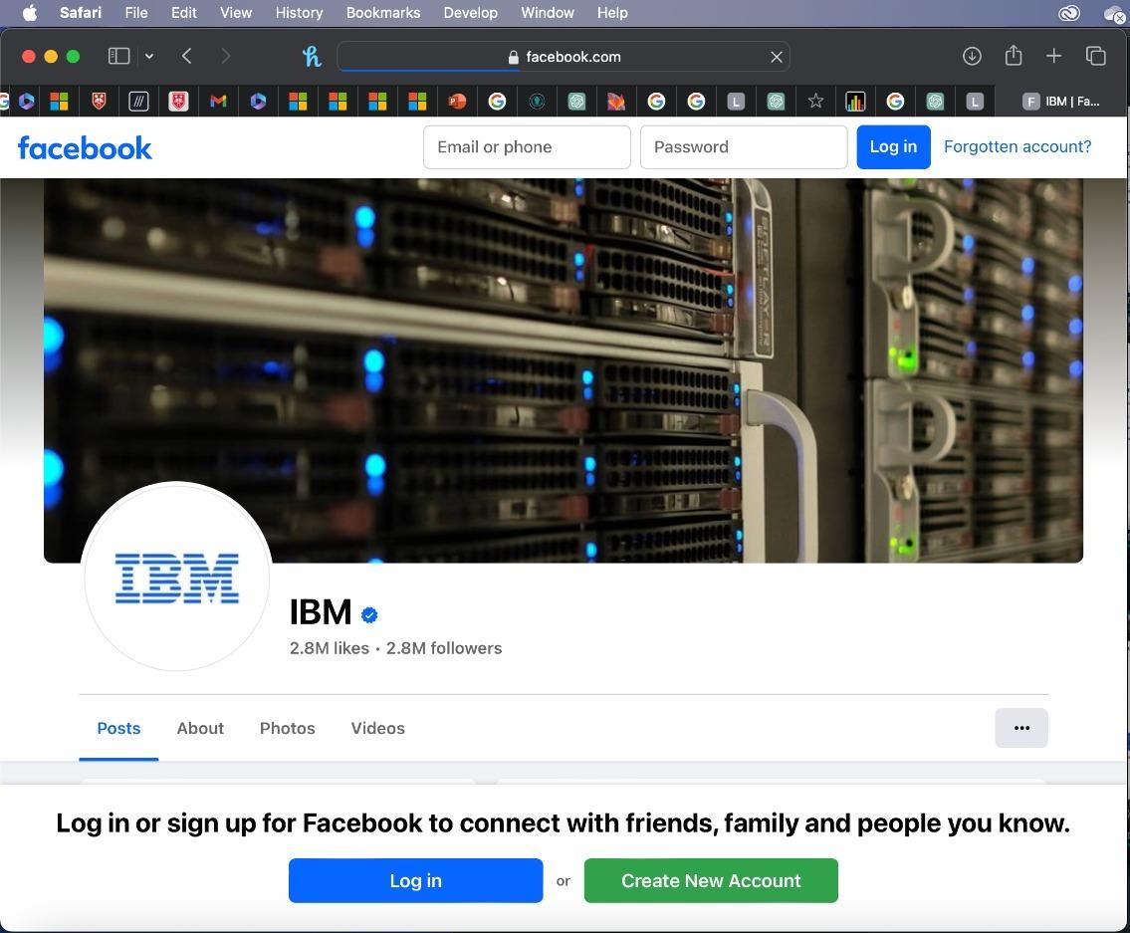

Figure 11- shows what happens when the user clicks on the Facebook link in the footer.

Completing Courses:

This part of the webapp allows you as a user to confirm the completion of your course from the dashboard.

Figure 12- dashboard page

As you can see there is a “complete” button on the right most part of the dashboard next to the “status” button. Clicking this button will reload the page and add 1 to your total tally of courses completed.

Figure 13- user page before the complete button is pressed

Figure 14- user page after the complete button is pressed

Leader board:

This part of the webapp shows the users rank against all the registered users. Newly registered players will appear on this leader board at any time.

Figure 15- showing the leader board after new user "Moksh" has registered

After the user completes a course the number of their “courses completed” will update instantly in real time.

Figure 16- leader board after "Moksh" completed 1 course

Any user that completes a course will have their score updated and if their score surpasses anyone higher than them, they will be able to climb the leader board in real time.

Figure 17- leader board after "Moksh" completed 5 courses in total

As you can see player “Moksh” went from 4th on the leader board with 0 courses completed to 3rd on the leader board after completing 5 courses overtaking player “Adam”.

Badges:

As a user, you will be awarded badges as you complete more courses. These badges will be shown in your user page.

Figure 18- shows badges for completing 1 and 5 courses on user page