***Mobile Application Development Lab***

***CSL-341***

***Lab Journal***



**Student Name: Syed Amber Ali Shah**

**Enrollment No: 01-134222-146**

**Class and Section: 6-B**

**Department of Computer Science**

**BAHRIA UNIVERSITY ISLAMABAD**

# Tasks:

1. Create a simple application with following functionality:
   1. Background color white
   2. Add an App bar with ‘blue Accent’ background color
   3. Give a title to that App bar of ‘White’ color
2. Introduce yourself and add it in your application. Your application includes:
   1. One paragraph of your introduction
   2. Your name should be bold (use bold property of text)
   3. Your qualities should be slanted (use italic property of text)
   4. Paragraph should be in center of the screen
3. Add a star icon with your paragraph

**CODE:**

import 'package:flutter/material.dart';

void main() {

  runApp(MyApp());

}

class MyApp extends StatelessWidget {

  @override

  Widget build(BuildContext context) {

    return MaterialApp(

      debugShowCheckedModeBanner: false,

      home: Scaffold(

        backgroundColor: Colors.white,

        appBar: AppBar(

          title: Text(

            'My Introduction',

            style: TextStyle(color: Colors.white),

          ),

          backgroundColor: Colors.blueAccent,

        ),

        body: Center(

          child: Column(

            mainAxisAlignment: MainAxisAlignment.center,

            children: [

              Icon(

                Icons.star,

                color: Colors.amber,

                size: 50,

              ),

              SizedBox(height: 20),

              Padding(

                padding: EdgeInsets.all(16.0),

                child: RichText(

                  textAlign: TextAlign.center,

                  text: TextSpan(

                    style: TextStyle(fontSize: 18, color: Colors.black),

                    children: [

                      TextSpan(

                        text: 'My name is ',

                      ),

                      TextSpan(

                        text: 'Syed Amber Ali Shah',

                        style: TextStyle(fontWeight: FontWeight.bold),

                      ),

                      TextSpan(

                        text:

                            "I am a bscs 6 semester student with interest in programming. Other than that, I am a competitive programmer and ICPC 2024 regionalist.",

                        style: TextStyle(fontStyle: FontStyle.italic),

                      ),

                    ],

                  ),

                ),

              ),

            ],

          ),

        ),

      ),

    );

  }

}

**OUTPUT:**

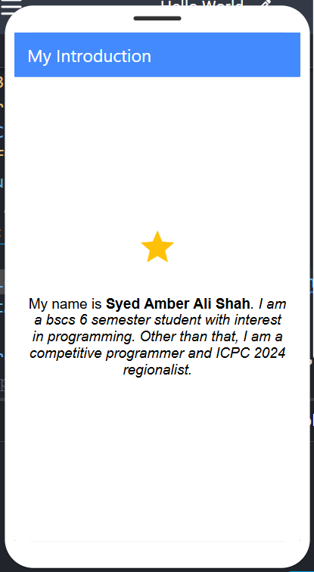

**THE END**