# DME Testplan

## Goal

This testplan will test the DME for all positive and negative functionality of the DME.

## Scope

The testplan will cover the following operations for both success and failure scenarios:

* Register Client
* Get AppInst List
* Find Cloudlet
* Platform Find Cloudlet
* Get App Official FQDN
* Get FQDN List
* Verify Location
* Get Location
* Show Device
* Show Device Report

## Register Client

The following call flows and testcases will be tested for Register Client.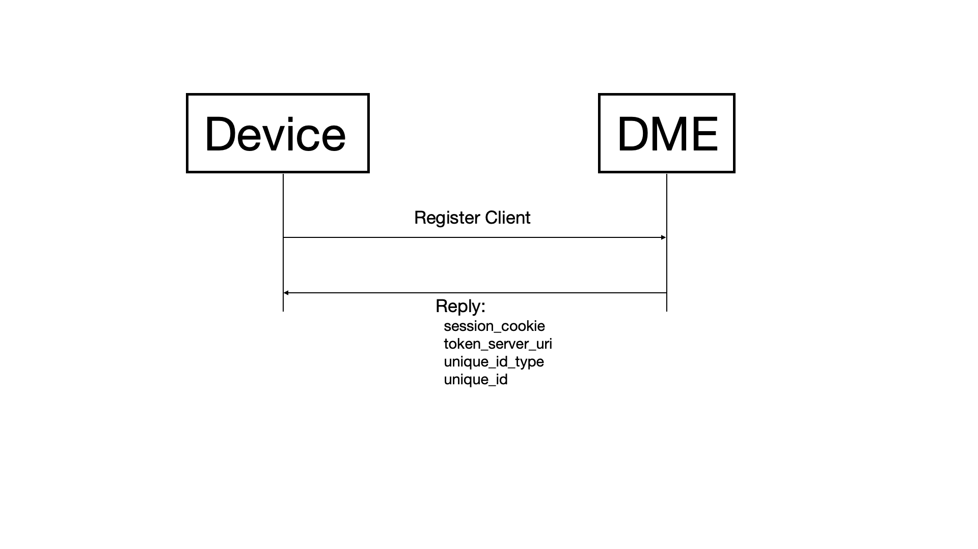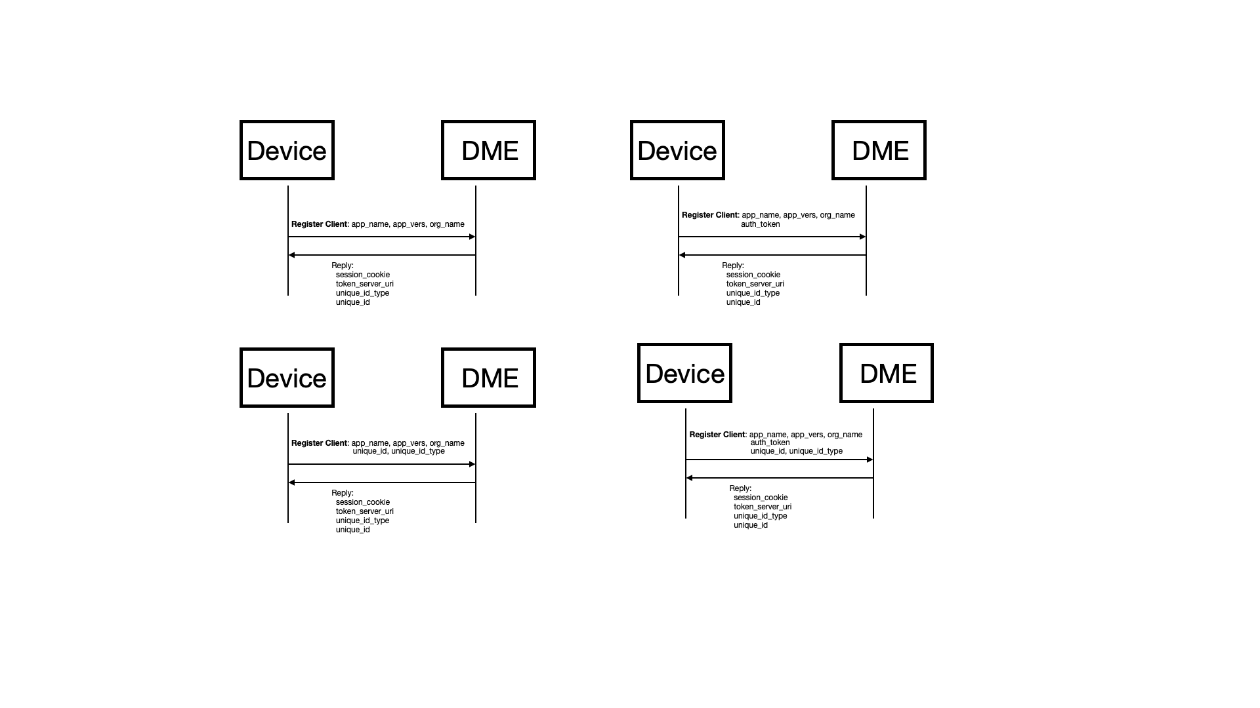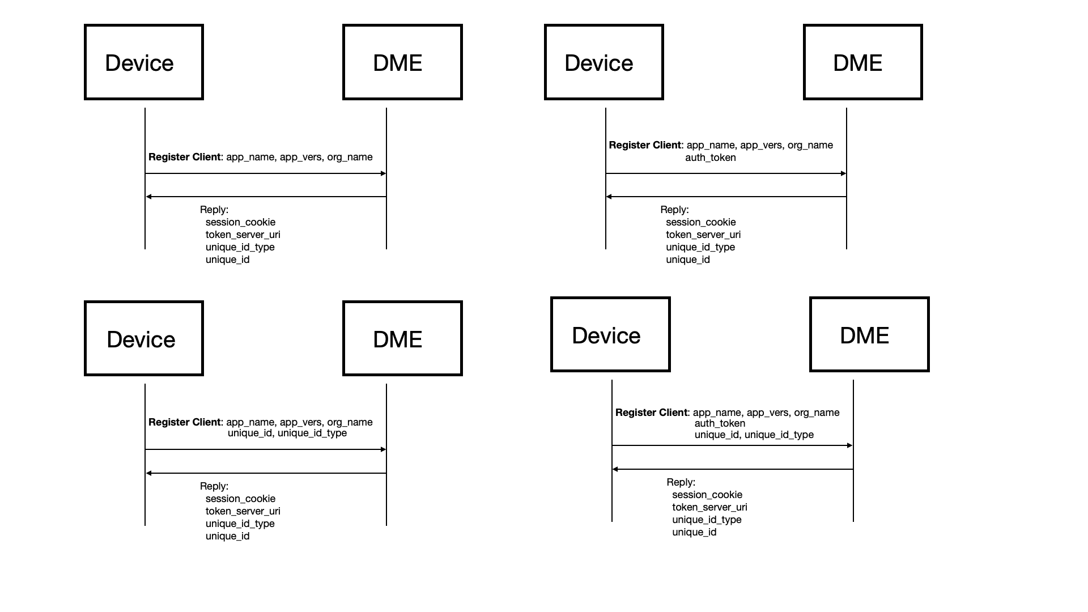

| RegisterClient Testcases | |
| --- | --- |
| Name | Description |
| RegisterClient - request without auth shall return proper JWT | Send RegisterClient without auth token to register a client for an app that doesnt contains an authpublickey  Verify returned JWT is correct |
| RegisterClient - request with wrong app_name shall return 'app not found' | send RegisterClient with app name that does not exist  verify 'app not found' error is received |
| RegisterClient - request with wrong app_version shall return 'app not found' | send RegisterClient with app name that exists but wrong app version  verify 'app not found' error is received |
| RegisterClient - request with wrong developer_name shall return 'app not found' | send RegisterClient with app name that exists but wrong developer  verify 'app not found' error is received |
| RegisterClient - request with wrong app_name,app_version, and developer_name shall return 'app not found' | send RegisterClient with app name, app version and developer that doenst exist  verify 'app not found' error is received |
| RegisterClient - request shall succeed after adding app | send RegisterClient with app that does not exist  verify 'app not found' is received  provision everything but an app  send RegisterClient again  verify 'app not found' is received since app inst is not added yet  provision app inst  send RegisgterClient again  register succeeds |
| RegisterClient - request with auth shall return proper JWT for deployment=docker | Send RegisterClient with auth token to register a client for an app that contains an authpublickey  Verify returned JWT is correct |
| RegisterClient - request with auth shall return proper JWT for deployment=kubernetes | Send RegisterClient with auth token to register a client for an app that contains an authpublickey  Verify returned JWT is correct |
| RegisterClient - request with auth shall return proper JWT for deployment=vm | Send RegisterClient with auth token to register a client for an app that contains an authpublickey  Verify returned JWT is correct |
| RegisterClient - request for app without authpublickey shall return 'No authkey found to validate token' | send RegisterClient with for app with no authpublickey  verify 'No authkey found to validate token' is received |
| RegisterClient - request with invalid version in token shall return 'failed to verify token - token appvers mismatch' | send RegisterClient with wrong app version  verify 'failed to verify token - token appvers mismatch' is received |
| RegisterClient - request with invalid appname in token shall return 'failed to verify token - token appname mismatch' | send RegisterClient with wrong app name  verify 'failed to verify token - token appname mismatch' is received |
| RegisterClient - request with invalid devname in token shall return 'failed to verify token - token developer mismatch' | send RegisterClient with wrong developer name  verify 'failed to verify token - token developer mismatch' |
| RegisterClient - request with invalid token shall return 'failed to verify token - token contains an invalid number of segments' | send RegisterClient with wrong auth token  verify 'failed to verify token - token contains an invalid number of segments' is received |
| RegisterClient - request with expired token shall return 'failed to verify token - token is expired' | generate at token  send RegisterClient with the token which should pass  wait 70secs and send RegisterClient again with the same token  verify 'failed to verify token - token is expired' is received |
| RegisterClient - request with app_name only shall return 'DevName cannot be empty' | Send RegisterClient with app_name only  Verify 'DevName cannot be empty' is returned |
| RegisterClient - request with app_version only shall return 'DevName cannot be empty' | Send RegisterClient with app_version only  Verify 'DevName cannot be empty' is returned |
| RegisterClient - request with developer name only shall return 'AppName cannot be empty' | Send RegisterClient with developer name only  Verify 'AppName cannot be empty' is returned |
| RegisterClient - request without developer name shall return 'DevName cannot be empty' | Send RegisterClient without developer name  Verify 'DevName cannot be empty' is returned |
| RegisterClient - request without app version shall return 'AppVers cannot be empty' | Send RegisterClient without app version  Verify 'AppVers cannot be empty' is returned |
| RegisterClient - request without app name shall return 'AppName cannot be empty' | Send RegisterClient without app_name  Verify 'AppName cannot be empty' is returned |
| RegisterClient - request without authtoken for app with token shall return 'No authtoken received' | Send RegisterClient without authtoken for app that does not have a public key  Verify 'No authtoken received' is returned |
| RegisterClient - register shall work when keep creating/deleting same app instance | Create app instance  register client  delete/readd app instance  register client again to same app instance  repeat 10 times |
| RegisterClient - request without id and type shall return device information | registerClient with samsung app without unique_id and typ  verify returns id and type |
| RegisterClient - request without id shall return error | registerClient with samsung app without id  verify returns error |
| RegisterClient - request with id and type shall return empty unique_id and type | registerClient with samsung app with unique_id and type  verify returns empty id and type |
| RegisterClient - request with id and type and auth shall return device information | registerClient with samsung app with unique_id and type and auth  verify returns id and type |

## Get AppInst List

The following call flow and testcases will be tested for Get AppInst List.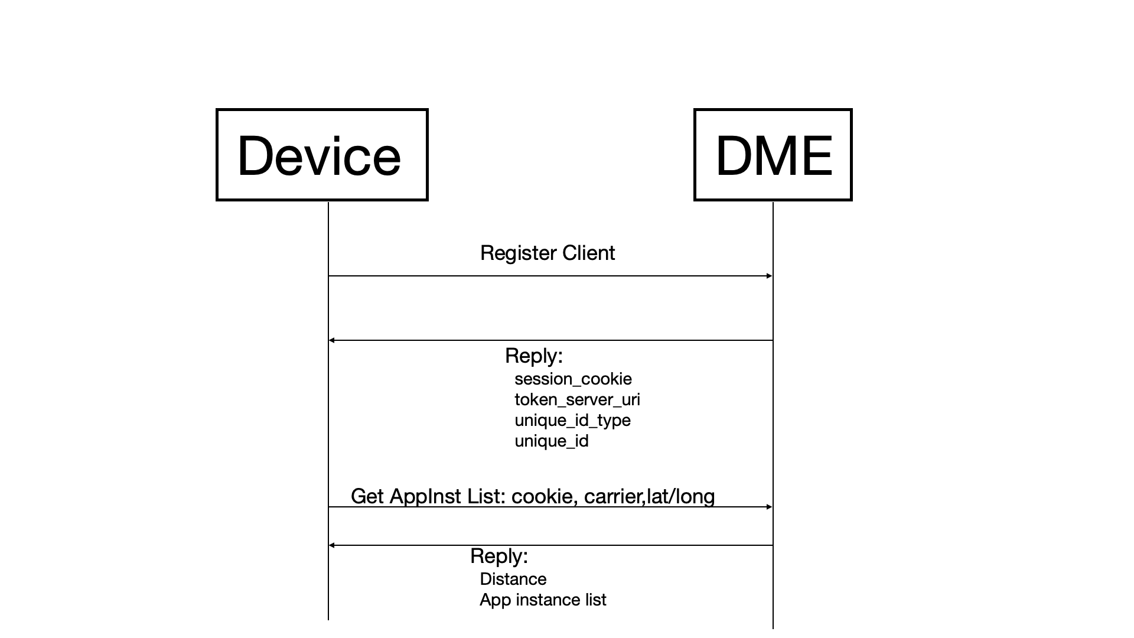

| Get AppInst List Testcases | |
| --- | --- |
| Name | Description |
| GetAppInstList - request with no app instance shall return 0 app | registerClient against app with no app instance  send GetAppInstList for 0 app  verify returns 0 result |
| GetAppInstList - request shall return 10 cloudlets | registerClient  send GetAppInstList for 10 cloudlets  verify returns 10 cloudlets |
| GetAppInstList - request shall return 1 app | registerClient  send GetAppInstList for 1 app  verify returns 1 result |
| GetAppInstList - request shall return only app that matches carrier | registerClient  send GetAppInstList for 1 app  verify returns only appinst that matches carrier |
| GetAppInstList - request shall return app with mulitple ports | registerClient  send GetAppInstList for app with multiple ports  verify returns 1 result with multiple ports |
| GetAppInstList - request shall return azure app | add azure app  registerClient  send GetAppInstList for azure app  verify returns azure result |
| GetAppInstList - request without cookie should return 'missing cookie' | Send GetAppInstList without a session cookie  verify 'missing cookie' error is received |
| GetAppInstList - request with invalid cookie of x should return 'token contains an invalid number of segments' | Send getAppInstList with session cookie of 'x'  verify 'token contains an invalid number of segments' error is received |
| GetAppInstList - request with invalid cookie of x.x.x should return 'illegal base64 data at input byte 1' with invalid cookie | Send GetAppInstList with session cookie of 'x.x.x'  verify 'illegal base64 data at input byte 1' error is received |
| GetAppInstList - request with truncated cookie should return 'VerifyCookie failed: Invalid cookie, no key' | Send GetAppInstList with parital session cookie  verify 'VerifyCookie failed: Invalid cookie, no key' error is received |
| GetAppInstList - request with expired cookie should return 'token is expired by' | Send GetAppInstList with expired session cookie  verify 'token is expired by' error is received |
| GetAppInstList - request shall not return default cloudlet apps | create an appinst with cloudlet_name=tmocloud-2 and operator_name=tmus  create an appinst with cloudlet_name=default and operator_name=developer  registerClient  send GetAppInstList  verify returns only tmocloud-2 app and not default cloudlet app |
| GetAppInstList - request shall return GCP app | add GCP app  registerClient  send GetAppInstList for GCP app  verify returns GCP result |
| GetAppInstList - request shall fail with no GPS coords | registerClient  send GetAppInstList with no GPS coord  verify returns missing GPS location" |
| GetAppInstList - request shall return app with no ports | registerClient  send GetAppInstList for app with no ports  verify returns 1 result without ports section |
| GetAppInstList - request without carriername shall return 3 apps | registerClient  send GetAppInstList without carrier name  verify returns 3 result |
| GetAppInstList - request without carriername and large limit shall return all apps | registerClient  send GetAppInstList without carrier name and large limit  verify returns 3 result |
| GetAppInstList - request without carriername and limit shall return right apps | registerClient  send GetAppInstList with limit  verify returns right number of apps |
| GetAppInstList - request with invalid limit shall return error | registerClient  send GetAppInstList with invalid limit  verify returns right error |
| GetAppInstList - request with opertor code mapping shall return 1 app | registerClient  send GetAppInstList with operator code for 1 app  verify returns 1 result |

## Find Cloudlet

The following call flow and testcases will be tested for Find Cloudlet.

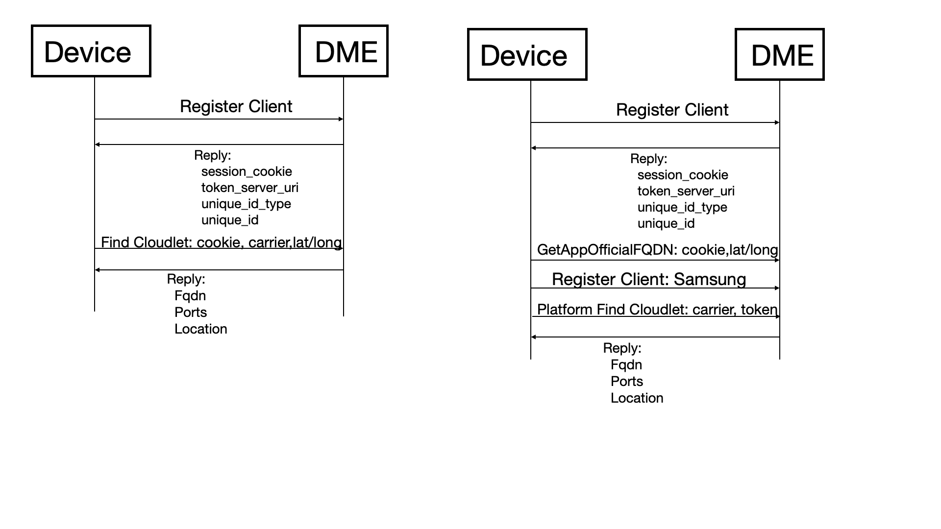

| FindCloudlet Testcases | |
| --- | --- |
| Name | Description |
| FindCloudlet - findCloudlet shall return azure with with azure cloudlet provisioned and closer by more than 100km | findCloudlet with tmus and azure. tmus farther but greater than 100km from azure - return azure  tmus tmocloud-2 cloudlet at: 35 -95  azure azurecloud-1 cloudlet at: 37 -95  find cloudlet closest to : 37 -96  239.89km from tmus  88.80km from azure  azure is closer by 151.09km which is more than 100km closer. return azure cloudlet  ShowCloudlet  - key:  operatorkey:  name: tmus  name: tmocloud-2  location:  lat: 35  long: -95  - key:  operatorkey:  name: azure  name: azurecloud-1  location:  lat: 37  long: -95 |
| FindCloudlet - request shall return azure with tmus and gcp/azure cloudlet provisioned and tmus farther and > 100km than azure and gcp and azure closer than gcp | findCloudlet with tmus/gcp/azure provisioned. tmus farther than 100km from azure/gcp. azure closer than gcp by more than 100km. return azure  tmus tmocloud-2 cloudlet at: 35 -95  gcp gcpcloud-1 cloudlet at: 38 -96  azure azurecloud-1 cloudlet at: 37 -95  find cloudlet closest to : 37 -96  239.89km from tmus  111.19km from gcp  88.80km from azure  azure is closer by 151.09km which is more than 100km closer. return azure cloudlet  gcp is closer by 128.70km which is greater than 100km closer  ShowCloudlet  - key:  operatorkey:  name: tmus  name: tmocloud-2  location:  lat: 35  long: -95  - key:  operatorkey:  name: azure  name: azurecloud-1  location:  lat: 37  long: -95  - key:  operatorkey:  name: gcp  name: gcpcloud-1  location:  lat: 38  long: -96 |
| FindCloudlet - request shall return azure with tmus and gcp/azure cloudlet provisioned and tmus farther but > 100km than azure and < 100km than gcp and azure closer than gcp | findCloudlet with tmus/azure/gcp provisioned. tmus farther than azure/gcp. tmus > 100km than azure. tmus < 100km than gcp. azure closer than gcp. return azure  tmus tmocloud-2 cloudlet at: 35 -95  gcp gcpcloud-1 cloudlet at: 36 -95  azure azurecloud-1 cloudlet at: 37 -95  find cloudlet closest to : 37 -96  239.89km from tmus  142.67km from gcp  88.80km from azure  azure is closer by 151.09km which is more than 100km closer. return azure cloudlet  gcp is closer by 97.22km which is less than 100km closer  ShowCloudlet  - key:  operatorkey:  name: tmus  name: tmocloud-2  location:  lat: 35  long: -95  - key:  operatorkey:  name: azure  name: azurecloud-1  location:  lat: 37  long: -95  - key:  operatorkey:  name: gcp  name: gcpcloud-1  location:  lat: 36  long: -95 |
| FindCloudlet - request shall return azure with tmus and gcp/azure cloudlet provisioned and requesting azure | findCloudlet with tmus/gcp/azure provisioned. request azure. return azure  tmus tmocloud-2 cloudlet at: 35 -95  gcp gcpcloud-1 cloudlet at: 36 -95  azure azurecloud-1 cloudlet at: 37 -95  find cloudlet closest to : 36 -96  143.38km from tmus  89.96km from gcp  142.67km from azure  tmus farther than gcp/azure but less than 100km closer. return azure cloudlet since requesting azure  ShowCloudlet  - key:  operatorkey:  name: tmus  name: tmocloud-2  location:  lat: 35  long: -95  - key:  operatorkey:  name: azure  name: azurecloud-1  location:  lat: 37  long: -95  - key:  operatorkey:  name: gcp  name: gcpcloud-1  location:  lat: 36  long: -95 |
| FindCloudlet - request without cookie should return 'missing cookie' | Send FindCloudlet without a session cookie  verify 'missing cookie' error is received |
| FindCloudlet - request with invalid cookie of x should return 'token contains an invalid number of segments' | Send FindCloudlet with session cookie of 'x'  verify 'token contains an invalid number of segments' error is received |
| FindCloudlet - request with invalid cookie of x.x.x should return 'illegal base64 data at input byte 1' with invalid cookie | Send FindCloudlet with session cookie of 'x.x.x'  verify 'illegal base64 data at input byte 1' error is received |
| FindCloudlet - request with truncated cookie should return 'VerifyCookie failed: Invalid cookie, no key' | Send FindCloudlet with parital session cookie  verify 'VerifyCookie failed: Invalid cookie, no key' error is received |
| FindCloudlet - request with expired cookie should return 'token is expired by' | Send FindCloudlet with expired session cookie  verify 'token is expired by' error is received |
| FindCloudlet - request without cookie should return 'missing cookie' | Send FindCloudlet without a session cookie  verify 'missing cookie' error is received |
| FindCloudlet - request with invalid cookie of x should return 'token contains an invalid number of segments' | Send FindCloudlet with session cookie of 'x'  verify 'token contains an invalid number of segments' error is received |
| FindCloudlet - request with invalid cookie of x.x.x should return 'illegal base64 data at input byte 1' with invalid cookie | Send FindCloudlet with session cookie of 'x.x.x'  verify 'illegal base64 data at input byte 1' error is received |
| FindCloudlet - request with truncated cookie should return 'VerifyCookie failed: Invalid cookie, no key' | Send FindCloudlet with parital session cookie  verify 'VerifyCookie failed: Invalid cookie, no key' error is received |
| FindCloudlet - request with expired cookie should return 'token is expired by' | Send FindCloudlet with expired session cookie  verify 'token is expired by' error is received |
| FindCloudlet - request shall return gcp with tmus and gcp/azure cloudlet provisioned and tmus farther and > 100km from gcp and azure and gcp closer than azure | findCloudlet with tmus/gcp/azure provisioned. tmus >100km than azure/gcp. gcp closer than azure. return gcp  tmus tmocloud-2 cloudlet at: 35 -95  azure azurecloud-1 cloudlet at: 38 -96  gcp gcpcloud-1 cloudlet at: 37 -95  find cloudlet closest to : 37 -96  239.89km from tmus  111.19km from azure  88.80km from gcp  gcp is closer by 151.09km which is more than 100km closer. return gcp cloudlet  azure is closer by 128.70km which is greater than 100km closer  ShowCloudlet  - key:  operatorkey:  name: tmus  name: tmocloud-2  location:  lat: 35  long: -95  - key:  operatorkey:  name: gcp  name: gcpcloud-1  location:  lat: 37  long: -95  - key:  operatorkey:  name: azure  name: azurecloud-1  location:  lat: 38  long: -96 |
| FindCloudlet - request shall return gcp with tmus farther and > 100km farther than gcp | findCloudlet with gcp closer by more than 100km. return gcp  tmus tmocloud-2 cloudlet at: 35 -95  gcp gcpcloud-1 cloudlet at: 37 -95  find cloudlet closest to : 37 -96  239.89km from tmus  88.80km from gcp  gcp is closer by 151.09km which is more than 100km closer. return gcp cloudlet  ShowCloudlet  - key:  operatorkey:  name: tmus  name: tmocloud-2  location:  lat: 35  long: -95  - key:  operatorkey:  name: gcp  name: gcpcloud-1  location:  lat: 37  long: -95 |
| FindCloudlet - request shall return gcp with tmus and gcp/azure cloudlet provisioned and tmus farther and > 100km than gcp and < 100km than azure and gcp closer than azure | findCloudlet with tmus/gcp/azure provisioned. tmus farther than gcp and azure. tmus > 100km than gcp. tmus < 100km than azure. gcp closer than azure. return gcp  tmus tmocloud-2 cloudlet at: 35 -95  azure azurecloud-1 cloudlet at: 36 -95  gcp gcpcloud-1 cloudlet at: 37 -95  find cloudlet closest to : 37 -96  239.89km from tmus  142.67km from azure  88.80km from gcp  gcp is closer by 151.09km which is more than 100km closer. return gcp cloudlet  azure is closer by 97.22km which is less than 100km closer  ShowCloudlet  - key:  operatorkey:  name: tmus  name: tmocloud-2  location:  lat: 35  long: -95  - key:  operatorkey:  name: gcp  name: gcpcloud-1  location:  lat: 37  long: -95  - key:  operatorkey:  name: azure  name: azurecloud-1  location:  lat: 36  long: -95 |
| FindCloudlet - request shall return gcp with tmus and gcp/azure cloudlet provisioned and requesting gcp | findCloudlet with tmus/gcp/azure provisioned. request gcp. return gcp  tmus tmocloud-2 cloudlet at: 35 -95  gcp gcpcloud-1 cloudlet at: 36 -95  azure azurecloud-1 cloudlet at: 37 -95  find cloudlet closest to : 36 -96  143.38km from tmus  89.96km from gcp  142.67km from azure  tmus farther than gcp/azure but less than 100km closer. return gcp cloudlet since requesting gcp  ShowCloudlet  - key:  operatorkey:  name: tmus  name: tmocloud-2  location:  lat: 35  long: -95  - key:  operatorkey:  name: azure  name: azurecloud-1  location:  lat: 37  long: -95  - key:  operatorkey:  name: gcp  name: gcpcloud-1  location:  lat: 36  long: -95 |
| FindCloudlet - request with too small latitude should return 'Invalid GpsLocation' | send FindCloudlet with latitude of -91  verify 'Invalid GpsLocation' is received |
| FindCloudlet - request with too large latitude should return 'Invalid GpsLocation' | send FindCloudlet with latitude of 91  verify 'Invalid GpsLocation' is received |
| FindCloudlet - request with too small longitude should return 'Invalid GpsLocation' | send FindCloudlet with longitude of -181  verify 'Invalid GpsLocation' is received |
| FindCloudlet - request with too large longitude should return 'Invalid GpsLocation' | send FindCloudlet with longitude of 181  verify 'Invalid GpsLocation' is received |
| FindCloudlet - request with out-of-range latitude/longitude should return 'Invalid GpsLocation' | send FindCloudlet with latitude=99999999999999999 and longitude of -99999999999999999  verify 'Invalid GpsLocation' is received |
| FindCloudlet - request without lat/long should return 'Missing GpsLocation' | send FindCloudlet with no latitude or longitude  verify 'Missing GpsLocation' is received |
| FindCloudlet - request with latitude only should return error | send FindCloudlet with latitude only  verify proper error is received |
| FindCloudlet - request with longitude only should return error | send FindCloudlet with longitude only  verify proper error is received |
| FindCloudlet - request with carrier_name and latitude only should fail | send FindCloudlet with carrier name and latitude only  verify error is received |
| FindCloudlet - request with carrier_name and longitude only should fail | send FindCloudlet with carrier name and longitude only  verify error is received |
| FindCloudlet - findCloudlet without carrier shall return cloudlet regardless of carrier | findCloudlet without carrier name and with att and tmus and azure.  verify returns each appinst based on location only  tmus tmocloud-2 cloudlet at: 35 -95  azure azurecloud-1 cloudlet at: 37 -95  find cloudlet closest to : 37 -96  239.89km from tmus  88.80km from azure  azure is closer by 151.09km which is more than 100km closer. return azure cloudlet  ShowCloudlet  - key:  operatorkey:  name: tmus  name: tmocloud-2  location:  lat: 35  long: -95  - key:  operatorkey:  name: azure  name: azurecloud-1  location:  lat: 37  long: -95 |
| FindCloudlet Samsung - findCloudlet shall return azure with with azure cloudlet provisioned and closer by more than 100km | registerClient  getAppOfficialFqdn  registerClient with samsung app  platformFindCloudlet with token. tmus farther but greater than 100km from azure - return azure  tmus tmocloud-2 cloudlet at: 35 -95  azure azurecloud-1 cloudlet at: 37 -95  find cloudlet closest to : 37 -96  239.89km from tmus  88.80km from azure  azure is closer by 151.09km which is more than 100km closer. return azure cloudlet  ShowCloudlet  - key:  operatorkey:  name: tmus  name: tmocloud-2  location:  lat: 35  long: -95  - key:  operatorkey:  name: azure  name: azurecloud-1  location:  lat: 37  long: -95 |
| FindCloudlet Samsung - request shall return gcp with tmus farther and > 100km farther than gcp | registerClient  getAppOfficialFqdn  registerClient with samsung app  platformFindCloudlet with token and gcp closer by more than 100km. return gcp  tmus tmocloud-2 cloudlet at: 35 -95  gcp gcpcloud-1 cloudlet at: 37 -95  find cloudlet closest to : 37 -96  239.89km from tmus  88.80km from gcp  gcp is closer by 151.09km which is more than 100km closer. return gcp cloudlet  ShowCloudlet  - key:  operatorkey:  name: tmus  name: tmocloud-2  location:  lat: 35  long: -95  - key:  operatorkey:  name: gcp  name: gcpcloud-1  location:  lat: 37  long: -95 |
| FindCloudlet Samsung - request shall return tmus with azure cloudlet provisioned and tmus closer and > 100km from request | registerClient  getAppOfficialFqdn  registerClient with samsung app  platforFindCloudlet with token and tmus and azure provisioned. tmus closer and > 100km from request. return tmus  tmus tmocloud-2 cloudlet at: 35 -95  azure azurecloud-1 cloudlet at: 37 -95  find cloudlet closest to : 34 -96  144.09km from tmus  345.64km from azure  tmus closer than azure. return tmus cloudlet  ShowCloudlet  - key:  operatorkey:  name: tmus  name: tmocloud-2  location:  lat: 35  long: -95  - key:  operatorkey:  name: azure  name: azurecloud-1  location:  lat: 37  long: -95 |
| FindCloudlet Samsung - request shall return tmus with gcp/azure cloudlet provisioned and tmus closer and < 100km from request | registerClient  getAppOfficialFqdn  registerClient with samsung app  send platformFindcloudlet with token and tmus/gcp/azure provisioned. tmus closer and < 100km from request. return tmus  tmus tmocloud-2 cloudlet at: 35 -95  gcp gcpcloud-1 cloudlet at: 37 -94  azure azurecloud-1 cloudlet at: 37 -95  find cloudlet closest to : 35 -94  91.09km from tmus  222.39km from gcp  239.89km from azure  tmus closer than gcp/azure. return tmus cloudlet  ShowCloudlet  - key:  operatorkey:  name: tmus  name: tmocloud-2  location:  lat: 35  long: -95  - key:  operatorkey:  name: azure  name: azurecloud-1  location:  lat: 37  long: -95  - key:  operatorkey:  name: gcp  name: gcpcloud-1  location:  lat: 37  long: -94 |
| FindCloudlet Samsung - request shall return tmus with gcp cloudlet provisioned and tmus closer and < 100km from request | registerClient  getAppOfficialFqdn  registerClient with samsung app  platformFindCloudlet with token and with tmus and gcp. tmus closer and < 100km from request - return tmus  tmus tmocloud-2 cloudlet at: 35 -95  gcp gcpcloud-1 cloudlet at: 37 -95  find cloudlet closest to : 35 -94  91.09km from tmus  239.89km from gcp  tmus closer than and gcp but less than 100km. return tmus cloudlet  ShowCloudlet  - key:  operatorkey:  name: tmus  name: tmocloud-2  location:  lat: 35  long: -95  - key:  operatorkey:  name: gcp  name: gcpcloud-1  location:  lat: 37  long: -95 |
| FindCloudlet REST - request with timestamp shall return tmus | findCloudlet rest with tmus and azure provisioned. tmus closer and > 100km from request. return tmus  tmus tmocloud-2 cloudlet at: 35 -95  azure azurecloud-1 cloudlet at: 37 -95  find cloudlet closest to : 34 -96  144.09km from tmus  345.64km from azure  tmus closer than azure. return tmus cloudlet  ShowCloudlet  - key:  operatorkey:  name: tmus  name: tmocloud-2  location:  lat: 35  long: -95  - key:  operatorkey:  name: azure  name: azurecloud-1  location:  lat: 37  long: -95 |
| FindCloudlet - request shall return tmus with azure cloudlet closer but no appinst provisioned | findCloudlet with tmus and azure provisioned but not appinst provisioned for azure. return tmus  tmus tmocloud-2 cloudlet at: 35 -95  azure azurecloud-1 cloudlet at: 37 -95  find cloudlet closest to : 37 -96  239.89km from tmus  88.80km from azure  azure is closer by 151.09km which is more than 100km closer. return tmus cloudlet since no azure appinst  ShowCloudlet  - key:  operatorkey:  name: tmus  name: tmocloud-2  location:  lat: 35  long: -95  - key:  operatorkey:  name: azure  name: azurecloud-1  location:  lat: 37  long: -95 |
| FindCloudlet - request shall return tmus with no gcp/azure provisioned ond same coord as tmocloud-1 | send findCloudlet with same coord as tmocloud-1 and no gcp/azure provisioned. return tmocloud-1 |
| FindCloudlet - request shall return tmus with no gcp/azure provisioned ond same coord as tmocloud-1 | send findCloudlet with same coord as tmocloud-1 and no gcp/azure provisioned. return tmocloud-1 |
| FindCloudlet - request shall return FIND_NOT_FOUND when requesting an operator that doesnt exist | send findCloudlet with an operator that does not exist. return 'FIND_NOTFOUND' |
| FindCloudlet - request shall return tmus with gcp cloudlet closer but no appinst provisioned | findCloudlet with with gcp closer by more than 100km but not appinst provisioned. return tmus  tmus tmocloud-2 cloudlet at: 35 -95  gcp gcpcloud-1 cloudlet at: 37 -95  find cloudlet closest to : 37 -96  239.89km from tmus  88.80km from gcp  gcp is closer by 151.09km which is more than 100km closer. return tmus cloudlet since no gcp appinst  ShowCloudlet  - key:  operatorkey:  name: tmus  name: tmocloud-2  location:  lat: 35  long: -95  - key:  operatorkey:  name: gcp  name: gcpcloud-1  location:  lat: 37  long: -95 |
| FindCloudlet - request shall return proper cloudlet when multiple cloudlets exist | findCloudlet with 10 tmus and 1 azure/gcp cloudlet provisioned. verify returns proper cloudlet  tmus tmocloud-1 cloudlet at: 31 -91  tmus tmocloud-2 cloudlet at: 35 -95  tmus tmocloud-3 cloudlet at: 35 -96  tmus tmocloud-4 cloudlet at: 35 -97  tmus tmocloud-5 cloudlet at: 35 -98  tmus tmocloud-6 cloudlet at: 35 -99  tmus tmocloud-7 cloudlet at: 35 -100  tmus tmocloud-8 cloudlet at: 35 -101  tmus tmocloud-9 cloudlet at: 35 -102  tmus tmocloud-10 cloudlet at: 35 -103  azure azurecloud-1 cloudlet at: 35 -93  gcp gcpcloud-1 cloudlet at: 35 -105  find cloudlet closest to : 31 -91  find cloudlet closest to : 35 -92  find cloudlet closest to : 35 -93  find cloudlet closest to : 35 -94  find cloudlet closest to : 35 -95  find cloudlet closest to : 35 -96  find cloudlet closest to : 35 -97  find cloudlet closest to : 35 -98  find cloudlet closest to : 35 -99  find cloudlet closest to : 35 -100  find cloudlet closest to : 35 -101  find cloudlet closest to : 35 -102  find cloudlet closest to : 35 -103  find cloudlet closest to : 35 -104  find cloudlet closest to : 35 -105  find cloudlet closest to : 35 -106  find cloudlet closest to : 35 -107 |
| FindCloudlet - request shall return tmus with no gcp/azure provisioned ond same coord as tmocloud-1 | send findCloudlet with same coord as tmocloud-1 and no gcp/azure provisioned. return tmocloud-1 |
| FindCloudlet - request shall return tmus with no gcp/azure provisioned ond same coord as tmocloud-2 | send findCloudlet with same coord as tmocloud-2 and no gcp/azure provisioned. return tmocloud-2 |
| FindCloudlet - request shall return tmus with no gcp/azure provisioned ond coord closer to tmocloud-1 | send findCloudlet with coord closer to tmocloud-1 and no gcp/azure provisioned. return tmocloud-1 |
| FindCloudlet - request shall return tmus with no gcp/azure provisioned ond coord closer to tmocloud-2 | send findCloudlet with coord closer to tmocloud-2 and no gcp/azure provisioned. return tmocloud-2 |
| FindCloudlet - request shall return tmus with no gcp/azure provisioned ond coord of max distance | send findCloudlet with coord of max distance and no gcp/azure provisioned. return tmocloud-1 |
| FindCloudlet - request shall return tmus with no gcp/azure provisioned ond coord of min distance | send findCloudlet with coord of min distance and no gcp/azure provisioned. return tmocloud-1 |
| FindCloudlet - request shall return tmus with azure cloudlet provisioned and tmus and azure same coord | findCloudlet with tmus and azure provisioned. tmus and azure same coord. return tmus  tmus tmocloud-2 cloudlet at: 35 -95  azure azurecloud-1 cloudlet at: 35 -95  find cloudlet closest to : 36 -95  111.19km from tmus  111.19km from azure  tmus and azure are same coord/distance. return tmus cloudlet  ShowCloudlet  - key:  operatorkey:  name: tmus  name: tmocloud-2  location:  lat: 35  long: -95  - key:  operatorkey:  name: azure  name: azurecloud-1  location:  lat: 35  long: -95 |
| FindCloudlet shall return tmus with azure cloudlet provisioned and tmus and azure same distance | findCloudlet with tmus and azure provisioned. tmus and azure same distance from request. return tmus  tmus tmocloud-2 cloudlet at: 35 -95  azure azurecloud-1 cloudlet at: 37 -95  find cloudlet closest to : 36 -95  111.19km from tmus  111.19km from azure  tmus and azure are same distance. return tmus cloudlet  ShowCloudlet  - key:  operatorkey:  name: tmus  name: tmocloud-2  location:  lat: 35  long: -95  - key:  operatorkey:  name: azure  name: azurecloud-1  location:  lat: 37  long: -95 |
| FindCloudlet - request shall return tmus with azure cloudlet provisioned and tmus closer and > 100km from request | findCloudlet with tmus and azure provisioned. tmus closer and > 100km from request. return tmus  tmus tmocloud-2 cloudlet at: 35 -95  azure azurecloud-1 cloudlet at: 37 -95  find cloudlet closest to : 34 -96  144.09km from tmus  345.64km from azure  tmus closer than azure. return tmus cloudlet  ShowCloudlet  - key:  operatorkey:  name: tmus  name: tmocloud-2  location:  lat: 35  long: -95  - key:  operatorkey:  name: azure  name: azurecloud-1  location:  lat: 37  long: -95 |
| FindCloudlet - request shall return tmus with azure cloudlet provisioned and tmus closer and < 100km from request | findcloudlet with tmus and azure. tmus closer and < 100km from request. return tumus  tmus tmocloud-2 cloudlet at: 35 -95  azure azurecloud-1 cloudlet at: 37 -95  find cloudlet closest to : 35 -94  91.09km from tmus  239.89km from azure  tmus closer than azure. return tmus cloudlet  ShowCloudlet  - key:  operatorkey:  name: tmus  name: tmocloud-2  location:  lat: 35  long: -95  - key:  operatorkey:  name: azure  name: azurecloud-1  location:  lat: 37  long: -95 |
| FindCloudlet - request shall return tmus with gcp/azure cloudlet provisioned and tmus closer and > 100km from request | send findcloudlet with tmus/gcp/azure provisioned. tmus closer and > 100km from request. return tmus  tmus tmocloud-2 cloudlet at: 35 -95  gcp tmocloud-2 cloudlet at: 37 -94  azure tmocloud-2 cloudlet at: 37 -95  find cloudlet closest to : 34 -96  144.09km from tmus  379.52km from gcp  345.64km from azure  tmus closer than gcp/azure. return tmus cloudlet  ShowCloudlet  - key:  operatorkey:  name: tmus  name: tmocloud-2  location:  lat: 35  long: -95  - key:  operatorkey:  name: azure  name: tmocloud-2  location:  lat: 37  long: -95  - key:  operatorkey:  name: gcp  name: tmocloud-2  location:  lat: 37  long: -94 |
| FindCloudlet - request shall return tmus with gcp/azure cloudlet provisioned and tmus closer and < 100km from request | send findcloudlet with tmus/gcp/azure provisioned. tmus closer and < 100km from request. return tmus  tmus tmocloud-2 cloudlet at: 35 -95  gcp gcpcloud-1 cloudlet at: 37 -94  azure azurecloud-1 cloudlet at: 37 -95  find cloudlet closest to : 35 -94  91.09km from tmus  222.39km from gcp  239.89km from azure  tmus closer than gcp/azure. return tmus cloudlet  ShowCloudlet  - key:  operatorkey:  name: tmus  name: tmocloud-2  location:  lat: 35  long: -95  - key:  operatorkey:  name: azure  name: azurecloud-1  location:  lat: 37  long: -95  - key:  operatorkey:  name: gcp  name: gcpcloud-1  location:  lat: 37  long: -94 |
| FindCloudlet - request shall return tmus with gcp/azure cloudlet provisioned and tmus closer and with large distances | send findcloudlet with tmus/gcp/azure provisioned with large distances. tmus closer. return tmus  tmus tmocloud-2 cloudlet at: 35 -95  gcp gcpcloud-1 cloudlet at: 37 -94  azure azurecloud-1 cloudlet at: 37 -95  find cloudlet closest to : -90 -180  15006.44km from tmus  15226.61km from gcp  15228.78km from azure  tmus closer than gcp/azure. return tmus cloudlet  ShowCloudlet  - key:  operatorkey:  name: tmus  name: tmocloud-2  location:  lat: 35  long: -95  - key:  operatorkey:  name: azure  name: azurecloud-1  location:  lat: 37  long: -95  - key:  operatorkey:  name: gcp  name: gcpcloud-1  location:  lat: 37  long: -94 |
| FindCloudlet - request shall return tmus with gcp cloudlet provisioned and tmus closer and > 100km from request | findCloudlet with with tmus and gcp. tmus closer and > 100km from request. return tmus  tmus tmocloud-2 cloudlet at: 35 -95  gcp gcpcloud-1 cloudlet at: 37 -95  find cloudlet closest to : 34 -96  144.09km from tmus  345.64km from gcp  tmus closer than gcp. return tmus cloudlet  ShowCloudlet  - key:  operatorkey:  name: tmus  name: tmocloud-2  location:  lat: 35  long: -95  - key:  operatorkey:  name: gcp  name: gcpcloud-1  location:  lat: 37  long: -95 |
| FindCloudlet - request shall return tmus with gcp cloudlet provisioned and tmus closer and < 100km from request | findCloudlet with with tmus and gcp. tmus closer and < 100km from request - return tmus  tmus tmocloud-2 cloudlet at: 35 -95  gcp gcpcloud-1 cloudlet at: 37 -95  find cloudlet closest to : 35 -94  91.09km from tmus  239.89km from gcp  tmus closer than and gcp but less than 100km. return tmus cloudlet  ShowCloudlet  - key:  operatorkey:  name: tmus  name: tmocloud-2  location:  lat: 35  long: -95  - key:  operatorkey:  name: gcp  name: gcpcloud-1  location:  lat: 37  long: -95 |
| FindCloudlet - request shall return tmus with azure cloudlet provisioned and tmus farther but < 100km than azure | send findcloudlet request with tmus/azure provisioned. tmus farther but < 100km than azure. return tmus  tmus tmocloud-2 cloudlet at: 35 -95  azure azurecloud-1 cloudlet at: 37 -95  find cloudlet closest to : 36 -96  143.38km from tmus  142.67km from azure  tmus farther than azure but less than 100km closer. return tmus cloudlet  ShowCloudlet  - key:  operatorkey:  name: tmus  name: tmocloud-2  location:  lat: 35  long: -95  - key:  operatorkey:  name: azure  name: azurecloud-1  location:  lat: 37  long: -95 |
| FindCloudlet - request shall return tmus with gcp/azure cloudlet provisioned and tmus farther but < 100km from gcp/azure | send findcloudlet request with tmus/gcp/azure provisioned. tmus farther but < 100km from gcp/azure. return tmus  tmus tmocloud-2 cloudlet at: 35 -95  gcp gcpcloud-1 cloudlet at: 36 -95  azure azurecloud-1 cloudlet at: 37 -95  find cloudlet closest to : 36 -96  143.38km from tmus  89.96km from gcp  142.67km from azure  tmus farther than gcp/azure but less than 100km closer. return tmus cloudlet  ShowCloudlet  - key:  operatorkey:  name: tmus  name: tmocloud-2  location:  lat: 35  long: -95  - key:  operatorkey:  name: azure  name: azurecloud-1  location:  lat: 37  long: -95  - key:  operatorkey:  name: gcp  name: gcpcloud-1  location:  lat: 36  long: -95 |
| FindCloudlet - request shall return tmus with gcp cloudlet provisioned and tmus farther but < 100km than gcp | findCloudlet with with tmus and gcp. tmus farther but < 100km from request. return tmus  tmus tmocloud-2 cloudlet at: 35 -95  gcp gcpcloud-1 cloudlet at: 37 -95  find cloudlet closest to : 36 -96  143.38km from tmus  142.67km from gcp  tmus farther than gcp but less than 100km closer. return tmus cloudlet  ShowCloudlet  - key:  operatorkey:  name: tmus  name: tmocloud-2  location:  lat: 35  long: -95  - key:  operatorkey:  name: gcp  name: gcpcloud-1  location:  lat: 37  long: -95 |
| FindCloudlet - request shall return tmus with azure/gcp cloudlet provisioned and tmus/azure/gcp same coord | send findCloudlet with with tmus and gcp and azure set to the same coord  tmus tmocloud-2 cloudlet at: 35 -95  gcp gcpcloud-1 cloudlet at: 35 -95  azure azurecloud-1 cloudlet at: 35 -95  find cloudlet closest to : 36 -95  111.19km from tmus  111.19km from gcp  111.19km from azure  tmus and gcp are same coord/distance. return tmus cloudlet  ShowCloudlet  - key:  operatorkey:  name: tmus  name: tmocloud-2  location:  lat: 35  long: -95  - key:  operatorkey:  name: gcp  name: gcpcloud-1  location:  lat: 35  long: -95  - key:  operatorkey:  name: azure  name: azurecloud-1  location:  lat: 35  long: -95 |
| FindCloudlet - request shall return tmus with gcp cloudlet provisioned and tmus and gcp same coord | findCloudlet with with tmus and gcp same coord. return tmus  tmus tmocloud-2 cloudlet at: 35 -95  gcp gcpcloud-1 cloudlet at: 35 -95  find cloudlet closest to : 36 -95  111.19km from tmus  111.19km from gcp  tmus and gcp are same coord/distance. return tmus cloudlet  ShowCloudlet  - key:  operatorkey:  name: tmus  name: tmocloud-2  location:  lat: 35  long: -95  - key:  operatorkey:  name: gcp  name: gcpcloud-1  location:  lat: 35  long: -95 |
| FindCloudlet - request shall return tmus with gcp cloudlet provisioned and tmus and gcp same distance away | findCloudlet with with tmus and gcp same distance. return tmus  tmus tmocloud-2 cloudlet at: 35 -95  gcp gcpcloud-1 cloudlet at: 37 -95  find cloudlet closest to : 36 -95  111.19km from tmus  111.19km from gcp  tmus and gcp are same distance. return tmus cloudlet  ShowCloudlet  - key:  operatorkey:  name: tmus  name: tmocloud-2  location:  lat: 35  long: -95  - key:  operatorkey:  name: gcp  name: gcpcloud-1  location:  lat: 37  long: -95 |
| GetAppOfficialFqdn - request without cookie shall return error | send GetAppOfficialFqdn without cookie  verify proper error is received |
| GetAppOfficialFqdn - request with bad cookie shall return error | send GetAppOfficialFqdn with bad cookie  verify proper error is received |
| GetAppOfficialFqdn - request with invalid lat/long shall return error | send GetAppOfficialFqdn with invalid lat/long  verify proper error is received |
| PlatformFindCloudlet - request without cookie shall return error | send PlatformFindCloudlet without cookie  verify proper error is received |
| PlatformFindCloudlet - request with bad cookie shall return error | send PlatformFindCloudlet with bad cookie  verify proper error is received |
| PlatformFindCloudlet - request with bad client_token shall return error | send PlatformFindCloudlet with bad client_token  verify proper error is received |
| PlatformFindCloudlet - request with non-samsung session cookie shall return error | send PlatformFindCloudlet with non-samsung session cookie  verify proper error is received |

## Get FQDN List

The following call flow and testcases will be tested for Get FQDN List.

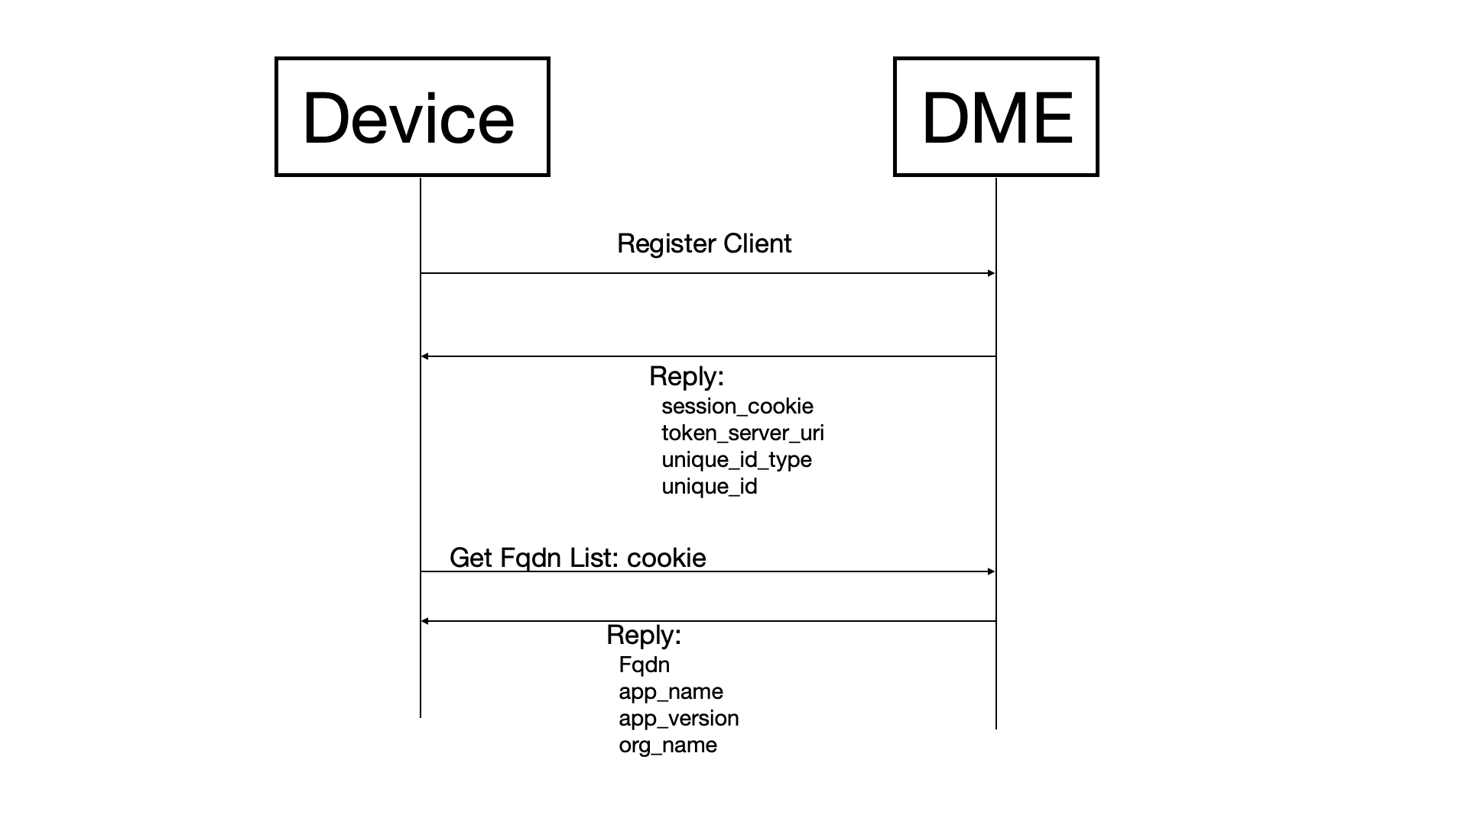

## Verify Location

The following call flow and testcases will be tested for Verify Location.

| Get FQDN List Testcases | |
| --- | --- |
| Name | Description |
| GetFqdnList - request shall return 0 apps | registerClient with samsung app  send GetFqdnList for 0 apps  verify returns empty result |
| GetFqdnList - request for apps with permits_platform_apps=False shall return 0 apps | registerClient with samsung app  send GetFqdnList for 0 apps since permits_platform_apps=False  verify returns empty result |
| GetFqdnList - request for apps with no permits_platform_apps shall return 0 apps | registerClient with samsung app  send GetFqdnList for 0 apps since permits_platform_apps parm is not set  verify returns empty result |
| GetFqdnList - request shall return 10 apps | registerClient with samsung app  send GetFqdnList for 10 apps  verify returns 10 results |
| GetFqdnList - request shall return 1 app | registerClient with samsung app  send GetFqdnList for 1 app  verify returns 1 result |
| GetFqdnList - request without cookie should return 'missing cookie' | Send GetFqdnList without a session cookie  verify 'missing cookie' error is received |
| GetFqdnList - request with invalid cookie of x should return 'token contains an invalid number of segments' | Send getFqdnList with session cookie of 'x'  verify 'token contains an invalid number of segments' error is received |
| GetFqdnList - request with invalid cookie of x.x.x should return 'illegal base64 data at input byte 1' with invalid cookie | Send GetFqdnList with session cookie of 'x.x.x'  verify 'illegal base64 data at input byte 1' error is received |
| GetFqdnList - request with truncated cookie should return 'VerifyCookie failed: Invalid cookie, no key' | Send GetFqdnList with parital session cookie  verify 'VerifyCookie failed: Invalid cookie, no key' error is received |
| GetFqdnList - request with expired cookie should return 'token is expired by' | Send FindCloudlet with expired session cookie  verify 'token is expired by' error is received |
| GetFqdnList - request fqdnlist for non-samsung app should fail | register client for non-samsung app  Send GetFqdnList  verify 'API Not allowed for developer' error is received |
| GetFqdnList - request shall only return apps with permits_platform_apps=True | registerClient with samsung app  send GetFqdnList  verify only returns apps with permits_platform_apps=True |

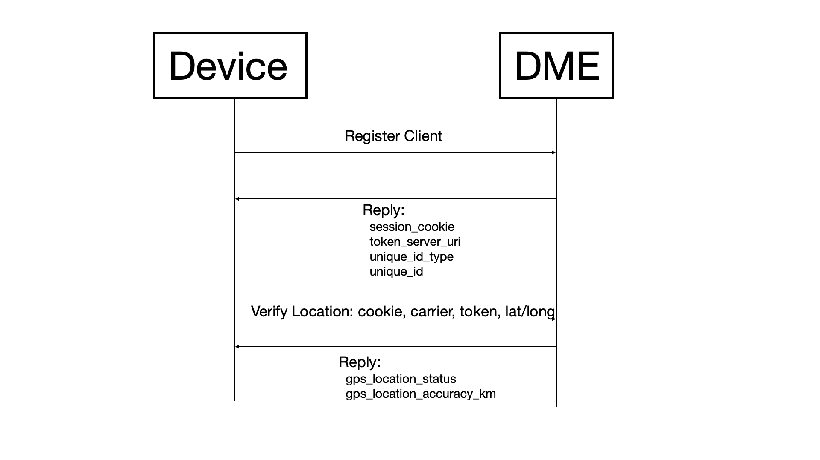

| Verify Location Testcases | |
| --- | --- |
| Name | Description |
| VerifyLocation - request with coord barely > 10km and < 100km shall return LOC_VERIFIED of 100km | update location to Berlin  send VerifyLocatoin with coord barely over 10km away from Berlin  Berlin at 52.52,13.4050 and verifyLocation at 52.61,13.4050. distance of 10.01 KM  verify return LOC_VERIFIED of 100km |
| VerifyLocation - request with coord > 10km and < 100km shall return LOC_VERIFIED of 100km | update location to Berlin  send VerifyLocatoin with coord < 100km away.  Berlin at 52.52,13.4050 and verifyLocation at 53.41,13.4050. distance of 98.96 KM  verify return LOC_VERIFIED of 100KM |
| VerifyLocation - request with coord barely > 2km and < 10km shall return LOC_VERIFIED of 10km | update location to Berlin  send VerifyLocatoin with coord barely over 2km away from Berlin  Berlin at 52.52,13.4050 and verifyLocation at 52.54,13.4050. distance of 2.22 KM  verify return LOC_VERIFIED of 10km |
| VerifyLocation - request with coord > 2km and < 10km shall return LOC_VERIFIED of 10km | update location to Berlin  send VerifyLocatoin with coord < 10km away.  Berlin at 52.52,13.4050 and verifyLocation at 52.609,13.4050. distance of 9.90 KM  verify return LOC_VERIFIED of 10KM |
| VerifyLocation - request with same coord shall return LOC_VERIFIED of 2KM | update location to Berlin  send VerifyLocatoin with same coord as Berlin  verify return LOC_VERIFIED of 2KM |
| VerifyLocation - request within < 2KM shall return LOC_VERIFIED of 2KM | update location to Berlin  send VerifyLocatoin with coord < 2km away.  mobile at 52.52,13.4050 and verifyLocation at 52.53,13.4050. distance of 1.11 KM  verify return LOC_VERIFIED of 2KM |
| VerifyLocation - request with bad token shall return LOC_ERROR_UNAUTHORIZED | send VerifyLocatoin with token=xx  verify return LOC_ERROR_UNAUTHORIZED |
| VerifyLocation - request with empty token shall return 'verifyloc token required' | send VerifyLocatoin with empty token  verify return 'verifyloc token required' |
| VerifyLocation REST - request with bad token shall return LOC_ERROR_UNAUTHORIZED | send VerifyLocatoin with token=xx  verify return LOC_ERROR_UNAUTHORIZED |
| VerifyLocation REST - request with empty token shall return 'verifyloc token required' | send VerifyLocatoin with empty token  verify return 'verifyloc token required' |
| VerifyLocation - request with carrier not found should pass | send VerifyLocation with carrier that does not exist  verify request passes |
| VerifyLocation - request with bad session cookie shall return app not found | send VerifyLocatoin with session cookie with an app that does not exist  verify return LOC_VERIFIED of 2KM |
| VerifyLocation - request without cookie should return 'missing cookie' | Send VerifyLocation without a session cookie  verify 'missing cookie' error is received |
| VerifyLocation - request with invalid cookie of x should return 'token contains an invalid number of segments' | Send VerifyLocation with session cookie of 'x'  verify 'token contains an invalid number of segments' error is received |
| VerifyLocation - request with invalid cookie of x.x.x should return 'illegal base64 data at input byte 1' with invalid cookie | Send VerifyLocation with session cookie of 'x.x.x'  verify 'illegal base64 data at input byte 1' error is received |
| VerifyLocation - request with truncated cookie should return 'VerifyCookie failed: Invalid cookie, no key' | Send VerifyLocation with parital session cookie  verify 'VerifyCookie failed: Invalid cookie, no key' error is received |
| VerifyLocation - request with expired cookie should return 'token is expired by' | Send VerifyLocation with expired session cookie  verify 'token is expired by' error is received |
| VerifyLocation - request claiming to be home but actually in neighboring country shall return LOC_MISMATCH_OTHER_COUNTRY | update location to Warsaw, Poland  send VerifyLocatoin with coord in Berlin  verify return LOC_MISMATCH_OTHER_COUNTRY |
| VerifyLocation - request claiming to be home but actually overseas shall return LOC_MISMATCH_OTHER_COUNTRY | update location to Allen, TX  send VerifyLocatoin with coord in Berlin  verify return LOC_MISMATCH_OTHER_COUNTRY |
| VerifyLocation - request claiming to be in neighboring country but actually home shall return LOC_ROAMING_COUNTRY_MISMATCH | update location to Berlin  send VerifyLocatoin with coord in Warsaw, Poland  verify return LOC_ROAMING_COUNTRY_MISMATCH |
| VerifyLocation - request claiming to be overseas but actually home shall return LOC_ROAMING_COUNTRY_MISMATCH | update location to Allen, TX  send VerifyLocatoin with coord in Berlin  verify return LOC_ROAMING_COUNTRY_MISMATCH |
| VerifyLocation - request claiming to be in neighboring country and actually there shall return LOC_ROAMING_COUNTRY_MATCH | update location to Warsaw  send VerifyLocatoin with coord in Warsaw, Poland  verify return LOC_ROAMING_COUNTRY_MATCH |
| VerifyLocation - request claiming to be overseas and actually there shall return LOC_ROAMING_COUNTRY_MATCH | update location to Allen, TX  send VerifyLocatoin with coord in Allen  verify return LOC_ROAMING_COUNTRY_MISMATCH |
| VerifyLocation - request with coord barely > 100km and still within country shall return LOC_MISMATCH_SAME_COUNTRY | update location to Berlin  send VerifyLocatoin with coord barely over 100km away from Berlin  Berlin at 52.52,13.4050 and verifyLocation at 53.42,13.4050. distance of 100.08 KM  verify return LOC_MISMATCH_SAME_COUNTRY |
| VerifyLocation - request with coord > 100km and within same country shall return LOC_MISMATCH_SAME_COUNTRY | update location to Berlin  send VerifyLocatoin with coord > 100km away.  Berlin at 52.52,13.4050 and verifyLocation at 50.73438 7.09549(Bonn, Germny).  verify return LOC_VERIFIED of 100KM |
| VerifyLocation - request with invalid low lat should return 'Invalid GpsLocation' | send VerifyLocation with latitude=-91  verify 'Invalid GpsLocation' is received |
| VerifyLocation - request with invalid high lat should return 'Invalid GpsLocation' | send VerifyLocation with latitude=91  verify 'Invalid GpsLocation' is received |
| VerifyLocation - request with invalid low long should return 'Invalid GpsLocation' | send VerifyLocation with longitude=-181  verify 'Invalid GpsLocation' is received |
| VerifyLocation - request with invalid high long should return 'Invalid GpsLocation' | send VerifyLocation with longitude=181  verify 'Invalid GpsLocation' is received |
| VerifyLocation - request without lat/long should return 'Missing GpsLocation' | send VerifyLocation with no latitude or longitude  verify 'Missing GpsLocation' is received |
| VerifyLocation - request without carrier should succeed | send VerifyLocation with no carrier  verify no error is received |
| VerifyLocation - request without token should return 'verifyloc token required' | send VerifyLocation with no token  verify 'verifyloc token required' is received |
| VerifyLocation - request with latitude only should not succeed | send VerifyLocation with carrier name and latitude only  verify error is received |
| VerifyLocation - request with longitude only should not succeed | send VerifyLocation with carrier name and longitude only  verify error is received |

## Get Location

The following call flow and testcases will be tested for Get Location.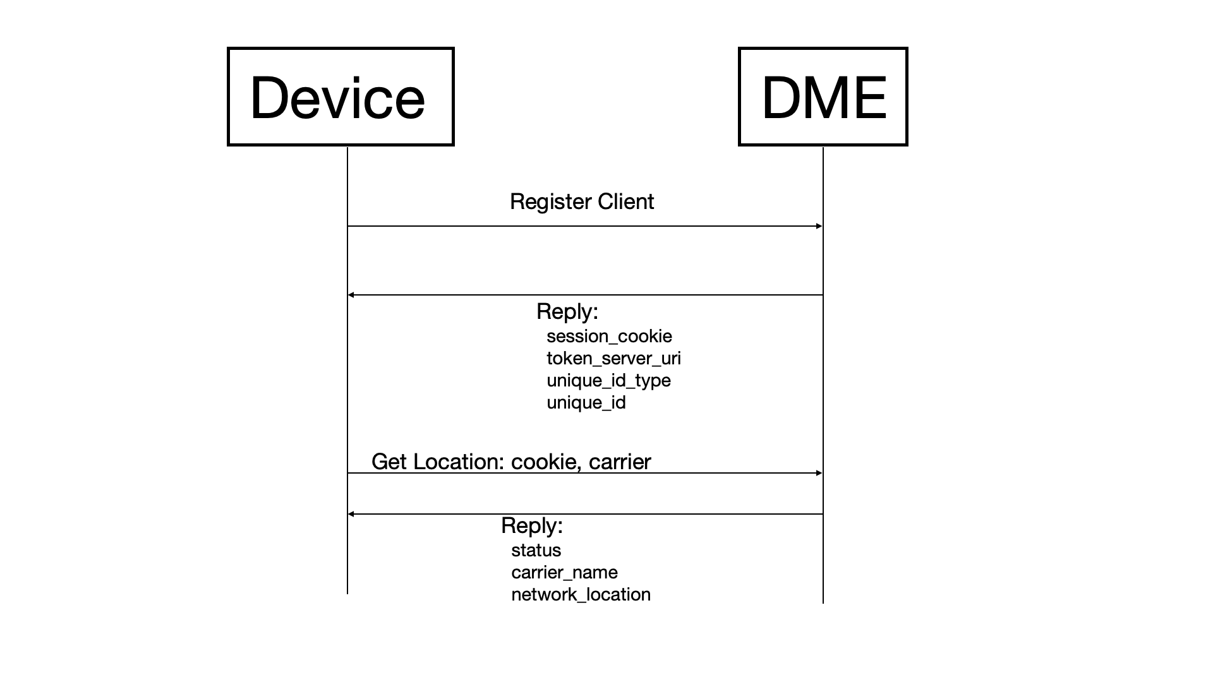

| Get Location Testcases | |
| --- | --- |
| Name | Description |
| GetLocation - request should return LOC_FOUND | send GetLocation  verify return LOC_FOUND |
| GetLocation - request without cookie should return 'missing cookie' | Send GetLocation without a session cookie  verify 'missing cookie' error is received |
| GetLocation - request with invalid cookie of x should return 'token contains an invalid number of segments' | Send GetLocation with session cookie of 'x'  verify 'token contains an invalid number of segments' error is received |
| GetLocation - request with invalid cookie of x.x.x should return 'illegal base64 data at input byte 1' with invalid cookie | Send GetLocation with session cookie of 'x.x.x'  verify 'illegal base64 data at input byte 1' error is received |
| GetLocation - request with truncated cookie should return 'VerifyCookie failed: Invalid cookie, no key' | Send GetLocation with parital session cookie  verify 'VerifyCookie failed: Invalid cookie, no key' error is received |
| GetLocation - request with expired cookie should return 'token is expired by' | Send GetLocation with expired session cookie  verify 'token is expired by' error is received |

## Show Device

The following call flow and testcases will be tested for Show Device.

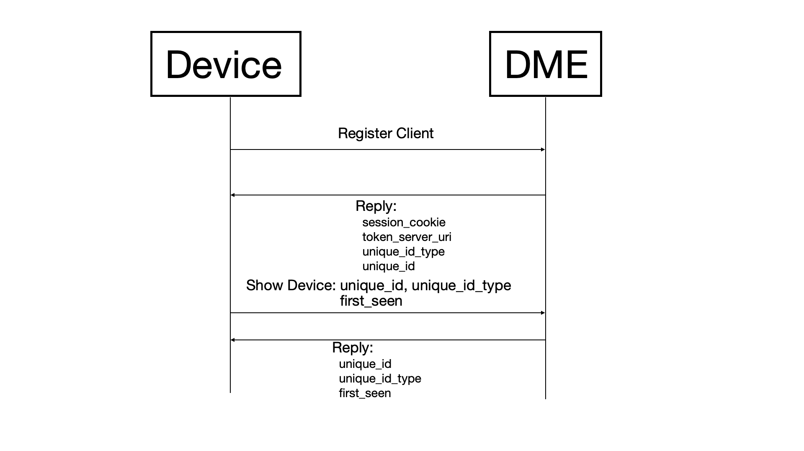

| Show Device Testcases | |
| --- | --- |
| Name | Description |
| showDevice - request with id and type shall return device information | registerClient with samsung app with unique_id and type  verify showDevice returns all information supported  key.uniqueidtype key.uniqueid firstseen.seconds firstseen.nanos lastseen.seconds lastseen.nanos and notify_id |
| showDevice - request with first_seen and seconds shall return device information | showDevice displays requested firstseen data  verify returns time of first_seen seconds requested  key.uniqueidtype key.uniqueid firstseen.seconds firstseen.nanos lastseen.seconds lastseen.nanos and notify_id |
| showDevice - request without first_seen_seconds shall return device information | showDevice displays firstseen data without requesting  verify showDevice returns first_seen device information  firstseen.seconds firstseen.nanos |
| showDevice - request with first_seen_nanos shall return device information | showDevice check display of first_seen_nanos  verify returns time of first_seen_nanos requested |
| showDevice - without first_seen_nanos shall return device information | showDevice check display of time_seen_nanos without specifying time  verify time_seen_nanos is displayed without being requested |
| showDevice - with notify_id shall return device information | showDevice check display of notify_id  verify notify_id is displayed as requested |
| showDevice - without notify_id shall return device information | showDevice check display of notify_id  verify notify_id is displayed without being requested |
| showDevice - request with bad token | showDevice verify error for bad token  verify no bearer token found |
| showDevice - request token error jwt | showDevice verify jwt error  verify invalid or expired jwt |

## Show Device Report

The following call flow and testcases will be tested for Show Device Report.

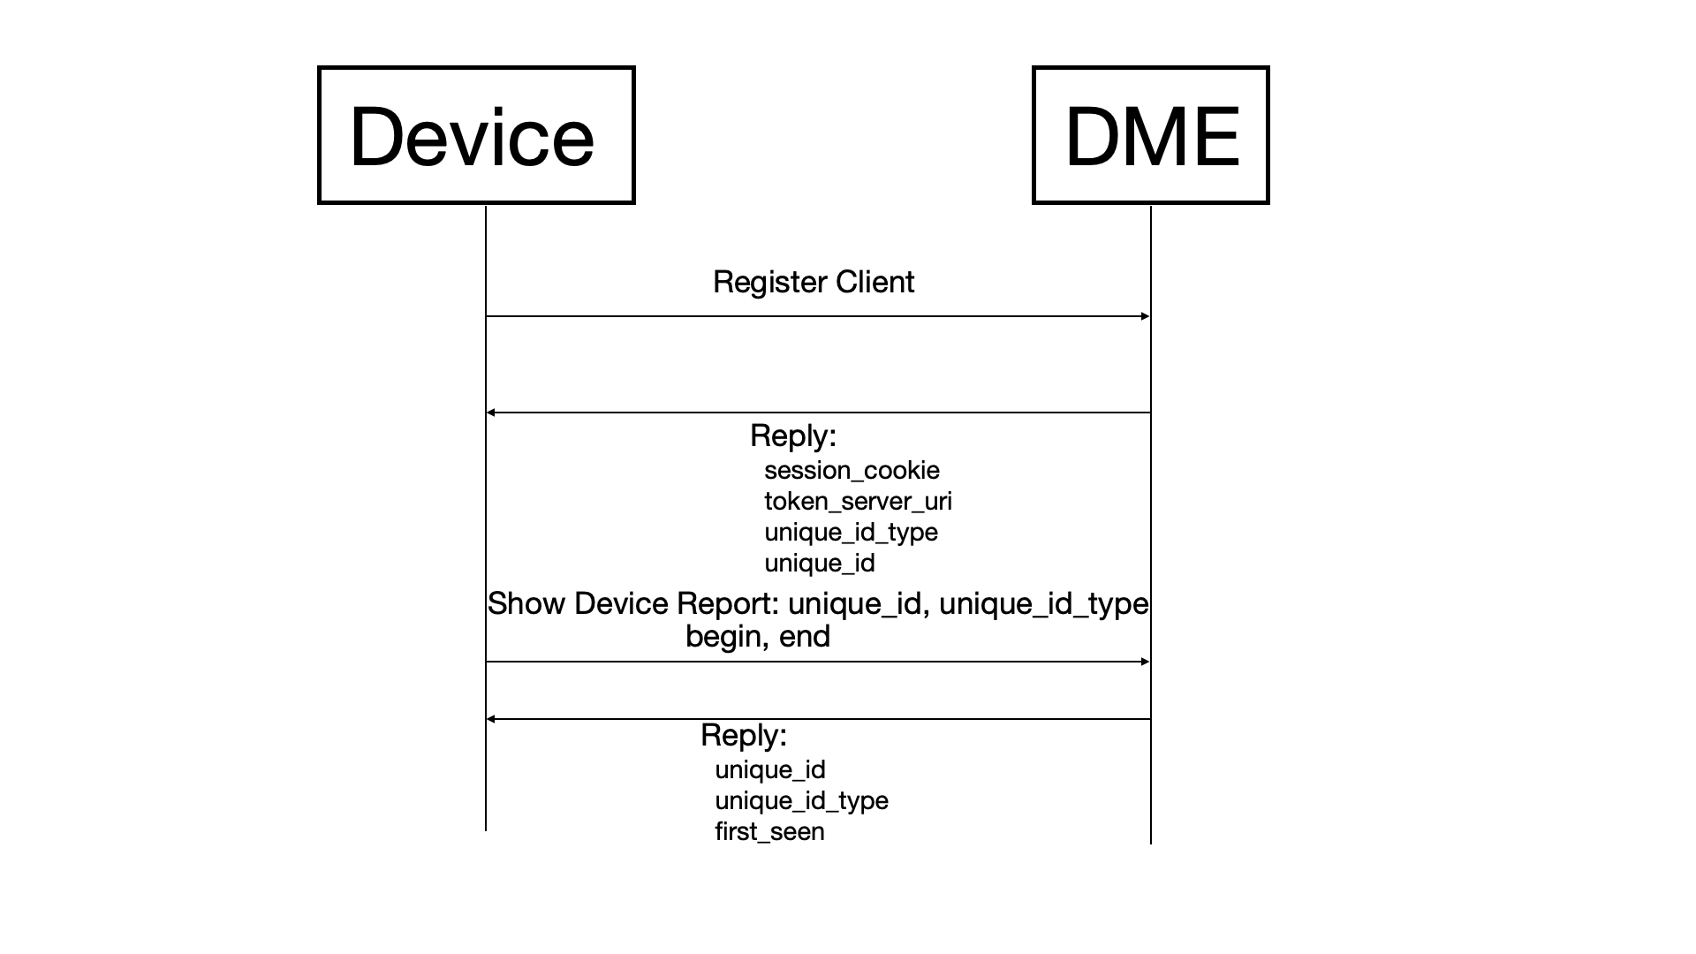

| Show Device Report Testcases | |
| --- | --- |
| Name | Description |
| showDeviceReport - request unique_id with only begin_nanos shall return device information | showDeviceReport returns uuid information  verify showDeviceReport returns uuid device information with only begin_nanos specified parameters |
| showDeviceReport - request unique_id unique_id_type begin_seconds and begin_nanos shall return specified device information | showDeviceReport returns uuid information using begin_seconds and begin_nanos  verify showDeviceReport returns uuid device information with unique_id unique_id_type begin_seconds and begin_nanos |
| showDeviceReport - request unique_id and unique_id_type with begin_nanos shall return device information | showDeviceReport returns uuid using only with unique_id and unique_id_type with begin_nanos  verify showDeviceReport returns uuid device information with unique_id and unique_id_type with begin_nanos |
| showDeviceReport - request with only begin_seconds and begin_nanos shall return device information | showDeviceReport returns uuid device information only using begin_seconds and begin_nanos  verify showDeviceReport returns uuid device information only using begin_seconds and begin_nanos |
| showDeviceReport - request uuid with only begin_nano shall return device information | showDeviceReport returns uuid device information using only begin_nanos  verify uuid information is returned using only begin_nanos |
| showDeviceReport - request uuid with only begin_seconds shall returns device information | showDeviceReport returns uuid device information with begin_seconds  verify returned uuid returns device information |
| showDeviceReport - request with only end_seconds and end_nanos shall return device information | showDeviceReport returns uuid device information with begin_seconds and begin_nanos  verify returned uuid returns device information with begin_seconds and begin_nanos |
| showDeviceReport - request with added time to end_seconds shall return device data | showDeviceReport returns uuid device information with unique_id end_seconds and end_nanos  verify returned uuid returns device information with unique_id end_seconds and end _nanos |
| showDeviceReport - request with added time to end_nanos shall return device data | showDeviceReport returns uuid device information with end_seconds and end_nanos  verify returned uuid returns device information with end_seconds and end _nanos |
| showDeviceReport - request with unique_id_type with end_seconds and end_nanos shall return device information | showDeviceReport display uuid using a specified unique_id_type end_seconds and end_nanos  verify returned uuid returns device information using a specified unique_id_type end_seconds and end_nanos |
| showDeviceReport - request with unique_id unique_id_type begin_seconds and begin_nanos shall return specified device information | showDeviceReport display uuid using a specified unique_id unique_id_type end_seconds and end_nanos  verify returned uuid returns device information using a specified unique_id unique_id_type end_seconds and end_nanos |
| showDeviceReport - request with bad token | showDevice verify error for bad token  verify no bearer token found |
| showDeviceReport - request token error jwt | showDevice verify jwt error  verify invalid or expired jwt |