1. XCode

1) Used Frameworks in Xcode

SystemConfiguration.framework

ExternalAccessory.framework

BRPtouchPrinterKit.framework

libc++.tbd

2)PronectName-info.plist

You need to insert the following information to info.plist in your Xcode project.

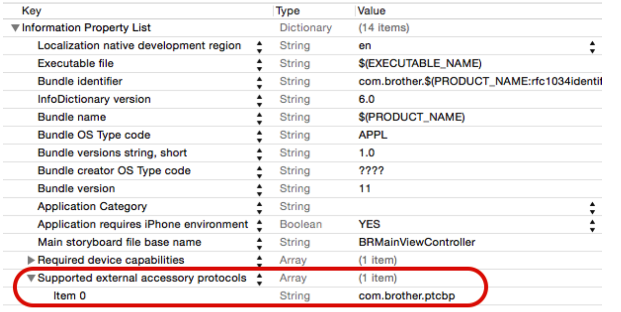

3) PrintList.plist

You need to insert the file in your Xcoe project.

When you insert the file, please select Group Create option in Add Dialog

1. Javascript
2. Please add following line confixg.xml

<feature name="BrotherPrinterPlugin">

<param name="ios-package" value="BrotherPrinterPlugin" />

<param name="onload" value="true" />

</feature>

1. Please add following line in index.html

<script type="text/javascript" src="brother-printer/printer.js"></script>

Please refer index.html and js/index.js

var Printer = new BrotherPrinterPlugin;

var printers = [];

var successPrint = function(data){

console.log(data);

};

var errorPrint = function(){

};

getPrinters.addEventListener('click', function() {

Printer.getPrinters(function(data){

printers = data;

},

function errorHandler(err){

console.log(err);

});

});

printer.addEventListener('click', function() {

var printOptions = {

device:'1',//1:WIFI, 0:Bluetooth

settings:printers[0],

pdfPath:'data/test/test.pdf',

success: successPrint, // success callback function, argument is a json string.

// parsed json format:

// {success: true}

error: errorPrint // error callback function, argument is a json string.

// parsed json format:

// {success: [boolean], available: [boolean], error: [string], dismissed: [boolean]}

};

alert(printOptions.settings.SelectedDeviceFromWiFi);

Printer.print(printOptions);

});

cancelPrinter.addEventListener('click', function() {

Printer.cancelPrint();

});