GSDA - Sine template-based gait detection algorithm

During normal walking, an acceleration signal, recorded using a lower back sensor, has a repeatable pattern in frequencies between 0.5-3.0 Hz. To minimize false detection of gait, the signal is band-passed filtered [0.5-3.0 Hz] to extract only the gait frequencies and to remove noises and harmonies of the walk. The next stage of the algorithm uses a running window of 3 seconds with 50% overlap on the vertical and anterior-posterior acceleration axes. The data from these windows is convolved with a 2 Hz sinusoidal signal that represents a cycle of gait in the filtered data. The resultant signal enables the detection of gait by searching for local maxima which represent one gait cycle. Only windows with 2–9 steps were considered as potential gait and only if detected at both axes. This range was chosen since gait typically takes place in the range of 0.5-3.0 Hz where 0.5 Hz reflects a stride every two seconds and 3.0 Hz reflects 3 steps every second.

Additional post-processing is used to make sure that the windows contain gait. The average value of the signal should be above 0.5 [g] for the vertical axis. Otherwise, the subject is not in a standing position (e.g. lying). To remove transitions such as stand-to-sit and sit-to-stand, the mean values of the first and last seconds are compared using 3 seconds windows. If the mean value of the last second deviates by more than 15% from the one in the first second, the window is marked as non-gait. In the final stage only walking bouts longer than 5 seconds are kept.

Algorithm input/output files structure

Mobilise-D standardized data structure format is depicted in figure 1 and elaborated at [1].

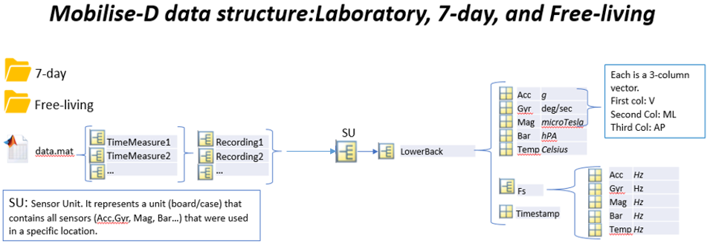

Figure 1: Mobilise-D standardized data structure.

The algorithm receives the input folder (where the "data.mat" file exists) and output folder to store the "GSDA_Output.mat" and "GSDA_Output.json" files that contain the gait sequence detection results. Figure 2 depicts an example of such GSDA_Output.mat output.

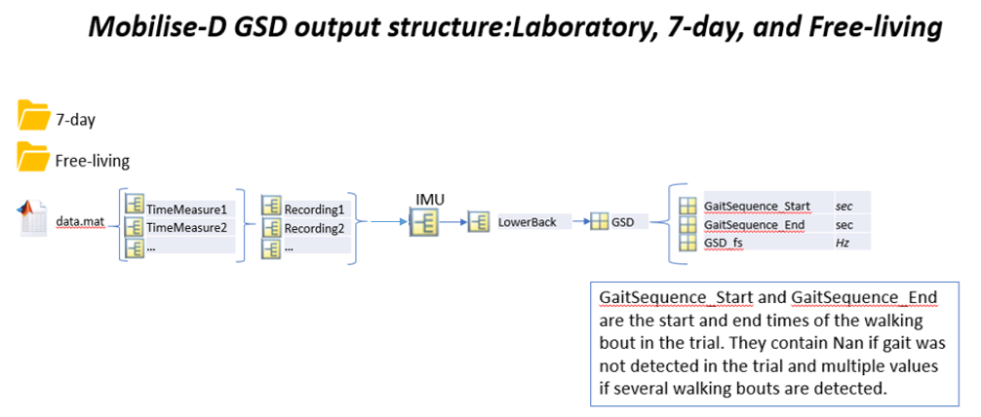

Figure 2: Mobilise-D standardized Gait Sequence Detection output structure

The folder contains an example of the expected output for running the code on the data.mat that is supplied with the code.

References

[1] Luca Palmerini et al, "Mobility recorded by wearable devices and gold standards: the Mobilise-D procedure for data standardization".

“Under review in Scientific Data”