MARITIME TRANSFORMATION PROGRAMME
Technical Approach Document
Sagar Drishti — AI Analytics Platform
The AI analytics companion to the operations platform: the analytics surface, the nine-agent analyst workforce, grounded and multilingual assistance, and the evidence behind every number — photographed from the running build.
Document control
Classification | CONFIDENTIAL — commercial in confidence
Version / Date | 1.0 · August 2026
Method | - Companion to the master Technical Approach Document (V15). Same evidence rules: run the software, photograph what runs, count what is countable.
Alignment | Target stack aligned to the Client's shared Azure platform architecture: Microsoft Foundry Agent Service AI layer, AKS microservices, ADLS Gen2 + AI Search data/AI foundation, Entra ID + UAE PASS identity, UAE North / UAE Central regions
Baseline evidence | A working 12-module maritime operations platform and a companion AI analytics portal (live demo available); production reference architecture on Azure in operation
Estimate status | Indicative delta engineering effort; to be confirmed in the detailed scoping phase (D0/D1)

How to read this document: every screenshot is of the running Sagar Drishti build over the same reference dataset as the master TAD; nothing is a mock-up. Where a capability depends on an external model or feed, the text says so plainly.

Contents
TOC \o "1-2" \h \z \u1. What Sagar Drishti is 1
2. Architecture 1
2.1 Shape 1
2.2 Honest boundaries 3
3. The analytics surface 3
4. The AI analyst workforce 8
5. Grounded, multilingual, spoken 10
6. The findings engine and its evidence 12
7. Security and governance 13
8. What Drishti evidences for the programme 13

1. What Sagar Drishti is
Sagar Drishti is the AI analytics companion to the operations platform this programme’s master document describes. Where the operations platform is the system of record — registers, lifecycles, audit — Sagar Drishti is the system of understanding: it reads the same operational world and turns it into benchmarked findings, ranked hotspots, anomaly watch, predictions, an autonomous analyst workforce, and a grounded assistant a harbour master can question in three languages, by keyboard or by voice.
The two applications are deliberately coupled only by a versioned data contract: the operations platform exports its deterministic world, Sagar Drishti ingests, analyses and explains it. Nothing in Drishti writes back to the system of record — analysis can never contaminate the register, and either side can evolve behind its contract. On the reference deployment that world is three and a half years of port operation: 1,224 vessel calls across 24 berths and ten terminals, incidents, inspections, revenue and crew — the same dataset every screenshot in the master document runs on.
What this document shows. Every screenshot is the running build. The analytics are computed by a deterministic engine whose numbers can be re-derived from the exported panels; the language around them — explanations, briefs, chat — is generated by a large language model that is permitted to phrase, but never to invent, the numbers. Where a capability needs an external model key or feed, the text says so.

2. Architecture

2.1 Shape
Layer | What it is
Frontend | React 18 single-page application (Vite) with Recharts for analytics, a Three.js 3D port twin, and full i18n in English, Hindi and Gujarati — the language switch is in the header of every screen, demonstrating the multilingual pattern the target platform carries to Arabic.
Backend | A FastAPI service: analytics endpoints over the ingested panels, the findings engine outputs, the agent workforce, retrieval-augmented research, guarded text-to-SQL, and JWT auth (12-hour tokens, PBKDF2-hashed passwords, per-user scopes such as a single terminal).
Data contract | A versioned export from the operations platform: the deterministic snapshot is parsed into four monthly panels — operations, marine, HSE, revenue — at port/zone/terminal/berth grain, plus vessel reliability and watchlist tables. The contract file documents the hierarchy and invariants; the ingestion agent rebuilds panels and analysis on demand.
Findings engine | A pure analytical pass over the panels emitting fifteen severity-ranked findings across seven areas — operations efficiency, hotspots, HSE, compliance, revenue, reliability, typology — each with the evidence rows and benchmark citations that produced it, written to a reviewable evidence pack.
AI layer | A deterministic grounding engine answers first; a large language model phrases and explains. Chart-bearing chat answers, executive briefs, work orders and the voice loop all run through the same grounding, and the QA agents test the pipeline continuously against the database ground truth.

2.2 Honest boundaries
- The AIS-style live picture, weather and third-party feeds are not present — Drishti analyses the exported operational world. Live-feed analytics arrive with the target platform’s NMC integrations.
- LLM-dependent surfaces (chat phrasing, briefs, research, voice replies) require a model key at runtime; without one, the deterministic engine still serves every number, chart and finding.
- Speech recognition is browser-native; the neural voice engine is an optional local service.

3. The analytics surface
The screenshots below are of the running build, signed in as the harbour master.
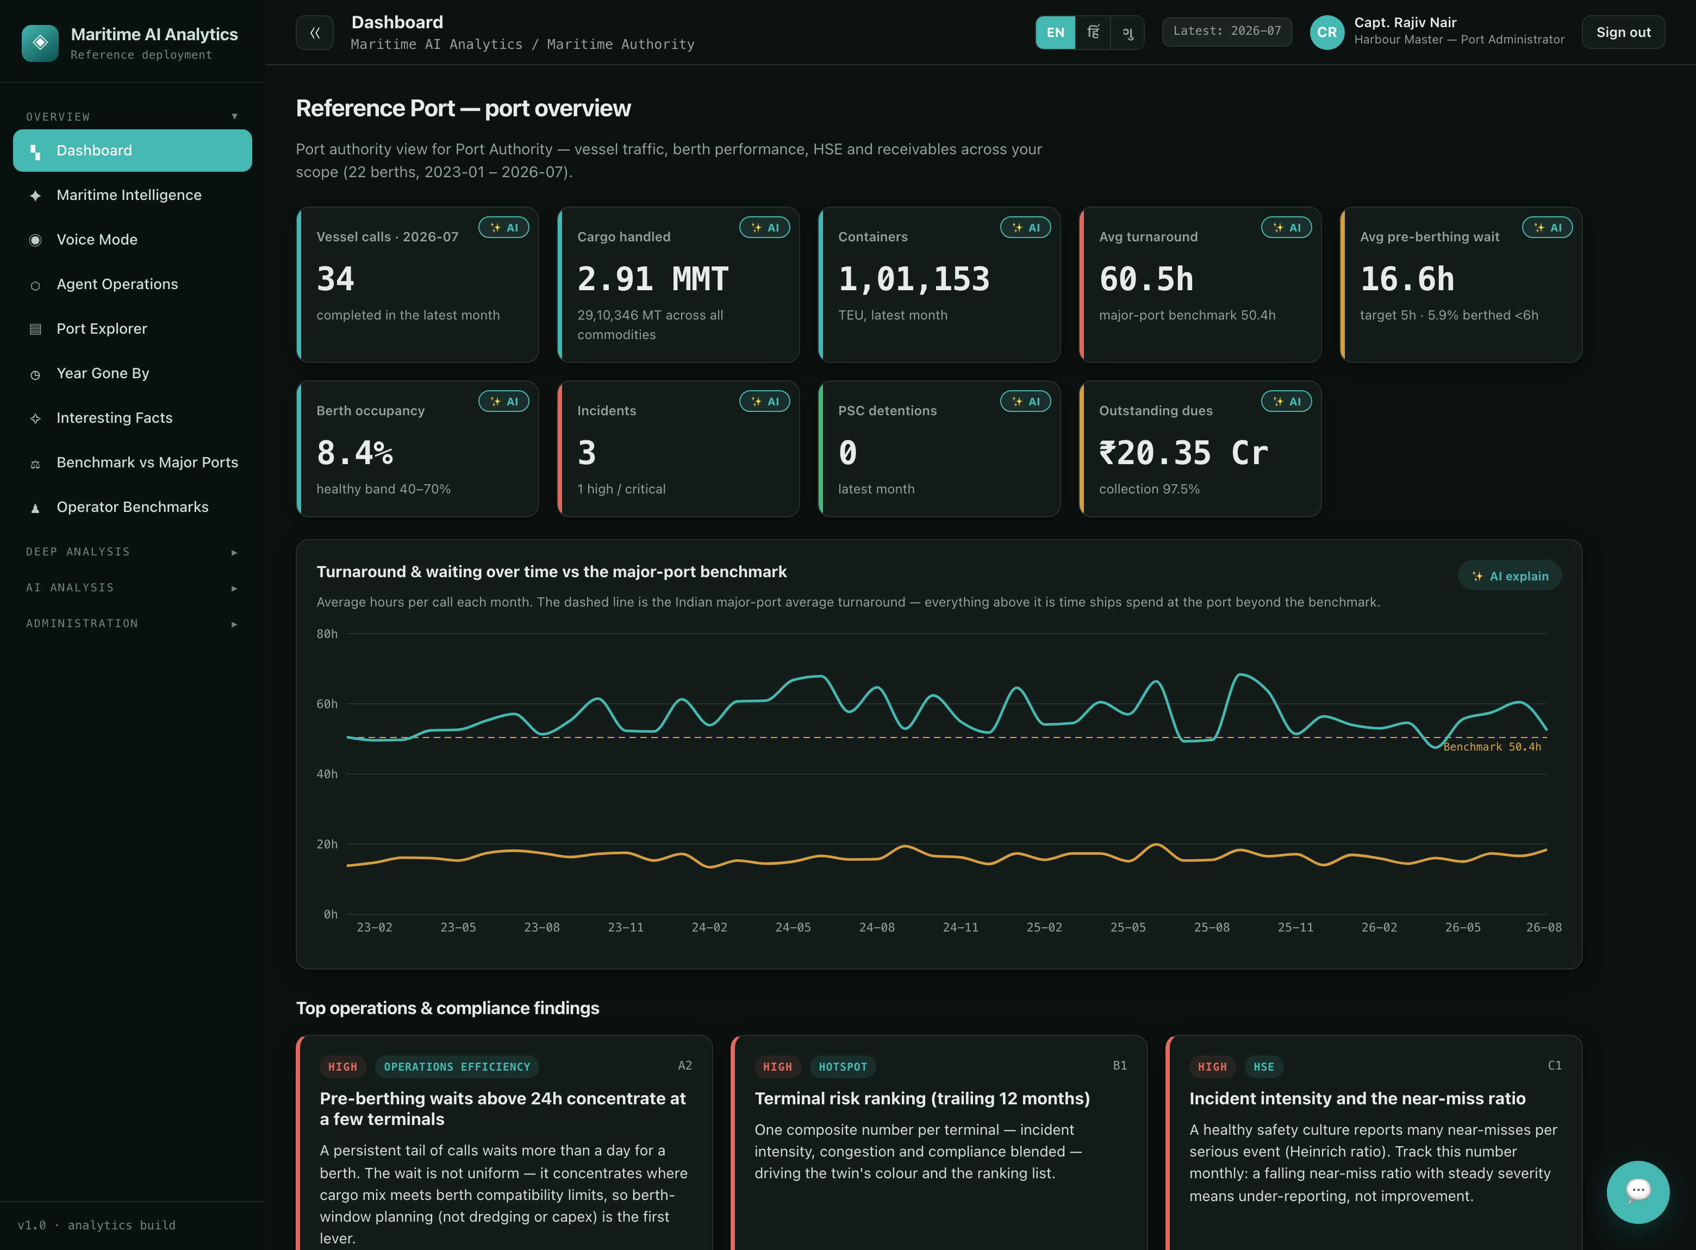
Screenshot 1 — the port overview: AI-chipped KPIs for the latest month — calls, cargo, containers, turnaround, pre-berthing wait, occupancy, incidents, detentions, receivables — the turnaround trend against the published major-port benchmark, and the top findings surfaced on the landing page. The language switch (EN · हि · ગુ) is in the header.
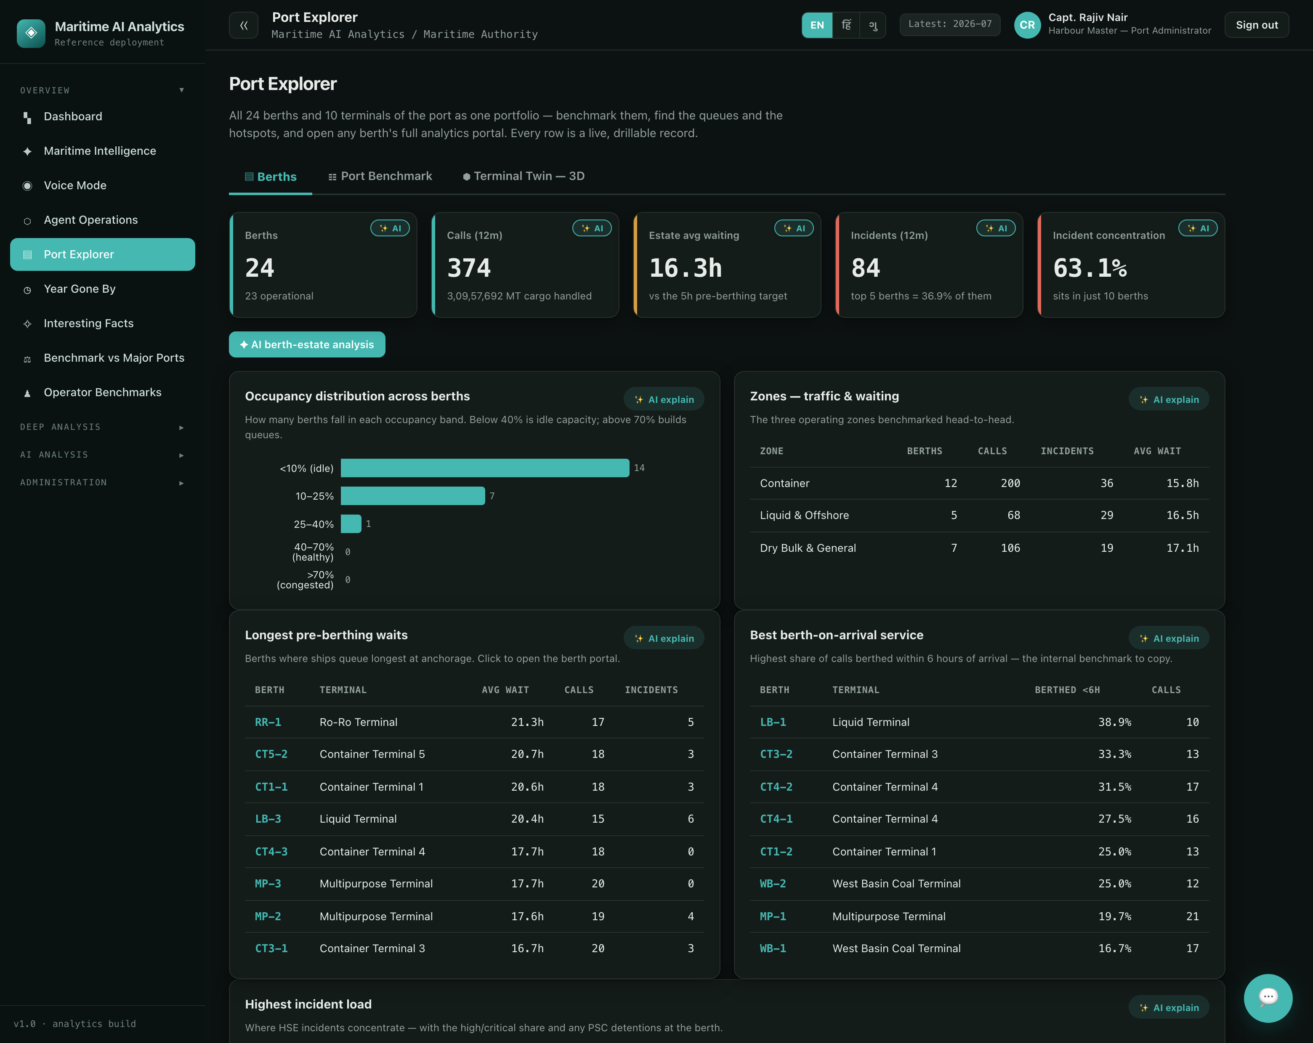
Screenshot 2 — the Port Explorer: all 24 berths and ten terminals as one portfolio — occupancy distribution, zone benchmarks, longest pre-berthing waits and best berth-on-arrival service — every row a live, drillable record.
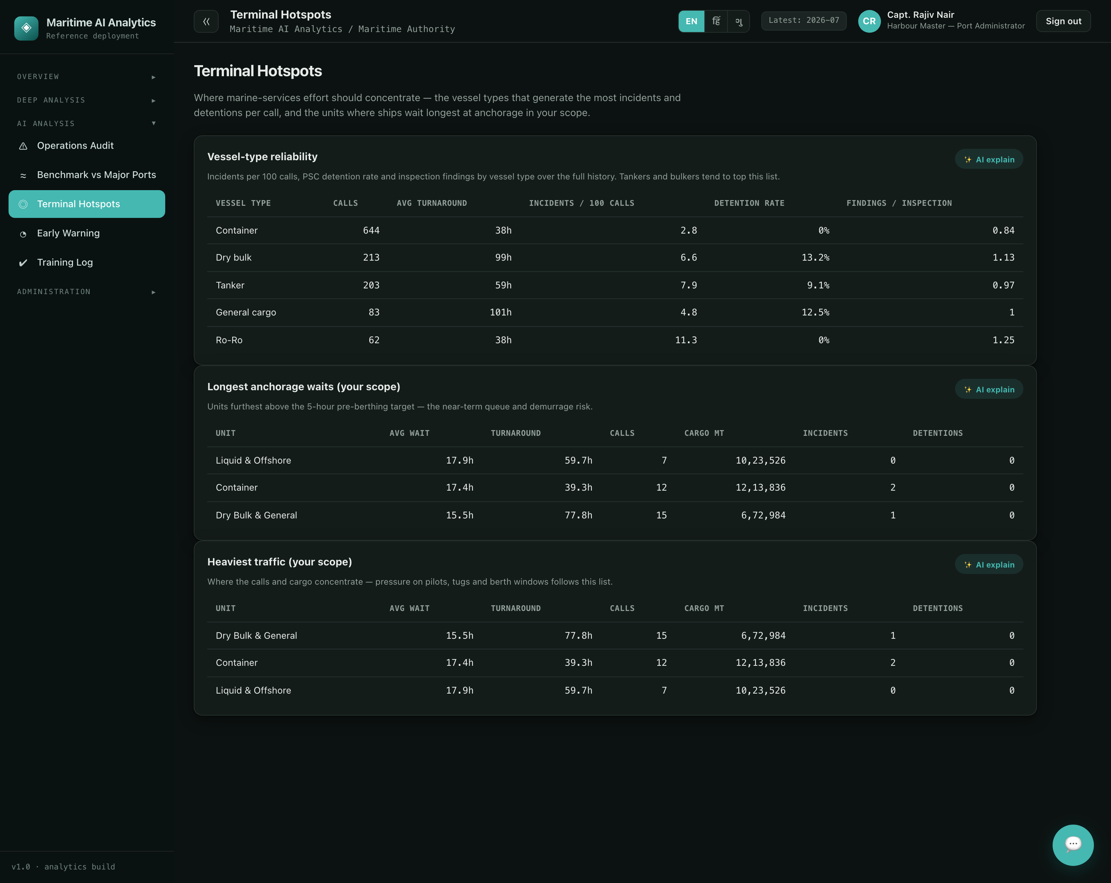
Screenshot 4 — hotspot ranking: one composite number per terminal blending incident intensity, congestion and compliance, driving the twin’s colours and the action queue.
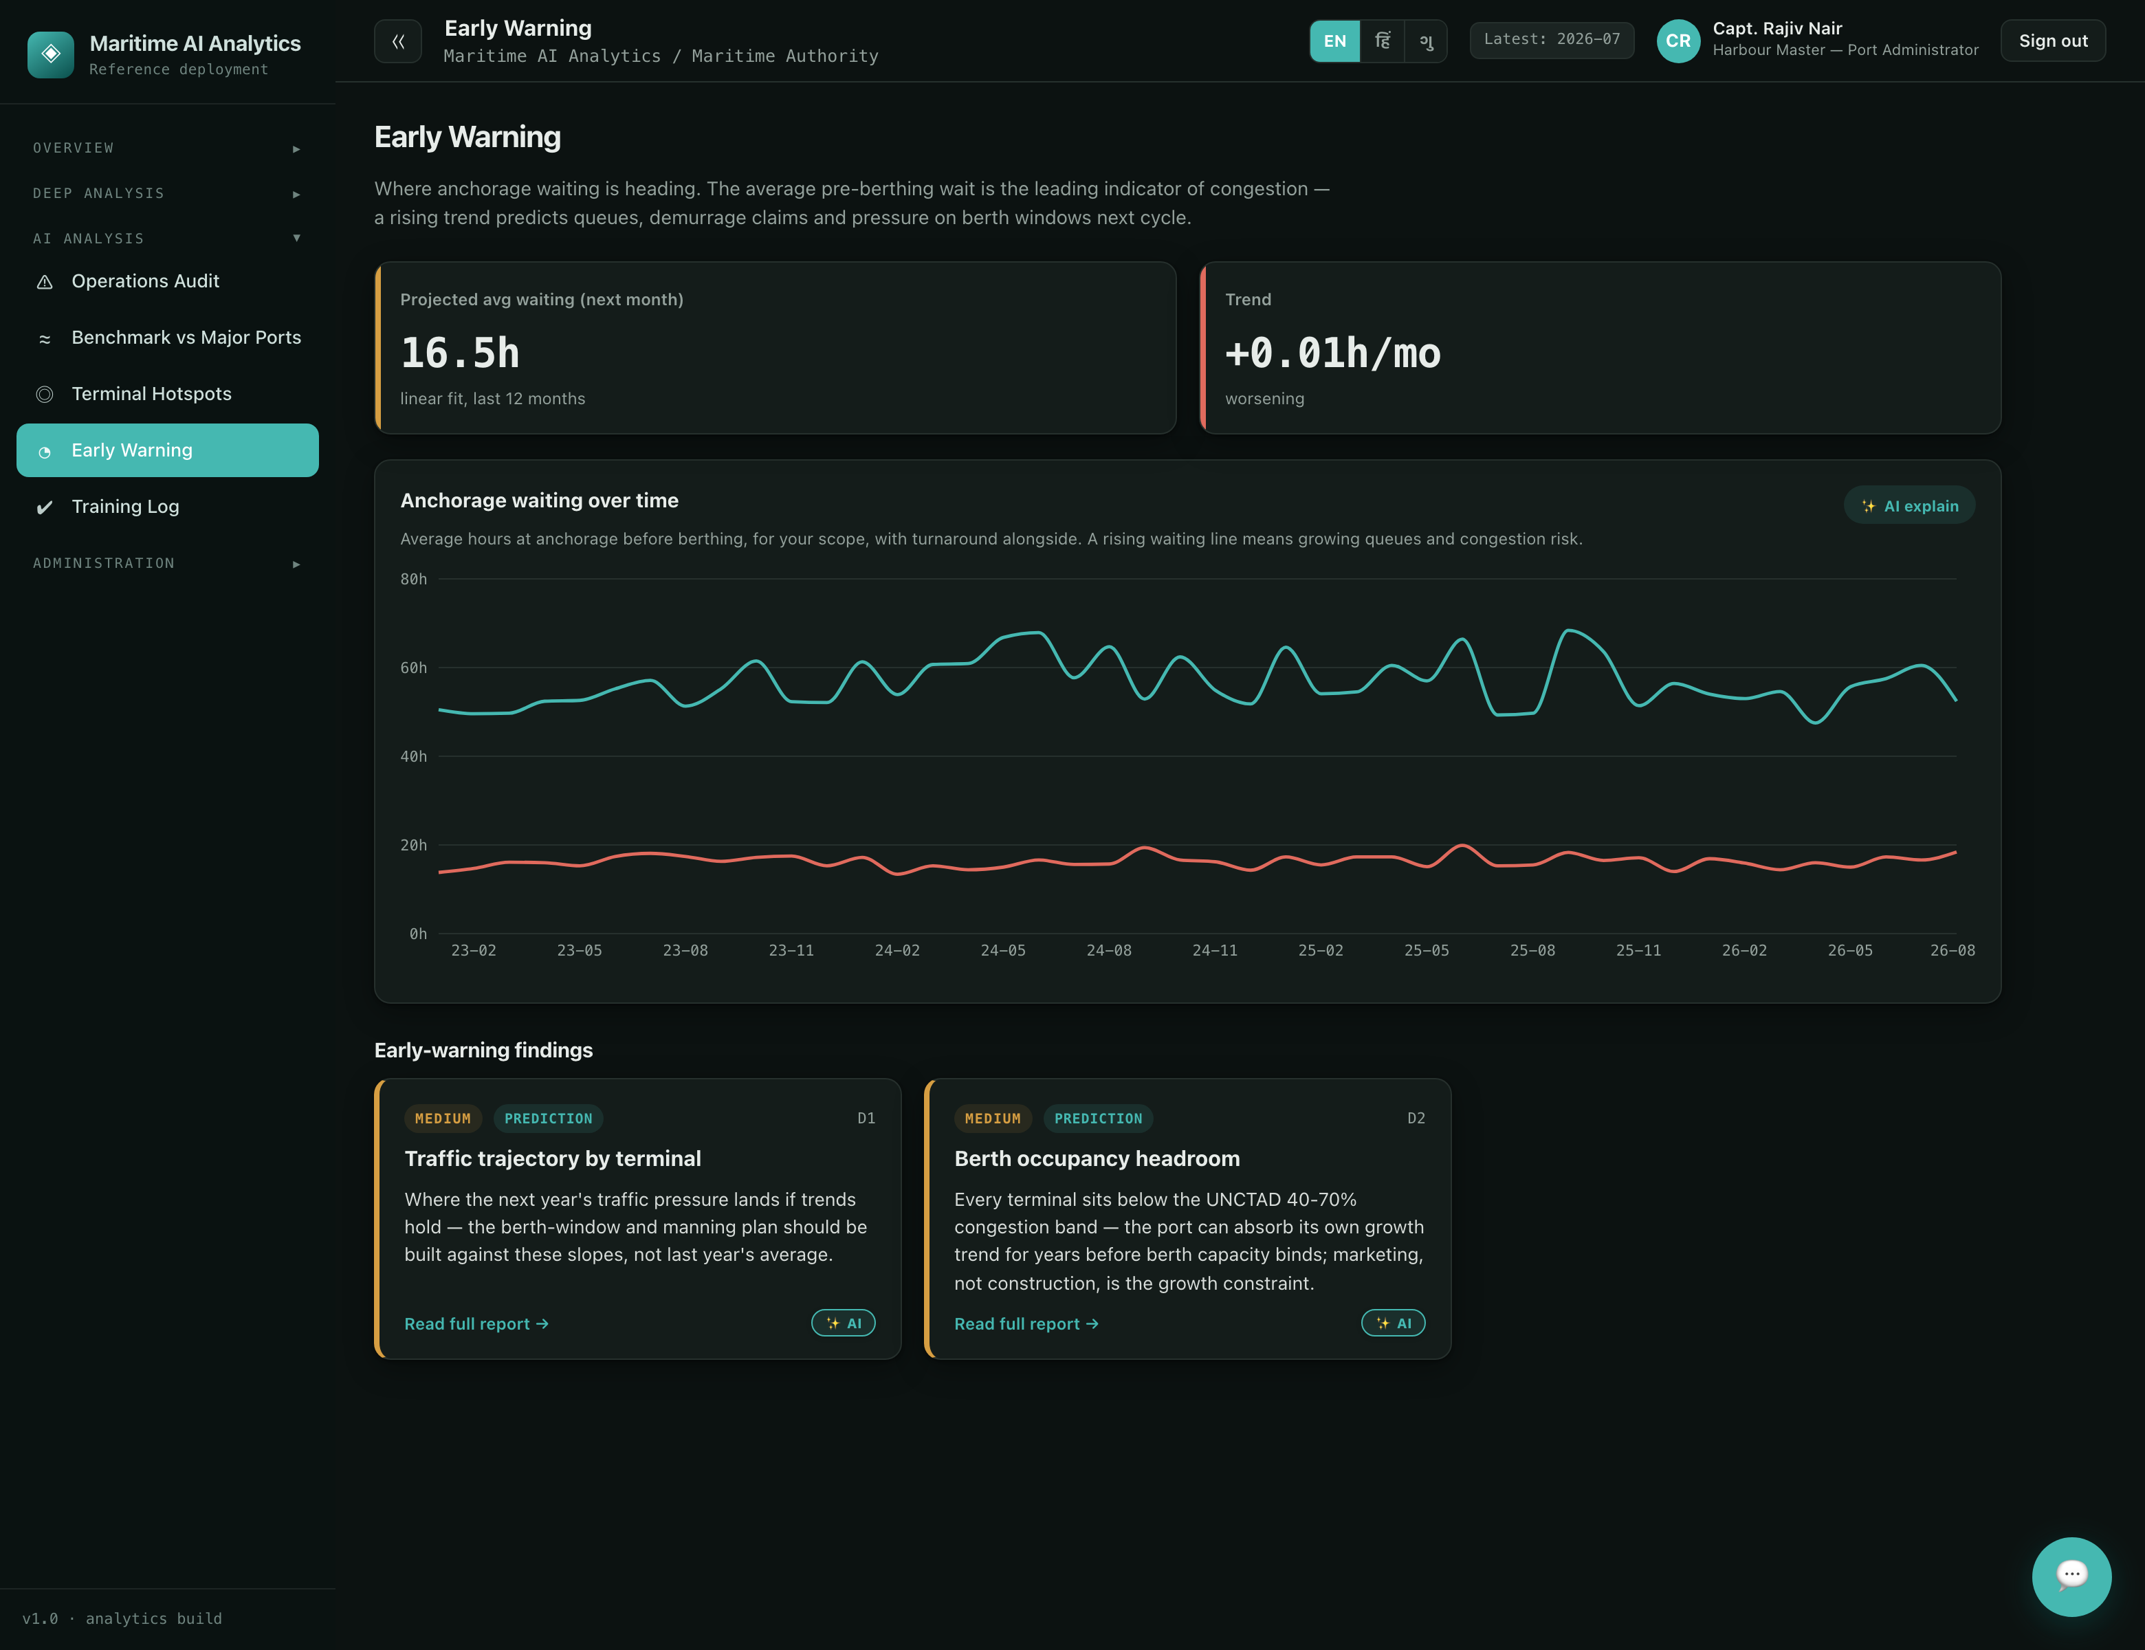
Screenshot 5 — the prediction view: model-projected trajectories with their driver decomposition, presented beside the actuals they will be scored against.

4. The AI analyst workforce
Sagar Drishti’s analysis does not wait for a user to open a page. A workforce of nine agents runs a two-hourly cycle — and can be run live from the console — keeping the picture fresh, watched and explained. The duty officer orchestrates: collector → sentinel → auditor → planner → analyst, with the curator, the two QA agents and the validator around them.
Agent | Duty | What it does
Harbour Collector | Ingestion | Rebuilds the panels and analysis artifacts from the latest snapshot — the system’s knowledge stays current.
Facts Curator | Insight | Re-mines and re-verifies the headline facts daily, reporting which facts shifted.
Berth Sentinel | Monitoring | Compares each cycle against its learned baseline, flags anchorage-wait rises per terminal, and adapts its own alert thresholds over time.
Marine Auditor | Validation | Scores each terminal’s marine service — waiting versus benchmark, turnaround, detentions, incident load — and explains what looks off.
Berth Planner | Targeting | Turns alerts and low scores into a prioritised action list — tug and pilot cover, berth windows to re-plan, dues to chase.
Trade Analyst | Reporting | Writes the cycle’s executive brief in plain language, grounded only in the live data and the other agents’ findings.
QA Examiner | Training | Writes the questions leadership would ask and puts them to the live chatbot pipeline.
QA Validator | Correction | Independently verifies every chatbot answer against the database ground truth with its own SQL, scores it, and turns failures into persistent lessons injected back into the chatbot — the reinforcement loop.
Duty Officer | Orchestration | Runs the cycle, routes hand-offs, and escalates high-severity items to a human.
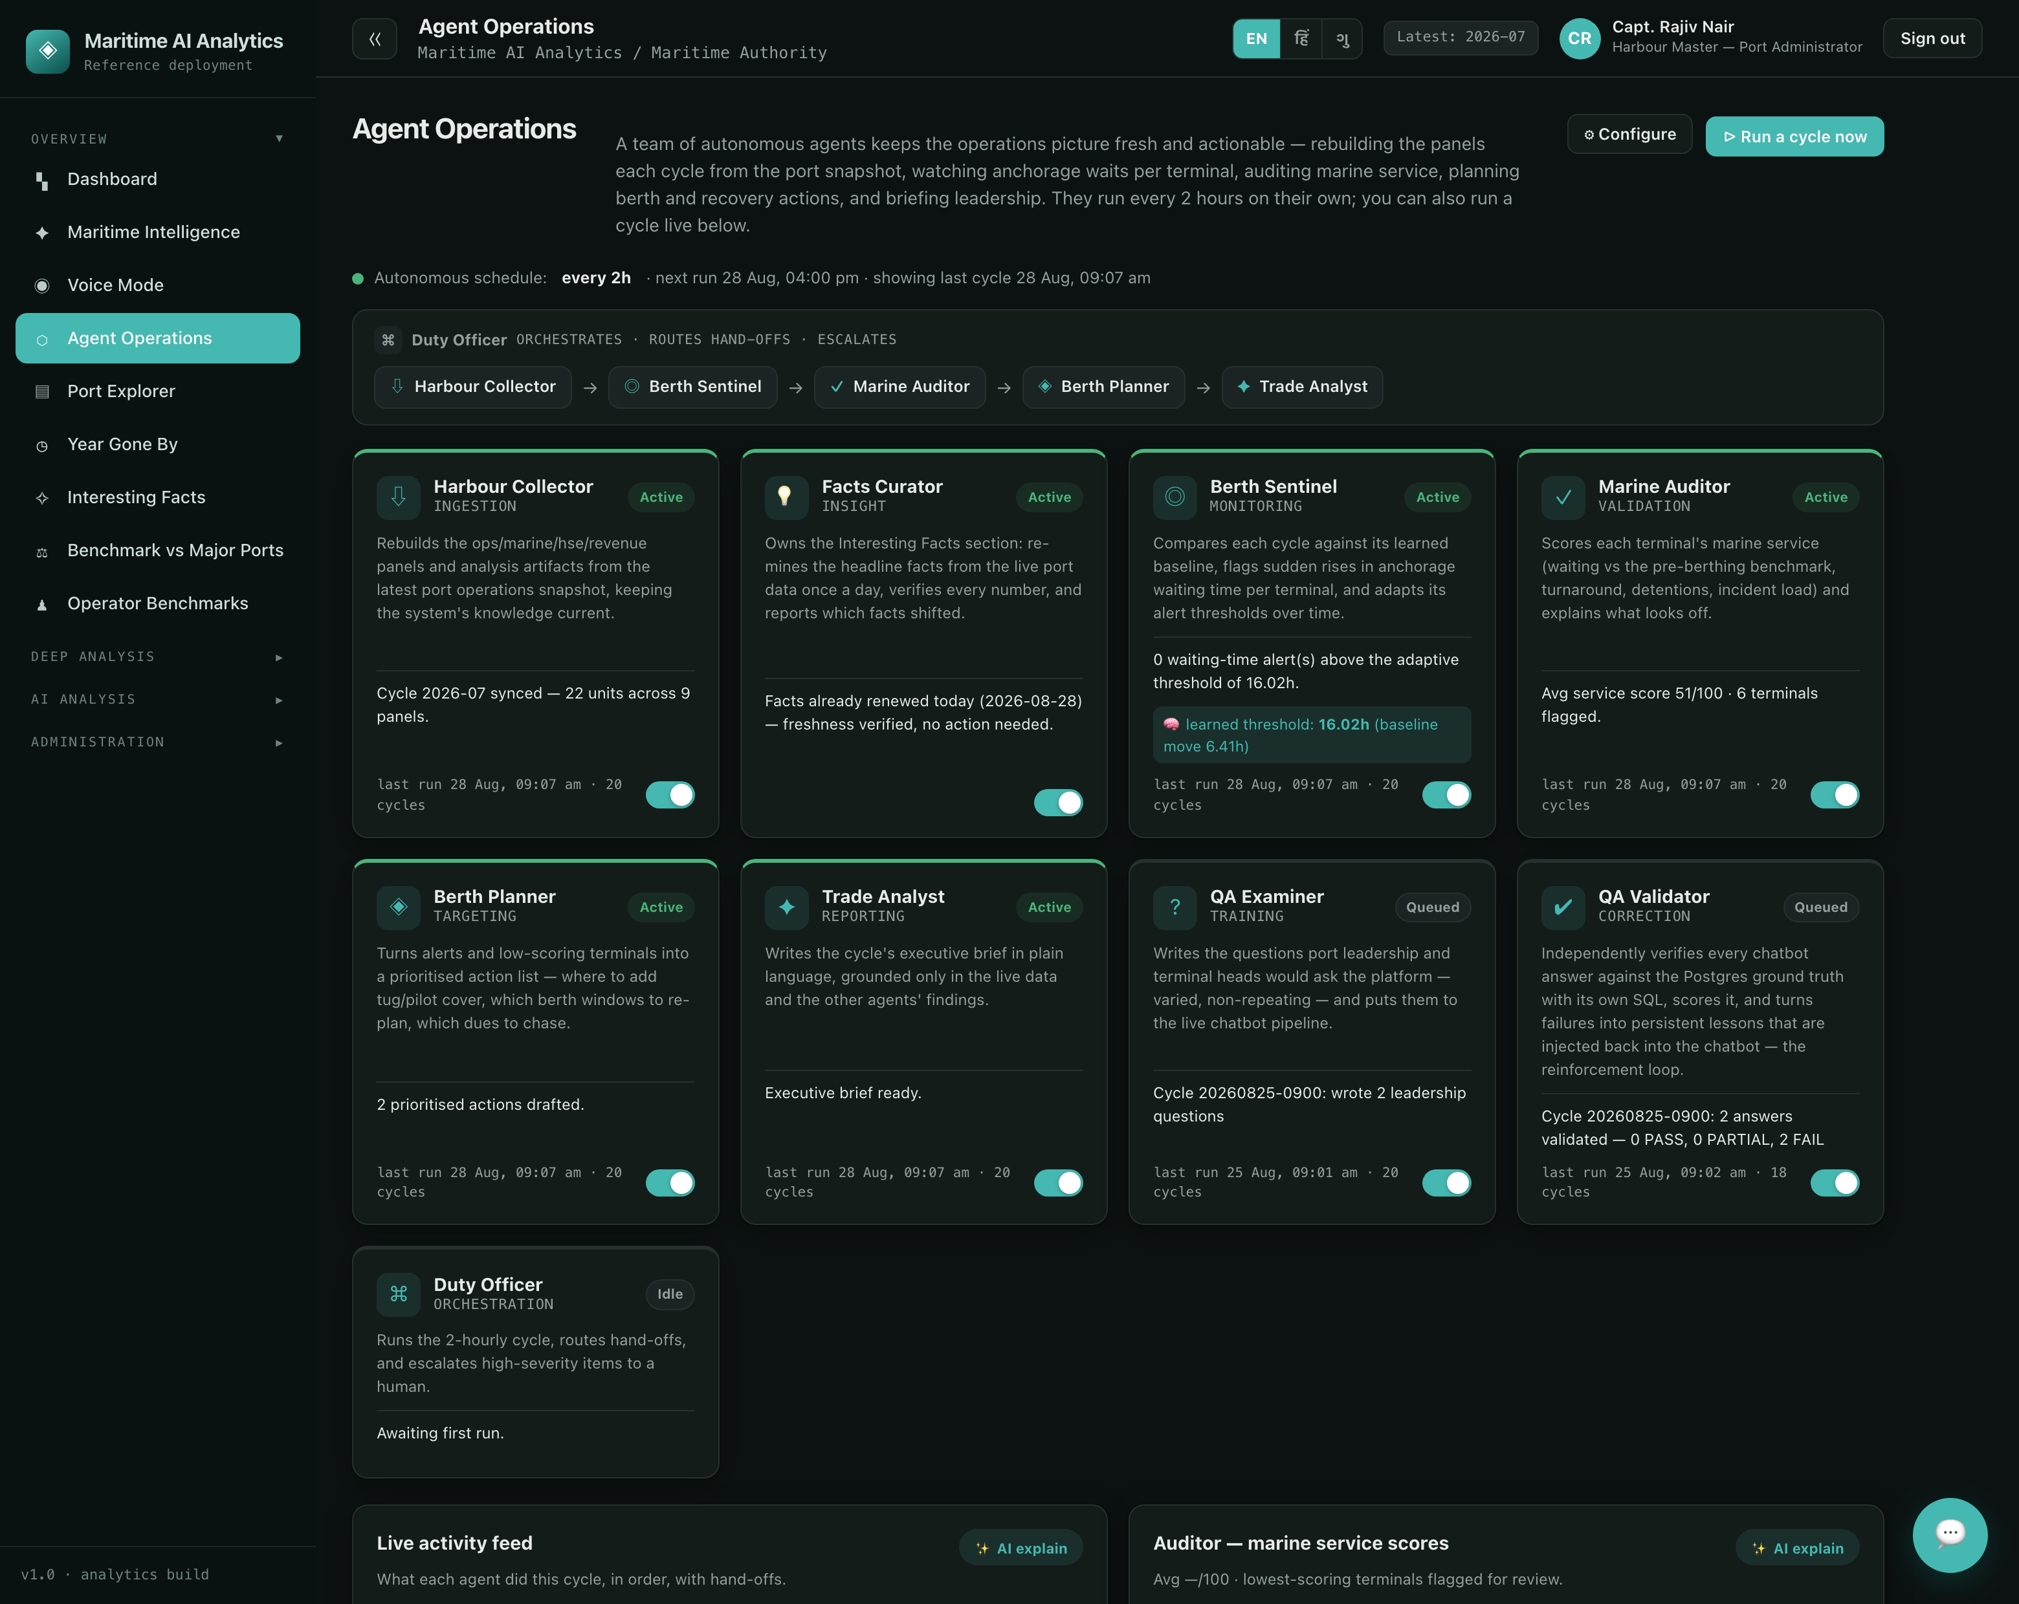
Screenshot 7 — Agent Operations: the workforce with its orchestration chain, each agent’s last cycle and its live state — the sentinel showing its learned threshold and how far the baseline has moved, and the QA pair honestly reporting failed answers being turned into lessons. Autonomy here is scheduled and inspectable, not hidden.
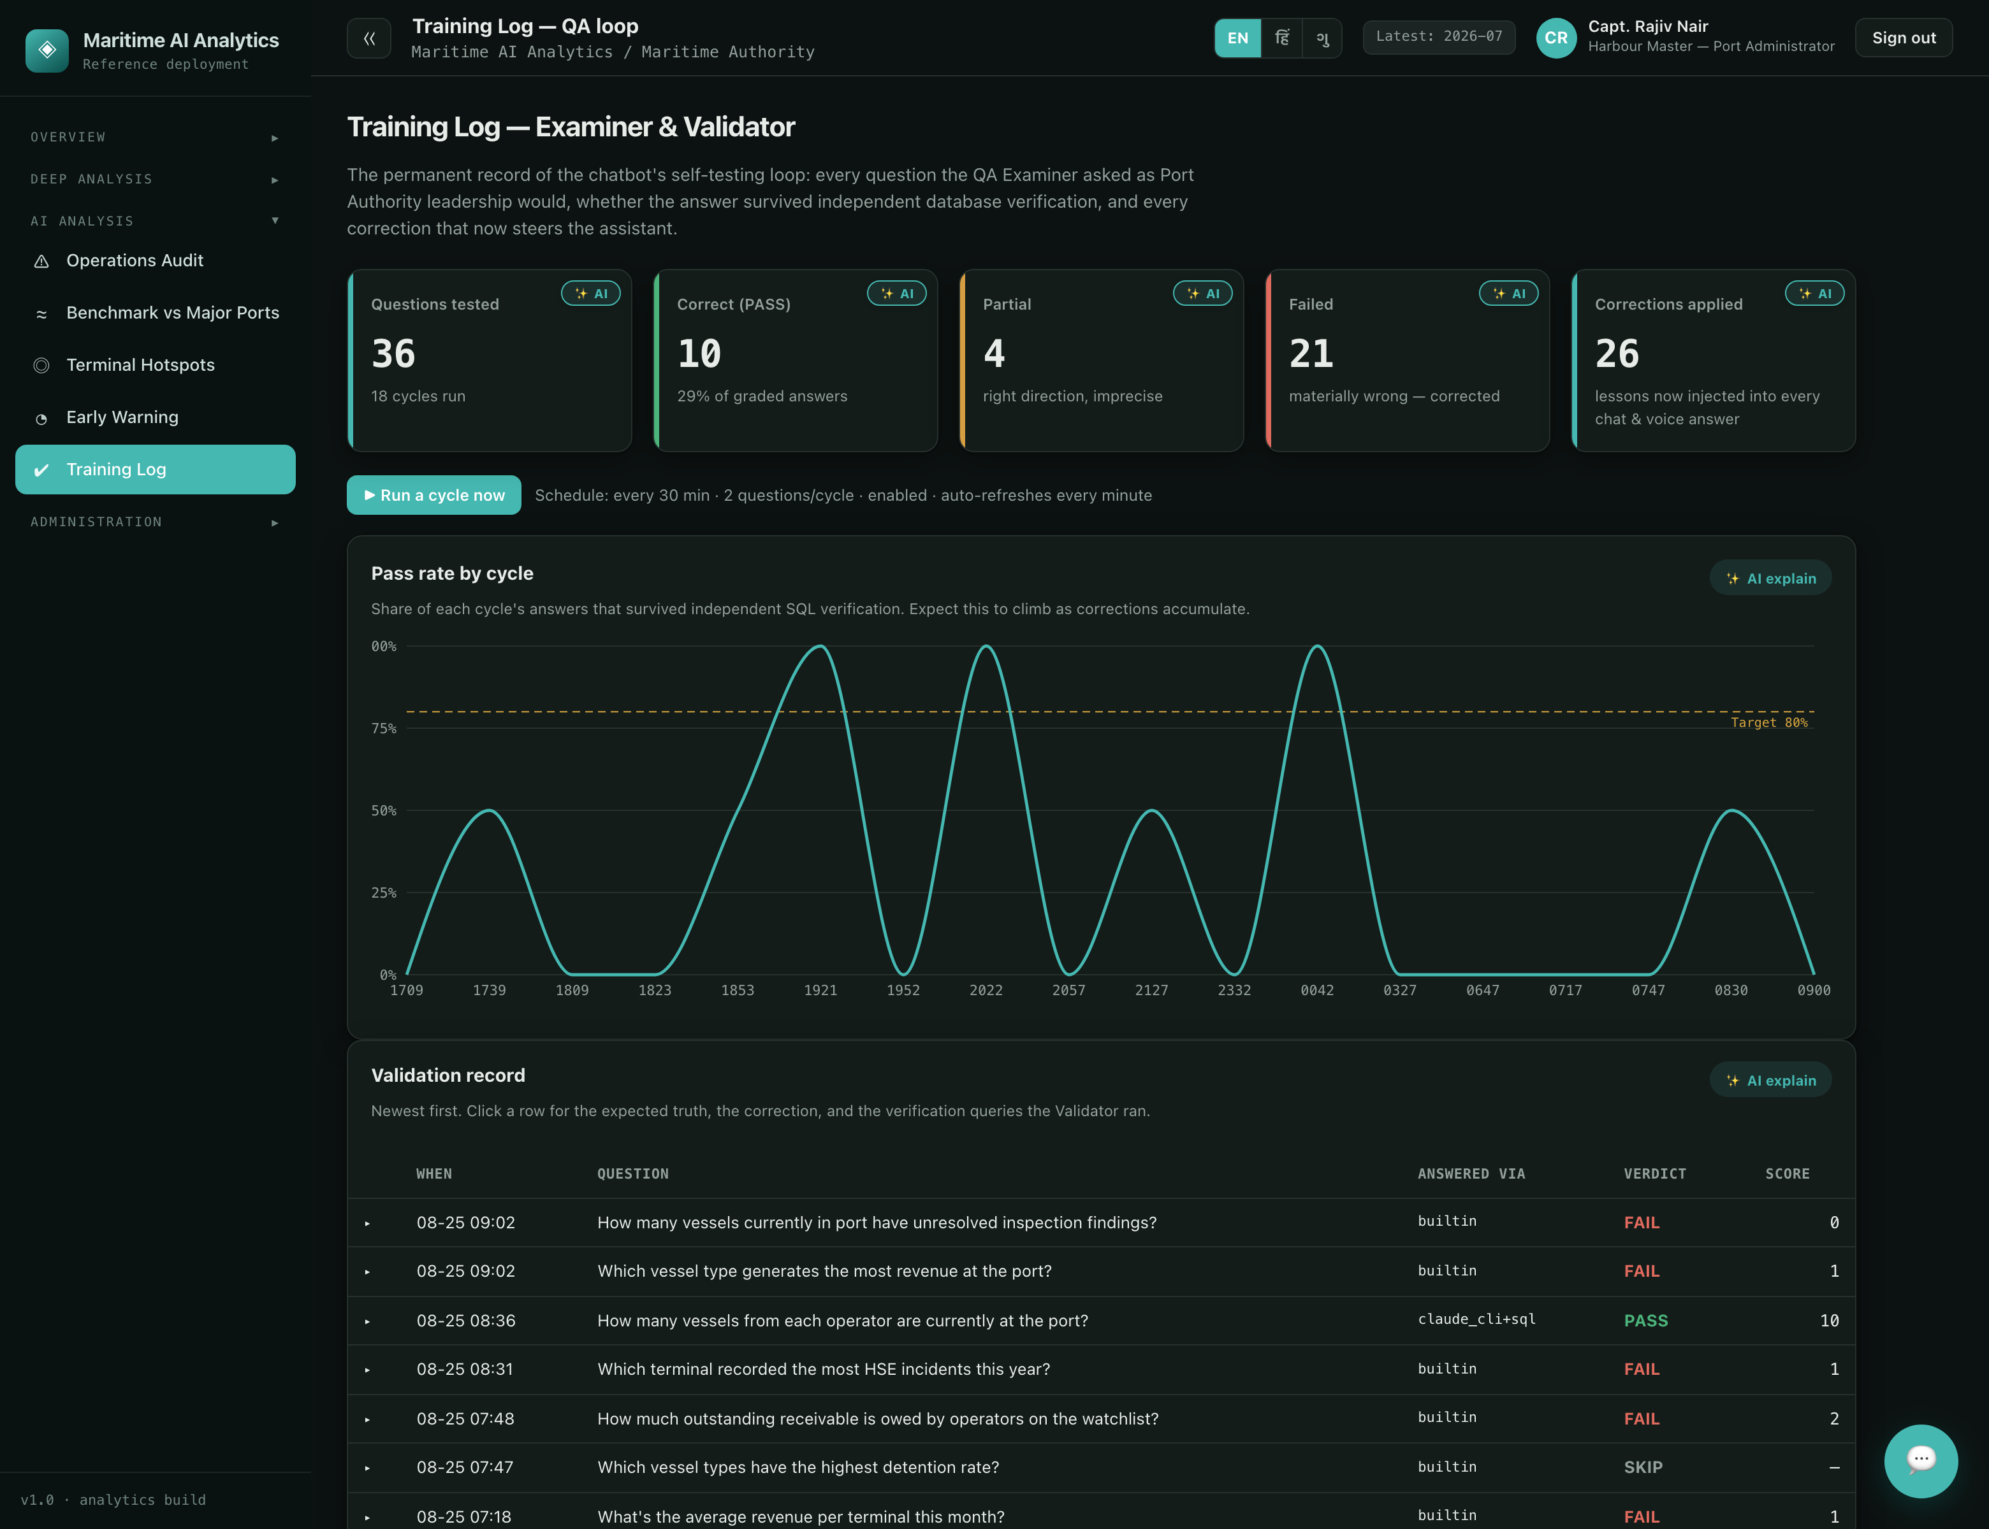
Screenshot 8 — the training log: the QA examiner’s questions, the validator’s verdicts against ground truth, and the lessons written back — the platform grading its own assistant, continuously.

5. Grounded, multilingual, spoken
The assistant answers from the data or not at all: a deterministic engine computes the numbers and charts; the language model phrases them; citations point at the panels behind every answer. Questions arrive typed or spoken — the voice mode runs a hands-free listen–think–speak loop — and the whole surface operates in English, Hindi and Gujarati, the working demonstration of the Arabic/English pattern the target platform commits to.
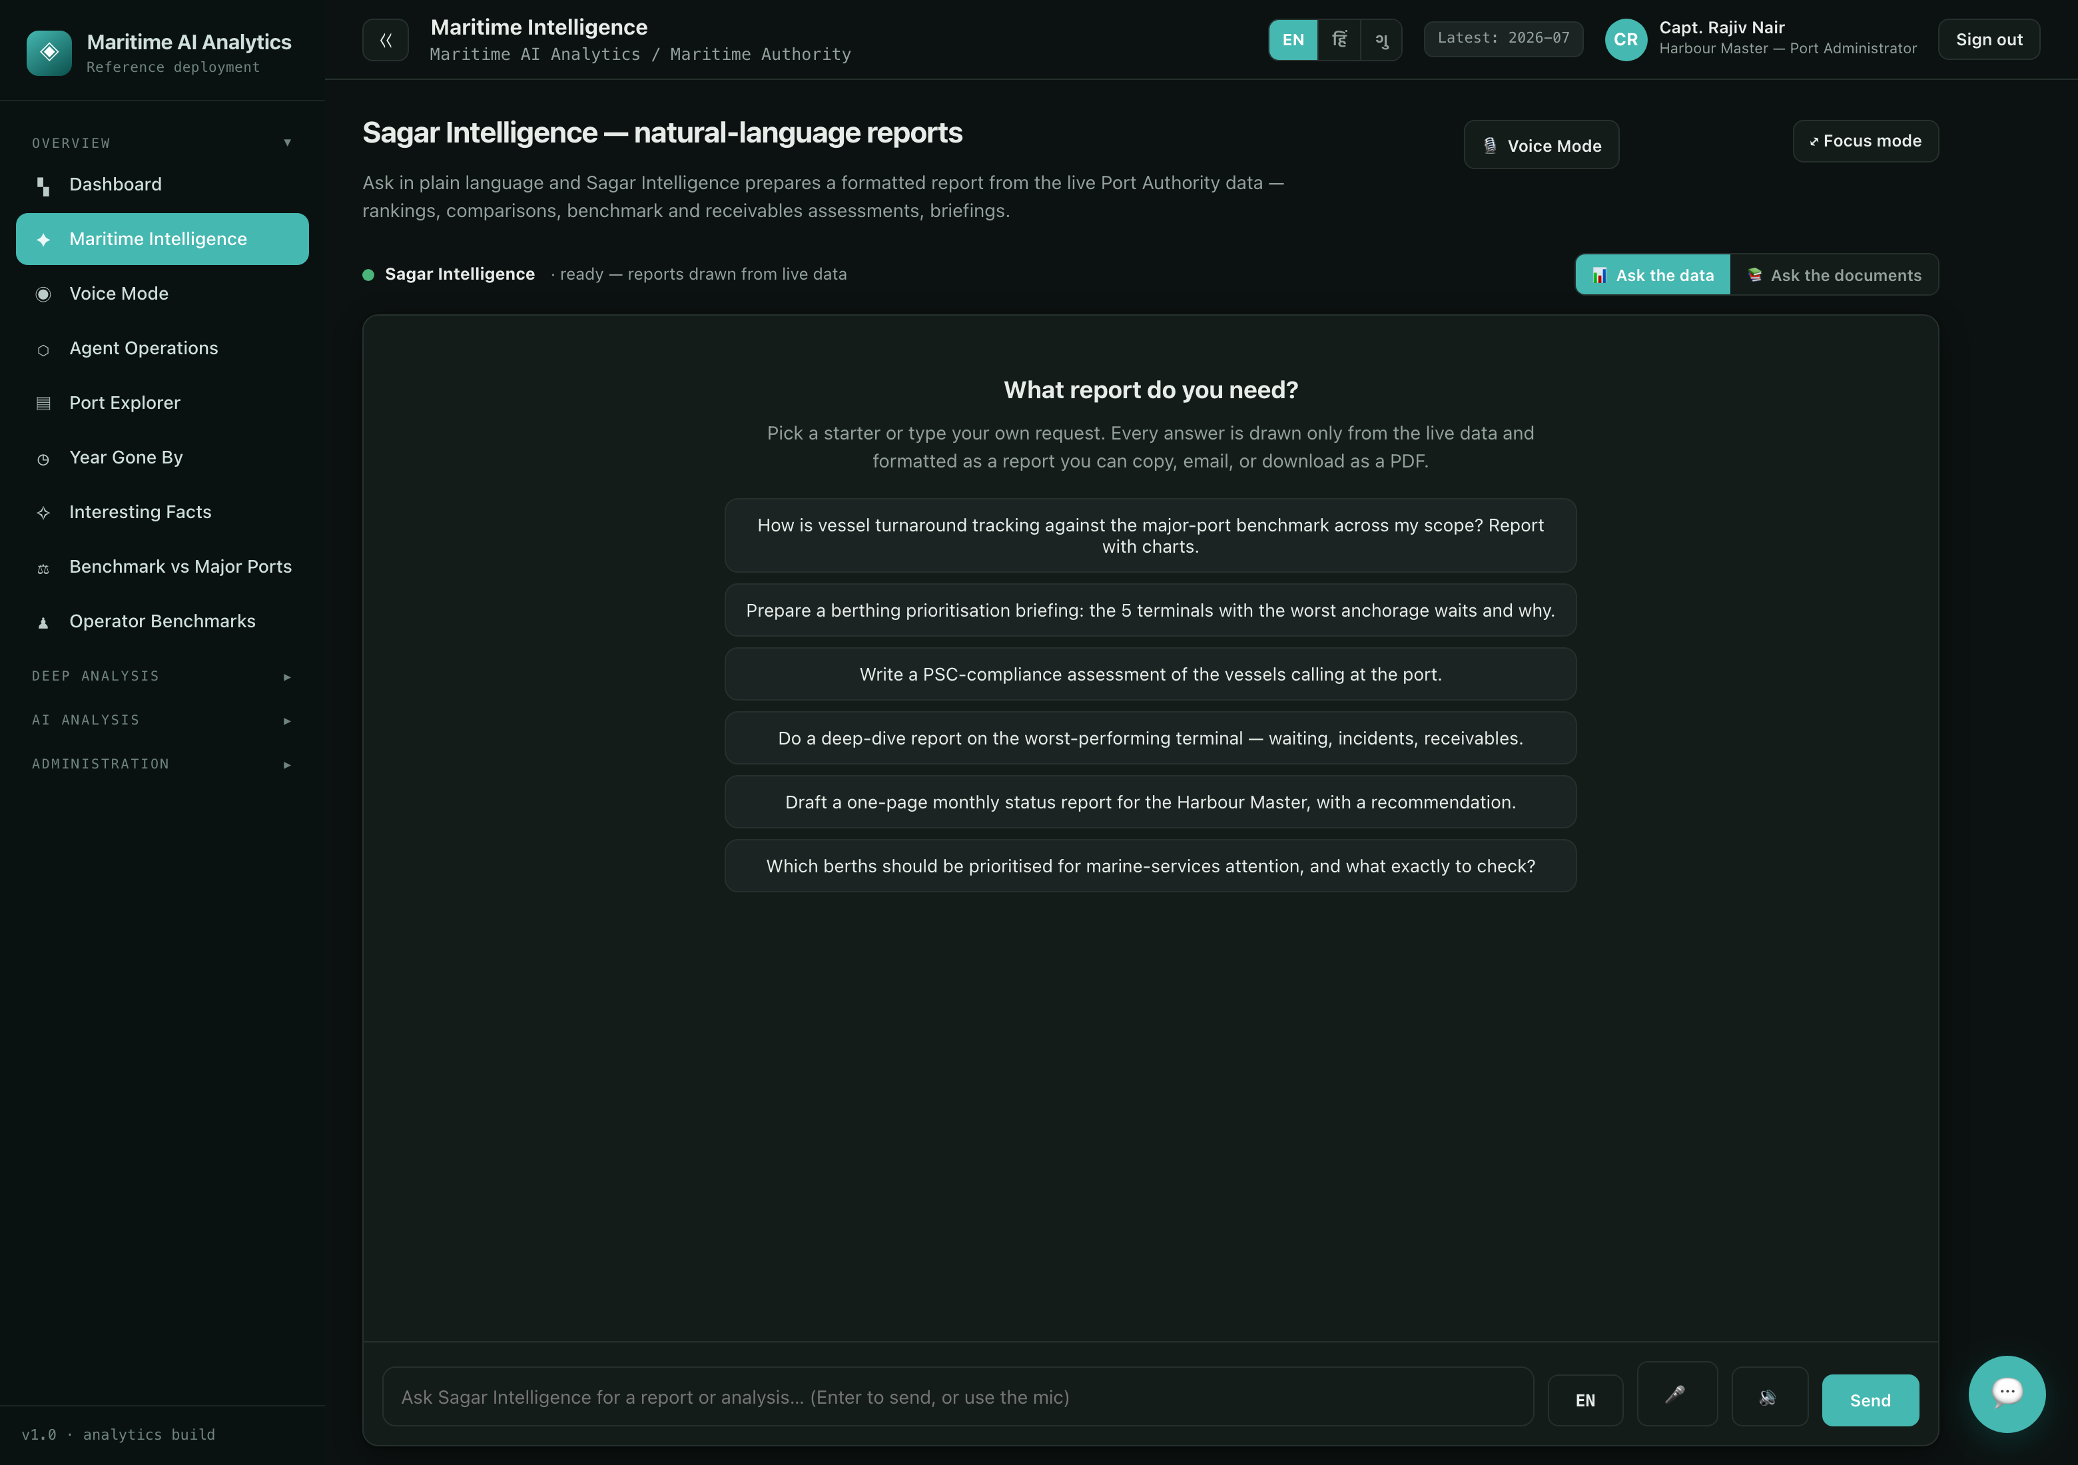
Screenshot 9 — the maritime intelligence assistant: grounded answers with the evidence behind them, chart replies where a chart answers better, and guarded analytical SQL — free text never reaches the store.

Screenshot 10 — voice mode: the hands-free loop with its state orb — listening, thinking, speaking — for the deck, the car and the control room.

6. The findings engine and its evidence
Fifteen severity-ranked findings across seven analytical areas are recomputed from the panels on every ingestion cycle — operations efficiency, hotspots, HSE, compliance, revenue, reliability and terminal typology — each carrying its evidence rows and, where a public benchmark exists, the citation it is judged against. The evidence pack is written alongside: every claim in the findings can be traced to the rows that produced it.
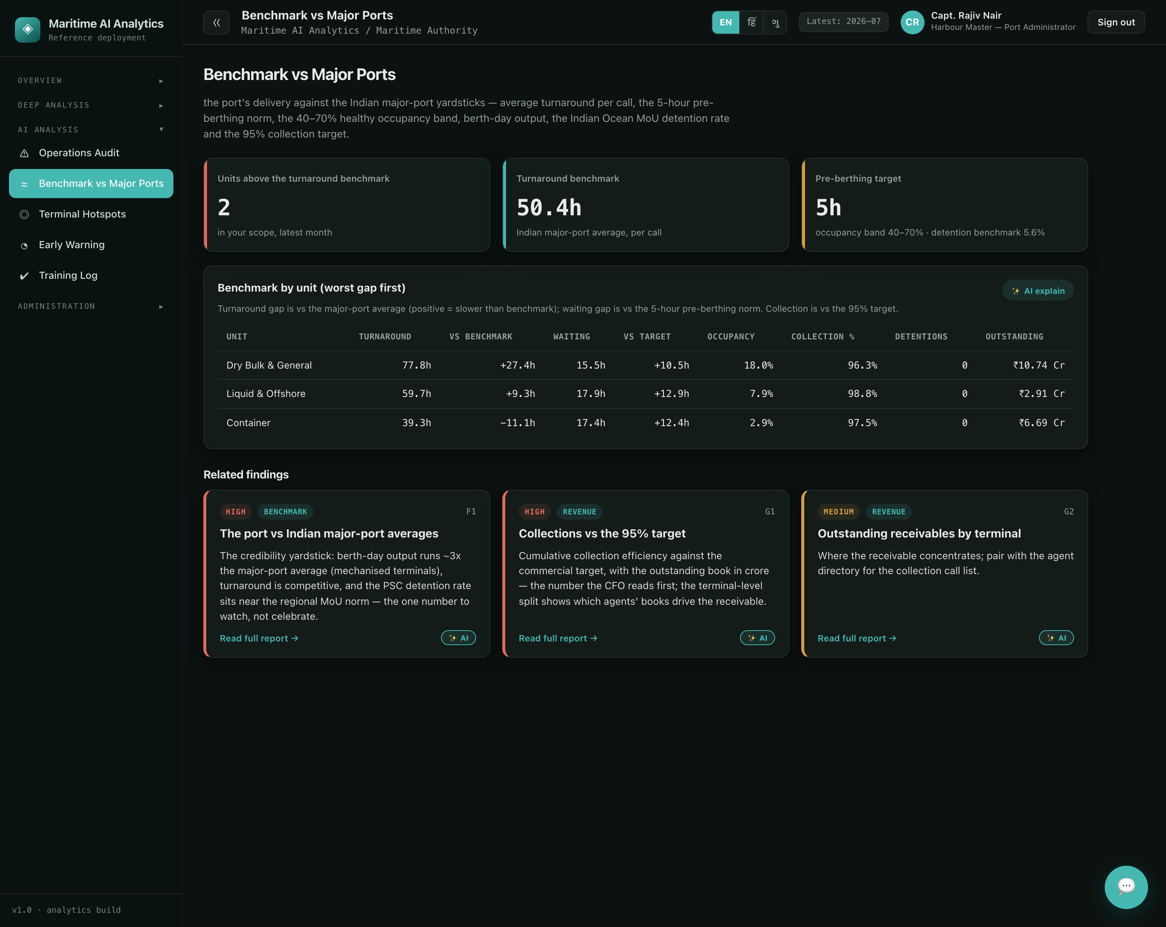
Screenshot 11 — validation: the findings register with severity, area and the evidence trail behind each finding — analysis a reviewer can re-derive, not narrative to take on trust.
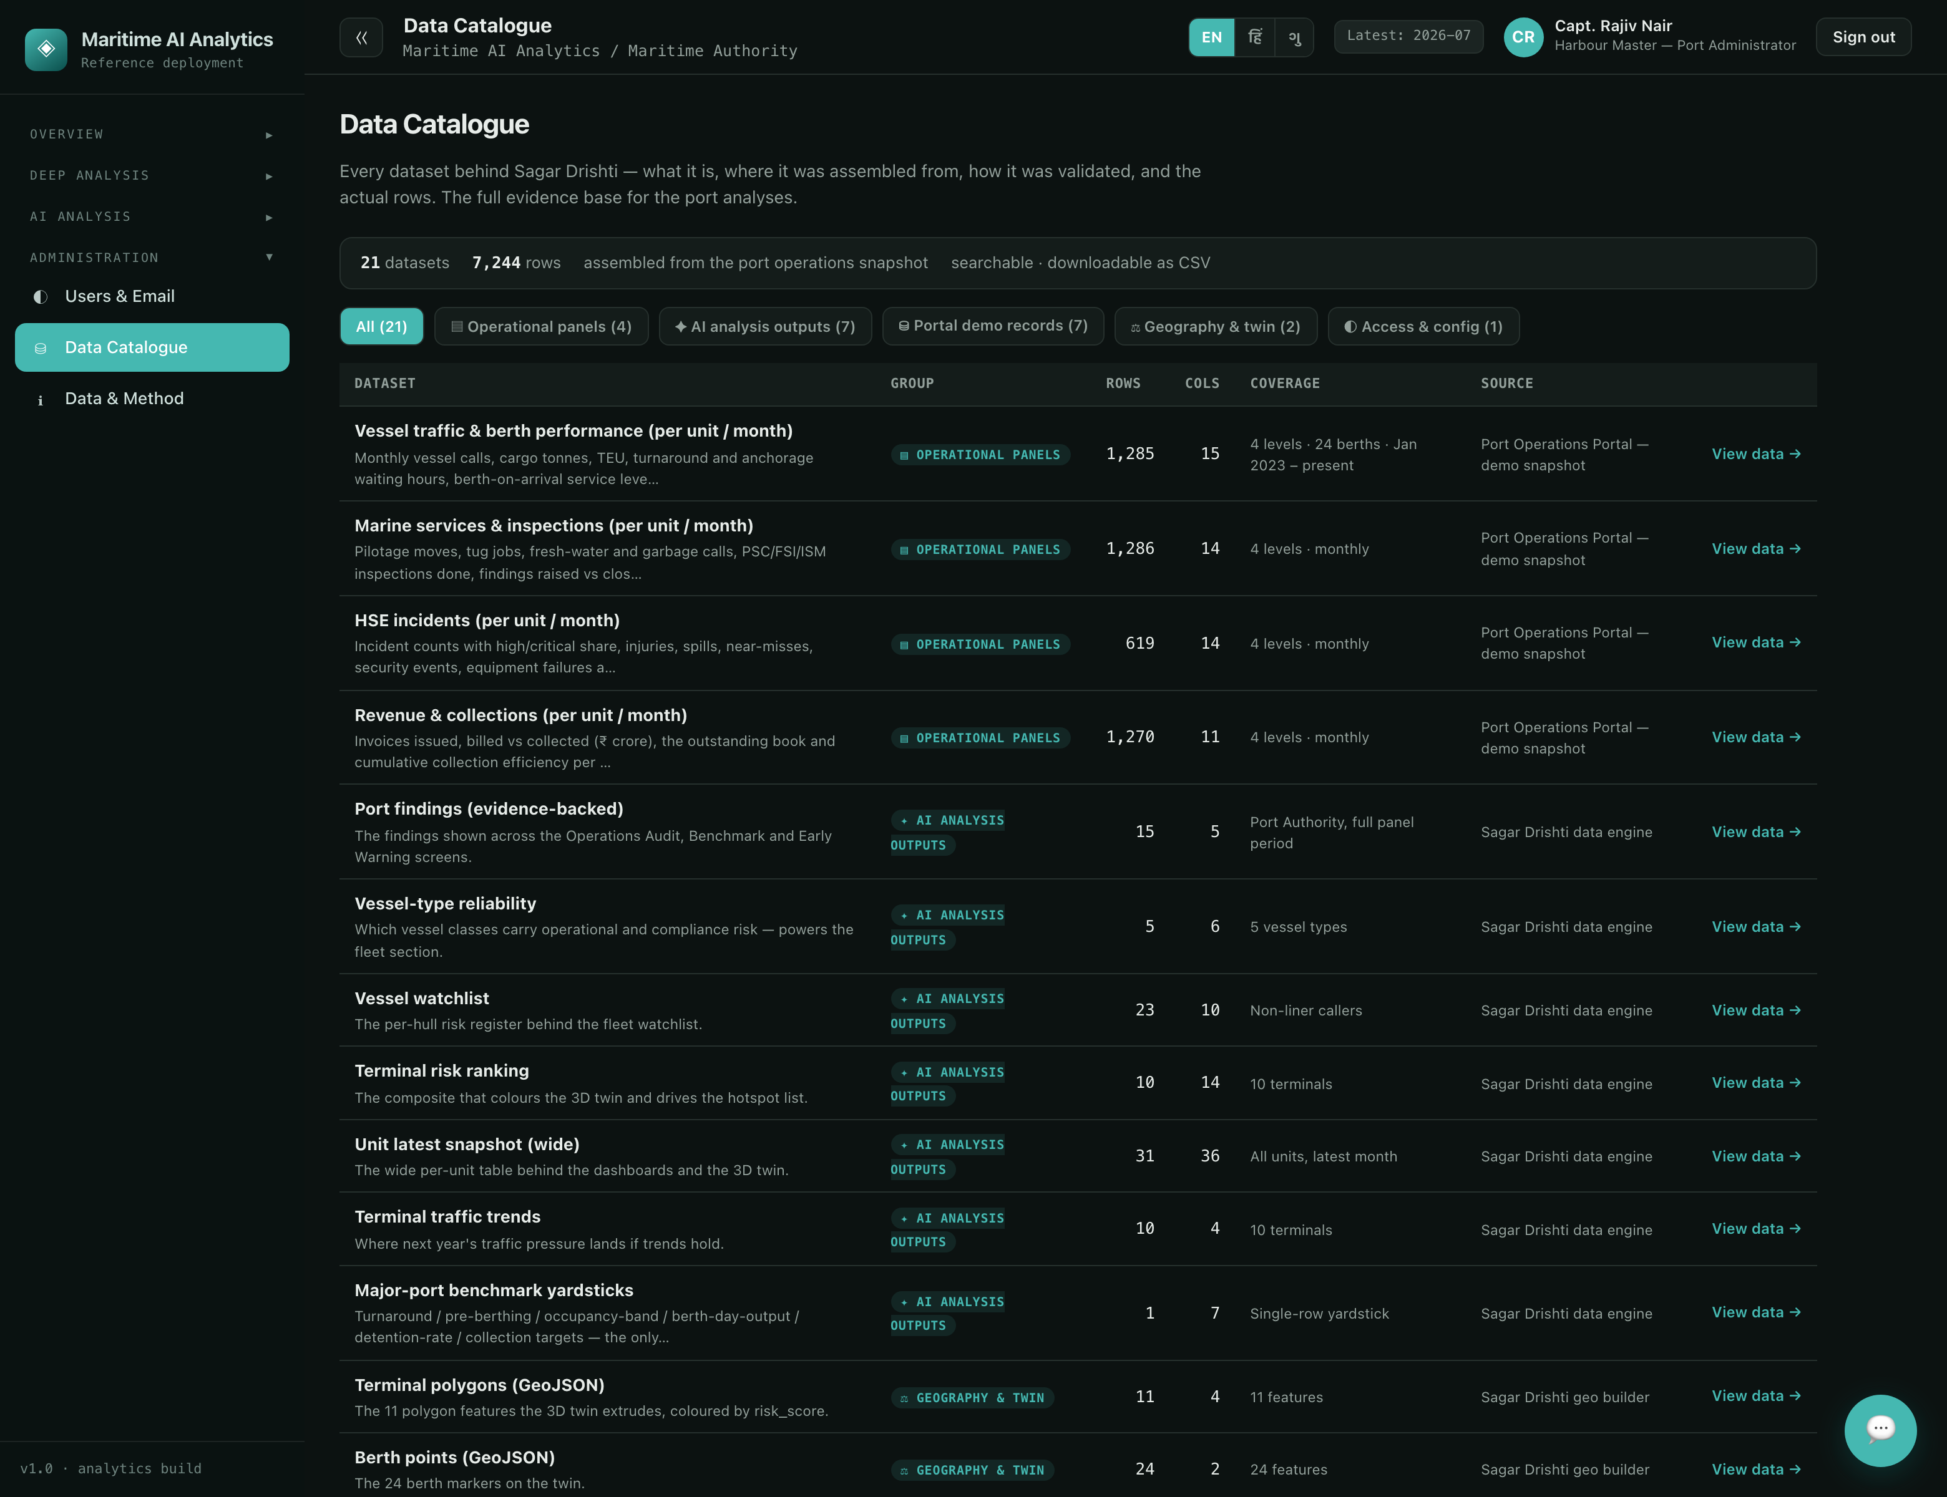
Screenshot 12 — the data catalog: every dataset the analyses stand on, with provenance — source, build method, validation notes — and browsable rows. The evidence base is a first-class screen, not an appendix.

7. Security and governance
- JWT bearer authentication with 12-hour tokens; passwords hashed with PBKDF2-SHA256 at 120,000 iterations; a managed user store with per-user scopes — a terminal manager sees their terminal, the authority sees the port.
- Role-appropriate views throughout: the same screens, scoped by what the signed-in user is entitled to read.
- The QA reinforcement loop is the assistant’s governance: continuously examined against ground truth, failures becoming lessons, the log open to inspection on the training screen.
- Nothing writes back to the system of record; the analytics estate can be rebuilt from the contract export at any time.

8. What Drishti evidences for the programme
Programme claim | What Drishti demonstrates today
Multilingual by design | Three full languages with instant switching — the working pattern for Arabic/English with RTL on the target platform.
Agentic autonomy, governed | A nine-agent workforce on a schedule, with learned thresholds, hand-offs, human escalation and a self-testing QA loop — autonomy as an inspectable operating discipline.
Grounded conversational AI | Deterministic numbers, model phrasing, citations, guarded SQL — the §6.6 explainability posture, running.
Benchmarked analytics | Findings judged against published major-port figures, with the evidence pack to re-derive them.
Voice as a channel | A hands-free spoken loop over the same grounded pipeline.
Contract-coupled architecture | Analytics fed by a versioned export, never writing back — the pattern for the target platform’s analytics zone.
Taken with the master document, the position is simple: the operations platform proves the system of record; Sagar Drishti proves the system of understanding. Both run today, over one dataset, and both are photographed rather than promised.

