MARITIME TRANSFORMATION PROGRAMME
Technical Approach Document
Unified Maritime Digital Services Platform
Module-by-module: current capability, RFP target state on the Azure/AI stack, and the delta — with every Azure service's concrete role, the AI features fully elaborated, and effort in man-weeks.
Document control
Classification | CONFIDENTIAL — commercial in confidence
Version / Date | 4.0 · August 2026
Method | - One module detailed end-to-end per iteration on the standard template.  - This issue: Master Data Management in full depth — the complete feature inventory, screenshots of the running module, the canonical master data model, the target architecture on Azure with data/AI-flow diagram, the AI pipeline, per-service Azure utilisation, and a decomposed effort estimate.  - Remaining modules are catalogued and follow on the same template.
Alignment | Target stack aligned to the Client's shared Azure platform architecture: Microsoft Foundry Agent Service AI layer, AKS microservices, ADLS Gen2 + AI Search data/AI foundation, Entra ID + UAE PASS identity, UAE North / UAE Central regions
Baseline evidence | A working 12-module maritime operations platform and a companion AI analytics portal (live demo available); production reference architecture on Azure in operation
Estimate status | Indicative delta engineering effort; to be confirmed in the detailed scoping phase (D0/D1)

How to read the compliance tables: ● AVAILABLE — running in the current platform today. ◐ PARTIAL — the engine exists; the RFP service is configured/extended on it (delta). ○ NEW BUILD — net-new development.

Contents
Contents 2
1. Current application overview 3
1.1 Application overview 3
1.2 Current production reference architecture (Azure) 3
2. Method — one module at a time 4
3. Module 1 — Master Data Management 4
3.1 Modules detailing — current features, in depth 4
3.2 Feature inventory — the complete module surface 6
3.3 The module in operation 8
3.4 Flowchart — master data change (as running today) 12
3.5 The canonical master data model 13
3.6 Target architecture on Azure — data & AI flow 15
3.7 Current feature → target state on Azure 14
3.8 The MDM AI pipeline — stage by stage 17
3.9 Roles & permissions 19
3.10 Business benefits 22
3.11 Functional requirements compliance (RFP §5.4.1, §5.4.4, §7.5) 22
3.12 Improvements — TO BE 19
3.13 Effort estimation for the delta (man-weeks) 19
4. Azure services — how each will be used 21
8. Effort summary & timeline 30
8.1 Phased timeline (24 months) 30
9. Assumptions & exclusions 31

1. Current application overview

1.1 Application overview
The baseline is working software, not slideware: two applications over one dataset.
- Operations platform (Node/Express API + React 18 SPA; PostgreSQL per the production reference architecture): 12 modules, ~190 REST endpoints, 26 data models, deny-by-default RBAC (24 permission groups / 65 permissions with a visual matrix editor), an audit log with before/after snapshots on every write, server-enforced workflow state machines, digitally signed certificates (Ed25519) with unauthenticated public verification, notifications, global search, and a zero-install read-only demo build.
- AI analytics portal (FastAPI + React): findings engine benchmarked against public maritime figures, a grounded AI assistant with per-answer citations, retrieval-augmented Q&A over a curated regulatory library, anomaly and prediction views, a 3D port twin, an agent workforce (collector, sentinel, auditor, planner, analyst, QA), voice mode, and three-language i18n — proving the multilingual architecture ahead of Arabic RTL.
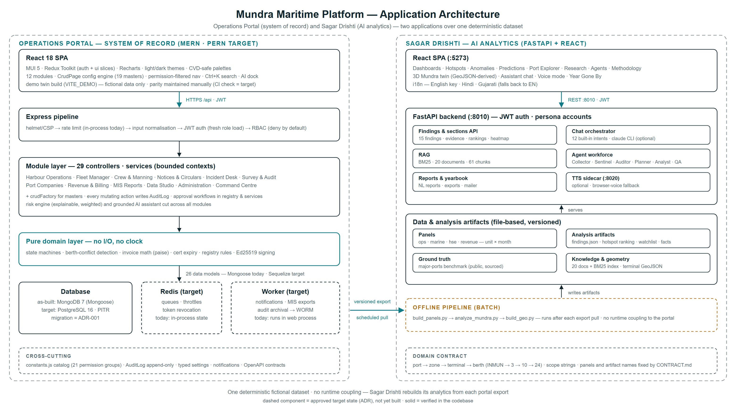
Figure 1 — Current application landscape: the operations platform (system of record) and the AI analytics portal, coupled only by a versioned data export.

1.2 Current production reference architecture (Azure)
In operation today — the foundation the target infrastructure (Section 7) evolves from. Only HTTPS 443 is public; the database is reachable only privately; administration is via P2S VPN and a jump-box.
Component | Role | Port / path
Application Gateway + WAF | Secure public entry point for all users | HTTPS 443
Front-end (presentation VNet) | Presentation layer | HTTPS 443
Azure Firewall | Filters traffic between front-end and app layer | HTTPS 443
App layer (application VNet) | Application services | HTTPS 443
Keycloak SSO (identity VNet) | Single sign-on identity provider (migrates to Entra ID in the target state) | 443 / SSH 22
PostgreSQL | Database — private network only | TCP 5433
Key Vault | Secrets, keys and certificates | HTTPS 443
Storage + Blob | Files and diagnostics | HTTPS 443
Jump-box + VPN hub | Admin access path (P2S) | RDP 3389 / SSH 22
Backup Vault + DR region | Daily restore points; replicated VMs/disks in a second region | —

- DevSecOps in operation: static analysis (SonarQube) with CI quality gates · dynamic testing (OWASP ZAP) · continuous vulnerability management (Qualys) with CVSS-based patch SLAs · periodic grey-box VAPT with re-test evidence.

2. Method — one module at a time
Each module passes through the same template, in this order:
- Current modules detailing
- Flowcharts
- Roles & permissions
- Business benefits
- Functional requirements compliance
- AI section — agents, AI compliance, AI benefits
- Improvements TO BE — delta develop · application revamp · unified data architecture platform · AI agents + AI platform
- Effort estimation in man-weeks
This issue applies the template to Master Data Management at full depth — including its target architecture on the Azure stack and the AI pipeline that keeps golden records golden. Section 6 catalogues the remaining modules queued for the same treatment.

3. Module 1 — Master Data Management
Master data is where the RFP's core promise — single master records for vessels, seafarers, companies, ports and facilities, shared across all seven domains with zero duplication (RFP §5.4.1, §7.5) — is won or lost. The current platform already runs a disciplined master-data layer; this section details it feature by feature, then its target architecture on Azure, then the AI pipeline.

3.1 Modules detailing — current features, in depth
# | Feature | How it works today
1 | Config-driven CRUD engine | - Every master is a configuration, not a component: list + search + filters + pagination (capped at 100 rows) + a slide-over add/edit drawer, all rendered by one engine from a column/field definition.  - Adding a master is a configuration entry, not a code change — the seed of the RFP's low-code requirement.
2 | Lookup framework — 19 categories | One unified, category-keyed store covering:  - vessel types  - cargo types  - ports (UN/LOCODE)  - shipping agents  - deficiency codes  - PSC action codes  - countries  - states  - cities  - units of measure  - currencies  - equipment types  - equipment & assets  - departments  - designations  - shifts  - document types  - incident locations  - holiday calendar.  Every entry carries an active/inactive flag; inactive values stop appearing in forms but keep rendering in history.
3 | Berths & terminals master | A structural master with behaviour: terminal grouping, capability limits (maximum LOA, declared draft) enforced during berth allocation, maintenance status, outage capture with reasons and durations, and 12-month availability statistics (e.g. 40 outages · 262 days lost · 97% availability) with a per-berth outage-history drawer.
4 | Tariff master with dated rate history | Each tariff item (basis: GRT/service/cargo, unit, currency) preserves its full rate history; historical invoices always reference the rate in force at their time — 'what did this cost in March 2024?' is answerable. The single pricing source for the billing engine.
5 | Versioned checklist templates | Inspection templates are versioned and copied into each inspection at creation, so template evolution never mutates completed inspections — the substrate for the RFP's dynamic AI checklists.
6 | Document numbering series | Per-series, per-year counters (calls, inspections, incidents, licences, invoices) driven by settings-held prefixes, with uniqueness guaranteed — no gaps abused, no duplicates possible.
7 | Typed module settings | Behavioural knobs for all 12 modules (expiry windows, tug rules, GST rounding, session timeout, audit retention…) with typed defaults, server-side validation and in-process caching — behaviour is configuration, not code.
8 | Single-source catalog | Permission groups, workflow state machines, lookup categories, numbering prefixes and setting defaults live in one definition; backend middleware, the seeding pipeline and the frontend matrix editor all read the same source — drift is architecturally impossible.
9 | Integrity rules | Soft delete only for referenced masters (deactivate, never disappear); derived values (certificate validity, berth availability, vessel risk) are computed live and never stored stale.
10 | Governance | masters.view/manage and tariffs.view/manage permissions, deny-by-default on every route; every change writes an immutable audit entry with actor and before/after snapshots, reviewable with JSON diffs.

3.2 Feature inventory — the complete module surface
Section 3.1 describes the ten headline capabilities in depth. The table below is the complete inventory — every feature of the Master Data Management module as it runs today, grouped by family. Each is demonstrable live; Section 3.3 shows nine of them on screen.
# | Feature | What it does today
A · Catalogue and engine
1 | Config-driven CRUD engine | - Every master is a configuration entry, not a component.  - One engine renders the list, server-side search, filters, column sort, pagination and the slide-over add/edit drawer from a single column/field definition.  - Adding a master is a configuration change, not a code change — the seed of the RFP’s low-code requirement.
2 | Data Studio hub | Every configuration master presented as an icon card in six families — geography, commercial, marine, assets, organisation, compliance — each showing its live record count.
3 | Lookup framework — 19 categories | - One category-keyed store, unique on (category, code), covering vessel types  - cargo types  - ports (UN/LOCODE)  - shipping agents  - deficiency codes  - PSC action codes  - countries  - states  - cities  - units of measure  - currencies  - equipment types  - equipment & assets  - departments  - designations  - shifts  - document types  - incident locations  - holiday calendar.
4 | Typed attribute extension | Each category carries its own typed attributes: a cargo type holds statistical group, unit and MT conversion factor; a shipping agent holds address and tax registration; a holiday holds date and working note; a city holds its state and country.
5 | Raw lookup editor | A tabbed view across every category with direct attribute editing, for bulk reference-data work and for categories whose attributes are still being shaped.
6 | Active / inactive lifecycle | Every entry carries an active flag. Inactive values stop appearing in forms but keep rendering in history, so records written when the value was current stay readable.
7 | Export | Excel, PDF and CSV export from any master, honouring the search term, filters and sort currently applied to the list.
B · Structural masters that carry behaviour
8 | Berths & terminals master | Terminal grouping, berth type, maximum LOA, declared maximum draft, operational status and remarks — the physical inventory behind the berth board and the quay twin.
9 | Capability-limit enforcement | Maximum LOA and declared draft are enforced server-side during berth allocation: a vessel that exceeds the limits cannot be assigned to the berth.
10 | Outage capture | Dated outage windows per berth with kind (planned, breakdown, dredging, weather), reason, duration in days and the party that carried out the work.
11 | Per-berth availability analytics | Rolling-window availability percentage, days lost, outage count, breakdown by cause, longest outage and a month-by-month series — all computed on read from the outage windows.
12 | Estate downtime panel | Availability across the whole berth estate with by-cause and by-terminal breakdowns, worst-affected berths and a monthly trend line.
13 | Referential protection | A berth carrying active or planned port calls cannot be deleted; the attempt is refused with the reason.
C · Pricing master
14 | Tariff master | Code, charge name, category, unit basis (per GRT, per TEU, per movement, per day), rate, currency and active flag — the single pricing source the billing engine reads.
15 | Dated rate history | Every revision preserved with its effective-from date, the previous rate, the change percentage, the circular that published it and a note.
16 | Rate-in-force resolution | Invoices resolve the rate that applied on their own date, so historical documents never move when the rate card changes — “what did this cost in March 2024?” is answerable.
17 | Rate history analytics | Base versus current rate, cumulative change, average revision, compound annual growth and a step series for the rate trend.
D · Template and numbering masters
18 | Versioned checklist templates | Item sets with section category, answer type, weight, critical flag, inspector guidance and a pass score — versioned as they evolve.
19 | Copy-on-use versioning | A template is copied into each inspection at creation, so later template changes never mutate completed inspections — the substrate for the RFP’s dynamic AI checklists.
20 | Document numbering series | Per-series, per-year counters for calls, inspections, incidents, licences, certificates and invoices, driven by settings-held prefixes, allocated inside the same transaction so uniqueness is guaranteed.
E · Configuration
21 | Typed module settings | Behavioural knobs for all 12 modules — expiry windows, tug rules, tax rounding, session timeout, audit retention — with typed defaults, server-side validation, in-process caching and reset-to-defaults.
22 | Platform settings | Organisation identity, base currency, timezone, tax registration, billing, notification and mail configuration, each section feeding live behaviour across the portal.
23 | Single-source catalog | Permission groups, workflow state machines, lookup categories, numbering prefixes and setting defaults live in one definition that backend middleware, the seeding pipeline and the frontend matrix editor all read — drift between them is architecturally impossible.
24 | Jurisdiction profile | Benchmark set, port-state-control regime, currency and tax conventions, working week, registry statute and ports of registry as one swappable profile. Every figure carries its published source; anything that cannot be sourced is flagged unverified rather than passing silently as fact.
F · Integrity and governance
25 | Soft delete for referenced masters | Referenced entries deactivate rather than disappear, so historical transactions stay resolvable against retired masters.
26 | Derived values computed on read | Certificate validity, berth availability and vessel risk are computed at read time and never stored, so no master can hold a stale derived value.
27 | Typed validation | Schema validation per master, a category whitelist on lookups, non-negative rate enforcement and mandatory checklist item text — refusals carry the reason.
28 | Permission gating | masters.view / masters.manage and tariffs.view / tariffs.manage, deny-by-default on every route.
29 | Immutable audit | Every create, update and delete writes an audit entry with actor, entity, label and before/after snapshots, reviewable as a JSON diff.
30 | Visual permission matrix editor | A role by module.action grid, read from the same single-source catalog the middleware enforces at run time.

3.3 The module in operation
The screenshots below are of the running platform, captured from the live build. They are included so that every capability claimed in Sections 3.1 and 3.2 can be checked against the software rather than taken on trust.
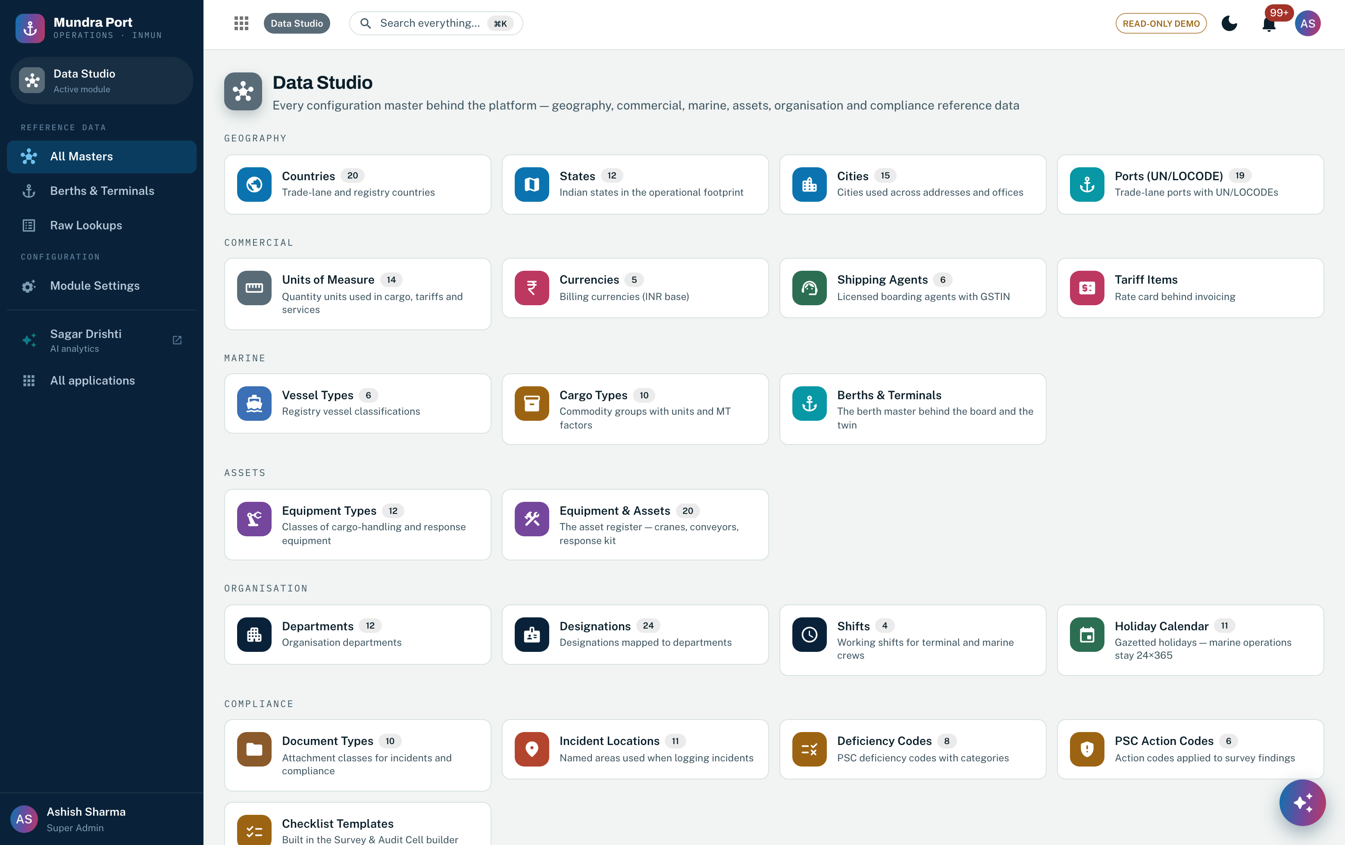
Screenshot 1 — Data Studio: every configuration master as a card in six families, each with its live record count. Features 1–3.
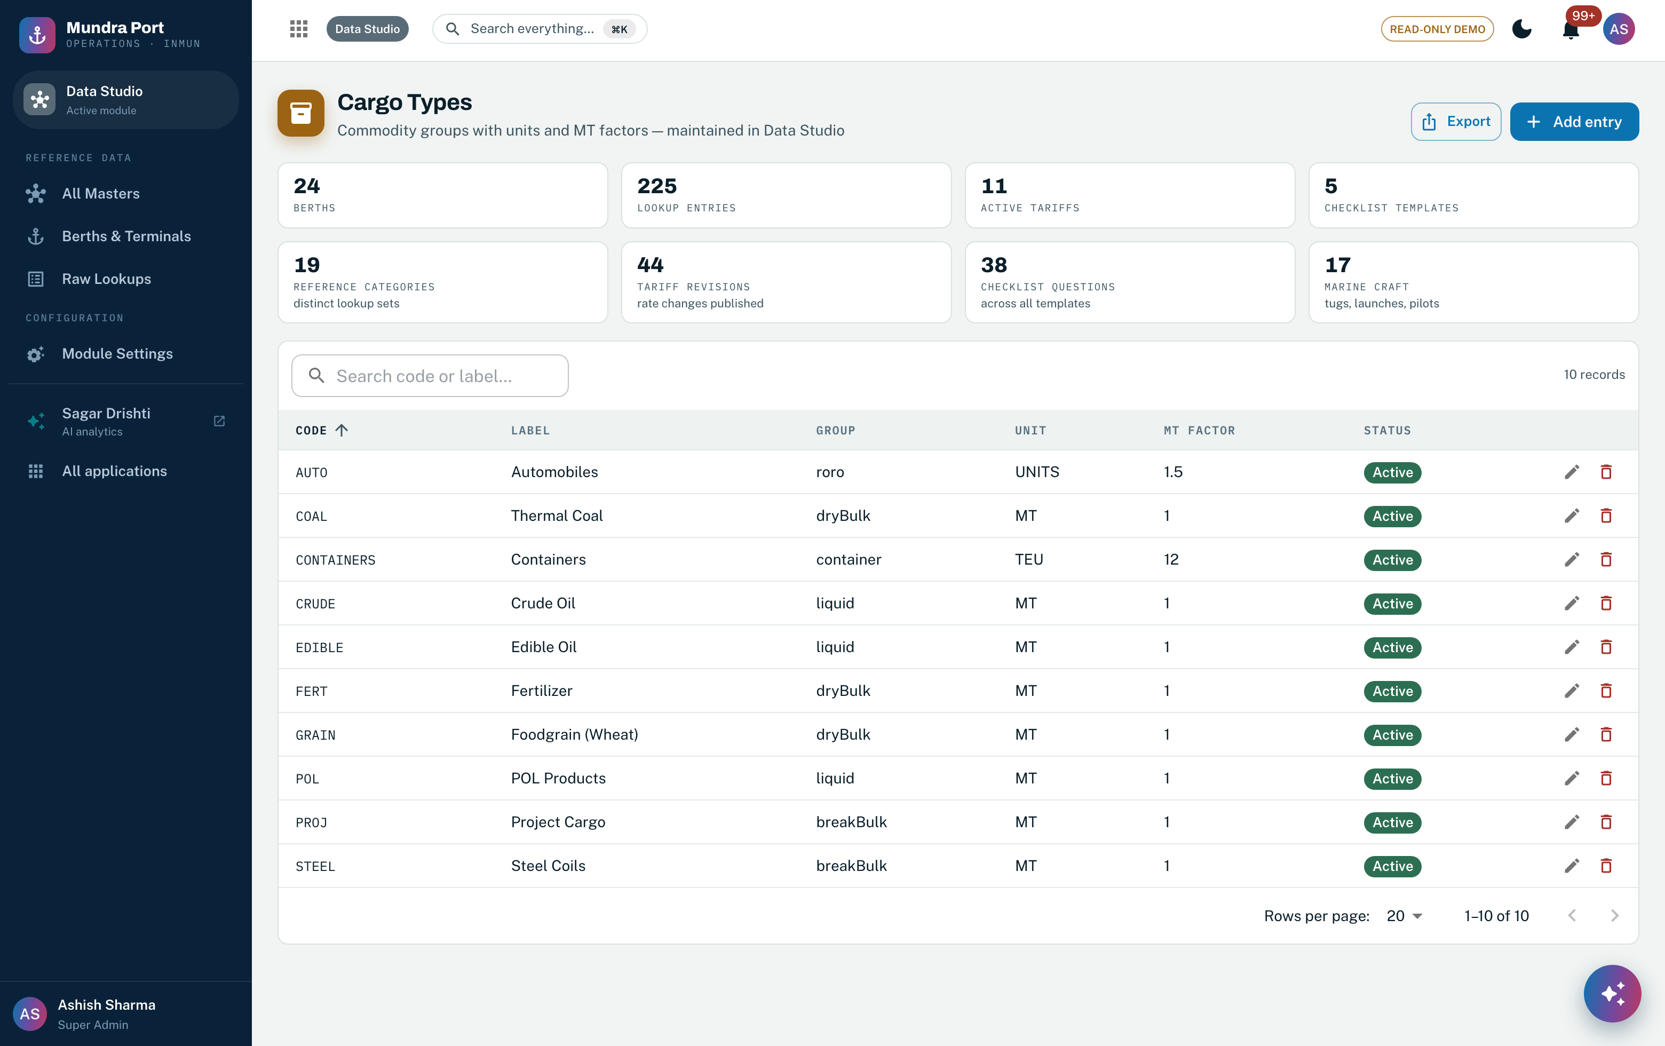
Screenshot 2 — One master, rendered by the config-driven engine: list, search, filters, sort, pagination, export and the add/edit drawer, with the category’s own typed attributes (statistical group, unit, MT factor) as columns. Features 1, 4, 7.
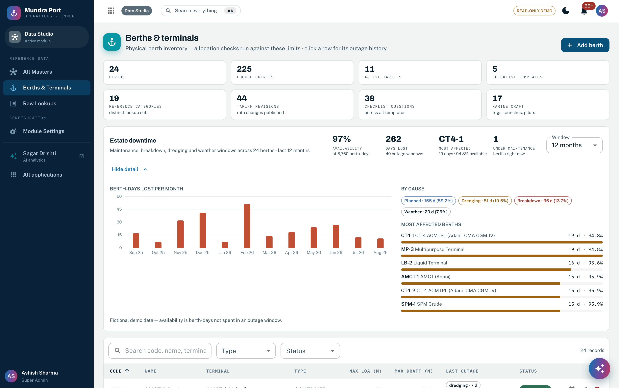
Screenshot 3 — The berths & terminals master with its estate downtime panel: availability, days lost, cause breakdown and the worst-affected berths, computed from dated outage windows. Features 8–12.
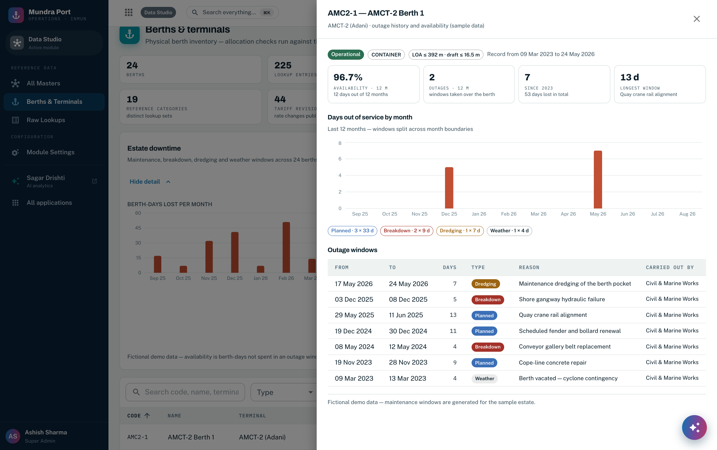
Screenshot 4 — One berth’s outage history: rolling availability, days out of service by month, and every window with its kind, reason, duration and the party that carried out the work. Features 10, 11, 26.
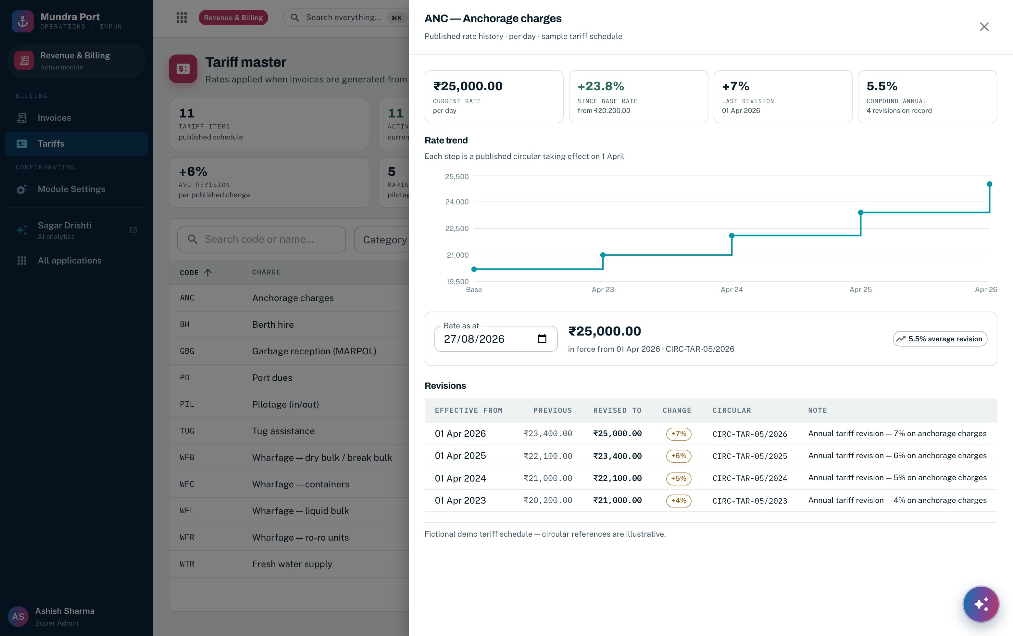
Screenshot 5 — Dated rate history on a tariff head: base versus current rate, cumulative change, compound annual growth, the rate-trend step series, and every revision with its effective date and publishing circular. Features 14–17.
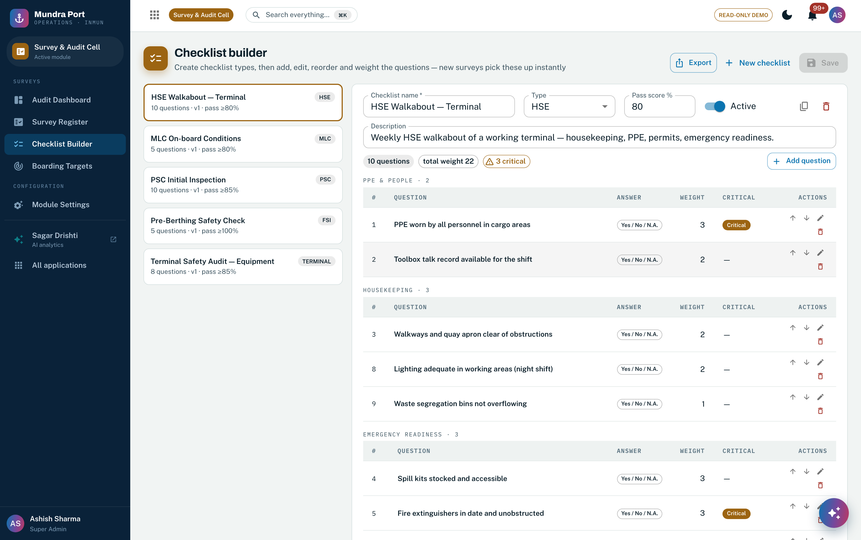
Screenshot 6 — Versioned checklist templates with section categories, answer types, weights, critical items and a pass score. A template is copied into each inspection at creation, so completed inspections never move. Features 18, 19.
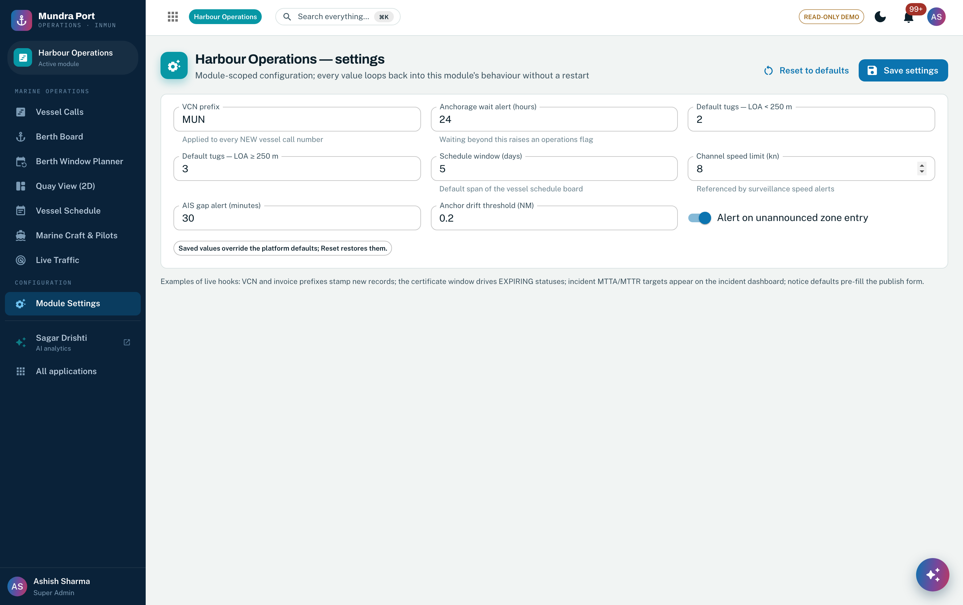
Screenshot 7 — The typed module-settings engine, shown here for Harbour Operations: typed defaults, server-side validation and reset-to-defaults. Every one of the 12 modules has its own settings page on this same engine, Data Studio included. Feature 21.
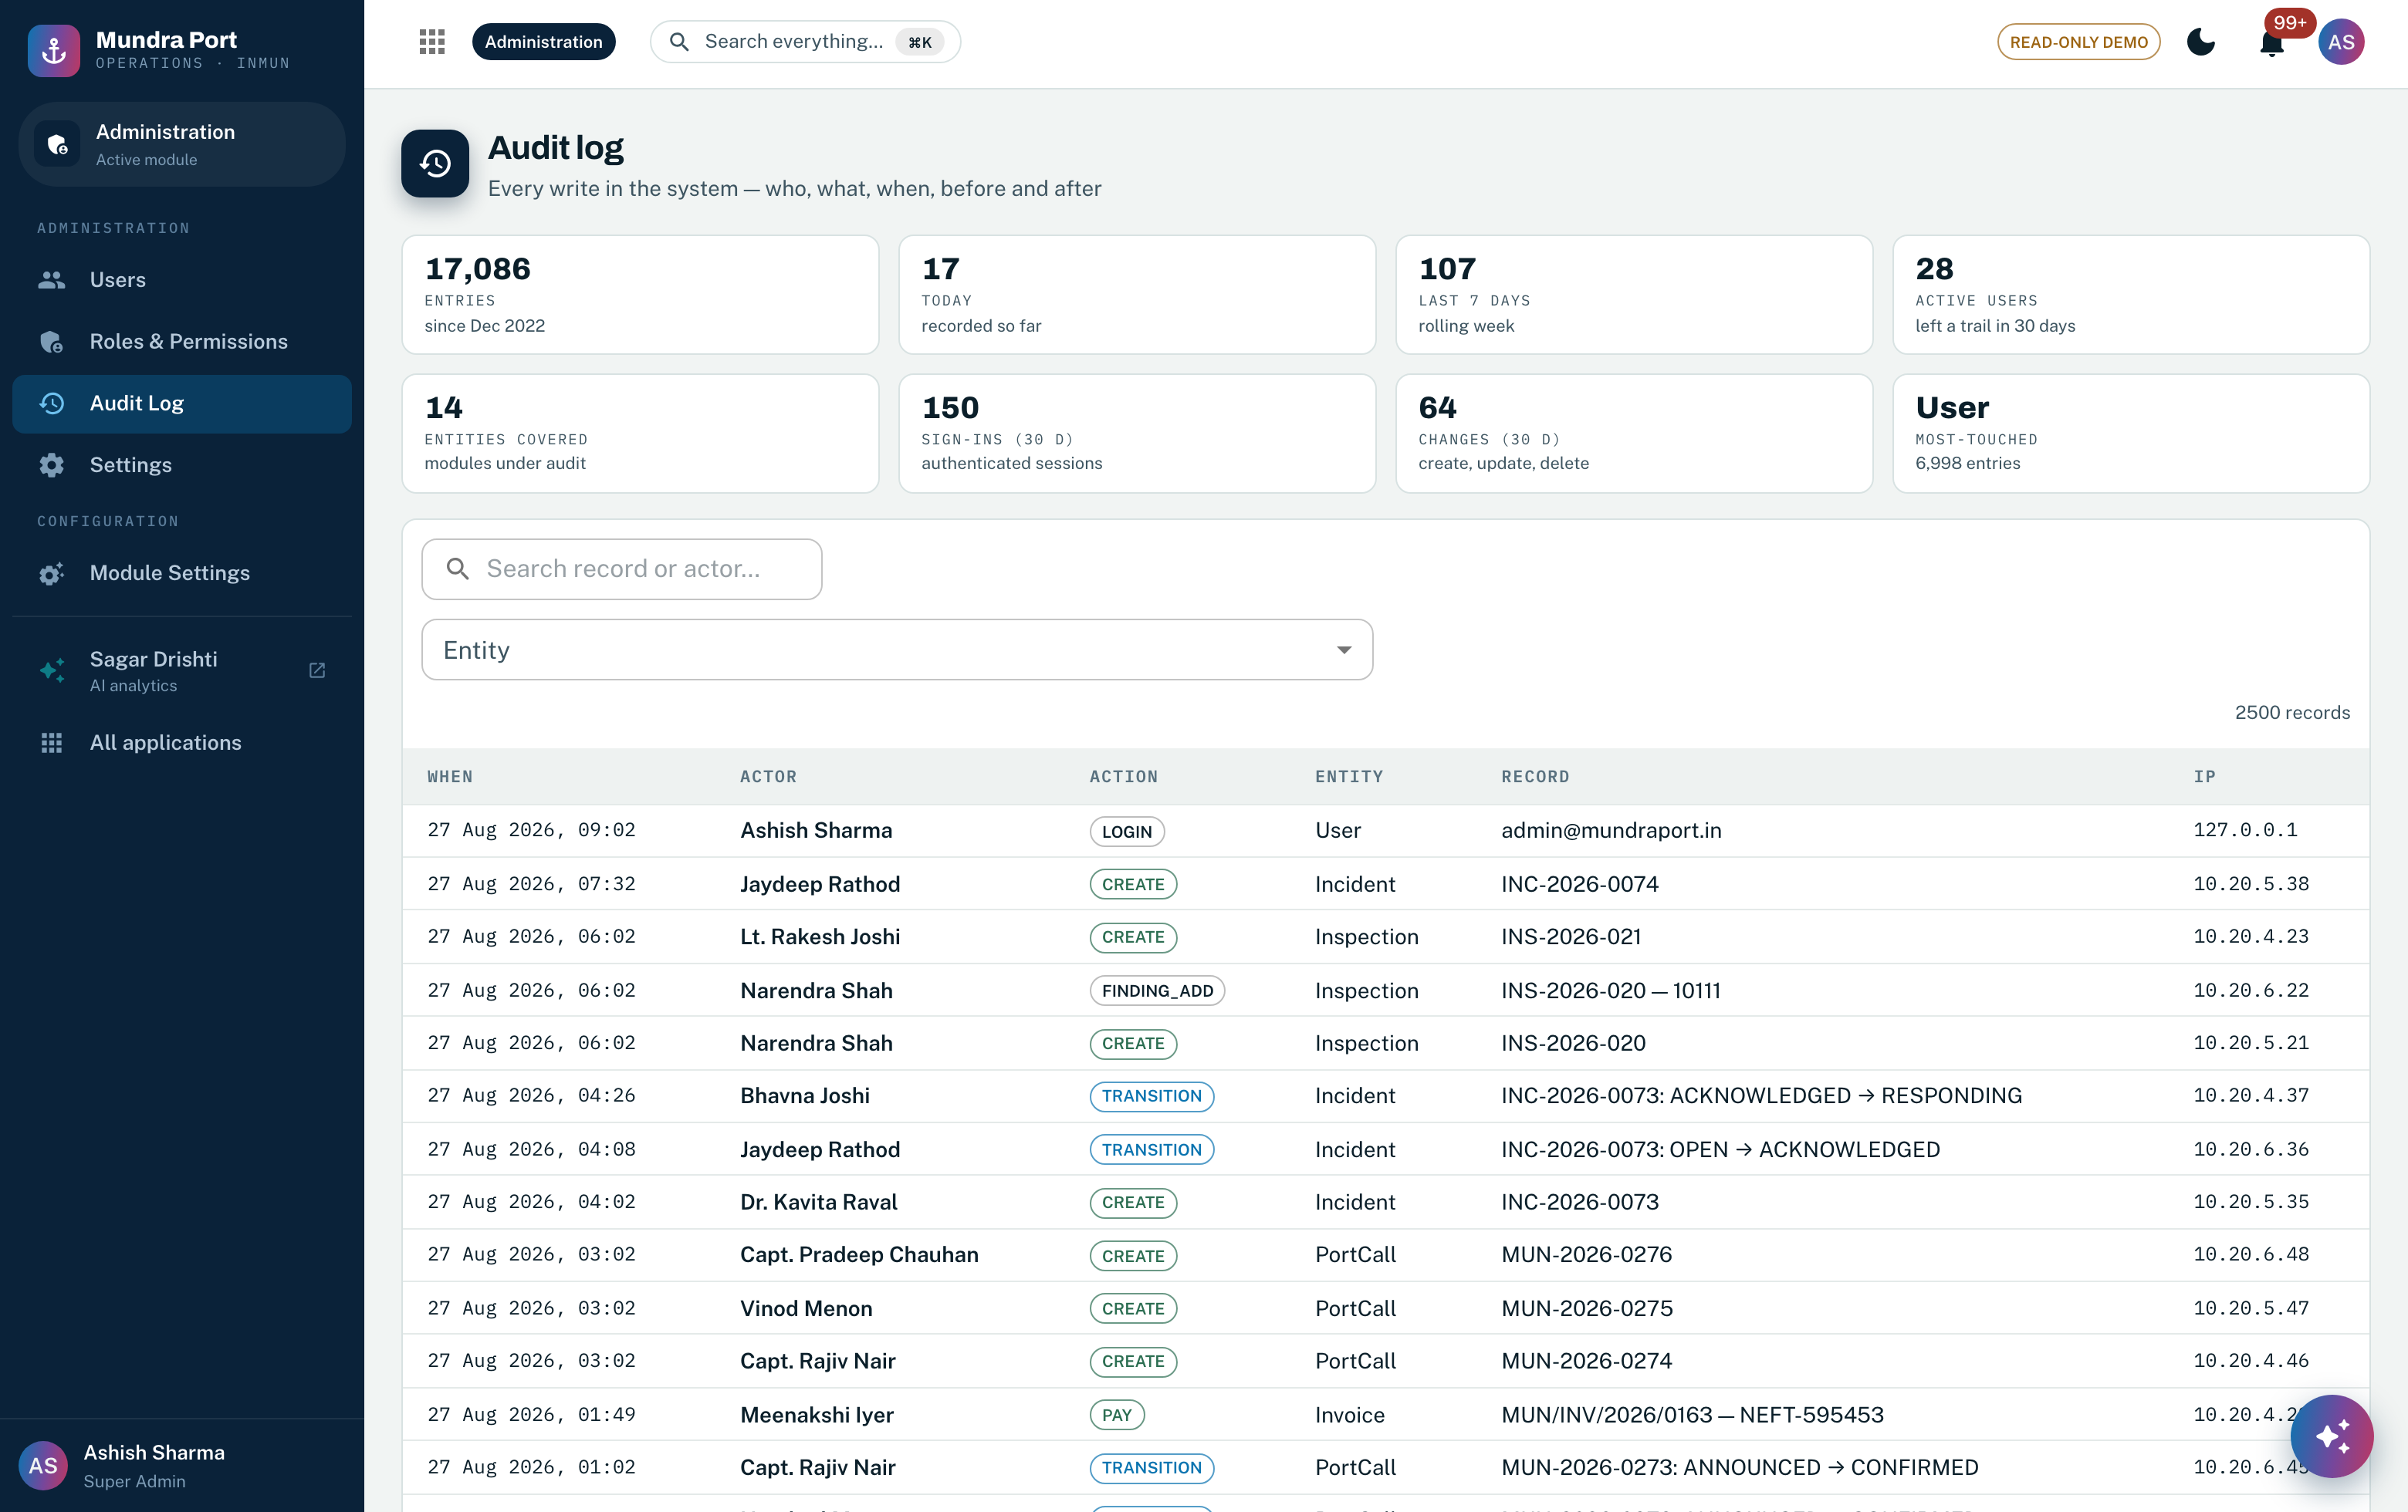
Screenshot 8 — The immutable audit register: every write in the system with actor, action, entity, record and before/after snapshots. Master-data changes are audited on exactly the same terms as transactions. Feature 29.
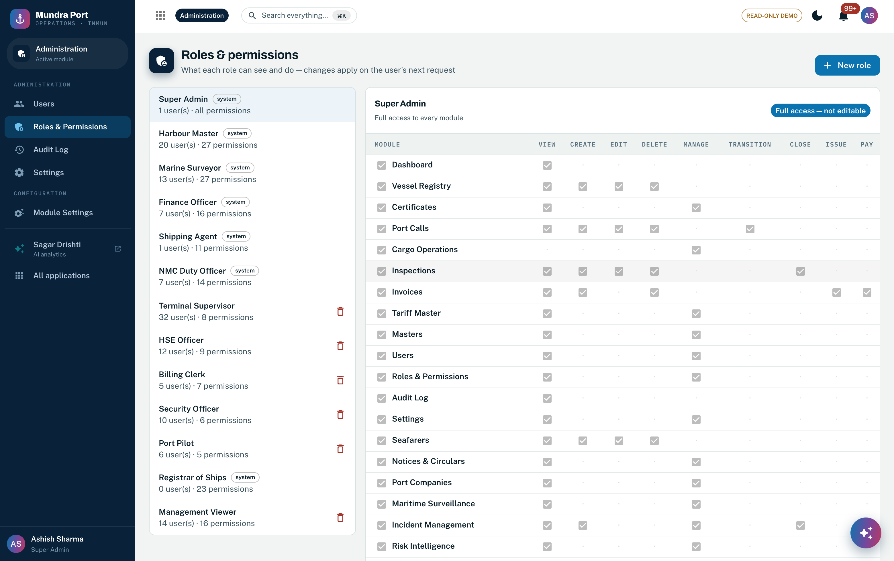
Screenshot 9 — The visual permission matrix: roles against module.action permissions, read from the same single-source catalog the deny-by-default middleware enforces at run time. Features 23, 28, 30.

3.4 Flowchart
Step | Actor | Behaviour
1 | Data steward (permission-gated) | Opens the master in the Data Studio; proposes add/edit via the standard drawer
2 | System — validation | Typed validation against the master's schema; referential rules block breaking changes (soft delete only for referenced rows)
3 | System — persistence | Change saved; audit entry written with before/after snapshots; versioned masters (tariffs, checklists) preserve the prior version
4 | System — propagation | Dependent modules see the new value immediately (single source, no copies); derived values recompute on next read
5 | TO-BE addition | Maker-checker approval on sensitive masters and change-event publication to all domain services (Section 3.6)

3.5 The canonical master data model
The RFP’s single-master-record requirement (§5.4.1, §7.5) is a statement about a data model before it is a statement about infrastructure. Figure 2 sets out that model: the five golden entities and the key each is identified by, the reference masters that type and price them, the instruments and records issued against them across the seven domains, and the one governance rule set that applies to every golden record. Ownership is single and explicit — each entity is mastered by exactly one domain service and consumed by the rest, which is what makes “zero duplication” enforceable rather than aspirational.
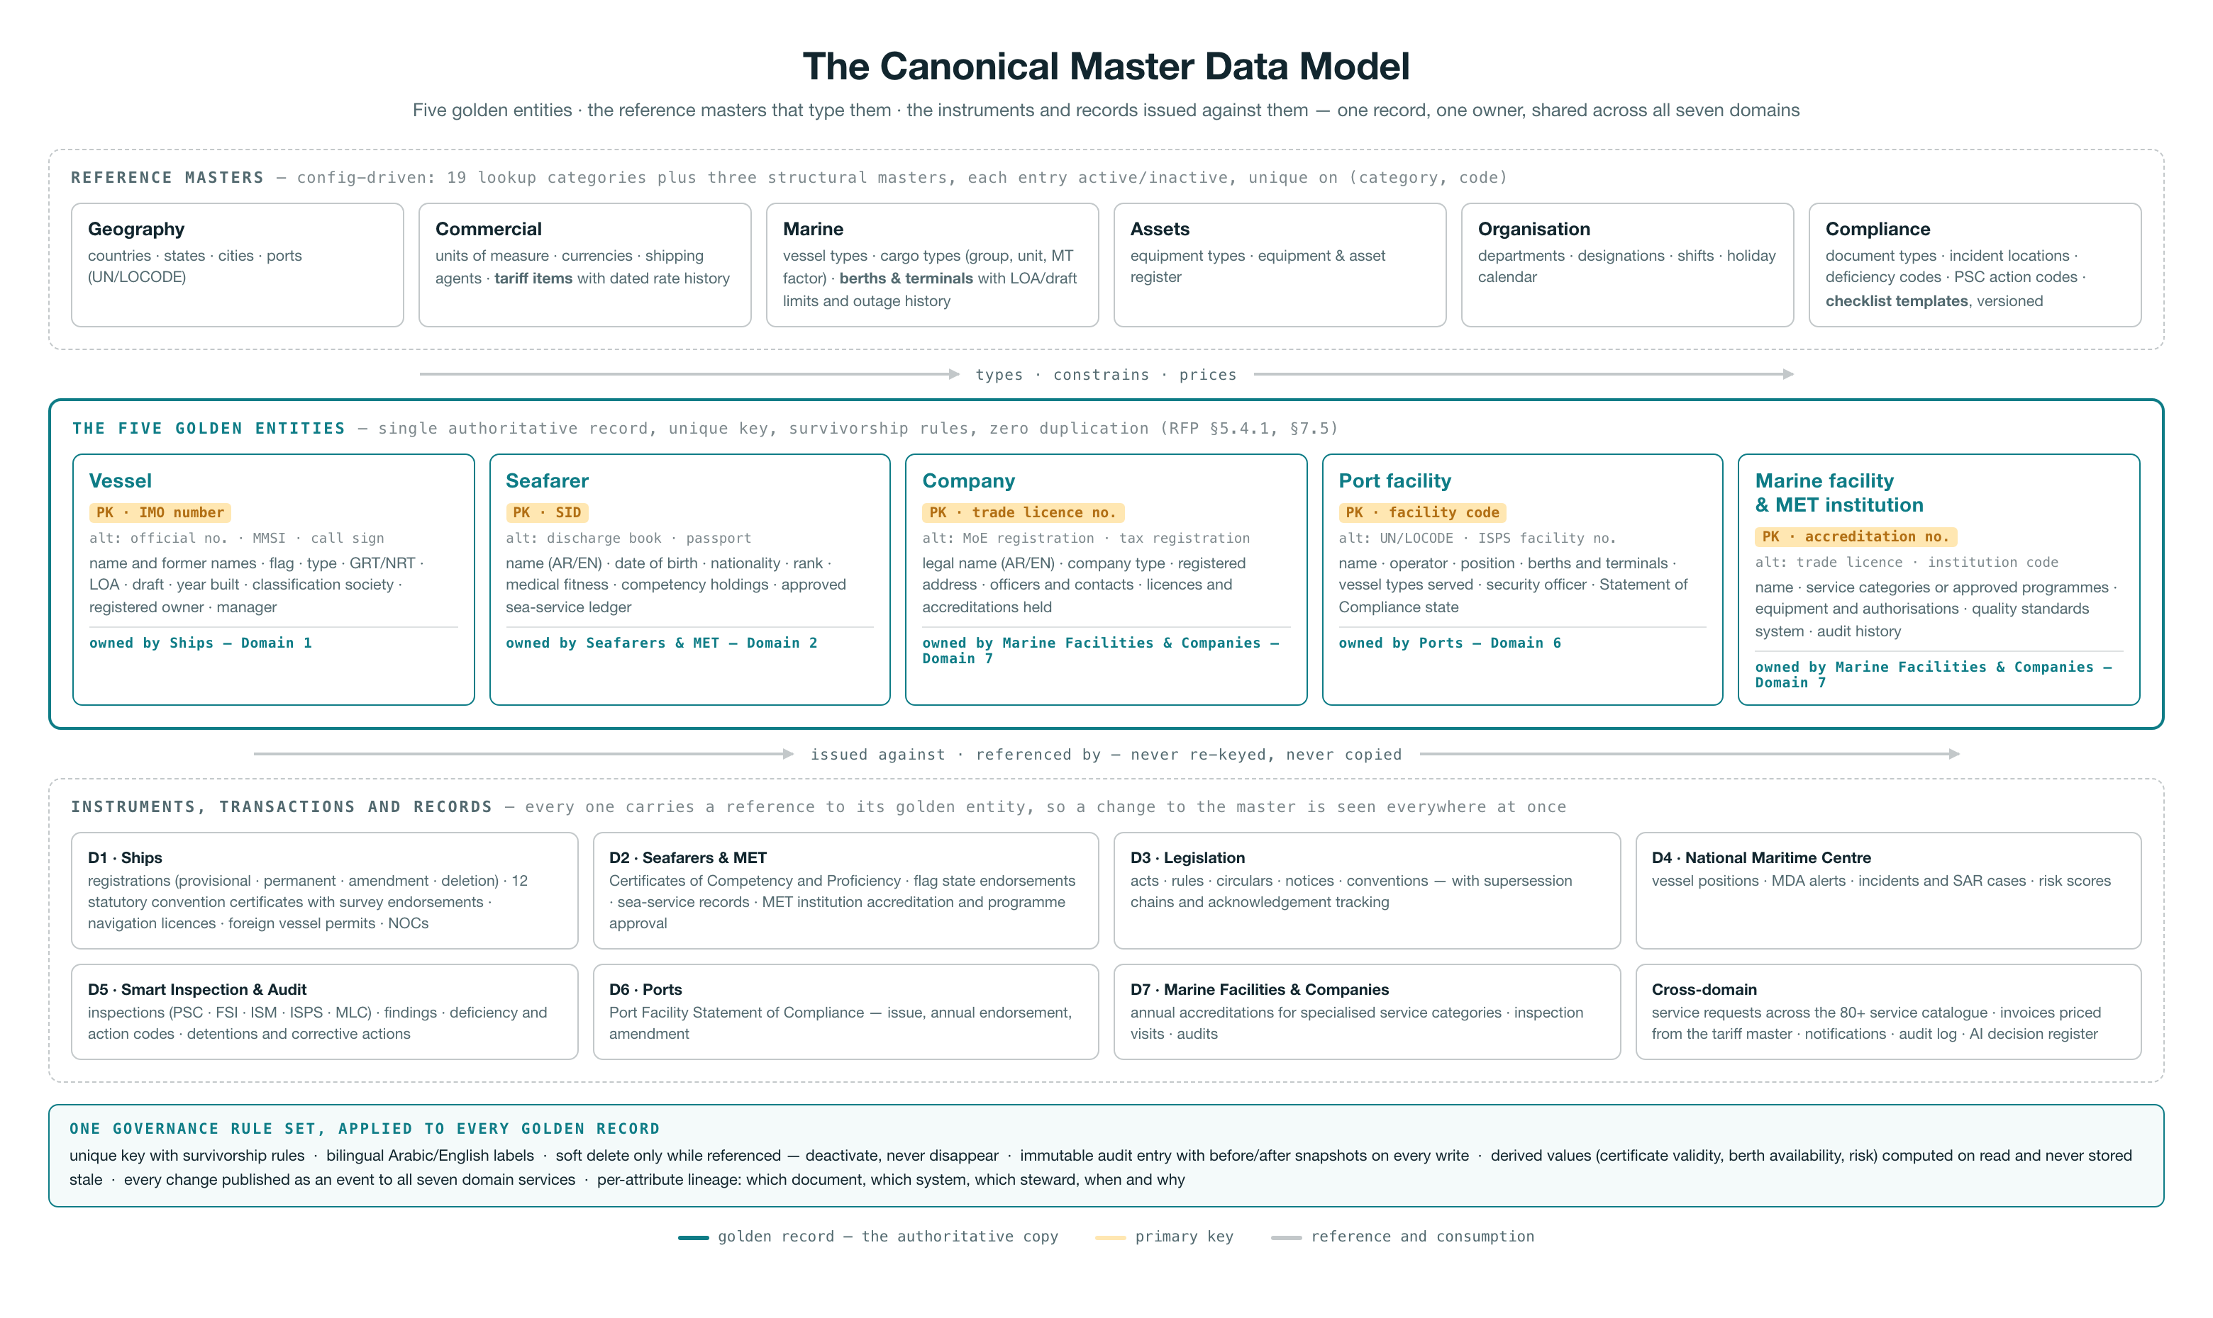
Figure 2 — The canonical master data model: reference masters (19 lookup categories plus three structural masters) type and price the five golden entities; every instrument, transaction and record across the seven domains references a golden entity rather than re-keying it; one governance rule set — unique key and survivorship, bilingual labels, soft delete, immutable audit, derived values computed on read, change events to all seven domains, per-attribute lineage — applies to every golden record.

3.6 Target architecture on Azure for Agentic AI flows
Golden records stay transactional in PostgreSQL (ACID, private endpoint); the analytical and AI plane runs on ADLS Gen2, Azure ML and AI Search; intake runs through AI Document Intelligence with a steward-in-the-loop; every change propagates in real time over Service Bus. Figure 3 is the complete flow; the numbered narrative follows.
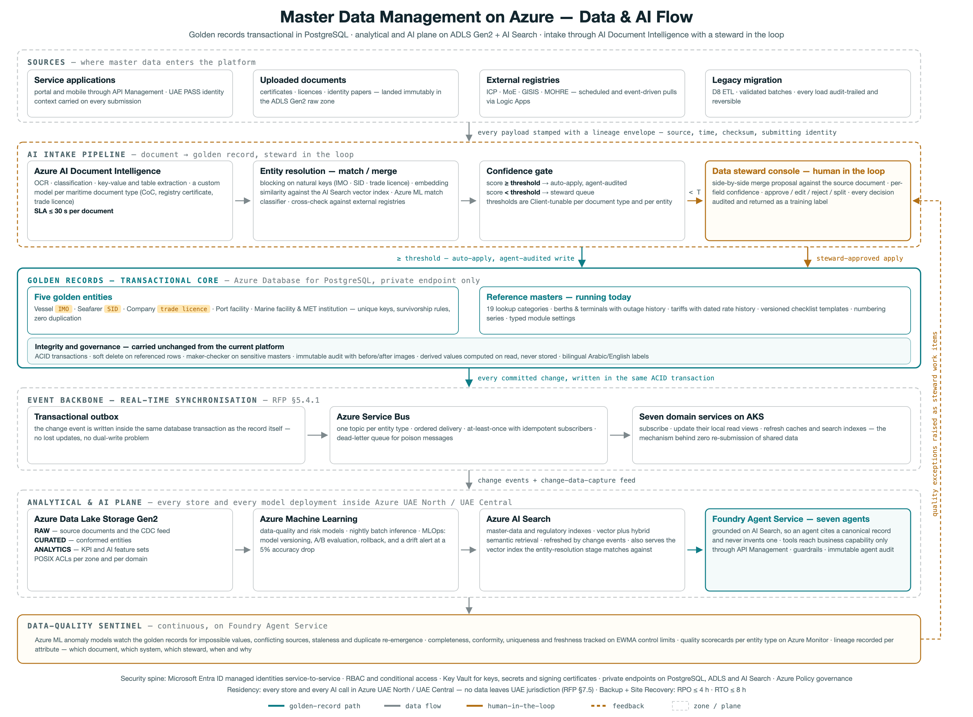
Figure 3 — Master Data Management on Azure: sources → AI intake pipeline (Document Intelligence → entity resolution → confidence gate → steward console) → PostgreSQL golden records → event backbone (outbox → Service Bus → 7 domain services) → analytical & AI plane (ADLS Gen2 zones → Azure ML → AI Search → Foundry agents), with the continuous data-quality sentinel beneath.
- 1 — Sources. Master data enters four ways: service applications (portal/mobile through API Management, carrying UAE PASS identity context), uploaded documents (landed in the ADLS raw zone), scheduled pulls from external registries (ICP, MoE, GISIS, MOHRE), and the audited D8 legacy-migration ETL.
- 2 — AI intake. Azure AI Document Intelligence extracts structured attributes (≤30 s per document, custom models per maritime document type); the entity-resolution stage blocks on natural keys (IMO, SID, trade licence) and scores candidate matches with embedding similarity plus rules; a Client-tunable confidence gate auto-applies high-confidence results (agent-audited) and queues the rest for the data-steward console — the human-in-the-loop the RFP's governance model requires.
- 3 — Golden records. The five golden entities and today's reference masters live in PostgreSQL with the integrity rules the current platform already enforces: ACID transactions, soft delete, maker-checker on sensitive masters, immutable before/after audit, bilingual labels.
- 4 — Real-time sync. A transactional outbox publishes every golden-record change to Azure Service Bus topics; the seven domain services subscribe and update their local views — the mechanism behind 'zero re-submission' and RFP §5.4.1 real-time synchronization. High-volume streams (AIS/LRIT) stay on Event Hubs; Azure Functions run the lightweight processors.
- 5 — Analytical & AI plane. Change data flows to ADLS Gen2 (raw → curated → analytics zones); Azure ML trains and runs data-quality and risk models with drift alerts; Azure AI Search maintains master-data and regulatory indexes (vector + hybrid) that ground the Foundry agents — agents cite canonical records, never free text.

3.7 Current feature and migrating to target state
Current MDM capability | Target Functionality with Agentic AI flows
19-category config-driven lookup framework (vessel types, cargo types, UN/LOCODE ports, deficiency codes, PSC action codes, currencies, etc.) | The config-driven CRUD engine carries over unchanged inside the relevant domain services on AKS, with its relational store deployed in UAE North with UAE Central DR. Lookup maintenance is exposed through Azure API Management under Entra ID SSO/RBAC, and reference values are additionally published to the ADLS Gen2 curated zone and indexed in Azure AI Search so the Foundry agents (A1 certificate validation, A2 compliance, A6 regulatory intelligence) ground against the same controlled vocabularies the portal uses.
Berths & Terminals master with LOA/draft capability limits and outage/downtime history | - Moves intact into the Ports domain service on AKS; capability-limit validation and outage recording stay server-side exactly as today.  - Outage and status events are additionally published to Azure Service Bus topics so dependent services and the A7 National Maritime Intelligence agent react in near real time, and the outage history feeds the ADLS Gen2 analytics zone for availability reporting.  - Availability statistics remain computed on read, never stored.
Tariff master with dated rate history | - Retained within the Ports / Marine Facilities & Companies services with effective-dated rate resolution logic unchanged.  - Rate changes go through Azure API Management with the existing audit trail, and Azure Logic Apps adds a low-code approval workflow for tariff revisions with Azure Communication Services notifying stakeholders.  - Historical rates replicate to the ADLS Gen2 analytics zone for revenue analytics and the A3 Service Processing agent's fee calculations.
Versioned checklist templates, copied into each inspection at execution time | Carries over into the Smart Inspection domain service with the copy-on-use versioning semantics preserved, so completed inspections stay bound to the template version they were executed against. Templates synchronize to inspector devices through Azure IoT Hub edge store-and-forward for offline field work, and template content is indexed in Azure AI Search so the A5 Smart Inspection agent grounds its pre-inspection dossiers and AI-drafted reports on the current approved checklist.
Per-series / per-year document numbering engine | - Remains a transactional server-side component inside each owning domain service, since sequence integrity depends on the service's own database transaction — no change to the allocation semantics.  - Numbering configuration is administered through the same Azure API Management-fronted APIs, and issued numbers are visible to the A3 agent for zero-touch application processing.  - Series definitions per document type and year carry over as-is.
Typed module settings store | - The typed, validated settings store carries over per domain service for business configuration, still audited on change.  - Secrets and connection material move out of settings into Azure Key Vault, accessed by AKS workloads through Entra ID managed identities, while Azure Policy enforces platform-level configuration compliance.  - Agent autonomy-level settings (supervised through autonomous) follow the same typed-settings pattern, surfaced to the Foundry Agent Service guardrails.
Single-source permission catalog feeding backend middleware, seeding, and the frontend matrix editor | - The catalog stays the single source of truth for module.action permission strings and the deny-by-default middleware in every AKS microservice — this pattern carries over intact.  - Permission groups map onto Microsoft Entra ID groups and app roles, so SSO, MFA, and conditional access govern who holds them, with UAE PASS federated OIDC login for customer identities  - Azure API Management adds coarse-grained scope enforcement at the gateway.  - The visual matrix editor is retained for fine-grained assignment.
Soft-delete-only integrity for referenced master records | - Soft-delete semantics carry over in each domain service, keeping historical transactions resolvable against retired masters.  - Because masters are now consumed across services and AI indexes, a deactivation event is published on Azure Service Bus so dependent services and the Azure AI Search indexes mark the record inactive consistently.  - Azure Backup and Site Recovery provide the platform recovery envelope (RPO <= 4h, RTO <= 8h) without altering application-level integrity rules.
Audit log with before/after images on every mutating write | - The controller-level audit pattern carries over unchanged in every domain service and extends to cover agent-initiated writes, satisfying the RFP's immutable agent audit requirement — Foundry Agent Service actions land in the same actor/entity/before-after model with the agent as actor.  - Audit streams ship to Azure Monitor and Application Insights for operational alerting and archive immutably to the ADLS Gen2 governed zones, supporting explainability retrieval within 30 seconds.
Derived values (certificate validity, berth availability, risk) computed on read, never stored | - The compute-on-read rule carries over for deterministic derivations such as certificate validity and availability, keeping masters free of stale denormalized state.  - Statistical derivations — vessel risk scores for A5 dossiers and A2 compliance — graduate to Azure Machine Learning models with MLOps deployment, drift monitoring (5% accuracy-drop alerting), and A/B evaluation, trained from the ADLS Gen2 analytics zone but still served on demand rather than persisted as master data.
Entity master records: vessels, seafarers, companies, ports, marine facilities | - Each master moves to its owning domain service on AKS — Ships, Seafarers & MET, Ports, Marine Facilities & Companies, with NMC consuming them — preserving single ownership per entity.  - Cross-service access goes through Azure API Management, change events broadcast on Azure Service Bus, and masters are indexed in Azure AI Search to ground A2 (100% automated compliance monitoring) and A7 (100% UAE-flag coverage)  - supporting certificates and documents are captured via Azure AI Document Intelligence into ADLS Gen2 and linked to the master record.
Deterministic demo/seed data tooling (fixed PRNG seed, anchored history window) | - The deterministic seeding carries over as environment-provisioning tooling for dev, test, and training namespaces on AKS, with seeded datasets confined to non-production ADLS Gen2 zones inside the UAE regions.  - Its reproducibility gains a second role: fixed, known-answer datasets become regression baselines for Foundry Agent Service evaluation runs and Azure Machine Learning model validation, so agent accuracy targets (e.g. A1's 95% certificate validation) are measured against a stable corpus.  - Production remains seed-free.

3.8 The MDM AI pipeline — stage by stage
Stage | Mechanics
1. Multi-channel document and data intake | Master-data-bearing content arrives through three routes:  - portal/API uploads pass through Azure API Management into an AKS intake microservice  - scheduled and event-driven pulls from registries and partner systems run as Azure Logic Apps workflows  - high-volume feeds (AIS/LRIT vessel observations) land via Azure Event Hubs.  - Every payload is written immutably to the raw zone of Azure Data Lake Storage Gen2 (UAE North, encrypted with Key Vault-managed keys), and an Azure Function stamps a lineage envelope — source, timestamp, checksum, submitting identity from Microsoft Entra ID — before publishing an intake event to Azure Service Bus.  - This stage builds directly on the platform's existing per-series document numbering and audit-log engine: every intake receives a numbered, auditable record with before/after state exactly as the current portal does for all writes.
2. Extraction and classification with Azure AI Document Intelligence | - A Service Bus-triggered Azure Function routes each document to Azure AI Document Intelligence: a custom classifier first assigns the document type (registration certificate, class certificate, crew document, tonnage certificate, invoice, survey report), then a matching custom extraction model pulls key-value pairs and tables — IMO number, call sign, flag, issue/expiry dates, issuing authority.  - Each extracted field carries a per-field confidence score  - fields at or above 0.85 are accepted, fields between 0.60 and 0.85 are flagged for verification, and below 0.60 the whole document is routed to manual keying.  - Structured output is written to the curated zone of ADLS Gen2 and cross-checked by a Foundry Models LLM call against typed validation rules (date coherence, checksum-valid IMO numbers, issuing-authority whitelist).  - This extends the platform's existing document-type master and typed module-settings engine, which already defines per-document-type required fields and validity rules.
3. Standardization and reference-data conformance | - Extracted attributes are normalized against the platform's existing 19-category config-driven lookup engine — vessel types, cargo types, UN/LOCODE ports, countries, currencies, UOM, deficiency and PSC action codes — now hosted as a reference-data microservice on AKS with PostgreSQL.  - Deterministic rules (unit conversion, ISO country/currency coercion, UN/LOCODE resolution) run first  - ambiguous values fall through to a Foundry Models embedding lookup against the reference catalog in Azure AI Search, accepted automatically at cosine similarity >= 0.90 and queued otherwise.  - Because the catalog is single-source — the same file that already feeds backend middleware, seeding, and the frontend permission matrix — a conformance decision made here is identical everywhere the value is consumed.  - Non-conforming values are never overwritten; the raw value is retained alongside the standardized one for lineage.
4. Entity resolution: blocking, embedding match, and merge proposal | - Candidate records (a vessel, seafarer, company, or facility) are first blocked on strong keys — IMO number, MMSI, license number, trade-license ID — so exact-key hits shortcut to a direct match.  - For residual candidates, a Foundry Models embedding of the concatenated identity attributes (name, former names, flag, type, dimensions, owner) is queried against the vector index in Azure AI Search restricted to the block, and an Azure Machine Learning match-classifier scores each candidate pair using attribute-level similarity features.  - The threshold pattern is three-band: score >= 0.92 auto-merge, 0.70–0.92 steward review, < 0.70 create-as-new.  - Survivorship rules (most-recent-authoritative-source wins per attribute, with source trust ranking) compute a merge proposal but never destroy losing values — mirroring the platform's existing soft-delete-only rule for referenced masters and its dated rate-history pattern, where superseded values remain queryable with their validity period.
5. Confidence gating and data-steward human-in-the-loop | - Everything in the review band lands in a steward work queue exposed through the portal UI, protected by the existing deny-by-default RBAC engine with dedicated mdm.review / mdm.approve permission strings and Entra ID conditional access.  - The steward sees the merge proposal side-by-side with source documents (deep link to the original in ADLS), per-field confidence, and the match classifier's feature attribution — satisfying the RFP requirement that any AI decision be explainable and retrievable within 30 seconds.  - Steward decisions (approve, edit-and-approve, reject, split) are captured with before/after snapshots by the same audit-log middleware that already records every platform write, and each decision is fed back to Azure Machine Learning as labeled training data for the match model.  - Escalations follow the RFP service level: unresolved reviews route to a senior steward within 4 business hours via Azure Communication Services notification.
6. Golden record apply and event publication | - Approved merges are applied transactionally by the master-data service on AKS: the golden record is versioned, contributing source records are cross-referenced (never deleted), and derived attributes — certificate validity, berth availability, risk indicators — are computed on read, never stored, per the platform's established rule.  - On commit, the service publishes a MasterDataChanged event to an Azure Service Bus topic  - subscribers include the seven domain services (Ships, Seafarers, NMC, Smart Inspection, Ports, Marine Facilities, Legislations), the AI Search indexer, and Logic Apps workflows that notify downstream consumers via Azure Communication Services.  - This generalizes the platform's existing server-enforced state-machine pattern: a golden record moves PROPOSED → REVIEWED → PUBLISHED → SUPERSEDED with transitions enforced server-side, so no client can skip a gate.
7. Continuous data-quality sentinel | - A resident quality agent — the productionized form of the platform's existing EWMA sentinel monitoring agent — runs on Foundry Agent Service with scheduled sweeps executed as Azure Functions.  - It tracks completeness, conformity, uniqueness, and freshness per master domain, applies EWMA control limits to each metric, and detects duplicate re-emergence by re-running the AI Search embedding match over recently touched records.  - Azure Machine Learning drift monitoring watches the match classifier and extraction models, raising an alert through Azure Monitor when accuracy on the steward-labeled holdout drops 5% — the RFP drift threshold — and triggering a retraining pipeline in AML with A/B rollout before promotion.  - Quality scorecards surface in the portal per domain, backed by the same findings-engine pattern the platform already ships.
8. Serving, grounding, and governance lineage | - Published golden records are indexed into Azure AI Search as hybrid semantic + vector documents with security trimming from Entra ID, so every AI agent (compliance, guidance, inspection) grounds on governed master data rather than raw sources — a direct evolution of the platform's existing BM25 RAG grounded assistant, upgraded to Azure AI Search hybrid retrieval with Foundry Models embeddings and rerankers.  - Structured access flows only through API Management with throttling and full call analytics; no agent reads the database directly.  - End-to-end lineage — raw document in ADLS, extraction confidence, match decision, steward identity, publish event — is reconstructable from the immutable audit trail for any attribute of any golden record, meeting UAE PDPL accountability and the AI Governance Committee's audit needs, with data never leaving UAE North / UAE Central and cross-region DR meeting RPO <= 4h / RTO <= 8h via Azure Backup and Site Recovery.

3.9 Roles & permissions
Current: masters.view/manage and tariffs.view/manage govern the Data Studio; admin groups govern platform masters; deny-by-default with the visual matrix editor. Target: data-steward, approver and publisher modelled as Entra ID app roles gating master-data write endpoints; the MDM service's managed identity is the only principal with write access to the golden-record schema; maker-checker dual control on sensitive masters; per-domain stewardship scoping.
The platform ships thirteen roles. Six are system roles that the seeding pipeline guarantees; the remaining seven are ordinary custom roles, created and edited in the matrix editor exactly as the Client would create its own. Every route is deny-by-default: a role holds a permission or the request is refused.
Role | Code | Type | What the role is for | Permissions
Super Admin | SA | System | Platform administration. The only role that may change master data, module settings, roles and users. | all 65
Harbour Master | HM | System | Marine operations: the port-call lifecycle end to end, berthing, cargo work and incident command. Reads master data, cannot change it. | 27
Marine Surveyor | MS | System | Inspection and certification: surveys, findings, closure, seafarer records, statutory certificates and regulatory instruments. | 27
Finance Officer | FO | System | Revenue: invoicing through issue and payment, and the only role besides the administrator that may publish a tariff revision. | 16
Shipping Agent | AG | System | External party. Announces calls, lodges service and registration applications, tracks its own invoices. No master-data access at all. | 11
NMC Duty Officer | ND | System | Surveillance centre: the live traffic picture, maritime domain alerts, incident response and search and rescue. | 14
Terminal Supervisor | TS | Custom | Terminal shift work: cargo operations and first-line incident reporting. | 8
HSE Officer | HO | Custom | Health, safety and environment: incident response, investigation and closure. | 9
Billing Clerk | BC | Custom | Invoice preparation and collections follow-up. May raise an invoice but not issue or settle one. | 7
Security Officer | SO | Custom | ISPS and gate security: watchkeeping and incident reporting. | 6
Port Pilot | PP | Custom | Pilotage: vessel movements and schedules. Read-only throughout. | 5
Registrar of Ships | RS | System | The registry and service desk: ship registration through grant, statutory certificates, company accreditation, and the audit register. | 23
Management Viewer | MV | Custom | Read-only oversight across every operational module. Holds no write permission anywhere. | 16

The matrix below is the whole authorisation model — 24 permission groups against all thirteen roles. It is generated from the same single-source catalog that the backend middleware enforces and the matrix editor renders, so the document and the running system cannot drift apart.
Module — actions in the group | SA | HM | MS | FO | AG | ND | TS | HO | BC | SO | PP | RS | MV
Dashboard — view | ● | ○ | ○ | ○ | ○ | ○ | ○ | ○ | ○ | ○ | ○ | ○ | ○
Vessel Registry — view/create/edit/delete | ● | ◐ | ○ | ○ | ○ | ○ | ○ | – | ○ | – | ○ | ◐ | ○
Certificates — view/manage | ● | ○ | ● | – | – | – | – | – | – | – | – | ● | –
Port Calls — view/create/edit/delete/transition | ● | ● | ○ | ○ | ◐ | ○ | ○ | – | ○ | – | ○ | – | ○
Cargo Operations — manage | ● | ● | – | – | – | – | ● | – | – | – | – | – | –
Inspections — view/create/edit/close/delete | ● | ○ | ◐ | – | – | ○ | – | ○ | – | – | – | – | ○
Invoices — view/create/issue/pay/delete | ● | ○ | – | ● | ○ | – | – | – | ◐ | – | – | – | ○
Tariff Master — view/manage | ● | ○ | – | ● | – | – | – | – | ○ | – | – | – | –
Masters — view/manage | ● | ○ | ○ | ○ | – | – | ○ | – | – | – | – | ○ | –
Users — view/manage | ● | – | – | – | – | – | – | – | – | – | – | – | –
Roles & Permissions — view/manage | ● | – | – | – | – | – | – | – | – | – | – | – | –
Audit Log — view | ● | – | – | – | – | – | – | – | – | – | – | ○ | –
Settings — view/manage | ● | – | – | – | – | – | – | – | – | – | – | – | –
Seafarers — view/create/edit/delete | ● | ○ | ◐ | – | – | – | – | – | – | – | – | ○ | ○
Notices & Circulars — view/manage | ● | ○ | ● | ○ | ○ | ○ | – | ○ | – | ○ | ○ | ○ | ○
Port Companies — view/manage/approve | ● | ○ | ○ | ○ | – | – | – | – | – | – | – | ● | ○
Maritime Surveillance — view/manage | ● | ○ | – | – | – | ● | – | – | – | ○ | – | – | ○
Incident Management — view/create/manage/close | ● | ◐ | ● | ○ | – | ● | ◐ | ● | – | ◐ | – | – | ○
Risk Intelligence — view/manage | ● | ○ | ○ | – | – | ○ | – | – | – | – | – | – | ○
AI Assistant — use | ● | ○ | ○ | ○ | ○ | ○ | ○ | ○ | ○ | ○ | ○ | ○ | ○
MIS Reports — view | ● | ○ | ○ | ○ | – | ○ | – | ○ | – | – | – | ○ | ○
Service Requests — view/apply/assess/approve/manage | ● | ○ | ◐ | – | ◐ | – | – | – | – | – | – | ◐ | ○
AI Agents & Autonomy — view/configure/review | ● | – | – | – | – | – | – | – | – | – | – | – | ○
Ship Registration — view/apply/assess/grant | ● | ○ | ◐ | – | ◐ | – | – | – | – | – | – | ● | ○
● every action in the group ◐ view plus selected write actions ○ view only – no access. Role codes are given in the table above.

For this module specifically, the rights that govern master data are these — who holds them today, and the control that is added in the target state.
Capability | Permission | Roles that hold it today | Control added in the target state
Open the Data Studio and read any master | masters.view | Super Admin, Harbour Master, Marine Surveyor, Finance Officer, Terminal Supervisor, Registrar of Ships | Read stays broad by design — every operational role needs the controlled vocabularies. Modelled as an Entra ID group.
Create, edit or deactivate a master entry | masters.manage | Super Admin | Narrows to a dedicated data-steward app role, scoped per domain, with maker-checker dual control on sensitive masters.
Read the tariff master and its rate history | tariffs.view | Super Admin, Harbour Master, Finance Officer, Billing Clerk | Unchanged. Historical rates additionally replicate to the analytics zone for revenue reporting.
Publish a tariff revision | tariffs.manage | Super Admin, Finance Officer | Approver app role, plus a Logic Apps approval workflow and stakeholder notification before the new rate takes effect.
Read module settings | settings.view | Super Admin | Business settings stay in the typed store; secrets and connection material move to Key Vault, reached by managed identity.
Change module settings and platform configuration | settings.manage | Super Admin | Platform-administrator app role under Entra ID Privileged Identity Management, with just-in-time elevation.
Read the audit register | audit.view | Super Admin, Registrar of Ships | Extended to cover agent-initiated writes, with the agent recorded as the actor; streams to Azure Monitor and immutable archive.
Administer roles and the permission matrix | roles.manage | Super Admin | Permission groups map onto Entra ID groups and app roles, so assignment is governed by SSO, MFA and conditional access.
Create and manage users | users.manage | Super Admin | Workforce identity lifecycle moves to Entra ID; customer identity federates from UAE PASS.
Configure AI agent autonomy and thresholds | agents.configure | Super Admin | Held by the AI Governance Committee in the target state; every autonomy change is recorded with actor and reason.

3.10 Business benefits
- One version of the truth: a berth's limits, a company's identity or a tariff rate exists exactly once — every module, report and AI agent reads the same value; customers never re-submit data the platform already holds.
- Regulatory defensibility: every reference-data change is audited with before/after evidence and per-attribute lineage; historical transactions keep the rates and codes that applied at their time.
- Business agility: new categories, codes and fees are configuration on the low-code layer — the vendor-independence objective (O2) starts here.
- AI you can trust: agents grounded on canonical, quality-monitored records — the precondition for every zero-touch service in the other modules.

3.11 Functional requirements compliance (RFP §5.4.1, §5.4.4, §7.5)
RFP requirement — status | How it is delivered
◐ PARTIAL Single master records for vessels, seafarers, companies, ports, facilities — zero duplication | Single-record pattern runs today inside one application; federated platform-wide as golden records with unique keys (IMO, SID, licence) and survivorship rules (Figure 3)
◐ PARTIAL Unified data model enabling cross-domain queries, compliance checks and AI analytics | One relational model with a documented entity graph exists; extended to the seven-domain canonical model with data dictionary, ADLS curated zone and AI Search indexes
○ NEW BUILD Real-time synchronisation so all domains reflect the latest state of shared records | Transactional outbox → Service Bus topics → domain subscribers; cache invalidation and index refresh via Functions
◐ PARTIAL Configurable reference data manageable without vendor involvement (low-code) | Config-driven masters exist; the Logic Apps-based designer adds Client-authored masters, forms and validation rules
● AVAILABLE Master data management ensuring consistency across domains (§7.5) | Single-source catalog + soft delete + audited changes run today; scaled with stewardship workflows and quality scorecards
◐ PARTIAL Arabic and English data storage with full Arabic Unicode support | Unicode storage throughout today; Arabic collation, bilingual master labels and RTL rendering added
○ NEW BUILD Structured retention and archiving per government records standards | Retention schedules per record class; WORM archival to immutable storage; lineage preserved

