MARITIME TRANSFORMATION PROGRAMME
Technical Approach Document
Unified Maritime Digital Services Platform
Module-by-module: current capability, RFP target state on the Azure/AI stack, and the delta — with every Azure service's concrete role, the AI features fully elaborated, and effort in man-weeks.
Document control
Classification | CONFIDENTIAL — commercial in confidence
Version / Date | 6.0 · August 2026
Method | - One module detailed end-to-end per iteration on the standard template. This issue adds Module 3 — Seafarers’ Affairs & MET Oversight (Domain 2) alongside Module 1 — Master Data Management and Module 2 — Ships, each at full depth: complete feature inventory, screenshots of the running module, module diagram with per-capability fields and permissions, RBAC matrix, target architecture on Azure, functional and AI compliance with the effort to reach 100%, and a decomposed effort estimate. Remaining modules follow on the same template.  - This issue: Master Data Management in full depth — the complete feature inventory, screenshots of the running module, the canonical master data model, the target architecture on Azure with data/AI-flow diagram, the AI pipeline, per-service Azure utilisation, and a decomposed effort estimate.  - Remaining modules are catalogued and follow on the same template.
Alignment | Target stack aligned to the Client's shared Azure platform architecture: Microsoft Foundry Agent Service AI layer, AKS microservices, ADLS Gen2 + AI Search data/AI foundation, Entra ID + UAE PASS identity, UAE North / UAE Central regions
Baseline evidence | A working 12-module maritime operations platform and a companion AI analytics portal (live demo available); production reference architecture on Azure in operation
Estimate status | Indicative delta engineering effort; to be confirmed in the detailed scoping phase (D0/D1)

How to read the compliance tables: ● AVAILABLE — running in the current platform today. ◐ PARTIAL — the engine exists; the RFP service is configured/extended on it (delta). ○ NEW BUILD — net-new development.

Contents
TOC \o "1-2" \h \z \uContents 2
1. Current application overview 4
1.1 Application overview 4
1.2 Current production reference architecture (Azure) 4
2. Method — one module at a time 5
3. Module 1 — Master Data Management 5
3.1 Modules detailing — current features, in depth 5
3.2 Feature inventory — the complete module surface 7
3.3 The module in operation 9
3.4 Flowchart 14
3.5 The canonical master data model 14
3.6 Target architecture on Azure for Agentic AI flows 16
3.7 Current feature and migrating to target state 17
3.8 The MDM AI pipeline — stage by stage 18
3.9 Roles & permissions 20
3.10 Business benefits 24
3.11 Functional requirements compliance (RFP §5.4.1, §5.4.4, §7.5) 24
3.12 Agentic AI in Master Data Management 26
TOC \o "1-2" \h \z \u4. Module 2 — Ships (Domain 1) 26
4.1 Modules detailing — current capability, in depth 27
4.2 Feature inventory — the complete module surface 27
4.3 Module diagram & flow 30
4.4 The module in operation 31
4.5 On the Azure stack 36
4.6 Roles & permissions 36
4.7 Business benefits 36
4.8 Functional requirements compliance (RFP Domain 1 — Ships) 37
4.9 Agentic AI in the Ships domain 38
4.10 Improvements — TO BE 39
4.11 Effort estimation for the delta (man-weeks) 39
5. Module 3 — Seafarers' Affairs & MET Oversight (Domain 2) 40
5.1 Modules detailing — current capability, in depth 40
5.2 Feature inventory — the complete module surface 40
5.3 Module diagram & flow 43
5.4 The module in operation 45
5.5 On the Azure stack 48
5.6 Roles & permissions 48
5.7 Business benefits 49
5.8 Functional requirements compliance (RFP Domain 2 — Seafarers & MET) 49
5.9 Agentic AI in Seafarers' Affairs & MET Oversight 50
5.10 Improvements — TO BE 52
5.11 Effort estimation for the delta (man-weeks) 52
TOC \o "1-2" \h \z \u6. Agentic AI across the platform 53
6.1 How a decision is made 53
6.2 The seven agents, and the latitude each holds 54
6.3 What the agents decided on the reference dataset 55
6.4 The agents in operation 56
6.5 How the platform learns from its own decisions 60
6.6 Where agentic AI sits beside the user 62
6.7 Governance, autonomy and the audit record 62
6.8 AI functional requirements compliance, and the effort to full compliance 63

1. Current application overview

1.1 Application overview
The baseline is working software, not slideware: two applications over one dataset.
- Operations platform (Node/Express API + React 18 SPA; PostgreSQL per the production reference architecture): 12 modules, ~190 REST endpoints, 26 data models, deny-by-default RBAC (24 permission groups / 65 permissions with a visual matrix editor), an audit log with before/after snapshots on every write, server-enforced workflow state machines, digitally signed certificates (Ed25519) with unauthenticated public verification, notifications, global search, and a zero-install read-only demo build.
- AI analytics portal (FastAPI + React): findings engine benchmarked against public maritime figures, a grounded AI assistant with per-answer citations, retrieval-augmented Q&A over a curated regulatory library, anomaly and prediction views, a 3D port twin, an agent workforce (collector, sentinel, auditor, planner, analyst, QA), voice mode, and three-language i18n — proving the multilingual architecture ahead of Arabic RTL.
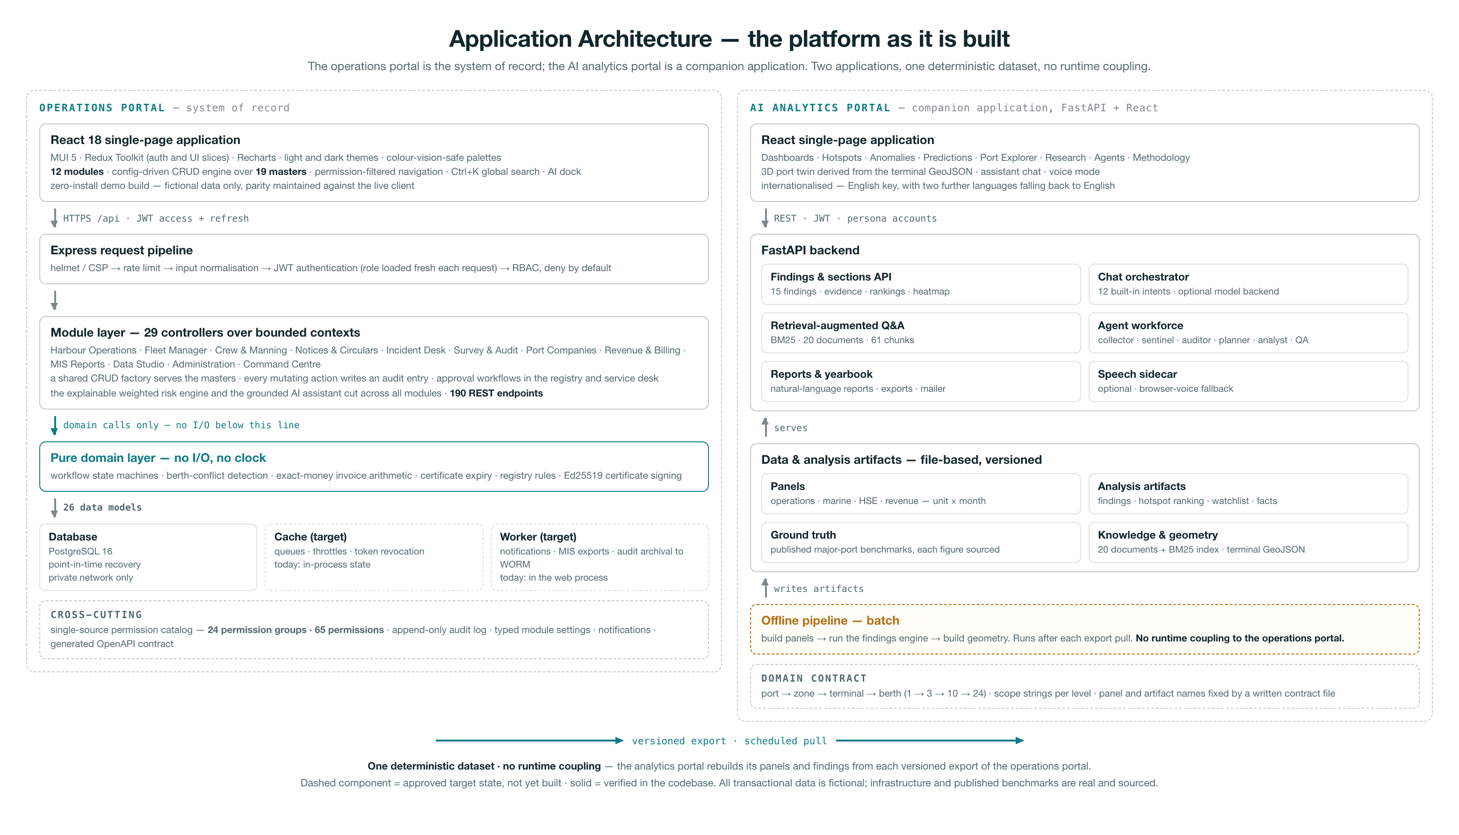
Figure 1 — Current application landscape: the operations platform (system of record) and the AI analytics portal, coupled only by a versioned data export.

1.2 Current production reference architecture (Azure)
In operation today — the foundation the target infrastructure (Section 7) evolves from. Only HTTPS 443 is public; the database is reachable only privately; administration is via P2S VPN and a jump-box.
Component | Role | Port / path
Application Gateway + WAF | Secure public entry point for all users | HTTPS 443
Front-end (presentation VNet) | Presentation layer | HTTPS 443
Azure Firewall | Filters traffic between front-end and app layer | HTTPS 443
App layer (application VNet) | Application services | HTTPS 443
Keycloak SSO (identity VNet) | Single sign-on identity provider (migrates to Entra ID in the target state) | 443 / SSH 22
PostgreSQL | Database — private network only | TCP 5433
Key Vault | Secrets, keys and certificates | HTTPS 443
Storage + Blob | Files and diagnostics | HTTPS 443
Jump-box + VPN hub | Admin access path (P2S) | RDP 3389 / SSH 22
Backup Vault + DR region | Daily restore points; replicated VMs/disks in a second region | —

- DevSecOps in operation: static analysis (SonarQube) with CI quality gates · dynamic testing (OWASP ZAP) · continuous vulnerability management (Qualys) with CVSS-based patch SLAs · periodic grey-box VAPT with re-test evidence.

2. Method — one module at a time
Each module passes through the same template, in this order:
- Current modules detailing
- Flowcharts
- Roles & permissions
- Business benefits
- Functional requirements compliance
- AI section — agents, AI compliance, AI benefits
- Improvements TO BE — delta develop · application revamp · unified data architecture platform · AI agents + AI platform
- Effort estimation in man-weeks
This issue applies the template to Master Data Management at full depth — including its target architecture on the Azure stack and the AI pipeline that keeps golden records golden. Section 6 catalogues the remaining modules queued for the same treatment.

3. Module 1 — Master Data Management
Master data is where the RFP's core promise — single master records for vessels, seafarers, companies, ports and facilities, shared across all seven domains with zero duplication (RFP §5.4.1, §7.5) — is won or lost. The current platform already runs a disciplined master-data layer; this section details it feature by feature, then its target architecture on Azure, then the AI pipeline.

3.1 Modules detailing — current features, in depth
# | Feature | How it works today
1 | Config-driven CRUD engine | - Every master is a configuration, not a component: list + search + filters + pagination (capped at 100 rows) + a slide-over add/edit drawer, all rendered by one engine from a column/field definition.  - Adding a master is a configuration entry, not a code change — the seed of the RFP's low-code requirement.
2 | Lookup framework — 19 categories | One unified, category-keyed store covering:  - vessel types  - cargo types  - ports (UN/LOCODE)  - shipping agents  - deficiency codes  - PSC action codes  - countries  - states  - cities  - units of measure  - currencies  - equipment types  - equipment & assets  - departments  - designations  - shifts  - document types  - incident locations  - holiday calendar.  Every entry carries an active/inactive flag; inactive values stop appearing in forms but keep rendering in history.
3 | Berths & terminals master | A structural master with behaviour: terminal grouping, capability limits (maximum LOA, declared draft) enforced during berth allocation, maintenance status, outage capture with reasons and durations, and 12-month availability statistics (e.g. 40 outages · 262 days lost · 97% availability) with a per-berth outage-history drawer.
4 | Tariff master with dated rate history | Each tariff item (basis: GRT/service/cargo, unit, currency) preserves its full rate history; historical invoices always reference the rate in force at their time — 'what did this cost in March 2024?' is answerable. The single pricing source for the billing engine.
5 | Versioned checklist templates | Inspection templates are versioned and copied into each inspection at creation, so template evolution never mutates completed inspections — the substrate for the RFP's dynamic AI checklists.
6 | Document numbering series | Per-series, per-year counters (calls, inspections, incidents, licences, invoices) driven by settings-held prefixes, with uniqueness guaranteed — no gaps abused, no duplicates possible.
7 | Typed module settings | Behavioural knobs for all 12 modules (expiry windows, tug rules, GST rounding, session timeout, audit retention…) with typed defaults, server-side validation and in-process caching — behaviour is configuration, not code.
8 | Single-source catalog | Permission groups, workflow state machines, lookup categories, numbering prefixes and setting defaults live in one definition; backend middleware, the seeding pipeline and the frontend matrix editor all read the same source — drift is architecturally impossible.
9 | Integrity rules | Soft delete only for referenced masters (deactivate, never disappear); derived values (certificate validity, berth availability, vessel risk) are computed live and never stored stale.
10 | Governance | masters.view/manage and tariffs.view/manage permissions, deny-by-default on every route; every change writes an immutable audit entry with actor and before/after snapshots, reviewable with JSON diffs.

3.2 Feature inventory — the complete module surface
Section 3.1 describes the ten headline capabilities in depth. The table below is the complete inventory — every feature of the Master Data Management module as it runs today, grouped by family. Each is demonstrable live; Section 3.3 shows nine of them on screen.
# | Feature | What it does today
A · Catalogue and engine
1 | Config-driven CRUD engine | - Every master is a configuration entry, not a component.  - One engine renders the list, server-side search, filters, column sort, pagination and the slide-over add/edit drawer from a single column/field definition.  - Adding a master is a configuration change, not a code change — the seed of the RFP’s low-code requirement.
2 | Data Studio hub | Every configuration master presented as an icon card in six families — geography, commercial, marine, assets, organisation, compliance — each showing its live record count.
3 | Lookup framework — 19 categories | - One category-keyed store, unique on (category, code), covering vessel types  - cargo types  - ports (UN/LOCODE)  - shipping agents  - deficiency codes  - PSC action codes  - countries  - states  - cities  - units of measure  - currencies  - equipment types  - equipment & assets  - departments  - designations  - shifts  - document types  - incident locations  - holiday calendar.
4 | Typed attribute extension | Each category carries its own typed attributes: a cargo type holds statistical group, unit and MT conversion factor; a shipping agent holds address and tax registration; a holiday holds date and working note; a city holds its state and country.
5 | Raw lookup editor | A tabbed view across every category with direct attribute editing, for bulk reference-data work and for categories whose attributes are still being shaped.
6 | Active / inactive lifecycle | Every entry carries an active flag. Inactive values stop appearing in forms but keep rendering in history, so records written when the value was current stay readable.
7 | Export | Excel, PDF and CSV export from any master, honouring the search term, filters and sort currently applied to the list.
B · Structural masters that carry behaviour
8 | Berths & terminals master | Terminal grouping, berth type, maximum LOA, declared maximum draft, operational status and remarks — the physical inventory behind the berth board and the quay twin.
9 | Capability-limit enforcement | Maximum LOA and declared draft are enforced server-side during berth allocation: a vessel that exceeds the limits cannot be assigned to the berth.
10 | Outage capture | Dated outage windows per berth with kind (planned, breakdown, dredging, weather), reason, duration in days and the party that carried out the work.
11 | Per-berth availability analytics | Rolling-window availability percentage, days lost, outage count, breakdown by cause, longest outage and a month-by-month series — all computed on read from the outage windows.
12 | Estate downtime panel | Availability across the whole berth estate with by-cause and by-terminal breakdowns, worst-affected berths and a monthly trend line.
13 | Referential protection | A berth carrying active or planned port calls cannot be deleted; the attempt is refused with the reason.
C · Pricing master
14 | Tariff master | Code, charge name, category, unit basis (per GRT, per TEU, per movement, per day), rate, currency and active flag — the single pricing source the billing engine reads.
15 | Dated rate history | Every revision preserved with its effective-from date, the previous rate, the change percentage, the circular that published it and a note.
16 | Rate-in-force resolution | Invoices resolve the rate that applied on their own date, so historical documents never move when the rate card changes — “what did this cost in March 2024?” is answerable.
17 | Rate history analytics | Base versus current rate, cumulative change, average revision, compound annual growth and a step series for the rate trend.
D · Template and numbering masters
18 | Versioned checklist templates | Item sets with section category, answer type, weight, critical flag, inspector guidance and a pass score — versioned as they evolve.
19 | Copy-on-use versioning | A template is copied into each inspection at creation, so later template changes never mutate completed inspections — the substrate for the RFP’s dynamic AI checklists.
20 | Document numbering series | Per-series, per-year counters for calls, inspections, incidents, licences, certificates and invoices, driven by settings-held prefixes, allocated inside the same transaction so uniqueness is guaranteed.
E · Configuration
21 | Typed module settings | Behavioural knobs for all 12 modules — expiry windows, tug rules, tax rounding, session timeout, audit retention — with typed defaults, server-side validation, in-process caching and reset-to-defaults.
22 | Platform settings | Organisation identity, base currency, timezone, tax registration, billing, notification and mail configuration, each section feeding live behaviour across the portal.
23 | Single-source catalog | Permission groups, workflow state machines, lookup categories, numbering prefixes and setting defaults live in one definition that backend middleware, the seeding pipeline and the frontend matrix editor all read — drift between them is architecturally impossible.
24 | Jurisdiction profile | Benchmark set, port-state-control regime, currency and tax conventions, working week, registry statute and ports of registry as one swappable profile. Every figure carries its published source; anything that cannot be sourced is flagged unverified rather than passing silently as fact.
F · Integrity and governance
25 | Soft delete for referenced masters | Referenced entries deactivate rather than disappear, so historical transactions stay resolvable against retired masters.
26 | Derived values computed on read | Certificate validity, berth availability and vessel risk are computed at read time and never stored, so no master can hold a stale derived value.
27 | Typed validation | Schema validation per master, a category whitelist on lookups, non-negative rate enforcement and mandatory checklist item text — refusals carry the reason.
28 | Permission gating | masters.view / masters.manage and tariffs.view / tariffs.manage, deny-by-default on every route.
29 | Immutable audit | Every create, update and delete writes an audit entry with actor, entity, label and before/after snapshots, reviewable as a JSON diff.
30 | Visual permission matrix editor | A role by module.action grid, read from the same single-source catalog the middleware enforces at run time.

3.3 The module in operation
The screenshots below are of the running platform, captured from the live build. They are included so that every capability claimed in Sections 3.1 and 3.2 can be checked against the software rather than taken on trust.
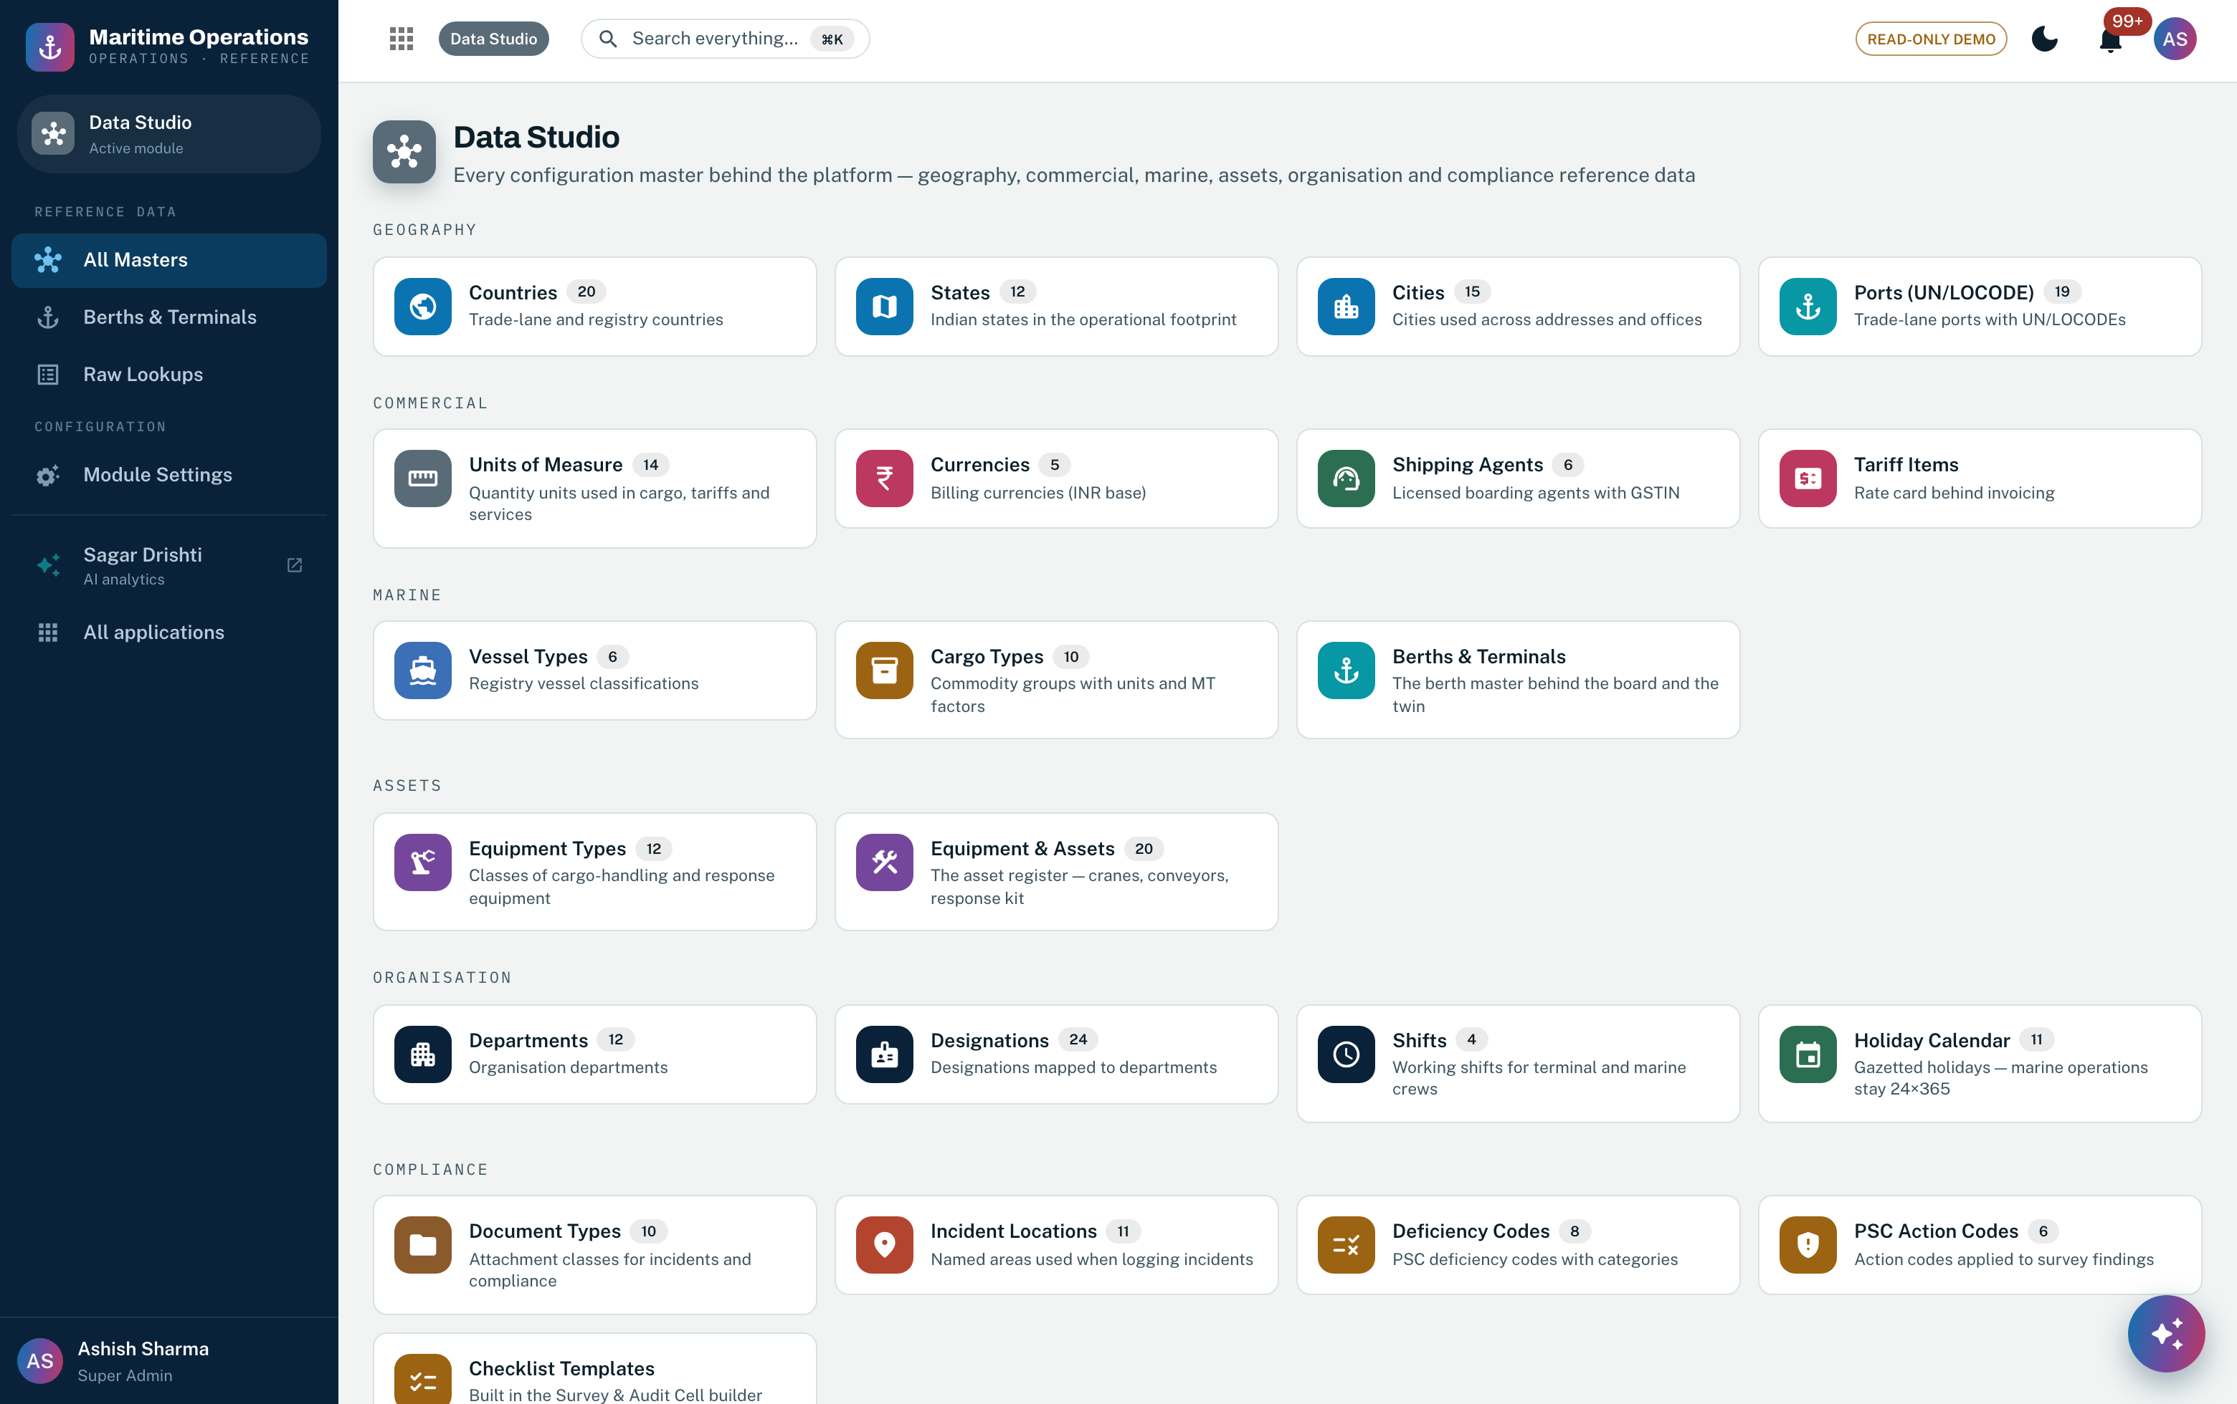
Screenshot 1 — Data Studio: every configuration master as a card in six families, each with its live record count. Features 1–3.
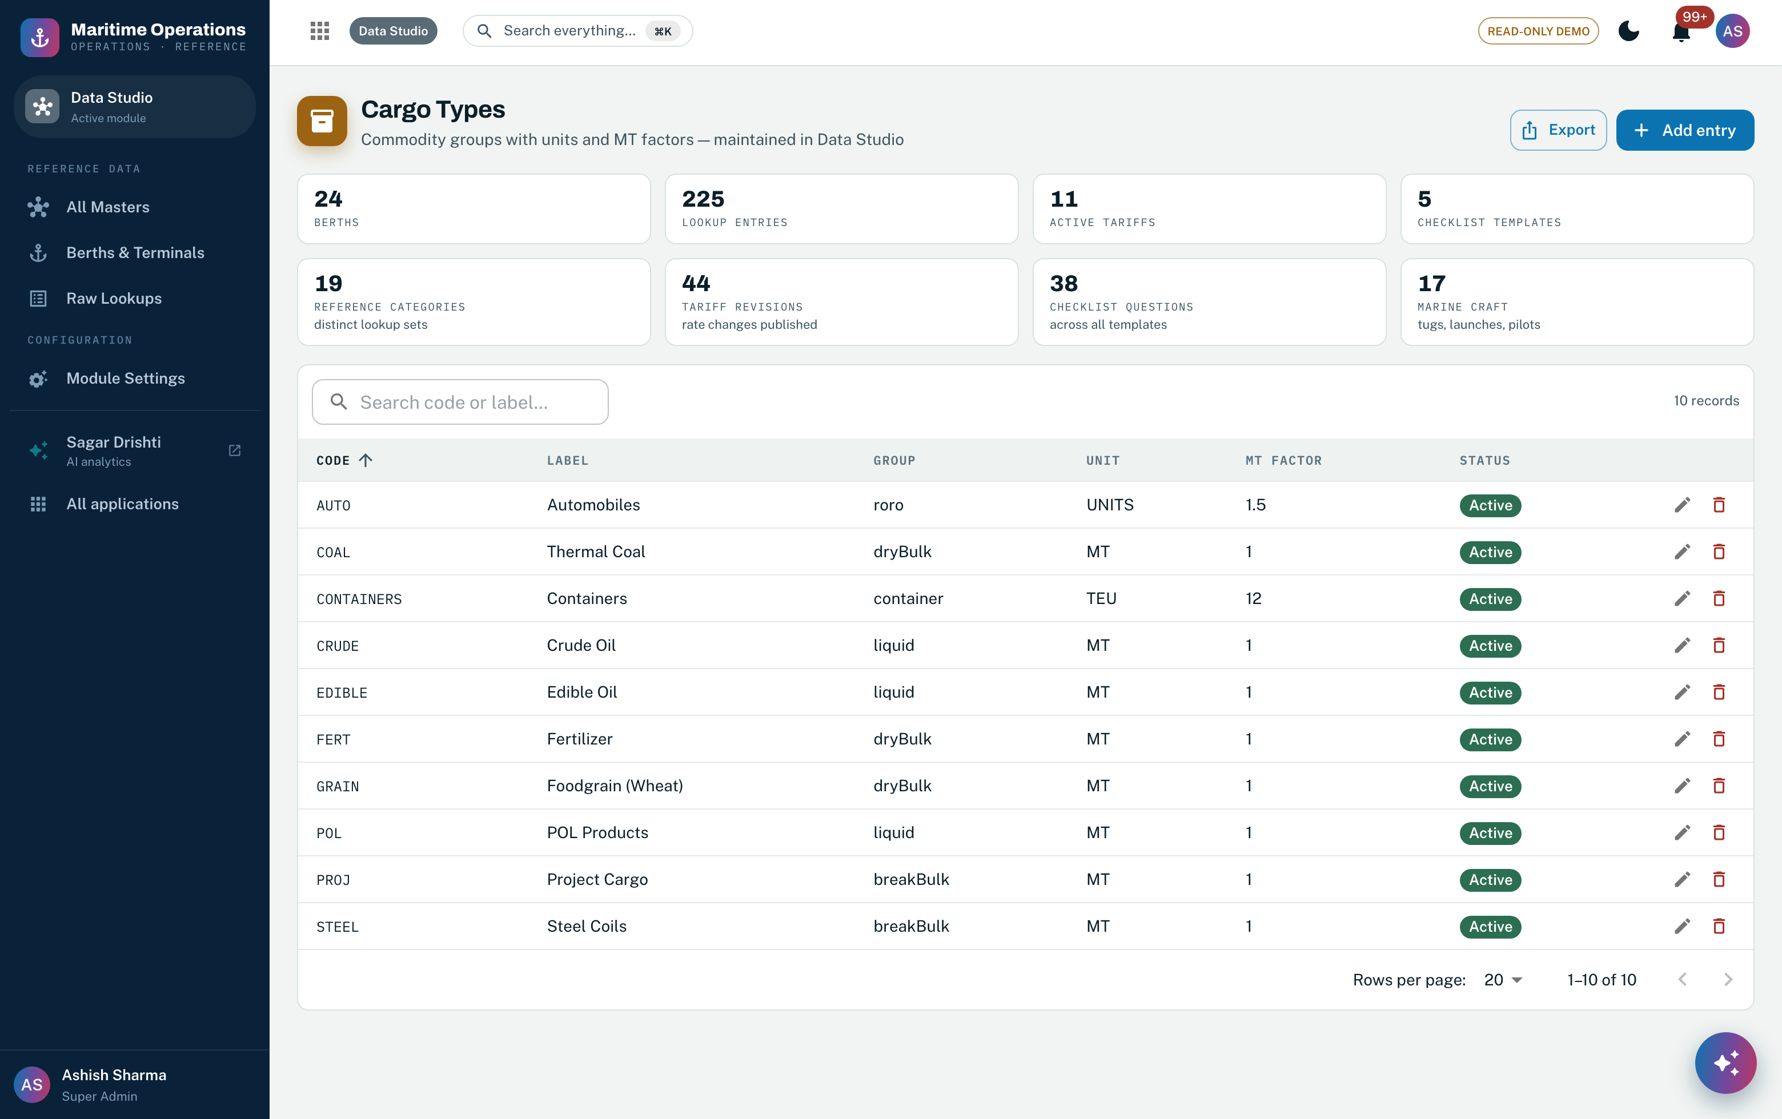
Screenshot 2 — One master, rendered by the config-driven engine: list, search, filters, sort, pagination, export and the add/edit drawer, with the category’s own typed attributes (statistical group, unit, MT factor) as columns. Features 1, 4, 7.
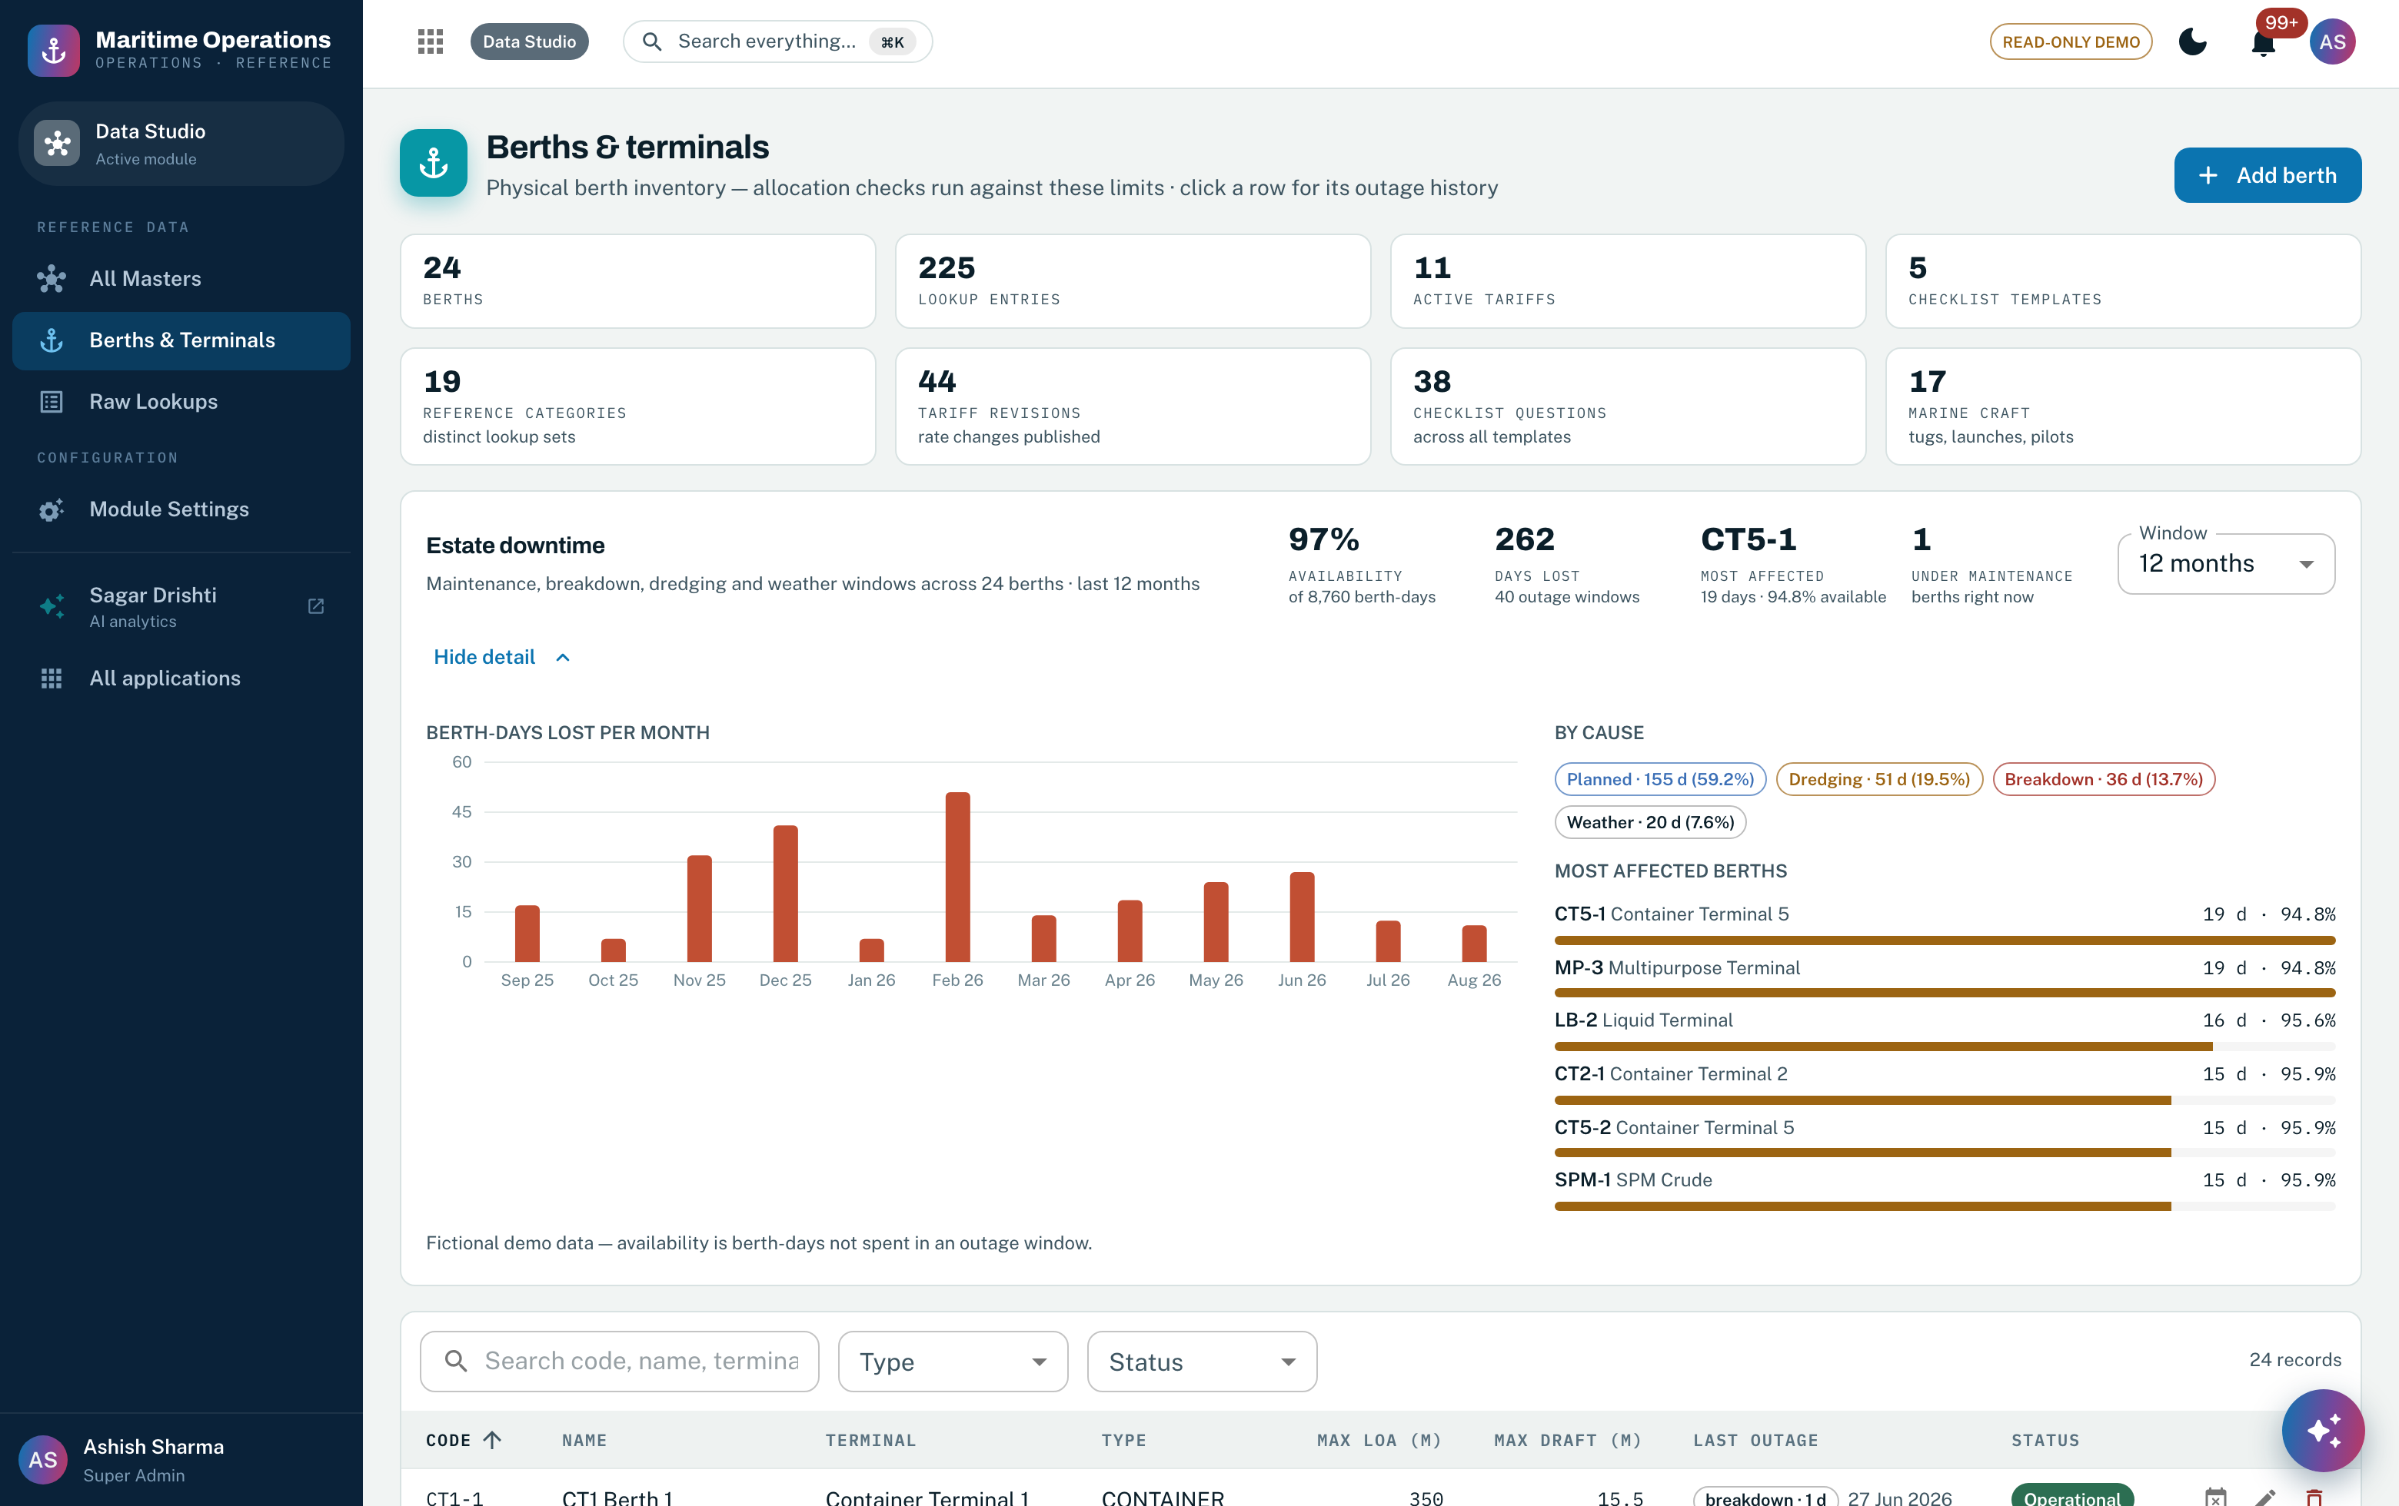
Screenshot 3 — The berths & terminals master with its estate downtime panel: availability, days lost, cause breakdown and the worst-affected berths, computed from dated outage windows. Features 8–12.
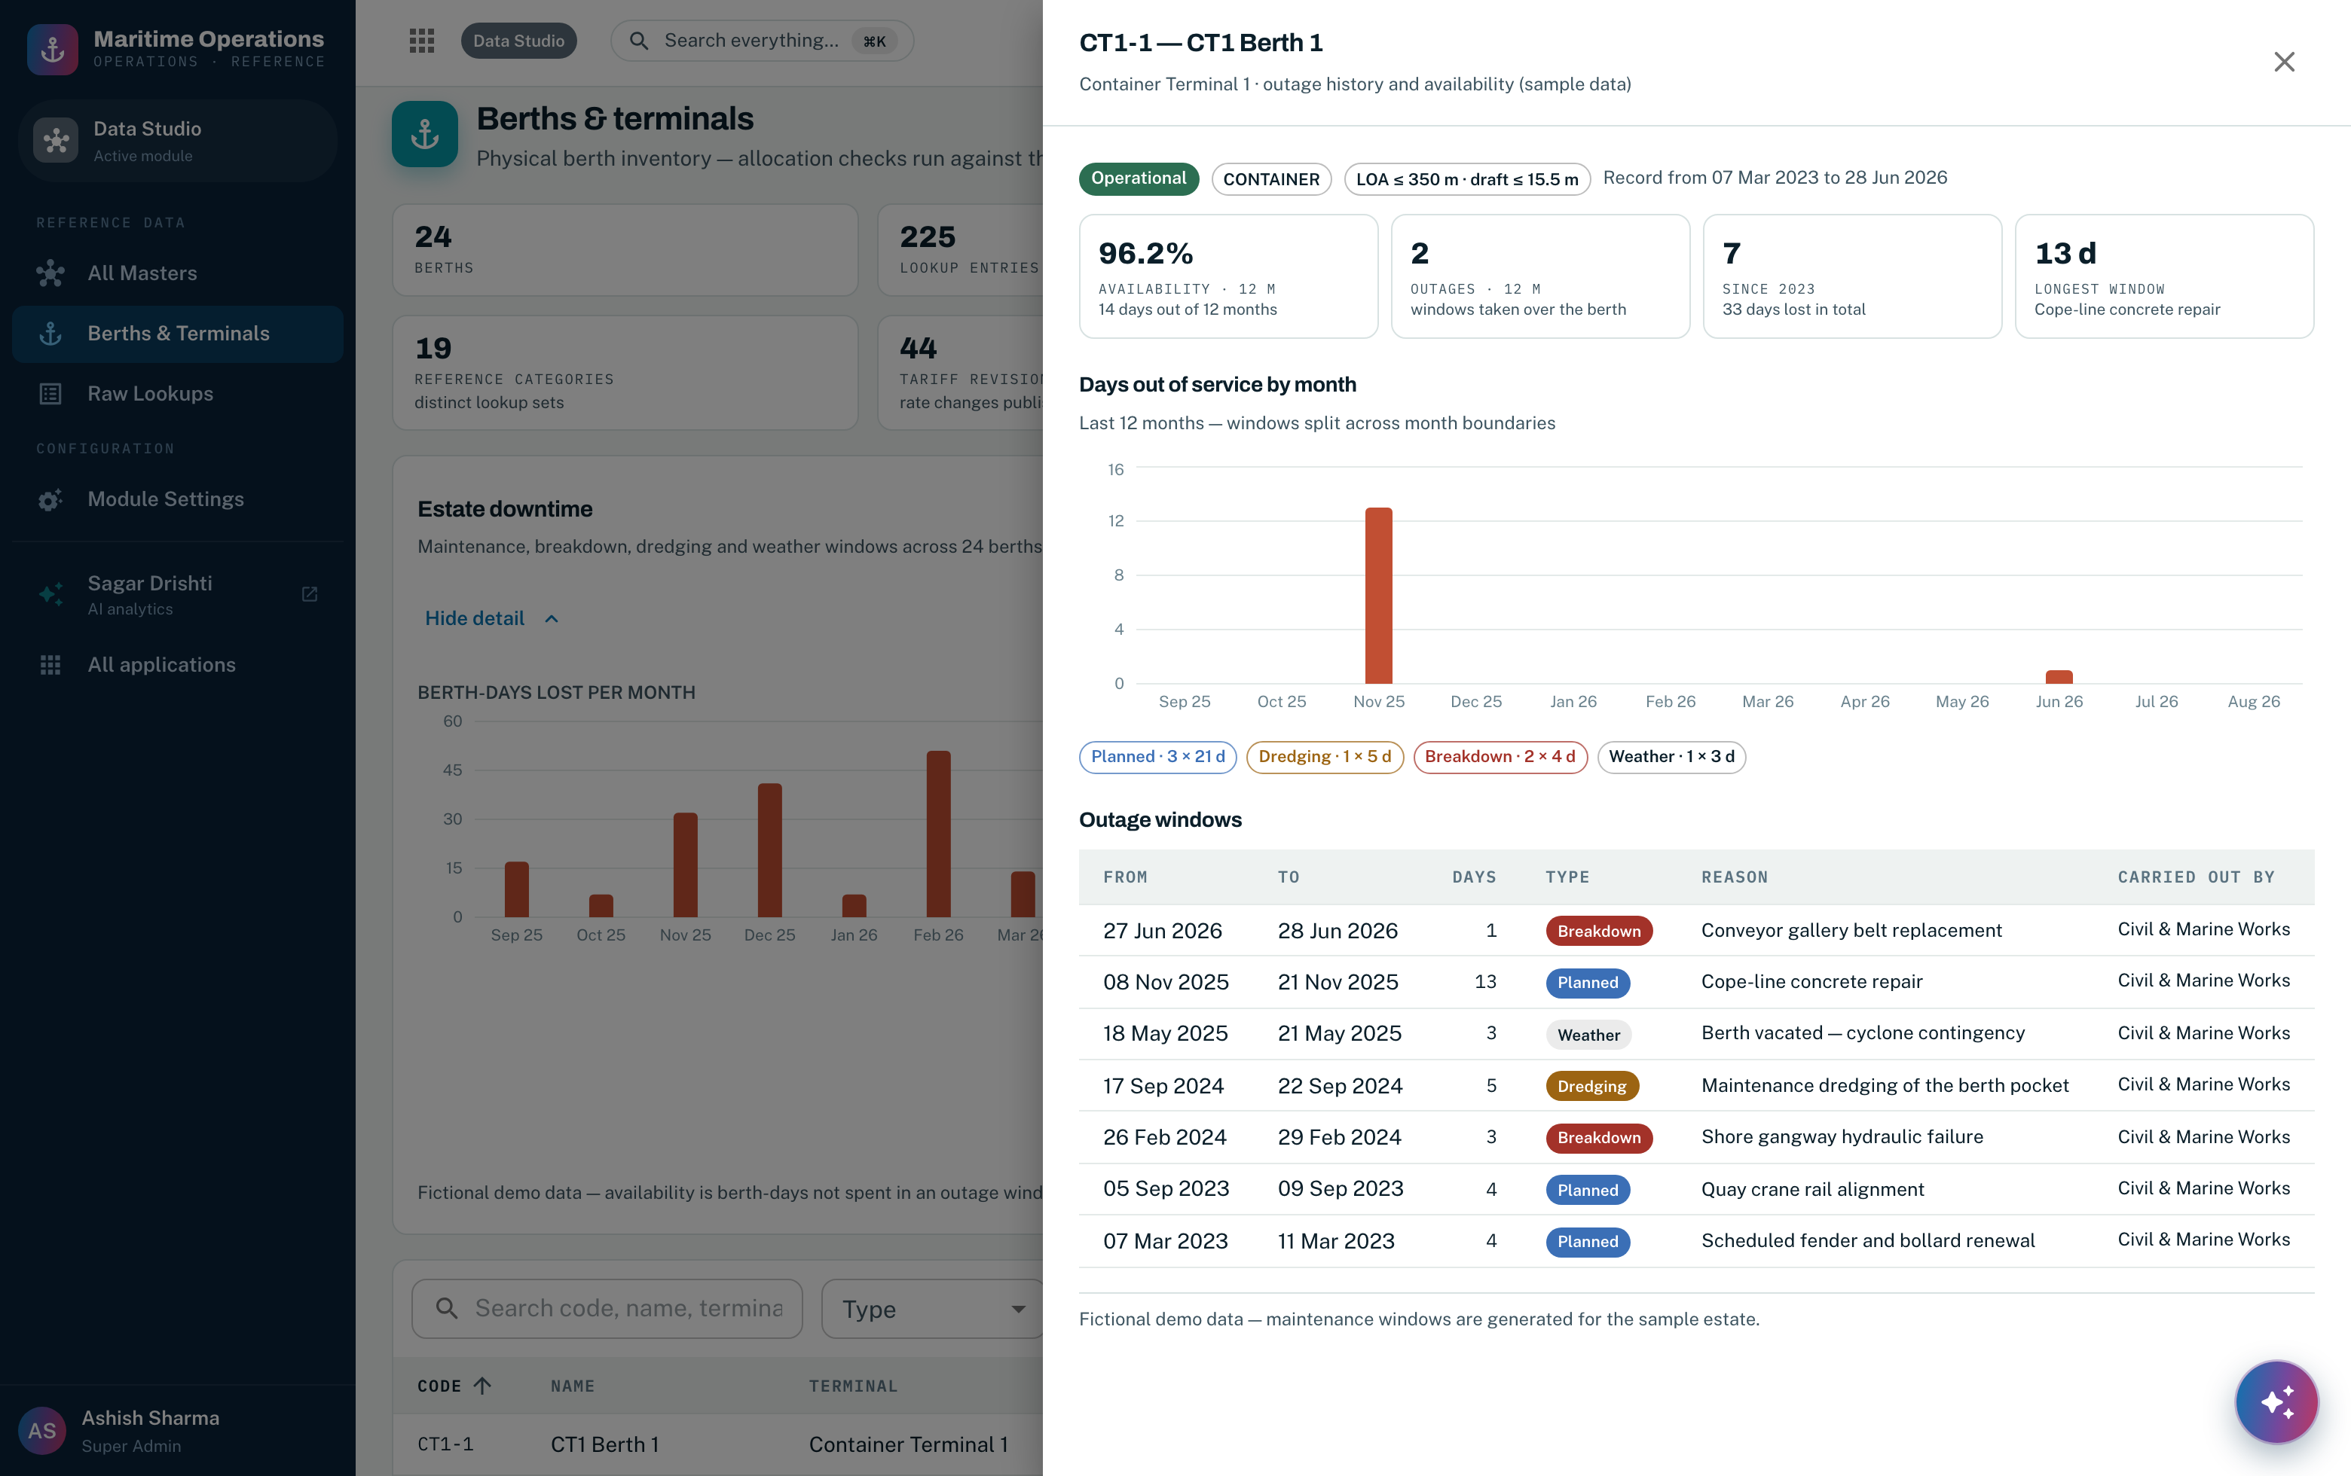
Screenshot 4 — One berth’s outage history: rolling availability, days out of service by month, and every window with its kind, reason, duration and the party that carried out the work. Features 10, 11, 26.
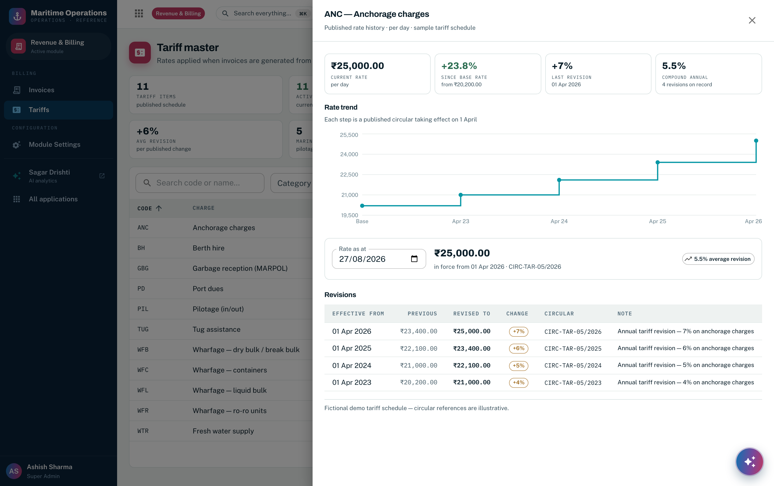
Screenshot 5 — Dated rate history on a tariff head: base versus current rate, cumulative change, compound annual growth, the rate-trend step series, and every revision with its effective date and publishing circular. Features 14–17.
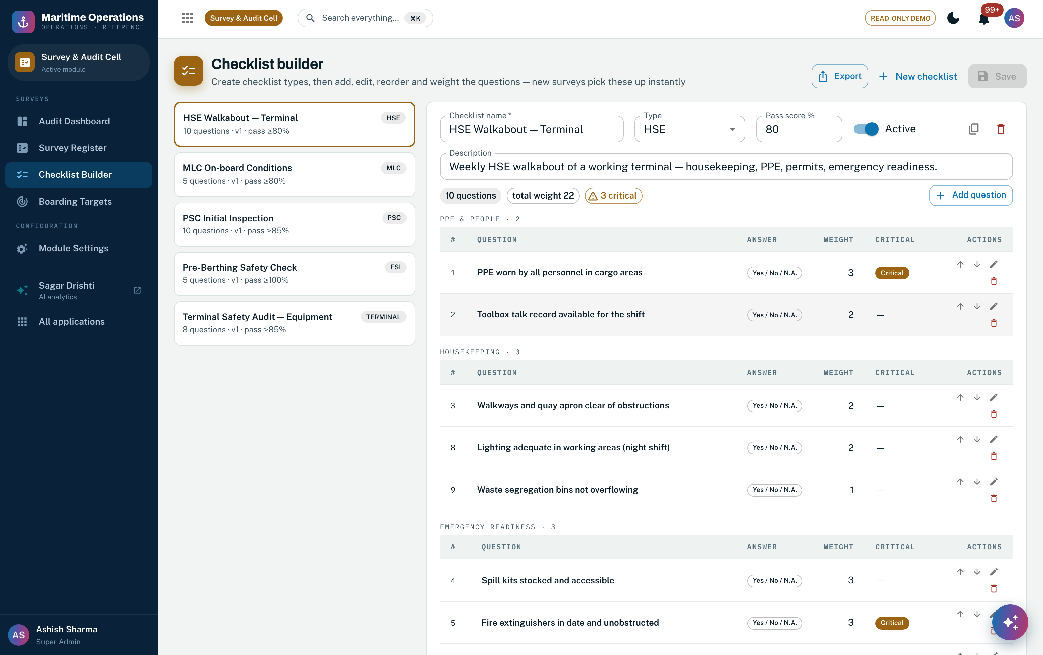
Screenshot 6 — Versioned checklist templates with section categories, answer types, weights, critical items and a pass score. A template is copied into each inspection at creation, so completed inspections never move. Features 18, 19.
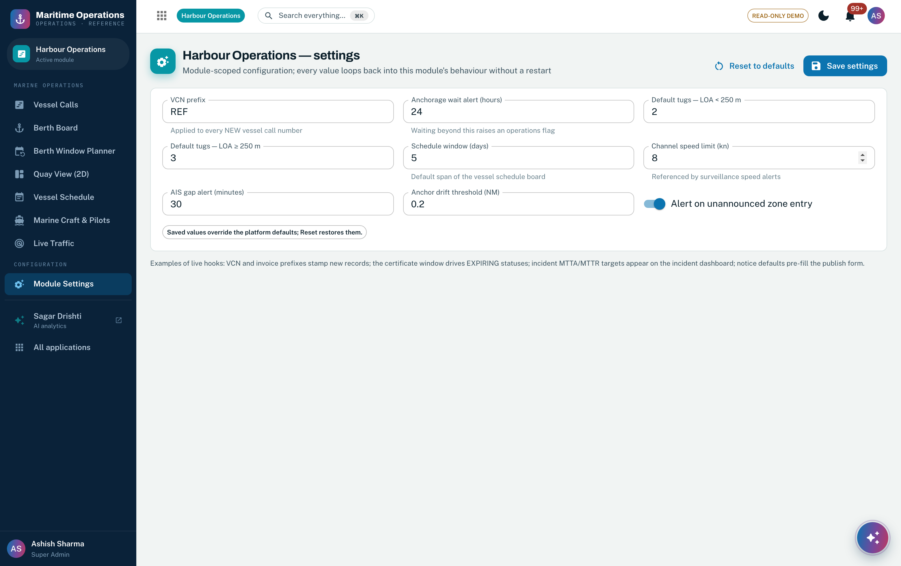
Screenshot 7 — The typed module-settings engine, shown here for Harbour Operations: typed defaults, server-side validation and reset-to-defaults. Every one of the 12 modules has its own settings page on this same engine, Data Studio included. Feature 21.
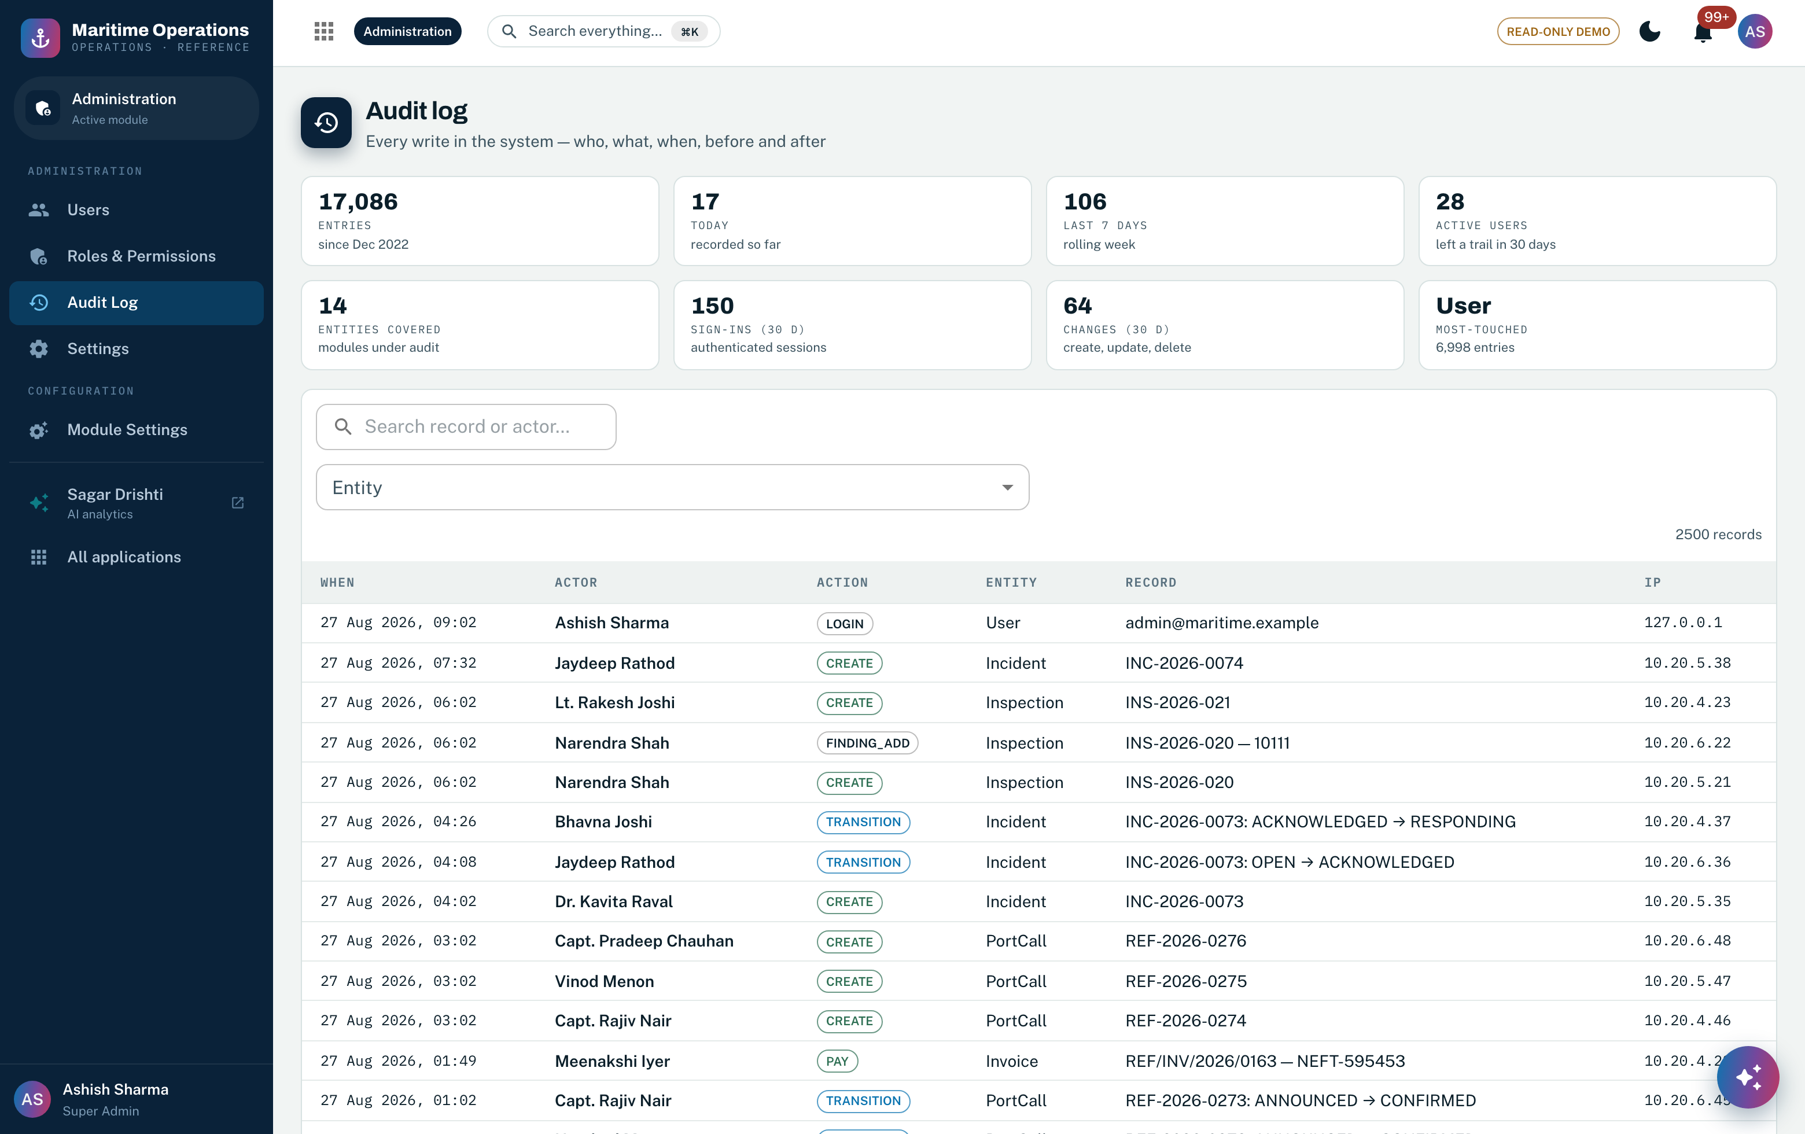
Screenshot 8 — The immutable audit register: every write in the system with actor, action, entity, record and before/after snapshots. Master-data changes are audited on exactly the same terms as transactions. Feature 29.
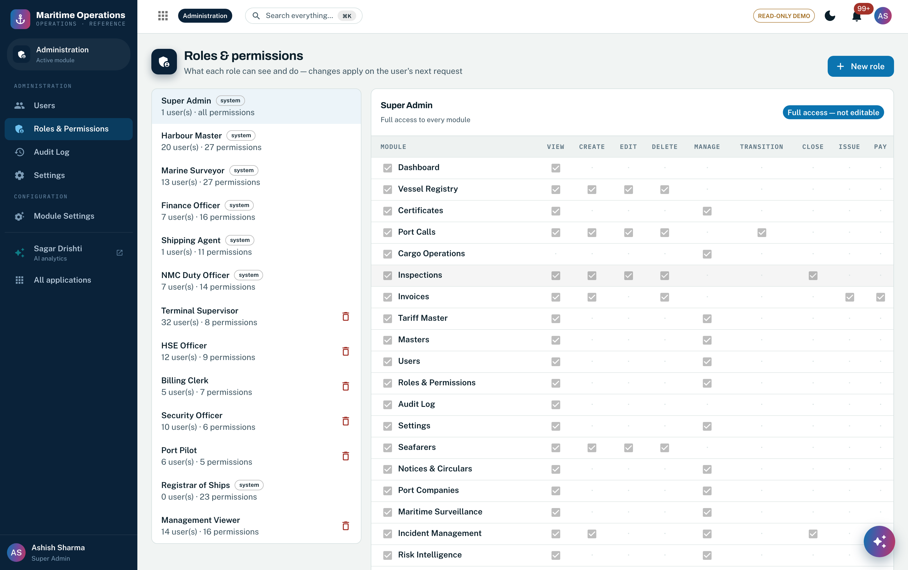
Screenshot 9 — The visual permission matrix: roles against module.action permissions, read from the same single-source catalog the deny-by-default middleware enforces at run time. Features 23, 28, 30.

3.4 Flowchart
Step | Actor | Behaviour
1 | Data steward (permission-gated) | Opens the master in the Data Studio; proposes add/edit via the standard drawer
2 | System — validation | Typed validation against the master's schema; referential rules block breaking changes (soft delete only for referenced rows)
3 | System — persistence | Change saved; audit entry written with before/after snapshots; versioned masters (tariffs, checklists) preserve the prior version
4 | System — propagation | Dependent modules see the new value immediately (single source, no copies); derived values recompute on next read
5 | TO-BE addition | Maker-checker approval on sensitive masters and change-event publication to all domain services (Section 3.6)

3.5 The canonical master data model
The RFP’s single-master-record requirement (§5.4.1, §7.5) is a statement about a data model before it is a statement about infrastructure. Figure 2 sets out that model: the five golden entities and the key each is identified by, the reference masters that type and price them, the instruments and records issued against them across the seven domains, and the one governance rule set that applies to every golden record. Ownership is single and explicit — each entity is mastered by exactly one domain service and consumed by the rest, which is what makes “zero duplication” enforceable rather than aspirational.
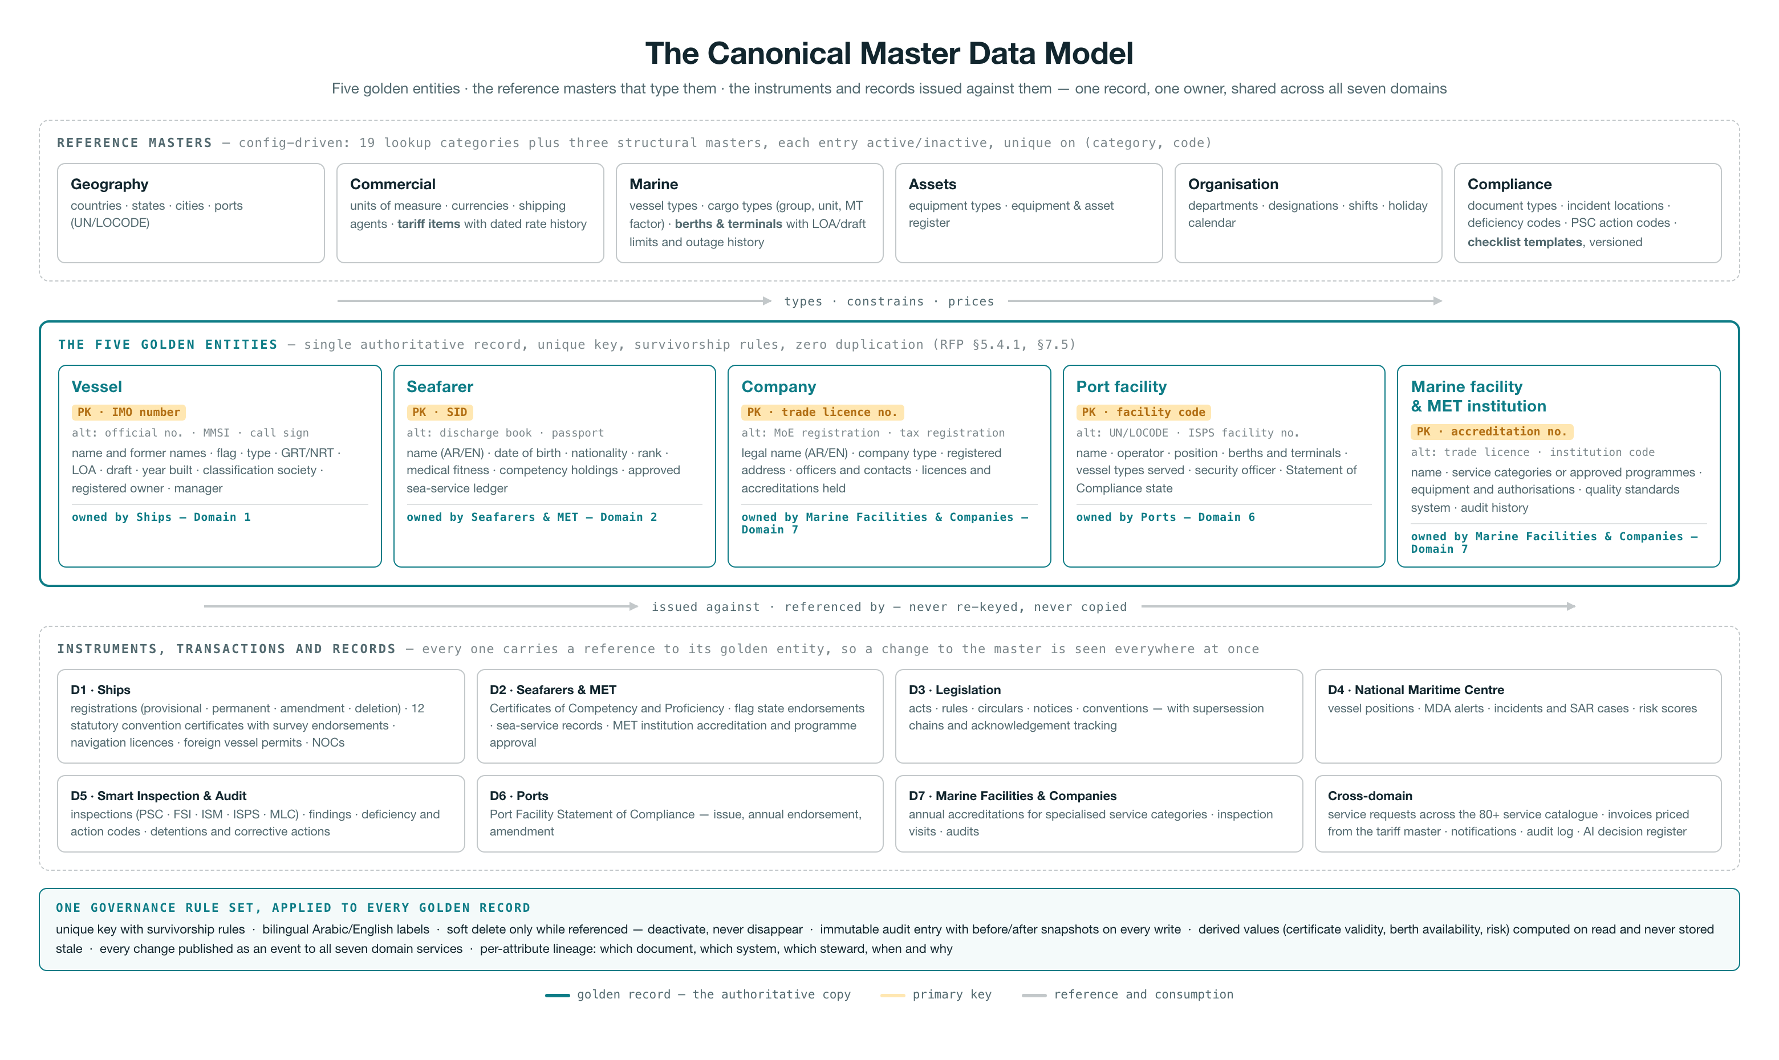
Figure 2 — The canonical master data model: reference masters (19 lookup categories plus three structural masters) type and price the five golden entities; every instrument, transaction and record across the seven domains references a golden entity rather than re-keying it; one governance rule set — unique key and survivorship, bilingual labels, soft delete, immutable audit, derived values computed on read, change events to all seven domains, per-attribute lineage — applies to every golden record.

3.6 Target architecture on Azure for Agentic AI flows
Golden records stay transactional in PostgreSQL (ACID, private endpoint); the analytical and AI plane runs on ADLS Gen2, Azure ML and AI Search; intake runs through AI Document Intelligence with a steward-in-the-loop; every change propagates in real time over Service Bus. Figure 3 is the complete flow; the numbered narrative follows.
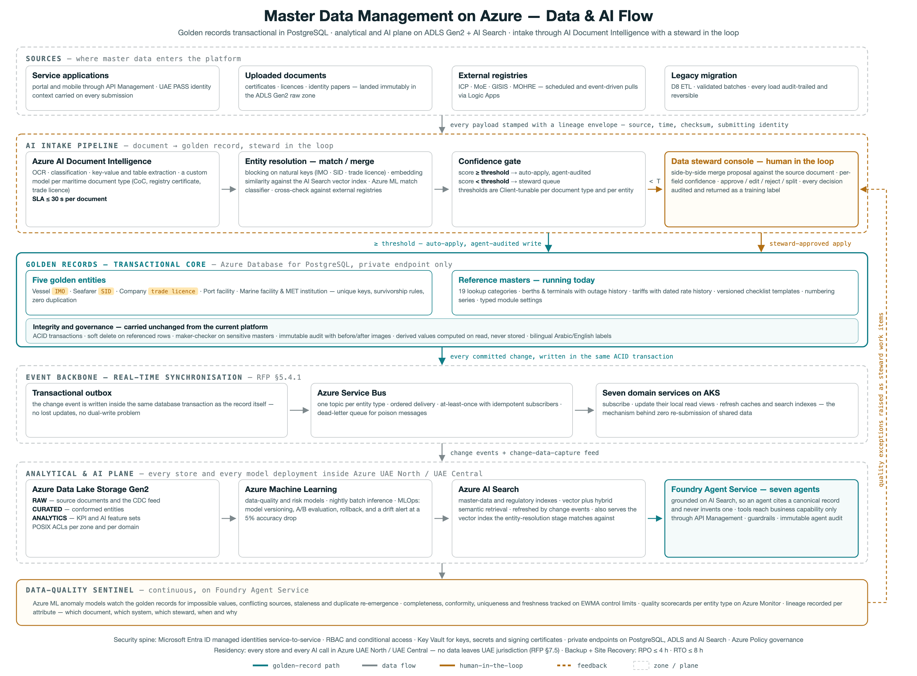
Figure 3 — Master Data Management on Azure: sources → AI intake pipeline (Document Intelligence → entity resolution → confidence gate → steward console) → PostgreSQL golden records → event backbone (outbox → Service Bus → 7 domain services) → analytical & AI plane (ADLS Gen2 zones → Azure ML → AI Search → Foundry agents), with the continuous data-quality sentinel beneath.
- 1 — Sources. Master data enters four ways: service applications (portal/mobile through API Management, carrying UAE PASS identity context), uploaded documents (landed in the ADLS raw zone), scheduled pulls from external registries (ICP, MoE, GISIS, MOHRE), and the audited D8 legacy-migration ETL.
- 2 — AI intake. Azure AI Document Intelligence extracts structured attributes (≤30 s per document, custom models per maritime document type); the entity-resolution stage blocks on natural keys (IMO, SID, trade licence) and scores candidate matches with embedding similarity plus rules; a Client-tunable confidence gate auto-applies high-confidence results (agent-audited) and queues the rest for the data-steward console — the human-in-the-loop the RFP's governance model requires.
- 3 — Golden records. The five golden entities and today's reference masters live in PostgreSQL with the integrity rules the current platform already enforces: ACID transactions, soft delete, maker-checker on sensitive masters, immutable before/after audit, bilingual labels.
- 4 — Real-time sync. A transactional outbox publishes every golden-record change to Azure Service Bus topics; the seven domain services subscribe and update their local views — the mechanism behind 'zero re-submission' and RFP §5.4.1 real-time synchronization. High-volume streams (AIS/LRIT) stay on Event Hubs; Azure Functions run the lightweight processors.
- 5 — Analytical & AI plane. Change data flows to ADLS Gen2 (raw → curated → analytics zones); Azure ML trains and runs data-quality and risk models with drift alerts; Azure AI Search maintains master-data and regulatory indexes (vector + hybrid) that ground the Foundry agents — agents cite canonical records, never free text.

3.7 Current feature and migrating to target state
Current MDM capability | Target Functionality with Agentic AI flows
19-category config-driven lookup framework (vessel types, cargo types, UN/LOCODE ports, deficiency codes, PSC action codes, currencies, etc.) | The config-driven CRUD engine carries over unchanged inside the relevant domain services on AKS, with its relational store deployed in UAE North with UAE Central DR. Lookup maintenance is exposed through Azure API Management under Entra ID SSO/RBAC, and reference values are additionally published to the ADLS Gen2 curated zone and indexed in Azure AI Search so the Foundry agents (A1 certificate validation, A2 compliance, A6 regulatory intelligence) ground against the same controlled vocabularies the portal uses.
Berths & Terminals master with LOA/draft capability limits and outage/downtime history | - Moves intact into the Ports domain service on AKS; capability-limit validation and outage recording stay server-side exactly as today.  - Outage and status events are additionally published to Azure Service Bus topics so dependent services and the A7 National Maritime Intelligence agent react in near real time, and the outage history feeds the ADLS Gen2 analytics zone for availability reporting.  - Availability statistics remain computed on read, never stored.
Tariff master with dated rate history | - Retained within the Ports / Marine Facilities & Companies services with effective-dated rate resolution logic unchanged.  - Rate changes go through Azure API Management with the existing audit trail, and Azure Logic Apps adds a low-code approval workflow for tariff revisions with Azure Communication Services notifying stakeholders.  - Historical rates replicate to the ADLS Gen2 analytics zone for revenue analytics and the A3 Service Processing agent's fee calculations.
Versioned checklist templates, copied into each inspection at execution time | Carries over into the Smart Inspection domain service with the copy-on-use versioning semantics preserved, so completed inspections stay bound to the template version they were executed against. Templates synchronize to inspector devices through Azure IoT Hub edge store-and-forward for offline field work, and template content is indexed in Azure AI Search so the A5 Smart Inspection agent grounds its pre-inspection dossiers and AI-drafted reports on the current approved checklist.
Per-series / per-year document numbering engine | - Remains a transactional server-side component inside each owning domain service, since sequence integrity depends on the service's own database transaction — no change to the allocation semantics.  - Numbering configuration is administered through the same Azure API Management-fronted APIs, and issued numbers are visible to the A3 agent for zero-touch application processing.  - Series definitions per document type and year carry over as-is.
Typed module settings store | - The typed, validated settings store carries over per domain service for business configuration, still audited on change.  - Secrets and connection material move out of settings into Azure Key Vault, accessed by AKS workloads through Entra ID managed identities, while Azure Policy enforces platform-level configuration compliance.  - Agent autonomy-level settings (supervised through autonomous) follow the same typed-settings pattern, surfaced to the Foundry Agent Service guardrails.
Single-source permission catalog feeding backend middleware, seeding, and the frontend matrix editor | - The catalog stays the single source of truth for module.action permission strings and the deny-by-default middleware in every AKS microservice — this pattern carries over intact.  - Permission groups map onto Microsoft Entra ID groups and app roles, so SSO, MFA, and conditional access govern who holds them, with UAE PASS federated OIDC login for customer identities  - Azure API Management adds coarse-grained scope enforcement at the gateway.  - The visual matrix editor is retained for fine-grained assignment.
Soft-delete-only integrity for referenced master records | - Soft-delete semantics carry over in each domain service, keeping historical transactions resolvable against retired masters.  - Because masters are now consumed across services and AI indexes, a deactivation event is published on Azure Service Bus so dependent services and the Azure AI Search indexes mark the record inactive consistently.  - Azure Backup and Site Recovery provide the platform recovery envelope (RPO <= 4h, RTO <= 8h) without altering application-level integrity rules.
Audit log with before/after images on every mutating write | - The controller-level audit pattern carries over unchanged in every domain service and extends to cover agent-initiated writes, satisfying the RFP's immutable agent audit requirement — Foundry Agent Service actions land in the same actor/entity/before-after model with the agent as actor.  - Audit streams ship to Azure Monitor and Application Insights for operational alerting and archive immutably to the ADLS Gen2 governed zones, supporting explainability retrieval within 30 seconds.
Derived values (certificate validity, berth availability, risk) computed on read, never stored | - The compute-on-read rule carries over for deterministic derivations such as certificate validity and availability, keeping masters free of stale denormalized state.  - Statistical derivations — vessel risk scores for A5 dossiers and A2 compliance — graduate to Azure Machine Learning models with MLOps deployment, drift monitoring (5% accuracy-drop alerting), and A/B evaluation, trained from the ADLS Gen2 analytics zone but still served on demand rather than persisted as master data.
Entity master records: vessels, seafarers, companies, ports, marine facilities | - Each master moves to its owning domain service on AKS — Ships, Seafarers & MET, Ports, Marine Facilities & Companies, with NMC consuming them — preserving single ownership per entity.  - Cross-service access goes through Azure API Management, change events broadcast on Azure Service Bus, and masters are indexed in Azure AI Search to ground A2 (100% automated compliance monitoring) and A7 (100% UAE-flag coverage)  - supporting certificates and documents are captured via Azure AI Document Intelligence into ADLS Gen2 and linked to the master record.
Deterministic demo/seed data tooling (fixed PRNG seed, anchored history window) | - The deterministic seeding carries over as environment-provisioning tooling for dev, test, and training namespaces on AKS, with seeded datasets confined to non-production ADLS Gen2 zones inside the UAE regions.  - Its reproducibility gains a second role: fixed, known-answer datasets become regression baselines for Foundry Agent Service evaluation runs and Azure Machine Learning model validation, so agent accuracy targets (e.g. A1's 95% certificate validation) are measured against a stable corpus.  - Production remains seed-free.

3.8 The MDM AI pipeline — stage by stage
Stage | Mechanics
1. Multi-channel document and data intake | Master-data-bearing content arrives through three routes:  - portal/API uploads pass through Azure API Management into an AKS intake microservice  - scheduled and event-driven pulls from registries and partner systems run as Azure Logic Apps workflows  - high-volume feeds (AIS/LRIT vessel observations) land via Azure Event Hubs.  - Every payload is written immutably to the raw zone of Azure Data Lake Storage Gen2 (UAE North, encrypted with Key Vault-managed keys), and an Azure Function stamps a lineage envelope — source, timestamp, checksum, submitting identity from Microsoft Entra ID — before publishing an intake event to Azure Service Bus.  - This stage builds directly on the platform's existing per-series document numbering and audit-log engine: every intake receives a numbered, auditable record with before/after state exactly as the current portal does for all writes.
2. Extraction and classification with Azure AI Document Intelligence | - A Service Bus-triggered Azure Function routes each document to Azure AI Document Intelligence: a custom classifier first assigns the document type (registration certificate, class certificate, crew document, tonnage certificate, invoice, survey report), then a matching custom extraction model pulls key-value pairs and tables — IMO number, call sign, flag, issue/expiry dates, issuing authority.  - Each extracted field carries a per-field confidence score  - fields at or above 0.85 are accepted, fields between 0.60 and 0.85 are flagged for verification, and below 0.60 the whole document is routed to manual keying.  - Structured output is written to the curated zone of ADLS Gen2 and cross-checked by a Foundry Models LLM call against typed validation rules (date coherence, checksum-valid IMO numbers, issuing-authority whitelist).  - This extends the platform's existing document-type master and typed module-settings engine, which already defines per-document-type required fields and validity rules.
3. Standardization and reference-data conformance | - Extracted attributes are normalized against the platform's existing 19-category config-driven lookup engine — vessel types, cargo types, UN/LOCODE ports, countries, currencies, UOM, deficiency and PSC action codes — now hosted as a reference-data microservice on AKS with PostgreSQL.  - Deterministic rules (unit conversion, ISO country/currency coercion, UN/LOCODE resolution) run first  - ambiguous values fall through to a Foundry Models embedding lookup against the reference catalog in Azure AI Search, accepted automatically at cosine similarity >= 0.90 and queued otherwise.  - Because the catalog is single-source — the same file that already feeds backend middleware, seeding, and the frontend permission matrix — a conformance decision made here is identical everywhere the value is consumed.  - Non-conforming values are never overwritten; the raw value is retained alongside the standardized one for lineage.
4. Entity resolution: blocking, embedding match, and merge proposal | - Candidate records (a vessel, seafarer, company, or facility) are first blocked on strong keys — IMO number, MMSI, license number, trade-license ID — so exact-key hits shortcut to a direct match.  - For residual candidates, a Foundry Models embedding of the concatenated identity attributes (name, former names, flag, type, dimensions, owner) is queried against the vector index in Azure AI Search restricted to the block, and an Azure Machine Learning match-classifier scores each candidate pair using attribute-level similarity features.  - The threshold pattern is three-band: score >= 0.92 auto-merge, 0.70–0.92 steward review, < 0.70 create-as-new.  - Survivorship rules (most-recent-authoritative-source wins per attribute, with source trust ranking) compute a merge proposal but never destroy losing values — mirroring the platform's existing soft-delete-only rule for referenced masters and its dated rate-history pattern, where superseded values remain queryable with their validity period.
5. Confidence gating and data-steward human-in-the-loop | - Everything in the review band lands in a steward work queue exposed through the portal UI, protected by the existing deny-by-default RBAC engine with dedicated mdm.review / mdm.approve permission strings and Entra ID conditional access.  - The steward sees the merge proposal side-by-side with source documents (deep link to the original in ADLS), per-field confidence, and the match classifier's feature attribution — satisfying the RFP requirement that any AI decision be explainable and retrievable within 30 seconds.  - Steward decisions (approve, edit-and-approve, reject, split) are captured with before/after snapshots by the same audit-log middleware that already records every platform write, and each decision is fed back to Azure Machine Learning as labeled training data for the match model.  - Escalations follow the RFP service level: unresolved reviews route to a senior steward within 4 business hours via Azure Communication Services notification.
6. Golden record apply and event publication | - Approved merges are applied transactionally by the master-data service on AKS: the golden record is versioned, contributing source records are cross-referenced (never deleted), and derived attributes — certificate validity, berth availability, risk indicators — are computed on read, never stored, per the platform's established rule.  - On commit, the service publishes a MasterDataChanged event to an Azure Service Bus topic  - subscribers include the seven domain services (Ships, Seafarers, NMC, Smart Inspection, Ports, Marine Facilities, Legislations), the AI Search indexer, and Logic Apps workflows that notify downstream consumers via Azure Communication Services.  - This generalizes the platform's existing server-enforced state-machine pattern: a golden record moves PROPOSED → REVIEWED → PUBLISHED → SUPERSEDED with transitions enforced server-side, so no client can skip a gate.
7. Continuous data-quality sentinel | - A resident quality agent — the productionized form of the platform's existing EWMA sentinel monitoring agent — runs on Foundry Agent Service with scheduled sweeps executed as Azure Functions.  - It tracks completeness, conformity, uniqueness, and freshness per master domain, applies EWMA control limits to each metric, and detects duplicate re-emergence by re-running the AI Search embedding match over recently touched records.  - Azure Machine Learning drift monitoring watches the match classifier and extraction models, raising an alert through Azure Monitor when accuracy on the steward-labeled holdout drops 5% — the RFP drift threshold — and triggering a retraining pipeline in AML with A/B rollout before promotion.  - Quality scorecards surface in the portal per domain, backed by the same findings-engine pattern the platform already ships.
8. Serving, grounding, and governance lineage | - Published golden records are indexed into Azure AI Search as hybrid semantic + vector documents with security trimming from Entra ID, so every AI agent (compliance, guidance, inspection) grounds on governed master data rather than raw sources — a direct evolution of the platform's existing BM25 RAG grounded assistant, upgraded to Azure AI Search hybrid retrieval with Foundry Models embeddings and rerankers.  - Structured access flows only through API Management with throttling and full call analytics; no agent reads the database directly.  - End-to-end lineage — raw document in ADLS, extraction confidence, match decision, steward identity, publish event — is reconstructable from the immutable audit trail for any attribute of any golden record, meeting UAE PDPL accountability and the AI Governance Committee's audit needs, with data never leaving UAE North / UAE Central and cross-region DR meeting RPO <= 4h / RTO <= 8h via Azure Backup and Site Recovery.

3.9 Roles & permissions
Current: masters.view/manage and tariffs.view/manage govern the Data Studio; admin groups govern platform masters; deny-by-default with the visual matrix editor. Target: data-steward, approver and publisher modelled as Entra ID app roles gating master-data write endpoints; the MDM service's managed identity is the only principal with write access to the golden-record schema; maker-checker dual control on sensitive masters; per-domain stewardship scoping.
The platform ships thirteen roles. Six are system roles that the seeding pipeline guarantees; the remaining seven are ordinary custom roles, created and edited in the matrix editor exactly as the Client would create its own. Every route is deny-by-default: a role holds a permission or the request is refused.
Role | Code | Type | What the role is for | Permissions
Super Admin | SA | System | Platform administration. The only role that may change master data, module settings, roles and users. | all 65
Harbour Master | HM | System | Marine operations: the port-call lifecycle end to end, berthing, cargo work and incident command. Reads master data, cannot change it. | 27
Marine Surveyor | MS | System | Inspection and certification: surveys, findings, closure, seafarer records, statutory certificates and regulatory instruments. | 27
Finance Officer | FO | System | Revenue: invoicing through issue and payment, and the only role besides the administrator that may publish a tariff revision. | 16
Shipping Agent | AG | System | External party. Announces calls, lodges service and registration applications, tracks its own invoices. No master-data access at all. | 11
NMC Duty Officer | ND | System | Surveillance centre: the live traffic picture, maritime domain alerts, incident response and search and rescue. | 14
Terminal Supervisor | TS | Custom | Terminal shift work: cargo operations and first-line incident reporting. | 8
HSE Officer | HO | Custom | Health, safety and environment: incident response, investigation and closure. | 9
Billing Clerk | BC | Custom | Invoice preparation and collections follow-up. May raise an invoice but not issue or settle one. | 7
Security Officer | SO | Custom | ISPS and gate security: watchkeeping and incident reporting. | 6
Port Pilot | PP | Custom | Pilotage: vessel movements and schedules. Read-only throughout. | 5
Registrar of Ships | RS | System | The registry and service desk: ship registration through grant, statutory certificates, company accreditation, and the audit register. | 23
Management Viewer | MV | Custom | Read-only oversight across every operational module. Holds no write permission anywhere. | 16

The matrix below is the whole authorisation model — 24 permission groups against all thirteen roles. It is generated from the same single-source catalog that the backend middleware enforces and the matrix editor renders, so the document and the running system cannot drift apart.
Module — actions in the group | SA | HM | MS | FO | AG | ND | TS | HO | BC | SO | PP | RS | MV
Dashboard — view | ● | ○ | ○ | ○ | ○ | ○ | ○ | ○ | ○ | ○ | ○ | ○ | ○
Vessel Registry — view/create/edit/delete | ● | ◐ | ○ | ○ | ○ | ○ | ○ | – | ○ | – | ○ | ◐ | ○
Certificates — view/manage | ● | ○ | ● | – | – | – | – | – | – | – | – | ● | –
Port Calls — view/create/edit/delete/transition | ● | ● | ○ | ○ | ◐ | ○ | ○ | – | ○ | – | ○ | – | ○
Cargo Operations — manage | ● | ● | – | – | – | – | ● | – | – | – | – | – | –
Inspections — view/create/edit/close/delete | ● | ○ | ◐ | – | – | ○ | – | ○ | – | – | – | – | ○
Invoices — view/create/issue/pay/delete | ● | ○ | – | ● | ○ | – | – | – | ◐ | – | – | – | ○
Tariff Master — view/manage | ● | ○ | – | ● | – | – | – | – | ○ | – | – | – | –
Masters — view/manage | ● | ○ | ○ | ○ | – | – | ○ | – | – | – | – | ○ | –
Users — view/manage | ● | – | – | – | – | – | – | – | – | – | – | – | –
Roles & Permissions — view/manage | ● | – | – | – | – | – | – | – | – | – | – | – | –
Audit Log — view | ● | – | – | – | – | – | – | – | – | – | – | ○ | –
Settings — view/manage | ● | – | – | – | – | – | – | – | – | – | – | – | –
Seafarers — view/create/edit/delete | ● | ○ | ◐ | – | – | – | – | – | – | – | – | ○ | ○
Notices & Circulars — view/manage | ● | ○ | ● | ○ | ○ | ○ | – | ○ | – | ○ | ○ | ○ | ○
Port Companies — view/manage/approve | ● | ○ | ○ | ○ | – | – | – | – | – | – | – | ● | ○
Maritime Surveillance — view/manage | ● | ○ | – | – | – | ● | – | – | – | ○ | – | – | ○
Incident Management — view/create/manage/close | ● | ◐ | ● | ○ | – | ● | ◐ | ● | – | ◐ | – | – | ○
Risk Intelligence — view/manage | ● | ○ | ○ | – | – | ○ | – | – | – | – | – | – | ○
AI Assistant — use | ● | ○ | ○ | ○ | ○ | ○ | ○ | ○ | ○ | ○ | ○ | ○ | ○
MIS Reports — view | ● | ○ | ○ | ○ | – | ○ | – | ○ | – | – | – | ○ | ○
Service Requests — view/apply/assess/approve/manage | ● | ○ | ◐ | – | ◐ | – | – | – | – | – | – | ◐ | ○
AI Agents & Autonomy — view/configure/review | ● | – | – | – | – | – | – | – | – | – | – | – | ○
Ship Registration — view/apply/assess/grant | ● | ○ | ◐ | – | ◐ | – | – | – | – | – | – | ● | ○
● every action in the group ◐ view plus selected write actions ○ view only – no access. Role codes are given in the table above.
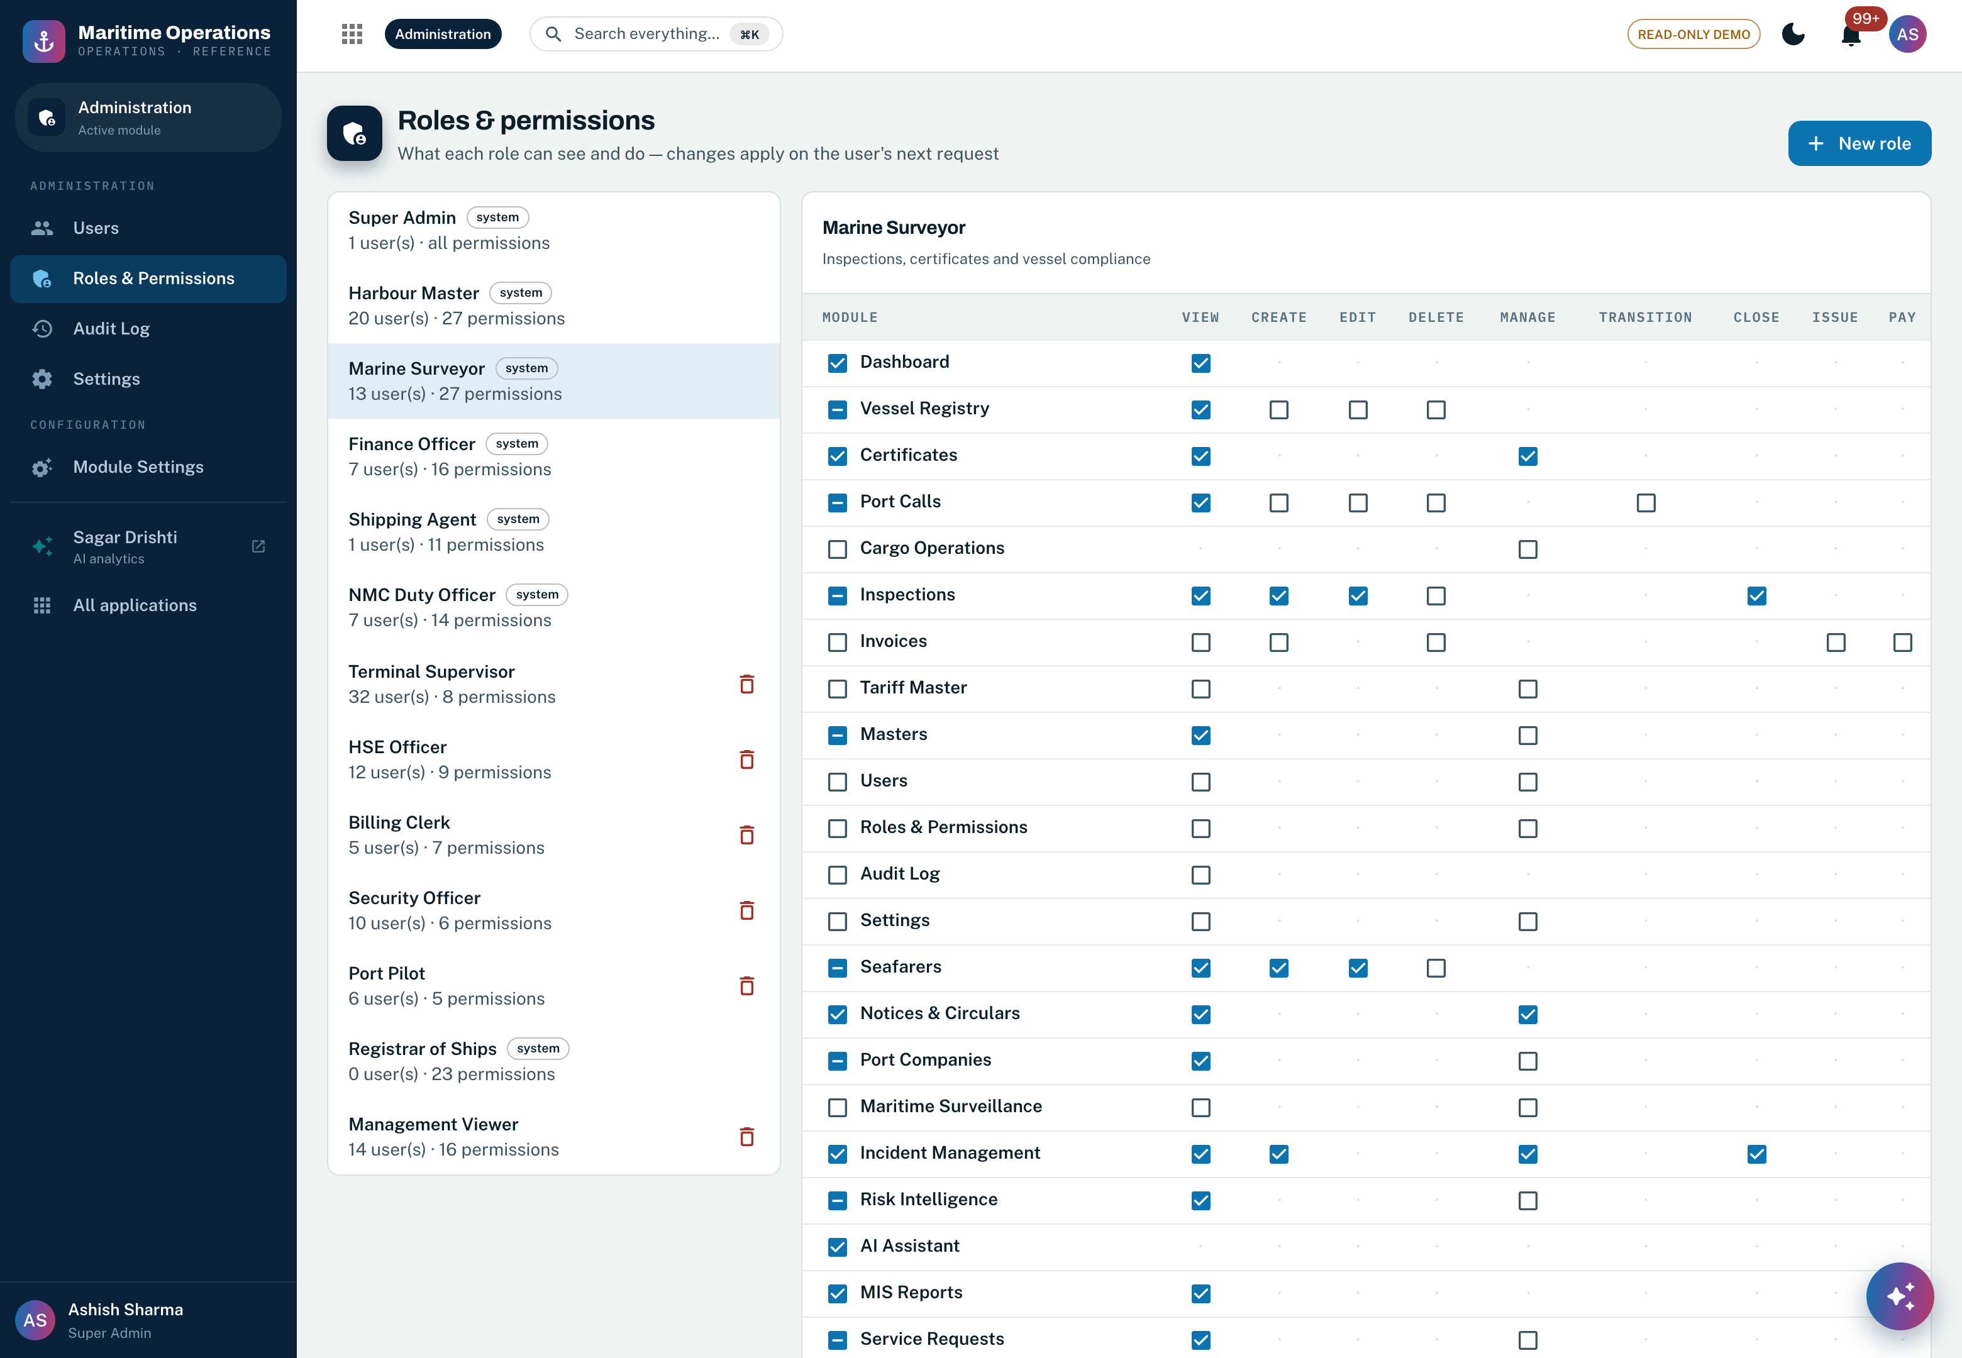
Screenshot 10 — the same matrix in the product: all thirteen roles with their user counts and permission counts on the left, and the selected role’s permissions as a module by action grid on the right. Marine Surveyor is shown. The grid is rendered from the single-source permission catalog, so what an administrator sees here is exactly what the backend middleware enforces.

For this module specifically, the rights that govern master data are these — who holds them today, and the control that is added in the target state.
Capability | Permission | Roles that hold it today | Control added in the target state
Open the Data Studio and read any master | masters.view | Super Admin, Harbour Master, Marine Surveyor, Finance Officer, Terminal Supervisor, Registrar of Ships | Read stays broad by design — every operational role needs the controlled vocabularies. Modelled as an Entra ID group.
Create, edit or deactivate a master entry | masters.manage | Super Admin | Narrows to a dedicated data-steward app role, scoped per domain, with maker-checker dual control on sensitive masters.
Read the tariff master and its rate history | tariffs.view | Super Admin, Harbour Master, Finance Officer, Billing Clerk | Unchanged. Historical rates additionally replicate to the analytics zone for revenue reporting.
Publish a tariff revision | tariffs.manage | Super Admin, Finance Officer | Approver app role, plus a Logic Apps approval workflow and stakeholder notification before the new rate takes effect.
Read module settings | settings.view | Super Admin | Business settings stay in the typed store; secrets and connection material move to Key Vault, reached by managed identity.
Change module settings and platform configuration | settings.manage | Super Admin | Platform-administrator app role under Entra ID Privileged Identity Management, with just-in-time elevation.
Read the audit register | audit.view | Super Admin, Registrar of Ships | Extended to cover agent-initiated writes, with the agent recorded as the actor; streams to Azure Monitor and immutable archive.
Administer roles and the permission matrix | roles.manage | Super Admin | Permission groups map onto Entra ID groups and app roles, so assignment is governed by SSO, MFA and conditional access.
Create and manage users | users.manage | Super Admin | Workforce identity lifecycle moves to Entra ID; customer identity federates from UAE PASS.
Configure AI agent autonomy and thresholds | agents.configure | Super Admin | Held by the AI Governance Committee in the target state; every autonomy change is recorded with actor and reason.

3.10 Business benefits
- One version of the truth: a berth's limits, a company's identity or a tariff rate exists exactly once — every module, report and AI agent reads the same value; customers never re-submit data the platform already holds.
- Regulatory defensibility: every reference-data change is audited with before/after evidence and per-attribute lineage; historical transactions keep the rates and codes that applied at their time.
- Business agility: new categories, codes and fees are configuration on the low-code layer — the vendor-independence objective (O2) starts here.
- AI you can trust: agents grounded on canonical, quality-monitored records — the precondition for every zero-touch service in the other modules.

3.11 Functional requirements compliance (RFP §5.4.1, §5.4.4, §7.5)
Requirement — RFP reference | Compliance today | Effort to 100% (MW)
Single master records for vessels, seafarers, companies, ports and facilities — shared and reused with zero duplication (§5.4.1) | ◐ PARTIAL | 24
A unified data model enabling cross-domain queries, compliance checks and AI analytics (§5.4.1) | ◐ PARTIAL | 10
Real-time data synchronisation ensuring every domain reflects the latest status of shared records (§5.4.1) | ○ NEW BUILD | 11
Configurable reference data manageable by the Client without vendor involvement — low-code (§5.4.4) | ◐ PARTIAL | 8
Master data management ensuring consistency across all seven domains (§7.5) | ● AVAILABLE | —
Arabic and English data storage with full Arabic Unicode character-set support (§7.5) | ◐ PARTIAL | 5
Structured retention and archiving aligned with UAE government records standards (§7.5) | ○ NEW BUILD | 2
Total delta engineering attributable to these requirements |  | 60
Compliance levels follow the legend used throughout: ● AVAILABLE — running in the current platform today · ◐ PARTIAL — the engine exists and the RFP service is configured or extended on it · ○ NEW BUILD — net-new development. Effort is indicative delta engineering from the running platform, in man-weeks, to be confirmed at D0/D1. A further 29 man-weeks in this module are not attributable to these seven requirements: stewardship and data-quality hardening (14), scheduled external-registry cross-checks (2), separating master data management into its own service (3), and the document-intelligence and MLOps work that serves the §5.5 agent requirements (10).

3.12 Agentic AI in Master Data Management
Master Data Management is the one domain in which the agents are mostly consumers rather than actors, and that is the point of it. Every agent in Section 6 reaches its conclusion by reading canonical records — a service definition, a document requirement, an instrument, a company, a tariff. An agent grounded on a register that contradicts itself will produce confident, well-explained, wrong answers, and it will produce them faster than a human could produce them by hand. The quality controls described earlier in this section are therefore not adjacent to the AI programme; they are its precondition.
Running today. Three of the seven mandated agents read master data on every run. Document Intelligence tests each lodged document against the requirement list held on the service definition, so what an applicant is asked for and what an assessor checks come from the same record and cannot diverge. Customer Guidance answers from the service catalogue rather than from a separately maintained help text. Regulatory Intelligence reads the instrument library as a whole and reports where two instruments are in force over the same subject with no supersession recorded — the master-data defect that no single record review would ever surface.
What this buys. Because guidance, validation and adjudication all resolve to the same canonical definition, a change to a service — a new mandatory document, an amended fee, a withdrawn prerequisite — propagates to the applicant-facing guidance, the intake check and the eligibility gate in one edit, with one audit entry. There is no second place to update and no window in which the two disagree.
Agent | What it reads from MDM | What fails if the master record is wrong
A1 — Document Intelligence | The requirement list on the service definition; recognised issuing authorities; the subject record the document is claimed to belong to. | Applicants are asked for documents the assessor does not need, or not asked for ones they do — and the agent reports a clean intake on an incomplete file.
A4 — Customer Guidance | The service catalogue: prerequisites, document lists, fees and processing expectations. | Guidance drifts from the rule actually applied, which is the single most common source of rejected applications and repeat contact.
A6 — Regulatory Intelligence | The whole instrument library, with each instrument’s status, subject and the services that cite it. | A superseded instrument stays in force and is applied to live cases; a conflict between two instruments is never detected because nobody owns reading both.
A2, A3, A5, A7 — indirectly | Companies, vessels, seafarers, berths, tariffs and lookups as the identity and reference layer beneath every judgement they make. | Duplicate or stale identities split a subject’s history in two, so compliance scores, targeting and the national picture are all computed on part of the evidence.

Effort to bring MDM to full AI-readiness. The delta here is not a model — it is coverage: extending automated data-quality scoring to every master entity, publishing the recognised-issuer and instrument registries as first-class managed masters, and adding lineage on the reference data the agents read. Estimated at 12 man-weeks, carried within the Section 3.11 figure.

4. Module 2 — Ships (Domain 1)
This domain governs the full legal and regulatory lifecycle of every vessel operating under the flag or in national waters — registration, statutory certificates, navigation licensing, permits, no-objection certificates, vessel transactions and the vessel master record. The RFP calls it the foundational domain upon which all other maritime services depend, and it is where the current platform is strongest: a ship register with an append-only transaction log, the convention certificate set with its survey-endorsement regime, cryptographically signed instruments with unauthenticated public verification, and an explainable vessel risk model are all running today.

4.1 Modules detailing — current capability, in depth
Engine | What it does today
Vessel Register | Full particulars — IMO, MMSI, call sign, flag, type, year built, DWT/GRT, LOA, beam, maximum draft, registered owner, commercial operator, ISM manager, agent, classification society, P&I club, builder, main engine and service speed. Each vessel carries its certificate wallet, call history, voyages, movements, inspections, crew on board, incidents and a risk profile.
Ship Registration | A true register rather than a form: four journeys — provisional, permanent, amendment and closure — share one file and one statutory lifecycle. Ownership is held as shares against a statutory divisor; evidence is verified item by item; the carving and marking note is recorded; a grant allocates the official number and mints the Certificate of Registry.
Statutory Certificates | The twelve convention certificates issued against a ship plus the Document of Compliance issued against the company operating it, each carrying the instrument it is issued under and its own survey regime. Validity is derived live — never stored stale — and an issued certificate is mirrored onto the ship’s own certificate list under its printed name.
Survey endorsement regime | A statutory certificate is not simply in date or expired. Each carries a schedule of annual, intermediate and renewal surveys through its term, and a certificate whose survey window has closed unendorsed has ceased to be in force even though its expiry date is years away. The register holds that distinction because port state control acts on it.
Digital signing & public verification | Every issued instrument is signed with Ed25519 over the register facts themselves. The signed payload is deliberately never stored: verification recomputes it from the record, so any later alteration to the holder, the expiry or the status breaks the signature. A public endpoint lets any holder verify a certificate without asking the platform, and the public key is published alongside it.
Vessel Risk Register | An explainable factor-weighted score — vessel age, certificate standing, deficiency history, detentions, inspection gap and operator record — with the weights exposed in an audited editor. Scores are computed on read from operational records, never stored.
Class Survey & Dry-Dock Planner | A twenty-four month horizon across the fleet showing each vessel’s annual, intermediate, special-survey and dry-dock windows, so survey planning is a view of the register rather than a spreadsheet beside it.

4.2 Feature inventory — the complete module surface
Section 4.1 describes the seven engines. The table below is the complete inventory of what each of them does today, grouped by family. Every entry is demonstrable live; Section 4.4 shows nine of them on screen.
# | Feature | What it does today
A · Vessel master record
1 | Vessel particulars | IMO (unique), MMSI, call sign, flag, type, year built, DWT, GRT, LOA, beam, maximum draft, registered owner, commercial operator, ISM manager, agent, classification society, P&I club, port of registry, builder, main engine (maker, model, kW), service speed, TEU capacity and dry-dock dates.
2 | Certificate wallet | Per-vessel certificate list — type, number, issuer, issue and expiry dates, remarks — written automatically when a statutory instrument is issued, under the name printed on the certificate.
3 | Registry face | The vessel’s standing on the register — state, official number, port of registry, certificate number, registered date, provisional expiry, closure date and ground. Written only by the registration engine on grant, never edited directly: the register entry is the authority and this is its denormalised face.
4 | Vessel dossier | One vessel, nine views: certificates, port calls, voyages and routes, movements, inspections, crew on board, incidents, risk profile and registry history.
5 | Fleet dashboard | Composition by type, age profile, flag-state and classification-society distribution, and the vessels needing certificate attention inside the warning window.
B · Ship registration — the register
6 | Four journeys, one file | Provisional, permanent, amendment and closure share one record and one lifecycle, because they share an evidence file, an officer and a register.
7 | Statutory lifecycle | DRAFT → SUBMITTED → UNDER SCRUTINY → CARVING NOTE ISSUED → SURVEY COMPLETE → APPROVED → GRANTED, with rejection and withdrawal paths. Transitions are enforced server-side; an amendment or closure runs the short path because it has nothing to carve and nothing to survey.
8 | Ownership ledger | Owners recorded as shares against the statutory divisor, with owner kind (individual, body corporate, co-operative society) and its registration identifiers. The engine checks that the shares account for the whole ship and that the number of registered owners is within the statutory ceiling.
9 | Evidence file | Each lodged document carries its reference as issued, the issuing authority, the issue date, the file, and who verified it and when.
10 | Carving and marking note | Number, issued on and by, complied on, surveyor and remarks — a permanent certificate cannot be granted until the official number is cut into the ship and a surveyor has reported compliance.
11 | Encumbrance register | Mortgages, liens and charges with holder, amount, registration and discharge dates. A subsisting mortgage blocks closure of the registry entry.
12 | Statutory checks engine | Nine families of checks — standing on the register, port of registry, ownership qualification, tonnage, evidence, carving and marking, closure conditions, amendment particulars and the state of the ship — each marked blocking or advisory, and recorded on the file so a decision can be re-read exactly as it was made.
13 | Amendment tracking | What is being altered (name, ownership, port of registry, tonnage, alteration, manager, mortgage) with the before and after state and the prior approval reference where one is required.
14 | Closure | Ground for closure — sold foreign, transfer of registry, broken up, total loss, missing, ceased to qualify — with the receiving flag and the deletion certificate that flag will accept.
15 | Grant | Official number allocation, certificate number, granted on and by, provisional expiry where applicable, and the fee record.
16 | Decision and history | Outcome, officer, timestamp and reason, over a full transition history with notes.
17 | Jurisdiction-driven constants | Registrar, governing statute, declared ports of registry, share divisor and owner ceiling live in a swappable jurisdiction profile. Every figure carries its published source, and any figure that cannot be sourced is surfaced as unverified rather than passing silently as fact.
C · Statutory certificates
18 | Twelve convention certificates + Document of Compliance | Safety Construction, Safety Equipment, Safety Radio, Load Line, IOPP, IAPP, ISPP, Safety Management, Ship Security, Maritime Labour, Tonnage and Minimum Safe Manning issued against the ship; the Document of Compliance issued against the company operating it.
19 | Convention provenance | Each certificate carries the instrument it is issued under — SOLAS chapter I, the Load Line Convention, MARPOL Annexes I, IV and VI, the ISM and ISPS Codes, and MLC 2006.
20 | Survey endorsement regime | A per-certificate schedule of annual, intermediate and renewal surveys, with each endorsement recorded against its anniversary: kind, completion date, surveyor, recognised organisation, place and result.
21 | In-force determination | Status, then expiry, then the survey schedule — the order a port state control officer applies them. A certificate in date but carrying an overdue endorsement is not in force, and the register states why.
22 | Non-expiring instruments | Tonnage and Minimum Safe Manning are reissued on change rather than renewed on a term, and are never presented to a reader as a renewal deadline.
23 | Certificate mirroring | An issued statutory instrument writes onto the ship’s own certificate list under its printed name, keyed so a reissue replaces the entry rather than adding a second one — a certificate the registry has issued but the fleet screens cannot see is a certificate the crew will let lapse.
24 | Fleet certificate register | Every certificate across the active fleet ordered by expiry, with valid, expiring and expired derived live against an administrator-controlled warning window.
25 | Class survey & dry-dock planner | A twenty-four month horizon across the fleet showing annual, special-survey and dry-dock windows per vessel, with overdue items flagged.
D · Instruments, licences and permits
26 | Subject-agnostic licensing engine | One instrument record, whatever it is issued against. For vessels it carries the navigation licence, the foreign vessel permit and the vessel NOC alongside the statutory certificate set.
27 | Per-register numbering | Each register numbers in its own per-year series — NAV, PRM, NOC, SAFCON, IOPP, ISSC, MLC, TON, MSMD and the rest — using the abbreviations the trade already uses, so a number read off a printed certificate is recognisable without a lookup.
28 | Issue dependency checks | The checks that ran at issue are recorded with their result and detail, so an issue decision can be re-read as it was made.
29 | Instrument lifecycle | APPLIED → UNDER REVIEW → ISSUED → SUSPENDED or REVOKED, with a reinstatement path from suspension, enforced server-side.
30 | Validity terms | Default terms per instrument class and per type, applied on issue when no explicit expiry is supplied.
E · Digital signing and public verification
31 | Ed25519 signature over the register facts | Taken at issue over the certificate’s own asserted facts in a fixed field order.
32 | Signed payload never stored | Verification recomputes the payload from the stored record, so altering the holder, the expiry or the status after issue breaks the signature — which is the entire point of signing it.
33 | Stable key identifier | A short identifier derived from the public key, so a certificate issued before a key rotation still tells a verifier which key signed it.
34 | Public verification endpoint | Unauthenticated: any holder or port state officer can verify a certificate without an account and without asking the administration.
35 | Published signing key | The public key is served from its own public endpoint, so verification can be performed with any Ed25519 implementation rather than only through this platform.
F · Risk and compliance
36 | Explainable factor-weighted risk | Vessel age, certificate standing, deficiency history, detentions, inspection gap and operator record, each contributing a capped share of a 0–100 score with its factor value shown.
37 | Audited weight editor | The weights are configuration, not code; every change is audited with actor and before/after.
38 | Fleet risk register | Every active vessel ranked with its score and band, recomputed from operational records.
39 | Computed on read | Certificate validity, in-force state and risk are computed at read time and never stored, so no vessel record can hold a stale derived value.

4.3 Module diagram & flow
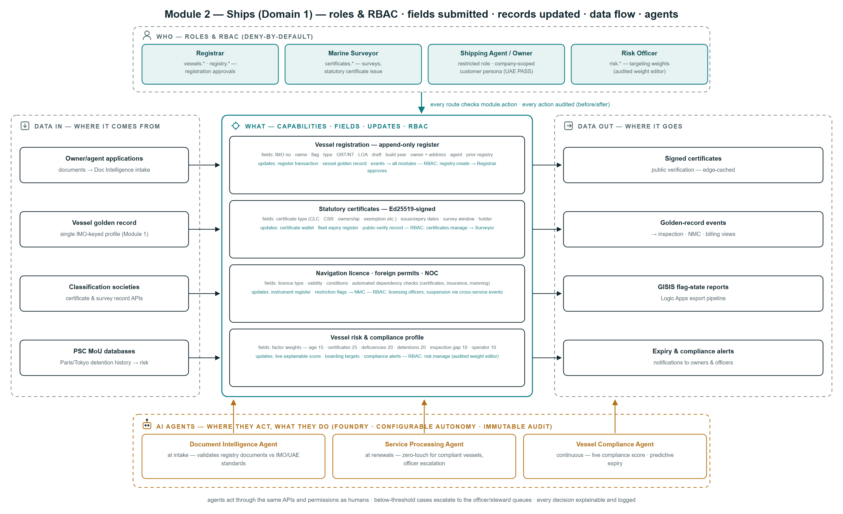
Figure 4 — Ships at a glance: the operating roles and the permission groups they hold, each capability with the fields submitted and the records and views it updates, where the data comes from and where it goes, and the point at which each AI agent acts.
Reading the diagram:
- Top lane — the operating roles. The Registrar approves register transactions, the Marine Surveyor issues signed certificates, agents and owners submit through company-scoped federated accounts, and the Risk Officer tunes the audited weight editor. Every route checks a module.action permission and every action is audited with before/after images.
- Left to right — an application arrives carrying the vessel particulars named in the first capability box; on approval the register gains an append-only transaction, the vessel golden record updates, and the change is published to every domain that consumes it.
- Certificates are Ed25519-signed at the moment of issue, and verification is public and edge-cached — high-volume data out that never loads the core.
- Bottom lane — where AI acts: Document Intelligence validates papers at intake, Service Processing renews compliant vessels zero-touch and escalates the rest to an officer queue, and the Vessel Compliance Agent rescores continuously with predictive expiry alerts.

Diagram elaboration — feature by feature:
Capability | Fields captured | Role / permission required | Where the data is stored | Used by AI?
Vessel registration | IMO number · name · flag · type · GRT and NT · LOA · draft · year built · owners with their shares and addresses · agent · previous registry · supporting evidence | Agent or owner submits through a company-scoped federated account; registry.apply to lodge; registry.assess to scrutinise; registry.grant reserved to the Registrar | Append-only register transaction plus the evidence file in PostgreSQL; documents in the ADLS raw zone | YES — Document Intelligence at intake; Service Processing for compliant renewals
Statutory certificates | Certificate type · issue and expiry dates · survey window · holder · recognised organisation · endorsement records | certificates.manage — the Marine Surveyor issues; verification needs no role at all | Instrument register in PostgreSQL, mirrored onto the vessel’s certificate wallet; signature recomputed on read | YES — document validation against convention standards; predictive expiry
Navigation licence · foreign permit · NOC | Licence type · validity · conditions · the dependency-check results (certificates, insurance, manning) | Licensing officers hold the instrument permission set; suspension is an officer decision, never an automatic one | Instrument register with the checks recorded as they ran at issue | YES — Service Processing adjudicates standard cases; officer queue otherwise
Vessel risk and compliance profile | Factor weights — age 15 · certificates 25 · deficiencies 20 · detentions 20 · inspection gap 10 · operator 10 — with the live factor values behind each | risk.manage — the Risk Officer edits weights and every change is audited; scores are visible to every operational role | Computed on read from operational records; weights in the typed settings store | YES — Vessel Compliance Agent rescores on every relevant event
Vessel registration and certificate issue, as it runs today:
Step | Actor | Behaviour
1 | Applicant or agent | Lodges the application with the vessel particulars, the ownership ledger and the supporting evidence
2 | System — statutory checks | Nine families of checks run against the file, the ship and the register; blocking failures stop the grant and are shown with their reason, advisory ones are recorded and passed to the officer
3 | Registrar (permission-gated) | Scrutinises the file; the workflow state machine enforces the legal transitions server-side — nothing may skip carving and survey on a first registration
4 | System — carving and marking | The carving note is issued; a surveyor reports that the official number and registered tonnage have been cut into the main beam
5 | System — grant | The official number is allocated, the Certificate of Registry is minted and numbered in its own per-year series, and the instrument is Ed25519-signed over the register facts
6 | Any verifier (public, no account) | Verifies the certificate against the published signing key — the payload is recomputed from the register entry, so any later alteration breaks verification
7 | System — continuous | Validity and in-force state are derived on every read; expiry alerts fire ahead of lapse; every step is on the audit trail with actor and before/after

4.4 The module in operation
Screens from the running platform, captured from the live build, so that every capability claimed in Sections 4.1 and 4.2 can be checked against the software rather than taken on trust.
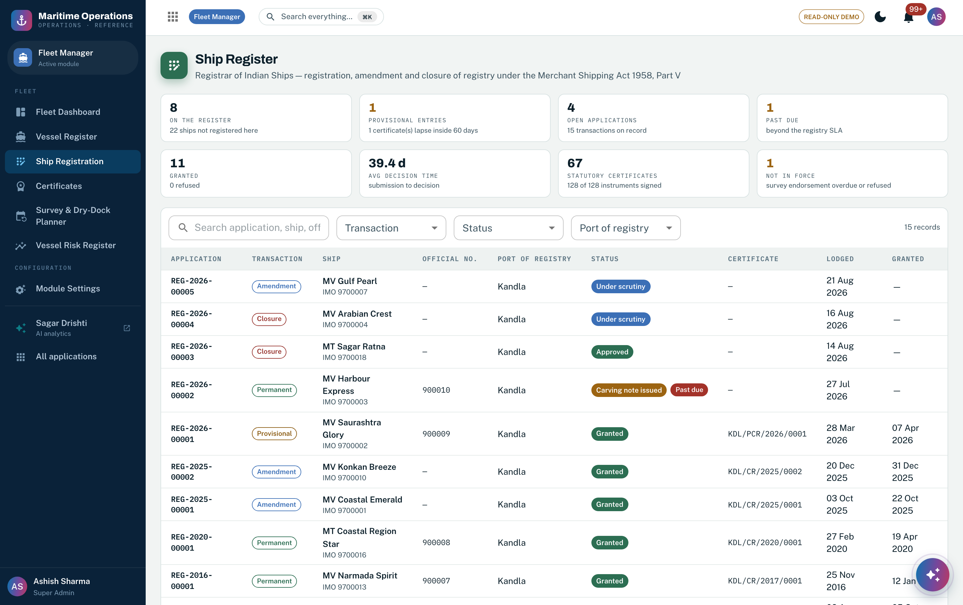
Screenshot 11 — the ship register: every transaction on the register — permanent registrations, amendments and closures — with its official number, port of registry, lifecycle state, certificate and dates. Features 6, 7, 15, 16.
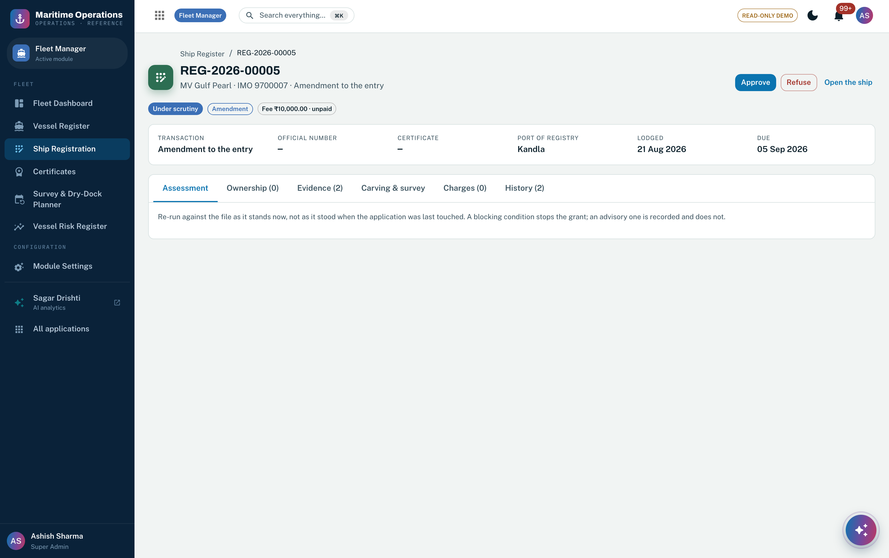
Screenshot 12 — one registration file, with the statutory checks resolved and the blocking condition stated in plain words, over tabs for ownership, evidence, carving and survey, charges and history. The approve and refuse actions are permission-gated. Features 8–13, 16.
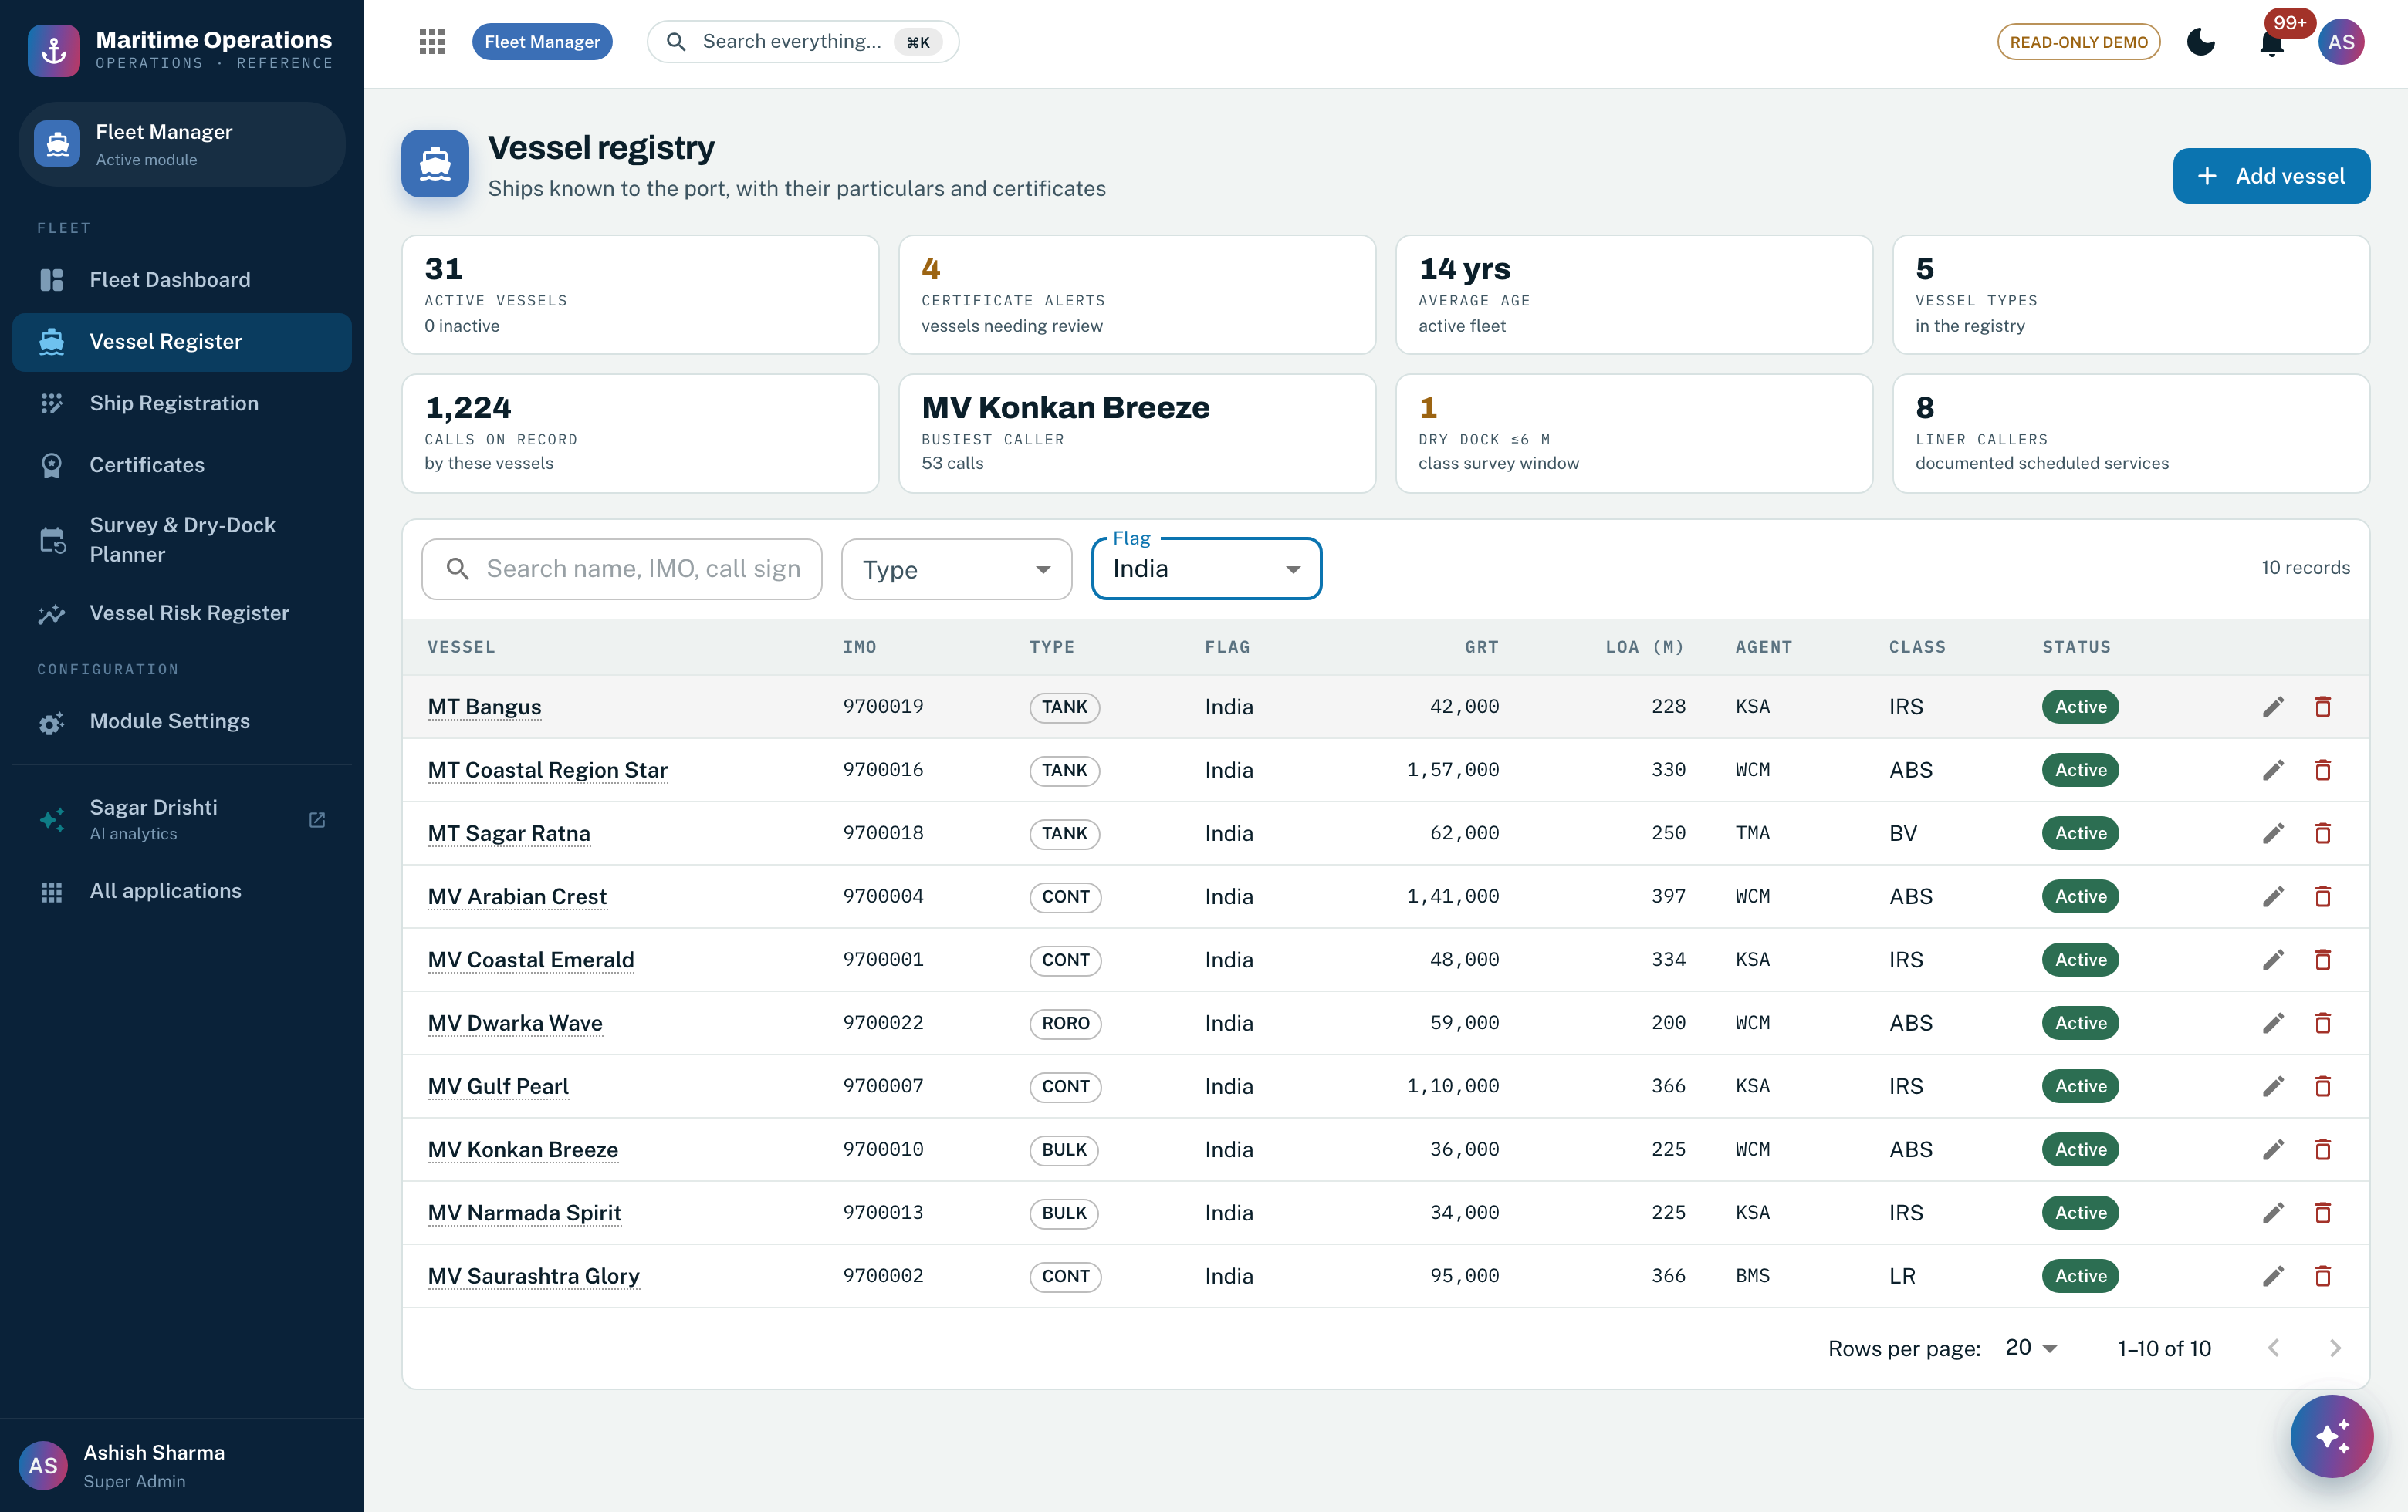
Screenshot 13 — the vessel register with particulars, tonnage, dimensions, agent and classification society, filtered here to the national flag. Features 1, 5.
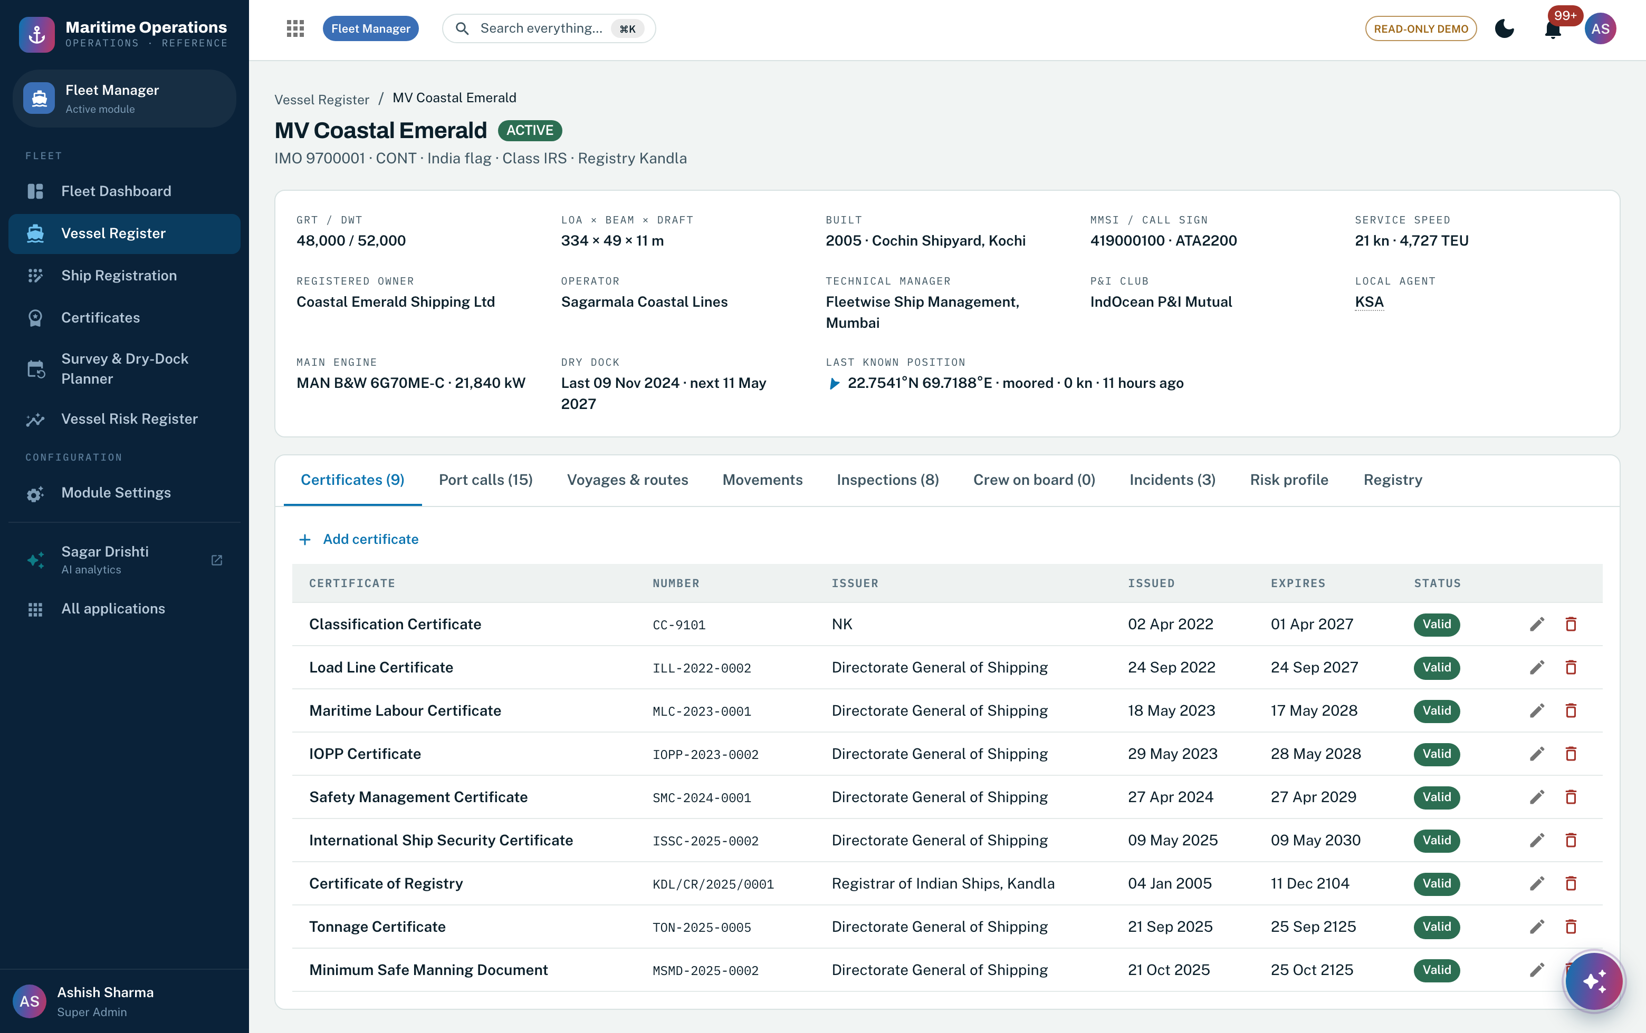
Screenshot 14 — one vessel: particulars, registry standing and the certificate wallet showing the convention set with issuer and derived validity, over nine views of the same ship. Features 1–4, 18, 19, 23.
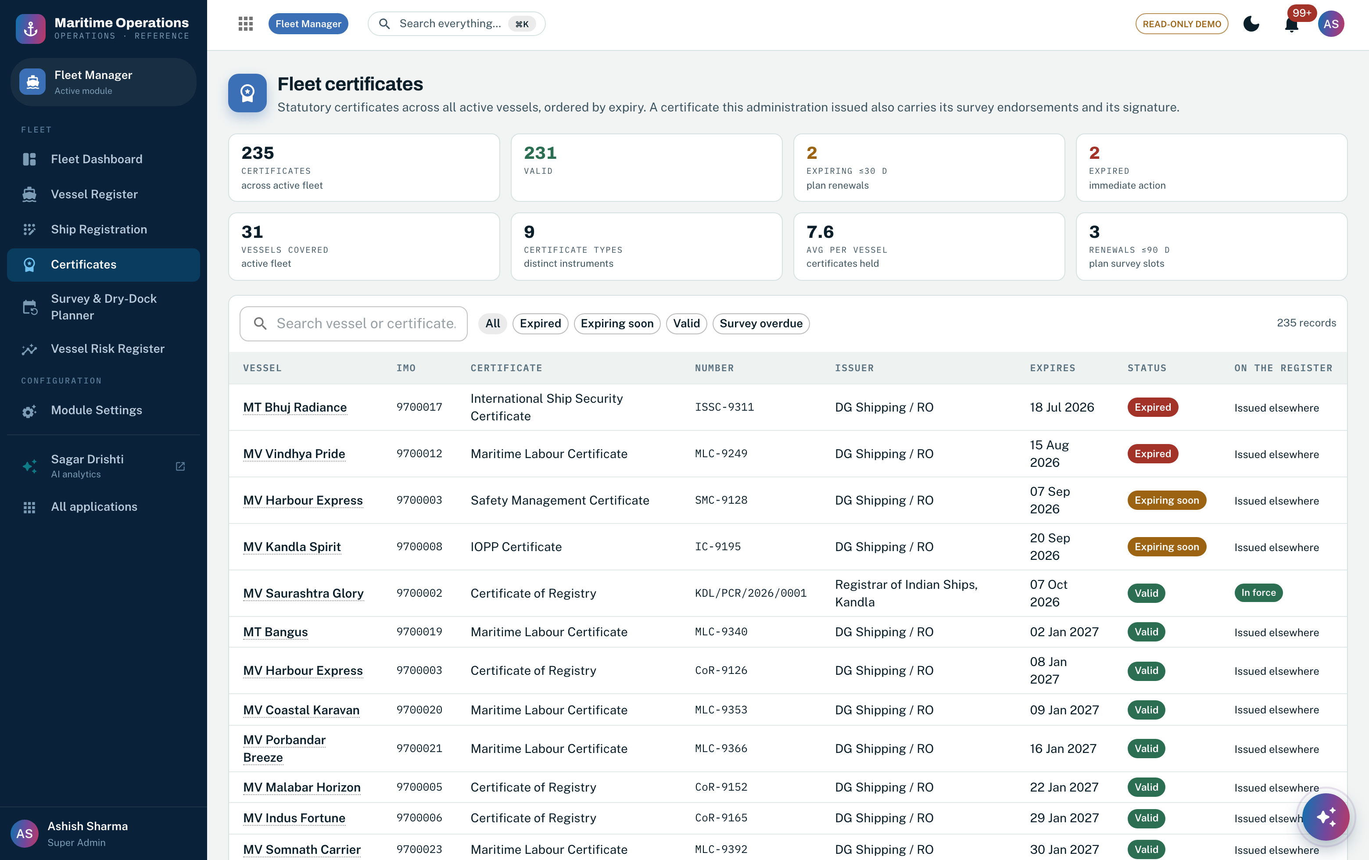
Screenshot 15 — the fleet certificate register: every certificate across the active fleet ordered by expiry, with valid, expiring and expired derived live rather than stored. Features 21, 24.
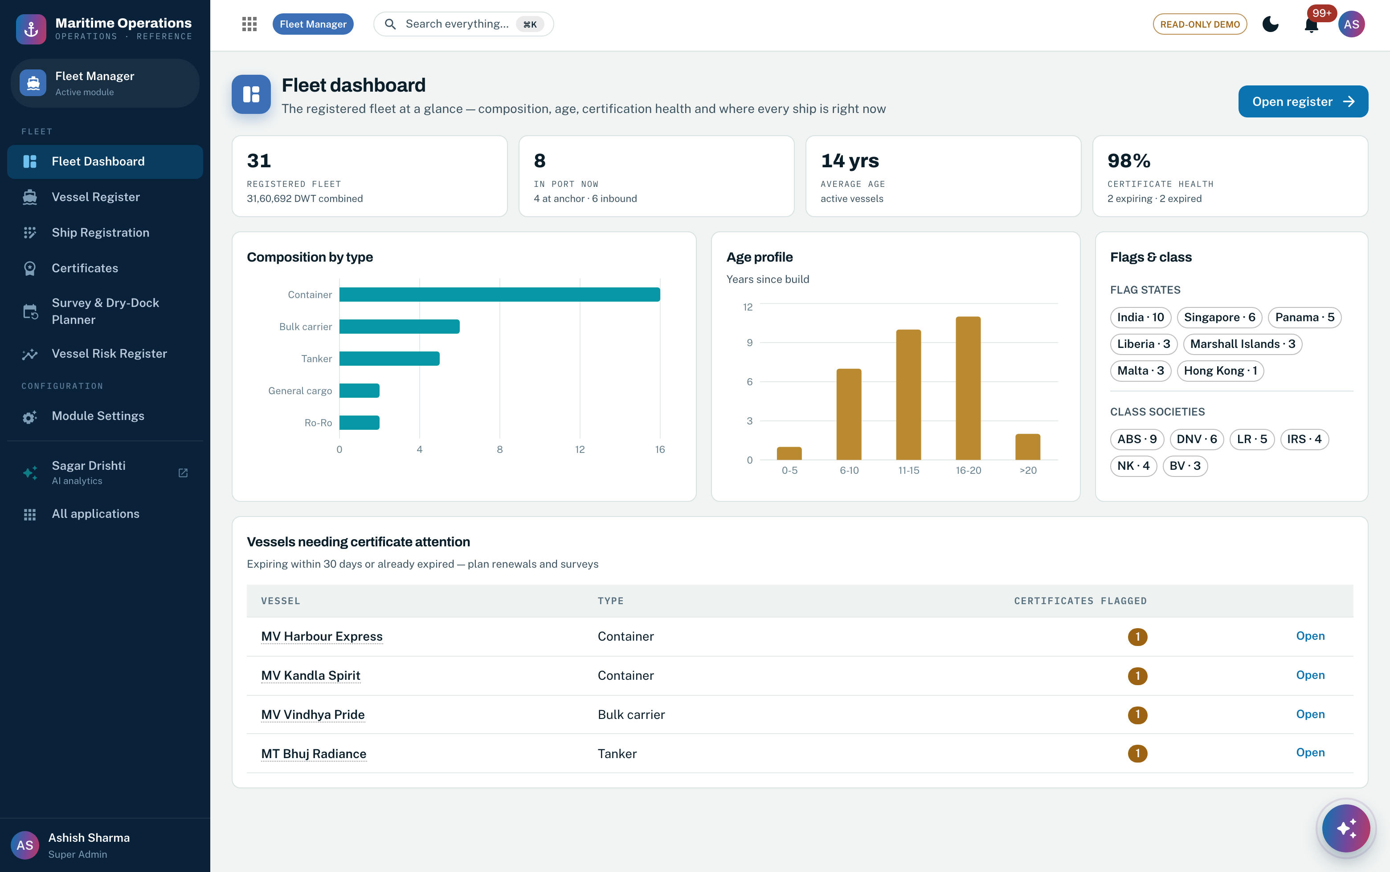
Screenshot 16 — the fleet at a glance: composition by type, age profile, flag-state and classification-society distribution, and the vessels needing certificate attention inside the warning window. Feature 5.
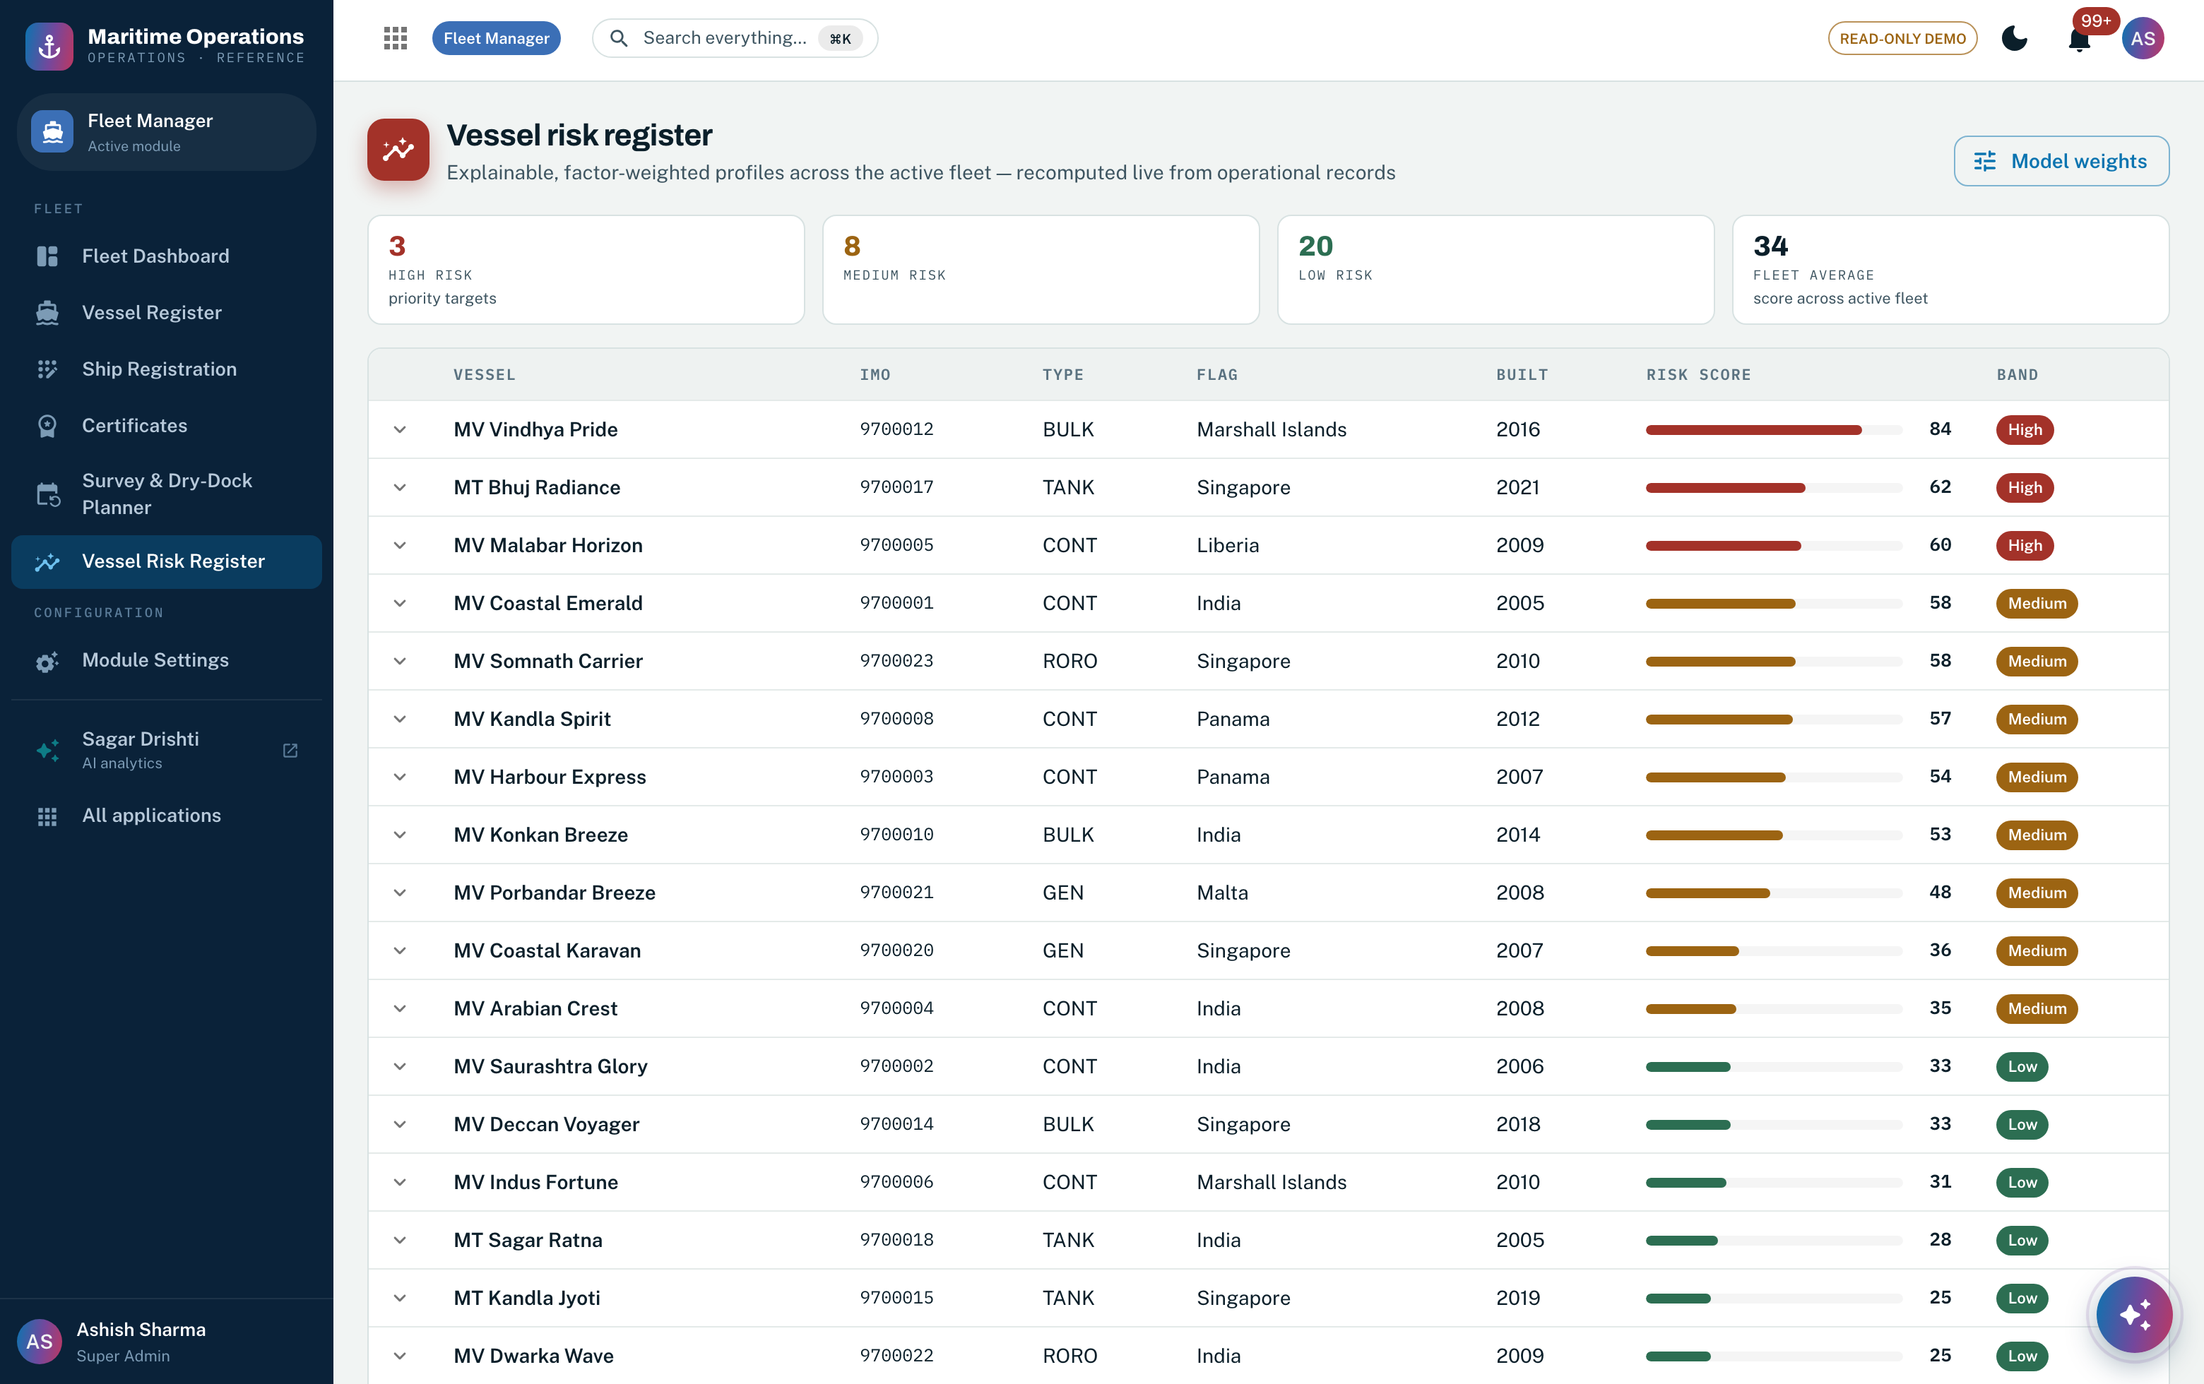
Screenshot 17 — the vessel risk register: an explainable factor-weighted score per vessel with its band, recomputed from operational records, with the weight editor behind the Model weights action. Features 36–39.
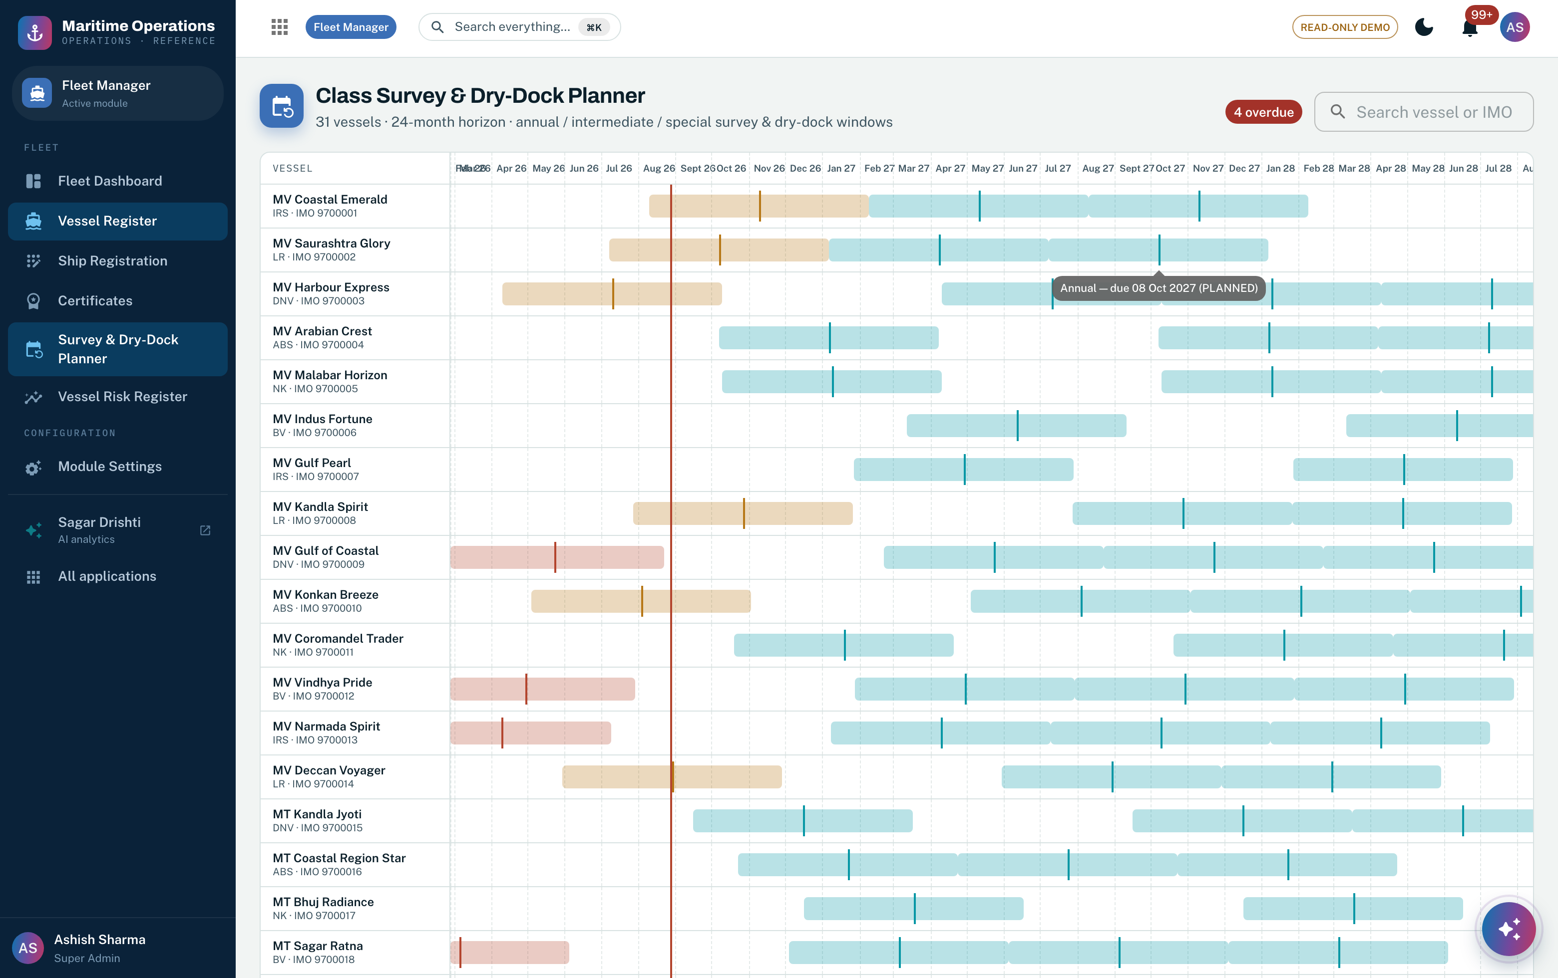
Screenshot 18 — the class survey and dry-dock planner: a twenty-four month horizon of survey and dry-dock windows across the fleet, with overdue items flagged. Feature 25.

4.5 On the Azure stack
- Registration documents land in the ADLS Gen2 raw zone and pass the Section 3 intake pipeline: AI Document Intelligence extracts the particulars and entity resolution binds them to the vessel golden record on the IMO key before any officer opens the file.
- Certificate signing keys move into Key Vault (HSM-backed) and are reached by managed identity; the code never sees key material. The public verification endpoint is edge-cached at Front Door, so a verification storm never reaches the core.
- Vessel golden-record changes publish on Service Bus, so the inspection, national-centre and billing views update in real time rather than on a nightly reconciliation. GISIS flag-state reporting runs as a Logic Apps workflow through API Management.
- The Vessel Compliance Agent runs nightly Azure ML batch scoring across the whole register and event-driven rescoring on any certificate, inspection, insurance or ownership change, with drift monitoring on the model.
- Classification-society certificate and survey-record APIs are consumed through API Management with per-society throttling, and their responses are cached so a society outage degrades freshness rather than availability.

4.6 Roles & permissions
Four permission groups govern this domain — vessels, certificates, registry and risk — with the service desk (services) carrying the applications that feed it. The matrix below is the authorisation model for those groups across all thirteen roles, generated from the same single-source catalog the middleware enforces. Role codes are as given in Section 3.9.
Module — actions in the group | SA | HM | MS | FO | AG | ND | TS | HO | BC | SO | PP | RS | MV
Vessel Registry — view/create/edit/delete | ● | ◐ | ○ | ○ | ○ | ○ | ○ | – | ○ | – | ○ | ◐ | ○
Certificates — view/manage | ● | ○ | ● | – | – | – | – | – | – | – | – | ● | –
Risk Intelligence — view/manage | ● | ○ | ○ | – | – | ○ | – | – | – | – | – | – | ○
Service Requests — view/apply/assess/approve/manage | ● | ○ | ◐ | – | ◐ | – | – | – | – | – | – | ◐ | ○
Ship Registration — view/apply/assess/grant | ● | ○ | ◐ | – | ◐ | – | – | – | – | – | – | ● | ○
● every action in the group ◐ view plus selected write actions ○ view only – no access.
Two properties of this model matter to the RFP. Only the Registrar may grant a registration (registry.grant is held by that role and the administrator alone), and only the Marine Surveyor may issue a statutory certificate — so the two acts that confer legal status on a ship are each reserved to one named office. The Shipping Agent, an external party, can lodge an application and read its own instruments but holds no assess, approve or grant permission anywhere. In the target state these become Entra ID app roles with row-level company scoping, and customer identities federate through UAE PASS.

4.7 Business benefits
- A tamper-evident national register — because the signature is taken over the register facts and recomputed on verification, fraud on an issued certificate is cryptographically detectable by anyone holding it, without contacting the administration.
- Zero-lapse compliance — validity and in-force state are derived, never stored, so the register cannot quietly disagree with itself; expiry alerts fire ahead of lapse rather than after it.
- The survey-endorsement distinction is held where it belongs — a certificate in date but unendorsed is reported as not in force, which is what a port state control officer will act on and what a flag state is judged by.
- One authoritative vessel profile feeds every other domain — inspection targeting, the national picture and billing all read the same record, which is where the RFP’s zero-duplication promise becomes operational rather than architectural.
- Decisions are re-readable — the checks that ran, the evidence that was verified and the officer who decided are all on the file, which is what an IMSAS audit asks for.

4.8 Functional requirements compliance (RFP Domain 1 — Ships)
Requirement — RFP Domain 1 | Compliance today | Effort to 100% (MW)
Vessel Master Record — a single authoritative vessel profile shared across all domains and services | ◐ PARTIAL | 5
Vessel Registration — provisional, permanent, amendments and deletion from the registry | ◐ PARTIAL | 4
Vessel Certificates — issuance, renewal, amendment, extension and cancellation of CLC, CSR, exemption, ownership and all statutory flag-state certificates | ◐ PARTIAL | 8
Navigation Licence — issuance, renewal, amendment and suspension with automated dependency checks | ◐ PARTIAL | 2
Foreign Vessel Permits — risk-based evaluation and issuance for non-national-flagged vessels | ○ NEW BUILD | 5
Vessel No Objection Certificates — digitised submission, AI-assisted assessment and automated restriction enforcement | ○ NEW BUILD | 5
Vessel Transactions — ownership transfer, mortgage registration and cancellation, sale contract attestation | ◐ PARTIAL | 9
AI requirements — RFP Domain 1
AI agent for end-to-end processing of registration and certificate renewals — zero manual intervention for compliant vessels | ○ NEW BUILD | 8
Automated AI validation of submitted vessel documents against IMO standards and national regulations | ○ NEW BUILD | 6
AI-generated compliance score for each vessel, updated in real time as data changes | ◐ PARTIAL | 7
Predictive alerts for upcoming certificate expirations, enabling proactive renewal before lapse | ● AVAILABLE | —
Total delta engineering attributable to these requirements |  | 59
Effort is indicative delta engineering from the running platform, in man-weeks, to be confirmed at D0/D1. A further 24 man-weeks in this module are not attributable to these eleven requirements: GISIS flag-state reporting (4), separating Ships into its own service (3), Arabic and English bilingual forms and certificate rendering (6), classification-society integration (5), edge-cached public verification with HSM-held signing keys (3), and refinement of the predictive expiry model (3).
One row deserves comment. Predictive expiry alerting is marked AVAILABLE because it runs today, and the compliance score is PARTIAL rather than NEW BUILD because the explainable weighted engine is in production — what the RFP adds is continuous rescoring on every relevant event and a trained model behind the statistical factors. Foreign permits and NOCs are honestly NEW BUILD: the licensing engine will carry them as configured instrument types, but neither service exists today.

4.9 Agentic AI in the Ships domain
Running today. A real-time explainable vessel compliance and risk score; predictive certificate-expiry alerting; vessel watchlist and reliability analytics in the AI portal; and a grounded assistant that answers vessel questions with per-answer citations to the records it read.
Target state. Three of the seven mandatory agents act in this domain, all on Foundry Agent Service, all reaching business capability only through API Management so that an agent action carries the same authentication, permission check and audit entry as a human one:
- A1 — Document Intelligence Agent, at intake: classifies and extracts every registry document, cross-validates the extraction against the vessel golden record and the issuing authority, and routes anything below the confidence threshold to a document officer rather than into the register.
- A3 — Service Processing Agent, at renewal: adjudicates registration and certificate renewals end to end for compliant vessels — eligibility, prerequisite certificates, outstanding dues, no open compliance hold — and escalates first-time applicants, enforcement-linked cases and anomalies to an officer queue.
- A2 — Vessel Compliance Agent, continuously: rescores every registered vessel on any certificate, inspection, insurance or ownership change, issues pre-expiry alerts, and initiates renewal workflows. Any enforcement-grade action — a detention recommendation, a certificate suspension — requires named-officer approval with the evidence dossier attached.
AI benefits. Compliant vessels renew without a human touch, which is the national directive expressed in one domain; document fraud is detected at submission rather than at audit; and officers spend their time only on the exceptions the agents escalate.

Evidence — these agents run today. The three agents named above are not a design. They are registered on the platform, they hold a stated autonomy level and confidence threshold, and they have written decisions against this domain’s own records — vessels on the register, their statutory certificates and their inspection history. Section 6 describes how a decision is made and shows the register that holds them; the table below is what these three produced on the reference dataset.
Agent | What it decided in this domain | Latitude in force | Decisions | Outcome
A1 — Document Intelligence | Tested every document lodged against a ship service — required-document coverage, IMO check digit, issue-before-expiry, expiry not already past, issuing authority recognised. | Assisted · 0.85 | 12 | All escalated — see below
A2 — Vessel Compliance | Rescored every active vessel on the register from its inspection history and the certificates it holds, including whether each certificate is in force on its survey schedule rather than merely unexpired. | Assisted · 0.80 | 12 | 12 applied
A3 — Service Processing | Ran the eligibility gates on open ship-service applications — mandatory documents, verification, subject on record, fee settled, compliance hold — stopping at the first failure. | Supervised · 0.90 | 12 | 12 queued for review

Reading the escalations. A1 escalated all twelve. That is the intended behaviour, not a shortfall: the required documents were present and every integrity check passed, but none of the lodged documents had yet been verified by an officer, so the agent scored 0.75 against its 0.85 threshold and declined to vouch for the file. The register records the reason in those terms — “Confidence 0.75 below threshold 0.85” — with the three weighted factors that produced it. An agent that cannot tell a verified document from an unverified one is worth less than no agent at all, and this is what the alternative looks like in operation.

4.10 Improvements — TO BE
Stream | Scope
Delta develop | Foreign vessel permit service with risk-based evaluation; vessel NOC service with automated restriction enforcement; mortgage and encumbrance register with registration, cancellation and discharge; sale-contract attestation and ownership transfer; the full national statutory certificate catalogue with its terms and survey regimes; GISIS flag-state reporting.
Application revamp | Ships as its own microservice on AKS with its own scaling profile; the registration and certificate journeys re-expressed as low-code configured workflows so the Client can alter evidence lists, checks and fees without a release; Arabic and English forms and certificate rendering with right-to-left layout.
Unified data architecture platform | The vessel golden record with event-driven synchronisation to every consuming domain, so vessel particulars are never re-submitted anywhere; classification-society certificate and survey-record integration; public verification served from the edge with signing keys held in an HSM-backed vault.
AI agents + AI platform | Document Intelligence validation of registry documents against convention and national standards; the Service Processing agent for zero-touch renewals; the Vessel Compliance agent with Azure ML scoring, drift monitoring and event-driven rescoring — all registered on Foundry Agent Service with configurable autonomy and immutable agent audit.

4.11 Effort estimation for the delta (man-weeks)
Decomposed to testable line items on the same basis as Section 3.11. It supersedes the four-line figure carried in earlier issues: detailing the module at this depth showed the earlier number did not carry the encumbrance register, the attestation workflow, the bilingual certificate rendering, the classification-society integration or the MLOps behind the compliance score.
Work item | MW
Stream A — Delta develop · 29 MW
Foreign vessel permit service — risk-based evaluation, conditions, issuance | 5
Vessel NOC service — submission, AI-assisted assessment, automated restriction enforcement | 5
Mortgage and encumbrance register — registration, cancellation, discharge, closure blocking | 5
Sale-contract attestation and ownership transfer workflow | 4
Full national statutory certificate catalogue — types, terms, survey regimes, certificate forms | 6
GISIS flag-state reporting export pipeline | 4
Stream B — Application revamp · 17 MW
Ships extracted as its own microservice on AKS — scaling profile, probes, GitOps pipeline | 3
Registration and certificate journeys re-expressed as low-code configured workflows | 8
Arabic and English bilingual forms and certificate rendering with right-to-left layout | 6
Stream C — Unified data architecture platform · 13 MW
Vessel golden record with event-driven synchronisation to every consuming domain | 5
Classification-society certificate and survey-record integration through API Management | 5
Edge-cached public verification; signing keys moved to an HSM-backed vault | 3
Stream D — AI agents + AI platform · 24 MW
Document Intelligence validation of registry documents against convention and national standards | 6
Service Processing agent — zero-touch registration and certificate renewals with officer escalation | 8
Vessel Compliance agent — Azure ML scoring, event-driven rescoring, drift monitoring, MLOps | 7
Predictive expiry model refinement and proactive renewal triggers | 3
TOTAL — Ships | 83

5. Module 3 — Seafarers' Affairs & MET Oversight (Domain 2)
This domain governs the certification of seafarers, the verification of their professional competence and seagoing service, and the approval and quality auditing of the maritime education and training institutions that produce them. It is the domain in which the RFP is most prescriptive — naming the Seafarer Identification Number as the primary key, a separate ledger for foreign certificates and flag endorsements, cross-referencing against the Minimum Safe Manning Document and IMO FAL Form 5 crew lists, and a public certificate verification page. The current platform runs the crew register, the certificate wallet, a verified sea-service ledger and the accreditation engine; the delta is largely about federating those onto the identifiers and ledgers the RFP names.

5.1 Modules detailing — current capability, in depth
Engine | What it does today
Crew register | Every seafarer as an identity record: discharge-book number as the unique key, INDoS number as the national seafarer identifier, name, date of birth, nationality, rank from an eighteen-rank controlled list, contact details, and a status of active, shore leave, signed off or suspended.
Certificate wallet | Per-seafarer certificates with type, grade (for example Class 1, Master Foreign-Going), number, issuing authority, issue and expiry dates. Validity is derived on read against an administrator-controlled warning window, never stored.
Sea-service ledger | Vessel, IMO number, rank held, sign-on and sign-off dates and duration for every tour, each entry carrying a verified flag. Service recorded by the platform’s own sign-off is verified by construction, because the platform knows who was on which ship and when.
Sign-on document gate | Sign-on is refused when medical fitness is missing, expired, or expires inside the tour; the Certificate of Competency is checked when the module setting requires it. A refusal can be overridden, and the override and its stated reason go onto the audit trail with the officer’s name.
Certification instruments | Certificates of Competency, Certificates of Proficiency and Flag State Endorsements are issued on the same subject-agnostic instrument engine as ship certificates — own numbering series, own lifecycle, Ed25519-signed and publicly verifiable.
MET oversight | Training institutions are accredited as instrument subjects in their own right, with an accreditation term, a lifecycle and an audit history recording date, auditor, result and remarks. Programme approval is a separate instrument class on the same engine.
Crew dashboard | Roll strength, on board against ashore, medical issues, average sea days, rank distribution, a certificate expiry funnel across the whole roll and a needs-attention list ranked by document alerts.

5.2 Feature inventory — the complete module surface
The complete inventory of what this module does today, grouped by family. Section 5.4 shows seven of these on screen.
# | Feature | What it does today
A · Seafarer master profile
1 | Identity record | Discharge-book number as the unique key, INDoS number as the national seafarer identifier, name, date of birth, nationality, rank and contact details.
2 | Rank control list | Eighteen ranks from Master through Deck and Engine Cadet, so rank is a controlled value rather than free text.
3 | Status lifecycle | Active, shore leave, signed off and suspended, with the current vessel and the date the present tour began.
4 | Certificate wallet | Type, grade, number, issuing authority, issue and expiry dates and remarks, held per seafarer.
5 | Nine certificate types | Certificate of Competency · GMDSS General Operator · Medical Fitness (ILO/MLC) · STCW Basic Safety Training · Advanced Fire Fighting · Medical First Aid · Ship Security Officer · Tanker Familiarisation · Certificate of Discharge.
6 | Derived validity | Valid, expiring or expired computed at read time against an administrator-controlled window, so no certificate row can hold a stale status.
7 | Crew register | Searchable by name, discharge-book and INDoS number, filterable by rank and status, showing each seafarer’s certificate-alert count and accumulated sea days.
B · Sea-service ledger
8 | Service entries | Vessel name, IMO number, rank held, from and to dates, duration and remarks for every tour.
9 | Verified service | Each entry carries a verified flag. Service written by the platform’s own sign-off is verified by construction rather than by self-declaration.
10 | Automatic generation on sign-off | Closing a tour writes the ledger entry — vessel, IMO, rank, dates and day count — without a separate form for the seafarer to complete.
11 | Service totals | Days accumulated per seafarer, surfaced on the register, the profile and the dashboard.
C · Sign-on and sign-off with a document gate
12 | Document gate | Medical fitness must be on file and valid before sign-on; the Certificate of Competency is checked when the module setting requires it; STCW Basic Safety is advisory and reported without blocking.
13 | Tour-outlast rule | A document expiring within thirty days blocks sign-on with the reason stated plainly — the tour would outlast the certificate.
14 | Configurable enforcement | Whether the Certificate of Competency is verified on sign-on, and the medical warning window, are typed module settings rather than code.
15 | Override with reason | A blocked sign-on can be overridden by an authorised officer; the override, the reason given and the officer’s name are written to the audit trail.
16 | Sign-off closes the tour | Clears the assignment, sets the status and writes the verified sea-service entry with its day count in one action.
D · Certification instruments
17 | Seafarer instruments | Certificates of Competency, Certificates of Proficiency and Flag State Endorsements run on the same subject-agnostic instrument engine as ship certificates and company licences.
18 | Per-register numbering | COC, COP and FSE series, numbered per year, using the abbreviations the trade already recognises.
19 | Instrument lifecycle | Applied → under review → issued → suspended or revoked, with a reinstatement path, enforced server-side.
20 | Signing and public verification | A seafarer instrument is Ed25519-signed over its register facts and verifiable by anyone on the same public endpoint as a ship certificate — the mechanism the RFP’s public CoC verification page requires.
21 | Service catalogue entries | Certificate of Competency issue and revalidation, and Flag State Endorsement under STCW Regulation I/10, each defined with its fee, service level and required-document list.
22 | Application journey | Submitted → under assessment → information requested → approved → issued, with a permission and a service level on each stage.
E · MET oversight
23 | Institution accreditation | A training institution is an accreditation subject in its own right, with its own instrument, term and lifecycle.
24 | Programme approval | A separate instrument class for approved programmes, so a programme can be approved, suspended or withdrawn without touching the institution’s own accreditation.
25 | Institution profile | Training institute as a company type in the directory, carrying contacts, addresses and the instruments it holds.
26 | Audit history | Date, auditor, result — satisfactory, observations or non-conformity — and remarks, recorded against the accreditation itself.
27 | Evidence requirements | The approval service defines what must be lodged: registration certificate, Quality Standards System manual, instructor qualifications, and the facility and simulator inventory.
F · Oversight and governance
28 | Crew dashboard | Roll strength, on board against ashore, medical issues, average sea days and rank distribution across the whole roll.
29 | Expiry funnel | Every document on the roll bucketed as expired, within thirty days, within ninety days, or valid.
30 | Needs-attention ranking | Seafarers ordered by the number of documents in alert, so the crewing desk works the worst cases first.
31 | Permission gating | seafarers.view / create / edit / delete govern the register; MET instruments sit under the facilities permission set; deny-by-default on every route.
32 | Immutable audit | Every certificate change, sea-service entry, sign-on, sign-off and override is recorded with actor and before/after images.
33 | Typed module settings | Medical expiry window, minimum rest hours and certificate verification on sign-on, with typed defaults and server-side validation.

5.3 Module diagram & flow
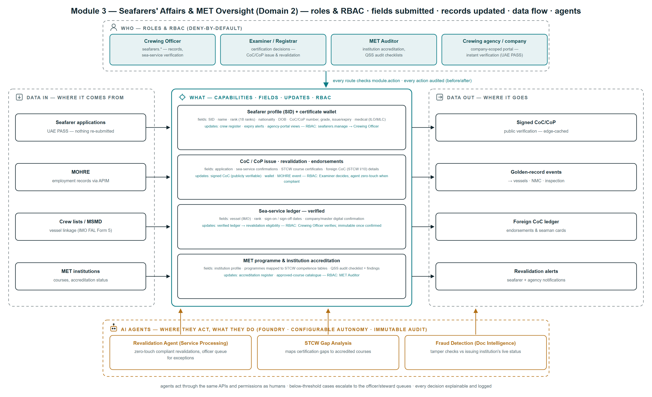
Figure 5 — Seafarers' Affairs & MET Oversight at a glance: the operating roles and the permission groups they hold, each capability with the fields submitted and the records it updates, where the data comes from and where it goes, and the point at which each AI agent acts.
Reading the diagram:
- Top lane — the Crewing Officer maintains records and verifies sea service, the Examiner or Registrar decides certification, the MET Auditor accredits institutions and runs quality-standards checklists, and the crewing agency reaches a company-scoped portal through federated identity.
- Left to right — applications arrive against an existing seafarer identity so nothing is re-submitted; employment records arrive from the labour authority; crew lists and the Minimum Safe Manning Document bind the seafarer to the ship; institutions supply their courses and accreditation status.
- Centre — the seafarer profile and certificate wallet, certification issue and revalidation, the verified sea-service ledger, and MET programme and institution accreditation. Each box names the fields captured and, beneath, the records that update and the permission required.
- Bottom lane — where AI acts: the Revalidation Agent processes compliant revalidations zero-touch and queues the rest, gap analysis maps a seafarer’s shortfall to accredited courses, and document intelligence checks a submitted certificate against the issuing institution’s live accreditation status.
Diagram elaboration — feature by feature:
Capability | Fields captured | Role / permission required | Where the data is stored | Used by AI?
Seafarer profile and certificate wallet | Identifier · name · rank · nationality · date of birth · certificate type, grade, number, issue and expiry · medical fitness | seafarers.manage — the Crewing Officer maintains the record; the seafarer and their agency read it through a scoped portal | Seafarer record in PostgreSQL; supporting documents in the ADLS raw zone linked to the profile | YES — document intelligence at intake; fraud and tamper checks
Certificate of Competency and Proficiency, and endorsements | Application · sea-service confirmations · STCW course certificates · foreign certificate details under Regulation I/10 | The Examiner or Registrar decides; issue is permission-gated and signed; verification needs no role at all | Instrument register with its signature; mirrored into the seafarer’s wallet | YES — zero-touch revalidation when every statutory condition is already satisfied
Verified sea-service ledger | Vessel and IMO · rank · sign-on and sign-off dates · digital confirmation from the master or company | The Crewing Officer verifies; an entry written by the platform’s own sign-off is verified by construction and immutable once confirmed | Sea-service ledger on the seafarer record, feeding revalidation eligibility | YES — service totals drive the revalidation agent’s eligibility test
MET programme and institution accreditation | Institution profile · programmes mapped to STCW tables of competence · quality-standards audit checklist and findings | MET Auditor holds the accreditation permission set; audit results are recorded against the instrument | Accreditation register and the approved-course catalogue | YES — cross-validation of a submitted certificate against the issuing institution’s live status
Certification and sea-service verification, as it runs today:
Step | Actor | Behaviour
1 | Crewing desk | Signs a seafarer on to a vessel; the document gate runs before the assignment is accepted
2 | System — document gate | Medical fitness must be on file and valid; a certificate expiring inside the tour is refused with the reason stated; the Certificate of Competency is checked when the module setting requires it
3 | Officer (where necessary) | May override a refusal; the override and the reason given are written to the audit trail against the officer’s name
4 | System — sign-off | Closes the tour and writes the sea-service entry — vessel, IMO, rank, dates and day count — marked verified, because the platform recorded the assignment itself
5 | Examiner / Registrar | Assesses a certification application against the accumulated verified service, the medical certificate and the training record
6 | System — issue | Mints the instrument in its own per-year series, signs it, and mirrors it into the seafarer’s certificate wallet
7 | Any verifier (public) | Verifies the certificate against the published signing key, with no account and without contacting the administration

5.4 The module in operation
Screens from the running platform, so that every capability claimed in Sections 5.1 and 5.2 can be checked against the software rather than taken on trust.
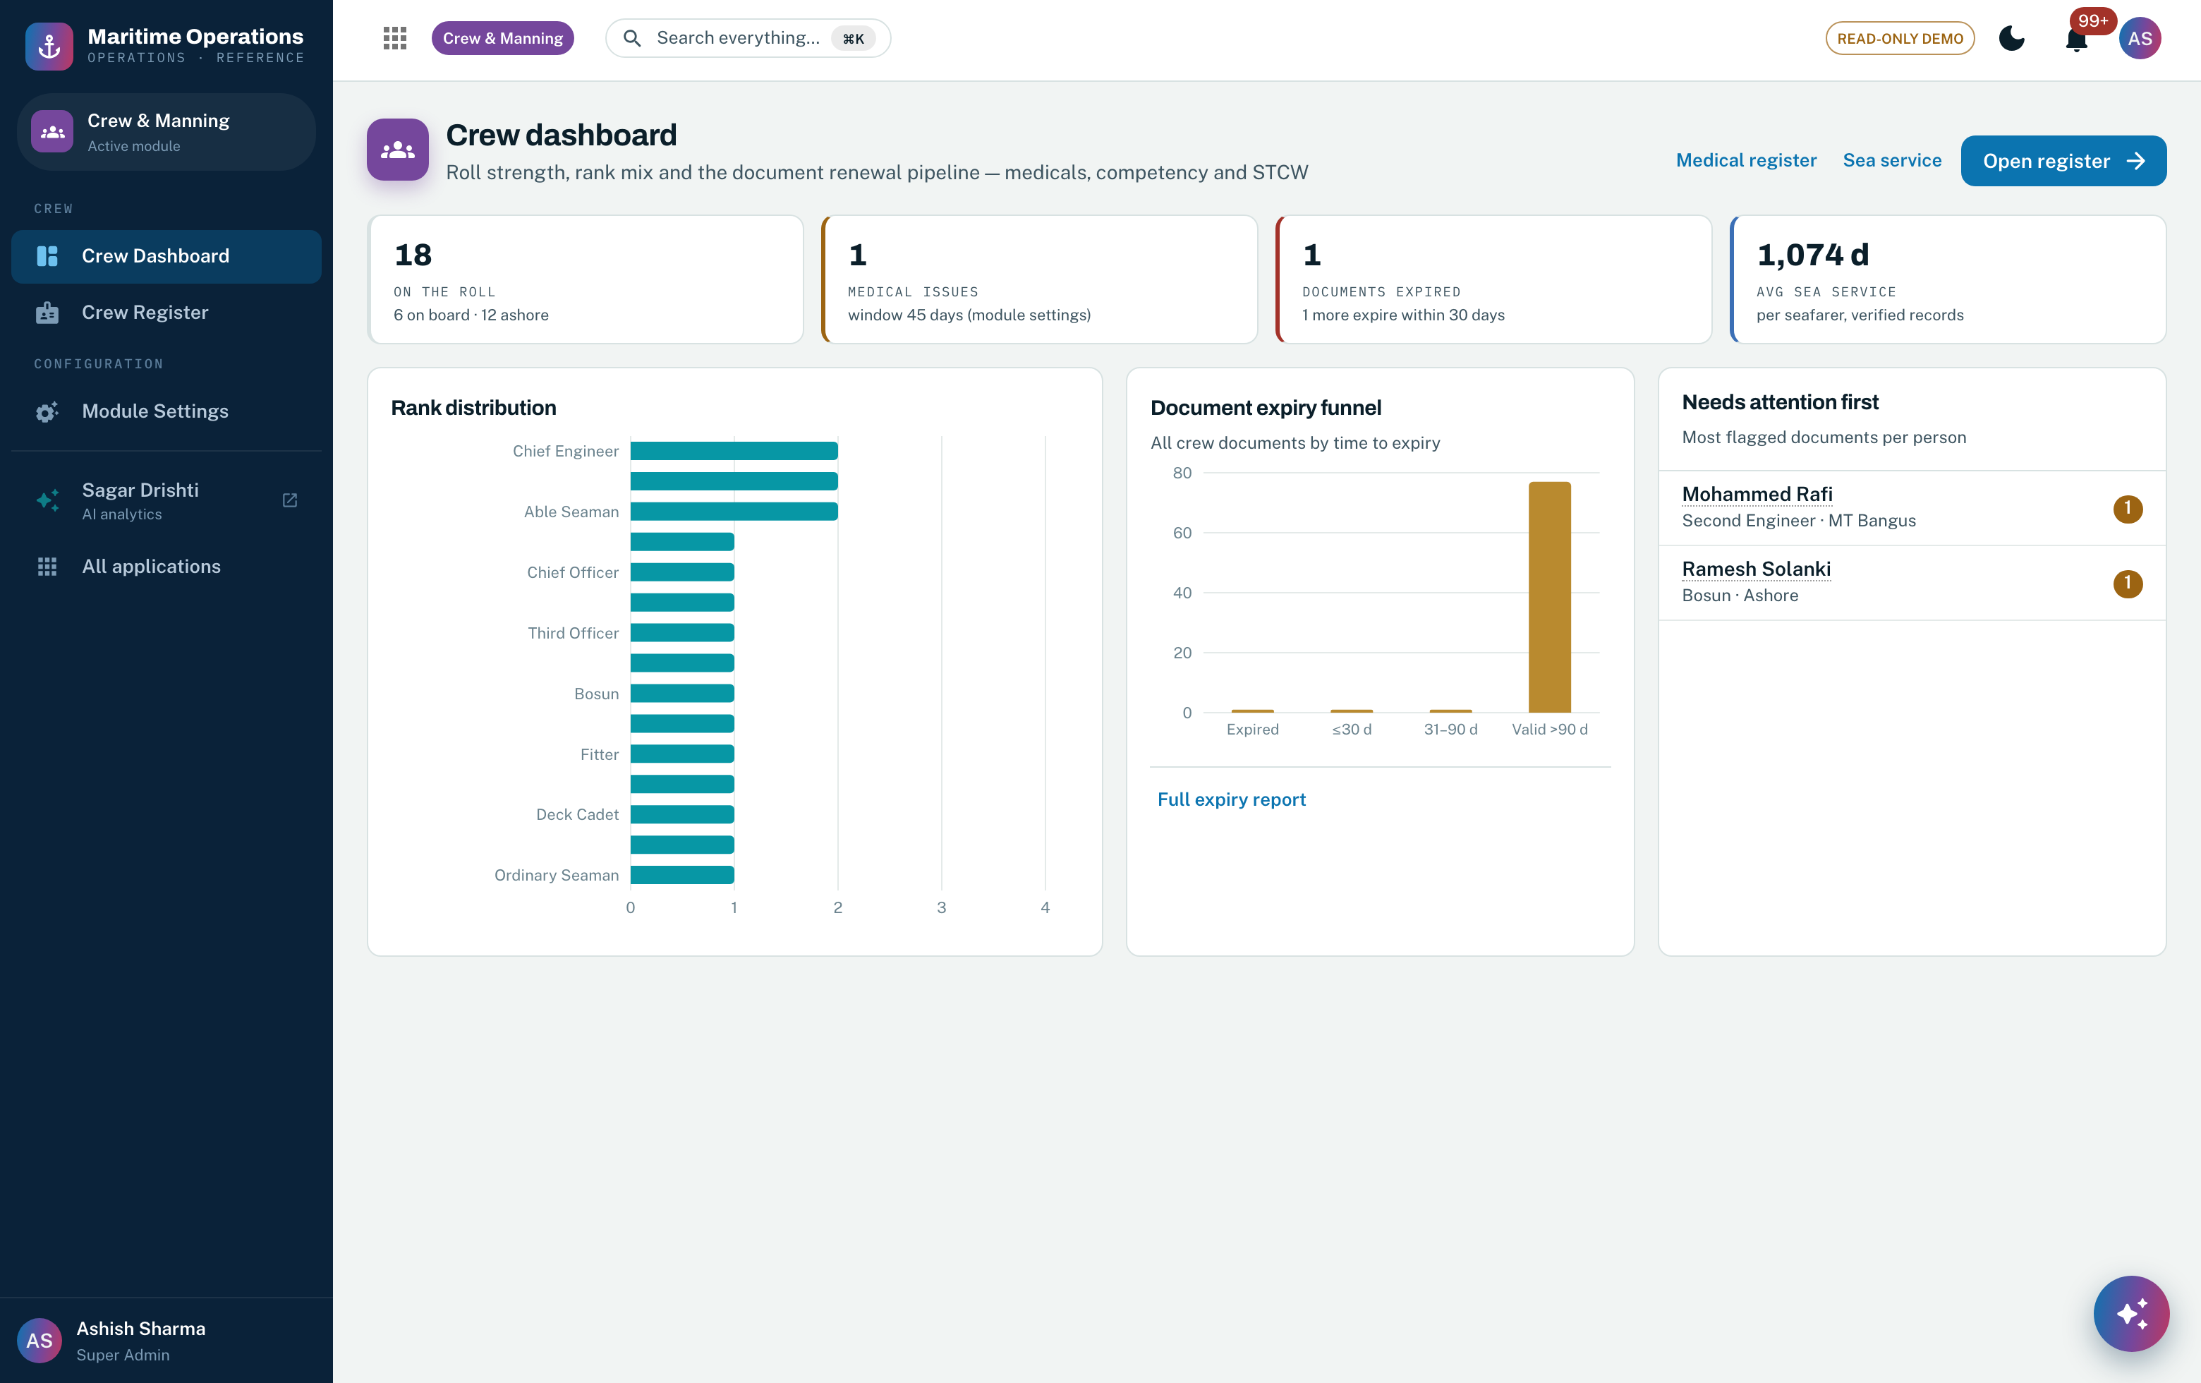
Screenshot 19 — the crew dashboard: roll strength, on board against ashore, medical issues and average sea days, over the rank distribution, the document expiry funnel across the whole roll and the seafarers needing attention first. Features 28–30.
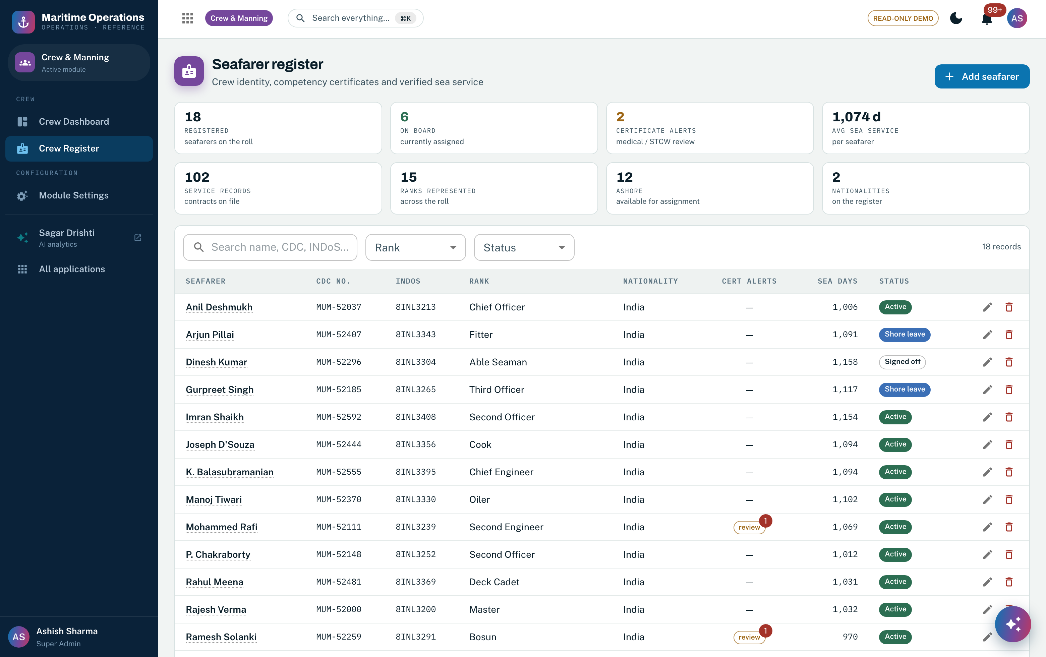
Screenshot 20 — the crew register: discharge-book number and INDoS number side by side, rank, nationality, certificate alerts, accumulated sea days and status. The national seafarer identifier is already carried alongside the discharge book. Features 1–3, 7.
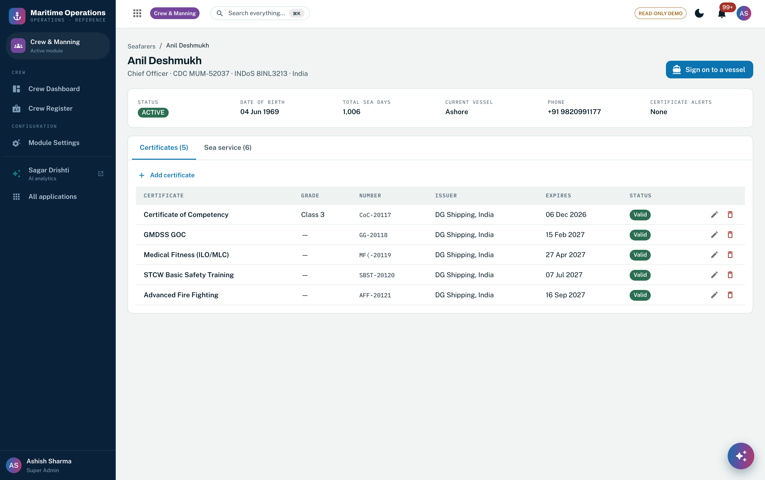
Screenshot 21 — one seafarer: identity, status, accumulated sea service and current assignment, over the certificate wallet showing type, grade, number, issuing authority, expiry and derived validity. Features 4–6.
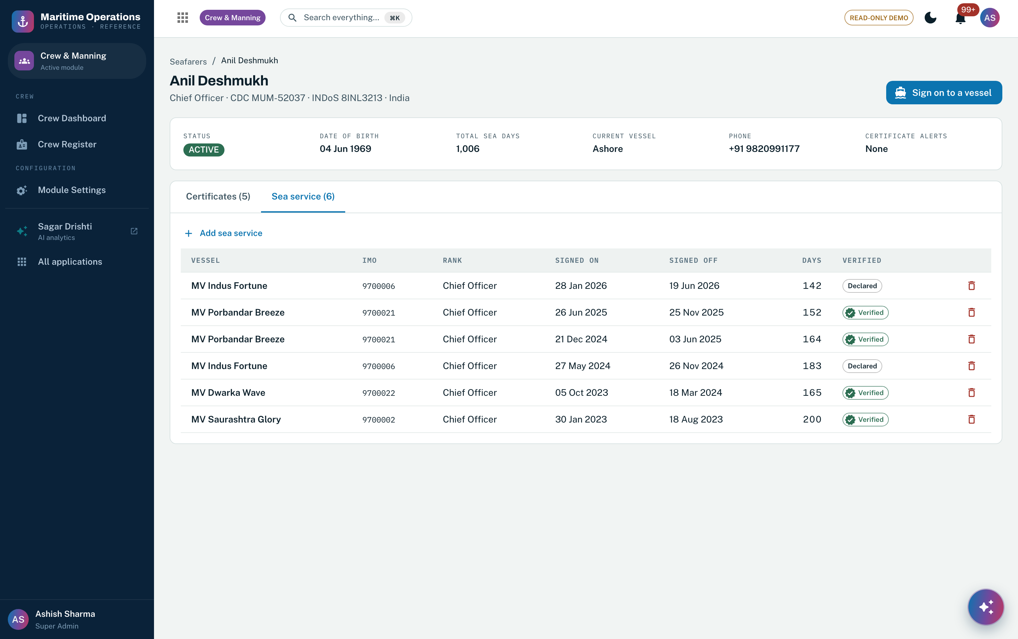
Screenshot 22 — the sea-service ledger: every tour with vessel, IMO, rank, sign-on and sign-off dates, duration and its verified flag. Entries written by the platform’s own sign-off carry verification by construction. Features 8–11, 16.
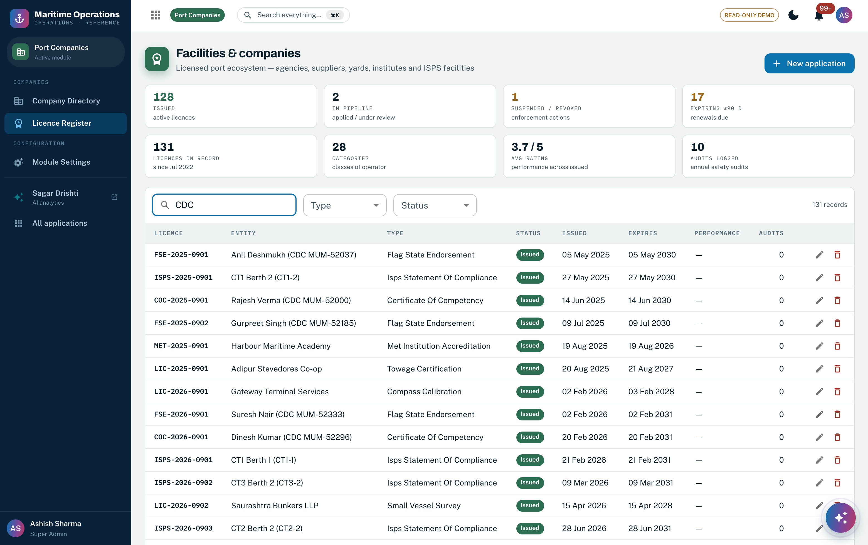
Screenshot 23 — the instrument register: Certificates of Competency and Flag State Endorsements sit in the same subject-agnostic register as port facility statements of compliance and specialised company approvals, each with its own numbering series and lifecycle. Features 17–19.
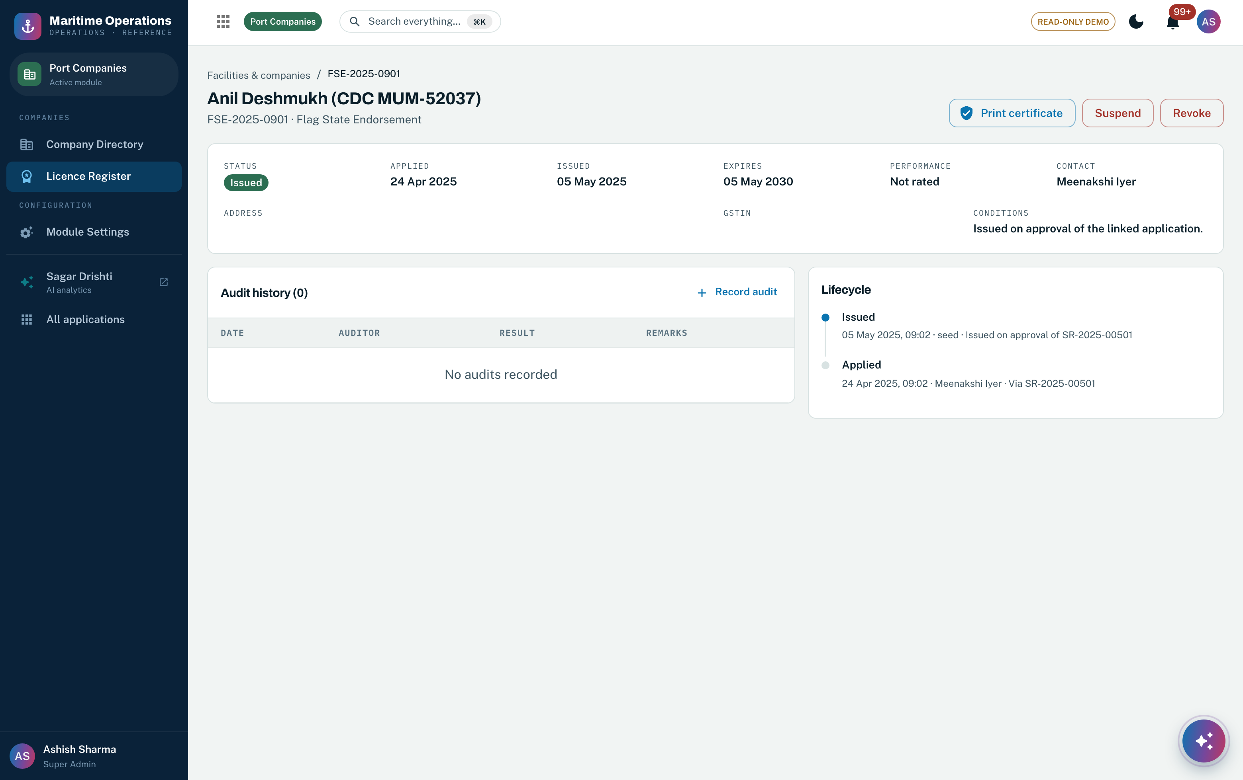
Screenshot 24 — a Flag State Endorsement record under STCW Regulation I/10: status, application and issue dates, term, the conditions recorded at issue, and the lifecycle history. Print, suspend and revoke are permission-gated. Features 17–20.
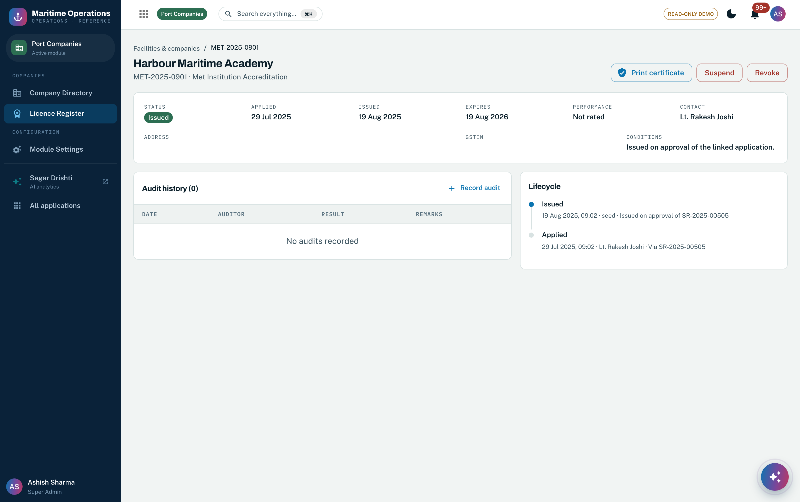
Screenshot 25 — a MET institution accreditation: the institution as an accreditation subject with its own term, contact, conditions, lifecycle history and an audit register for quality-standards findings. Features 23, 25–27.

5.5 On the Azure stack
- Seafarer documents land in the ADLS Gen2 raw zone and pass the Section 3 intake pipeline: Document Intelligence extracts the certificate, entity resolution binds it to the seafarer identity on the national identifier, and anything below the confidence threshold reaches an examiner rather than the register.
- Employment and labour-compliance records are consumed from the labour authority through API Management, cached so an upstream outage degrades freshness rather than availability.
- Crew lists and the Minimum Safe Manning Document are read against the vessel golden record on Service Bus events, so a manning shortfall is detected when the crew list changes rather than at the next inspection.
- The approved-course catalogue and each institution’s live accreditation status are indexed in Azure AI Search, which is what lets an agent check a submitted certificate against the issuing institution as it stood on the issue date.
- Revalidation eligibility runs as an Azure ML scored view over the verified sea-service ledger, the medical certificate and the training record, refreshed on every relevant event.

5.6 Roles & permissions
The crew register is governed by the seafarers permission group; MET accreditation sits under facilities, because an institution is accredited on the same engine as any other regulated entity; and applications arrive through the service desk. The matrix below covers those groups across all thirteen roles, generated from the same catalog the middleware enforces. Role codes are as given in Section 3.9.
Module — actions in the group | SA | HM | MS | FO | AG | ND | TS | HO | BC | SO | PP | RS | MV
Certificates — view/manage | ● | ○ | ● | – | – | – | – | – | – | – | – | ● | –
Seafarers — view/create/edit/delete | ● | ○ | ◐ | – | – | – | – | – | – | – | – | ○ | ○
Port Companies — view/manage/approve | ● | ○ | ○ | ○ | – | – | – | – | – | – | – | ● | ○
Service Requests — view/apply/assess/approve/manage | ● | ○ | ◐ | – | ◐ | – | – | – | – | – | – | ◐ | ○
● every action in the group ◐ view plus selected write actions ○ view only – no access.
The Marine Surveyor is the only role besides the administrator that may create or edit a seafarer record, and the Registrar of Ships holds the approval and grant permissions on the service desk through which certification applications arrive. In the target state the RFP’s named offices — Crewing Officer, Examiner or Registrar, MET Auditor — become Entra ID app roles, and shipowners, managing companies and crewing agencies reach a company-scoped portal through UAE PASS with row-level scoping to their own crew.

5.7 Business benefits
- Sea service is verified by construction, not by declaration — the platform records who was on which ship and for how long, so the evidence a revalidation depends on is a by-product of operations rather than a form somebody fills in afterwards.
- Unfit crew cannot quietly join a ship — the document gate refuses a sign-on whose medical certificate would expire inside the tour, and an override is a named decision on the audit trail rather than a silent one.
- One certificate register for people, ships and companies — a seafarer certificate is signed, numbered and publicly verifiable on exactly the same engine as a ship certificate, which is why the public verification page the RFP asks for is a configuration rather than a build.
- Accreditation and certification meet in one place — because the institution’s live accreditation status sits in the same register as the certificates its graduates hold, a certificate can be checked against the standing of the body that issued it.
- Audit-ready by default — every certificate change, sea-service entry, sign-on, sign-off and override carries an actor and a before/after image, which is the evidence an IMSAS audit of a flag state’s certification function asks for.

5.8 Functional requirements compliance (RFP Domain 2 — Seafarers & MET)
Requirement — RFP Domain 2 | Compliance today | Effort to 100% (MW)
Seafarer certification and endorsements — issuance, revalidation, upgrade, suspension and revocation of CoC, CoP and Flag State Endorsements with automated STCW compliance verification | ◐ PARTIAL | 8
Verification of approved seagoing service against crew lists, discharges and master or company logs via digitally verifiable confirmations | ◐ PARTIAL | 6
Statutory certification management — continuous tracking and registry maintenance of CoCs and CoPs with automated revalidation and expiry alerts | ● AVAILABLE | —
MET programme approval and course accreditation aligned to STCW Code tables of competence | ◐ PARTIAL | 7
MET institution accreditation with periodic regulatory inspection and Quality Standards System audit integration | ◐ PARTIAL | 6
Seafarer master profile — a unified, secure digital identity serving as the single source of truth across every administrative and regulatory service | ◐ PARTIAL | 10
Ship management company and crewing agency portal — real-time verification of licence validity and STCW compliance | ○ NEW BUILD | 5
Technical specification — the integrated seafarer registry
Unified seafarer database keyed on the Seafarer Identification Number, capturing discharge books, certificates of competency and live maritime training records | ◐ PARTIAL | 5
Foreign CoC and flag endorsement ledger — certificates of receipt of application, Regulation I/10 endorsements and seaman cards | ○ NEW BUILD | 6
Vessel linkage — automated Minimum Safe Manning Document cross-referencing and digital crew lists (IMO FAL Form 5) | ○ NEW BUILD | 5
Public certificate verification page, open to anyone, to confirm the authenticity of an issued certificate | ◐ PARTIAL | 2
AI requirements — RFP Domain 2
Automated statutory revalidation agent — zero-touch processing where medical fitness, approved sea service and updated training are all satisfied | ○ NEW BUILD | 8
STCW gap analysis and training matrices — deficiency identification against higher grades and amendments, automatically mapped to required accredited courses | ○ NEW BUILD | 7
Cross-validation of authenticity against the issuing institution’s live accreditation status and approved course listings | ○ NEW BUILD | 5
Fraud detection and document integrity — models to detect fraudulent, altered or tampered certificates | ○ NEW BUILD | 6
Total delta engineering attributable to these requirements |  | 86
Effort is indicative delta engineering from the running platform, in man-weeks, to be confirmed at D0/D1. A further 13 man-weeks in this module are not attributable to these fifteen requirements: separating Seafarers and MET into its own service (3), Arabic and English bilingual forms and certificate rendering (5), and labour-authority employment-record integration (5).
Two rows deserve comment. Statutory certification management is marked AVAILABLE because continuous tracking, derived validity and expiry alerting across the whole roll run today. The public verification page is PARTIAL rather than NEW BUILD because the signing and verification engine is in production and already serves seafarer instruments — what remains is a seafarer-specific public page, which is why the figure is two man-weeks rather than a build. The foreign certificate ledger and the crew-list linkage are honestly NEW BUILD: the RFP names structures — certificates of receipt of application, seaman cards, FAL Form 5 synchronisation — that have no counterpart in the platform today.

5.9 Agentic AI in Seafarers' Affairs & MET Oversight
Running today. Derived certificate validity and expiry alerting across the entire roll; the needs-attention ranking that puts the worst document cases in front of the crewing desk first; and the grounded assistant answering crew and certification questions with citations to the records it read.
Target state. Four AI capabilities act in this domain, all on Foundry Agent Service and all reaching business capability only through API Management, so an agent action carries the same permission check and audit entry as a human one:
- Automated Statutory Revalidation Agent (A3, Service Processing) — where medical fitness is valid, the verified sea-service ledger meets the statutory minimum and the required training is recorded, a revalidation is processed end to end with no human touch. Anything short of that goes to the examiner queue with the shortfall stated.
- STCW gap analysis and training matrices — measures a seafarer’s portfolio against the requirements of a higher grade or an updated STCW amendment and maps the shortfall onto specific accredited courses at approved institutions, so the answer is not "you are short" but "these three courses, at these institutions".
- Cross-validation of authenticity (A1, Document Intelligence) — checks a submitted certificate against the issuing institution’s accreditation status and approved course listing as they stood on the issue date, which catches a certificate that was genuine-looking but issued outside an institution’s approved scope.
- Fraud detection and document integrity (A1) — tamper and alteration models over submitted certificates, with anything suspicious routed to a named examiner rather than rejected automatically.
AI benefits. A compliant seafarer revalidates without touching a queue, which is the national directive expressed in the domain with the highest transaction volume; a forged or out-of-scope certificate is caught at submission rather than discovered at a port state inspection; and examiners spend their time on the exceptions rather than on arithmetic over sea-service dates.

Evidence — the same agents, the same register. Seafarer certification runs on the same instrument engine and the same service-request pipeline as ship certification, so the agents that act here are the ones already described rather than a parallel set. That is the architectural claim this domain makes: A1 validates a Certificate of Competency exactly as it validates a Safety Management Certificate, because both are instruments on subjects, and A3 adjudicates a revalidation exactly as it adjudicates a ship renewal. The agents inherit the domain rather than being rebuilt for it.
Agent | What it does for seafarers and MET | Latitude in force | Status
A1 — Document Intelligence | Structural and integrity validation of lodged certificates: presence against the requirement list, issue-before-expiry coherence, and recognition of the issuing authority against the recognised-issuer list. | Assisted · 0.85 | Running
A3 — Service Processing | Eligibility adjudication on revalidation and endorsement applications, with medical fitness and verified sea service entering as gates rather than as advisory notes. | Supervised · 0.90 | Running
A4 — Customer Guidance | Tells a seafarer what a grade or endorsement requires and what their application is now waiting on, drawn from the service definition itself. | Autonomous · 0.75 | Running
A6 — Regulatory Intelligence | Audits the instrument library that governs STCW certification for instruments in force on the same subject with no supersession recorded. | Assisted · 0.80 | Running
STCW gap analysis | Measures a portfolio against the requirements of a higher grade and returns the training and sea-service still outstanding. Specified, not yet built — the sea-service ledger and certificate wallet it needs are both in place. | — | Delta
Document authenticity and tamper models | Cross-validation against issuing institutions and alteration detection on submitted images. Specified, not yet built; A1 today validates structure and coherence, not imagery. | — | Delta

An honest boundary. Two of the six capabilities in this domain are genuine deltas, and they are the two that need something the platform does not yet hold: a channel to the issuing institutions for cross-validation, and image-level models for tamper detection. They are costed in Section 6.8 rather than claimed here. Everything else in the table above can be demonstrated on the reference deployment.

5.10 Improvements — TO BE
Stream | Scope
Delta develop | Seafarer Identification Number as the primary key with alternate-key resolution across discharge book, national identifier and passport; the foreign certificate and flag endorsement ledger including certificates of receipt of application and seaman cards; the seafarer master profile as a shared golden record; MET programme approval against STCW tables of competence; institution accreditation with quality-standards audit integration; live maritime training records; the public certificate verification page.
Application revamp | Seafarers and MET as its own microservice on AKS; the certification journeys — issue, revalidate, upgrade, suspend and revoke — re-expressed as low-code configured workflows so the Client can change evidence lists, eligibility rules and fees without a release; Arabic and English forms and certificate rendering with right-to-left layout.
Unified data architecture platform | Minimum Safe Manning Document cross-referencing against the live crew composition; digital crew list synchronisation on IMO FAL Form 5 with credential, medical and watchkeeping validation; labour-authority employment-record integration; and a company-scoped portal giving shipowners, managers and crewing agencies instant verification of licence validity.
AI agents + AI platform | The statutory revalidation agent for zero-touch processing; STCW gap analysis with automatic mapping to accredited courses; cross-validation of submitted credentials against the issuing institution’s live accreditation status; and document-integrity models for fraud and tampering — all registered on Foundry Agent Service with configurable autonomy and immutable agent audit.

5.11 Effort estimation for the delta (man-weeks)
Decomposed to testable line items on the same basis as Sections 3.11 and 4.11. It supersedes the four-line figure carried in earlier issues: detailing the module at this depth showed the earlier number did not carry the foreign certificate ledger, the crew-list and manning-document linkage, the training-records register, the agency portal or the document-integrity models.
Work item | MW
Stream A — Delta develop · 36 MW
Seafarer Identification Number as primary key; alternate-key resolution across discharge book, national identifier and passport | 5
Foreign CoC and flag endorsement ledger — certificates of receipt of application, Regulation I/10 endorsements, seaman cards | 6
Seafarer master profile as a shared golden record with company and agency scoped access | 5
MET programme approval and course accreditation against STCW tables of competence | 7
MET institution accreditation with quality-standards audit integration and inspection scheduling | 6
Maritime training records — live tracking of trainees completing approved STCW courses | 5
Public certificate verification page for seafarer instruments | 2
Stream B — Application revamp · 16 MW
Seafarers and MET extracted as its own microservice on AKS | 3
Certification journeys re-expressed as low-code configured workflows | 8
Arabic and English bilingual forms and certificate rendering with right-to-left layout | 5
Stream C — Unified data architecture platform · 21 MW
Minimum Safe Manning Document cross-referencing against live crew composition | 5
Digital crew list synchronisation (IMO FAL Form 5) with credential, medical and watchkeeping validation | 6
Labour-authority employment-record validation and labour compliance integration | 5
Ship management company and crewing agency portal with real-time licence validity verification | 5
Stream D — AI agents + AI platform · 26 MW
Automated statutory revalidation agent — zero-touch processing with examiner escalation | 8
STCW gap analysis and training matrices with automatic mapping to accredited courses | 7
Cross-validation of authenticity against the issuing institution’s live accreditation status | 5
Fraud detection and document-integrity models for altered or tampered certificates | 6
TOTAL — Seafarers' Affairs & MET Oversight | 99

6. Agentic AI across the platform
The RFP names seven AI agents and asks how each will work, how its decisions will be explained, and who remains accountable for them. This section answers those three questions once, for all seven, because they share one mechanism: every agent forms a judgement the same way, every judgement passes the same autonomy gate, and every outcome lands in the same append-only register. Sections 3.12, 4.9 and 5.9 map the agents onto each domain; this section describes the machinery underneath them.
What is claimed here. All seven agents are registered on the platform today and have written decisions against its own regulatory records — service applications, statutory certificates, inspection histories and the instrument library. The screenshots in Section 6.4 are of those decisions, not of a mock-up. Where a capability is specified but not yet built, it is named as a delta and costed in Section 6.8 rather than folded into the claim.

6.1 How a decision is made
An agent does four things in order: it is triggered, it reads the records it is responsible for, it forms a judgement, and it hands that judgement on. It does not decide whether its own conclusion takes effect. That decision belongs to the autonomy gate, which is the only place in the platform where latitude is applied and the only setting an administrator has to change to alter what an agent is permitted to do.
The judgement is a pure function. Each agent’s reasoning is written with no database access and no clock of its own — the records and the current time are passed in. The same inputs therefore always produce the same judgement, which is what makes an agent testable in the ordinary way, re-checkable after the fact, and safe to reason about in an audit. It is also what allows the platform to ship the agents’ logic under unit test alongside the rest of the domain layer.
Every judgement carries its own justification. An agent returns the action it proposes, the inputs it was given, the output it produced, a plain-language explanation, the weighted factors behind it with each factor’s contribution, and a confidence between zero and one. None of this is reconstructed later for the benefit of an auditor; it is the shape of the return value.
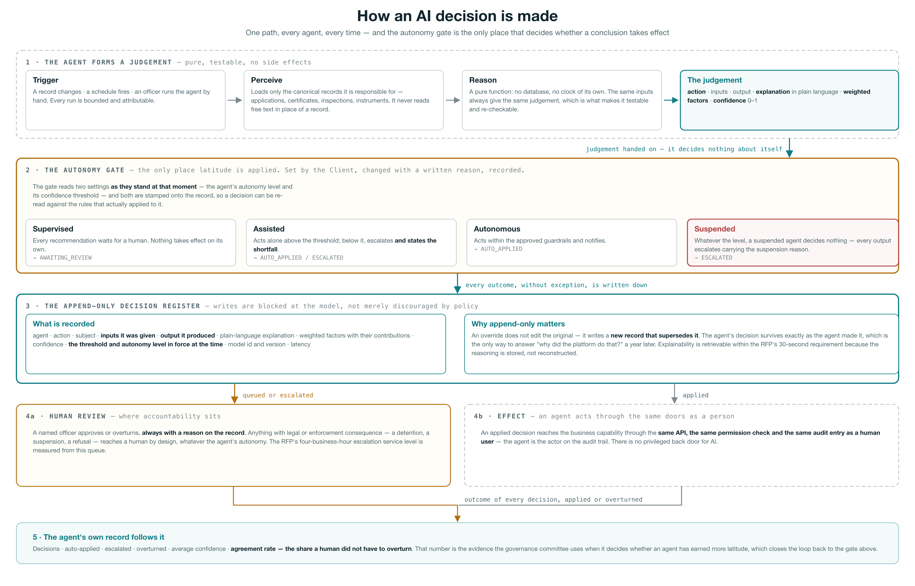
Figure 6 — the decision path every agent follows. The autonomy gate is the single point at which a conclusion becomes an action, and the register records the threshold and autonomy level that applied at that moment, so a decision can be re-read a year later against the rules that actually governed it rather than the rules in force today.

An agent acts through the same doors as a person. When a decision is applied it reaches the business capability through the same API, the same permission check and the same audit entry as a human user, with the agent named as the actor on the trail. There is no privileged path for AI, which means an agent cannot do anything a suitably permissioned officer could not do, and the existing authorisation model governs both without modification.

6.2 The seven agents, and the latitude each holds
The autonomy levels below are the ones seeded on the reference deployment. They are deliberately conservative — an agent earns latitude on its record rather than arriving with it — and every one of them is a setting the Client controls, not a property of the release.
Agent | What it decides | Autonomy | Threshold
A1 — Document Intelligence | Whether the documents lodged against an application can be relied on: required-document coverage, IMO check-digit validity, issue-before-expiry coherence, expiry not already past, and recognition of the issuing authority. | Assisted | 0.85
A2 — Vessel Compliance | A composite compliance and risk score for every active vessel, computed from its inspection history and the certificates it holds — including whether each certificate is genuinely in force on its survey schedule, which an expiry date alone cannot establish. | Assisted | 0.80
A3 — Service Processing | Whether an application clears each eligibility gate in an assessor’s own order — mandatory documents, verification, subject on record, fee settled, no open compliance hold — stopping at the first failure and naming it. | Supervised | 0.90
A4 — Customer Guidance | What an applicant should be told: what the service requires before they apply, and what their application is now waiting on, expressed in the language of the application rather than of the workflow engine. | Autonomous | 0.75
A5 — Smart Inspection | Which vessels warrant boarding, ranked on their own inspection history, with the deficiency categories most likely to be found and a boarding dossier assembled in advance. | Assisted | 0.82
A6 — Regulatory Intelligence | Whether the instrument library is internally consistent — in particular where two instruments are in force over the same subject with no supersession recorded, and which services each instrument bears on. | Assisted | 0.80
A7 — National Maritime Intelligence | One situation level for the maritime picture, synthesised from open incidents, severity concentrations, certificate exposure and recent detentions — a stated posture rather than a wall of counters. | Autonomous | 0.78

Why A3 is supervised and A4 is autonomous. The distinction is consequence, not confidence. A3 decides whether an application may proceed, which is a step on the path to a statutory act, so every one of its conclusions waits for a person however certain it is. A4 tells an applicant what they must do next; being wrong there is recoverable and being slow there is the main complaint the service receives. Autonomy is set by what a mistake costs, and that is a judgement for the Client rather than for the vendor — which is why it is a setting.

6.3 What the agents decided on the reference dataset
Running the seven agents over the reference deployment produced seventy decisions: thirty-six applied automatically, twenty-two escalated for want of confidence, and twelve queued for review because the agent that made them is supervised. The distribution is not tuned for presentation — it is what conservative thresholds produce against records that contain real gaps, which is the point of showing it.
Agent | A decision it actually recorded | Outcome
A1 — Document Intelligence | “Flagged a document problem — 1 integrity check failed: IMO check digit. 3 documents lodged but not yet verified.” | Escalated
A2 — Vessel Compliance | “Rescored vessel compliance — composite compliance risk 42/100 (medium) from 7 inspections and 7 certificates.” | Applied
A3 — Service Processing | “Held an application at a gate — held at 2 gates: Documents verified — 3 awaiting verification; Fee settled — outstanding.” | Queued for review
A4 — Customer Guidance | “Answered an application status enquiry — your International Ship Security Certificate has been issued. The instrument is on the register.” | Applied
A5 — Smart Inspection | “Selected a vessel for boarding — risk 42/100 (medium), 590 days since the last inspection. Prior history points at deficiency codes 18203, 11101, 07105.” | Applied
A6 — Regulatory Intelligence | “Reviewed an instrument in force — bears on 2 services: FAC-PEST, CERT-ISSC.” | Applied
A7 — National Maritime Intelligence | “Raised the maritime picture to elevated — 4 open incidents at high or critical severity; 2 vessels carrying an expired certificate.” | Applied

The escalations are the interesting half. A1 escalated every one of its twelve decisions. In each case the required documents were present and the integrity checks it could run had passed — but the documents had not been verified by an officer, so the agent scored 0.75 against its 0.85 threshold and stopped. A6 escalated five of nine, in most cases because the instrument carried no date it could use to establish recency, so it recorded “Recency: unknown” as a factor and declined to act on a library entry it could not date. Neither is a failure of the agent. Both are the behaviour an authority should insist on: the platform states what it does not know, and the shortfall is on the record in those words.

6.4 The agents in operation
The console is a module in its own right, reached from the same launcher and governed by the same permission model as every other module. Two permissions divide it: one to view agents and their decisions, and one to change an agent’s latitude or review its work.
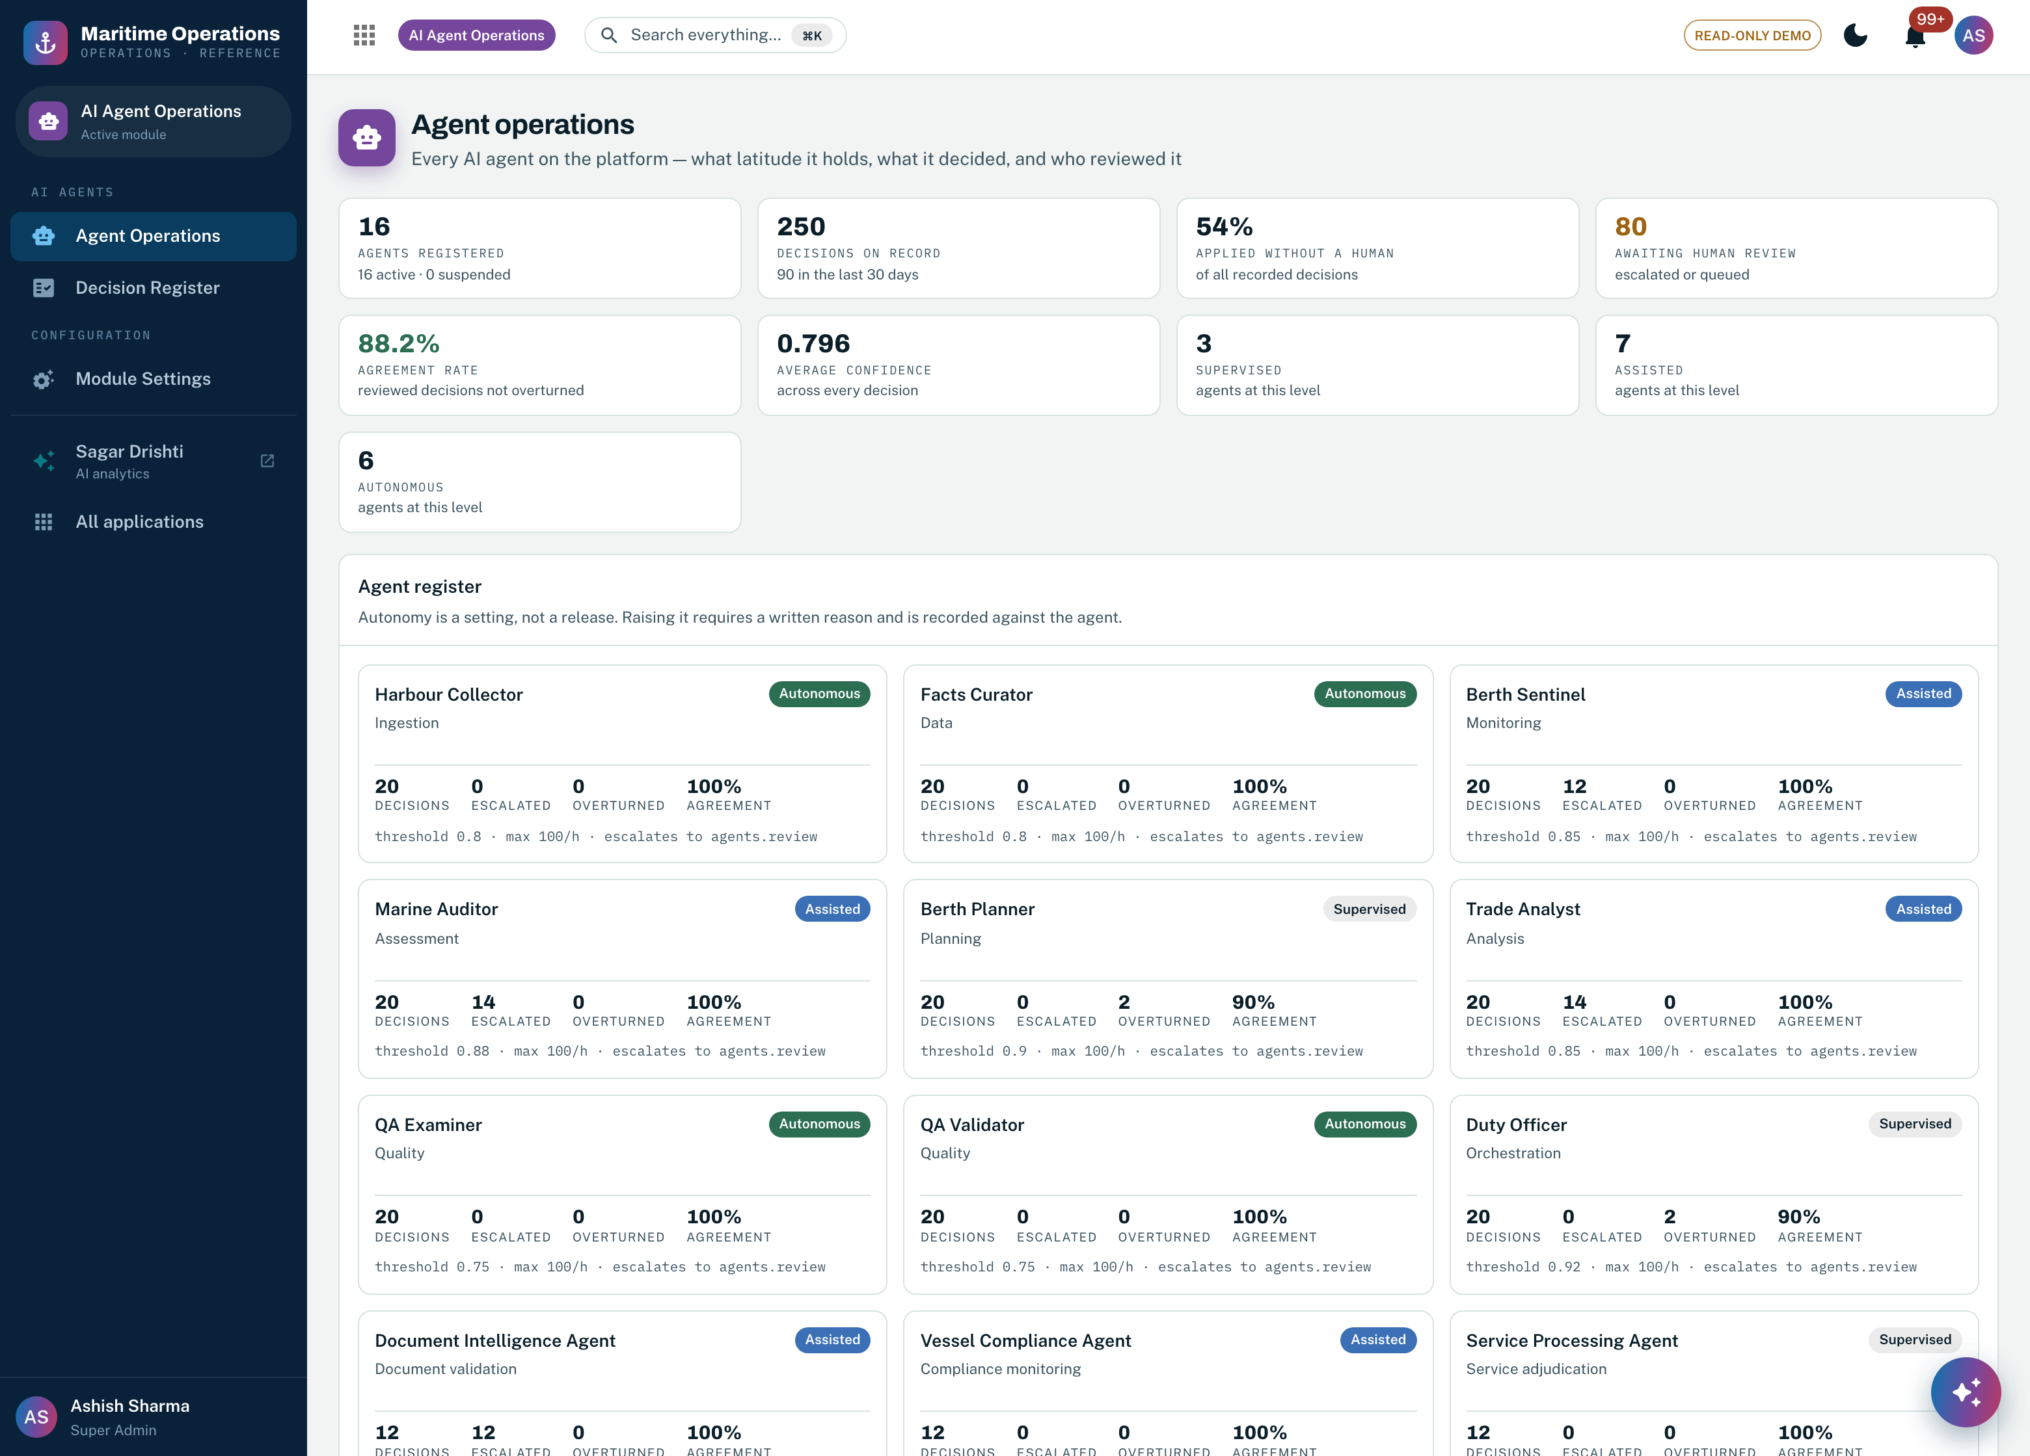
Screenshot 26 — Agent operations. The strip across the top is the whole AI estate at a glance: agents registered, decisions on record, the share applied without a human, the number awaiting review, and the agreement rate — the proportion of reviewed decisions a human did not overturn. Below it every agent carries its own decision count, escalations, overturns, agreement rate, threshold, rate cap and escalation target.

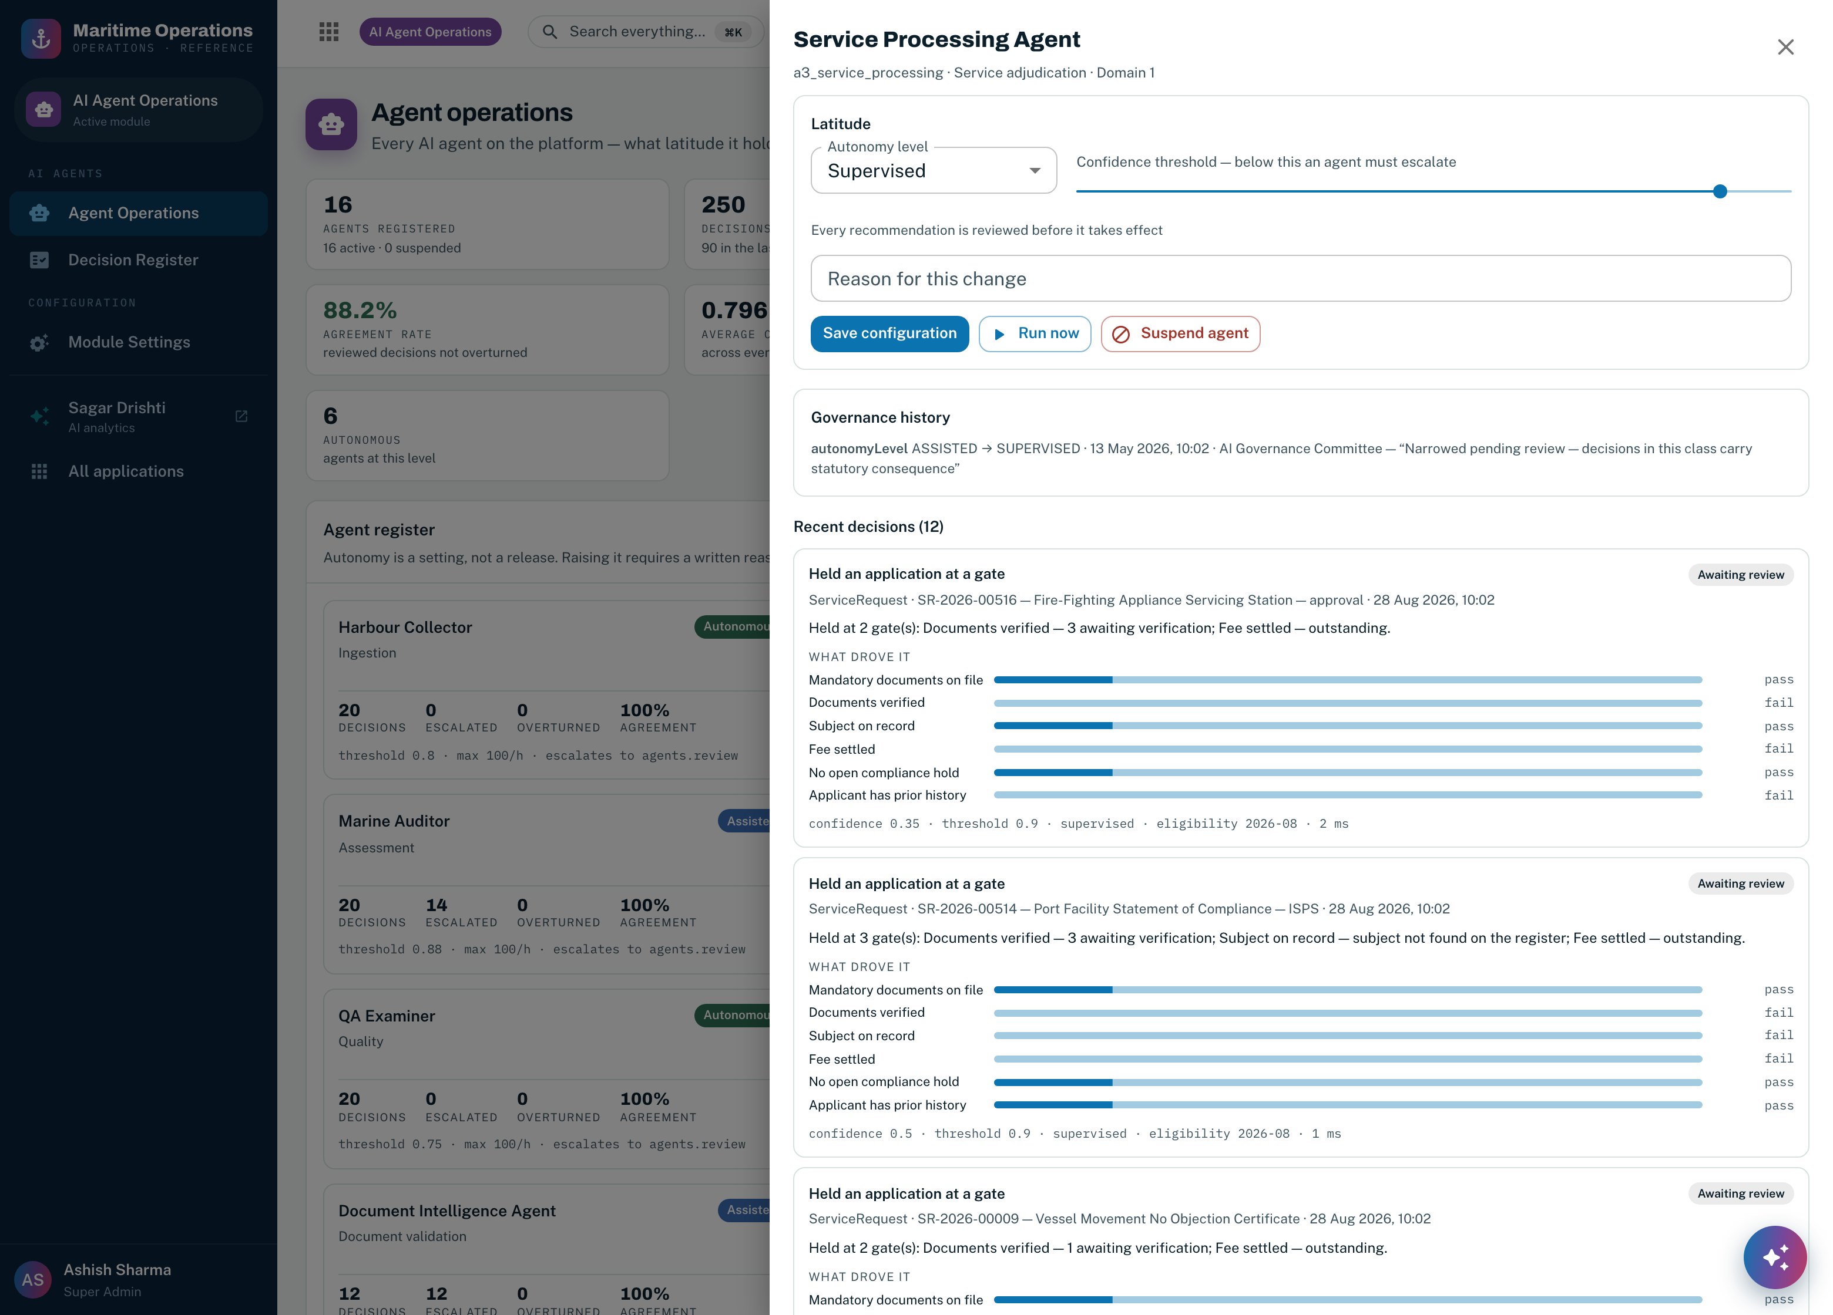
Screenshot 27 — one agent in detail. Latitude is set at the top: the autonomy level, the confidence threshold below which the agent must escalate, and a mandatory reason for the change. Beneath it the governance history — here recording that this agent was narrowed from assisted back to supervised because its decisions carry statutory consequence — and then its recent decisions, each showing the gates it ran and whether each passed.

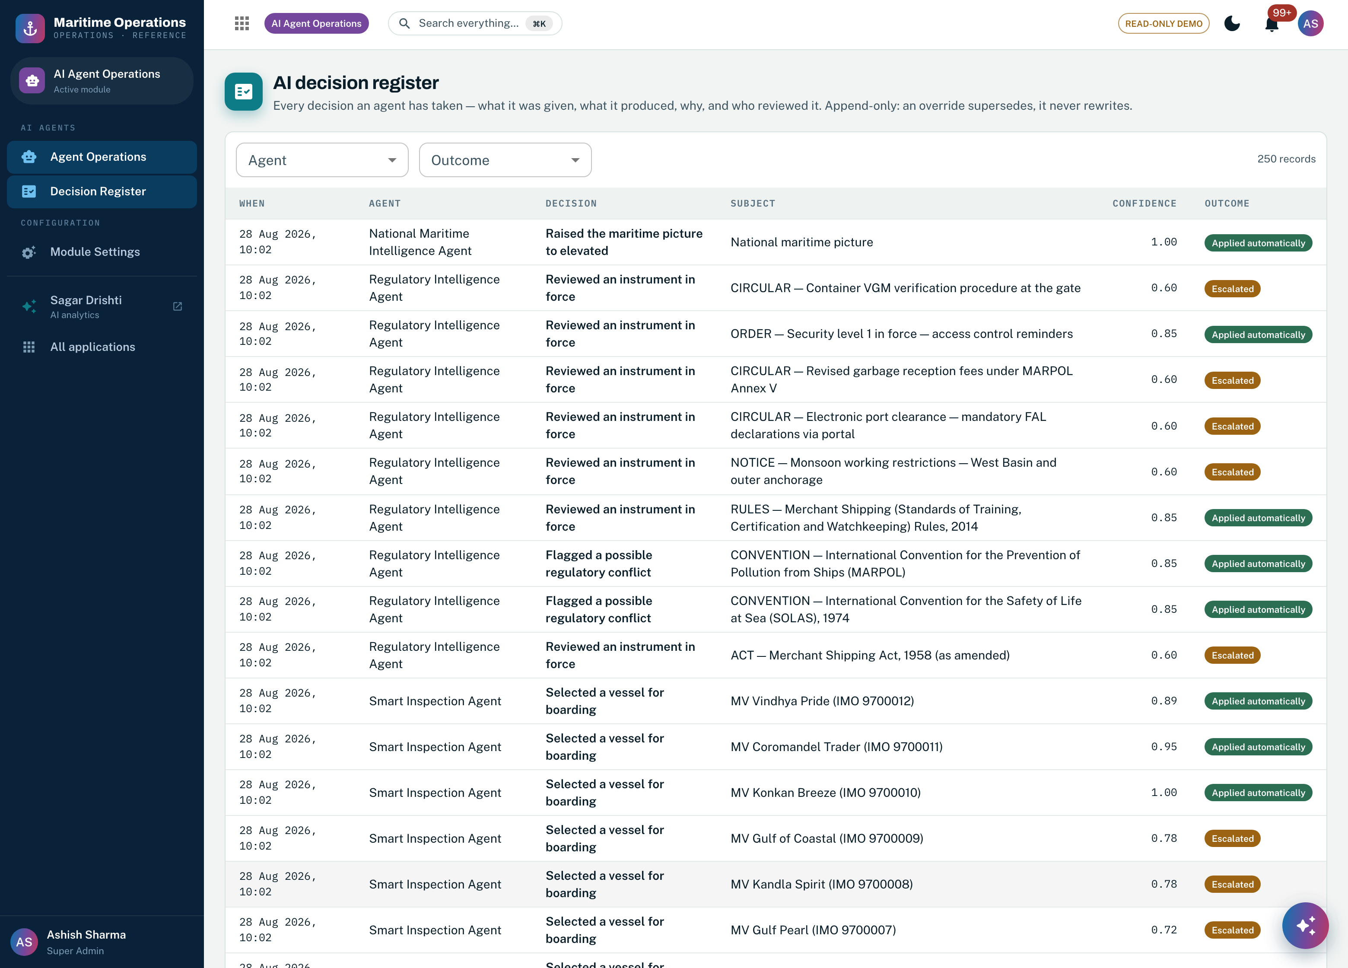
Screenshot 28 — the decision register: every decision any agent has taken, filterable by agent and by outcome. It is append-only at the data model, not by convention — the application layer has no path that updates a decision once written.

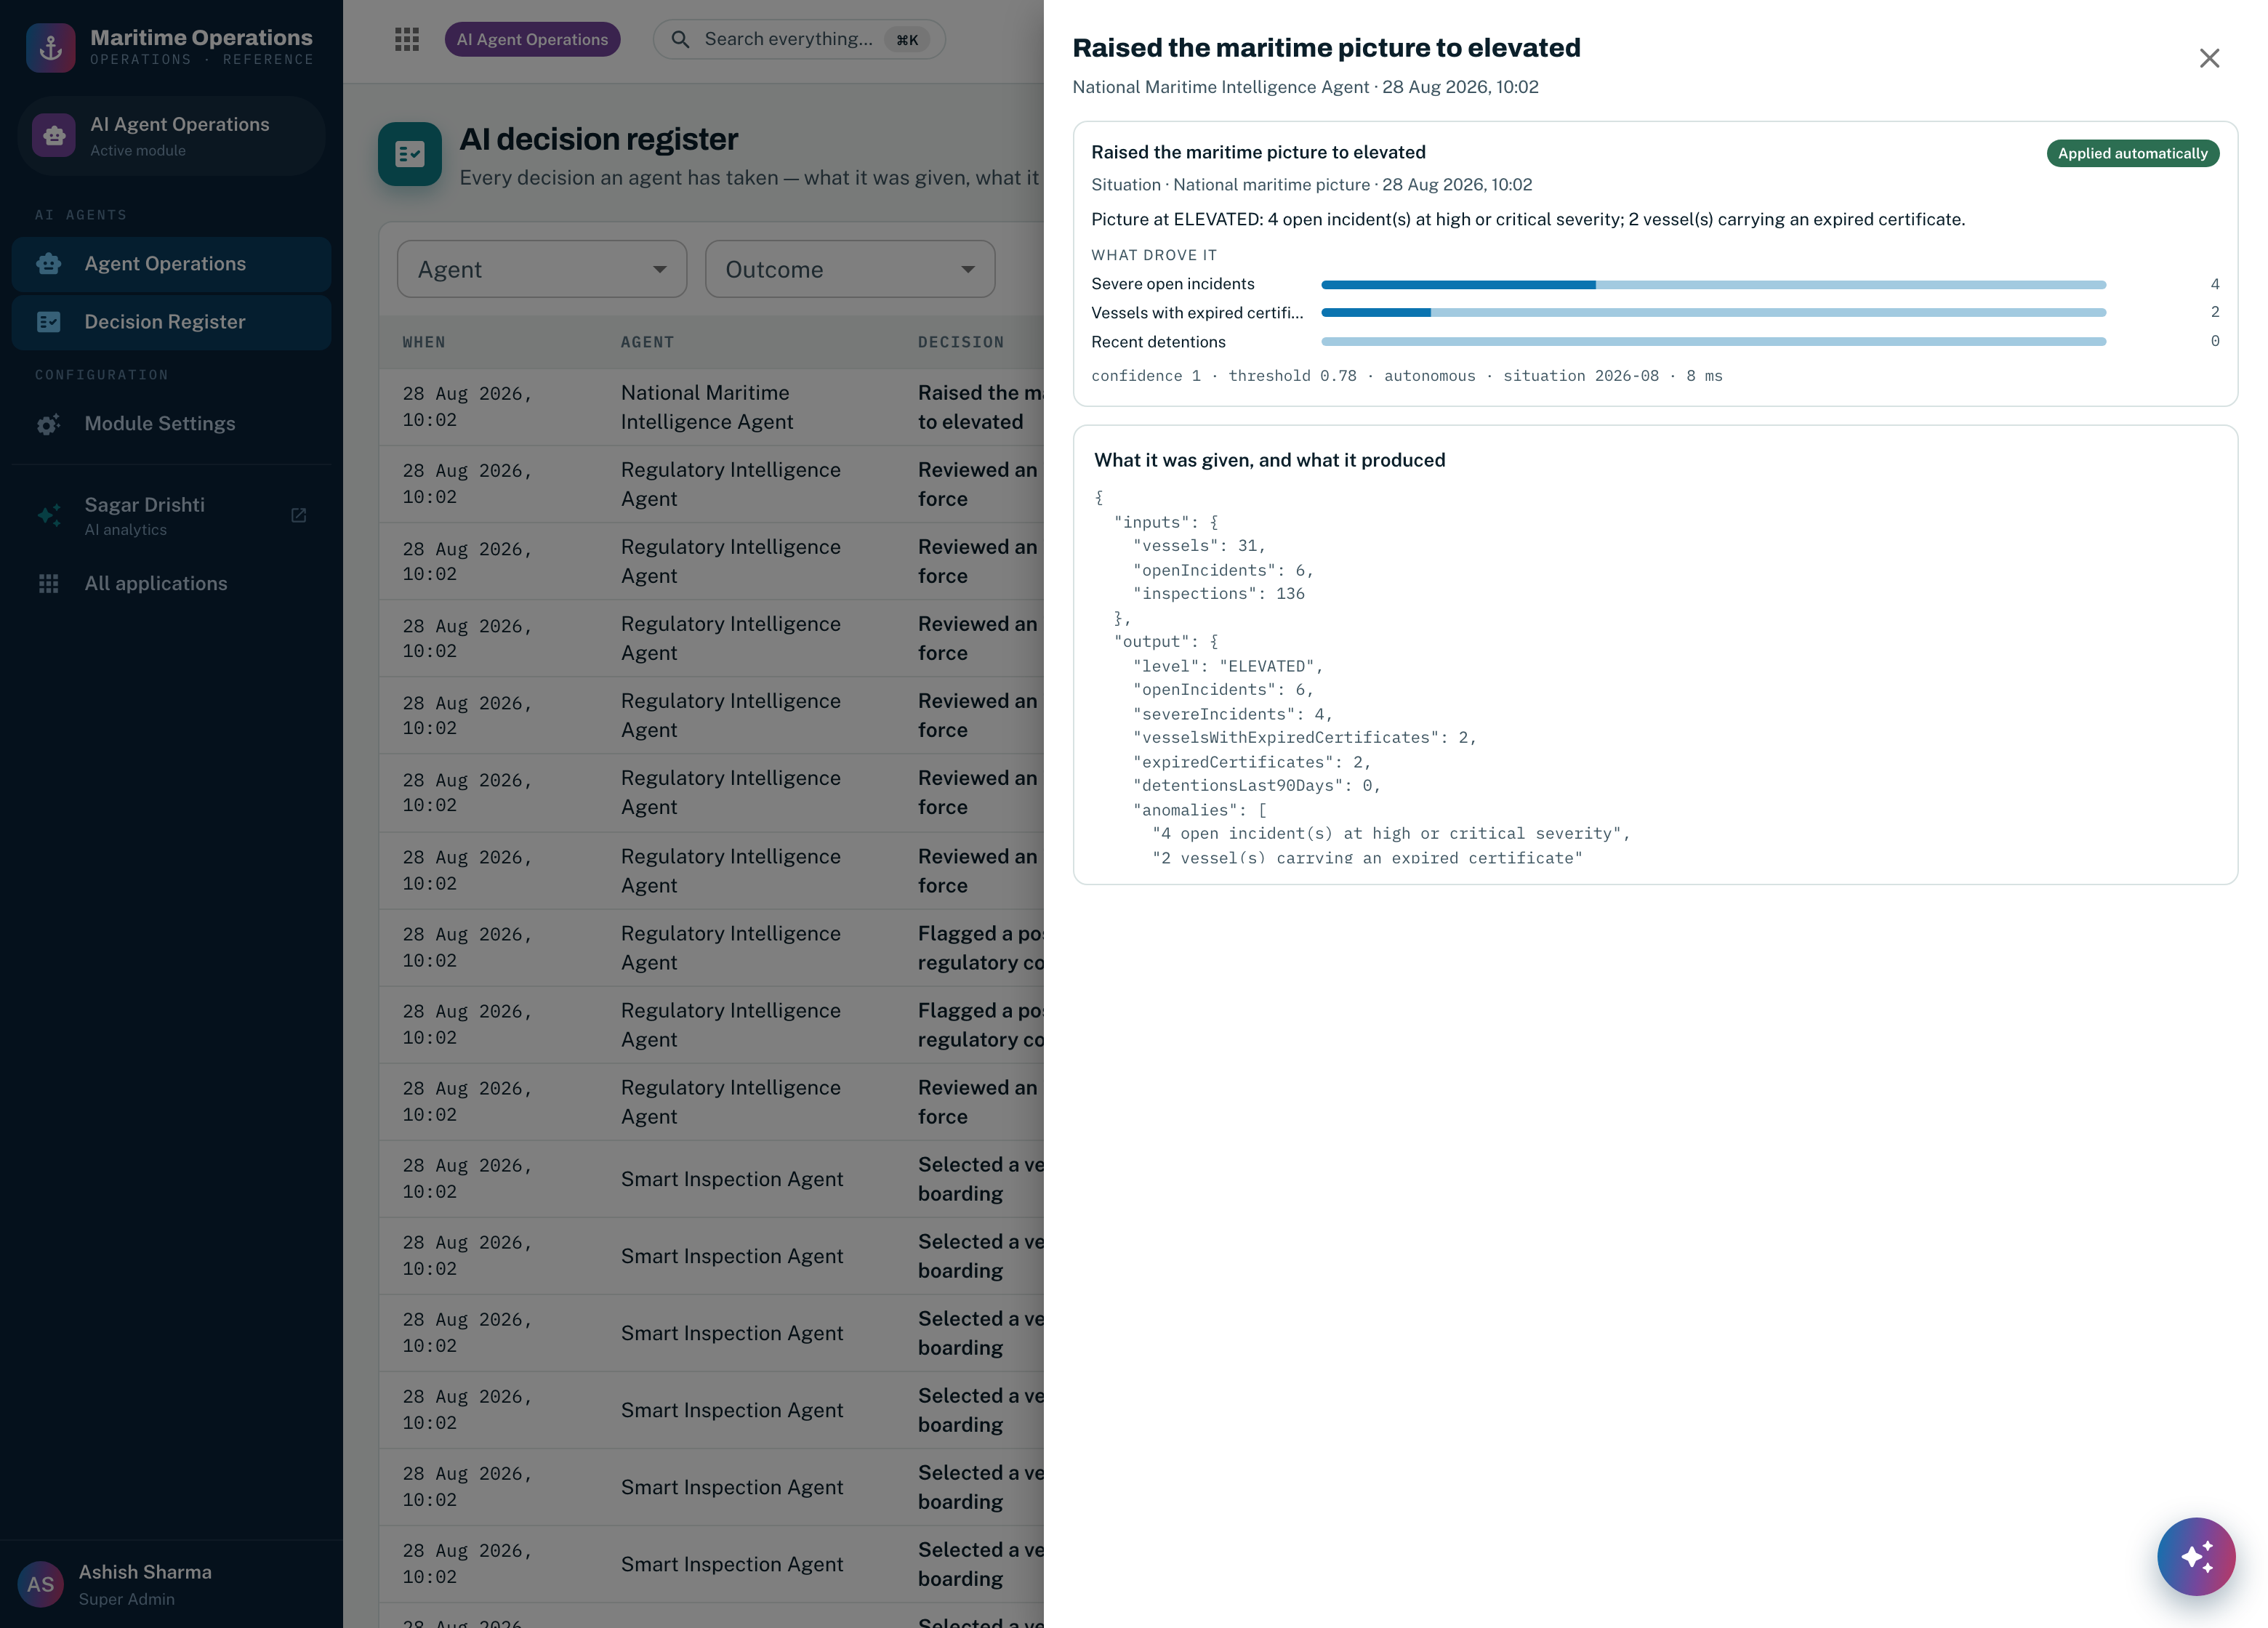
Screenshot 29 — a single decision opened. The weighted factors that drove it, the confidence against the threshold that applied at the time, the autonomy level, the model and version that produced it, the latency, and the exact inputs and outputs as JSON. This is what the RFP’s explainability requirement asks for, retrievable in one click because it was stored rather than reconstructed.

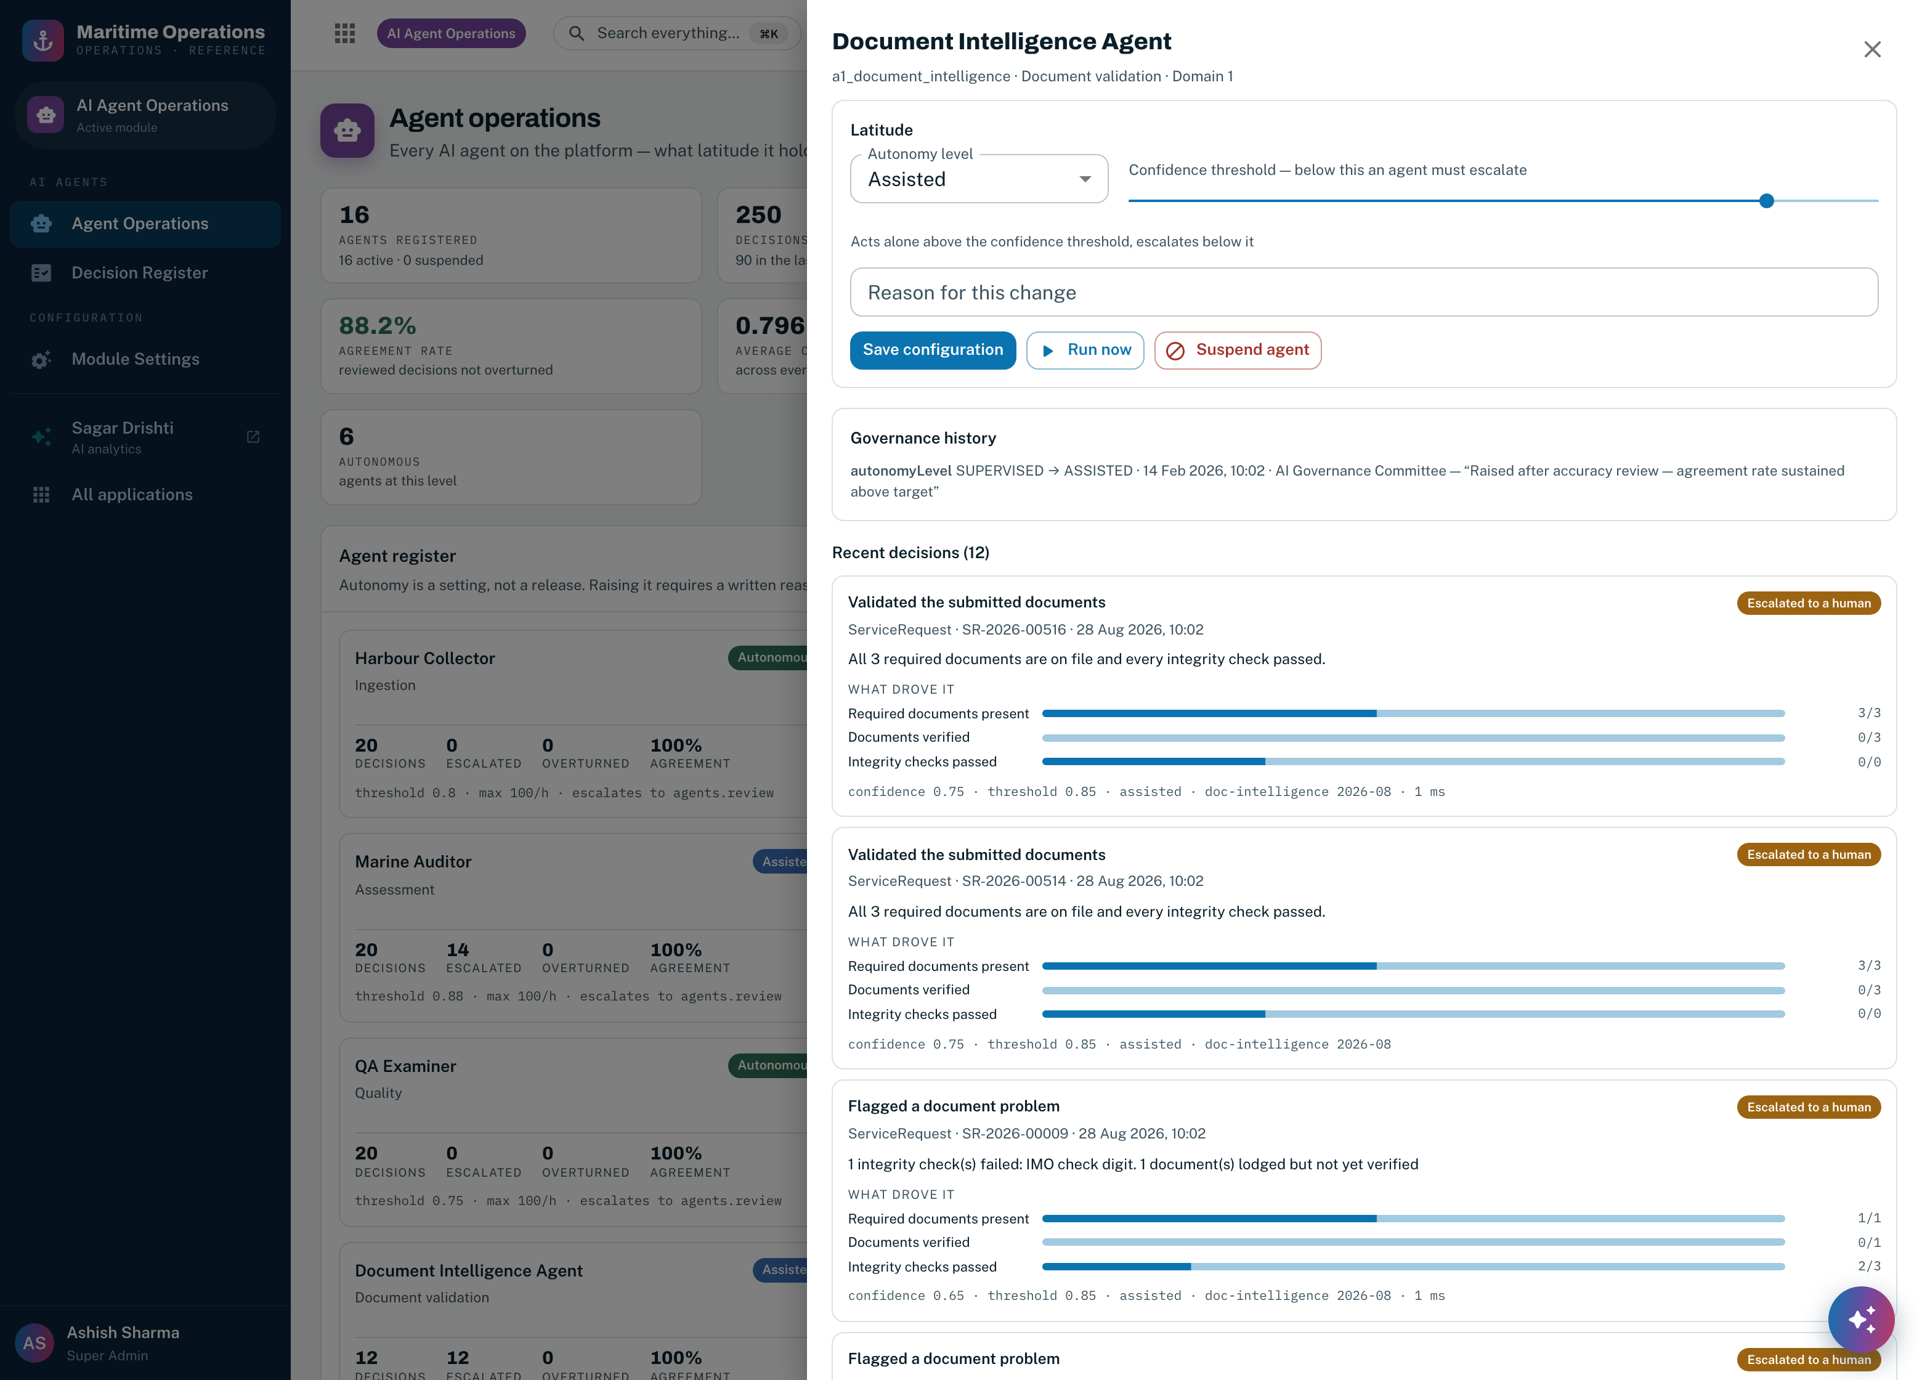
Screenshot 30 — Document Intelligence, showing the twelve escalations discussed in Section 6.3 with the factor breakdown that produced each one: required documents present, documents verified, integrity checks passed, and the confidence those three weights produce.

6.5 How the platform learns from its own decisions
Four feedback loops run at four different speeds. They are separated deliberately, because they carry very different risks: one recalibrates a baseline on every run and can safely do so unattended, while another changes what an agent is permitted to do and must not move without a person. Collapsing them into a single “the system learns” claim is how AI platforms acquire behaviour nobody authorised.
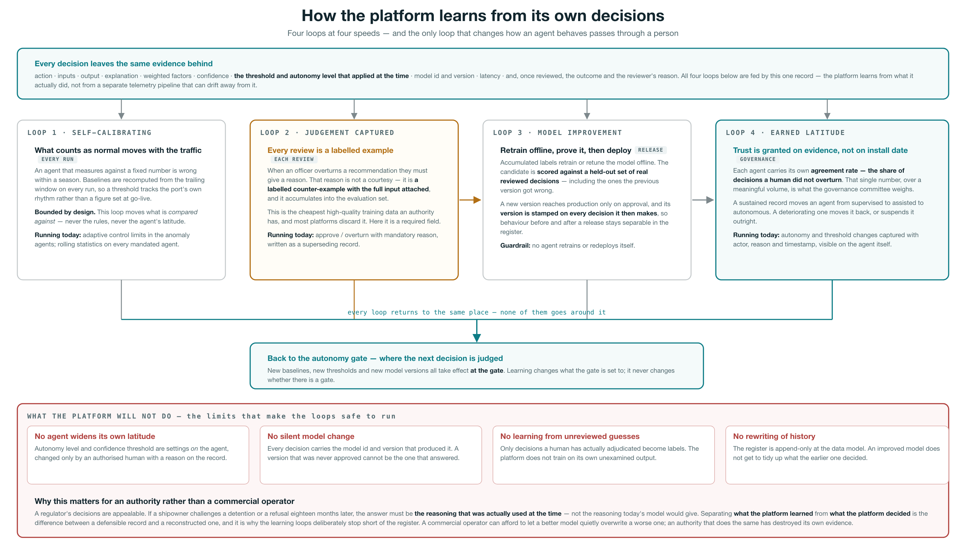
Figure 7 — the four learning loops, and the guardrails that bound them. Every loop is fed by the same decision record, and every loop returns to the autonomy gate rather than around it: learning changes what the gate is set to, never whether there is a gate.

Loop 1 — calibration, every run. What counts as normal is recomputed from the trailing window rather than fixed at go-live, so a threshold tracks the authority’s own traffic instead of a figure that was right in the first quarter. This loop moves only what a measurement is compared against; it cannot reach the rules or the agent’s latitude.
Loop 2 — captured judgement, every review. An officer who overturns a recommendation must give a reason. That reason, with the full input attached, is a labelled counter-example — the highest-quality training data an authority generates, and the data most platforms discard because they treat the review as a workflow step rather than as evidence. Here it is a required field on an append-only record.
Loop 3 — model improvement, at release. Accumulated labels retrain or retune a model offline. The candidate is scored against a held-out set of real reviewed decisions, including the ones the previous version got wrong, and reaches production only on approval. Its version is then stamped on every decision it makes, so behaviour either side of a release stays separable in the register. No agent retrains or redeploys itself.
Loop 4 — earned latitude, by governance. Each agent’s agreement rate — the share of reviewed decisions a human did not overturn — is the evidence the governance committee weighs when deciding whether an agent has earned more room or should be given less. Movement in both directions is recorded with the actor, the reason and the timestamp, and is visible on the agent itself.

Why the loops stop short of the register. A regulator’s decisions are appealable. If a shipowner challenges a detention or a refusal eighteen months later, the answer must be the reasoning that was actually used at the time — not the reasoning today’s model would give. Keeping what the platform learned separate from what the platform decided is the difference between a defensible record and a reconstructed one. A commercial operator can afford to let a better model quietly overwrite a worse one; an authority that does the same has destroyed its own evidence.

6.6 Where agentic AI sits beside the user
The agents are copilots in a specific and testable sense: each one carries load that does not need a person, and none of them holds authority that should not leave one. Figure 8 traces a single application from preparation to service, showing which agent assists at each step and which human retains the decision, and then the standing agents that are not attached to any one case.
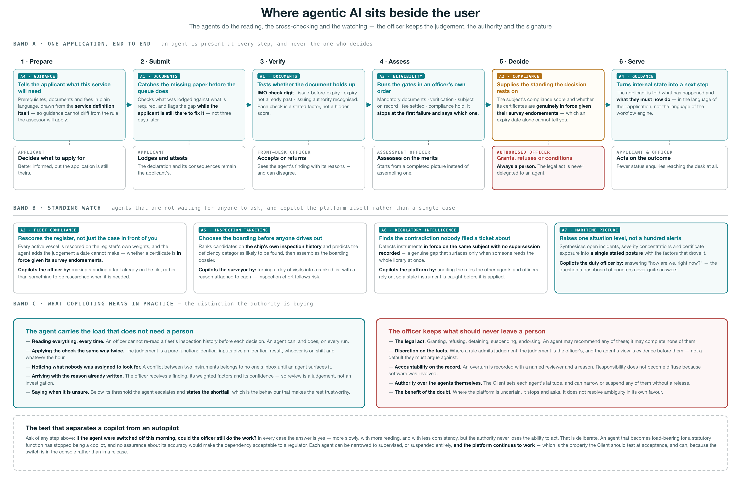
Figure 8 — agentic assistance across one application and across the platform as a whole. The lower bands set out the division the authority is actually buying: what the agent carries, what the officer keeps, and the test that distinguishes a copilot from an autopilot.

The test to apply at acceptance. Ask of any step: if the agent were switched off this morning, could the officer still do the work? In every case the answer is yes — more slowly, with more reading and with less consistency, but the authority never loses the ability to act. That is deliberate. An agent that becomes load-bearing for a statutory function has stopped being a copilot, and no assurance about its accuracy would make that dependency acceptable. Every agent can be narrowed to supervised or suspended outright and the platform continues to work — and because both are settings in the console rather than a release, the Client can test exactly that during acceptance.

6.7 Governance, autonomy and the audit record
Two records carry the whole governance model. An agent configuration holds what an agent is permitted to do; a decision record holds what it did. The first is mutable and every change to it is captured; the second cannot be changed at all.
Control | What the Client can do | How it is recorded
A · What an agent is permitted to do
Autonomy level | Move any agent between supervised, assisted and autonomous at any time, without a release. | Field, from-value, to-value, actor, reason and timestamp, appended to the agent’s governance history and shown on its detail panel.
Confidence threshold | Raise or lower the confidence below which an agent must escalate rather than act. | Recorded the same way, and stamped onto every decision the agent makes thereafter.
Rate cap | Bound the number of actions an agent may take per hour, so a misbehaving agent is limited by arithmetic rather than by monitoring. | Held on the agent configuration and audited on change.
Escalation target | Choose which permission an escalated decision is routed to, so escalations reach the officers who actually hold that authority. | Held on the agent configuration and audited on change.
Suspension | Suspend any agent immediately, with a stated reason. A suspended agent decides nothing: whatever its level, every output escalates carrying the suspension reason. | Suspension state and reason on the agent; the reason travels onto each escalated decision.
B · What an agent actually did
The decision record | Read and filter, by agent and by outcome. It cannot be edited or deleted through any path the application exposes. | Action, subject, inputs, output, explanation, weighted factors with contributions, confidence, the threshold and autonomy level in force, model id and version, and latency.
Human review | Approve or overturn a queued or escalated decision, with a reason. | Written as a superseding record. The agent’s original decision survives exactly as the agent made it.
Effect on the business record | Nothing additional to configure — an applied decision passes through the same API, permission check and audit entry as a human action. | The standard audit log, with the agent named as the actor.

Against the RFP’s two AI service levels. Explainability is required to be retrievable within thirty seconds: it is one click from the register, because the factors, confidence and inputs were stored at the moment of the decision rather than regenerated on request. Escalations are required to reach a human within four business hours: they are routed to a named permission the Client sets per agent, and the queue depth is on the console’s first screen so the service level is visible rather than inferred.

6.8 AI functional requirements compliance, and the effort to full compliance
Assessed on the same basis as the domain compliance tables in Sections 3.11, 4.8 and 5.8, and against the same legend.
Requirement — RFP reference | Compliance today | Effort to 100% (MW)
A · The seven mandated agents
A1 Document Intelligence — classification, extraction and cross-validation of submitted documents. Delta: optical extraction from scanned and photographed documents, tamper and alteration detection, and cross-validation against the issuing authority. | ◐ PARTIAL | 22
A2 Vessel Compliance — continuous compliance and risk scoring across the register. Delta: external data feeds, and a trained rather than weighted risk model. | ● AVAILABLE | 14
A3 Service Processing — end-to-end adjudication of applications. Delta: straight-through issuance for fully compliant cases, with payment and signature integration. | ◐ PARTIAL | 18
A4 Customer Guidance — applicant-facing guidance and status. Delta: conversational interface in Arabic and English, and channel integration. | ◐ PARTIAL | 20
A5 Smart Inspection — risk-based targeting and deficiency prediction. Delta: a model trained across the national fleet, and surveyor scheduling optimisation. | ◐ PARTIAL | 16
A6 Regulatory Intelligence — instrument monitoring and conflict detection. Delta: ingestion of IMO and regional instrument sources with change detection against them. | ◐ PARTIAL | 18
A7 National Maritime Intelligence — the national maritime picture. Delta: AIS and VTS integration, and forecasting rather than present-state synthesis. | ◐ PARTIAL | 24
B · The platform the agents run on
Explainability of every AI decision, retrievable on demand. Factors, contributions, confidence, threshold, model version and raw inputs are stored per decision and retrieved in one click. | ● AVAILABLE | —
Human-in-the-loop control over autonomous action. Three autonomy levels, per-agent confidence thresholds, rate caps, escalation routing and immediate suspension, all Client-controlled and audited. | ● AVAILABLE | —
Immutable audit trail of AI decisions. Append-only at the data model; overrides are written as superseding records. | ● AVAILABLE | —
Model lifecycle management — registry, evaluation, drift monitoring, rollback. Delta: the managed registry, automated drift monitoring and the release pipeline. | ◐ PARTIAL | 20
Responsible AI — bias evaluation, model documentation, impact assessment. Delta: fairness evaluation across nationality, flag and operator; model cards per agent; and a data protection impact assessment. | ○ NEW BUILD | 10
Agent orchestration — multi-agent sequencing with supervision. Delta: extending the sequenced orchestration and validation already running in the analytics workforce to the seven mandated agents. | ◐ PARTIAL | 12
Total delta engineering attributable to the agentic AI layer |  | 174
Compliance levels follow the legend used throughout:
● AVAILABLE — running in the current platform today ·
◐ PARTIAL — the engine exists and the RFP requirement is configured or extended on it ·
○ NEW BUILD — net-new development.
Effort is indicative delta engineering from the running platform, in man-weeks, to be confirmed at DD/D1. It is additional to the domain estimates in Sections 3.11, 4.11 and 5.11 — the agents are counted here, and the domain records they read are counted there. Four of the thirteen line items are met in full today and eight more are partially met, leaving one net-new build. The largest single item, A7’s AIS and VTS integration, depends on data access the Authority controls rather than on development the vendor can accelerate.

