North East University Bangladesh

Department of Computer Science and Engineering



**Learning by demonstration: A robot to teach basic geometry and alphabet and drawing for primary school children**

**By**

|  |  |  |
| --- | --- | --- |
|  | Tahmina Aktar Mispa  Reg. No: 160203020007  BSc(Engg) in CSE  4th year 2nd semester |  |

**Supervised By**

Noushad Sojib

Assistant Professor & Head

Department of Computer Science and Engineering

16th January, 2020

# 

# Abstract

Handwriting difficulties in the children effect negatively of their academic performance and teaching handwriting is not an easy task for parents. This research work based on how a robot can teach handwriting to the children by demonstrating the shape.

This research work will describe a method to generate a new shape from a particular shape. I am working with basic geometric shapes and the alphabet. For generating new shapes I am using Principal Component Analysis (PCA) algorithm. I had faced some challenges in my work. First, i started with image processing and made some image data of the Bengali alphabet “ব” and process them to make a vector, then find their coordinates to plot and it was not so good. I could not thin the shape to find the skeleton. Each coordinate gives a different shape and could not find any method to solve it. Then I changed the method and find a different working method, I draw the shapes on a website (made the website using HTML, CSS, PHP, and JavaScript) and save the shapes into the text file. Worked for four shapes: ‘Triangle’,’ ব ‘, ‘অ’,’ এ’, made the datasets into the same size, shift the data into 0 mean and calculate the average image for each shape. Then apply the PCA algorithm to generate the new shapes.

# Table of Contents

Abstract 2

Table of Contents 4

INTRODUCTION 1

BACKGROUND STUDY 2

2.1 Hood, Deanna, Séverin Lemaignan, and Pierre Dillenbourg. "When children teach a robot to write: An autonomous teachable humanoid which uses simulated handwriting." Proceedings of the Tenth Annual ACM/IEEE International Conference on Human-Robot Interaction. ACM, 2015. 2

2.1.1 Shape modeling of letters 2

2.1.2 Implementation of their shapes 3

2.1.3 Generating poor letters 4

2.2 S. Lemaignan, A. Jacq, D. Hood, F. Garcia, A. Paiva and P. Dillenbourg, "Learning by Teaching a Robot: The Case of Handwriting," in *IEEE Robotics & Automation Magazine*, vol. 23, no. 2, pp. 56-66, June 2016. 5

2.2.1 Result 6

2.3 Yussof, Salman, Adzly Anuar, and Karina Fernandez. "Algorithm for robot writing using character segmentation." 6

PROPOSED METHODOLOGY 8

3.1 Proposed dataset and its preprocessing 8

3.1.1 Challenge 1 8

3.1.2 Challenge 2 9

3.1.3 Challenge 3 9

3.2 Proposed Methodology 10

RESULTS OF WORK 11

FUTURE WORK 12

CONCLUSION 13

REFERENCES 14

**Chapter 1**

# INTRODUCTION

When the children started to write, they start drawing. They draw any kind of shape like flowers, birds, alphabet, numbers, etc. Parents teach them how to write those shapes. When they started their academic study at the age of 5-6, it is more difficult for the parents to teach them.

If it happens that, a partner teaches them to write then they draw with more interest. They take it as a part of the game and learn how to write easily. If a robot takes place as a partner it will be more interesting because it can work continuously.

Robots were initially designed to assist humans in doing work because it can work continuously and tirelessly. Teach handwriting is a very hard task and if we replace robot for this task, I think it will be a good effect in the education field

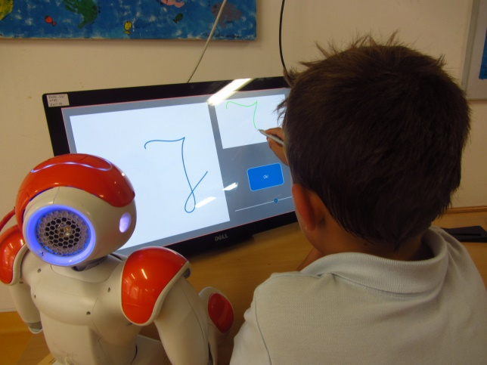

Figure 1: Human- robot interaction for children handwriting acquisition [source: internet]

Children interactions with robot weather as a toy or classroom friend, they are more curious to learn anything from robot. If robots teaching children basic geometric shapes and alphabet they will learn it more interestingly.

However, robots can’t do every single work that can be done by humans. There are so many tasks that can be easily done by humans but can’t be easily done by robots. This is because our brain is very good at recognizing and producing simple patterns. One example of such a task is writing.

Teach writing to the robot as like human write is not an easy task.

So my research work is how a robot can write. More specifically, learning by demonstration, how a robot can generate geometrical shapes and alphabet. There will be an app and kids will used it as a mobile screen.

**Chapter 2**

# BACKGROUND STUDY

This chapter contains a snapshot of some relevant works already been done for shape

## Hood, Deanna, Séverin Lemaignan, and Pierre Dillenbourg. "When children teach a robot to write: An autonomous teachable humanoid which uses simulated handwriting." Proceedings of the Tenth Annual ACM/IEEE International Conference on Human-Robot Interaction. ACM, 2015.

I implemented this paper and this research work presents a robotic partner (NAO ) which children can teach handwriting. The system relies on the learning by teaching paradigm to build an interaction, so as to stimulate meta-cognition, empathy and increased self-esteem in the child user.

Statistical shape models derived from principal component analysis of a dataset of adult-written letter trajectories allow the robot to draw.

By incorporating feedback from user demonstrations, the system is then able to learn the optimal parameters for the appropriate shape models.

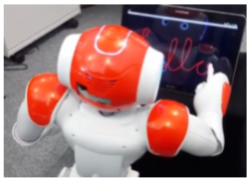

Figure 2: A demonstration of the robot simulating the writing of a word with its ﬁnger. This is NAO robot that they use into their research work [1]

### Shape modeling of letters

PCA is performed on a set of letter paths captured from a digital pen, using the UJI Pen Characters 2 dataset with 120 instances of each letter (2 repetitions from 60 adult users). **[**1**]**

The features are currently taken as n = 70 uniformly spaced points along the shape path. The points are arranged into a vector, which represent the coordinates of each of the points along the path.

They use 140 points for each data. The observation shapes are normalized to have a unit maximum dimension and 0 mean. Each shape is then approximated by the mean shape of the allograph and they use top 10 eigenvector and sum with the average shape.

### Implementation of their shapes

I implemented their English alphabet with given dataset and generate the new shapes with PCA algorithm. There are 140 points divided into x and y coordinates, calculate the mean shape. Use top 3 eigenvector, multiplied with 3 contribution and sum with the mean shape. For generating different shapes change the contribution value.

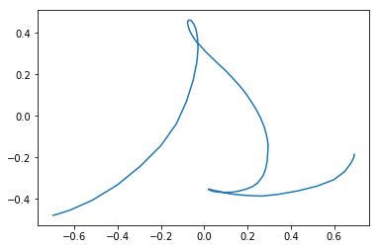

Figure 3: Calculate the mean shape of ‘s’ to generate the new shape

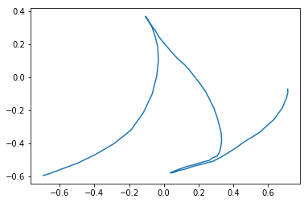

Figure 4: Applying PCA this is the generated shape of ‘s’ with (0.5, 0.9, 0.8) contribution

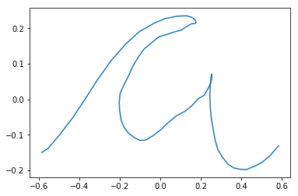

Figure 5: Calculate the mean shape of ‘a’ to generate the new shape

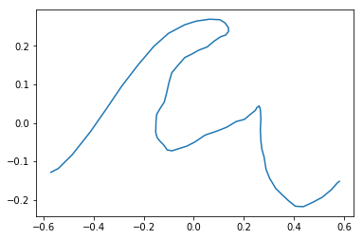

Figure 6: Applying PCA this is the generated shape of ‘a’ with (0.2, 0.2, 0.1) contribution

### Generating poor letters

If we increase the contribution value it generates the poor shapes

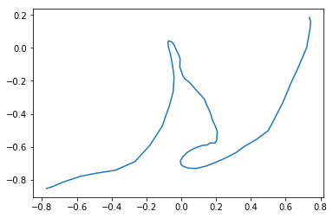

Figure 7: Increasing the contribution value generates the poor shape of ‘s’ with (2.5,1.7,1.3) contribution

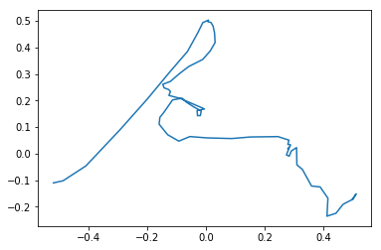

Figure 8: Increasing the contribution value generates the poor shape of ‘a’ with (0.8, 0.6, 1.2) contribution

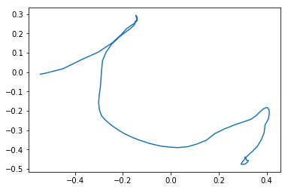

Figure 9: Increasing the contribution value generates the poor shape of ‘h’ with (0.9, 0.8, 0.3) contribution

## S. Lemaignan, A. Jacq, D. Hood, F. Garcia, A. Paiva and P. Dillenbourg, "Learning by Teaching a Robot: The Case of Handwriting," in IEEE Robotics & Automation Magazine, vol. 23, no. 2, pp. 56-66, June 2016.

This paper is case study of the first paper. They went 3 schools and take survey of school (A) with unstructured group/individual interaction at age 6-7, school (B) takes individual/pair at age 7-8, school(c) takes pair interaction at age 5-6, clinic study of 8 children, case study of two children Vincent and Thomas.

Table 1: Field studies of children-robot interaction to write handwriting [3]

|  |  |  |  |  |
| --- | --- | --- | --- | --- |
| Study | Type | Average duration | Children | Ages |
| School A 1 | Unstructured group interaction at school | 16 min/group | 4×8 children | 6-7 |
| School B | Individual/Pair interaction at school | 11 min/group | 7 (individual)+  7×2(pairs) | 7-8 |
| School C | Pair interaction at school | 26 min/group | 7×2 | 5-6 |
| School A 2 | Individual interaction at school | 20 min | 6 | 5-6 |
| Clinic | Individual interaction at clinic | 3 sessions ×1h | 8 | 6-8 |
| Vincent | Case-study | 4 weeks×1.5h | 1 | 6 |
| Thomas | Case-study | 4 weeks×1h | 1 | 5 |

### Result

All children maintained their engagement during the sessions. They provided on average 42 demonstrations per session.[3] They estimate the robot’s progress as the diﬀerence between an initial score (Euclidian distance between the shape drawn by the robot at its ﬁrst attempt and the shape of the current letter) and the robot’s score at the current round of demonstrations. Then they correlate this progress to the positive or negative feedback provided by the children.

Table 2: Feedback from the children to the robot. #Demos denotes the average number of demonstrations per hour provided by the children; #Positive and #Negative the total number of positive and negative response they provided [3]

|  |  |  |  |
| --- | --- | --- | --- |
| Child | Demos/hour | Positive | Negative |
| Valerie | 42 | 24 | 6 |
| Emilien | 74 | 20 | 9 |
| Mathieu | 43 | 10 | 3 |
| Nicolas | 38 | 16 | 4 |
| Johan | 32 | 10 | 5 |
| Antoine | 27 | 10 | 3 |
| Adele | 35 | 4 | 2 |
| Marie | 40 | 5 | 1 |

## Yussof, Salman, Adzly Anuar, and Karina Fernandez. "Algorithm for robot writing using character segmentation."

In this paper, they are presenting a flexible algorithm that can allow a robot to write. This algorithm is based on character segmentation, where the main idea is to store character information as segments and the segment information can then be used by the robot to write. [5]

Character segmentation divides a character into segments that consist of straight lines and curves. Divide a character into components that can be drawn by a robotic arm. For example, character 'n' is segmented into three segments. The first and third segments are straight lines, while the second segment is a curve

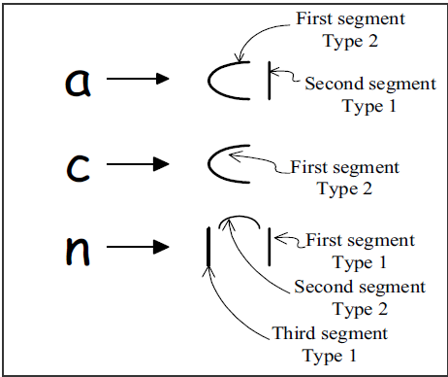

Figure 10: Segmentation on letters 'a', 'c' and 'n' [5]

Table 3: Character segment information of ‘a’ , ‘b’ and c showing how many segment are there [5]

|  |  |  |  |
| --- | --- | --- | --- |
| Character | No. Of Segments | Segment type 1 | Segment type 2 |
| a | 2 | 1 | 2 |
| b | 2 | 1 | 2 |
| c | 1 | 2 | - |

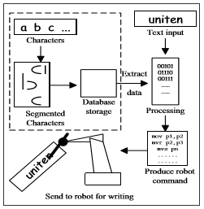

Figure 11: Block diagram of the robot writing system with letter segmentation [5]

**Chapter 3**

# PROPOSED METHODOLOGY

## Proposed dataset and its preprocessing

For generating shape the first target is to prepare a good dataset. For preparing the dataset I had been faced some challenges. My target was to get the shapes of Triangle, Bengali alphabet and I had been faced the following challenges:

### Challenge 1

At the beginning of my work, I was started with image data. Painted some images of the Bengali alphabet ‘ব’ Main goal was to find the mean shape from those images. For that, resize the images into (110×110), convert them into the grayscale image and convert them into the vector. From vector find its coordinate value. Since generating the average shape all of the image coordinate values have to be the same size but could not convert the coordinate values into the same size.

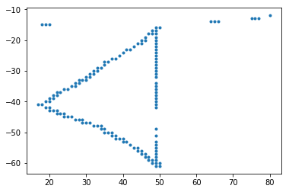 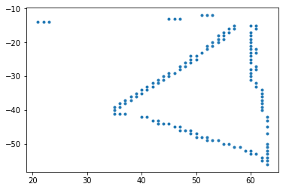

Figure 12: ‘ব’ shape (2,130) Figure 13: ‘ব’ shape (2,139)

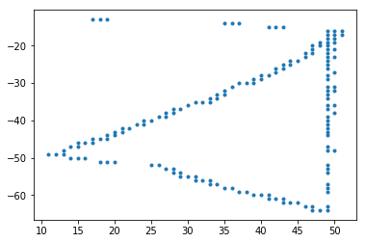 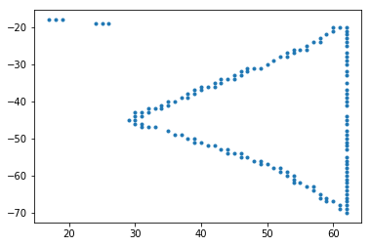

Figure 14: ‘ব’ shape (2,154) Figure 15: ‘ব’ shape (2,145)

This is not possible to make the mean shape with different shapes. For this reason, I switched into an another method

### Challenge 2

For making the dataset, I made a website (using HTML, CSS, PHP and JavaScript) for drawing shapes

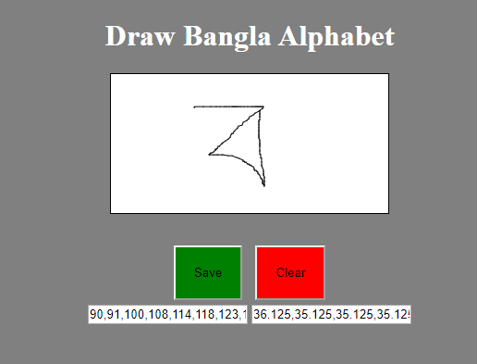

Figure 16: Create a Website for making the datasets

Save the coordinates into a text file and resize the coordinate where, $x$ coordinate contains 100 points and $y$ coordinate contains 100 points.

### Challenge 3

After finding the same size of coordinates it was needed to shift the coordinates of 0 mean otherwise, the average shape was not good. So, my third challenge was shifting the coordinates with 0 means so that each image can fit in the middle.

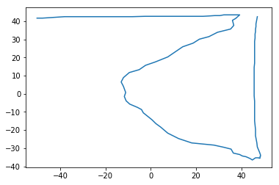

Figure 17: Average image of my own datasets

## 

## Proposed Methodology

My research work is to generate different shapes (geometrical shapes and alphabet) by the robot.

At present, the Principal Component Analysis (PCA) algorithm is used to generate different shapes. Since PCA is a well-known algorithm for image data and it has a vast use in different applications. Further, generative deep learning will be used to complete my research. Many concepts or methods can be changed in the future.

**Chapter 4**

# RESULTS OF WORK

Using my own dataset, generate different shapes. ‘Triangle’,’ ব ‘, ‘অ’,’ এ’ is shown below:

Basic steps:

Read the datasets from a text file and resized them into the same size.

Resized 10 Triangle each contain (65×65)

Resized 8 ব each contain (100×100)

Resized 7 এ each contain (47×47)

Resized 11 অ each contain (42×42)

Shift the images with 0 mean

Calculate the average image

Apply PCA algorithm to generate the new shapes

 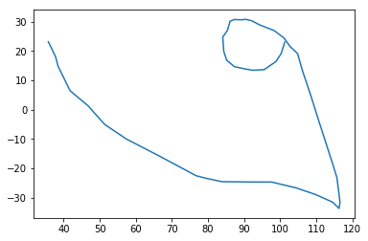

Figure 18: Generated ব using PCA,

Parameter (x, y $=$ 100×100) Figure 19: Generated এ using PCA, Parameter (x, y $=47$ ×47)

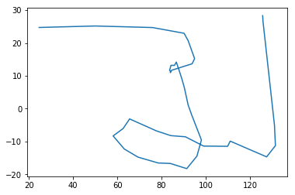 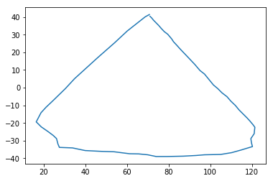

Figure 20: Generated অ using PCA Figure 21: Generated Triangle using PCA Parameter (x, y $=$ 42×42) Parameter (x, y $=$ 65×65)

**Chapter 5**

# FUTURE WORK

At present, my method can generate the new shape from the average shape applying the PCA algorithm but cannot convert into various shapes like poor shape. So, the next step of my work will generate various shapes with changing the contribution value to generate the poor shape.

Further, I will be work with generative deep learning. A Generative Model is a powerful way of learning any kind of data distribution using unsupervised learning and it has achieved tremendous success in just a few years. All types of generative models aim at learning the true data distribution of the training set so as to generate new data points with some variations.

After complete this research work, it will be tested by a robot and there will be an app so that children can use it as a mobile screen.

**Chapter 6**

# CONCLUSION

In Bangladesh robot interaction with children is not available. For this reason, they feel hesitant to talk with the robot, some of them can’t trust it. In this field, a few numbers of works have been done. I think this research work put a positive impact on the education system especially, for primary school children.

**Chapter 7**

# REFERENCES

1. Hood, Deanna, Séverin Lemaignan, and Pierre Dillenbourg. "When children teach a robot to write: An autonomous teachable humanoid which uses simulated handwriting." *Proceedings of the Tenth Annual ACM/IEEE International Conference on Human-Robot Interaction*. ACM, 2015.
   1. Westlund, Jacqueline M. Kory, et al. "Measuring children’s long-term relationships with social robots." *Workshop on Perception and Interaction dynamics in Child-Robot Interaction, held in conjunction with the Robotics: Science and Systems XIII*. 2017.
2. Lemaignan, Séverin, et al. "Learning by teaching a robot: The case of handwriting." *IEEE Robotics & Automation Magazine* 23.2 (2016): 56-66.
3. Williams, Randi, Hae Won Park, and Cynthia Breazeal. "A is for Artificial Intelligence: The Impact of Artificial Intelligence Activities on Young Children's Perceptions of Robots." *Proceedings of the 2019 CHI Conference on Human Factors in Computing Systems*. ACM, 2019.
4. Yussof, Salman, Adzly Anuar, and Karina Fernandez. "Algorithm for robot writing using character segmentation." *Third International Conference on Information Technology and Applications (ICITA'05)*. Vol. 2. IEEE, 2005.