Designer : Mobina Pooladi

Steps:

1: create a CRUD Aplication project folder

2: create a database and table ( id,name,email, designation)

3: download assets file (css/js)

-bootstrap

-font awesome

-jquery validation

-toastr jQuery plugin

4: layout files – main layout templates ( list , add modal , edite modal ) , db-config.php

5: functionality points

First I prepared project structure the database connection is in db-config.php file

The view is in index.php file and the PHP code is in functions.php file

Also there Are two other directories : js and css

Inside these directories we have the assets I mentioned in step 3.

Thu, to run the project first import the users.SQL file in phpmyadmin to create the users table, then clone the project from the linke below:

<https://github.com/mobinaPd/taskapp-skyroom>

\*\*\* in my project I am working with a base url inside js/script.js file if your local address is different change the first line of code \*\*

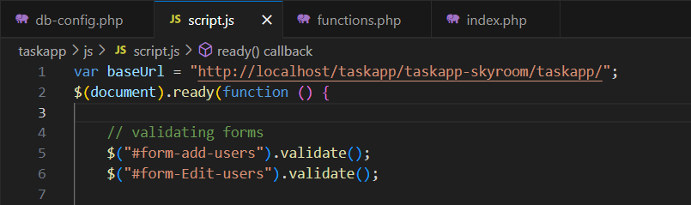

Then inside your browser you can see this:

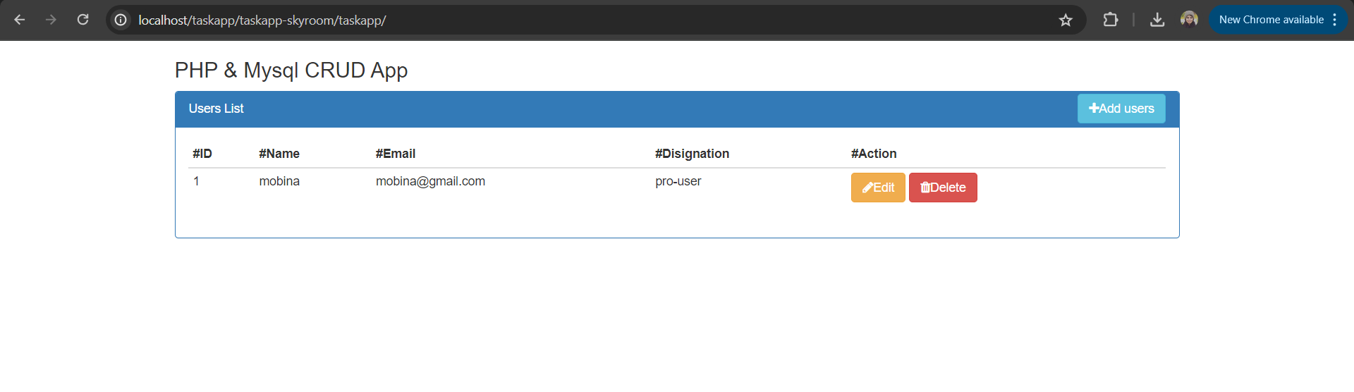

In our table we have id, name, email, and designstion the user can be a normal user or a pro user

There are 3 buttons Edit, Delete and Add users with font awesome icons beside the them, moreover we can see list of users inside the table:

If we click on add button a modal like the picture below will be opened that all the fields are required. I checked the validation of the form with jquery validation library

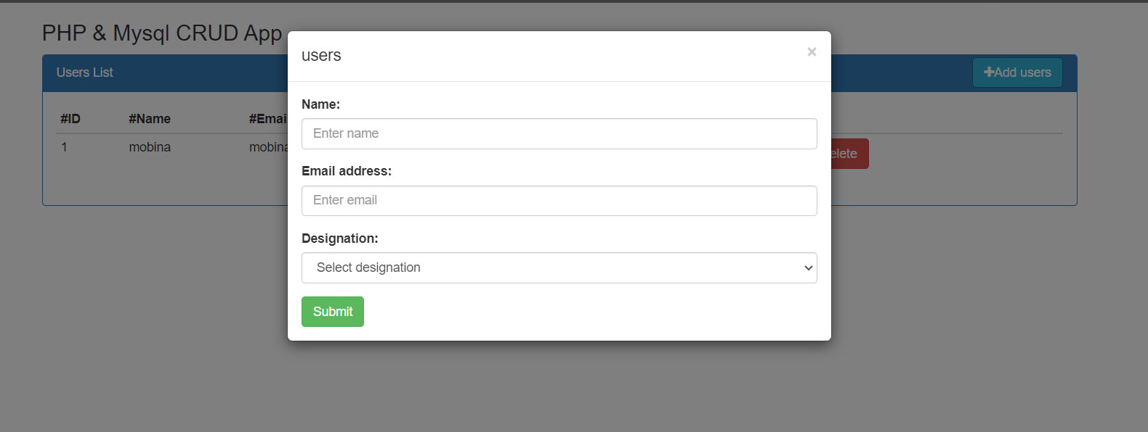

If we submit the form empty, it will warn us! But if we full the form write it will appear a message and add the new user to the list

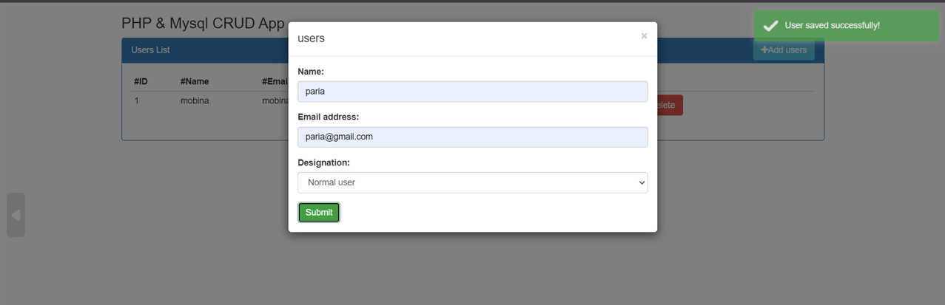

After 3 seconds it will reload the page automatically

If I click on edit button, it will load a modal with user information and if we change the inputs and click the submit, it will update user’s data and reloaded the page after 3 seconds

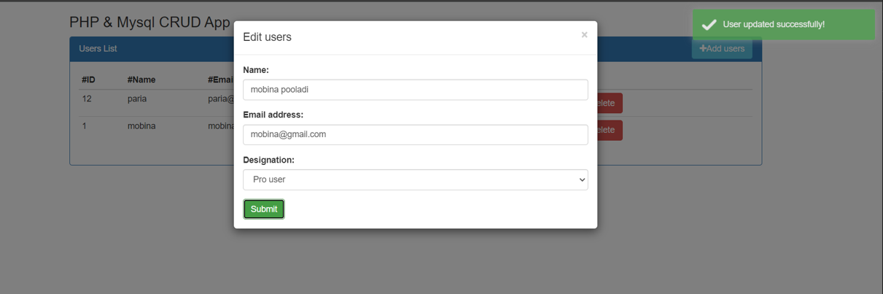

And for delete operation if we click on the delete button, an Alert asks if we are sure to delete the user and if we click on delete the user will be deleted

