**Aspose.Word**

A library for document processing tasks

Written in Java

By: Mobina Goodarzi

Table of Contents

Introduction 3

Setting up and using Aspose library in Java 3

Document Creator Class 3

Document Editor Class 4

Tables Class 4

Existence Checker Of Document Class 5

Font Checker Class 5

Challenges 6

# Introduction

Aspose.Words for Java is a class library that enables your applications to perform a great range of document processing tasks.

Aspose.Words supports most of the popular document formats such as DOC, DOCX, RTF, HTML, Markdown, PDF, XPS, EPUB, and others.

With Aspose.Words for Java, you can generate, modify, convert, render, and print documents without third-party applications or Office Automation.

# Setting up and using Aspose library in Java

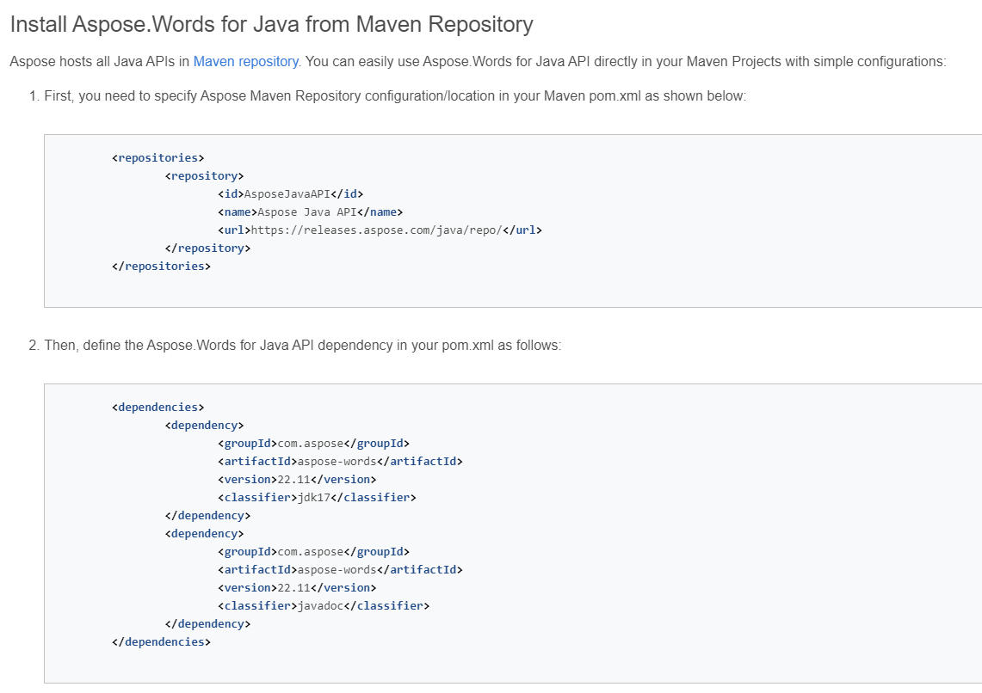

# Document Creator Class

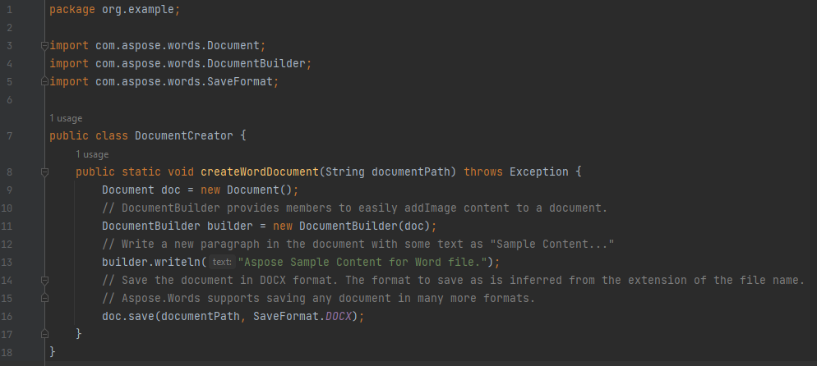

This method creates a new Word document.

* It uses the **Document** class constructor to initialize a new document object.
* It creates a **DocumentBuilder** object to facilitate content addition to the document.
* The **DocumentBuilder**'s **writeln** method is used to add sample content to the document.
* Finally, the **save** method of the **Document** class is called to save the document in the DOCX format at the specified path.

# Document Editor Class

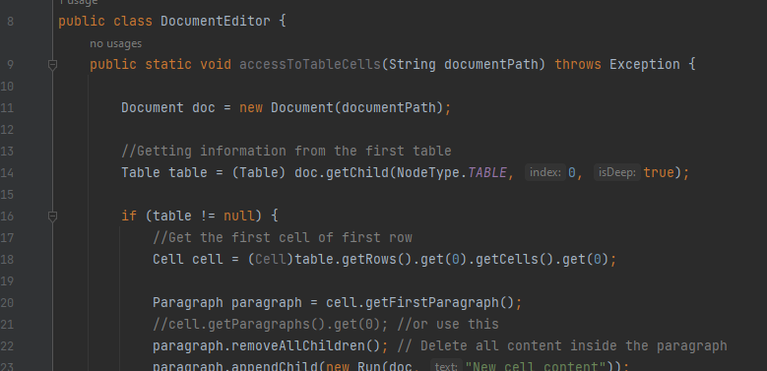

**DocumentEditor** class provides several methods for editing Word documents like;

1. **accessToTableCells(String documentPath)**: This method allows access to the cells of table in the specified Word document. It retrieves the selected cell of the selected row, and applies the desired changes.
2. **addTableToDocument(String documentPath)**: This method adds a table to the specified Word document. It utilizes some table method from the **Tables** class.
3. **addImage(String documentPath)**: This method inserts an image into the specified Word document. It inserts the image located at the desired path.

# Tables Class

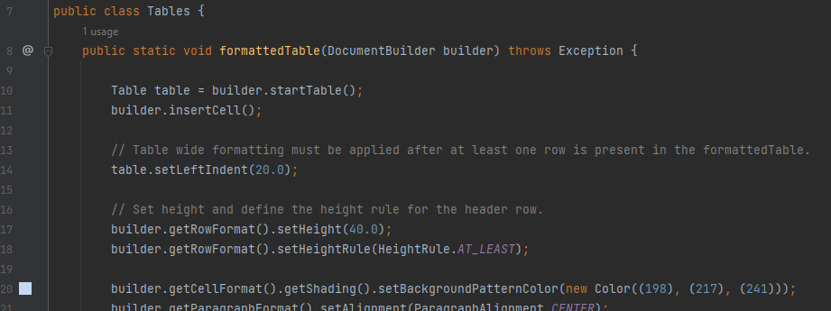

This **Tables** class provides methods to generate various types of tables in Word documents.

These methods offer flexibility in creating tables with different formats and styles.

# Existence Checker Of Document Class

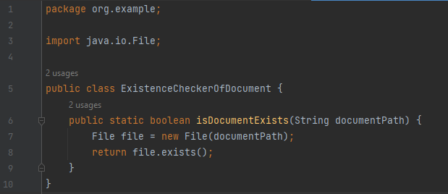

The **ExistenceCheckerOfDocument** class contains a static method **isDocumentExists(String documentPath)** that checks whether a document file exists at the specified path. It takes a **String** parameter **documentPath**, which represents the path to the document file, and returns a boolean value.

# Font Checker Class

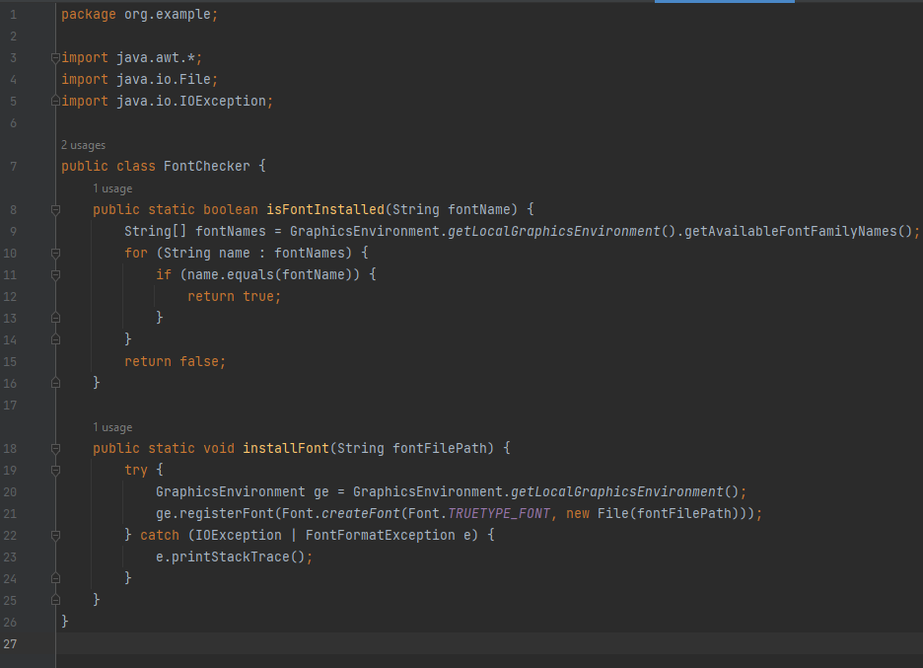

The **FontChecker** class contains two static methods:

1. **isFontInstalled(String fontName): boolean**: This method checks if a font with the specified name is installed on the system. It takes a **String** parameter **fontName**, representing the name of the font to check, and returns a boolean value.
2. **installFont(String fontFilePath)**: This method installs a custom font from the specified file path into the system. It takes a **String** parameter **fontFilePath**, representing the path to the font file (TTF format), and installs the font if it's not already installed.

# Challenges

**Limited free features:** Aspose.Words has restrictions on free usage, including the insertion of a message stating "Created with an evaluation copy of Aspose.Words" in documents generated with the evaluation version.

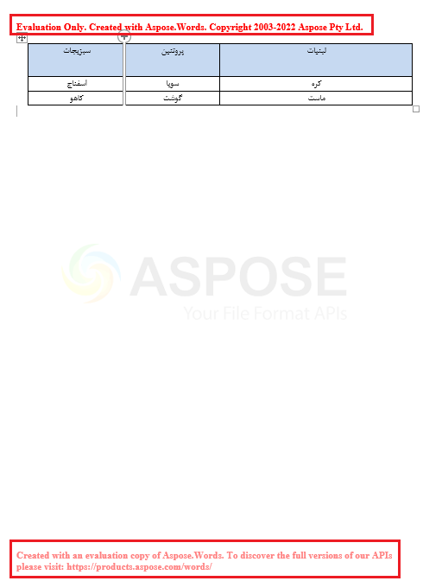

**Lack of extensive learning resources:** There is a shortage of comprehensive tutorials and examples for Aspose.Words, requiring users to rely primarily on official documentation.

**Alternative solution:** Apache POI is a popular open-source alternative to Aspose.Words, offering similar functionality for working with Microsoft Office documents in Java, along with extensive documentation and community support.