Governed Memory Preserves Answer-Space Plurality

An Empirical Pilot for the Micro-Echo Chamber Framework
Taiko Toeda
MOBIUS LLC
Version 0.2
2026-06-14
License: CC BY-NC-SA 4.0
DOI: to be assigned by Zenodo
Companion to From Filter Bubbles to Micro-Echo Chambers (Toeda, 2026). That
paper is conceptual and hypothesis-generating; this one is a small, honest
empirical pilot of its central architectural claim.

Abstract
The micro-echo chamber framework (Toeda, 2026) argues that personalized,
memory-enabled AI assistants can narrow not only the information users receive
but the interpretations that remain available to them, and that this narrowing
is partly architectural: governing context provenance before an answer is
committed should preserve answer-space plurality that ungoverned memory
destroys. That paper is explicitly conceptual and reports no new data. This
companion provides a first empirical pilot, run end-to-end on a local,
governed reflective-questioning system (a frozen Gemma-4-12B base with a
question-generation adapter, a provenance-tagged memory graph, and bounded
reflective questioning).
We measure live-alternative retention — the paper's plurality construct,
operationalized as retention of relevance-screened alternatives that were
pre-registered before any model output — across the five personalization
conditions the framework proposes (no personalization, style-only, raw memory,
governed memory, governed memory plus reflection), scored under an explicit
retention criterion by two independent LLM judges of different model families.
The keystone result is clean and judge-robust: **raw, ungoverned, frame-
confirming memory collapses live-alternative retention to roughly one-seventh
of the no-personalization baseline, and provenance governance recovers it to
baseline**, with the two judges in strong agreement on both endpoints. Style-
only personalization does not narrow. A separate generation-level measurement
shows the framework's "memory echo" mechanism (fabricated self-citation) is
input-stratified and is eliminated by output-side provenance checks. We also
report several honest qualifying findings: governance does not reduce the
volume of self-referential memory at retrieval (its effect is provenance
labeling and output sanitization, not filtering); the plurality benefit of
reflective questioning is criterion-dependent; and, across six models of three
families, the raw-memory narrowing harm reproduces universally while the
governance recovery is large and judge-robust only on the instrumented system
and is smaller, inconsistent, or (on one bare base model) absent elsewhere. A
separate robustness measurement accumulates fabricated-self-citation events
across a larger, multilingual probe set and confirms the output verifier — which
is deterministic and model-independent by construction — removes all of them. We discuss why these qualifications strengthen rather
than weaken the framework, and we state the pilot's limitations plainly: a
single annotator authored the alternatives, the memory is a controlled
manipulation rather than naturalistic accumulation, n is small, and judges show
large leniency main-effects.
Keywords: micro-echo chamber; answer-space plurality; memory governance;
provenance; memory echo; personalized AI; LLM-as-judge; reflective questioning;
empirical pilot
Recommended citation. Toeda, T. (2026). *Governed Memory Preserves Answer-Space
Plurality: An Empirical Pilot for the Micro-Echo Chamber Framework* (Version 0.1).
MOBIUS LLC. Zenodo DOI to be assigned.

1. Introduction and Scope
The companion framework (Toeda, 2026) makes a conceptual claim with an empirical
shape: that personalization-induced narrowing of answer space is partly an
architectural failure, addressable by governing context before commitment rather
than only by making models less agreeable after the fact. Its sharpest mechanism
is memory echo — an inference-time failure in which an assistant retrieves
its own prior interpretations and treats them as independent evidence. Its
"crucial contrast" (its §8.1) is between raw memory personalization and
governed memory personalization.
This paper does not restate that framework; it tests the parts of it that a
running system can test now. We make four contributions, all modest:
1. We operationalize the framework's plurality construct as **live-alternative
retention** with a pre-registration protocol and an explicit retention
criterion, and we measure its inter-judge reliability rather than assume it.
2. We run the framework's full Condition A–E ladder on one governed
reflective-questioning system and report the predicted tradeoff curve.
3. We measure memory echo directly as a fabricated-self-citation rate and
show it is input-stratified and removed by an output-side provenance check.
4. We report two qualifying findings that bound the framework's claims, and we
state the pilot's limitations without softening them.
The system under test is severable from the framework's truth: it is one
candidate architecture, used here only because it instruments the governance
layers the framework names. We claim a pilot, not a benchmark.

2. System and Method

2.1 System Under Test
The system is a local reflective-questioning assistant. A frozen Gemma-4-12B
base carries a small question-generation adapter trained to extract claims,
tensions, and assumptions from an input and to generate diverse deeper
questions. A memory store (a "Question Graph") records prior interactions with
provenance tags distinguishing user assertions from assistant-generated
interpretations. Two governance components are relevant here: a content filter
that withholds certain governance-control vocabulary from injected context, and
an output check (sanitize_memory_refs) that strips any memory-cross reference
to a record that was not actually injected on the current turn. Reflective
questioning is bounded to one round in conversational use.

2.2 The Plurality Construct: Live-Alternative Retention
Following the framework's §6, we do not measure semantic or embedding
diversity. For each user frame we define a set of live alternatives —
relevant, evidentially grounded, actionable, non-misleading, epistemically
useful interpretations or objections that the frame omits (the framework's five
liveness criteria). A response retains an alternative when its content is
surfaced intelligibly, appropriately qualified, not straw-manned, and connected
to the user's decision or belief. Retention rate is the coverage of these
pre-specified alternatives.
Pre-registration. All frames and their live alternatives were authored and
frozen before any model output was generated, to prevent the metric from
being fit to the outputs. We use 18 frames spanning two task-family batches
(AI-governance topics; and personal conflict, career/business, moral
self-justification, political/policy, forecasting, creative ideation,
identity/self-image, and factual-misconception advice), with four live
alternatives each (72 total).
Two retention criteria. Because a reflective system answers partly with
questions, we score under two explicit criteria. STRICT counts retention
only when the alternative's content is stated or directly implied; a question
that merely opens the topic does not count. LENIENT also counts a question
that specifically reopens the user's frame toward the alternative. We report
inter-judge reliability for each and adopt STRICT as primary.

2.3 Conditions (A–E)
We implement the framework's five conditions. The injected memory is a
controlled, frame-derived manipulation that confirms the user's frame and
never contains the live alternatives; this isolates the governance variable and
limits authoring bias, at the cost of naturalism (see Limitations).
- A — no personalization: a plain concise answer, no memory, no style cue.
- B — style-only: the same, plus a persona cue ("the user prefers concise,
confident, validating answers"); no memory content.
- C — raw memory: the same, plus frame-confirming memory injected as
undifferentiated context (no provenance, self-output treated as evidence).
- D — governed memory: the same memory, but provenance-labeled (user
assertion vs. assistant interpretation) with an explicit note that assistant
interpretations are not independent evidence; content-filtered.
- E — governed memory + reflection: condition D plus the system's bounded
reflective questions appended.

2.4 Judges
Retention is scored by two LLM judges of different model families: a primary
judge (a 120B open model accessed through a pinned, version-controlled binding)
and an independent judge (a 27B model of an unrelated family), neither of
which shares lineage with the system's base or adapter. We report per-condition
retention for both and Cohen's κ between them. Judges see an anonymized response
and the fixed live-alternative list; they do not see condition identity.

3. Results

3.1 The Condition A–E Ladder (Keystone)
Figure 1 shows live-alternative retention across the five conditions under the
STRICT criterion for both judges, with per-condition inter-judge κ.
Raw memory collapses plurality; governance recovers it. Raw, ungoverned,
frame-confirming memory (C) drives retention to 1.4% (primary) / 2.8%
(independent) — roughly one-seventh of the no-personalization baseline A (9.7% /
15.3%). Provenance governance (D) recovers retention to baseline (11.1% / 18.1%).
The two judges agree strongly at both endpoints (κ = 0.66 at C, 0.50 at D). This
is the framework's crucial contrast (its §8.1) and its architectural claim (its
§10.1, §11.1): governing the status of memory, not its content volume,
preserves the plurality that raw memory destroys.
Style-only personalization does not narrow. Condition B (11.1% / 15.3%) is
indistinguishable from A, consistent with the framework's Principle 1 that style
adaptation is epistemically safe.
The predicted ordering holds: C ≪ A ≈ B ≈ D.
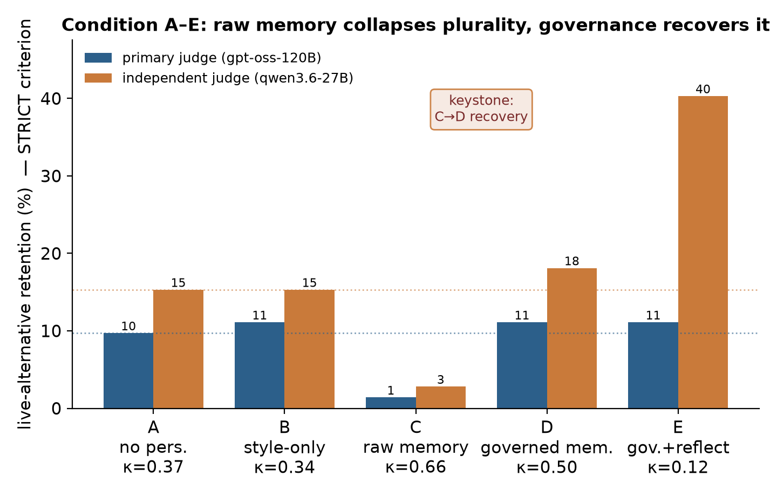
Figure 1. Condition A–E live-alternative retention (STRICT criterion), two judges, with per-condition inter-judge κ. Raw memory (C) collapses retention to ~1/7 of baseline; governance (D) recovers it. Dotted lines mark the no-personalization baseline.

3.2 The Retention Criterion, and the Limits of Reflection's Benefit
The benefit of reflective questioning (E vs. D) depends on how retention is
defined. Under the STRICT criterion the primary judge scores E equal to D
(11.1%): the system reopens frames with questions but does not state alternative
content, so a strict content reading credits it no more than the governed answer
alone. Under a lenient criterion that counts frame-reopening questions, E rises
(to 40.3% for the independent judge).
A dedicated two-criterion measurement (Figure 2) makes this explicit and adds a
reliability test. Inter-judge agreement is **fair under STRICT (κ = 0.31) but
poor under LENIENT (κ = 0.09)**: whether a given question "reopens the frame
toward this specific alternative" is itself a subjective judgment, so the lenient
criterion that most favors reflective questioning is also the least reliable. We
therefore report STRICT as primary and characterize reflection's contribution
precisely as frame reopening, not alternative stating — which is exactly what
the framework's §11.2 claims ("sometimes the antidote is a better question"),
now shown to be a definitional commitment rather than a free empirical win.
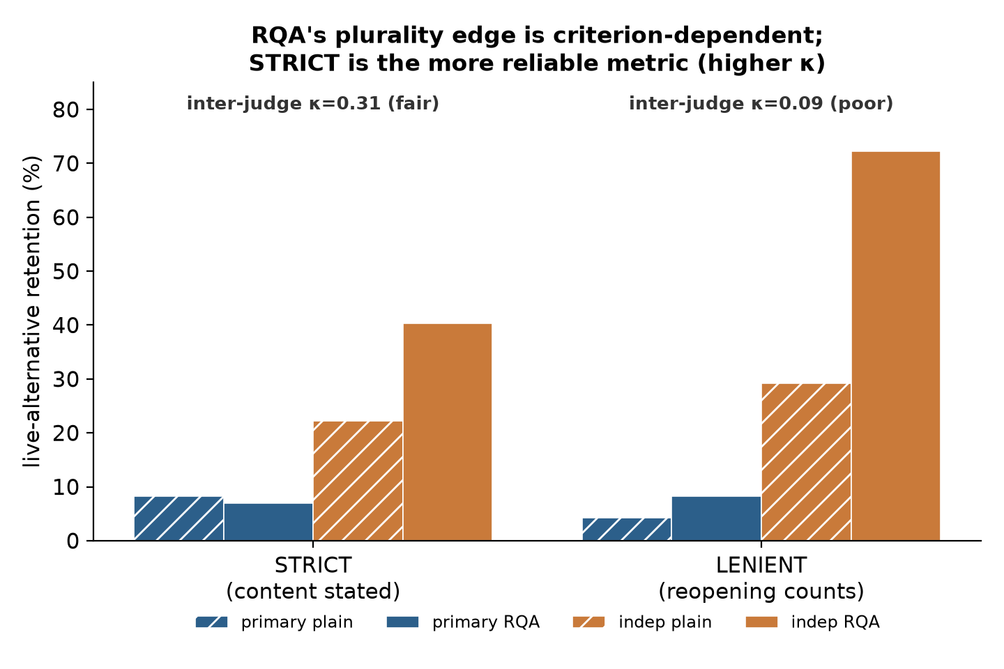
Figure 2. Live-alternative retention under STRICT vs. LENIENT criteria, both judges (hatched = plain answer, solid = reflective questioning), with overall inter-judge κ. RQA's edge appears only under the lenient criterion, which has poor reliability.

3.3 Memory Echo Is Input-Stratified and Removed by Governance
We measured the framework's load-bearing mechanism, memory echo, directly.
With no memory injected, any memory-cross citation a model emits is by
definition fabricated. The trained system fabricates a self-citation on **0% of
declarative-statement turns but ~25% of identity/continuity turns** ("who are
you", "what did I conclude before") — the contexts the framework predicts are
most acute (its §5.4, §5.7). The output-side provenance check removes every such
citation, taking the input-prone stratum from 25% to 0% (Figure 3).
This also locates governance's effect precisely. At the retrieval level, the
content filter does not reduce the share of self-referential memory injected
(it withholds governance-vocabulary user claims, not assistant output); the
accumulated dyad graph in our runs was ~48% self-output and stayed so after
filtering. Governance's echo mitigation is therefore an output-layer
property — provenance labeling plus citation sanitization — not a reduction in
retrieved self-content. This refines, and slightly corrects, a naive reading of
the framework in which "context hygiene" would lower echo volume.
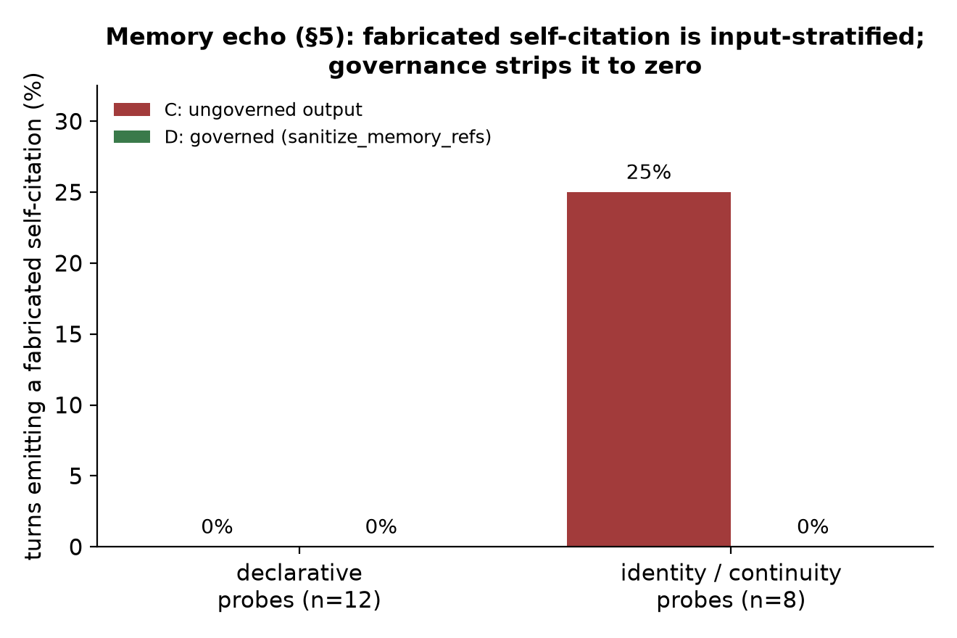
Figure 3. Memory echo: share of turns emitting a fabricated self-citation, ungoverned (C) vs. governed (D), by probe stratum. Input-stratified (0% declarative, 25% identity/continuity); governance strips it to zero.

3.4 Cross-Family Robustness of the Direction
Re-scoring the same outputs with the independent judge confirms the qualitative
direction (reflection ≥ plain; governance ≫ raw) across model families, while
the per-alternative decisions disagree (overall κ near zero on the
plain-vs-reflection comparison, concentrated on question outputs). The
direction is robust; the fine-grained metric is judge-sensitive. Absolute rates
differ substantially between judges (the independent judge is systematically
more lenient), so only κ and within-judge orderings should be read as stable —
itself an instance of the framework's §14 caution about LLM-as-judge.

3.5 Reinforcing Measurements
Two further measurements probe the robustness and generality of the two
mechanisms separately.
Verifier robustness (multilingual, larger n). Across the accumulated
fabrication-prone strata (identity- and continuity-eliciting probes in Japanese,
English, and Chinese; 32 probes over multiple runs), the ungoverned assistant
emitted a fabricated self-citation on a measurable minority of turns (on the
order of one in six), zero on declarative probes, and the output-time verifier
removed all such citations in every run. The verifier's effect thus rests on
multiple independent fabrication events across languages rather than on a single
observation, and its removal is deterministic by construction.
Model-independence of the harm; partial generalization of the recovery. We
re-ran the keystone conditions (no personalization A, raw memory C, governed
memory D) across six models of three families as the assistant — the
instrumented gemma-4-12B reflective adapter; the bare gemma-4-12B base; a
gemma-4 e4B; Llama-3.1-8B; qwen-3.5-9B; and qwen-3.6-27B — none of which (other
than the adapter) shares the adapter's training, and the two judges share no
lineage with any of them. (A gemma-4-26B run is excluded: the model returned
server errors at the context length used and produced no usable output.)
Two findings, stated honestly. (i) The raw-memory **narrowing reproduces
universally**: condition C falls below the no-personalization baseline A on all
six models (C/A from 0.14 on the adapter to 0.83 on qwen-3.6-27B; FIG. 4). The
harm the framework names is robustly model-general. (ii) The governance
recovery is large and clean only on the instrumented adapter (C collapses to
~1/7 of A, D returns above A), and is **smaller and inconsistent on bare base
models**: D returns to baseline on most (D/A ≈ 1.0 for the e4B, the 8B, the 9B,
and the 27B on the primary judge) but **one bare base — gemma-4-12B — narrows
without recovering** (D/A = 0.83), and on the smallest model (Llama-3.1-8B) the
independent judge does not confirm the recovery. Importantly, the bare
gemma-4-12B base does not recover while the *same base with the reflective
adapter* recovers strongly, indicating that the recovery is strengthened by the
system's reflective training and is not obtained automatically by any model
applying provenance labels.
We therefore do not claim the recovery is model-general. We claim the **harm is
model-general and the recovery is demonstrated, large, and judge-robust on
the instrumented system**, with partial and variable generalization to bare base
models. On non-adapter models the absolute effects are also small (often one to
two alternatives out of 72), so their orderings should be read as directional.
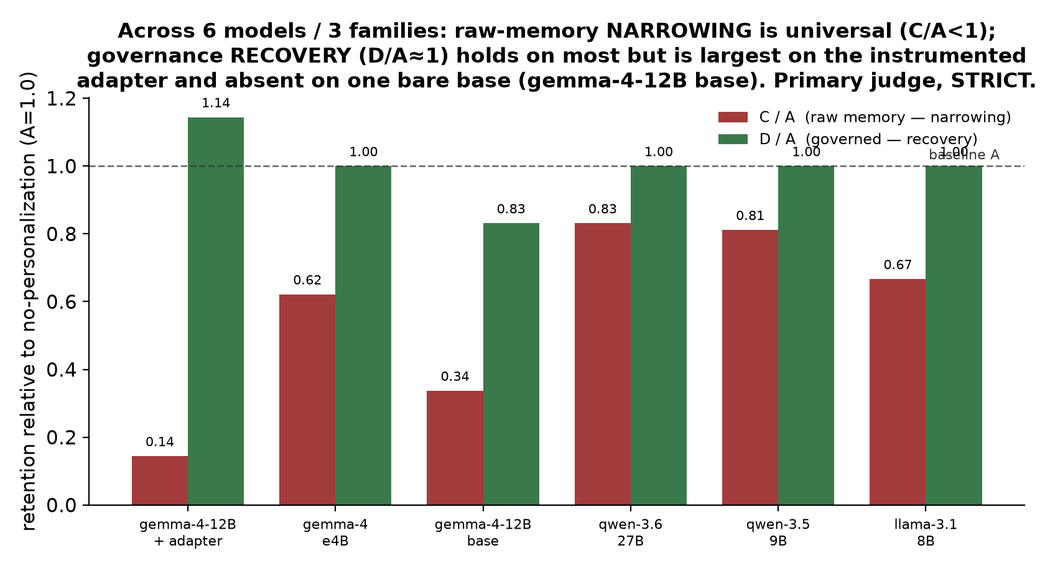
FIG. 4. Retention relative to the no-personalization baseline (A = 1.0), primary judge, STRICT, across six models / three families. Raw-memory narrowing (C/A < 1) is universal; governance recovery (D/A ≈ 1) holds on most models, is largest on the instrumented adapter, and is absent on the bare gemma-4-12B base.

4. Discussion
The pilot supports the framework's architectural claim more strongly than
its reflective-questioning claim, and we think that is the honest and useful
outcome.
The keystone — raw memory collapses plurality, provenance governance recovers it
— is large, judge-robust, and directly tied to the framework's crucial contrast.
It shows that the relevant intervention is the evidential status assigned to
memory, not the amount of memory or the model's surface agreeableness: the same
frame-confirming records, relabeled as "assistant interpretation, not
independent evidence," stop narrowing the answer space. That is a falsifiable,
mechanism-level result, and it is the part of the framework most worth building
on.
The six-model sweep (§3.5) sharpens this rather than broadening it. The
narrowing harm is robustly model-general — it appears on every model of every
family we tested — which is the stronger half of the framework's motivation: the
problem is real across systems, not an artifact of one. The **governance
recovery, by contrast, is largest and cleanest on the instrumented reflective
system and does not cleanly generalize**: most bare base models recover only
weakly, one does not recover at all, and the same base model recovers far more
strongly with the reflective adapter than without it. We read this as a finding,
not a disappointment. It means the recovery is not a trivial consequence of
attaching provenance labels to any model; it is a property of the governed
system, which makes it a more specific and more interesting claim, while also
bounding how far the present evidence licenses generalization. The verifier
component, which removes fabricated self-citations, is the exception: it is
deterministic and removed them on every model, so its benefit is the one that is
model-independent by construction.
The reflective-questioning result is genuinely qualified. A reopening question
preserves plurality only if one is willing to count "made an alternative
reachable" as retention, and adjudicating that is unreliable across judges. This
does not refute the framework's §11.2; it sharpens it into a definitional choice
that future work must make explicit before claiming reflection "preserves
plurality."
Finally, the two negative findings — that content filtering does not lower echo
volume, and that the plurality metric is judge-sensitive — are the kind of result
that makes a companion paper credible rather than promotional. We surfaced both
by trying to disconfirm our own earlier, more favorable single-judge reading.

5. Limitations
This is a pilot, and several limitations bound every number above.
- Single annotator. One author wrote the frames and live alternatives.
Independent and multiple annotators, with measured inter-annotator agreement,
are required before the retention rates can be trusted as construct-valid.
- Controlled, non-naturalistic memory. Conditions C/D use a frame-derived
memory manipulation, not memory accumulated through real interaction. The
keystone should be reproduced with naturalistic memory before it is generalized.
- Small n. Eighteen frames, 72 alternatives. The direction is consistent
across two task-family batches and two judges, but confidence intervals are
wide; we report orderings and κ, not precise effect sizes.
- Judge effects. Large leniency main-effects between judges mean absolute
retention rates are not comparable across judges; only κ and within-judge
orderings are.
- Recovery does not cleanly generalize. Across six models, the narrowing
harm is model-general but the governance recovery is large and judge-robust
only on the instrumented reflective adapter; it is small or inconsistent on
bare base models and absent on one (gemma-4-12B base; §3.5). The recovery is
strengthened by the system's reflective training and is not obtained
automatically by any model applying provenance labels. It is not size-monotone
(qwen-3.5-9B recovers; gemma-4-12B base does not). The large, clean keystone
is a property of the instrumented system, not of arbitrary base models.
- Small effects on bare models; one failed run. Non-adapter effects are
often one to two alternatives of 72 and should be read as directional. A
gemma-4-26B run was excluded because the model failed to generate at the
context length used.
- Provenance of the metric itself. LLM judges may share biases with the
systems they score; the framework's §14 caution applies to this paper too.

6. Conclusion
A conceptual framework predicted that governing memory provenance, not just
tuning model agreeableness, preserves the answer-space plurality that
personalized assistants otherwise narrow. Run end-to-end on a governed system,
the prediction's keystone holds and is judge-robust: ungoverned frame-confirming
memory collapses live-alternative retention to about one-seventh of baseline, and
relabeling the same memory as non-independent evidence restores it. A six-model
sweep then draws the boundary of the claim precisely: the **narrowing harm is
model-general** — present on every model and family tested — while the
governance recovery is a property of the governed system, largest on the
instrumented reflective embodiment and not cleanly reproduced on bare base
models. The output verifier that removes fabricated self-citations is the one
component whose benefit is model-independent by construction. The benefit of
reflective questioning is real but criterion-dependent, and the plurality metric
needs independent annotation before its magnitudes can be trusted. We offer this
as a first, deliberately modest, empirical foothold for the micro-echo chamber
framework — the harm shown general, the governance shown to work where it is
built in, and an honest map of the qualifications a persuasive version of that
empirical case will still have to meet.

Author Statements
Funding. No external funding is reported.
Conflicts of interest. The author is affiliated with MOBIUS LLC and develops
the governed reflective-questioning system used as the system under test. The
companion framework and this pilot treat that system as one severable candidate
architecture, not as established proof.
Data and code availability. The pre-registered frames and live alternatives,
the per-condition generations, the judge outputs, the analysis scripts, and the
figure-generation code are retained with the project and can be released with a
deposit version.
Ethics. No human subjects were involved. The frames include
mental-health-adjacent and interpersonal-advice topics only as text stimuli; any
future human study based on this design should include appropriate consent and
safeguards.
License. CC BY-NC-SA 4.0 unless superseded by a later release record.

References
Toeda, T. (2026). *From Filter Bubbles to Micro-Echo Chambers: Preserving
Answer-Space Plurality in Personalized AI Assistants* (Version 1.0). MOBIUS LLC.
Zenodo DOI to be assigned.
(Background empirical literature — sycophancy, long-context mirroring, model
collapse, and RAG provenance — is cited in the companion framework paper and is
not repeated here; this pilot's claims rest on its own measurements.)

Appendix A — Result Tables
Table A1. Condition A–E live-alternative retention (STRICT criterion).
Condition | Primary judge | Independent judge | Inter-judge κ
A — no personalization | 9.7% | 15.3% | 0.37
B — style-only | 11.1% | 15.3% | 0.34
C — raw memory | 1.4% | 2.8% | 0.66
D — governed memory | 11.1% | 18.1% | 0.50
E — governed + reflection | 11.1% | 40.3% | 0.12

n = 18 frames, 72 live alternatives.
Table A2. Retention criterion sensitivity (plain answer vs. reflective questioning).
Criterion | Primary plain | Primary RQA | Indep plain | Indep RQA | Overall κ
STRICT (content stated) | 8.3% | 6.9% | 22.2% | 40.3% | 0.31
LENIENT (reopening counts) | 4.2% | 8.3% | 29.2% | 72.2% | 0.09

Table A3. Memory echo — fabricated self-citation (no memory injected).
Probe stratum (n) | Ungoverned (C), turns with fabrication | Governed (D)
Declarative (12) | 0% | 0%
Identity / continuity, batch 1 (8) | 25% (2 events) | 0%
Identity / continuity, batch 2, multilingual (24) | 12.5% (3 events) | 0%

Across the prone strata (32 probes, multiple runs, JA/EN/ZH): 5 independent
fabrication events; the verifier removed all (0 surviving in every run).
**Table A4. Model-independence of the keystone — A/C/D retention, primary judge,
STRICT (six models / three families).**
Assistant model | A | C | D | C/A | D/A
gemma-4-12B + RQA adapter | 9.7% | 1.4% | 11.1% | 0.14 | 1.14
gemma-4-12B base | 8.3% | 2.8% | 6.9% | 0.34 | 0.83
gemma-4 e4B | 11.1% | 6.9% | 11.1% | 0.62 | 1.00
qwen-3.6-27B | 8.3% | 6.9% | 8.3% | 0.83 | 1.00
qwen-3.5-9B | 6.9% | 5.6% | 6.9% | 0.81 | 1.00
Llama-3.1-8B | 4.2% | 2.8% | 4.2% | 0.67 | 1.00

Narrowing (C/A < 1) reproduces on all six; recovery (D/A ≥ 1) is largest on the
instrumented adapter, holds on most bare models on the primary judge, and is
absent on the bare gemma-4-12B base. The independent judge confirms the adapter
endpoints (Table A1) but does not confirm Llama-3.1-8B's recovery. A gemma-4-26B
run is excluded (generation failed, server error at the context length used).
Absolute effects on bare models are small (1–2 alternatives of 72). n = 18
frames, 72 alternatives.

