Step 1:
Sample data frame:

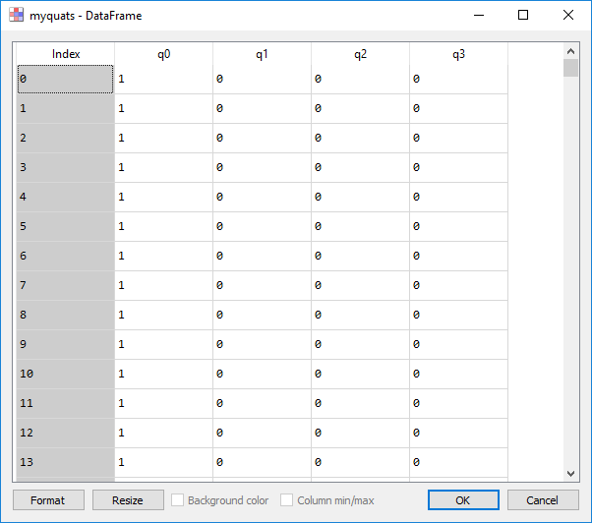
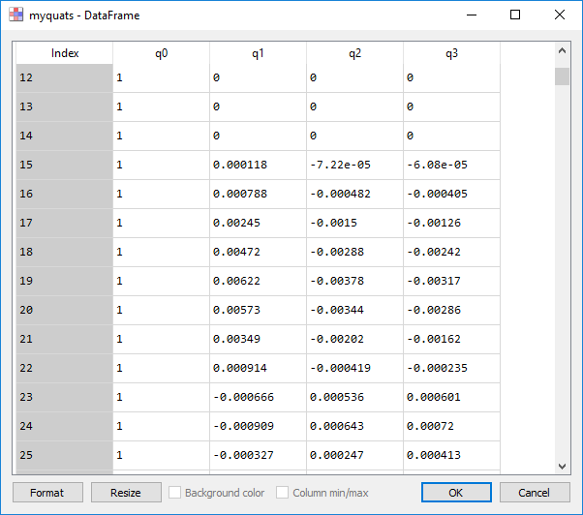

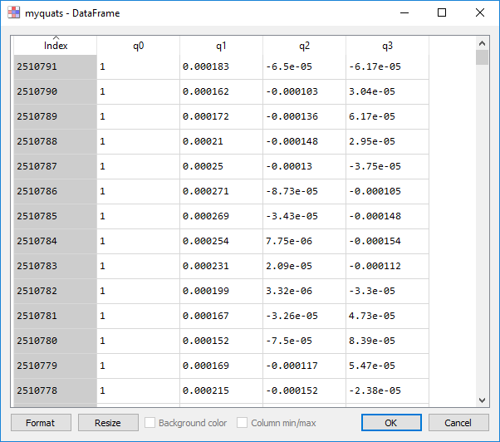
Step 2:
I am trying to load this dataframe values into quaternion array using df.values

import numpy as np
import quaternion as quat
import pandas as pd
del_q = quat.as_quat_array(myquats.values)

as_quat_array works fine but the problem is its working in other way.

From the first few screenshots we know that the first quaternion set is to quaternion(1,0,0,0) but here its quaternion(1,1,1,1).

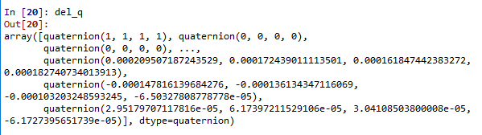

But if I use the same ‘quat.as_quat_array’ for some reduced length I am to convert it as a quaternion array.
For eg:
del_q = quat.as_quat_array(myquats[:20000].values)
here I am converting first 20000 values
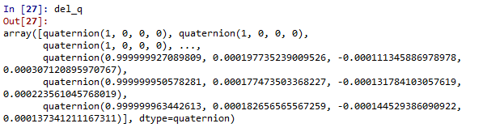

In this case the function works as expected.

