Mobotic MoboTerra— ROS 2 Jazzy
ROS 2 architecture deployment and user manual
Architecture summary. The platform uses a central supervisor to select which control source is active. Manual and autonomous velocity commands are sent through the kinematics node, which converts vehicle motion into wheel and steering setpoints. In autonomous direct-control mode, joint setpoints can be sent from the supervisor directly to the hardware driver. The driver executes the commands and publishes the actual hardware feedback.
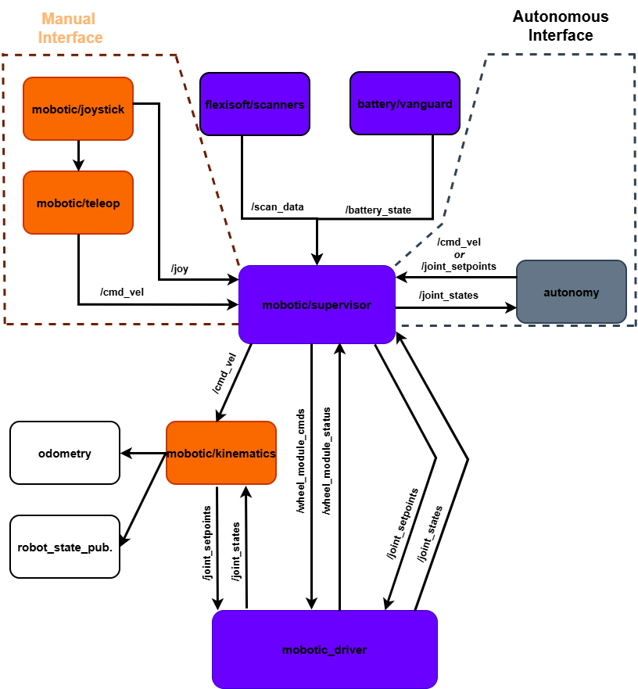
Figure 1. Current architecture diagram.

1. Architecture overview
Manual mode: joystick → teleoperation → supervisor → kinematics → mobotic_driver.
Autonomous velocity mode: autonomy → supervisor → kinematics → mobotic_driver.
Autonomous direct-control mode: autonomy → supervisor → mobotic_driver.
Feedback: mobotic_driver publishes the actual steering and traction states on /joint_states. Kinematics, supervisor, autonomy and robot_state_publisher use this feedback.

2. Nodes and ROS 2 interfaces
The following descriptions show what each node does and how it exchanges data with the other nodes.

2.1. mobotic/joystick
The joystick node is the interface to the physical REMdevice joystick. It reads the proportional joystick axes and the digital buttons/switches received from the joystick CANopen receiver.
Subscribes: No ROS 2 topic from another node; the input comes from the joystick receiver over CANopen.
Publishes: /joy to mobotic/teleop and mobotic/supervisor. Teleop uses the joystick axes and manual-control buttons, while the supervisor uses operator requests such as the Manual/Auto mode switch.
Result: The operator controls are available in ROS 2 as one joystick input. Safety actions such as the emergency stop and Safety Enable/Disable remain implemented outside ROS.

2.2. mobotic/teleop
The teleoperation node converts the manual joystick inputs into vehicle motion commands. The main joystick commands crab motion (longitudinal and lateral translation without changing yaw), while the steering joystick commands Ackermann turning. B1 is used as the manual-mode boost input.
Subscribes: /joy from mobotic/joystick.
Publishes: /cmd_vel to mobotic/supervisor.
Result: /cmd_vel describes the requested movement of the complete vehicle in manual mode. The speed scaling is increased while B1 boost is active, without bypassing configured platform or safety limits.

2.3. flexisoft/scan_data (/robot_states and /safety_io)
This node is the software interface to the Flexi Soft. Safety Enable/Disable and the emergency-stop function are not commanded by ROS; ROS only receives their state for monitoring and command gating.
Subscribes: No ROS 2 topic from another node; the node receives its information from the scanner / safety hardware.
Publishes: /robot_states and /safety_io to mobotic/supervisor.
Result: Scanner and safety status is available to the supervisor. If the safety system disables motion, the ROS software must recognize the state and must not attempt to re-enable the drives.

2.4. battery/vanguard
This node is the interface to the Vanguard battery and BMS.
Subscribes: No ROS 2 topic from another node; the node reads the battery system directly.
Publishes: /battery_state to mobotic/supervisor.
Result: Battery information is available to the supervisor for monitoring and system handling.

2.5. autonomy
The autonomy node creates motion commands when the platform is operating autonomously. It can control the vehicle through a vehicle velocity command or through direct joint setpoints.
Subscribes: /joint_states from mobotic_driver for actual steering and traction feedback. It can also use /odom from the odometry node when vehicle position and velocity feedback are required.
Publishes: /cmd_vel to mobotic/supervisor for velocity-based autonomous driving, or /joint_setpoints to mobotic/supervisor for direct joint control.
Result: The supervisor receives the autonomous command and forwards it through the control path that is active.

2.6. mobotic/supervisor
The supervisor is the central control and routing node. It selects manual or autonomous operation, monitors platform status, handles the RP1 mode request and forwards only commands that belong to the active mode. If a mode change is requested while the vehicle is moving, the supervisor first commands a controlled stop, waits for measured vehicle speed to reach zero, and then completes the mode change.
Subscribes: /joy from mobotic/joystick; /cmd_vel from mobotic/teleop or autonomy; /joint_setpoints from autonomy; /battery_state from battery/vanguard; /scan_data from flexisoft/scanners; /joint_states and /wheel_module_status from mobotic_driver.
Publishes: /cmd_vel to mobotic/kinematics for velocity-based control; /joint_setpoints to mobotic_driver for autonomous direct control; /wheel_module_cmds to mobotic_driver when module-level commands are required.
Result: Only the selected command path controls the platform. Manual and autonomous commands are not applied at the same time, and a mode transition is completed only after the vehicle has stopped.

2.7. mobotic/kinematics
The kinematics node converts the requested motion of the complete platform into individual steering and traction commands. It also calculates vehicle movement from the measured wheel and steering feedback.
Subscribes: /cmd_vel from mobotic/supervisor and /joint_states from mobotic_driver.
Publishes: /joint_setpoints to mobotic_driver. It also passes the calculated vehicle-motion information to the odometry node.
Result: A vehicle-level velocity request is converted into commands that can be executed by the individual wheel modules.

2.8. mobotic_driver
The driver is the low-level interface to the physical steering and traction units. It communicates with the motor controllers, executes the requested setpoints, reads the actual hardware state and performs low-level CAN actions such as clearing steering or traction controller errors.
Subscribes: /joint_setpoints from mobotic/kinematics during velocity-based control or from mobotic/supervisor during autonomous direct control. It also receives /wheel_module_cmds from the supervisor when used.
Publishes: /joint_states for kinematics, supervisor, autonomy and robot_state_publisher, and /wheel_module_status to mobotic/supervisor.
Result: The physical steering and traction units are controlled and their measured state is returned to the ROS 2 system. In autonomous direct-control mode, traction can be operated with velocity or current setpoints. A B2 clear-error request is handled through the supervisor/driver path and is translated by mobotic_driver into the required CAN command.

2.9. odometry
The odometry node provides the estimated movement of the complete vehicle. The estimate is based on the motion calculated from steering and traction feedback.
Subscribes: Calculated vehicle-motion information from mobotic/kinematics.
Publishes: /odom with the vehicle position, orientation and velocity, and /vehicle as the project vehicle-state output. It also publishes the vehicle pose transform odom → vehicle.
Result: Other parts of the system can determine where the vehicle is relative to its odometry start point and how it is currently moving.

2.10. robot_state_publisher
This node combines the robot model (URDF) with the measured joint positions to describe the position of the robot's links and moving parts.
Subscribes: /joint_states from mobotic_driver.
Publishes: /tf and /tf_static with the transforms between the robot links.
Result: The rest of the ROS 2 system can determine the position and orientation of the vehicle parts relative to each other.

3. Manual joystick interface
The REMdevice joystick is used for local manual control of MoboTerra. mobotic/joystick reads the joystick receiver over CANopen and makes the operator controls available to the ROS 2 software. Motion commands are processed by teleop/supervisor, while safety functions remain in the independent Flexi Soft safety chain.
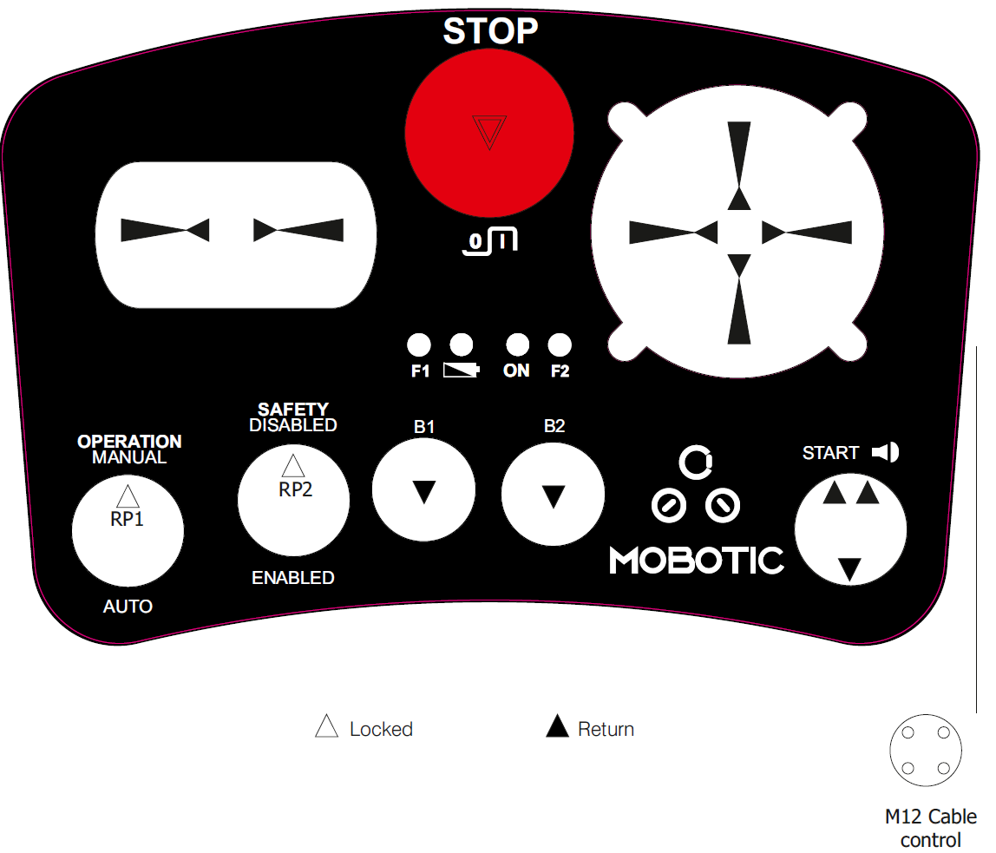
Figure 2. Manual joystick controls.
CANopen input: the REMdevice receiver provides digital buttons/status in TPDO1 and proportional joystick values in TPDO2. The default event timer is 50 ms. mobotic/joystick converts these CANopen values into the ROS 2 joystick input.

Joystick control functions
Control | Vehicle function | ROS / software behavior
Main joystick  (top right) | Crab translation: forward/backward = longitudinal motion; left/right = lateral motion, yaw stays unchanged. | teleop converts the axes into longitudinal and lateral vehicle velocity. This joystick does not add a yaw command.
Steering joystick | Ackermann steering: left/right input commands a turning motion and changes vehicle yaw. | teleop creates the turning command; kinematics calculates the individual steering and traction setpoints.
RP1  Manual / Auto | Requests Operation Manual or Auto. | If the vehicle is moving, supervisor commands a controlled stop, waits for measured speed = 0, then changes mode.
Safety Enable / Disable  (RP2) | Enables/disables the safety function through Flexi Soft. | Direct Flexi Soft function, not controlled by ROS. ROS only monitors the safety state and blocks motion when safety is disabled.
B1  Boost | Temporary manual speed boost. | teleop applies a higher configured manual speed scale while B1 is active. Safety and platform limits remain active.
B2  Clear errors | Clears/reset steering and traction MCU errors. | The request is forwarded to mobotic_driver, which sends the required clear/reset command over CAN.
STOP  Emergency stop | Emergency stop; disables all drives independently of ROS. | Hardware/Flexi Soft performs the stop. ROS monitors the active E-stop state and prevents motion while it is active.

4. Command routing and mode conditions
Manual | /joy → teleop → /cmd_vel → supervisor → kinematics → /joint_setpoints → driver
Autonomous, velocity | autonomy /cmd_vel → supervisor → kinematics → /joint_setpoints → driver
Autonomous, direct | autonomy /joint_setpoints → supervisor → driver
Mode switching | RP1 requests Manual/Auto. If the vehicle is moving, the supervisor commands a controlled stop, waits until measured speed is zero, then changes mode.

5. Earlier ROS 2 topic proposal
Topic / service | Type | Data flow | Small description
/joy | sensor_msgs/msg/Joy | mobotic/joystick → teleop, supervisor | Raw joystick axes and buttons.
/vehicle/cmd_vel | geometry_msgs/msg/Twist | supervisor → kinematics | The velocity command selected and allowed by the supervisor.
/kinematics/joint_setpoints | custom joint-setpoint message | kinematics → supervisor | Steering and traction setpoints calculated from /vehicle/cmd_vel.
/wheel_modules/command | custom wheel-module command | supervisor → mobotic_driver | Single final command interface to the hardware driver. Contains steering and traction targets.
/joint_states | sensor_msgs/msg/JointState | mobotic_driver → kinematics or supervisor | Measured steering and traction joint state. One authoritative feedback topic.
/wheel_modules/status | custom aggregated status message | mobotic_driver → supervisor | Per-module ready state, control mode and hardware status in one message instead of many small topics.
/odom | nav_msgs/msg/Odometry | odometry → autonomy | Vehicle position, orientation and velocity. A separate /vehicle/velocity topic is not needed.
/battery_state | sensor_msgs/msg/BatteryState | battery/vanguard → supervisor | Battery voltage, current, charge level, temperature and related battery state in one message.
/safety/robot_state  /safety/safety_io | custom aggregated safety message | flexisoft/scanners → supervisor, customer | Read-only safety status from Flexi Soft, including E-stop/STO, protective-field state and motion permission. ROS monitors this state but does not enable/disable the safety chain.
/scan (optional) | sensor_msgs/msg/LaserScan | scanner interface → navigation/customer | Actual laser range measurements, only if they are required outside the safety system.
/vehicle/mode | custom mode message | supervisor → autonomy, customer | Current operating mode, e.g. manual, autonomous velocity or autonomous direct control.
/vehicle/set_mode | custom ROS 2 service | operator/autonomy → supervisor | Requests Manual/Auto mode change. If the vehicle is moving, the supervisor first stops the platform, waits for zero measured speed, then completes the change.
/diagnostics | diagnostic_msgs/msg/DiagnosticArray | driver, battery and safety nodes → customer/diagnostic tools | Common place for warnings and faults instead of separate error topics for every component.
/tf, /tf_static | TF messages | odometry + robot_state_publisher → ROS 2 system | Coordinate transforms for the vehicle and its links.
/wheel_modules/  clear_errors | std_srvs/srv/Trigger | supervisor → mobotic_driver | Triggered by B2. Requests mobotic_driver to send the CAN clear/reset-error command to the steering and traction MCUs.

6. Docker container deployment
The MoboTerra deployment packages the ROS 2 Jazzy hardware stack for a supported ARM64 PC running Ubuntu 24.04. It builds versioned runtime and GUI images, installs a host supervisor, and starts the robot software automatically after boot when both configured USB-to-CAN adapters are available and healthy.

6.1. What the deployment does
The host, not the container, configures CAN and controls the container lifecycle. Each adapter is selected by its unique USB serial number, so Linux discovery order does not change its role. After both adapters remain present for the debounce interval, the supervisor assigns the interfaces as follows.
Adapter role | Linux interface | CAN settings
Platform | can0 | 500000 bit/s; automatic bus-off restart
Battery | can1 | 500000 bit/s; listen-only

The supervisor starts the ROS container only after both interfaces are configured. Adapter loss stops the complete stack; reconnection triggers fresh CAN configuration and a clean ROS launch. Persistent platform bus-off also causes bounded recovery. Existing ROS supervision rejects stale motion data, so a new operator or autonomy command is required after readiness returns.
Container isolation: The headless runtime uses host networking but runs as a non-root user with a read-only root filesystem. It is not privileged and has no NET_ADMIN capability. Docker restart policies are disabled because moboterra-supervisor.service is the single lifecycle owner.

6.2. Requirements
- ARM64 computer with Ubuntu 24.04. The current release does not run as-is on an x86-64 or amd64 PC.
- Two SocketCAN-compatible USB-to-CAN adapters with different ID_SERIAL_SHORT values.
- Internet access during installation to download Docker, ROS 2 Jazzy and build dependencies.
- Platform and battery CAN buses configured for 500000 bit/s.
- Scanner and safety Ethernet settings prepared separately; the installer does not change host Ethernet or safety wiring.
- The platform secured against unintended movement before installation and commissioning.

6.3. Guided installation
- Copy or clone the MoboTerra repository to the target computer and open a terminal in the repository root.
- Disconnect both robot USB-to-CAN adapters and any other serial-numbered CAN adapters.
- Start the guided installer.
sudo bash ./deploy/install.sh
- When prompted for the platform adapter, connect only that adapter and press Enter. The installer records its unique USB serial number.
- Disconnect the platform adapter. When prompted for the battery adapter, connect only the battery adapter and press Enter.
- After image build and tests complete, connect both configured adapters and press Enter. The installer enables the host service, configures can0 and can1, and waits for the required ROS processes.
- Confirm the installation state.
moboterra-ctl status
moboterra-ctl can
moboterra-ctl logs --lines 200
A successful installation reports the ROS processes /moboterra/mobotic_supervisor and /moboterra/platform_diagnostics. The service is enabled for later boots; if an adapter is missing, it waits with ROS stopped instead of starting a partial system.

6.4. Automated installation and configuration
For unattended provisioning, supply both adapter serials and the ROS domain ID.
sudo bash ./deploy/install.sh \
--platform-serial PLATFORM_SERIAL \
--battery-serial BATTERY_SERIAL \
--ros-domain-id 42
Use --no-start to build and install before the hardware is available. Installed settings are stored in /etc/moboterra/moboterra.env. Assign a different ROS_DOMAIN_ID to robots that share a network, and do not store credentials in this file.
PLATFORM_CAN_SERIAL=...
BATTERY_CAN_SERIAL=...
CAN_BITRATE=500000
ROS_DOMAIN_ID=42

6.5. Daily operation and adapter replacement
Command | Purpose
moboterra-ctl status | Show the systemd supervisor and container state.
moboterra-ctl can | Show adapter identity and detailed can0/can1 status.
moboterra-ctl logs --follow | Follow live supervisor and container logs.
sudo moboterra-ctl restart | Revalidate configuration and restart the supervised stack.
sudo moboterra-ctl rollback | Exchange the current and previous versioned releases, then restart.

Optional desktop tools can be started from an X11 or XWayland session.
moboterra-gui rviz2
moboterra-gui rqt
To replace one or both USB-to-CAN adapters, return to the repository root and run the installer with --reconfigure-can. Follow the same one-adapter-at-a-time identification sequence, then reconnect both adapters.
sudo bash ./deploy/install.sh --reconfigure-can

6.6. Troubleshooting and safety
- If the system waits for CAN, run moboterra-ctl can and moboterra-ctl logs --lines 200. Verify that both configured serial numbers are present and that no unrelated interface already uses can0 or can1.
- If both adapters report the same ID_SERIAL_SHORT, or neither reports a serial, the deployment cannot distinguish their roles and intentionally refuses to start. Use adapters with different firmware serial numbers; this deployment has no automatic physical-port fallback.
- If the platform CAN interface remains BUS-OFF, inspect CAN wiring, termination, controller power and bitrate before restarting the supervisor.
- Configure the scanner and safety Ethernet interface separately and validate it on the secured machine.
Safety: ROS monitoring and the Docker supervisor are not safety-rated. The independent emergency stop, brake and FlexiSoft safety chain remain responsible for physical safety. Complete the documented boot, disconnect, bus-off, stale-data and soak tests before operating the platform.

7. Current ROS 2 user manual
This section describes the current interfaces implemented by the default hardware launch in the /moboterra namespace. It supersedes the earlier proposal table in Section 5 for day-to-day operation. Standard ROS topics such as /rosout and /parameter_events are omitted from the reference tables.

7.1. Accessing ROS tools in the container
First confirm that the supervised container is running from the Ubuntu host.
moboterra-ctl status
moboterra-ctl can
Open an interactive shell in the running robot container, then source ROS 2 Jazzy and the installed MoboTerra workspace. Run all ros2 CLI examples in the remainder of this manual from this shell unless a command is marked as a host command.
sudo docker exec -it moboterra-robot bash
source /opt/ros/jazzy/setup.bash
source /opt/moboterra/setup.bash
ros2 node list
To view the live ROS graph from the Ubuntu desktop, leave the robot container running and execute this command on the host.
moboterra-gui rqt_graph
In rqt_graph select Nodes/Topics (all) and clear Hide leaf topics. External autonomy nodes appear only when they are running. Services are not displayed by rqt_graph; inspect them with ros2 service list -t.

7.2. Current ROS graph
The diagram below is generated from the current default hardware launch and source interfaces. It is an implementation reference, not a captured live hardware session; use the command in Section 7.1 to verify the running target.
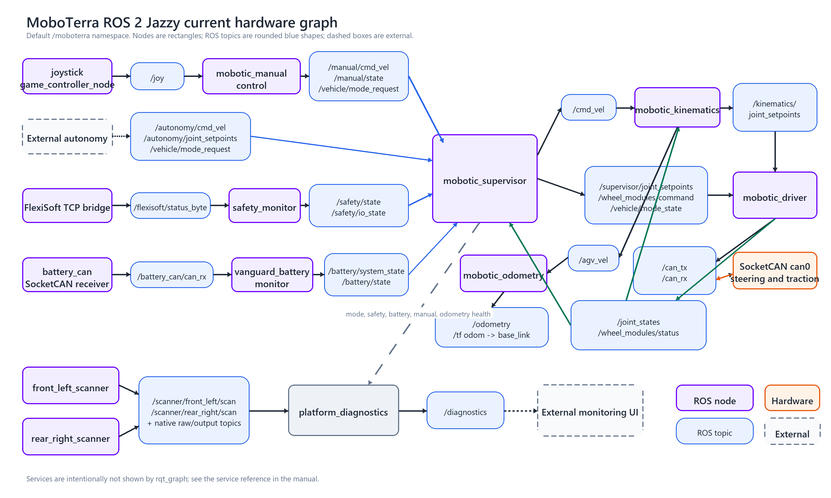
Figure 3. Current default hardware node and topic graph.

7.3. Default hardware nodes
Node | Package | User purpose
/moboterra/joystick | joy | Reads the temporary F310/F710 gamepad and publishes /joy.
/moboterra/mobotic_manual_control | mobotic_manual_control | Converts joystick input to manual velocity, source state and mode requests.
Drive SocketCAN receiver and sender | ros2_socketcan | Bridge can0 to /can_rx and /can_tx. Exact external-package node names must be verified in the live graph.
/moboterra/mobotic_driver | mobotic_driver | Controls four steering and four traction axes; publishes joint and module feedback.
/moboterra/mobotic_kinematics | mobotic_kinematics | Converts supervised body velocity to eight joint targets and measured joints back to body velocity.
/moboterra/mobotic_odometry | mobotic_odometry | Integrates measured agv_vel into wheel odometry and optional odom to base_link TF.
/moboterra/mobotic_supervisor | mobotic_supervisor | Selects one command source and gates motion using safety, battery and drive readiness.
/moboterra/flexisoft_tcp_bridge | mobotic_safety | Receives the FlexiSoft TCP telegram and publishes raw status.
/moboterra/safety_monitor | mobotic_safety | Decodes safety state and conservative ROS motion permission.
Battery SocketCAN receiver | ros2_socketcan | Receives can1 under /moboterra/battery_can. No battery sender is launched.
/moboterra/vanguard_battery_monitor | mobotic_vanguard_battery | Publishes public battery telemetry and aggregate readiness.
/moboterra/front_left_scanner | sick_safetyscanners2 | Publishes front scan and vendor auxiliary data.
/moboterra/rear_right_scanner | sick_safetyscanners2 | Publishes rear scan and vendor auxiliary data.
/moboterra/platform_diagnostics | mobotic_bringup | Aggregates platform, scanner, mode, manual, safety, battery and odometry health.

Optional branches: External autonomy is not included in this repository. robot_state_publisher is available through the separate mobotic_description launch. The virtual profile replaces physical CAN, safety and battery boundaries with protocol simulators and mock readiness; it is not a physical simulator.

8. ROS topic reference

8.1. Motion mode and feedback topics
Topic | Type | Flow | User meaning
/moboterra/joy | sensor_msgs/msg/Joy | joystick -> manual control | Raw gamepad axes and buttons.
/moboterra/manual/cmd_vel | geometry_msgs/msg/TwistStamped | manual control -> supervisor | Candidate manual body velocity in base_link.
/moboterra/manual/state | mobotic_interfaces/msg/ManualControlState | manual control -> supervisor | Connected and active manual-source state.
/moboterra/autonomy/cmd_vel | geometry_msgs/msg/TwistStamped | external autonomy -> supervisor | Candidate autonomous body velocity in base_link.
/moboterra/autonomy/joint_setpoints | sensor_msgs/msg/JointState | external autonomy -> supervisor | Complete eight-joint candidate for AUTO_DIRECT.
/moboterra/vehicle/mode_request | mobotic_interfaces/msg/VehicleModeRequest | manual or operator -> supervisor | Timestamped MANUAL or AUTO_VELOCITY request.
/moboterra/vehicle/mode_state | mobotic_interfaces/msg/VehicleModeState | supervisor -> system | Authoritative mode, transition and motion-permitted state.
/moboterra/cmd_vel | geometry_msgs/msg/TwistStamped | supervisor -> kinematics | Selected and safety-gated velocity.
/moboterra/kinematics/joint_setpoints | sensor_msgs/msg/JointState | kinematics -> driver | Joint targets for MANUAL and AUTO_VELOCITY.
/moboterra/supervisor/joint_setpoints | sensor_msgs/msg/JointState | supervisor -> driver | Validated direct targets for AUTO_DIRECT.
/moboterra/wheel_modules/command | mobotic_interfaces/msg/WheelModuleCommand | supervisor -> driver | Global enable and clear-error management; never motion.
/moboterra/wheel_modules/status | mobotic_interfaces/msg/WheelModuleStatusArray | driver -> supervisor | Per-module readiness, feedback freshness and faults.
/moboterra/joint_states | sensor_msgs/msg/JointState | driver -> kinematics and supervisor | Measured eight-joint feedback using oldest required sample time.
/moboterra/agv_vel | geometry_msgs/msg/TwistStamped | kinematics -> supervisor and odometry | Measured planar body velocity for standstill and odometry.

8.2. CAN safety and battery topics
Topic | Type | Flow | User meaning
/moboterra/can_rx | can_msgs/msg/Frame | SocketCAN -> driver | Timestamped drive CAN input, including configured error frames.
/moboterra/can_tx | can_msgs/msg/Frame | driver -> SocketCAN | Drive requests, commands and CANopen SYNC.
/moboterra/battery_can/can_rx | can_msgs/msg/Frame | battery receiver -> monitor | Read-only extended J1939 battery traffic.
/moboterra/flexisoft/status_byte | std_msgs/msg/UInt8 | TCP bridge -> safety monitor | Configured byte from each complete FlexiSoft telegram.
/moboterra/flexisoft/telegram | std_msgs/msg/UInt8MultiArray | TCP bridge -> monitoring | Complete received FlexiSoft telegram.
/moboterra/safety/state | mobotic_interfaces/msg/SafetyState | safety monitor -> supervisor | High-level ROS motion permission and stop states.
/moboterra/safety/io_state | mobotic_interfaces/msg/SafetyIOState | safety monitor -> supervisor | Decoded fields, known flags and raw safety byte.
/moboterra/battery/state | sensor_msgs/msg/BatteryState | battery monitor -> users | Single public battery telemetry message.
/moboterra/battery/system_state | mobotic_interfaces/msg/BatterySystemState | battery monitor -> supervisor | Aggregate communication, readiness, HV and minimum SOC.

8.3. Odometry scanner diagnostics and optional description
Topic | Type | Flow | User meaning
/moboterra/odometry | nav_msgs/msg/Odometry | odometry -> users | Measured wheel pose, twist and covariance in odom.
/moboterra/tf | tf2_msgs/msg/TFMessage | odometry and optional description -> users | odom to base_link plus moving joint transforms when description is running.
/moboterra/tf_static | tf2_msgs/msg/TFMessage | optional description -> users | Fixed robot and nominal scanner transforms.
/moboterra/robot_description | std_msgs/msg/String | optional description -> users | Expanded URDF for RobotModel tools.
/moboterra/scanner/front_left/scan | sensor_msgs/msg/LaserScan | front scanner -> diagnostics or autonomy | Front laser ranges.
/moboterra/scanner/rear_right/scan | sensor_msgs/msg/LaserScan | rear scanner -> diagnostics or autonomy | Rear laser ranges.
scanner/*/raw_data | sick_safetyscanners2_interfaces/msg/RawMicroScanData | scanner -> users | Vendor decoded measurement and device data.
scanner/*/output_paths | sick_safetyscanners2 vendor message | scanner -> users | Vendor output-path state.
scanner/*/extended_laser_scan | sick_safetyscanners2 vendor message | scanner -> users | Vendor extended laser output when configured.
/moboterra/diagnostics | diagnostic_msgs/msg/DiagnosticArray | driver, scanners, odometry and platform diagnostics -> users | Shared health information; no control authority.

8.4. Interpreting the main status messages
Message | Important fields | How the user should read it
VehicleModeState | current_mode, requested_mode, transition_in_progress, motion_permitted, status_message | Use this as the authoritative operating-mode state.
WheelModuleStatusArray | name, enabled, feedback_fresh, control_mode, error_code | Every configured module must have fresh, enabled and fault-free feedback for motion.
SafetyState | communication_ok, system_ready, motion_permitted, stop and warning flags | ROS monitoring result; not the safety-rated stop path.
SafetyIOState | E-stop, safety enable, STO known flags, field clear states, raw byte | Unknown STO or enable mappings are reported explicitly.
BatterySystemState | communication_ok, system_ready, high_voltage_connected, minimum_percentage | Minimum percentage is a fraction; 0.2 means 20 percent.
ManualControlState | connected, command_active, turbo_active, status_message | Manual mode requires a fresh connected and active source.

9. Services and operating modes

9.1. Operating modes
ID | Mode | Selected source | Use
0 | MANUAL | manual/cmd_vel | Temporary gamepad Back toggle or vehicle/set_mode. Requires fresh active manual source.
1 | AUTO_VELOCITY | autonomy/cmd_vel | External autonomy sends body velocity in base_link. Supervisor sends cmd_vel to kinematics.
2 | AUTO_DIRECT | autonomy/joint_setpoints | Service request only. Requires a complete eight-joint command and fresh feedback.

Every mode request first blocks candidate commands, stops the active path and verifies sustained standstill. The timeout is 10 seconds. A successful switch clears buffered commands, so a newly timestamped source command is required before motion can resume.

9.2. Service reference
Service | Type | Purpose and limitation
/moboterra/vehicle/set_mode | mobotic_interfaces/srv/SetVehicleMode | Request mode 0, 1 or 2 through the supervisor transition state machine.
/moboterra/initialize_all_drives | std_srvs/srv/Trigger | Commissioning operation that initializes every drive.
/moboterra/enable_all_drives | std_srvs/srv/Trigger | Enable every drive; a fresh supervisor enable lease is still required.
/moboterra/disable_all_drives | std_srvs/srv/Trigger | Stop and disable every drive. This is not persistent while a ready supervisor requests enable.
/moboterra/clear_errors | std_srvs/srv/Trigger | Clear errors on all steering and traction controllers after the cause is removed.
/moboterra/odometry/reset | std_srvs/srv/Trigger | Reset local wheel-odometry origin only with fresh measured standstill.

9.3. Mode and service commands
Request and observe modes from the container ROS shell.
# 0 = MANUAL, 1 = AUTO_VELOCITY, 2 = AUTO_DIRECT
ros2 service call /moboterra/vehicle/set_mode \
mobotic_interfaces/srv/SetVehicleMode "{requested_mode: 0}"
ros2 topic echo /moboterra/vehicle/mode_state
Clear drive faults or reset odometry only on a secured, stationary platform after checking the cause and the independent safety chain.
ros2 service call /moboterra/clear_errors std_srvs/srv/Trigger "{}"
ros2 service call /moboterra/odometry/reset std_srvs/srv/Trigger "{}"
The following driver services are commissioning tools, not the normal operator control path. Manual disable can be overwritten by the next ready supervisor cycle.
ros2 service call /moboterra/initialize_all_drives std_srvs/srv/Trigger "{}"
ros2 service call /moboterra/enable_all_drives std_srvs/srv/Trigger "{}"
ros2 service call /moboterra/disable_all_drives std_srvs/srv/Trigger "{}"

10. Operator procedures

10.1. Start and pre-operation check
1. Secure the platform against unintended movement and verify the hardware emergency-stop and brake chain.
2. Connect both configured USB-to-CAN adapters, FlexiSoft Ethernet, scanner Ethernet, battery CAN and the gamepad when manual mode is required.
3. Start the supervised stack and verify that can0 is active and can1 is active in listen-only mode.
4. Confirm the container is healthy and the mode, safety, battery, wheel-module and diagnostics topics are updating without ERROR status.
5. Release the secured test condition only after commissioning checks for the installed machine have passed.
sudo moboterra-ctl start
moboterra-ctl status
moboterra-ctl can
moboterra-ctl logs --lines 200

10.2. Inspect the live ROS interfaces
ros2 node list
ros2 topic list -t
ros2 service list -t
ros2 node info /moboterra/mobotic_supervisor
ros2 node info /moboterra/mobotic_driver
ros2 interface show mobotic_interfaces/srv/SetVehicleMode

10.3. Monitor readiness and faults
ros2 topic echo /moboterra/vehicle/mode_state
ros2 topic echo /moboterra/manual/state
ros2 topic echo /moboterra/safety/state
ros2 topic echo /moboterra/safety/io_state
ros2 topic echo /moboterra/battery/system_state
ros2 topic echo /moboterra/wheel_modules/status
ros2 topic echo /moboterra/diagnostics
Use topic rate checks to distinguish a present topic from a live data stream.
ros2 topic hz /moboterra/joint_states
ros2 topic hz /moboterra/agv_vel
ros2 topic hz /moboterra/odometry
ros2 topic hz /moboterra/scanner/front_left/scan
ros2 topic hz /moboterra/scanner/rear_right/scan

10.4. Optional description and visualization
The robot description is not part of the default bringup. Start it as an additional process in the running robot container, then launch RViz on the host. The detached process ends when the container stops.
sudo docker exec -d moboterra-robot bash -lc \
'source /opt/ros/jazzy/setup.bash && \
source /opt/moboterra/setup.bash && \
ros2 launch mobotic_description description.launch.py robot_name:=moboterra'
moboterra-gui rviz2 --ros-args \
-r /tf:=/moboterra/tf -r /tf_static:=/moboterra/tf_static
In RViz choose base_link for the stationary robot model or odom to include measured wheel motion. Use /moboterra/robot_description for RobotModel. The current scanner transforms are nominal CAD/manufacturer values and still require physical calibration.

10.5. Stop restart and rollback
sudo moboterra-ctl stop
sudo moboterra-ctl start
sudo moboterra-ctl restart
sudo moboterra-ctl rollback
Adapter loss automatically stops the ROS container. When both configured adapters return, the host supervisor configures CAN and starts a clean ROS session. The previous motion command is not replayed.

11. Troubleshooting the ROS system
Symptom | Check and response
rqt_graph is empty or incomplete | Confirm the container is running, use the configured ROS_DOMAIN_ID, select Nodes/Topics (all), clear Hide leaf topics, and remember that external autonomy appears only while running.
A service is not found | Run ros2 service list -t inside the robot container and use the full /moboterra namespace. Check logs for a node that failed or is restarting.
Drives enable but motion is blocked | Check vehicle/mode_state.motion_permitted, safety/state, safety/io_state, battery/system_state, wheel_modules/status.feedback_fresh and the selected source state.
Motion does not resume after recovery | This is expected. Send a newly timestamped command from the selected source after readiness returns or after a mode transition completes.
AUTO_DIRECT request is rejected | Use vehicle/set_mode service for mode 2. The mode_request topic accepts only MANUAL and AUTO_VELOCITY. Direct commands must contain all eight configured joints.
No scanner data | Verify the PC NIC and scanner addresses, then check both scan topic rates. Scanner loss raises diagnostics but protective-field safety remains in FlexiSoft.
No odometry | Check joint_states and agv_vel rates. Odometry stops publishing on measured-feedback loss and does not integrate through the gap.
Services do not appear in rqt_graph | This is normal. rqt_graph displays topic connections, not the service reference. Use ros2 service list -t.

12. User safety and interface limits
- ROS monitoring, the Docker supervisor and rqt tools are not safety-rated. The emergency stop, STO, brakes and FlexiSoft chain remain the physical safety path.
- Do not publish motion directly to driver-internal topics. External autonomy must use autonomy/cmd_vel or autonomy/joint_setpoints through the supervisor.
- Velocity commands must be fresh TwistStamped messages in base_link. Empty, map or odom frame IDs are rejected; the supervisor does not transform them.
- Direct autonomy commands must contain the exact eight configured steering and traction joints with finite, fresh values. Mechanical steering limits still require hardware verification.
- Safety, battery, wheel-feedback or selected-source loss clears buffered motion. Recovery and every completed mode transition require a new command.
- A healthy diagnostics message is evidence of observed software state, not proof that the CAN bus, STO wiring, brakes or physical environment are safe.

