Table 1. AEO 2018 LCOE [1]

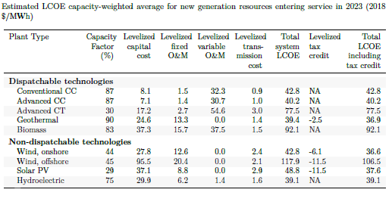

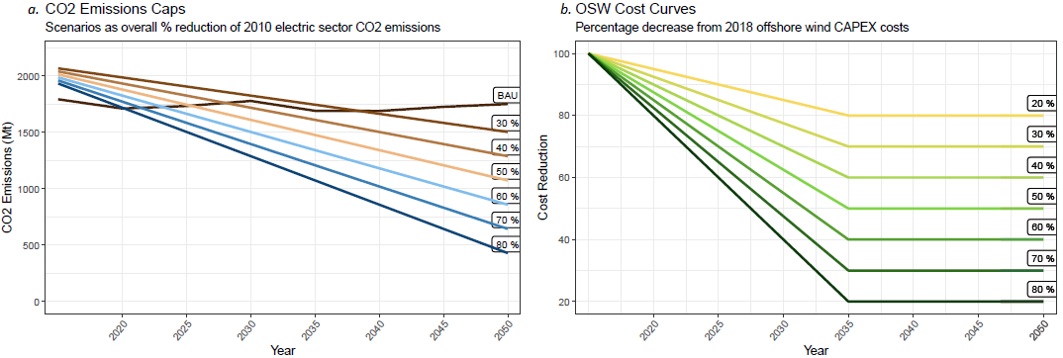

Figure 1. a. CO2 Cap and b. OSW Cost Curve Scenario Construction

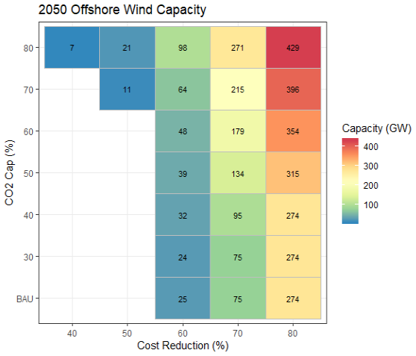

Figure . Total OSW Capacity in 2050

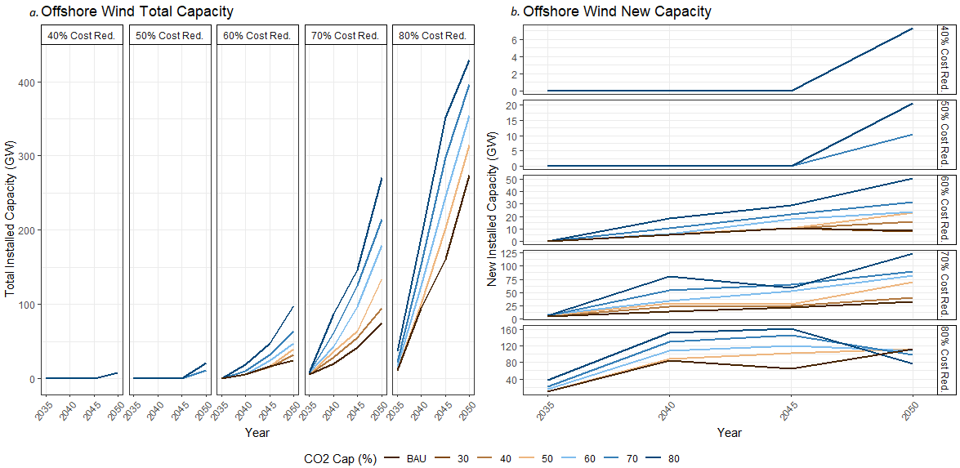

Figure 3. a. Total and b. New OSW Capacity by Scenario

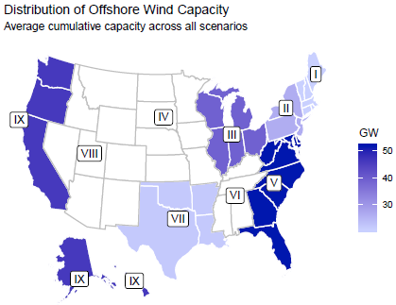

Figure 4. Average OSW capacity per region across scenarios

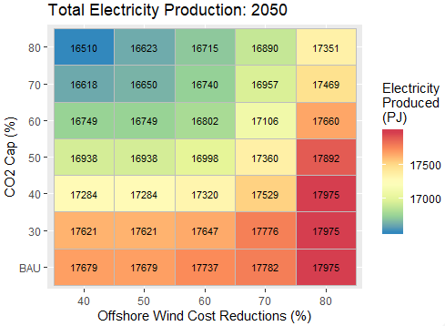

Figure 5. Total electric sector electricity production in 2050

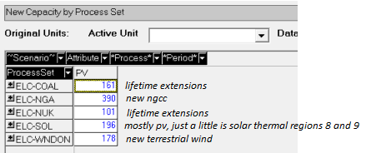

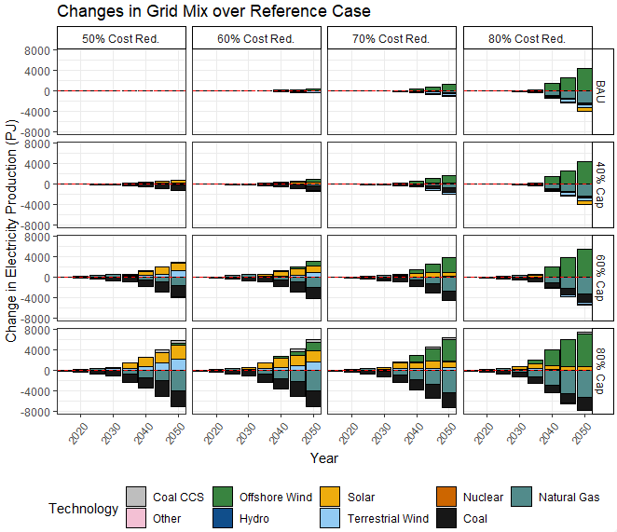

Figure . Capacity additions and retirements in relation to the reference case

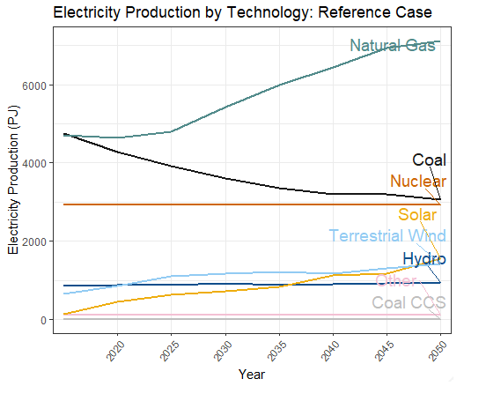

Figure 7. Reference case electricity production by technology

Table 2. Percent market share by technology in 2050 (Technology PJ/Total electric sector PJ)

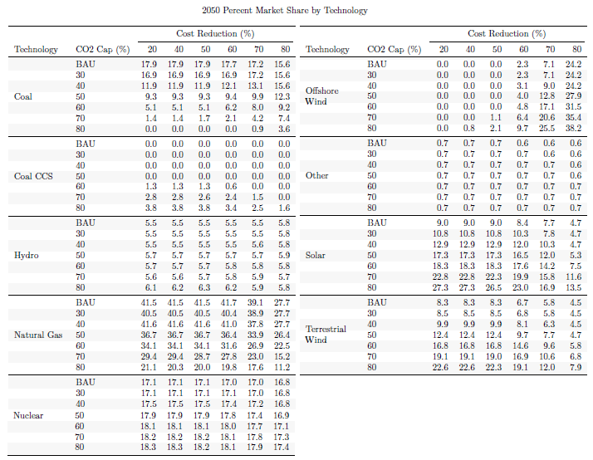

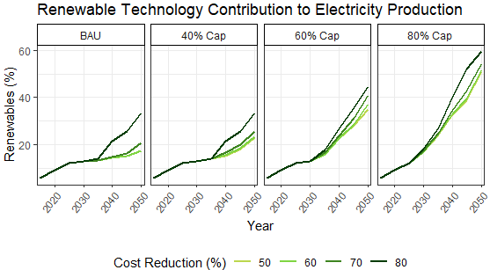

Figure . Percent of electric sector production from renewable technologies. Renewable technologies include solar, terrestrial wind, and OSW.

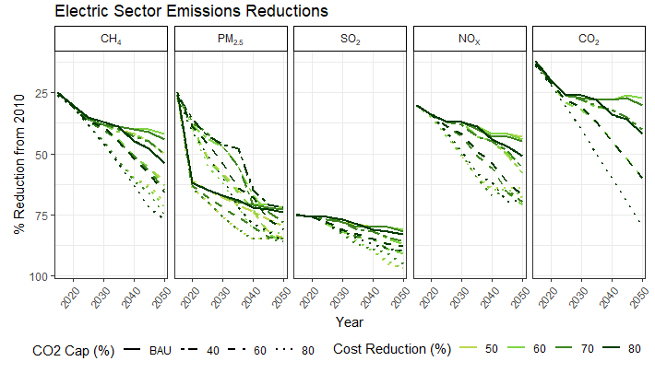

Figure . Electric sector emissions reductions

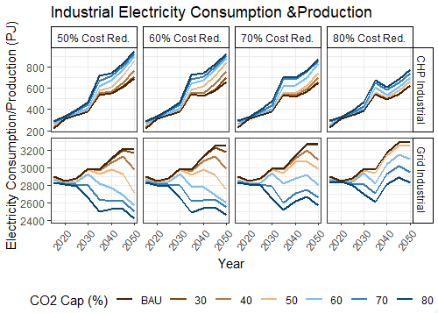

Figure . Industrial sector CHP and Grid electricity use

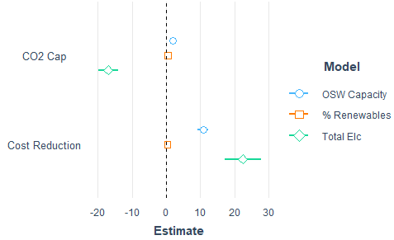

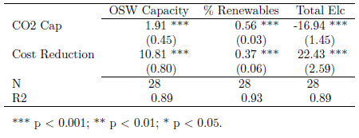

Figure . Electric sector regression analyses

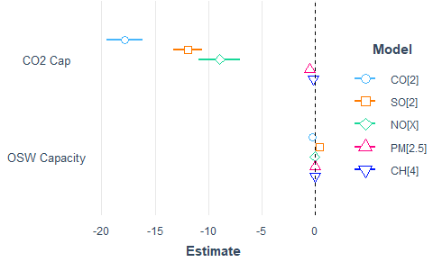

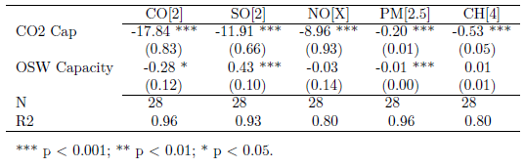

Figure . Emissions regression analyses

1. U.S. EIA, *Annual Energy Outlook 2019 - with projections to 2050*, U.S.E.I. Administration, Editor. 2019.