Richard Roman

Hubert Walton

Ryan Grogan

Michel Enanga

Online Forms System

Currently Coastal Carolina University uses paper forms to manage course information data, and process student requests. The goal of this project is to replace the manual paper form process for Coastal Carolina University with an online substitute which works in a similar manner. The objective is to streamline the forms process, increase efficiency, decrease time to completion, and achieve more accurate reporting, and accurate record keeping.

Stakeholders

Professor Cox

Coastal Carolina University

CCU Students

CCU Faculty

Richard Roman

Hubert Walton

Ryan Grogan

Michel Enanga

Information collection techniques

*Studying of the existing business procedures and forms*

We reviewed many if not all of the forms that Coastal Carolina University currently has from general permission to course repeat forms. These were valuable resources because we were able to obtain an understanding of the current business practice and procedures of the forms process at the college and the input and output of each of those processes.

*User Interviewing*

We conducted interviews at the school of students and faculty members that use the forms process as well as members of the team, since the team is made of CCU students.

Analysis Model

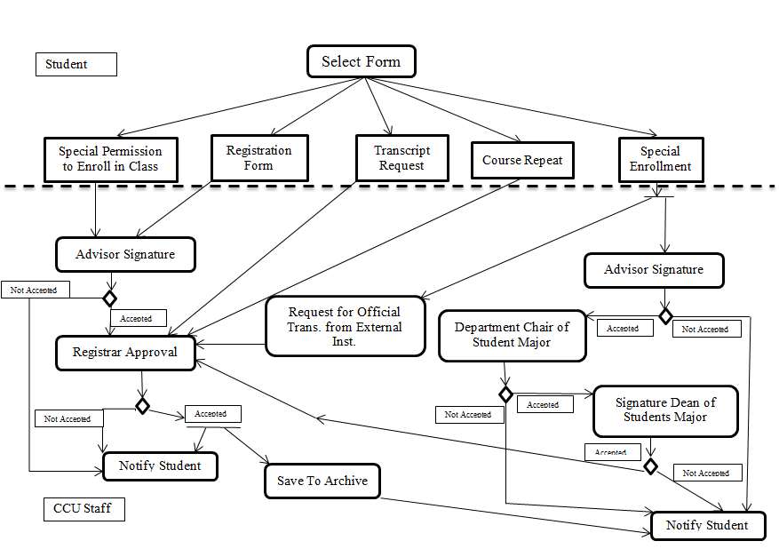

Rectangles are objects

Diamonds show decision points

Arrows show workflow

User stories

[EPIC]R1. As a User, I want to be able to cancel a form so that no action will be taken on it.

R1A. As a faculty member, I want to be able to cancel or disapprove a form.

[EPIC]R2. As a User, I want to be able to search and retrieve forms.

R2A. As a Student, I want to search by type and date so that I can see my recent activities.

R2B. As a faculty member, I want to search by student id, type of form, faculty id, or date so that I can see all active forms by a user.

R3. As a User, I want to be able to request assistance so that I can get help if I got stuck filling out form.

R4. As User, I want to be able to view form history so that I know when the form has been completed.

R5. As a User, I want to be able to save forms to the system I’m using on an external device so that I have records of each form.

[EPIC]R6. As a User I want to be able to obtain status reports of a form so that I know where the form is in the process.

R6A. As a Student, I want to be able to receive an email every time a form is acted on so that I know the last known location of my form.

R6B. As a faculty member, I want to be able to login to the system so that I can see what's been submitted, what needs to be approved, and what's been completed.

R7. As a User, I want to be able to access the online forms system from any mobile or pc device [Portability].

R8. As a Student I want to be able to edit the form so that I can make corrections.

R9. As a Student, I want to be able to create a new form online so that I don’t have to get paper copies.

[EPIC]R10. As a Faculty member, I want to be able to send back forms to the student, so that corrections can be made.

R10A. As a faculty member, I want to specify where in the form correction need to be made.