

**Our Story Services Events Members Only Investors Contact CMF**

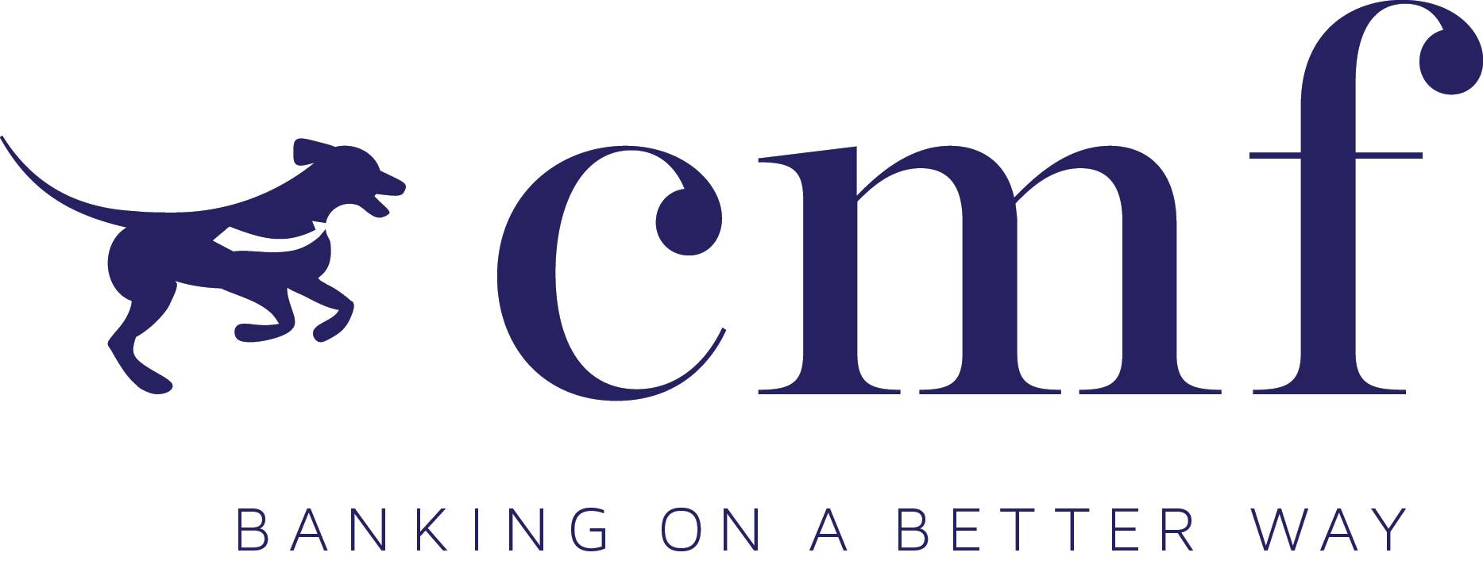

*The box above is slide one, with the other slides being testimonials from David Swales, Paul Mott, Ian Wren, Kitty Poor, Jim Snead, Kay Lanahan, etc.*

**CMF Blog**

**News & Articles**



**Our Story**

Community Mission Financial Corp. (“CMF”) is a relationship management company focused on the banking and financial-service needs of businesses and neighbors. The initial co-founders have thirty-six years of combined banking experience, though each invested those formative years in different roles and service areas. Regardless, each came to banking for the same desire: to provide for our families through financially-minded community service. In doing so, we achieved success and built names you might recognize: Ashley Carter, John Gobble, and Laurel Cartwright. But over the last decade, each co-founder became increasingly convinced that, in this economic time, true service is difficult to achieve within a traditional banking model.

In 2015, a moment came when this perception became too large to ignore, so we launched an innovative model that can directly serve the financial needs of the communities we love. CMF can provide almost any banking & financial service while enabling founders to enjoy the deep consultative relationships we have worked hard to build over the years. At the same time, the company is able to engineer around inefficiencies in the financial-service sector to provide an unsurpassed depth of services managed by the organizing founders. This streamlined company, this new kind of bank, has agility that a traditional bank sometimes covets. And with this agility comes one question. How can CMF work for you?

**CMF Services**

*Commercial Loan Origination & Advisory*

*Property & Casualty Insurance*

*Merchant Services*

*Purchasing / Commercial Credit Card*

*Payroll*

*Asset Management*

*Group Employee Benefit Plans*

*Life & Health Insurance*

*Brokerage & Retirement Plans*

*Residential Mortgage*

*Executive Recruiting*

*Depository & Treasury Management*

***Commercial Origination & Advisory***

John Gobble has run commercial-banking operations for both United Bank and SunTrust in the local marketplace as well as for SunTrust in Fort Lauderdale / West Palm Beach. Given this experience and expertise, CMF is able to work for directly for the borrower, who is looking for the most effective structure at an effective cost, or the financial institution, which is interested in growing its balance sheet with new borrowing relationships.

John can be reached directly at 434-964-6555 and jgobble@communitymissionfinancial.com.

***Property & Casualty Insurance***

John Gobble is a licensed property & casualty insurance agent and is locally affiliated with an independent insurance agency, Hanckel Citizens. Given John’s decades of experience servicing the needs of commercial businesses, this is a natural extension of addressing the entire needs of local businesses.

John can be reached directly at 434-964-6555 and jgobble@communitymissionfinancial.com.