**Overview**

At Sky Group, sustainability is more than a commitment—it’s at the heart of everything we do. As a aspired leader in the textile and garment manufacturing industry, we are dedicated to driving positive environmental and social impact through every stage of our value chain. Our approach blends innovation, efficiency, and ethical practices, with a focus on creating a better tomorrow.  
  
Responsible for Planet

**Aim:**

**To protect the environment by conserving resources, improving eǌciency, and enhancing innovation.**

**Energy & Emissions Management:** Improve energy eǌciency and adopt renewable energy to mitigate emissions.

**Water Neutrality:**

Reduce water consumption and aim for water neutrality and water positive.

**Chemical & Materials Stewardship:** Align with global standards for zero discharge of hazardous chemicals and source sustainable alternatives.

**Waste Towards Circularity:** Manage our waste to reduce, reuse, recycle, and ultimately close the loop.

Responsible for People

**Aim:**

**To nurture a growth-oriented environment for our employees and the communities we operate in.**

**Empowered Workforce:**

Enhance employees’ technical and soft skills.

**Employee Health & Well-being:**

Ensure safety, create awareness,

and tackle health issues our people face.

**Fair & Respectful Workplace:**

Uphold human rights through executed policies and robust grievance management systems.

**Corporate Social Responsibility (CSR):**

Drive impact in health, education, skill development, and environmental management.

Image   
  
Vision: **To lead the textile industry by creating a fully integrated, sustainable ecosystem that uplifts local communities through job creation and skill development. We strive to provide society with high-quality, eco-friendly textiles and garments, ensuring that our innovations not only meet global standards but also support the growth and prosperity of rural regions. By empowering people and delivering sustainable solutions, we are shaping a brighter, greener future for generations to come.**

:   
Mission : At Sky Group, we believe that success is not only measured by financial growth but also by the positive impact we create for our employees, communities, and the planet. Our workforce is a cornerstone of our mission, dedicated to upholding the highest standards of quality, ethics, and innovation. By offering opportunities for skill development and long-term growth, we contribute to uplifting local communities where we operate.

With a deep commitment to transparency, traceability, and ethical practices throughout our supply chain, Sky Group aims to set a benchmark for sustainable textile production, driving the industry toward a more responsible future while delivering exceptional value to our customers worldwide.

Our Sustainability Pillars   
  
1.Energy Efficient & Waste Management

Sky Group is transitioning to a low-carbon future with 12 MW solar installations and a coal phaseout, while responsibly managing waste through the 5 R's—Reduce, Reuse, Recycle, Refuse, and Recover.

2.Water Conservations :   
  
Sky Group ensures 100% wastewater recycling, saving 3,51,681 KL of water in 2023 through advanced water treatment and recycling technologies.

3.Sustainable Manufacturing  
  
Sky Group's Fiber-to-Fashion model ensures transparency and ethical sourcing from farms to production, while our focus on organic cotton, recycled fibers, and eco-friendly dyes reduces the environmental impact  
  
  
  
  
4. Social Responsibility   
  
Sky Group upholds fair labor practices certified by WRAP, SEDEX, and SLCP, while fostering community growth through local employment, development initiatives, and workforce training for long-term success.

5. Innovations and Improvisations   
Sky Group leverages advanced technology to enhance efficiency and reduce environmental impact, while adhering to global sustainability standards like Higg FEM 4.0 to continuously improve our environmental performance.  
  
6. Chemical Complaince

Sky Group uses 99% ZDHC MRSL V3.0 certified chemicals, ensuring safe, sustainable, and responsible manufacturing free from harmful substances.

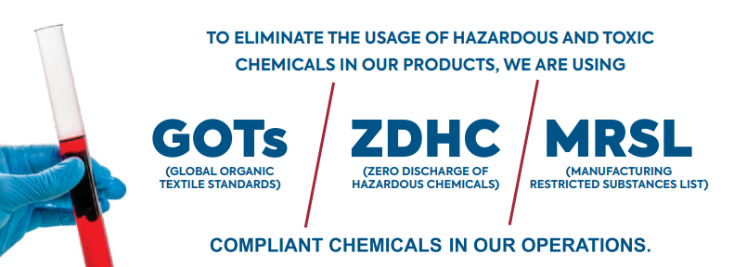

Future Plans:

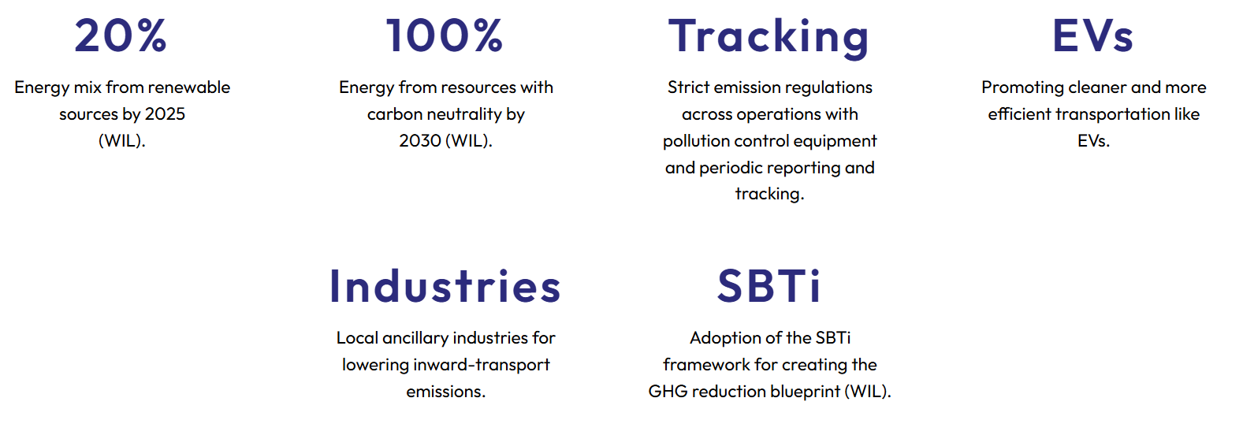

Similar to This ( May use Pictures )

1. 50 % Energy Mix from renewable sources by 2030.
2. 100% Waste Recycling
3. Tracking: same as above
4. Coal Phase out: Upgradation of Coal fired boiler to biomass.
5. SBTi: Adoption of SBTi framework for creating the GHG reduction blueprint and reporting.
6. Integration of Farm in the Sky Group for complete vertical setup and minimizing the delivery timing and control over ethical sourcing