Finally, we tested the system’s ability to determine the user’s preferences and scale the video appropriately when channel bandwidth changes. For the purposes of this study, we provided the learning mechanism with an arbitrary training set with the intent to prove the system’s ability to properly learn and make predictions. By using a predefined training set, we know in advance what classes should be predicted in different situations, allowing us to validate the accuracy of the cognitive mechanism by comparing the actual predicted values with the expected values. The training set we provided is given in Table 1.

|  |  |  |
| --- | --- | --- |
| **Channel Bandwidth (Kbps)** | **Content Type** | **Class Label** |
| 1200 | 0 | 0 |
| 1300 | 0 | 0 |
| 800 | 0 | 2 |
| 500 | 0 | 3 |
| 900 | 0 | 2 |
| 300 | 0 | 3 |
| 1100 | 0 | 0 |
| 1300 | 0 | 0 |
| 1500 | 0 | 0 |
| 850 | 0 | 2 |
| 500 | 1 | 3 |
| 1200 | 1 | 0 |
| 600 | 1 | 1 |
| 1300 | 1 | 0 |
| 300 | 1 | 3 |
| 400 | 1 | 3 |
| 800 | 1 | 0 |
| 600 | 1 | 1 |
| 700 | 1 | 1 |
| 1200 | 2 | 0 |
| 500 | 2 | 3 |
| 1200 | 2 | 0 |
| 2000 | 2 | 0 |
| 1300 | 2 | 2 |
| 300 | 2 | 3 |
| 900 | 2 | 3 |
| 1400 | 2 | 2 |
| 1900 | 2 | 0 |
| 700 | 2 | 3 |
| 1200 | 2 | 2 |

**Table 1 – Training Set**

The class distribution for this training set is depicted pictorially in Figure 15.

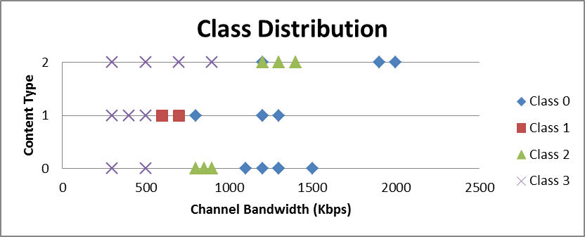

**Figure 15 – Class Distribution**

The “Content Type” feature is used to classify different scenes that are transmitted in real world scenarios. For example, a content type of 0 may be a video conferencing application with a “talking head” based scene, while a content type of 2 may be a medical based scene that requires extremely high bandwidth and video quality. In this experiment, we used 3 different content types, giving us the approximated expected prediction values in Table 2.

|  |  |  |
| --- | --- | --- |
| **Channel Bandwidth Range (Kpbs)** | **Content Type** | **Expected Class** |
| 0-500 | 0 | 3 |
| 500-1000 | 0 | 2 |
| 1000+ | 0 | 0 |
| 0-500 | 1 | 3 |
| 500-800 | 1 | 1 |
| 800+ | 1 | 0 |
| 0-900 | 2 | 3 |
| 900-1700 | 2 | 2 |
| 1700+ | 2 | 0 |

**Table 2 – Expected Prediction Values**

We trained the support vector machines and tested the learning mechanism by setting the bandwidth to 1600Kbps, 800Kbps, and 400Kbps while viewing video streams with content types 0, 1, and 2. For equation (1) we selected the K parameter to be 0.85 and for equation (3) we selected the Qmax parameter to be 3.5. The resulting bandwidth changes, encoding parameter changes, and class predictions are given in Figures 16-18.



**Figure 16 – Predictions with Content Type 0**



**Figure 17 – Predictions with Content Type 3**



**Figure 18 – Predictions with Content Type 5**

In all cases, the video bandwidth was adapted when the channel bandwidth changed. In addition, the video bandwidth was consistently kept at 85% of the channel bandwidth as a result of our selection of K. In order to validate the accuracy of the predictions, Table 3 compares the expected class values and the predicted class values at time instances *T0*, *T1*,and *T2*, where *T0* is the instant when the channel bandwidth changes to 1600Kbps.

|  |  |  |  |
| --- | --- | --- | --- |
| **Segment** | **Content Type** | **Expected Class** | **Predicted Class** |
| T0 | 0 | 0 | 0 |
| 1 | 0 | 0 |
| 2 | 2 | 2 |
| T1 | 0 | 2 | 2 |
| 1 | 1 | 1 |
| 2 | 3 | 3 |
| T2 | 0 | 3 | 3 |
| 1 | 3 | 3 |
| 2 | 3 | 3 |

**Table 3 – Expected vs. Predicted Classes**

As the table indicates, the support vector machines predicted the correct classes with 100% accuracy. In addition, the resulting changes to the encoding parameters followed the changes defined in Figure 11. When class 0 was predicted, the spatial and temporal resolutions were kept high at the cost of fewer bits per pixel. When class 1 was predicted, the temporal resolution was kept high and the spatial resolution was reduced. The prediction of class 2 resulted in a loss in temporal resolution with the spatial resolution being kept high. Finally, when class 3 was predicted, the spatial and temporal resolutions were reduced, resulting in greater quality with more bits per pixel.