- Task Title | Baseline Massage Milk |  | Date of Assessment: | 29/07/2025 |  | Assessment Review Date: | 29/07/2026 | Risk Assessment Code / Version: | TORS:SHHN:CS 26/v1
Summary of task being undertaken | For Physiotherapy classes.
Location(s) of task | Robert Winston Building – F200 – F204 and F407
Owner of the task / activity: | Stuart Barton |  | Role of Owner |  | Technical Manager
Risk Assessor(s) | Name | Role / position of study |  |  | Contribution
 | Angela Turner | Technical Assistant |  |  | RA completed

- Main Hazards – select the appropriate hazard symbols
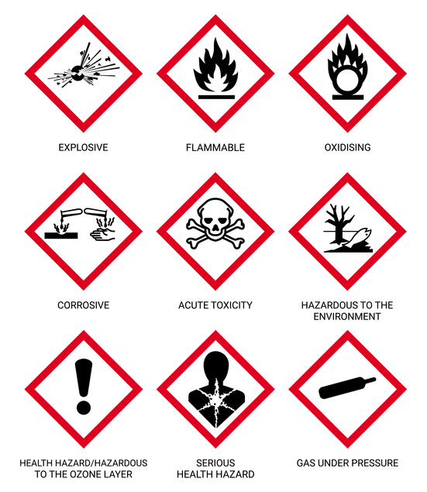  ☐ |   ☐ |  |   ☐ |  |   ☐ |   ☐ |  |   ☐ |  | 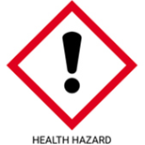  ☐ |  |   ☐ |  |  |   ☐ |  | 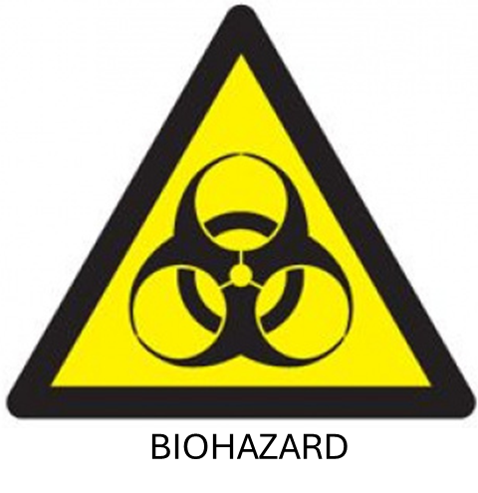  ☐
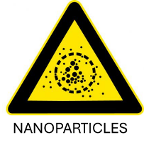 ☐ | 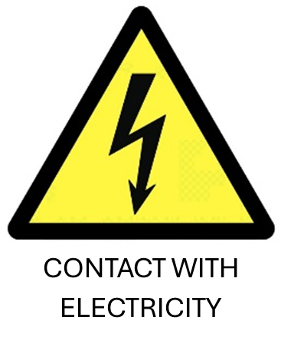 ☐ |  | 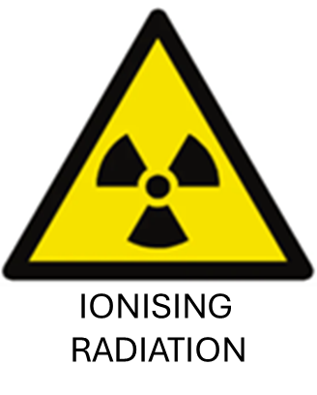 ☐ |  | 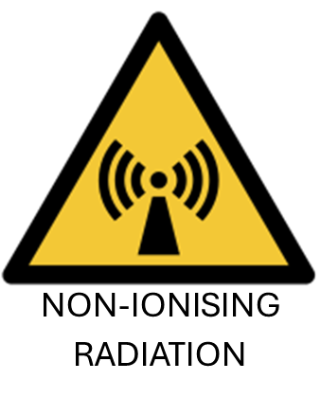 ☐ | 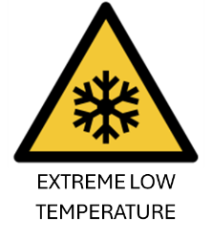 ☐ |  | 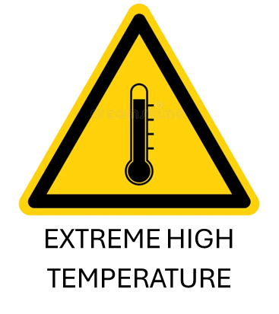 ☐ |  | 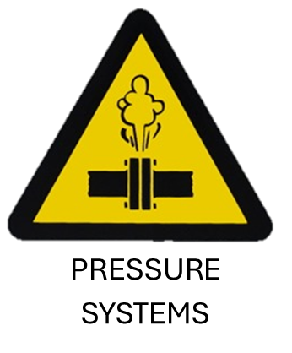 ☐ |  | 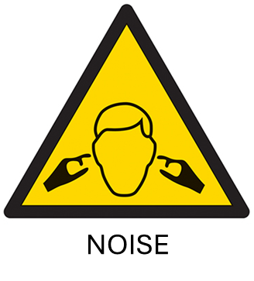 ☐ |  |  | 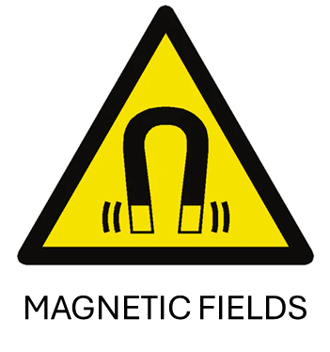 ☐ |  | 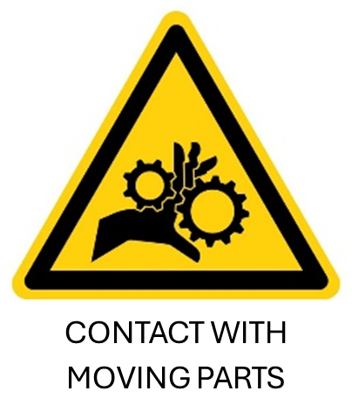 ☐
- Description of significant hazards, and any hazards not covered in section 2 Include equipment or mechanical hazards, and any specific health hazards associated with the task. See guidance notes for examples.
N/A

- Does the task involve use of teratogens or mutagens, that may cause harm during pregnancy? If yes, list them below. |  |  |  |  |  |  |  |  |  |  | Yes ☐ |  |  | No ☒
- Who is at risk? – Vulnerable groups/visitors/cleaners/security/maintenance staff.
Academics and students.
- Control Measures – Apply the hierarchy of controls
PPE – N/A.
Administration – Read instructions on product for use.
Engineering controls – Ensure appropriate cleaning materials are on hand.
Substitution – Use of other skin friendly baby oil if required.
Elimination – Use of other skin friendly baby oil if able.
- PPE/RPE Requirements
  ☐ |  |   ☐ |  |   ☐ |  |  |   ☐ |  |   ☐ |  |  |  |   ☐ |  |  | 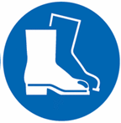  ☐
- PPE / RPE specifics and details
No other protective equipment is needed under normal use conditions.
- Accident, Incident, First Aid and Emergency Arrangements - What needs to be done should something go wrong?
Contact with skin: No damage to health is expected.
Contact with eyes: wash immediately with water for at least 10 minutes.
Swallowing; Rinse your mouth out immediately and then drink a large amount of water. If symptoms persist visit a first aid attendant or a doctor and show the safety data sheet.
Inhalation: No damage to health is expected.
- Lone working / out of hours working

- Hazardous Substances used or generated - There is no need to include non-hazardous substances. If the work process is likely to create/generate hazardous emissions (including dusts and fumes), include these. If using a solution, state its concentration. Add additional rows as required.
Name of substance or product | Volume / Weight / Concentration / Physical form | Hazardous Properties | Waste Disposal  If not on list, add below | Spillage information | Emergency information – inhalation/skin /eye contact | Chemical Segregation category
 |  |  | Choose an item.
 |  |  | Choose an item.
 |  |  | Choose an item.
 |  |  | Choose an item.
 |  |  | Choose an item.
 |  |  | Choose an item.
 |  |  | Choose an item.

- Is Exposure Monitoring Required ? If applicable, including WELS | Yes ☐ (provide details below) | No ☒
Always wash hands after handling. Remove and wash contaminated clothing before re-using.
- Information, Training, Instruction and Supervision – must be complete before task takes place
For use as massage practices. Follow directions on packaging for appropriate dose. Wash hands after use.
Spillage, disposal and storage - If possible, collect product for disposal. Rinse remainder with water. Avoid contaminating the earth as well as surface and ground water.
This product should be disposed of in accordance with the instructions of the local authorities. It should not be entered into sewage systems, nor be disposed of in the environment. The soiled packaging should be disposed of in the same way as the product. Dispose the removed material according to regulations.
Store in a dry place, protected from sunlight at room temperature not exceeding 25 C.
- Documentation – detail other documents that are referred to or are inked to this risk assessment e.g. SOPs, ethics, GM, method statements.
SDS available - https://www.alfacare.no/media/multicase/documents/sikkerhetsdatablad/forbruksmateriell/massasjekremer%20-%20salver%20-%20oljer/809010%20baselin_massagemilk%20sikkerhetsdatablad.pdf

- Reviews and amendments to the risk assessment
Date of review | Name of the reviewer | Reason for the review | Comments / amendments | Date of next review (if applicable)
Click or tap to enter a date. |  |  |  | Click or tap to enter a date.
Click or tap to enter a date. |  |  |  | Click or tap to enter a date.
Click or tap to enter a date. |  |  |  | Click or tap to enter a date.
Click or tap to enter a date. |  |  |  | Click or tap to enter a date.
Click or tap to enter a date. |  |  |  | Click or tap to enter a date.
Click or tap to enter a date. |  |  |  | Click or tap to enter a date.

- Ownership of the activity
To be completed by the person responsible for the activity / task and has the authority to allow it to progress
I confirm that this risk assessment is an accurate reflection of the activity / task.
I am agreeing to the controls that have been identified and accept responsibility for their implementation.
Based on the findings of this risk assessment (delete as required):
- I have no objection to this activity / task from being undertaken.
- I object to this activity / task from being undertaken (objections detailed below).
Owner’s comments / observations / further recommendations / objections
Owner’s name and job title: | Stuart Barton | Date | 23/09/2025

