This is an exercise to practice the use of stacked widgets.

It is a simple party invite interface.

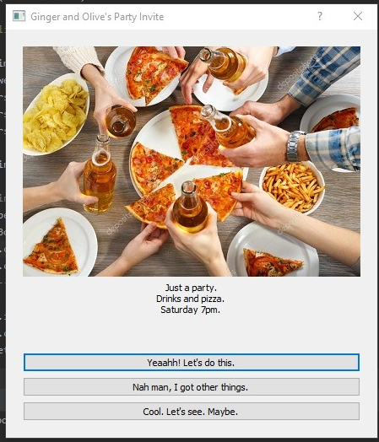

Image credits: <https://depositphotos.com/111556890/stock-photo-friendly-party-with-hot-pizza.html>