基于LightSwitch与百度地图API地理信息数据库平台构建——以洪山区体育场馆信息发布平台为例
李晓飞¹，何津¹，温博格 ¹，贾超卫¹
- 湖北大学资源环境学院，湖北 武汉430062）
Construction of Geographic Information Database Platform Based on LightSwitch and Baidu Maps API – Taking Hongshan District Information Publishing Platform as an Example
摘要：随着GIS技术的发展以及信息化建设的不断推进，对地理信息的发布提出了更高的要求。本文提出了一种以LightSwitch为框架，百度地图API为地理信息展示平台的地理信息发布平台构建方法，可以快速建立一套集数据采集、数据管理、地理数据展示、属性数据统计分析的信息发布平台，实现简单、便于维护管理，大大提高了开发效率。本文还讨论了洪山区体育场馆信息发布平台的具体实现方案。
关键词：LightSwitch；百度地图API；地理信息发布平台
Abstract: With the development of GIS technology development and the advancement of in-formation construction, it puts a higher demand for geographic information release. This paper presents a way to build the geographic information publishing platform by using LightSwitch framework and Baidu Maps API , which you can quickly establish a set of data collection, data management, geographic data presentation and attribute data analysis information release plat-form. Simple to maintenance and easy to realize, that greatly improve the efficiency of information platform development. This article also discusses the concrete solution of Hongshan District stadium information release platform.
Keywords: LightSwitch; Baidu Maps API; geographic information publishing platform

一、引言

Introduction
随着我国信息化建设的不断推进，以及GIS技术的发展与普及，各单位的信息化建设也提升到了新的高度，从过去单一的属性数据入库管理，到现在多种形式的数据展示，地理信息服务技术日趋成熟，国家、省市级单位应用地理信息系统进行管理应用已非常普遍[]。从技术角度来看，目前主流的地图服务如百度地图、高德地图等地图服务功能完善，市场认可度较高，能够满足大众对于地理信息的在线查询浏览需求；从市场角度来看，各企事业单位对于手中的地理数据迫切需要通过地图形式进行表达，而非传统单一的表格形式描述。
Along with the continuous advancement of information construction in our country, as well as the development and popularization of GIS Technology, the information construction of various institutions has also raised to a new height. From the past single attribute data warehousing management to the present forms of data display, geographic information service technology is becoming more and more mature, national, provincial and municipal units of application of geographic information system management application has been very common. From a technical standpoint, the current mainstream map services such as Baidu Maps and Autonavi Maps have provided fully functional online map services, they all have a high degree of market acceptance to meet the public for online geographic information querying, browsing demand; From a market perspective, many units are in urgent need of expression through the map for geographical data in hand, instead of describing the traditional simple forms.
With the help of information and GIS technology’s development and widespread, the information construction for enterprises and institutions are also raised to a new level, from the past simple attribute data storage management to the present various forms of data presentation, geographic information service technology has been more and more mature. It is very common to use geographic information system for the government and institutions in the daily management. From a technical perspective, the current mainstream map services such as Baidu Maps and Autonavi Maps have provided fully functional online map services and were well received by the market, both of them can meet the public demand for online map browsing and querying; from the market perspective, the enterprises and institutions get an urgent need for representing their geographic data through the online maps rather than traditional tabular forms.
本文提出了一种基于微软LightSwitch开发框架以及百度地图API的地理信息数据发布平台，通过利用LightSwitch的数据服务接口以及百度地图丰富的地理表现形式，实现快速构建地理信息数据发布平台，从而满足各企事业单位对于数据采集、管理及地理信息的发布。
In this paper, we present a way to construct the geographic information publishing platform by using Microsoft newest developing framework and Baidu Maps API, through the use of LightSwitch data service interface and a wealth of geographic representation of Baidu map, to realize the rapid construction of geographic information platform, So as to meet the needs for data collection, management and geographic information release.
In this paper, we present a way to construct the geographic information publishing platform by using Microsoft newest developing framework and Baidu Maps API, with the help of LightSwitch data service interface and a wealth of geographic presentation of Baidu Maps, we can easily and rapidly build a geographic information publishing platform, so as to meet the requirement of enterprises and institutions for data collection, management and geographic information release.

二、需求分析

Demand analysis
随着信息化时代的到来，以及电子政务的普及，各级单位对于电子信息发布有着越来越迫切的需求，因此需要寻求一种旨在快速构建信息入库、信息管理、信息发布及查询的通用解决方案。并且随着地理信息服务的普及，对于地理信息的发布与展示的需求也越发强烈。综合以上需求分析，本系统应实现如下功能：
With the advent of the information age and the popularization of electronic government affairs, Units at all levels have more and more urgent demand for the publication of electronic information. Therefore, we need to find a solution to the rapid construction of information storage, information management, information dissemination and query. And with the popularization of the geographic information service, the demand for the publication and display of the geographic information is also more intense. Comprehensive analysis of the above requirements, the system should achieve the following functions:
With the advent of the information age, as well as the popularization of E-government, all institutions have a more and more urgent demand for online information publishing. Therefore, we need to find a common solution to build a public information release platform with data storage, data management, data dissemination and query functions easily, rapidly and efficiently. Also, with the popularization of the GIS service, the demand for the publication and display of the geographic information is also more intense. With the comprehensive analysis of the above requirements, the system should realize the following functions:
（1）数据管理。实现对于用户信息数据的管理，如数据采集、录入、编辑、查询等。
(1) Data management. To realize the user information data management, such as data acquisition, input, edit, query etc.
Data management. To achieve the management of user information data, such as data collection, data inputting, data editing, data query, etc.
（2）地图数据显示。实现地图展示的一些基本功能如查询点聚簇显示、全景地图漫游、实时交通路况信息显示等。
(2) Map data display. Some of the basic functions of the map display, such as query point cluster display, Panoramic Map roaming, real-time traffic information display, etc.
Geographic information presentation. To achieve some of the basic map display functions, such as query result points clustering display, panorama roaming, real-time traffic information display, etc.
（3）数据统计分析。实现对地图数据点的热力分析、对于属性数据能够生成透视分析图表等。
(3) Statistical analysis of data. To achieve the base spatial analysis of the map points data such as building heat maps. For the attribute data to generate a perspective analysis chart, etc.
Data statistics and analysis. To achieve the heat map analysis of geographic data points and generate analysis pivot chart for attribute data, etc.
（4）权限管理。实现对系统用户分级权限管理，不同权限用户对应系统不同功能以确保数据安全性。
(4) Authority management. The system user permissions management, different functions of different users corresponding system to ensure the data security.
Permission management. To achieve hierarchical authority management for system users, different users of different rights to ensure data security.
（5）构建快速，维护简单。
(5) Rapid construction, maintenance is simple
Rapid constructing and easy to maintenance.

三、系统设计

System design
1系统结构设计
1 System structure design
本系统采用目前较为流行的四层架构，包括界面层、业务层、数据接口层、数据层，结构清晰，便于维护。
Our system uses current popular four tier structure including interface layer, business layer, data interface layer and data layer.
（1）用户界面层：基于Internet/Intranet，通过浏览器/客户端软件查询、显示指定用户信息、及业务组件提供的处理结果信息，例如数据查询检索界面、分析图表显示界面、电子地图显示等功能。
(1)The UI tier: Based on Internet/Intranet, through the browser and client software to display the query result, the specified user information and the processed result provided by business components, such as data query UI, the statistics and analysis charts and electronic map UI, etc.
（2）业务逻辑层：包括各种业务组件的功能模块，及负责功能模块之间的协作、数据交换等功能，以实现完整业务流程，是系统的核心部分。
(2) Business logic tier: Including the function modules of various business components and responsible for the function of collaboration and data exchange between modules to achieve complete business processes. It is the core part of the system.
(2) Business logic tier: Including all kinds of business logic modules. This tier contains most functions to achieve a complete business process such as data exchange, collaboration between modules. It is the core of the system.
（3）数据接口层：封装对数据库的访问功能，使业务层与具体数据库平台无关。
(3) Data interface layer: Encapsulating the function of database accessing to decouple the business layer and the data layer.
（4）数据层：用于在MS-SQL Server数据库中存储数据。其提供保存应用程序数据、配置信息等功能。
(4)Data tier: It used to store data in a MS-SQL Server databases such the Coordinates data and user configuration informations, etc.
系统总体结构图如下所示：
The overall system structure is shown below:
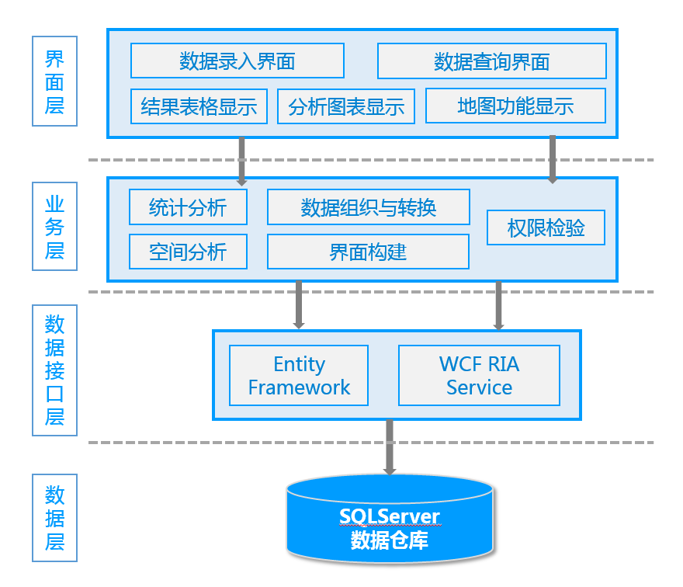
图1系统总体结构图
Fig.1 The diagram of system architecture
2数据库设计
Database design
本系统采用SQL Server作为数据库管理软件。，通过SQL Server的附加功能，将开发数据库（mdb文件）附加到SQL Server中，从而实现数据的管理与发布。体育场馆信息涉及到空间数据和专题属性数据。根据各类数据的特点及其相关性，主要设计了场馆、场地类别、所属街道、场地基本信息、场地运营情况、场馆照片、场地归属等数据表，具体数据库关系见下图2。涉及空间位置信息的数据以经纬度表示，并将空间信息与场馆进行关联，以便开展空间定位和相应的查询[]。
Our system use SQL Server as the database management software. By using SQL Server attach function, the testing database (mdb file) can be easily attached to the SQL Server database. So as to achieve the data management and release. Stadium information related to spatial data and attribute data. According to the characteristics of various types of data and their correlation, we have designed stadium base information table, stadium table, stadium category table, streets table, stadium economy status table, stadium photo table, stadium owner table, etc. The specific relational database see Figure 2. Data on spatial position information is represented by latitude and longitude. The spatial information associated with the stadiums in order to process the spatial orientation and corresponding query.
Our system use SQL Server as the database management software. By using SQL Server attach function, we can easily import our developing database into SQL Server, so that we can realize data management and release. Stadium information includes spatial information and attribute information. Considering the characteristics of various types of data and their correlation, we have designed stadium base information table, stadium table, stadium category table, streets table, stadium economy status table, stadium photo table, stadium owner table, etc. The concrete database relationship see the figure2 below. Data related to the spatial location information expressed in latitude and longitude, and the spatial information associated with the stadiums in order to process the spatial orientation and corresponding query.
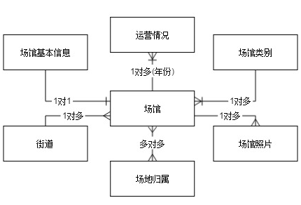
图2数据库结构设计图
Fig.2 diagram of database design

四、系统实现

4 System implementation
1技术平台简介
- Technology Platform Introduction

（1）LightSwitch
Microsoft Visual Studio LightSwitch 是一种开发环境，旨在简化并缩短业务应用程序和数据服务的开发过程。LightSwitch 简化了以数据为中心的桌面及云业务应用程序的开发，使用户致力于业务逻辑处理[]，从而大大缩短了开发时间，同时得益于LightSwitch对数据的良好封装，使程序的可维护性大大提高。
Visual Studio LightSwitch is a development environment designed to simplify and shorten the development of businesses applications and data services. LightSwitch makes it easy to create data-centric business applications that can consume a variety of data sources and create clients that can run on a variety of devices. It can shorten the development time greatly. At the same time, thanks to the good data packaging of LightSwitch, The maintainability of the program is significantly improved.
- LightSwitch
Visual Studio LightSwitch is a development environment designed to simplify and shorten the development of businesses applications and data services. LightSwitch makes it easy to create data-centric business applications that can consume a variety of data sources and create clients that can run on a variety of devices thus reducing the development time greatly. Also, benefiting from LightSwitch good package for data, the program’s maintainability improved greatly.
（2）百度地图API（JavaScript API大众版）
百度地图JavaScript API是一套由JavaScript语言编写的应用程序接口，可在网站中构建功能丰富、交互性强的地图应用[]。百度地图还提供了强大的地图数据和全景数据支持，可以为用户提供更好的数据浏览体验，此外百度地图API接口丰富，开发文档完善，大大降低了开发难度。
- Baidu Maps API
Baidu Maps JavaScript API is a set of application interface written by JavaScript that can help us build rich, interactive online map applications. Thanks to the Baidu Maps API provides the powerful map data and panoramic data support, We can provide a better browsing experience for the users. Besides Baidu Maps API provides lots of useful functions and perfect developement documentation which greatly reduce the development effort.
（3）jQuery EasyUI
平台网页版界面框架，是一组基于jQuery的UI插件集合体，能够快速搭建出功能丰富并且界面美观的UI界面。
- jQuery EasyUI
The front end framework for web UI, it is a set of plug-ins based on jQuery and helps us build feature-rich and beautiful user interface web applications.
（4）HighCharts
功能强大、开源、美观、图表丰富、兼容性良好的纯js图表库。与pivottable控件相结合可动态生成各种分析图表。
- HighCharts
Powerful, open, beautiful, rich chart, good compatibility, pure js charting library. Combined with pivottable control can generate variety of analytical charts dynamically.
2系统实现原理
2 System Realization Principles
本方法创新性的提出将微软的LightSwitch快速开发框架与百度地图相结合，利用LightSwitch良好的数据封装特性，以及百度地图API在地图数据和功能上的强大支持，实现地理信息数据在线发布平台的快速构建。
The method creatively combined Microsoft LightSwitch rapid development framework with Baidu Maps API, take full advantage of LightSwitch good data package characteristics and Baidu Maps API on map data supporting and map manipulation to realize geographic data online publishing platform fast construction.
具体开发路线可以分为以下几个主要阶段：
Specific development flow can be divided into the following main stages:
①利用LightSwitch平台搭建整体框架。在VS2013（Visual Studio 2013）中创建好LightSwitch项目后，分别创建好“桌面项目”（DesktopClient）和“网页项目”（HTMLClient），其中“桌面项目”作为数据的录入、管理及用户登录管理客户端，“网页项目”作为地图数据展示客户端；
① Use LightSwitch platform to build the overall framework. Once the LightSwitch solution has been created in the Visual Studio 2013, then create “DesktopClient” and “HTMLClient” projects separately, where “DesktopClient” as data entry, management and user login ad-ministration client and “HTMLClient” use as the web map showing client.
②在“网页项目”中，自定义编写网页显示界面来替换掉LightSwitch默认的“网页项目”界面，但保留LightSwitch提供的数据接口用来获取查询数据；
② In the "HTMLClient" project, we could write custom UI pages to replace the LightSwitch default "HTMLClient" project user interface but retain the data interface which LightSwitch provides for us to query data at the same time.
③利用前端界面框架“jQuery EasyUI”搭建网页界面，同时在页面中调用百度地图API生成地图；
Use the front-end UI framework "jQuery EasyUI" to build web interface, while calling Baidu Maps API to generate an online map;
④利用“pivottable”开源控件与“HighCharts”图表控件相结合，实现数据统计分析图表的动态生成功能；
Use the open source control "pivottable" combine to the chart control "HighCharts” to generate the statistical and analytical charts dynamically;
⑤添加用户权限系统，根据不同的用户权限动态生成不同的页面，保证数据的安全。
Add user privilege system, dynamically generated different HTML pages depending on the user permissions to ensure the data's security.
3系统实现关键技术讨论
Key technologies of system implementation
（1）使用自定义网页界面
Custom the web user interface
在解决方案中添加HTML项目后，系统会自动生成Screen文件夹，按照需要添加完成屏幕后，系统会根据所提供的数据表自动生成窗体设计界面，此时数据浏览方式为默认的“行布局”，将数据展示控件由“行布局”替换为“自定义控件”，系统即可根据用户自定义的HTML界面进行显示。在系统中，LightSwitch提供了element和contentItem两个接口，其中element用来接受自定义的HTML界面，用户只需要将自己设计好的页面内容附加到element上即可实现自定义界面；contentItem为LightSwitch数据接口，其中的screen属性提供了数据查询和数据载入功能，从而实现对数据库中的数据进行访问。
After adding the “HTMLClient” project into the solution, LightSwitch will create the “Screen” folder automatically for you. After finish adding HTML screens as the case requires, the system will automatically generate the form designer interface based on the provided data table, at this point the default data view mode is "Row Layout", replace the default layout control "Row" by "Custom Control", then the system can be displayed according to user-defined HTML interface. In the system, LightSwitch provides “element” and “contentItem” two interfaces, which “element” is used to accept the custom HTML interface, we only need to design a HTML document and attach it to the “element” argument so that we can implement a custom web page; The contentItem provides a data interface which provides a screen attribute to query and load data from the server database.
（2）百度地图异步加载
Baidu Maps asynchronous loading
地图模块作为平台的核心模块，地图的正确加载并以适当的视域在页面上显示尤为重要，然而在整个页面初始化过程中，由于用户网络性能的差异，对于地图API的加载速度也有不同，采用传统的地图加载方式，对于网络较差的用户，会造成页面卡顿，用户浏览体验大大降低。这里通过采用百度地图API异步加载方式，在应用脚本的时候添加callback参数，当脚本加载完成后callback函数会被立刻调用[]，从而实现对地图的异步加载，进而不会影响其他模块的初始化。同时当用户加载地图模块失败后，不影响平台其他功能的使用。
The map module as the core modules of the platform, the map loads correctly and displays in the appropriate view of the page is very important. However, during the entire page's initialization, due to differences in the user network performance, the Maps API loading speed is also different, using the traditional way of map loading will be a disaster for poor user of network and may cause the page block, the browsing experience reduced greatly. Here by using Baidu Maps API asynchronously loading technology, adding the callback parameter when calling Baidu Maps API, the callback function will be executed immediately after Baidu Maps have been loaded so that other function modules will not be blocked. Moreover, when the user fails to load the map, it does not affect other modules work properly.
（3）使用RIA技术提升系统查询效率
Use RIA technology to enhance the efficiency of the system inquiry
随着系统中数据的不断增长，系统的查询效率会不断降低，此时可以通过使用WCF RIA（Windows Communication Foundation Rich Internet Application）服务来提高系统查询效率。
With the continuous growth of data in the system, query efficiency of the system will decrease continuously, In this case the system can be improved query efficiency by using WCF RIA （Windows Communication Foundation Rich Internet Application） Services.
WCF RIA是用来简化n层富互联网应用程序开发的服务[]，通过使用RIA服务，创建数据中间表，在服务器端重新组织用户所需的数据，同时该数据中间表可以根据底层数据的更改而自动更新。通过创建RIA服务，用户可以将多个数据表进行整合、连接，整合后的数据表可以提供诸如计数、求和等功能，同时使用RIA服务可以大大提高LightSwitch应用程序的执行效率[]。
WCF RIA Services simplifies the development of n-tier solutions for Rich Internet Applications (RIA), through the use of RIA services, create intermediate data tables on the server side, we can re-organize the data (for example integrate multiple data tables, connect, and consolidate data tables to provide services such as count, sum and other functions) what we really need to post. Moreover, once we create a RIA Services client that client is automatically updated with latest middle tier logic every time that the solution is re-compiled. The following figure-3 illustration shows a simplified version of n-tier application. RIA Services focuses on the box between the presentation tier and the data access layer (DAL) to facilitate n-tier development with a RIA Services client. Tests show that the use of RIA Services can greatly improve the query efficiency of LightSwitch applications
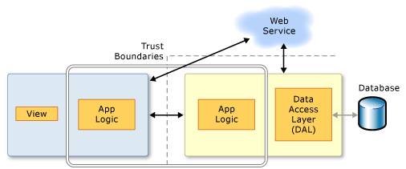
Fig-3 the n-tier application and RIA Services effective region
在本系统中，使用RIA服务在Server端重新组织数据，构建“场馆”和“运营状况”的数据表，用以提供web端数据浏览，经测试使用RIA服务后，查询2000条数据时间由原来的40秒缩短至3秒，系统查询效率提升显著。
In the Hongshan stadium geographic information publishing system, we have built “stadium” table and “economy status” table for providing web-side data browsing, after we have adopted the RIA services, the time queried for 2000 records reduced to 3s, however it used to take 40s at beginning.
（4）权限系统实现
Permissions system implementation
在信息平台中，数据安全是重中之重，本系统采用权限机制来确保系统安全。通过权限的验证，系统可以识别用户，一旦用户通过验证，就可以根据用户所具有的权限来设定其所能查看的屏幕，所能执行的功能[]。LightSwitch提供了一套完整的权限系统，但由于重写了LightSwitch默认的HTML页面，因此在web端无法使用其本身的访问控制系统。这里通过在页面中自定义一套权限系统来实现控制用户访问HTML页面的功能。
For information platform, data security is the most important feature so we provide a complete set of permissions to protect the user‘s data safety. The system can identify different login users by verifying the privileges. Once a user has been authenticated, the system will arrange the special UI and functions for him according to his permissions. Although LightSwitch provides a complete permissions-based authorization system for developing business rules, as shown in figure-3 [9], since we have re-write its default HTMLClient UI, so we could not take full advantage of its permission system. Fortunately, we can custom LightSwitch original permission system to control the user access to HTML pages and functions.
LightSwitch provides a permissions-based authorization system for developing business rules, as shown in figure-4. 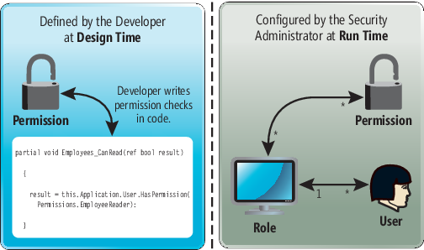
Fig-4 Implementing Authorization in LightSwitch
首先在web客户端获取当前系统用户所具备的权限。通过ServerApplicationContext API在服务器端获取当前系统用户权限等数据后[]，即可在web端请求到当前系统用户所具备的权限。其次在构建HTML页面过程中使用动态构建技术，通过动态生成HTML元素，并逐层插入HTML文档中的方式来搭建整个页面框架。在动态构建HTML元素过程中，结合用户权限生成相应的HTML元素，从而实现web页面端按权限浏览功能。
First, obtain the current user’s permissions in the web client. After getting the user permissions on the server side through the LightSwitch “ServerApplicationContext” API, we can request it from the web client. Secondly, construct the HTML pages dynamically, create HTML elements by JavaScript code and insert them into the HTML document separately. During the construction of each HTML element, the authority management module will check whether the current user has permission to build the element, by this way we can achieve the goal of restrict the user’s unauthorized behavior.
（5）热力图
Heat Map
百度地图热力图是用不同颜色的区块叠加在地图上实时描述人群分布、密度和变化趋势的一个产品[]。通过百度地图API热力图功能接口，可以实现对查询结果数据的热力图分析功能。不同于百度地图的热力地图，本系统中的热力图可以根据用户选择的统计属性自定义所需的热力图，从而实现对体育场馆分布情况的空间分析功能。
A heat map is a graphical representation of data where the individual values contained in a matrix are represented as colors [new2]. Here we use it as a statistic map layer overlays the Baidu Maps to describe the stadiums space and attribute statistic information, with the help of Baidu Maps API open source library we can easily build the stadium geographical heat map of attribute statistics. First instantiate a “HeatmapOverlay” object, then set the heat map data and the stadium influence radius, at last add the heat map layer into Baidu maps set. The figure below shows the result of stadiums area statistics.
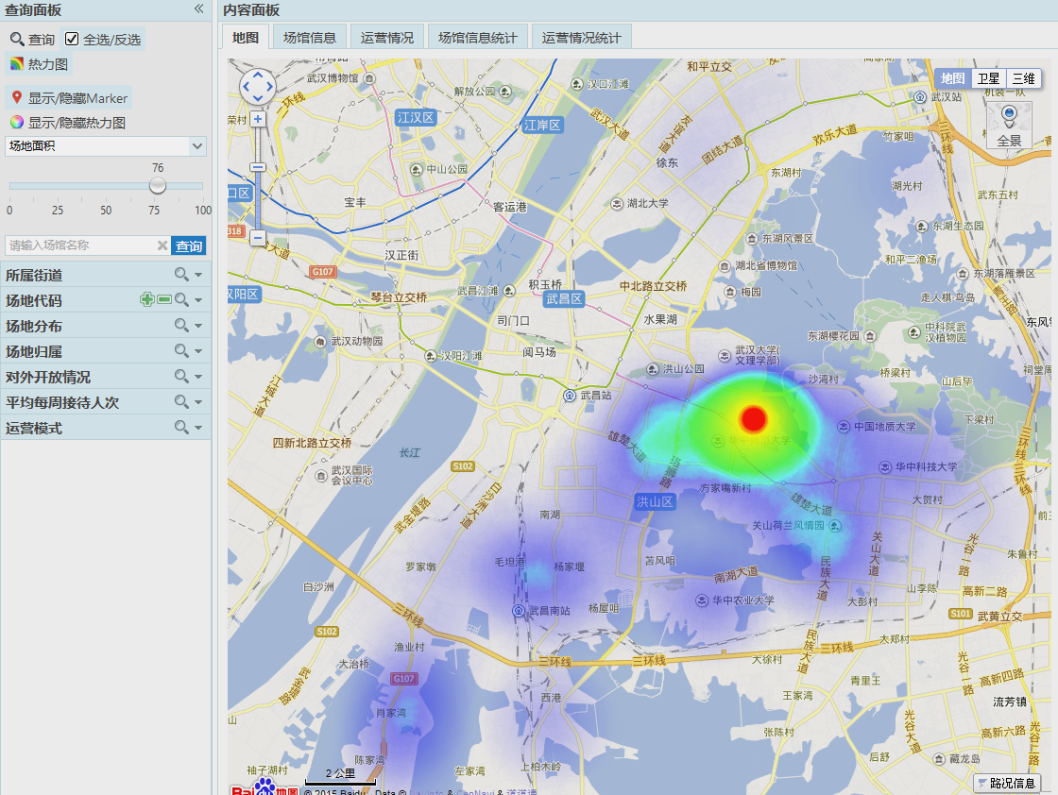
Figue-5 the heat map result of stadiums area statistics
4系统典型界面
The system typical UI
根据上述设计方案、技术路线及关键技术，以洪山区为例，实现了基于LightSwitch和百度地图API的体育场馆信息发布平台，系统运行界面如图3所示。
According to the system design, the Specific development flow and the key technologies, we have implemented the stadium information release platform based on LightSwitch and Baidu Maps API successfully. The system operation interface is shown blow.
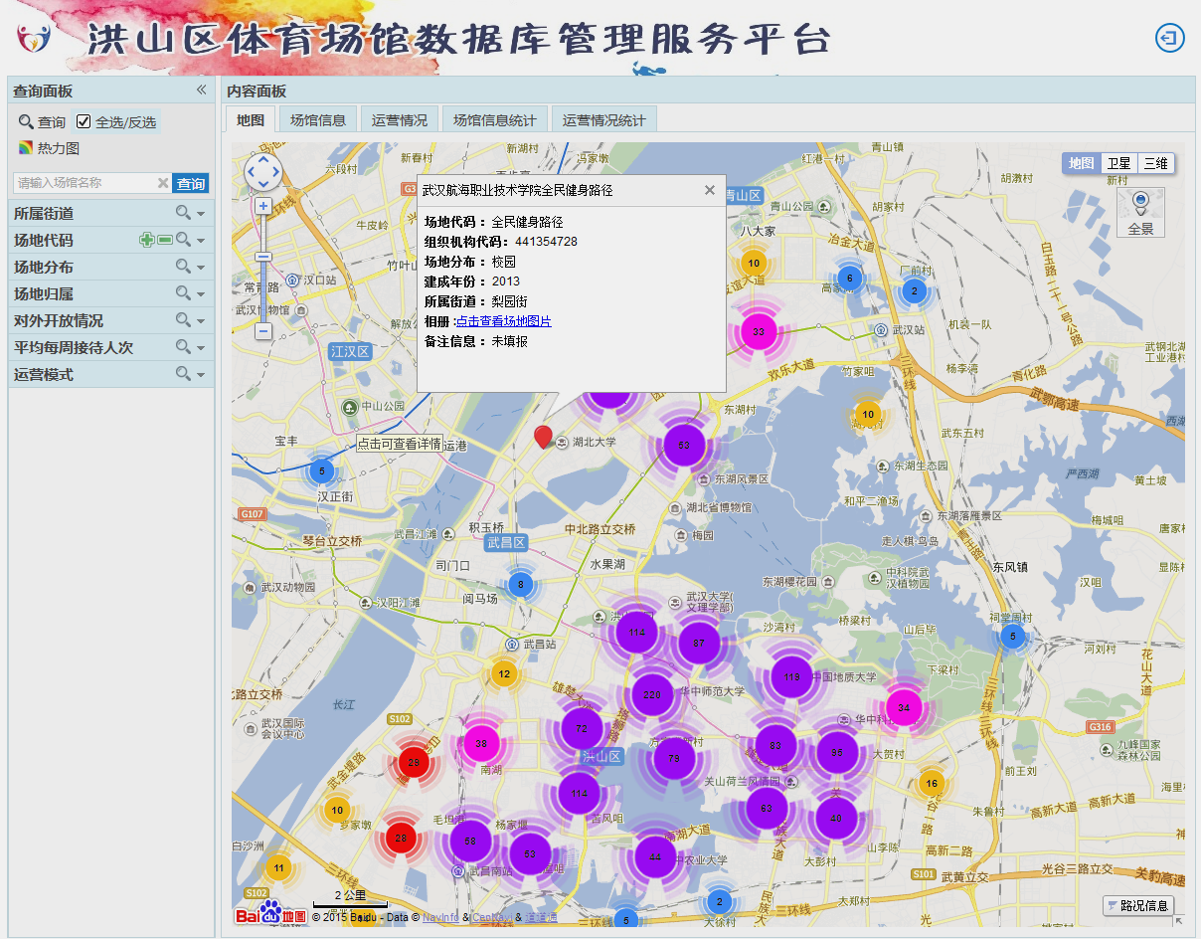
Fig-6 the query result of stadiums
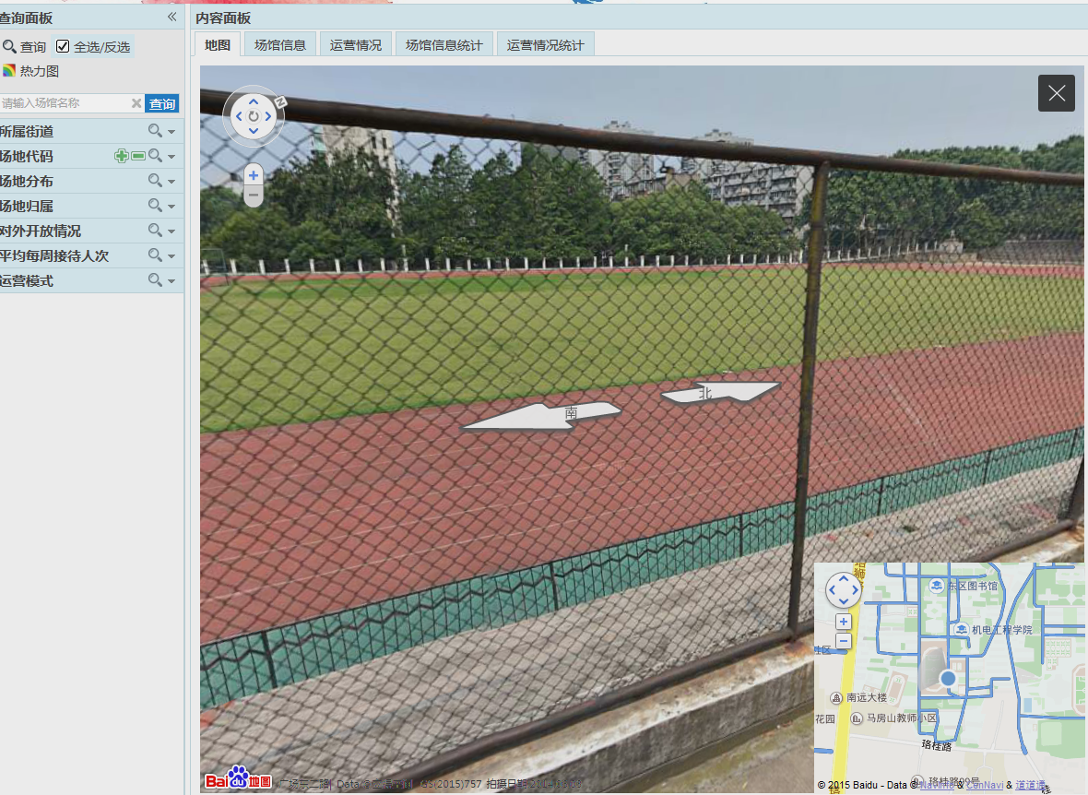
Fig-7 the paranoma roaming
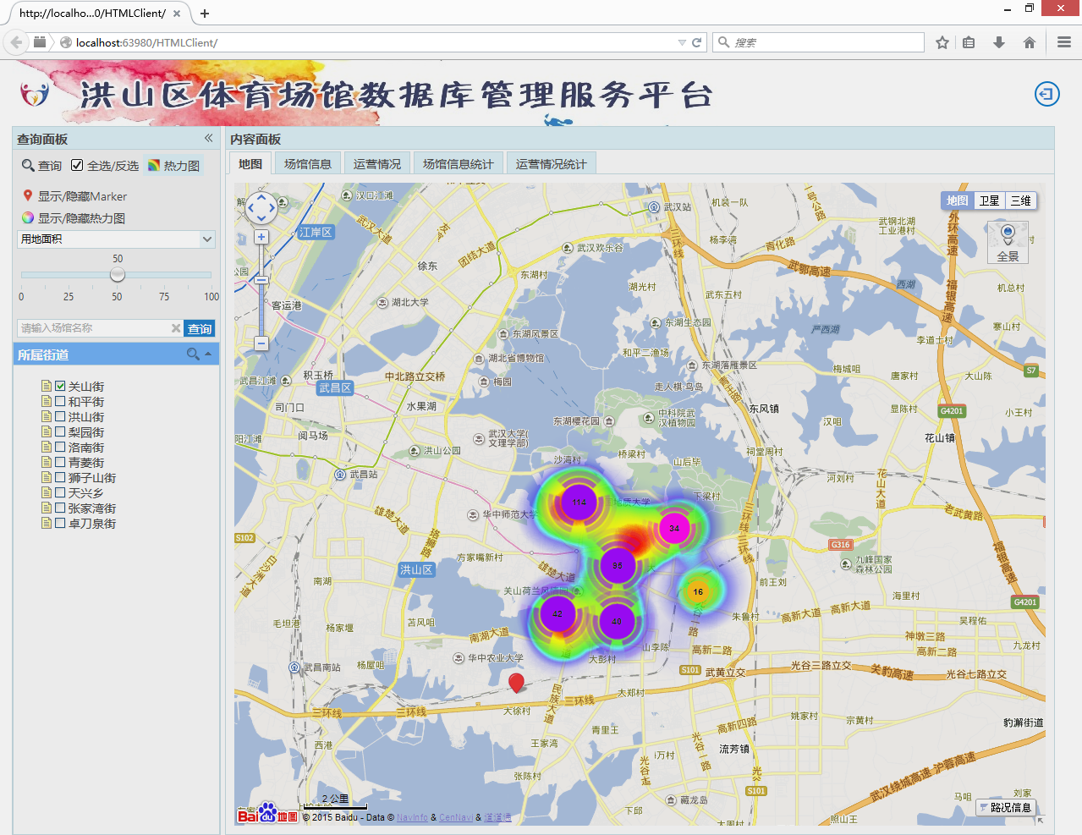
图3网页浏览界面
Fig.1 The web browser interface
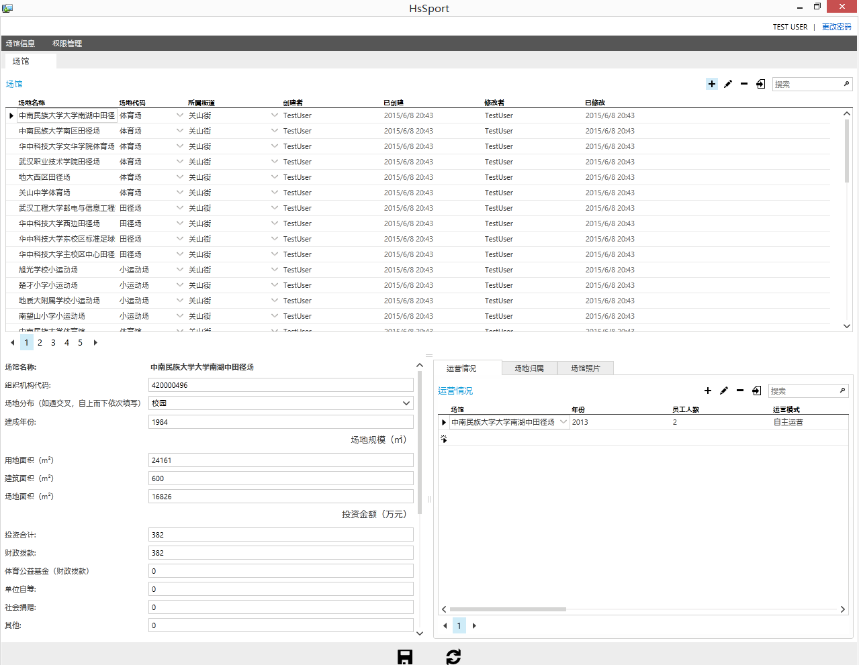
图8数据库管理界面
Fig.8 The database management interface

五、结语

Conclusion
通过采用LightSwitch开发框架结合百度地图API的方式，建设地理信息数据发布平台，能有效解决传统地理信息系统平台建设周期长，建立过程复杂，建设成本和维护成本高等弊端[Error: Reference source not found]，通过使用百度地图API，降低了整个平台的周期、成本和开发风险[]。
By using LightSwitch development framework and Baidu Maps API to build the geographic information publishing platform can effectively solve the traditional platform construction drawbacks such as long-term building, complex processing, high cost of construction and maintenance, etc. [new3].
本文以洪山区体育场馆信息发布平台为例，介绍了LightSwitch结合百度地图API快速开发地理信息发布平台的方法与其中一些关键技术。在平台实际运行过程中，具备维护简单，使用方便等特点。在网页项目中系统查询效率通过使用RIA技术有明显提升，达到用户对于性能的要求。
In this paper, we take Hongshan district stadium information publishing platform as an example to introduce an agilely solution to build the geographic information publishing platform by Microsoft LightSwitch and Baidu Maps API.

参考文献：

[?] 杜传明. 百度地图API在小型地理信息系统中的应用[J]. 测绘与空间地理信息，2011，34（2）：152-154.
[?] 张倩，靳云通，罗勇，张鸿吉. 基于百度地图API的农特产品地理信息系统设计与实现[J]. 安徽农业科学.
[?] Beth Massi. Advanced Programming Made Easy With Visual Studio LightSwitch [J]. MSDN Magazine.2011.
[?] 百度. 百度地图API[EB/OL].http://api.map.baidu.com.
[?] 百度. 百度地图 JavaScript API v2.0开发指南文档.
[?] MSDN. WCF RIA Services [EB/OL]. MSDN Library- Web开发.
[?] Tim Leung. Creating and Using RIA Services. Visual Studio LightSwitch 2012.
[?] Tim Leung. Authenticating Your Users. Visual Studio LightSwitch 2012.
[?] Michael Washington. Using ServerApplicationContext. Creating HTML5 Websites and Cloud Business Apps Using LightSwitch in Visual Studio 2013.
[?] 百度. 百度地图热力图. 百度百科.
[?] 程彬，段浩宇，董炜华. 基于百度地图API的购房平台系统开发[J] 长春师范大学学报（自然科学版）. [9] Valerie Andersen, Matt Evans, Sheel Shah, Michael Simons. LightSwitch Security - Securing Access to LightSwitch Applications[J] MSDN Magazine.2011 [new2] wiki. Heat Map

