ESD lab3 Report

192050214 Mu Yuankai

1.add include

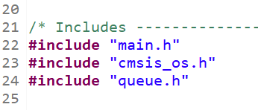

2.create xQueueHandle object

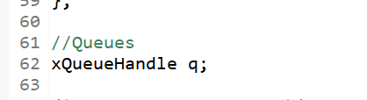

3.create a queue in main function

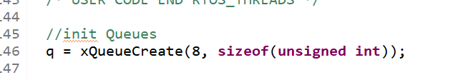

4.use method xQueueSend to send message and method xQueueReceive to receive

