Homework 4:

Reinforcement Learning

Part l. Implementation:

taxi:

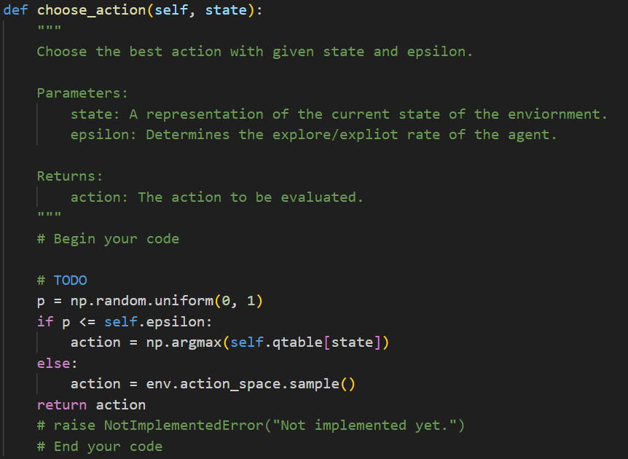

In the choose action part, I declare a variable called ‘p’ to store the random number, like possibility. If it is smaller than ‘epsilon’, then action is the one which has the maximum value in ‘qtable’ with this state. If not, then choose one action randomly by using ‘sample()’.

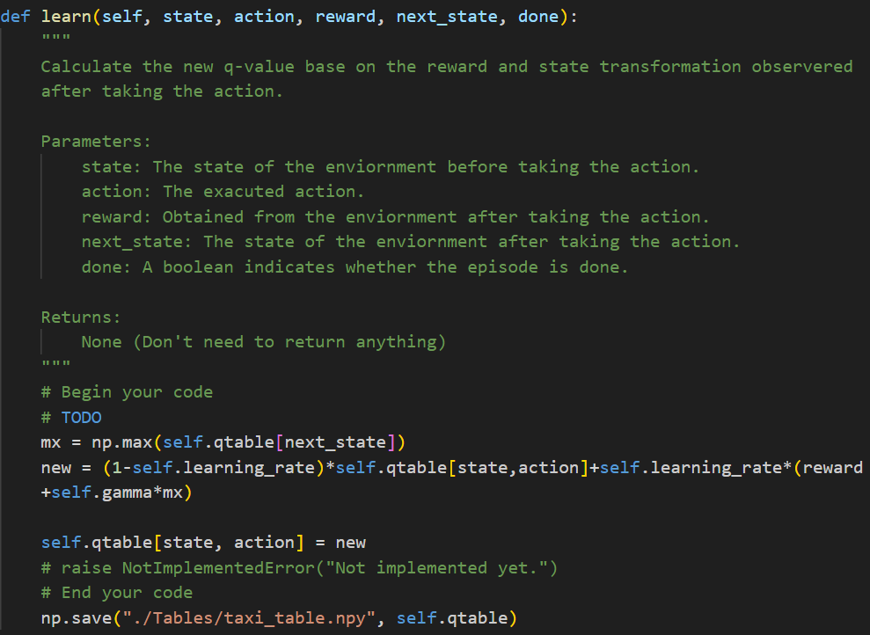

In learn part, I implement the formula of new value of the state

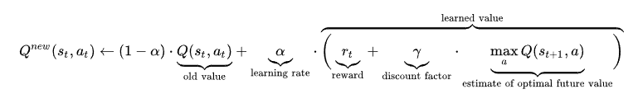

which alpha is learning rate, and old value is from ‘qtable’ with this state and action, and rt is reward, and discount factor is ‘self.gamma’, and maximum value of next state is from ‘qtable’ but using ‘next_state’ to search.

After this calculation, updating the value in the ‘qtable’ with this state and action.

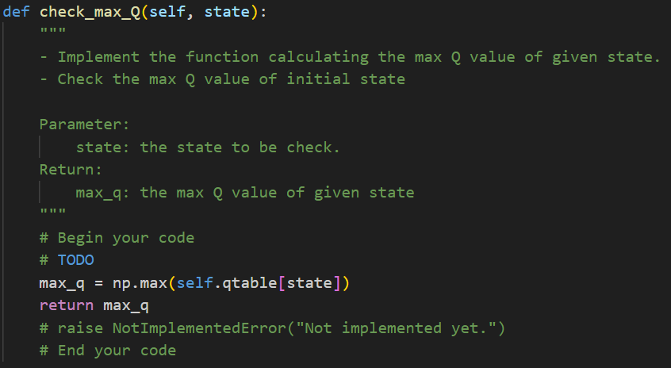

In check max Q part, What I do is just find the maximum value in ‘qtable’ with the state and return.

cartpole:

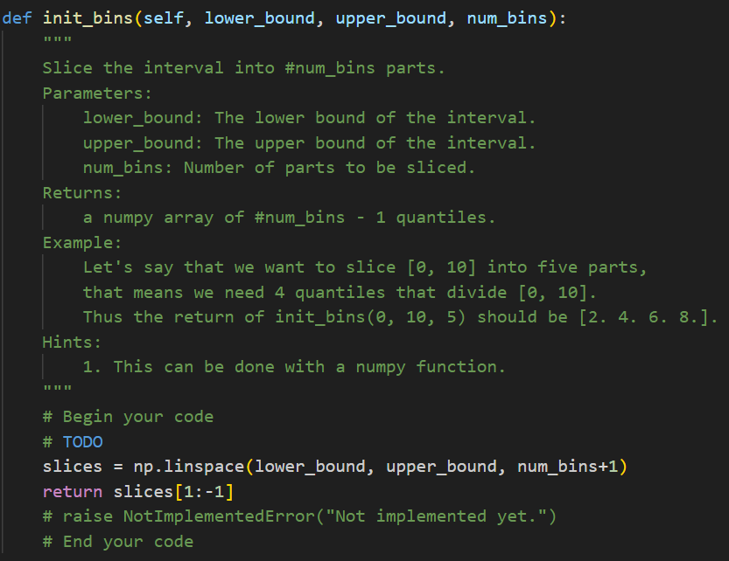

In init bins part, I use function ‘np.linspace’ to implement. Because in this function, the number of slices will equals to the third component value, I add the ‘num_bins’ by 1, and return the result without the first one and the last one.

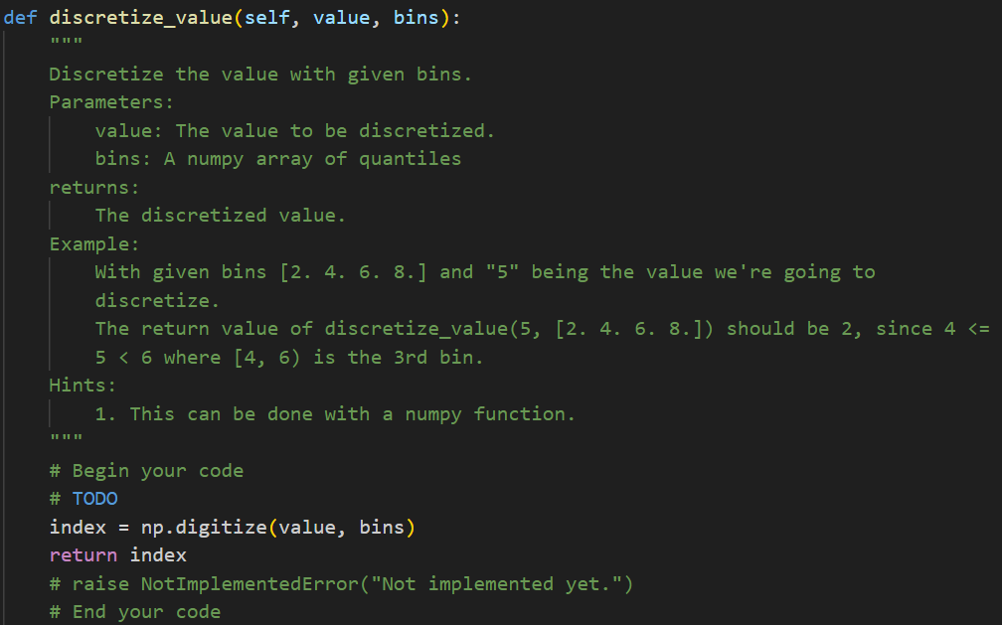

In discretize value part, I use the function ‘np.digitize’ to implement. By this function, I can find which interval includes this value((-inf, first component) is index 0), and return the index generated by this function.

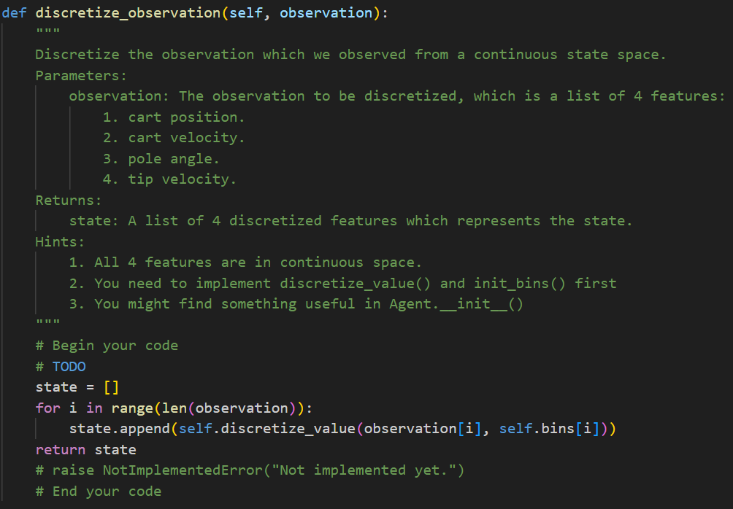

In discretize observation part, I implement by the function I have done called ‘discretize_vale’. According to the constructor, there is a object called ‘bins’ which has done the ‘init_bins’, I use it to find the interval index directly. I set a list called ‘state’ to store the four features, and use a for loop to find the interval index of each value in ‘observation’, and put them into state, and return state.

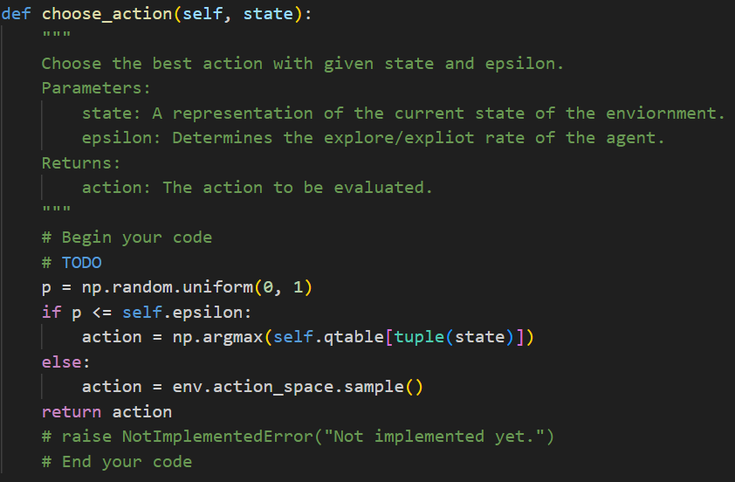

In this part, it is similar to the same part in taxi.py. However, because there are more dimension in ‘qtable’ than taxi.py, I use the ‘tuple’ to change the form of ‘state’, making it can be the index in ‘qtable’, and find the maximum value’s index.

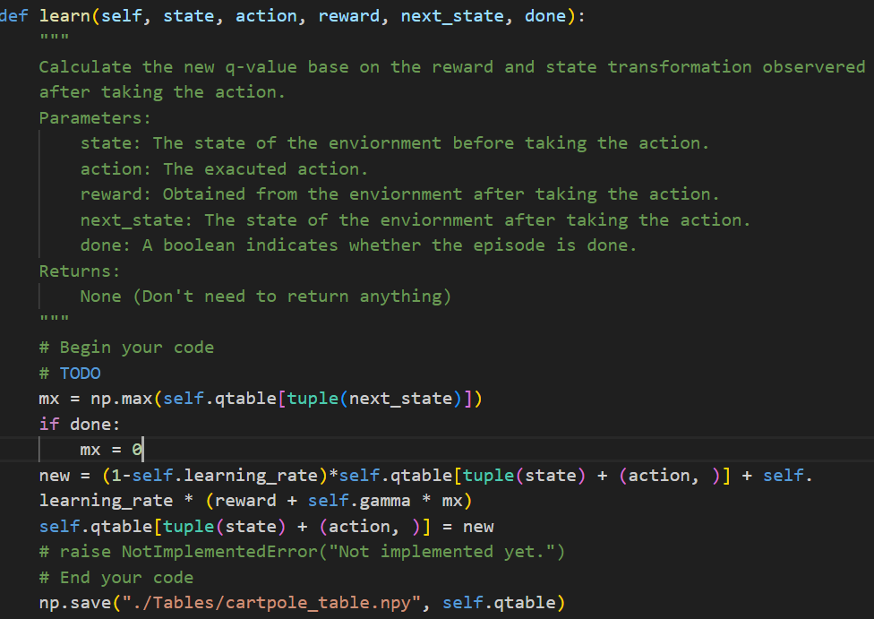

In this part, it’s similar to the same part in taxi.py, and use the same way to deal with the ‘qtable’ index problem, and if want to find the value of specific state with specific action, use ‘tuple(state) + (action, )’. A little different is that if ‘done’ is one, I set the maximum q value of the next state = 0 to calculate the new q value of this state because the episode ends.

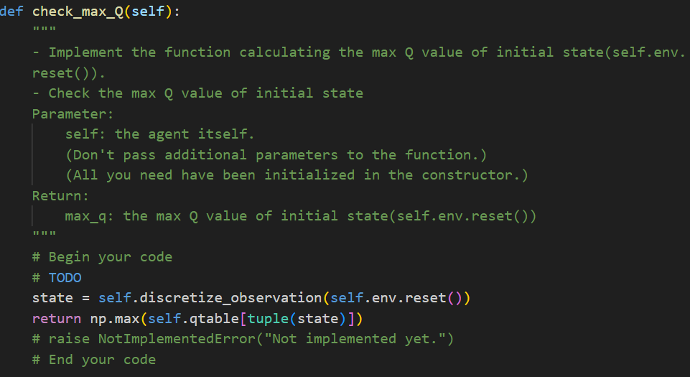

In this part, it’s similar to the same part in taxi.py, but it can’t use state directly because there is no this object in the function component. Therefore, because it need the initial state’s maximum q value, I use the function has been done called ‘discretize_observation’ with ‘self.env.reset()’ to get the indexes of each feature data in the initial state, and search the maximum value of this state in ‘qtable’, and return it.

DQN:

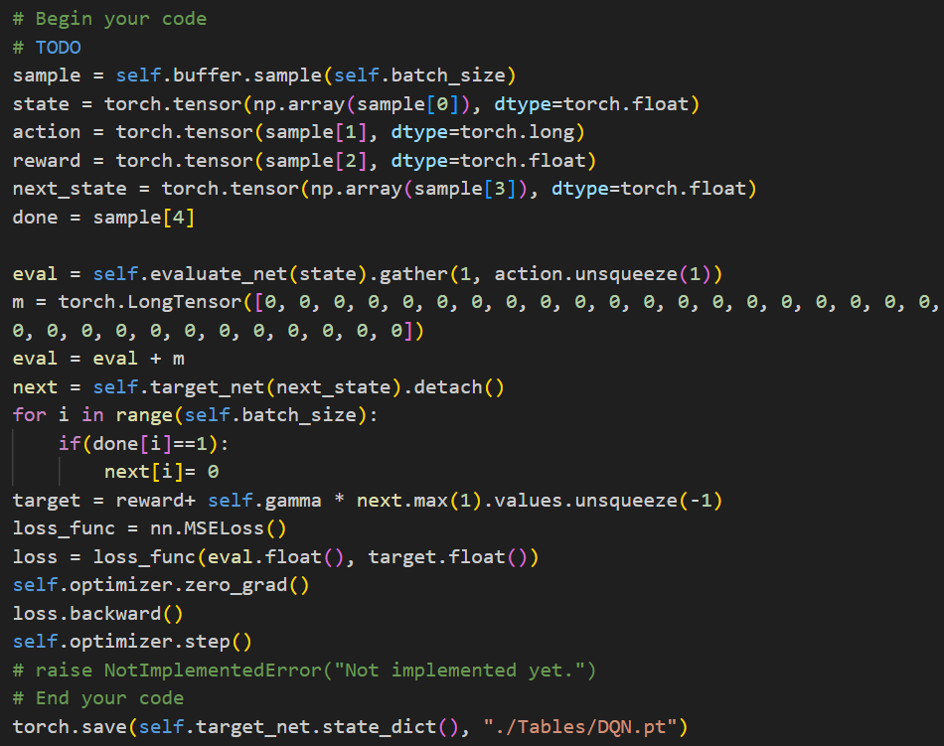

First, I do the ‘sample trajectories of batch size from the replay buffer’. I select some sample randomly from ‘buffer’, which number depends on ‘batch size’. After that, I use ‘torch.tensor’ and ‘np.array’ to change first item of sample into numpy array, and then into pytorch tensor, and components’ type is float, and then put into ‘state’. Next, use the similar way to change components in sample into ‘action’, ‘reward’, and ‘next_state’ respectively(‘action’ and ‘reward’ don’t need ‘np.array’), and ‘done’ equals to fourth item of sample.

Second, I do ‘forward the data to the evaluate net and target net’. I use the function ‘evaluate_net’ with ‘state’ declared before to get the q value of evaluation network now, and according to the value of ‘action.unsqueeze(1)’, select the corresponding components of each column and put the results into ‘eval’, and plus ‘eval’ with ‘m’ which length is 32 and all zero to specify ‘eval’ length.

Next, I do the ‘compute the loss with MSE’. I use ‘target_net’ with ‘next_state’ to evaluate the q value in target network, and separate components by ‘detach()’ and put them into ‘next’. Depending on corresponding index value of ‘done’, if it equals to one, then this index value in ‘next’ equals to zero. I declare ‘target’ which equals to ‘reward’ declared before + ‘self.gamma’(discount factor of this agent) * maximum value in ‘next’, and ‘unsqueeze(-1)’ is used to keep the same dimension in order to calculate with reward easily. I create a function ‘loss_func’ by ‘nn.MSELoss()’, and use it to calculate the loss between q value of ‘eval’ and ‘target’.

Next, I do the ‘Zero-out the gradients’. I use the function ‘zero_grad()’ to empty ‘optimizer’’s gradients which store in ‘grad’ attribute of tensor.

I do the ‘Backpropagation’ by ‘loss.backward()’ which do the back propagation with the gradient of ‘loss’, which can be used to update the model parameters.

I do the ‘Optimize the loss function’ by function ‘step()’ which updates the parameters of ‘optimizer’ according to calculation.

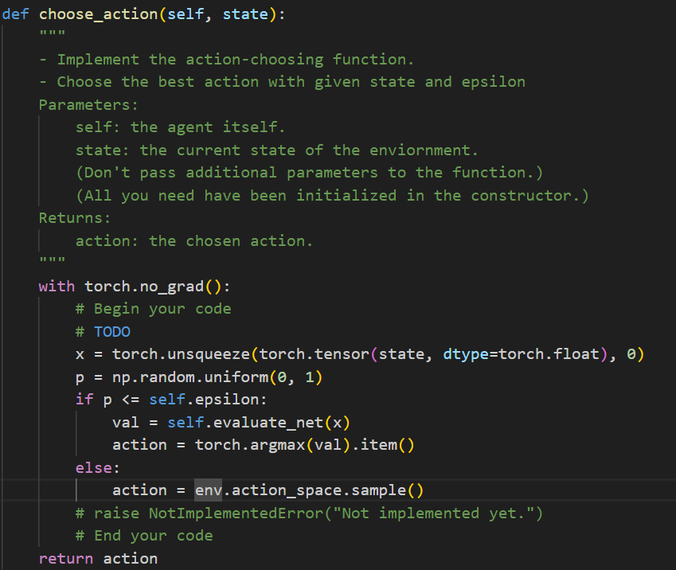

I change ‘state’ into pytorch tensor by function ‘torch.tensor’ and type is torch.float, and use function ‘torch.unsqueeze’ to add one dimension on it(n🡪(1, n)), and put it into ‘x’. the codes below are the epsilon greedy algorithm which has been implemented in the previous code. If p is smaller than epsilon, then calculate the q value of ‘x’ by ‘evaluate_net’, and select the ‘action’ according to the index of maximum value of ‘val’ after changing ‘val’ into scalar by ‘item()’. If not, just select one action in ‘action_space’ randomly.

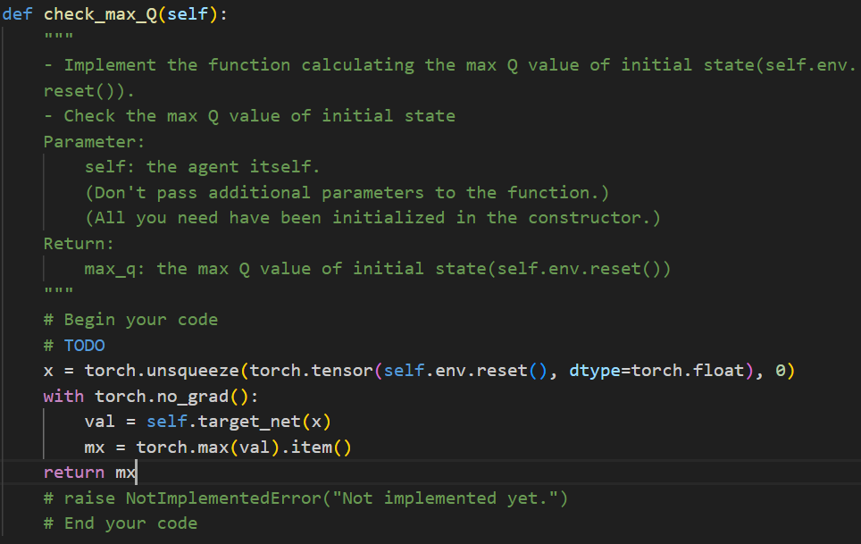

The way to get ‘x’ is the same to the way in the ‘choose_action’ part. There is only one difference is that because I want the check the initial state max q value, therefore, I use ‘env.reset()’ the get the initial state. After getting ‘x’, calculate the q value by ‘target_net’, and select the maximum value by ‘item()’ and ‘torch.max’ to return. Because we don’t need to consider the gradient, I use ‘torch.no_grad()’ to make the calculation ignore the gradient.

Part ll. Experiment Results:

1. taxi.png

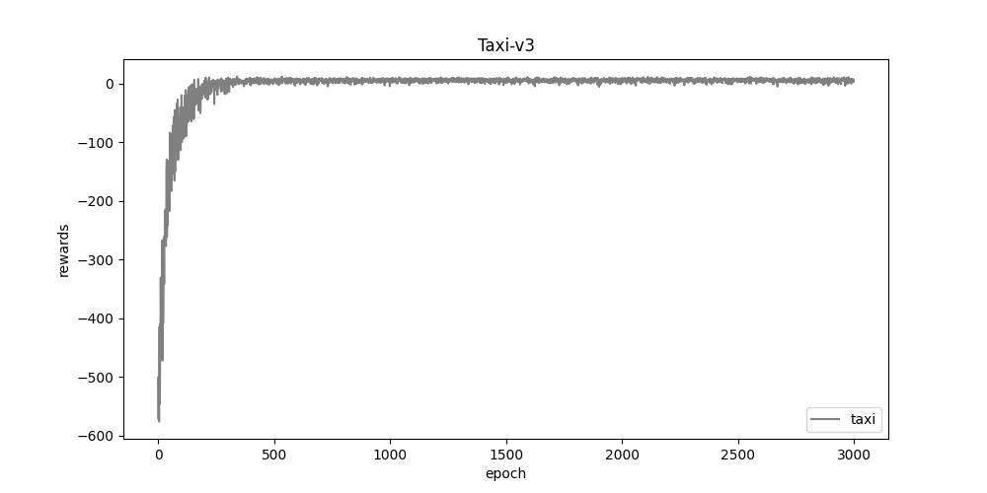

According to this figure, the rewards converge to 0 from -600 when epoch gets larger.

2. cartpole.png

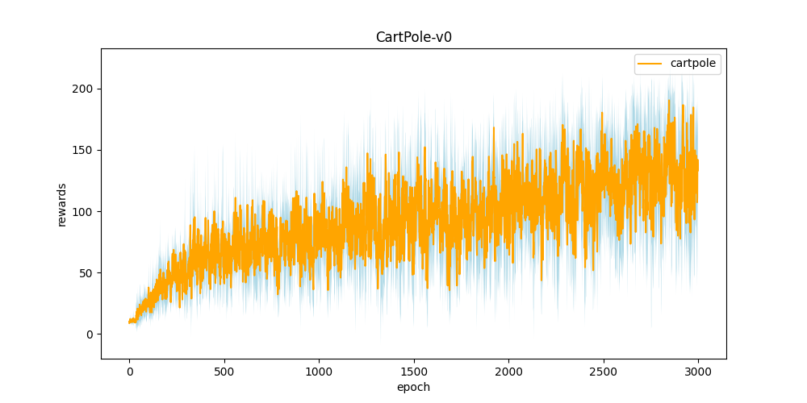

According to this figure, although it has large oscillation, the general trend is increase from near 0 to about 134.

3. DQN.png

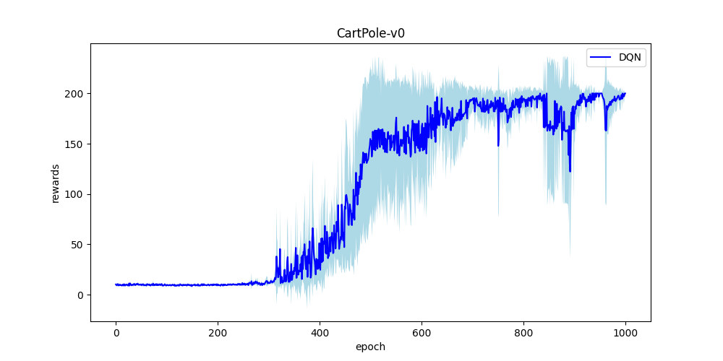

According to this figure, the rewards converge from 0 to about 200.

4. compare.png

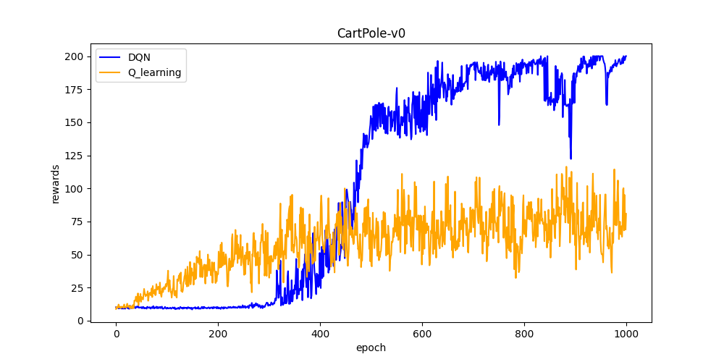

According to this figure, the increase of rewards of DQN is more than Q learning.

Part lll. Question Answering:

1. Calculate the optimal Q-value of a given state in Taxi-v3, and compare with the Q-value you learned (Please screenshot the result of the “check_max_Q” function to show the Q-value you learned).

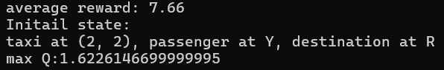

The optimal Q-value I calculate is 12(we need 8 steps from original point to passenger and from passenger to destination, and +20 when arriving the destination 🡪 20 – 8 = 12). It’s bigger than both average reward and max Q.

2. Calculate the optimal Q-value of the initial state in CartPole-v0, and compare with the Q-value you learned(both cartpole.py and DQN.py). (Please screenshot the result of the “check_max_Q” function to show the Q-value you learned)

in cartpole.py

in DQN.py

The optimal Q-value I calculate is 200(+1 in every step and limit of episode is 200 for v0). It’s bigger than both average reward and max Q in cartpole.py, and also bigger than both reward and max Q in DQN.py.

3.

a. Why do we need to discretize the observation in Part 2?

Because we want to represent the states during the movement of the cartpole. However, the movement is continuous, which means that the number of states will be infinite, making it impossible to implement. Therefore, we need to discretize it into specific states and define a finite set of states to work with.

b. How do you expect the performance will be if we increase “num_bins”?

I think that the time the train section takes will be longer, but if we plot the rewards, its oscillation will be smaller.

c. Is there any concern if we increase “num_bins”?

Firstly, it's time-consuming because as the number of bins increases, so does the number of states. Secondly, due to the increased number of states, the difference between two adjacent states may become negligible. Therefore, it would be wasteful to calculate between two states that are almost identical.

4. Which model (DQN, discretized Q learning) performs better in Cartpole-v0, and what are the reasons?

DQN performs better in Cartpole-v0 because it stores the previous experience and select randomly in them to train. This can use the sample more efficiently. Also, since DQN has two neural networks, which can increase the learning stability. However, discretized Q learning only has one Q table, so it will fluctuate more easily.

5.

a. What is the purpose of using the epsilon greedy algorithm while choosing an action?

The purpose is to strike a balance between exploitation and exploration. During exploitation, we select the action with the highest reward to maximize the utilization of the available data. In contrast, during exploration, we opt for actions that haven’t been extensively explored or may not be the best, in order to uncover additional possibilities. This ensures that we avoid overly relying on the currently known optimal strategy during the learning process.

b. What will happen, if we don’t use the epsilon greedy algorithm in the CartPole-v0 environment?

I run the cartpole.py without epsilon greedy, and the result as follow:

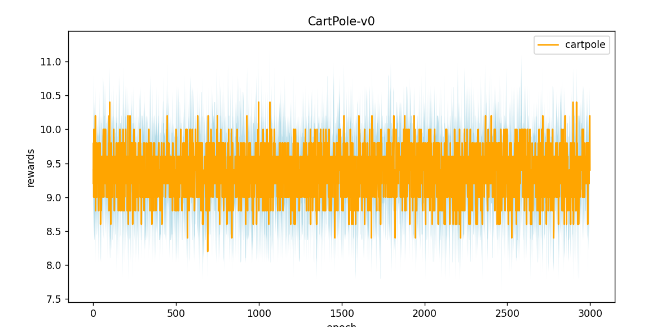

We can find that the rewards will stay about 9.5, and no increasing. This is because without epsilon greedy, this agent is lack of exploration, so it won’t find another way which may get more rewards, and always uses the currently known optimal strategy.

c. Is it possible to achieve the same performance without the epsilon greedy algorithm in the CartPole-v0 environment? Why or Why not?

Yes. If we design another reward function or a different exploration strategy, it may be possible. Also, a good initial policy is helpful. Because with these strategies, we are still possible to reach the more valuable action like epsilon greedy algorithm doing.

d. Why don’t we need the epsilon greedy algorithm during the testing section?

In the training phase, we calculate the best Q-value for states. During the testing phase, the system simply follows the best path we've trained to maximize rewards. It should rely entirely on what we've trained without any exploration. Therefore, there's no need for the epsilon-greedy algorithm.

6. Why does “with torch.no_grad():“ do inside the “choose_action” function in DQN?

Because we don’t update the parameters in the section since we just depend on the currently known q value to choose, we don’t need to trace the gradient. With this one, when we run the code inside it will not care about any data of gradient, which can save the resource and increase the calculation efficiency.