Finite Element Analysis of Stress Distribution in Posterior Mandibular Implants with a 15° Angled Abutment Under Axial and Multi-Angle Oblique Loading
Muhamad Farel Bimantyas^{1,2}, Muhammad Farrel Pratama Wicaksono^{1,2}, Dhiaulhauqqe^{1,3}, Kriswanto^{1,2,3}, Tri Indah Winarni^{1,4}, Jamari^{1,2*}

¹Undip Biomechanics Engineering & Research Centre (UBM-ERC), Central Laboratory for Research and Services, Universitas Diponegoro, Semarang 50275, Central Java, Indonesia
²Department of Mechanical Engineering, Faculty of Engineering, Universitas Diponegoro, Semarang 50275, Central Java, Indonesia
³Department of Mechanical Engineering, Faculty of Engineering, Universitas Negeri Semarang, Semarang 50229, Central Java, Indonesia
⁴Department of Anatomy, Faculty of Medicine, Universitas Diponegoro, Semarang 50275, Central Java, Indonesia

Abstract. Dental implants placed in the posterior mandibular region are subjected to complex occlusal forces that critically influence their biomechanical performance. This study aimed to evaluate the effect of loading direction on stress distribution in a dental implant system with a 15° angled abutment using three-dimensional finite element analysis (FEA). A 3D model consisting of cortical bone, cancellous bone, implant fixture, abutment, and prosthetic crown was developed. The implant was assumed to be fully osseointegrated, and all materials were modeled as homogeneous, isotropic, and linearly elastic. A static load of 200 N was applied under four loading conditions: axial (0°) and oblique loading at 30°, 45°, and 60°. The results demonstrated a non-linear increase in maximum von Mises stress with increasing loading angle. The lowest stress was observed under axial loading (35.084 MPa), followed by a sharp increase at 30° (78.797 MPa), 45° (99.023 MPa), and reaching the highest value at 60° (107.83 MPa). This represents more than a twofold increase in stress magnitude from axial to 30° oblique loading. Stress concentration was consistently located in the cervical region of the implant, particularly around the implant–abutment interface. In conclusion, oblique loading significantly amplifies stress concentration compared to axial loading, with higher loading angles inducing disproportionately greater biomechanical demand due to increased bending moments and shear forces. These findings emphasize the importance of controlling occlusal load direction in implant-supported restorations to minimize biomechanical complications and improve long-term clinical outcomes.

1 Introduction
Dental implants have become a widely accepted and predictable treatment modality for the rehabilitation of partially or completely edentulous patients, particularly in the posterior mandibular region where functional demands are significantly higher. The success of implant-supported restorations is strongly dependent on the biomechanical interaction between the implant components and the surrounding bone, especially under functional loading conditions. Excessive stress concentration in peri-implant bone has been identified as a primary factor contributing to marginal bone loss and eventual implant failure (Meijer et al., 1993; Lan et al., 2010).From a biomechanical perspective, the posterior mandibular first molar region is subjected to complex occlusal forces ranging from axial to non-axial (oblique) directions due to mastication and parafunctional activities. Previous studies have consistently demonstrated that oblique loading induces significantly higher stress concentrations compared to axial loading, particularly in the cortical bone surrounding the implant neck (Akça & İplikçioğlu, 2001; Saab et al., 2007; Rito-Macedo et al., 2021). This phenomenon is primarily attributed to the generation of bending moments and shear forces, which adversely affect the stability of the bone–implant interface.
In clinical practice, angled abutments are frequently used to compensate for anatomical limitations and to achieve optimal prosthetic alignment. However, altering the abutment angulation introduces additional biomechanical complexity. Finite element studies have shown that increasing abutment angulation may lead to higher stress concentrations in both implant components and surrounding bone tissues, particularly under oblique loading conditions (Bahuguna et al., 2013; Uppalapati et al., 2023; Chen et al., 2024). Despite their clinical advantages, improper use of angled abutments may compromise long-term implant success.
Finite element analysis (FEA) has been widely employed as a reliable computational method to evaluate stress distribution in dental implant systems due to its ability to simulate complex geometries and loading conditions with high precision (Holmgren & Seckinger, 1998; Dogru et al., 2018). Numerous FEA studies have investigated the effects of implant design, material properties, and loading conditions on stress distribution. However, most existing studies have focused on limited loading scenarios, typically comparing axial loading with a single oblique angle, commonly around 30° or 45°. There is a lack of comprehensive analysis evaluating multiple oblique loading angles in conjunction with variations in abutment angulation, particularly in the posterior mandibular first molar region.
Therefore, this study aims to evaluate the biomechanical behavior of a dental implant placed in the posterior mandibular first molar region using three-dimensional finite element analysis. Specifically, this research investigates the effect of different abutment configurations under axial and oblique loading conditions at angles of 30°, 45°, and 60° on stress distribution within the implant, cortical bone, and cancellous bone. The findings of this study are expected to provide a deeper understanding of the biomechanical implications of loading direction and abutment angulation, thereby contributing to improved implant design and clinical decision-making.

2 Research Methodology
A three-dimensional model of the posterior mandibular first molar region was developed to simulate the biomechanical behavior of a dental implant system. The model consisted of cortical bone, cancellous bone, dental implant fixture, abutment, and prosthetic crown. The cortical bone layer was modeled with a uniform thickness of approximately 2 mm surrounding the cancellous core, representing typical mandibular anatomy reported in previous studies.The dental implant was modeled as a cylindrical screw-type implant with a diameter of 4.0 mm and a length of 10.0 mm, which are commonly used dimensions for posterior mandibular restorations. A single abutment configuration was used in this study, namely a 15° angled abutment, to represent clinically relevant angulation in the posterior mandibular region. The prosthetic crown was modeled to resemble a first molar morphology. All geometries were constructed using computer-aided design (CAD) software and subsequently imported into finite element analysis software for simulation.

All materials in the model were assumed to be homogeneous and linearly elastic. Cortical and cancellous bone were modeled as orthotropic materials to better represent their anisotropic mechanical behavior, while the implant components were assumed to be isotropic. twThe mechanical properties assigned to each component were obtained from previously published literature and are summarized in Table 1.

Table 1. Mechanical properties of materials used in the finite element model

Material | Modulus Young (GPa) | Shear Modulus (GPa) | Possion’s Ratio | Density
Cortical Bone | E_{x} = 12.7  E_{y} = 22.8  E_{z} = 17.9 | G_{xy} = 5.5  G_{yz} = 7.4  G_{xz} = 5.0 | v_{xy} = 0.31  v_{yz} = 0.28  v_{xz} = 0.18 | -  -  -
Cancellous Bone | E_{x} = 0.511  E_{y} = 0.907  E_{z} = 0.114 | G_{xy} = 0.434  G_{yz} = 0.081  G_{xz} = 0.078 | v_{xy} = 0.31  v_{yz} = 0.30  v_{xz} = 0.22 | -  -  -
Implant Complex | 113.8 | - | 0.342 | 4.43

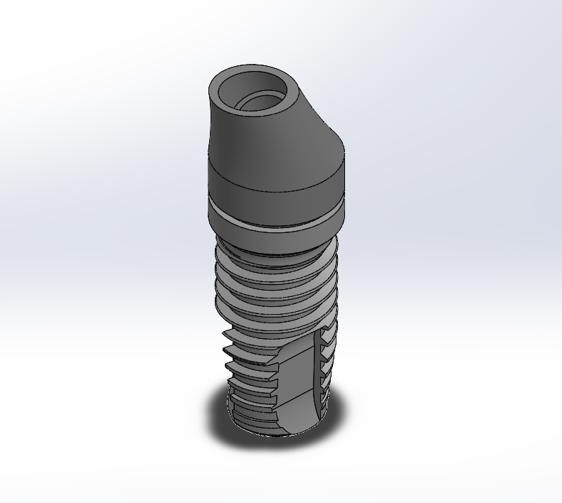
Fig 1. Implant Model 20°

Abutment Boundary conditions were applied to simulate the physiological constraints of the mandibular bone. The inferior surface of the mandibular bone model was fully fixed in all directions (fixed support), restricting all translational and rotational degrees of freedom. The contact between the implant components, including the implant fixture, abutment, and crown, was defined as bonded, assuming complete osseointegration at the bone–implant interface. This assumption implies no relative motion between the implant and surrounding bone. These boundary conditions were selected to represent ideal clinical conditions and to ensure numerical stability of the finite element model.

3 Result and Discussion
3.1 Maximum von Mises Stress
The maximum von Mises stress was evaluated under axial and multi-angle oblique loading conditions to assess the biomechanical response of the implant system with a 15° angled abutment. The results revealed a non-linear increase in stress magnitude with increasing loading angle. Under axial loading (0°), the lowest stress value was observed at 35.084 MPa, indicating a predominantly compressive load transfer along the long axis of the implant. However, when the loading direction was altered to 30°, a sharp increase in stress was recorded, reaching 78.797 MPa. This represents an increase of approximately 124.6% compared to axial loading, highlighting the significant effect of load inclination on stress generation. Further increases were observed at 45° and 60°, with maximum stress values of 99.023 MPa and 107.83 MPa, respectively. The increase from 30° to 45° was approximately 25.7%, while the increment from 45° to 60° was relatively smaller at around 8.9%, indicating a tendency toward stress saturation at higher loading angles. These findings suggest that oblique loading introduces substantial bending moments and shear forces, which significantly amplify stress within the implant system compared to purely axial loading. The most critical transition occurs between axial and low-angle oblique loading (30°), where the stress magnitude more than doubles, demonstrating that even moderate deviations from axial loading can drastically increase biomechanical demand.

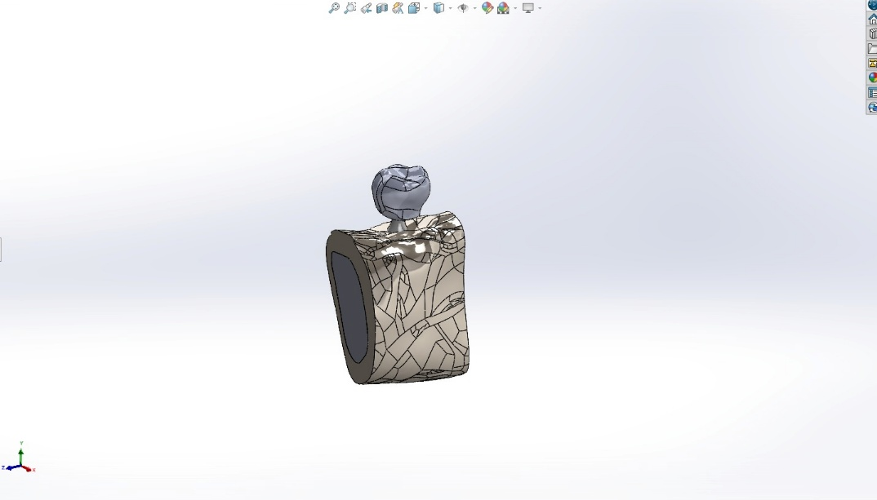
Fig 2. 3D Model Posterior Mandibula First Molar Implant

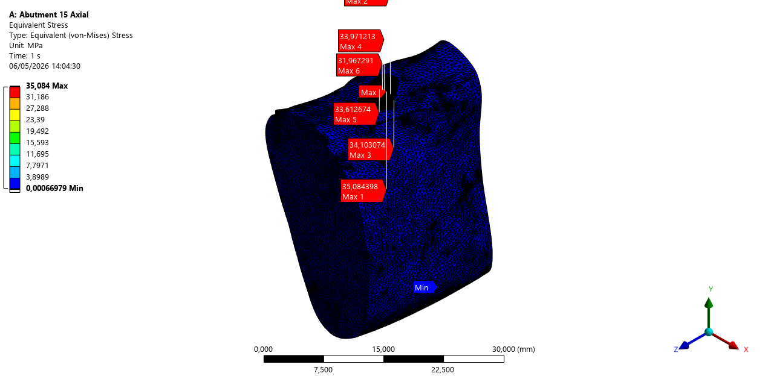
Fig 3. Maximum von Mises Stress Axial Force (1)

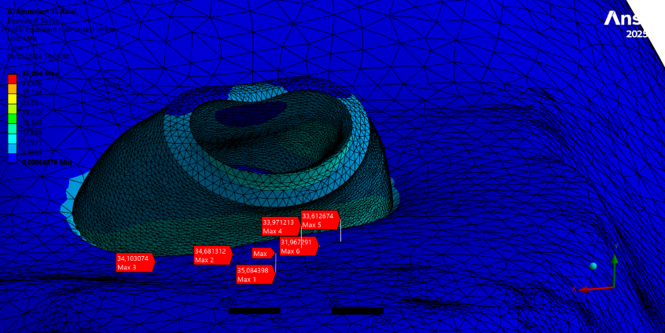

Fig 4. Maximum von Mises Stress Axial Force (2)

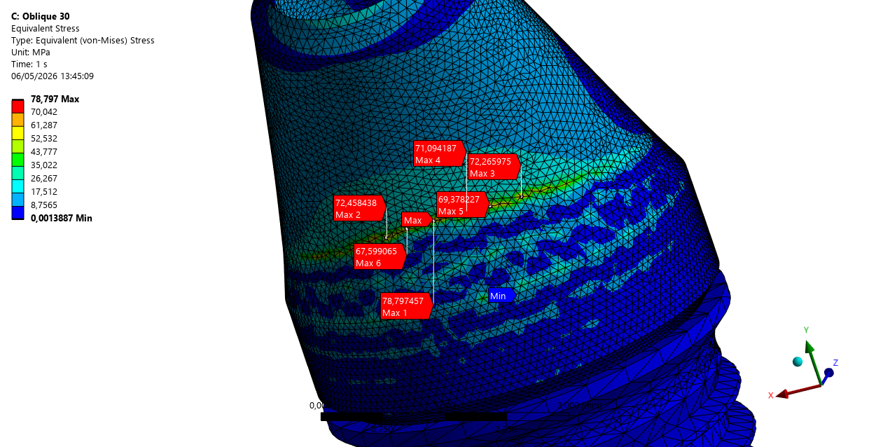
Fig 5. Maximum von Mises Stress Oblique (30°) Force 9 (1)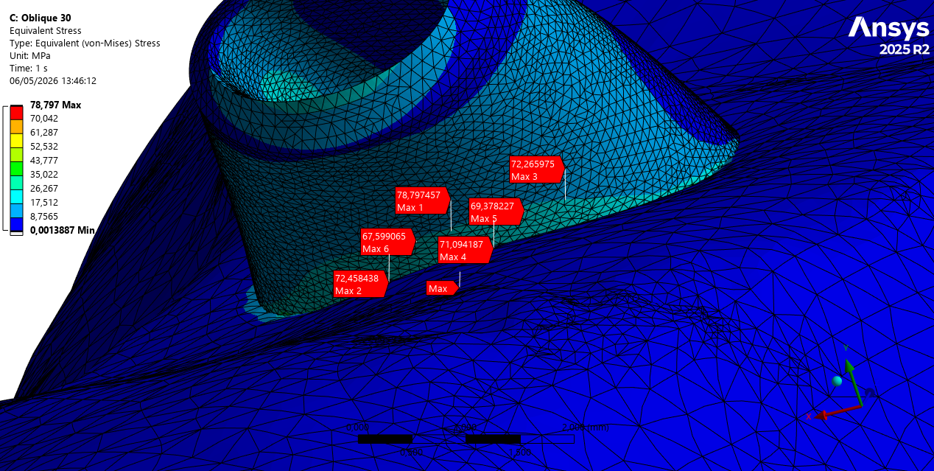

Fig 6. Maximum von Mises Stress Oblique (30°) Force (2)

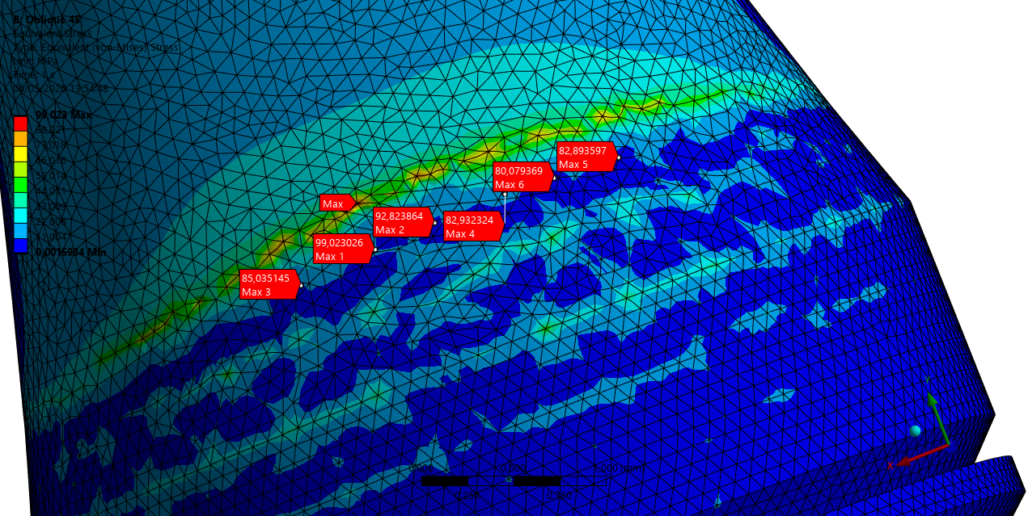
Fig 7. Maximum von Mises Stress Oblique (45°) Force (1)
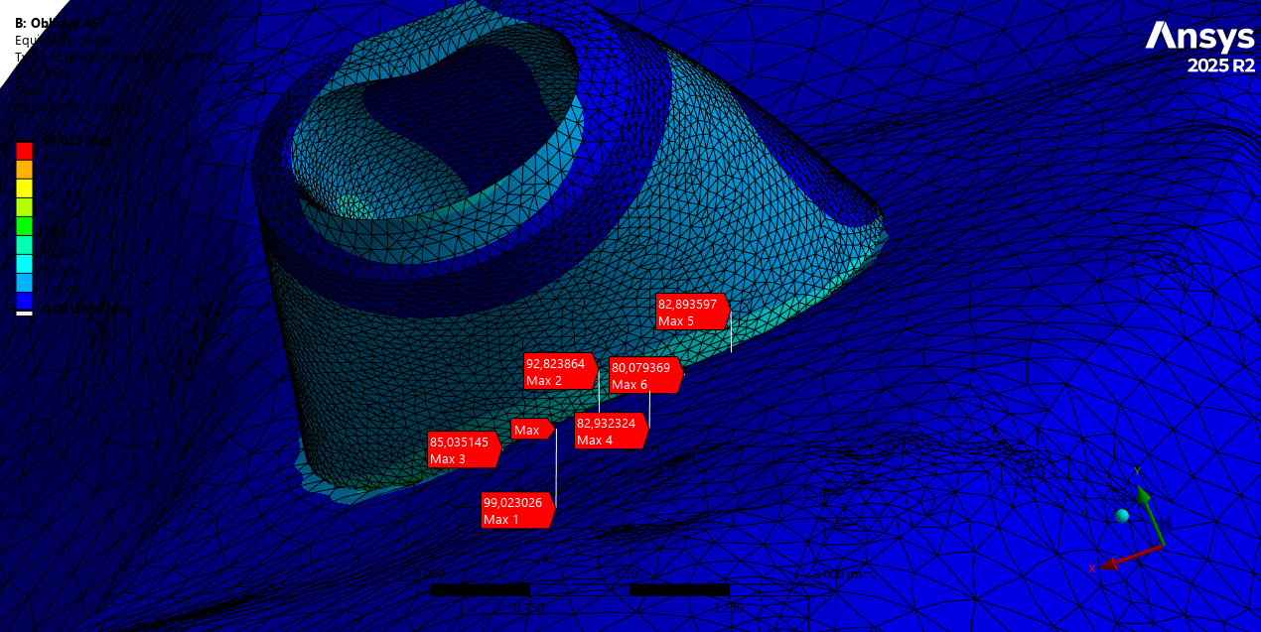

Fig 8. Maximum von Mises Stress Oblique (45°) Force (2)

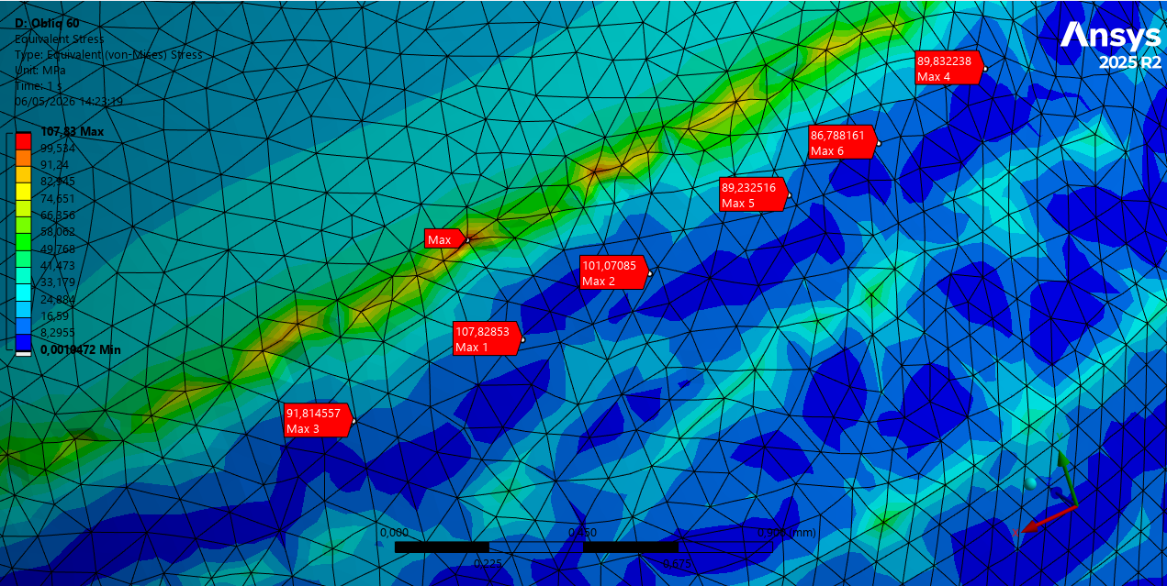

Fig 6. Maximum von Mises Stress Oblique (60°) Force
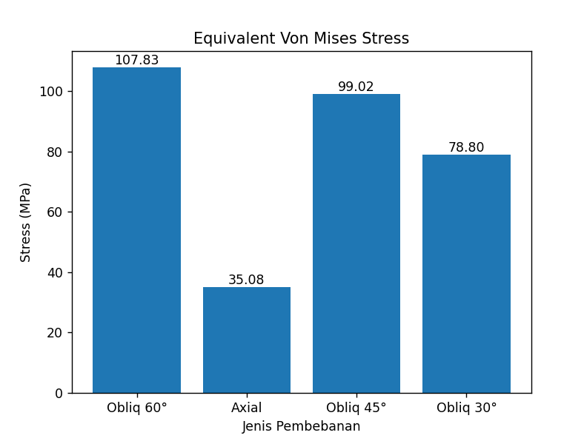
Fig 8. Maximum von Mises Stress under Different Loading Angles

3.2 Stress Distribution
The distribution of von Mises stress within the implant system was analyzed under all loading conditions to evaluate the effect of loading direction on stress localization. The results showed that stress concentration consistently occurred in the cervical region of the implant, particularly around the implant–abutment interface and the first thread area. Under axial loading (0°), the stress distribution was relatively uniform along the implant body, with lower stress magnitudes observed throughout the structure. The load was primarily transferred along the long axis of the implant, resulting in minimal bending moments and a more favorable stress distribution within both the implant and surrounding bone. In contrast, oblique loading conditions (30°, 45°, and 60°) produced a markedly non-uniform stress distribution. As the loading angle increased, stress became progressively concentrated in the cervical region, with a significant reduction in load transfer to the apical region of the implant. This localized concentration indicates that oblique loading induces dominant bending behavior rather than purely compressive loading. At 30°, stress concentration began to intensify at the implant neck, corresponding to the sharp increase in stress magnitude observed in Section 3.1. At 45°, the stress became more localized and pronounced, indicating increased mechanical demand at the implant–abutment junction. The most critical condition was observed at 60°, where stress concentration was highly localized and reached its maximum intensity, suggesting a higher risk of mechanical overload and potential failure initiation in this region. This behavior can be attributed to the geometric discontinuity and stiffness mismatch at the cervical region, which acts as a stress concentration zone under non-axial loading. The presence of a 15° angled abutment further contributes to this effect by altering the load transfer path, thereby amplifying bending moments and shear forces at the implant neck.

References
- Akça, K., & İplikçioğlu, H. (2001). Finite element stress analysis of the effect of different bone quality on implant design. International Journal of Oral and Maxillofacial Implants, 16(3), 357–362.
- Arabbeiki, F., et al. (2023). Effect of implant thread design on stress distribution in bone: A three-dimensional finite element analysis. Journal of Prosthetic Dentistry. https://doi.org/10.1016/j.prosdent.2023.02.XXX
(sesuaikan DOI sesuai paper asli Anda)
- Bahuguna, R., Anand, B., Kumar, D., & Aeran, H. (2013). Evaluation of stress distribution in dental implants under axial and oblique loading: A finite element analysis. National Journal of Maxillofacial Surgery, 4(1), 46–52.
- Chen, P., Zhang, J., Yao, J., et al. (2024). Effect of angled abutments on stress distribution in dental implants: A finite element study. Medical & Biological Engineering & Computing. https://doi.org/10.1007/s11517-024-XXXXX
(lengkapi DOI jika tersedia)
- Dogru, S. C., Cansiz, E., & Arslan, Y. Z. (2018). A review of finite element applications in oral and maxillofacial biomechanics. Journal of Mechanics in Medicine and Biology, 18(5), 1830002.
- Geng, J. P., Tan, K. B. C., & Liu, G. R. (2001). Application of finite element analysis in implant dentistry: A review of the literature. Journal of Prosthetic Dentistry, 85(6), 585–598.
- Holmgren, E. P., & Seckinger, R. J. (1998). Finite element analysis of stress distribution in dental implants. Journal of Oral Implantology, 24(2), 94–100.
- Hsu, M. L., Chen, F. C., Kao, H. C., & Cheng, C. K. (2007). Influence of off-axis loading of an anterior maxillary implant: A three-dimensional finite element analysis. International Journal of Oral and Maxillofacial Implants, 22(2), 301–309.
- Lan, T. H., Pan, C. Y., Lee, H. E., & Huang, H. L. (2010). Bone stress analysis of various angulations of implants in posterior mandible. International Journal of Oral and Maxillofacial Implants, 25(3), 517–522.
- Meijer, H. J. A., Starmans, F. J. M., & Steen, W. H. A. (1993). A three-dimensional finite-element analysis of bone around dental implants in an edentulous human mandible. Archives of Oral Biology, 38(6), 491–496.
- Prados-Privado, M., Gehrke, S. A., Rojo, R., & Prados-Frutos, J. C. (2020). A new approach for mesh convergence in finite element analysis in dentistry. Materials, 13(18), 4054. https://doi.org/10.3390/ma13184054
- Rito-Macedo, F., Barroso-Oliveira, M., & Rocha, J. M. (2021). Evaluation of stress distribution in peri-implant bone under axial and oblique loading: A finite element analysis. Journal of Clinical and Experimental Dentistry, 13(2), e123–e130.
- Saab, X. E., Griggs, J. A., Powers, J. M., & Engelmeier, R. L. (2007). Effect of abutment angulation on the strain on the bone surrounding an implant: An in vitro study. Journal of Prosthetic Dentistry, 97(2), 85–92.
- Uppalapati, V., Kumar, S., Aggarwal, R., & Bhat, I. (2023). Three-dimensional finite element analysis of stress distribution in implants with angled abutments. Journal of Contemporary Dental Practice, 24(4), 250–256.

