## Assignment_16-08-2024

Author: ThanhTH10

Date: 19/08/2024

August-16:

1. How to generate documentation with doxygen tool for c++ [programs](https://lms.vectorinstitute.in/mod/folder/view.php?id=67923" \o "Programs).

Step 1: Comment in cpp file

#include <stdio.h>

/**

 * @brief class A to store safely divides function

 *

 */

class A

{

public:

    /**

     * @brief Safely divides two numbers, handling division by zero.

     *

     * @param numerator The dividend.

     * @param denominator The divisor.

     * @return The result of the division as a float, or 0.0 if division by zero is attempted.

     */

    static float safeDivide(int numerator, int denominator)

    {

        if (denominator == 0)

        {

            printf("Error: Division by zero is not allowed.\n");

            return 0.0;

        }

        return (float)numerator / denominator;

    }

};

/**

 * @brief Main function to test safe division

 *

 * @return int

 */

int main()

{

    int num1, num2;

    float result;

    printf("Enter numerator: ");

    scanf("%d", &num1);

    printf("Enter denominator: ");

    scanf("%d", &num2);

    result = A::safeDivide(num1, num2);

    if (num2 != 0)

    {

        printf("Result: %.2f\n", result);

    }

    return 0;

}

Step 2: Config doxygen file and run command

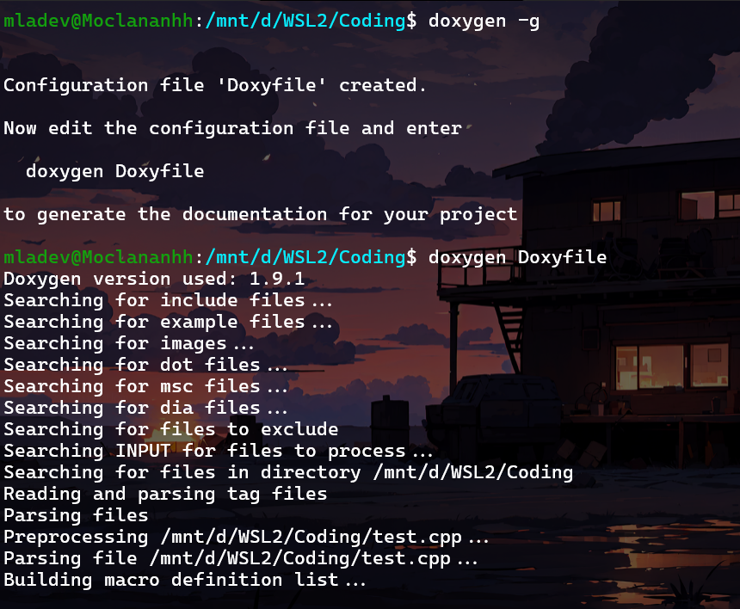

Step 3:

Open index.html

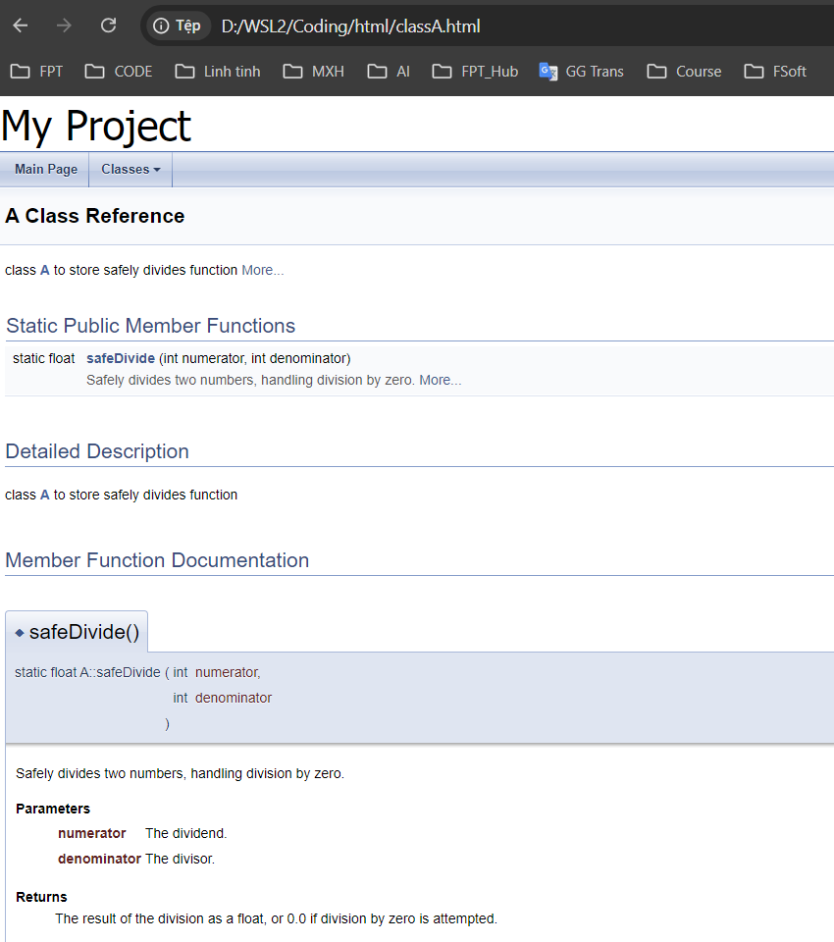

2.

int main()

{

char *s=”rama”; -> Why it is not part of stack/heap?

printf(“%s”,s);

}

The string literal "rama" is not allocated on the stack or heap. Instead, it is stored in a special section of the memory called the **read-only data segment** (sometimes called the **text segment** or **constant data segment**).

**- String Literals are Immutable**: String literals in C are stored in a read-only section of the memory. This is because string literals are typically immutable (cannot be modified). Thus, "rama" is placed in this read-only data segment by the compiler, which persists for the entire lifetime of the program.

**- Pointer** s **on Stack**: The pointer s itself is stored on the stack because it is a local variable of the main function. However, the string "rama" that s points to is in the read-only data segment.

**- Not on Heap**: The string literal "rama" is not stored on the heap because the heap is used for dynamic memory allocation

### Memory Layout:

* **Stack**: The pointer s is stored on the stack.
* **Read-only Data Segment**: The string literal "rama" is stored in a read-only memory segment.
* **Heap**: Not used in this case because no dynamic memory allocation has been performed.

3.Create Distance class with feet and inches as data members. Perform add, subtract with + and – operator overloading

#include <iostream>

using namespace std;

class Distance

{

    float feet;

    float inches;

public:

    Distance(float f = 0.0, float i = 0.0) : feet(f), inches(i) {}

    void display()

    {

        cout << feet << " feet, " << inches << " inches" << endl;

    }

    Distance operator+(const Distance &d);

    Distance operator-(const Distance &d);

};

Distance Distance::operator+(const Distance &d)

{

    float totalFeet = feet + d.feet;

    float totalInches = inches + d.inches;

    if (totalInches >= 12.0)

    {

        int extraFeet = totalInches / 12.0;

        totalFeet += extraFeet;

        totalInches -= extraFeet * 12.0;

    }

    return Distance(totalFeet, totalInches);

}

Distance Distance::operator-(const Distance &d)

{

    float totalFeet = feet - d.feet;

    float totalInches = inches - d.inches;

    if (totalInches < 0)

    {

        totalFeet -= 1.0;

        totalInches += 12.0;

    }

    return Distance(totalFeet, totalInches);

}

int main()

{

    Distance d1(5, 6.5);

    Distance d2(3, 8.2);

    Distance d3 = d1 + d2;

    d3.display();

    Distance d4 = d1 - d2;

    d4.display();

    return 0;

}

Output:



4. Create Stack with dynmaic memory allocation new, delete and perform push and pop operations

#include <iostream>

using namespace std;

class Stack

{

    int *arr;

    int top;

    int capacity;

public:

    Stack(int initCapcity = 10) : top(-1), capacity(initCapcity)

    {

        arr = new int[capacity];

    }

    ~Stack()

    {

        delete[] arr;

    }

    void push(int element);

    int pop();

    int peek();

    bool isEmpty();

    bool isFull();

};

bool Stack::isFull()

{

    return top == capacity - 1;

}

bool Stack::isEmpty()

{

    return top == -1;

}

void Stack::push(int element)

{

    if (isFull())

    {

        // if the stack is full, reallocate with double the capacity

        int *newArr = new int[capacity * 2];

        for (int i = 0; i < capacity; i++)

        {

            newArr[i] = arr[i];

        }

        delete[] arr;

        arr = newArr;

        capacity *= 2;

    }

    arr[++top] = element;

}

int Stack::pop()

{

    if (isEmpty())

    {

        cerr << "Stack empty" << endl;

        return -1;

    }

    return arr[top--];

}

int Stack::peek()

{

    if (isEmpty())

    {

        cerr << "Stack empty" << endl;

        return -1;

    }

    return arr[top];

}

int main(int argc, char const *argv[])

{

    Stack s;

    s.push(1);

    s.push(2);

    s.push(3);

    cout << "Peek: " << s.peek() << endl; // prints 3

    int popped = s.pop();

    cout << "Popped: " << popped << endl; // prints 3

    s.push(4);

    s.push(5);

    while (!s.isEmpty())

    {

        cout << "Popped: " << s.pop() << endl;

    }

    return 0;

}

Output:

