DOCUMENTATION

ASSIGNMENT 1

STUDENT NAME: Mocoi Ioan-Victor
GROUP: 30224

CONTENTS

1. Assignment Objective 3
2. Problem Analysis, Modeling, Scenarios, Use Cases 3
3. Design 3
4. Implementation 5
5. Results 6
6. Conclusions 6
7. Bibliography 6

Assignment Objective
The objective of this assignment was to implement a polynomial calculator. To be more precise, a calculator that takes two polynomials and does the following operations on those polynomials: addition, subtraction, multiplication, division; it can also be used to calculate the derivative or the integral of one of the polynomials.

Problem Analysis, Modeling, Scenarios, Use Cases
A polynomial is seen as a multitude of monomials, which are in turn pairs of variables, i.e. coefficient and exponent (ax^b, where a is the coefficient that can be positive or negative and is a floating point number, and b is the exponent, a positive integer). The model that was suggested to us in the implementation of this project was to consider the polynomial as a Map of <integer, monomial> pairs, which greatly eased the part of modeling the classes.

To facilitate the interaction with the user, in the graphic interface there are two text fields in which the user can directly type the polynomials e.g.: x^5+2.7x^3-4x-2. To make this possible, we used Regex to separate the monomials from the given input string as, and to identify the exponents and coefficients for each monomial. This method, although a little more complex, can ease the implementation process and validation process for the polynomials by a lot. If one of the polynomials introduced into the text fields cannot be validated by the Regex, then the program will display an error.

Design
I’ve decided to write the code for the classes to make it as easy to read and understand as possible.

The class Monomial has two attributes, the coefficient and the exponent, setters and getters, the toString() method and operation methods for addition, subtraction, multiplication and division, as well as overloaded constructors, most importantly a constructor that takes a String as an input parameter and is converted into a Monomial using Regex

The class Polynomial has only one attribute, a TreeMap<Integer, Monomial>, overloaded constructors, setters and getters, the toString() method and overloaded constructors, most importantly a constructor that takes a String as an input parameter and is converted into a Polynomial using Regex

Inside the Operations class we can find the complete implementation methods for all the aforementioned operations.

Inside the CalculatorView class there are all the elements regarding the GUI of the application.

The class CalculatorController creates the connections between the GUI and the functions that work on polynomials.

UML Diagram

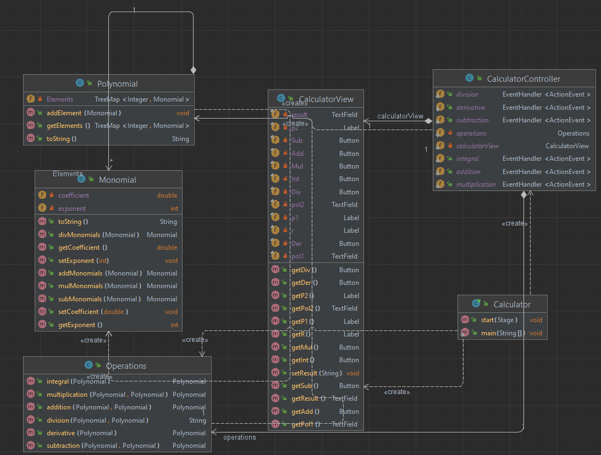

GUI
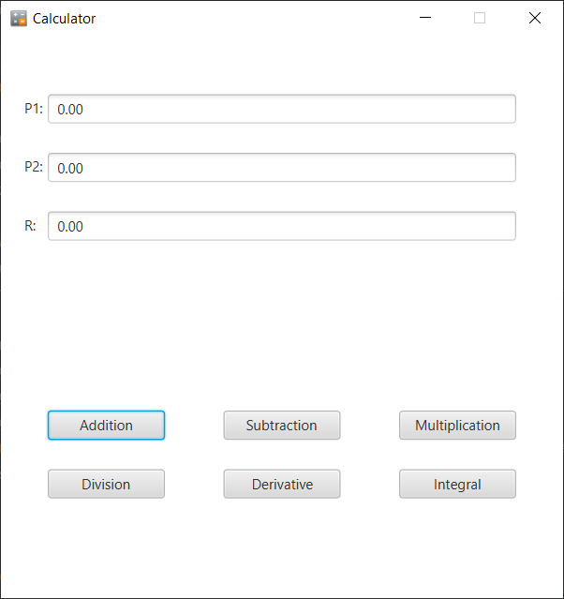

Implementation

- Example of the overloaded toString() method inside the Polynomial class, implemented to help with the displaying of the results of operations and with testing
@Override
public String toString() {
StringBuilder toRet = new StringBuilder();
for (Map.Entry<Integer, Monomial> entry : this.Elements.descendingMap().entrySet()) {
if ((toRet.length() > 0) && entry.getValue().getCoefficient() > 0)
toRet.append("+").append(entry.getValue());
else
toRet.append(entry.getValue());
}
return toRet.toString();
}

- Example of an operation (in this case addition) from the Monomial class, operation implemented to work on monomials and to help the coding process of polynomial operations
public Monomial addMonomials(Monomial m) {
return new Monomial(this.coefficient + m.coefficient, this.exponent);
}

- Example of an operation (in this case addition) from the Operations class, operation implemented to work on polynomials
public Polynomial addition(Polynomial a, Polynomial b) {
Polynomial x = new Polynomial(a.getElements());
for (Map.Entry<Integer, Monomial> entry : b.getElements().entrySet())
if (x.getElements().containsKey(entry.getKey()))
x.addElement(x.getElements().get(entry.getKey()).addMonomials(entry.getValue()));
else
x.addElement(entry.getValue());
return x;
}

- Example of an instantiated button inside the CalculatorView (GUI) class, every graphical element had a certain text on it, a certain position inside the application pane and a corresponding action
public CalculatorView(){
Add = new Button();
Add.setText("Addition");
Add.setLayoutX(40);
Add.setLayoutY(320);
Add.setPrefWidth(100);
Add.setOnAction(CalculatorController.addition);
…
}
- Example of an event handler inside the CalculatorController class; it takes the text introduced by the user into the text fields and adds up the polynomials
public static EventHandler<ActionEvent> addition = actionEvent -> {
Polynomial p1 = new Polynomial(calculatorView.getPol1().getText());
Polynomial p2 = new Polynomial(calculatorView.getPol2().getText());
calculatorView.setResult(operations.addition(p1, p2).toString());
};

Results
I did not use any external program for testing the project. I only used input data from the keyboard repeatedly and tried to cover as many cases as possible. In the final version of the project, there were no more errors or mistakes in the calculations. The program was tested both before the graphic interface and regexes, and after, all the problems found were solved.

Conclusions
This project strengthened and deepened my knowledge about the Java programming language, especially in the chapter of graphical interfaces, where I had to ask in all parts to cover my lacks and gaps in knowledge from last year. This project can also be attributed a greater purpose, that of serving as a tool for high school students to verify the correctitude of their homework.

Bibliography
The references that were consulted by the student during the implementation of the homework will be added.
Example:
- Bruce Eckel, Thinking in Java (4th Edition), Publisher: Prentice Hall PTRUpper Saddle River, NJUnited States, ISBN:978-0-13-187248-6 Published:01 December 2005.
- www.tutorialspoint.com
- https://stackoverflow.com/

