Johanna Gomez

Memory Drawing Task

Introduction

The Memory Drawing Task is an application that tests a user’s working memory utilizing visual feedback of prompted drawing assignments. It is intended to be in use to screen for cognitive impairment found in early Alzheimer’s disease [1]. The task is designed to test the user’s memory of self-drawn shapes after they have been distorted through different specified methods in order to assess the users’ memory. Memory loss is a cognitive impairment a common symptom leading to Alzheimer’s disease [1] and often tested in most screening tests as examined in many previous experiments [3, 5]. The visual feedback of the application assesses how well users are aware of their own sense of action [6] and sensory feedback through a screen interface. The distortion of the reference image is through a number of differing measured variables that each have a role in screening for Alzheimer’s Disease including size, rotation, shape disfiguration [3, 5], and color [4, 7]. The rotation effect utilizes the just noticeable difference method is previously employed in [2, 6] to distinguish what is self and externally produced. Each of these variables including the time is takes to complete the task are recorded in order to track the performance of users over time. The educational module provided by the lab helped to familiarize myself with the Unity software program such as the functions of creating objects and scripts.

How the Game Works

1. The user will be given instructions on how the task will work beforehand and be able to go through it as a tutorial. First, they will be given a prompt to draw a shape. The user will try to draw the shape to the best of their abilities while the curser that they are drawing with is white, so they cannot see their own drawing at this time. The user will then press the “Done” button once they are finished drawing. This button will then cause a distortion to the image (unacknowledged by the user) which will then be visible in black ink.

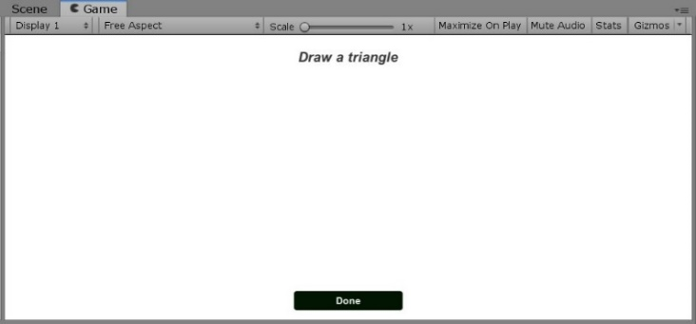

1. A question prompt will appear to ask the user if the shown image in black is distorted from the one they drew in white. The user will reply with either two options of “yes” or “no” on buttons. The “No” button will bring the user to the next question prompt, but the “yes” button will continue the task.

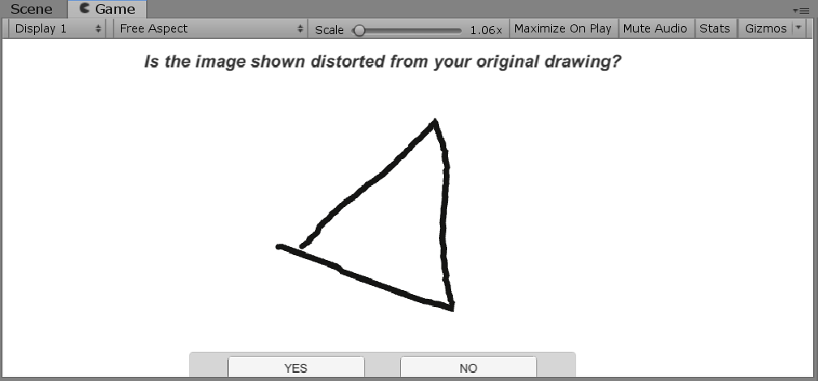

1. If the user answered “yes”, they will then be asked what type of distortion the image has gone through – rotation, size, shape disfiguration, color – and by further questions into each type. Once the user has answered to the best of their abilities, another picture will show with a different distortion in which the user will go the same previous steps again. The user is timed on how long it takes to answer each question. There are several levels with different shape prompts.

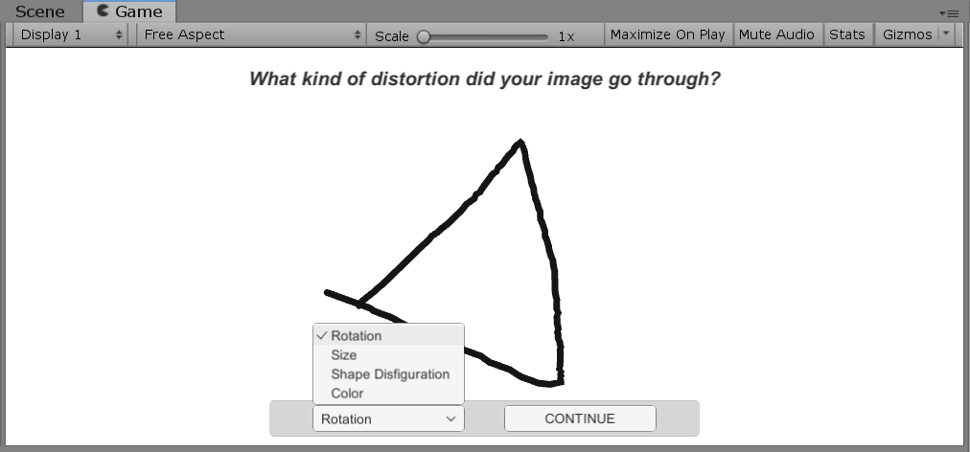

Creating the Game

* 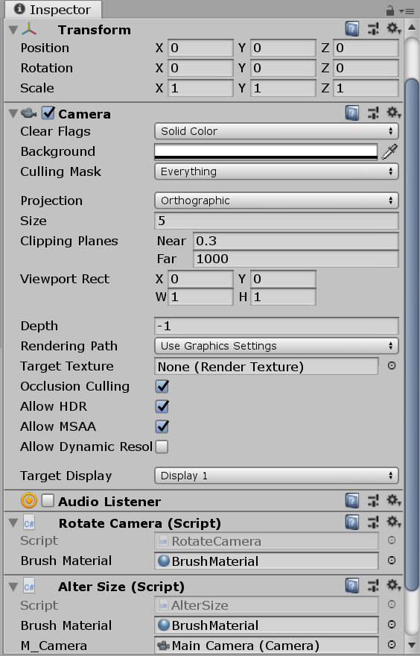Camera:
  + The main and only camera is set to an orthographic projection so that all the objects are rendered uniformly, with no perspective. The scripts to distort the image such as rotation and size are added as components to alter the camera’s rotation and size so that the image will seem altered.
* Drawing Tool:
  + Start with an empty object that will contain the script to draw and a line renderer component that the script utilizes. The drawing script will track the mouse position and add to the line renderer position when the user presses down on the mouse button. A material is also added as the “brush material” and set to different colors depending on which point of the game the user is at.

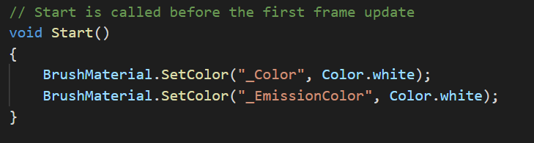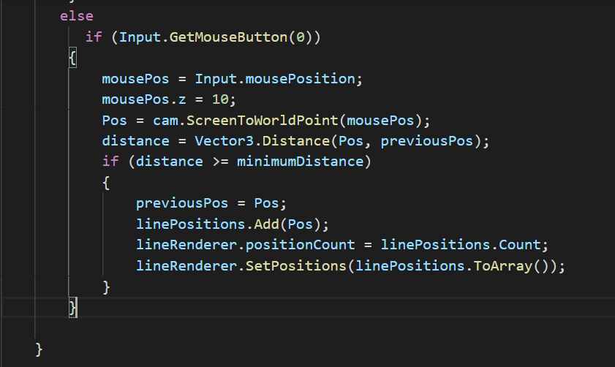

* Using Canvas: Integrating UI and code
  + The canvas contains the first main “done” button, prompts, and several panels that are activated and deactivated by buttons the user chooses as they continue throughout the task. Each panel carries the user through the process of asking whether they detect distortion, what kind, and more details of the specific type.

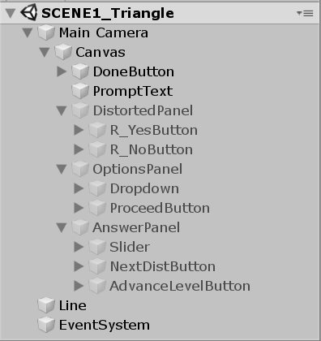

* + Collecting Information and Using It
    - There are several variables collected throughout the task used in combination to effectively track the cognitive performance of the user. The variables are measured mainly through time, buttons, and the input text box from the user are transferred to a file created on excel sheet every time the task is started.

References

[1] Kawas, Claudia H. “Early Alzheimer's Disease.” *New England Journal of Medicine*, vol. 349, no. 11, pp. 1056–1063, 2003.

[2] Lieberman, Harris R., and Alex P. Pentland. “Microcomputer-Based Estimation of Psychophysical Thresholds: The Best PEST.” *Behavior Research Methods &amp; Instrumentation*, vol. 14, no. 1, pp. 21–25, 1982.

[3] Maruff, Paul, et al. “Clinical Utility of the Cogstate Brief Battery in Identifying Cognitive Impairment in Mild Cognitive Impairment and Alzheimer’s Disease.” *BMC Psychology*, vol. 1, no. 1, 2013.

[4] Salamone, Giovanna, et al. “Color Discrimination Performance in Patients with Alzheimer’s Disease.” *Dementia and Geriatric Cognitive Disorders*, vol. 27, no. 6, pp. 501–507, 2009.

[5] Solomon, Paul R., et al. “A 7 Minute Neurocognitive Screening Battery Highly Sensitive to Alzheimer's Disease.” *Archives of Neurology*, vol. 55, no. 3, p. 349, 1998.

[6] Synofzik, Matthis, et al. “Misattributions of Agency in Schizophrenia Are Based on Imprecise Predictions about the Sensory Consequences of One's Actions.” *Brain*, vol. 133, no. 1, pp. 262–271, 2009.

[7] Takeda, Shinya., Tajime, Kayo., & Taniguchi, Toshiatsu. “The Takeda Three Colors Combination Test: A Screening Test for Detection of Very Mild Alzheimer’s Disease.” *The Scientific World Journal*, vol. 2014, pp. 1–5, 2014.