Project Title: Heating and Cooling Energy Consumption of an Ice Rink
Group Number: 8
Group Members: 21975066 Jake Pedersen
20937120 Bui Duc Minh Cao
20448350 Adam Zaltsman

Submission Date: 18 September 2026

Introduction (300-500 words)
Our group decided to model the heating energy consumption of an ice rink. Part of the learning in MATH3001 involves steady-state heat-exchange modelling. We believe that developing a model of an ice rink is a unique scenario for us to apply our learning.

Problem Statement
In this project, we will develop a model to predict the heat energy consumption of an ice rink. To complete this, we will utilise a lumped two-zone model, with one lower zone to maintain the ice and an upper zone to maintain comfort. The lower zone will interact with the ice floor and the upper zone. The upper zone will interact with the lower zone, the controlled heating or cooling device and the environmental heat from the building's exterior.
From this model, we will be able to analyse the sensitivity of parameters included in the model, such as comfort temperature, environmental temperature, ice floor area, rink dimensions, height of temperature zones and interzone heat-transfer coefficient.
This project is only intended to explore the heat energy consumption of an ice rink compared to its electrical consumption. We will also not be considering human activity in the rink as this would complicate our model in unpredictable ways.

Project Objectives
1.Develop a lumped two-zone steady state energy model for the ice rink representing the Lower and Upper zone, including the interzone heat transfer, ice heat transfer and envelope heat loss.
2.Formulate and analyse the governing equations for each zone.
3.Obtain the closed form analytical solution for the steady state zone temperatures and the required heating and cooling powers, if time permits extend the model to have the transient behaviour solving numerically using Forward Eulers method in python.
4.Convert the results for heating and cooling power into a estimated energy consumption over a defined period and interpret the results for the parameters and how these effect the energy usage.
5.The model will be validated by comparing our heating and cooling loads against published data for ice to determine how realistic our results are.

Preliminary Mathematical Model
Our initial model of the ice rink building will be a rectangular prism measuring 80m by 50m, with a rectangular ice rink in the centre measuring 60m by 30m.
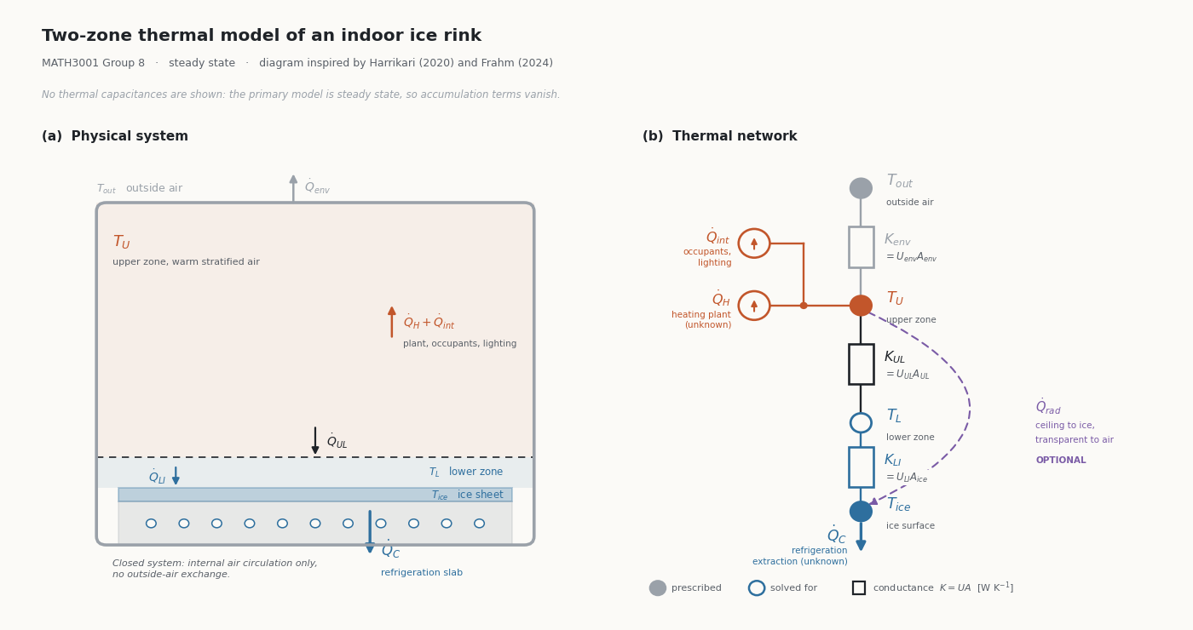Thermal Network Diagram
Conservation of energy
For a lumped thermal zone, the general energy balance is $Accumulation=HeatIn-HeatOut \left(1\right)$. Mathematically, $mc_{p}\frac{dT}{dt}=\sum_{ }^{ }{\dot{Q}} \left(2\right)$. The continuity equation established that the air mass in each zone is constant, so $mc_{p }=0$ is a constant coefficient and may be taken outside the derivative.
This project assumes steady-state operation. The justification is that the heating and refrigeration plant exists to hold each zone at its required temperature, so once those temperatures are reached, they do not change with time. Under this assumption $dT/dt = 0$ and the balance reduces to $\sum_{ }^{ }{=}\dot{Q} =0$.
Upper-Zone Energy Balance
Three heat flows cross the boundary of the upper zone: the heating plant, exchange with the outside environment through the building envelope, and transfer down to the lower zone. Applying ∑Q̇ = 0 to the zone gives
$0 = \dot{Q_{H}}+ U_{env}A_{env}\left(T_{out }-T_{U}\right)-U_{UL}A_{UL}\left(T_{U}-T_{L}\right)$
Lower-Zone Energy Balance
The general form of the lower-zone balance is
$$0 = U_{UL}A_{UL}\left(T_{U}-T_{L}\right)-U_{LI}A_{ice}\left(T_{L}-T_{ice}\right)+\dot{Q_{L, HV AC }}+\dot{Q_{L, other}}$$
Where $\dot{Q_{L, HV AC }}$represent the controlled heating or cooling applied to the lower zone and $\dot{Q_{L, other}}$ represents any additional thermal loads. Both vanish under the scope adopted here. The refrigeration system acts through the slab beneath the ice rather than on the air, so no plant is applied to the lower zone and $\dot{Q_{L,HVAC}}=0$. No additional loads have been included in the base model, so $\dot{Q_{L,other}}=0$. The balance reduces to
$$0 = U_{UL}A_{UL}\left(T_{U}-T_{L}\right)-U_{LI}A_{ice}\left(T_{L}-T_{ice}\right)$$
Ice-Surface Energy Balance
The ice surface is treated as a boundary of the lower zone rather than as a zone in its own right and carries no thermal capacity. Its balance is therefore instantaneous: the heat arriving from the air above must be removed by the refrigeration system to hold the surface at its required temperature
$$\dot{Q_{C}}= U_{LI}A_{ice}\left(T_{L}-T_{ice}\right)$$
Closure and analytical solution
Three balances contain three unknows: the lower-zone temperature $T_{L}$, the require heating power $\dot{Q_{H}}$ and the require cooling power $\dot{Q_{C}}$. The remaining temperature are prescribed $-T_{U }and T_{ice}$ are setpoints the plant maintains, the $T_{out }$is the outdoor condition. => The system is closed.
The lower-zone balance contains only one unknown and is solved directly:
$$T_{L }= \frac{U_{UL}A_{UL}T_{U}+U_{LI}A_{ice}T_{ice}}{U_{UL}A_{UL}+U_{LI}A_{ice}}$$
Substituting gives closed-form expressions for the two plant loads:
$\dot{Q_{C}}=U_{LI}A_{ice}\left(T_{L}-T_{ice}\right)$ and $\dot{Q_{H}}=U_{UL}A_{UL}\left(T_{U}-T_{L}\right)-U_{env}A_{env}\left(T_{out}-T_{U}\right)$
The “$U_{UL}A_{UL}\left(T_{U}-T_{L}\right)$“ is a loss from the upper zone and at the same time a load on the refrigeration plant: heat supplied to the comfort zone is subsequently removed again at the ice and is therefore paid for twice. This coupling between the heating and cooling demands is the central feature of the model and the reason an ice rink is not simply a warm room beside a cold one. The heating expression may return a negative value when the outdoor temperature is high.

Symbol | Meaning | Unit
T_{U} | Upper-zone temperature | °C or K
T_{L} | Lower-zone temperature | °C or K
T_{ice} | Ice surface temperature | °C or K
T_{out} | Outdoor temperature | °C or K
m_{U} | Air mass in the upper zone | kg
m_{L} | Air mass in the lower zone | kg
c_{p} | Specific heat capacity of air | J / (kg K)
A_{ice} | Ice surface area | m²
A_{building} | Whole building surface area | m²
A_{UL} | Interface area between the two zones | m²
U_{UL} | Interzone heat-transfer coefficient | W / (m²K)
U_{LI} | Heat-transfer coefficient between lower-zone air and ice surface | W / (m²K)
U_{env} | Outside environment heat-transfer coefficient | W / (m²K)
Q̇_{H} | Required heating power | W
Q̇_{C} | Required cooling power | W

Proposed Solution Method
Our primamLry model the steady-state two-zone energy bacplance will be solved analytically, At steady state our accumulation term (dT/dt = 0), will reduce our upper and lower zones to two linear equations in unknown zone temperatures $T_{U}$ & $T_{L}$.Since both equations contain both unknowns (interzone coupling term) they can be solved simultaneously by substitution, in doing so we’ll obtain closed form solution for $T_{U}$ & $T_{L}$and thus the required heating power $\dot{Q_{H }}$and cooling power $\dot{Q_{C }}$.
These results will give the required heating and cooling power in watts, not total energy consumption, to estimate the total energy consumption over a defined period we will need to multiple the power used over an operating time where $E = \dot{Q_{ }}×t_{f}$ assuming the load is constant over that period. Time permitting, we will add the transient extension to the model, this system will be solved numerically using the Forward Eulers method using Python.
Python will also.be used to carry out the sensitivity analysis to identify which parameters have the strongest impact on the required heating and cooling loads.
Finally, the models heating and cooling loads will be compared with energy data that for ice rinks that have been published to assess how realistic our results are.

Expected Outcomes
The steady-state model will produce a closed form expression for the zone temperatures, from these will provide the required heating and cooling power (in watts) required and will be converted to estimate the total energy consumption over a given operating time.
The parameter sensitivity will highlight how the heating and cooling loads react to a change in key parameters (outside temperature, interzone heat transfer coefficient and envelope value) to determine which influence the total energy demand the most.
If we add the transient extension, we’d expect to show the zone temperatures converge toward the analytical steady state values confirming agreement between the numerical and analytical solutions.
Comparing our predicted loads against published data will help determine whether our model is realistic or not.

Project Plan
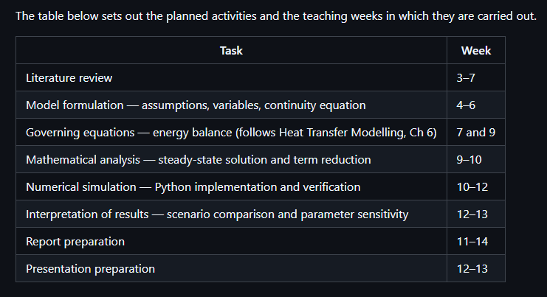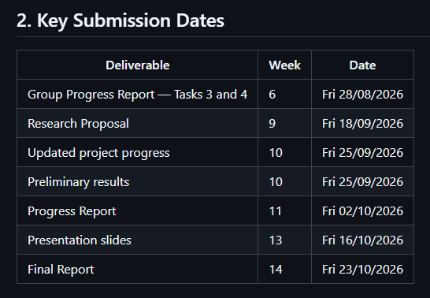
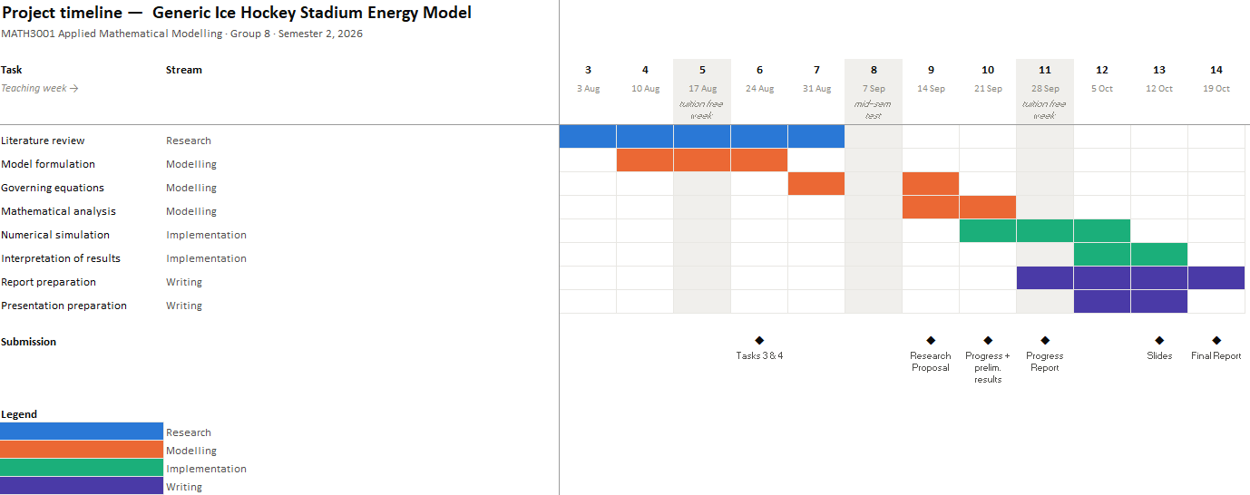Gantt Chart; Project timeline

Division of Responsibilities
Describe the expected contribution of each group member.
Member | Responsibilities
Adam  Jake  Cao | Literature review, model formulation
Adam  Jake  Cao | Mathematical derivation
Adam  Jake  Cao | Numerical implementation
Adam  Cao  (Maybe Jake but will be on placement) | Report preparation and presentation

Preliminary References
International Ice Hockey Federation. 2025. IIHF Official Rulebook 2025/26. Version 1.1. Zurich: IIHF. https://blob.iihf.com/iihf-media/iihfmvc/media/contentimages/3_the_iihf/2025-26_iihf_rulebook_22122025-v1.pdf — Standard rink dimensions (p. 17, sec. 1.2).
Khalil, Essam E. 2013. Air Distribution in Buildings. https://ebookcentral.proquest.com/lib/curtin/reader.action?docID=1408067 — Air movement and distribution within building interiors.
Lin, Wenyu, Xiaohua Liu, and Tao Zhang. 2023. "Experimental and Numerical Study of Zonal Heat and Moisture Migration inside Artificial Ice Rinks." Building and Environment 245: 110897. https://www.sciencedirect.com/science/article/pii/S0360132323009241 — Zonal model of an ice rink; heat and moisture exchange between zones.
Seghouani, Lotfi, Ahmed Daoud, and Nicolas Galanis. 2009. "Prediction of Yearly Energy Requirements of Indoor Ice Rinks." Energy and Buildings 41: 500–511. https://www.sciencedirect.com/science/article/pii/S0378778808002600 — Yearly energy requirements of indoor ice rinks.
Frahm, Moritz. 2024. Occupant-Oriented Demand Response with Model Predictive Heating Control in a Multi-Zone Residential Building. PhD thesis, Karlsruhe Institute of Technology. https://publikationen.bibliothek.kit.edu/1000174124.
Harrikari, Atte-Mainio. 2020. Multivariate Analysis of Heat Transfer in Ice Rinks with Carbon Dioxide as a Refrigerant. Master's thesis, Aalto University, School of Chemical Engineering. https://aaltodoc.aalto.fi/handle/123456789/45703.

