Project Title: Thermal Energy Consumption of Heating and Cooling an Ice Rink

Group Number: 8

Group Members: Bui Duc Minh Cao 20937120
Jake Pedersen 21975066
Adam Zaltsman 20448350

Submission Date: 09/10/2026

Introduction
Our group decided to model the energy consumption of air conditioning an indoor ice rink. An indoor ice rink must hold the ice below freezing while maintaining the air above it at a comfortable temperature for skaters. Our project models the thermal power and thermal energy required by the heating and refrigeration systems, using a lumped, two-zone, steady-state model of a hypothetical Ice rink in Perth, Western Australia. The model has an upper comfort zone, a lower zone next to the ice and floor and the ice surface held at a specified temperature. The main idea is that heat supplied to the upper zone leaks down to the lower zone and must then be removed by the refrigeration.
Our proposal outlined five objectives: build the two-zone model, formulate the governing equations, obtain a closed-form solution for the lower-zone temperature and the heating and cooling powers, convert those powers into energy and validate the loads against published rink data. Additionally, sensitivity analysis will be conducted to determine which parameters matter the most.
Since the proposal we have implemented the closed-form solution in Python and reproduced the proposals hand calculations in excel to account for our correction to the building envelope, we have computed baseline loads for a summer day, a winter day and a winter night, compared the cooling loads with two published measurements and run a normalised one parameter at a time sensitivity analysis. We have corrected the thermal capacity statement, rate notation and clarified the interpretation of the interzone coeffect. Thermal energy integration and final analysis remain to be completed.

Project Objectives
No. | Objective | Status | Progress to date
1 | Develop a lumped two-zone steady-state model (Interzone transfer, Ice transfer, Envelope Loss) | Completed | Model, assumptions and parameter table fixed, geometry correction to the upper envelope area.
2 | Formulate and analyse the governing equations for each zone | Completed | Upper-zone, Lower-zone and Ice-surface balances derived
3 | Closed-form solution for T_L, Heating power and Cooling power. | Completed | Equations [4.1] to [4.3] implemented and tested in Python/Excel
4 | Convert powers to thermal energy and interpret parameter effects | In progress | 24-hr thermal energy for three outdoor conditions. Further time frame pending.
5 | Validate loads against published rink data. | In progress | Cooling load compared with two published values, heating comparison and sources pending.
6 | Sensitivity analysis | In progress | Normalised one parameter at a time results are done. Combined scenario analysis pending (multiple variables changing)

Objectives 1 to 3 are completed. Objectives 4 and 5 are underway, and the sensitivity analysis is partly done.

Mathematical Model Development
The model has not changed from the proposal. The changes are corrections to notation and interpretation, and one modelling choice, the type of upper-zone unit, listed at the end of this section.
The rink building is a rectangular prism 80m x 50m x 10m (length, width, height) with a 60m x 30m ice pad in the centre. The lower zone is the first 1m above the floor. The upper zone is the remaining 9m. The interface between the zones has the full $4000 m^{2}$ floor area, of which $1800 m^{2}$ is ice, and $2200 m^{2}$ is concrete flooring. 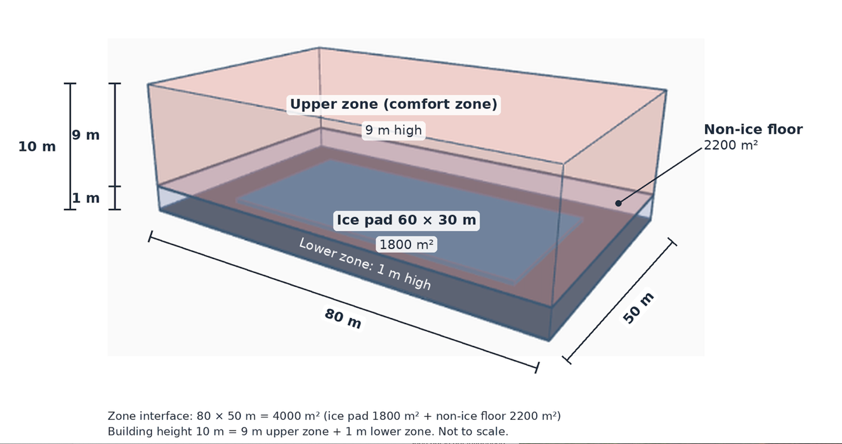
  - 3D model
Assumptions:
- The air temperature is uniform within each zone, and the ice surface temperature is uniform. This is the standard lumped simplification, splitting the in two zones captures the main difference between the cold air and the ice and the comfort zone above and ignores small variations within each zone.
- The system is in steady state, so each zone’s temperature doesn’t change in time. The plant holds the set points; once reached, the temperature stops changing. This ignores the startup (getting the building to the ideal temperature before opening to the public) and daily variation.
- There are no occupants, no humidity effects, no radiative exchange and no heat sources other than the refrigeration element and the outdoor environment. These are left out to keep the model manageable for this project. Because this was neglected, we would assume it adds load, which means our results are a lower bound on what they would be.
- The building is a closed system; Air circulates between the two zones but is not influenced by outside air ventilation. A real ice rink would bring in outside air, which would add to the load.
- The lower-zone has no direct connection to the outdoors; its 260m² of wall is roughly 4% of the envelope area and is neglected. It changed the loads by about 1kw or less (Section 6)
- The upper-zone temp T_{U} and ice temperature T_{ice} are setpoints that the plant holds. The lower-zone temperature T_{L} is not controlled and is found by our model. Set points are held by the plant, so they are inputs. The floor temperature T_{F} is also a fixed input assumed at 10 degrees (ranges between 8$℃$ to 18$℃$) because the slab temperature is not modelled. It is the least well-supported input and is varied in the sensitivity analysis.
- The upper-zone unit is a reverse-cycle air conditioner that can heat or cool; its power can be positive (Heats) or negative (Cools). This lets the reverse-cycle unit maintain the comfort set point in both hot and cool weather. Both the reverse-cycle unit and the refrigeration plant are described in terms of thermal power only, so no plant efficiency is introduced, and the results are thermal loads, not electrical consumption.

Variables and parameters
Symbol | Meaning | Value/Range | Unit | Source
T_{U} | Upper-zone Temperature | 10 (range 8.7 to 15) | °C | (Lin et al. 2022, 2)  (Cockburn Ice Area, 2026)
T_{L} | Lower-zone temperature | Computed by the model | °C | Model output
T_{ice} | Ice surface temperature | -4 (Range –5 to –3) | °C | (Ferrantelli et al. 2021, 6)
T_{env} | Outdoor/environment temperature | 32.1 (summer day) / 18.0 (winter day) / 8.1 (winter night) | °C | (Bureau of Meteorology 2026)
T_{floor} | Non-ice floor surface temperature | 10 | °C | Assumed
A_{ice} | Ice surface area | 1800 (60 × 30) | m² | (IIHF 2025, 17)
A_{env} | Building envelope area (roof and walls) | With height(H) = 9m, => 6340 (roof 4000 + wall 2340) | m² | Derived from assumed geometry
A_{UL} | Interface area between the two zones | 4000 (80 x 50) | m² | Ice:1800 + non-ice:2200
$$A_{floor}$$ | Surface area of the floor not covered by ice | 2200 | $$m^{2}$$ | Determined by 4000-1800
U_{UL} | Heat-transfer coefficient between the upper-zone air and the lower-zone air | 4 | W / (m²K) | (Lin et al 2023, 7)
U_{LI} | Heat-transfer coefficient between lower-zone air and ice surface | 5 (at V = 0.4–0.5 m/s) | W / (m²K) | (Karampour and Rogstam 2012, 4)
U_{env} | Outside environment heat-transfer coefficient | 0.45 (range 0.27–0.91) | W / (m²K) | (Australian Building Codes Board 2022, sect. J4D4, J4D6)
$$U_{LF}$$ | Heat-transfer coefficient between lower-zone air and concrete floor surface | $$U_{LF}=\left\{\begin{aligned}&\begin{matrix}4.0v+5.6 & v≤5\end{matrix} \\ &\begin{matrix}7.15v^{0.78} & v>5\end{matrix}\end{aligned}true\right.$$  Assume v = 0.2m/s inside the building.  $$U_{LF}=6.4$$ | W / (m²K) | (Zeng et al. 2022, 6)
$${\dot{Q}}_{U}$$ | Net power of the upper zone unit (Heating if positive, cooling if negative) | Computed by the model | W | Model output
Q̇_{C} | Required cooling power | Computed by the model | W | Model output

Governing equations

Conservation Of Energy
The conservation of energy equation is detailed as Accumulation = Heat In – Heat Out. For our lumped zone model, the energy balance is
$mc_{p}\frac{dT}{dt}=\sum{\dot{Q}}$ [3.1].
The term $mc_{p}$ is the zone’s thermal capacitance. It is non-zero. At steady state, the temperature doesn’t change,$\frac{dT}{dt}$ = 0, so the left side of the equation [3.1] vanishes, and we are left with $\sum_{ }^{ }{\dot{Q}}=0$.

Newton's Law of Cooling
Newton’s law of cooling is used to determine the heat transfer between zones with zones and zones with surface, and is expressed as a rate,
$$\dot{Q}=UAΔT \left[3.2\right].$$
This equation is used to model the upper-zone energy balance, lower-zone energy balance and the ice-surface energy balance. The figure below will show the model, with part (a) showing the building we are working on and two air zones, and part (b) shows the system in a thermal network.
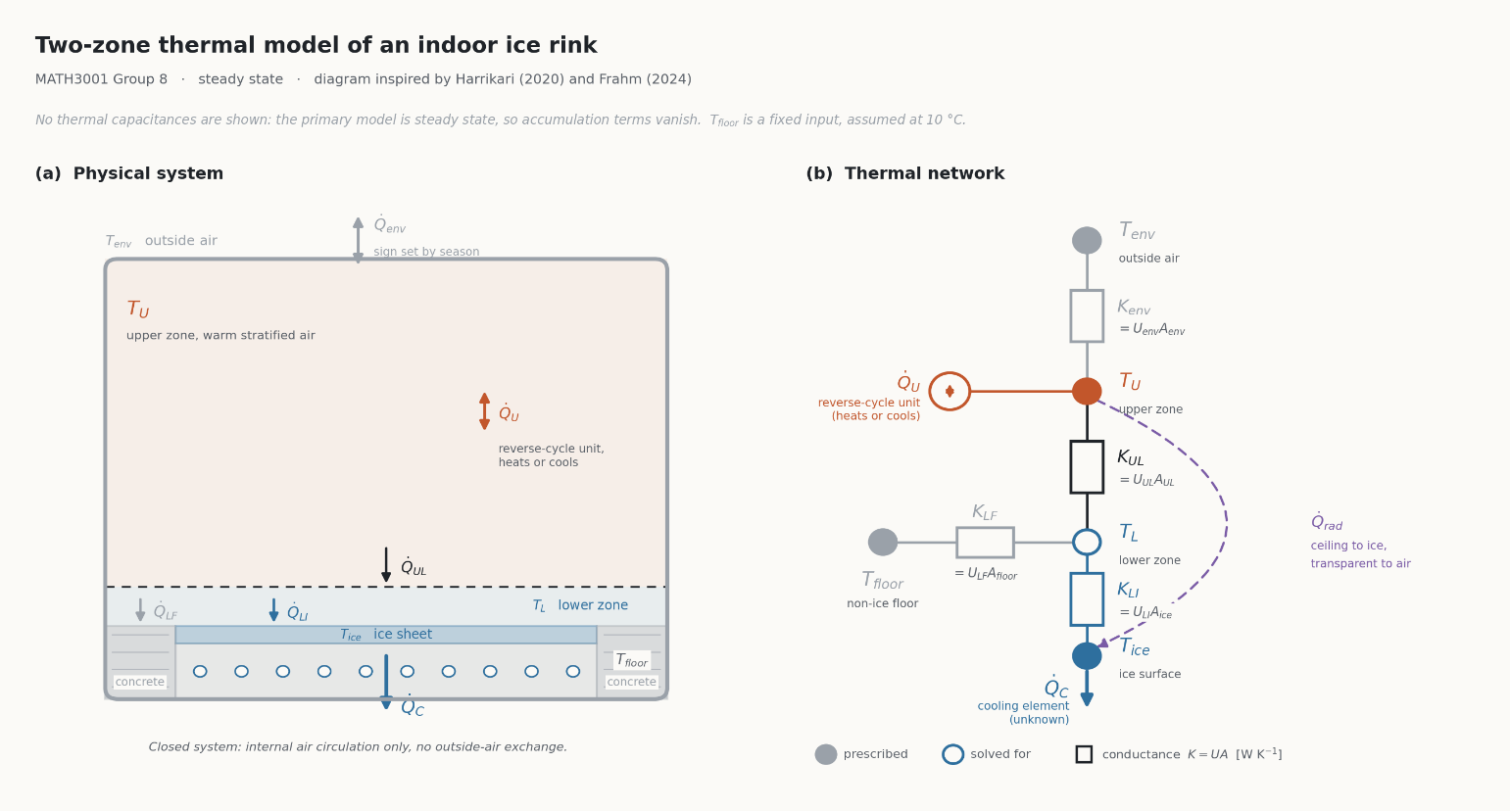
  - Figure 3.1: Two-zone model
Upper-Zone Energy Balance
The upper-zone receives heat from the upper-zone unit (reverse-cycle unit that heats when ${\dot{Q}}_{U}$ is positive and cools when negative), gains or loses heat through the building envelope and exchanges heat with the lower-zone, applying $\sum_{ }^{ }{\dot{Q}}=0$
$$0={\dot{Q}}_{U}+U_{env}A_{env}\left(T_{env}-T_{U}\right)-U_{UL}A_{UL}\left(T_{U}-T_{L}\right) \left[3.4\right]$$
Lower-Zone Energy Balance
The lower-zone exchanges heat with the upper-zone, the ice and the concrete floor. It has no heating or cooling element of its own. $\sum_{ }^{ }{\dot{Q}}=0$
$$0=U_{UL}A_{UL}\left(T_{U}-T_{L}\right)-U_{LI}A_{ice}\left(T_{L}-T_{ice}\right)+U_{LF}A_{F}\left(T_{F}-T_{L}\right) \left[3.5\right]$$
Ice-Surface Energy Balance
The ice surface is treated as part of the lower boundary of the lower zone rather than a zone and carries no thermal capacity. Its balance is therefore instantaneous: the heat arriving from the air above must be removed by the refrigeration system to hold the surface at its required temperature,
$\dot{Q}c=U_{LI}A_{ice}\left(T_{L}-T_{ice}\right) \left[3.6\right]$.

Boundary conditions
The model has no spatial domain (air temperature is uniform inside each zone), so the boundary conditions are the temperatures $T_{env}=32°$, $T_{Upper}=10°$, $T_{floor}=10°$ and $T_{ice}=-4°$ because the model is steady state, no initial condition is needed.

Changes since the proposal
- The statement that the continuity equation (3.1) gives $mc_{p}=0$ has been replaced by the correct argument above, $mc_{p}$ is non-zero and it is $\frac{dT}{dt}$ = 0 because when at steady-state, the temperature doesn’t vary with time.
- Heat transfer rates are written as $\dot{Q}=UAΔT$ in watts throughout, thermal energy E(in kWh) is defined and kept distinct from the rate $\dot{Q}$.
- $U_{UL}$ is the interzone heat-transfer coefficient, it’s the coefficient for heat transfer between the upper-zone air and the lower-zone air across their interface. It is not a conduction coefficient through a wall (from feedback we had to state this), its value is taken from Lin, Liu and Zhang (2023).
- Upper-zone unit. The proposal described only a heating source; the upper-zone unit is now a reverse-cycle air conditioner. The net power of ${\dot{Q}}_{U}$ in equation [3.4] can now be negative. A negative ${\dot{Q}}_{U}$ is a real cooling load, not a zero, the heating load ${\dot{Q}}_{H}$ and the upper-zone cooling load ${\dot{Q}}_{UC}$are defined by ${\dot{Q}}_{U}$ in section 4. The ice cooling power ${\dot{Q}}_{C}$ keeps its meaning from the proposal.

4. Mathematical Analysis

Analytical Solution and Properties
At steady-state, the upper-zone, lower-zone and ice-surface balance form three linear equations in three unknowns: the lower-zone temperature $T_{L}$, the net cooling/heating power of the upper zone ${\dot{Q}}_{U}$, and the required cooling power ${\dot{Q}}_{C}$. As the upper-zone temperature $T_{U}$ is fixed, the three balances can be solved simply, though the lower-zone temperature $T_{L}$must be solved before ${\dot{Q}}_{U} and {\dot{Q}}_{C}$.
Rearranging the lower-zone balance, which $T_{L}$ is unknown, gives:
$T_{L }= \frac{U_{UL}A_{UL}T_{U}+U_{LI}A_{ice}T_{ice}+U_{LF}A_{F}T_{F}}{U_{UL}A_{UL}+U_{LI}A_{ice}+U_{LF}A_{F}}$ [4.1]
$T_{L}$ is then substituted into the ice surface balance to give the cooling power:
${\dot{Q}}_{C}=U_{LI}A_{ice}\left(\frac{U_{UL}A_{UL}T_{U}+U_{LI}A_{ice}T_{ice}+U_{LF}A_{F}T_{F}}{U_{UL}A_{UL}+U_{LI}A_{ice}+U_{LF}A_{F}}-T_{ice}\right)$ [4.2]
And into the upper-zone balance to give the net heating/cooling power:
${\dot{Q}}_{U}=U_{UL}A_{UL}\left(T_{U}-\frac{U_{UL}A_{UL}T_{U}+U_{LI}A_{ice}T_{ice}+U_{LF}A_{F}T_{F}}{U_{UL}A_{UL}+U_{LI}A_{ice}+U_{LF}A_{F}}\right)-U_{env}A_{env}\left(T_{env}-T_{U}\right)$ [4.3]
These results show four features of the model:
- $T_{L}$ is the average of $T_{U}$, $T_{ice}$ and $T_{floor}$ weighted by their conductance. It must therefore lie between the coldest and warmest of these temperatures.
- Outdoor conditions do not affect the cooling power as $U_{env}$, $A_{env}$, and $T_{env}$ do not appear in [4.1] or [4.2]. This is because the envelope exchanges heat only with the upper zone. Since $T_{U}$ is fixed, a change in the heat flow through the envelope only changes how much heating or cooling the upper zone needs.
- The cooling power depends only on temperature differences. Subtracting $T_{ice}$ from [4.1] and subs into [4.2], with $θ_{U}=T_{U}-T_{ice} and θ_{F}=T_{F}-T_{ice}$, gives:
$${\dot{Q}}_{C}=U_{LI}A_{ice} \frac{U_{UL}A_{UL} θ_{U}+U_{LF}A_{F} θ_{F}}{U_{UL}A_{UL}+U_{LI}A_{ice}+U_{LF}A_{F}} \left[4.4\right]$$
- The heating and cooling loads are linked, and combining the lower-zone balance with [4.2] gives
$${\dot{Q}}_{C}=U_{UL}A_{UL}\left(T_{U}-T_{L}\right)+U_{LF}A_{F}\left(T_{F}-T_{L}\right) \left[4.5\right]$$
All the heat entering the lower zone, from the air above and from the surrounding floor, must be removed at the ice. In winter, ${\dot{Q}}_{U}$ is positive (heating) and in summer ${\dot{Q}}_{U}$ is negative (cooling). As the net power ${\dot{Q}}_{U}$ can be positive or negative, we must consider how to model the upper thermal plant correctly. We therefore split ${\dot{Q}}_{U}$into heating load ${\dot{Q}}_{H}$ and upper-zone cooling load ${\dot{Q}}_{UC}$ where,
${\dot{Q}}_{H}=\max\left({\dot{Q}}_{U},0\right) \& {\dot{Q}}_{UC}=\max\left(-{\dot{(Q}}_{U}),0\right)$.
If ${\dot{Q}}_{U}$ is positive, heating is required, so ${\dot{Q}}_{H}={\dot{Q}}_{U}$and ${\dot{Q}}_{UC}$= 0. If ${\dot{Q}}_{U}$ is negative, the unit is cooling, so ${\dot{Q}}_{UC}={-\dot{Q}}_{U},$which is a positive number, and ${\dot{Q}}_{H}=0$. Only one of the two loads is non-zero at any time. Equation [4.6] is then applied to each load. In our proposal, we hadn’t accounted for hot days when we would need to cool the upper-zone air, not just heat it. We also considered just using the absolute value of the original ${\dot{Q}}_{U}$ ,but thought this would be a cleaner approach as we can clearly see where thermal energy is being used between heating and cooling.
Energy Over a period. With constant powers the thermal energy over time t is

$$E=\int_{t_{1}}^{t_{2}}{\dot{Q}}\left(t\right) dt \left[4.6\right]$$
Where $t=t_{2}-t_{1}$, the length of the period.
But since ${\dot{Q}}_{C}$ is constant, [4.6] become:
$$E={\dot{Q}}_{C} t \left[4.7\right]$$

Normalised Sensitivity Analysis
The proposal’s sensitivity table showed how ${\dot{Q}}_{C}$ changed over a chosen range of each parameter. Because the parameters have different units and their ranges were chosen separately, these results cannot be compared fairly. Following the feedback on the proposal, each parameter was therefore also assessed with a normalised sensitivity coefficient,
$$S_{x}=\frac{\left[{\dot{Q}}_{C}\left(1.01 x\right)-{\dot{Q}}_{C}\left(x\right)\right]/{\dot{Q}}_{C}\left(x\right)}{0.01} \left[4.8\right]$$$S_{x}$has no units, so heat transfer coefficients and temperatures can be compared directly. Since Section 4.1 showed that ${\dot{Q}}_{C}$depends only on temperature differences; the temperatures are entered as the differences $θ_{U}$and $θ_{F}$rather than in degrees Celsius, where the arbitrary zero would make a 1% change meaningless.

Validation Measure
The model was checked with published measurements from operating ice rinks. Following the feedback on the proposal, the errors are measured as:
$${Error}_{\%}=\frac{{\dot{Q}}_{model}-{\dot{Q}}_{ref}}{{\dot{Q}}_{ref}}×100\% \left[4.9\right]$$

Two reference values were used; Ferrantelli, Viljanen and Kurnitski (2021) measured an average heat flux of 41.85 W/m² through the ice pad of an operating ice hockey hall. Multiplying by the ice area of 1800 m² gives a reference cooling power of 75.3 kW. And Karampour and Rogstam (2012) reported an average refrigeration capacity of 142 kW for an indoor rink with an ice sheet of about 1800 m², the same size as the modelled rink, so no scaling was needed. This value covers the whole refrigeration load, including ice resurfacing and pumping, and is therefore an upper reference rather than a like-for-like comparison.

Reference | Published Value | Scaled to 1800 $m^{2}\left(kW\right)$ | Model ${\dot{Q}}_{C}$ (kW) | Error (%)
(Ferrantelli et al. 2021, 6) | 41.85 W/$m^{2}$ average ice heat flux | 75.3 | 97 | +28.8
(Karampour and Rogstam 2012, 4) | 142kW for 1626 $m^{2}$rink | 157.4 | 97 | -38.4

Python implementation
The model was implemented in a Python script, sens.py (published in the GitHub appendix). A single function ‘solve’ is used to evaluate [4.1] and [4.3] for a given set of parameter values and return $T_{L}$, ${\dot{Q}}_{C}$ and ${\dot{Q}}_{U}$. The code runs with the values from the parameter table for three outdoor conditions. It then repeats the calculation with one parameter changing within its range and prints results one at a time.

5. Preliminary Results

Baseline Result
Table 5.1 shows the results of three equations [4.1], [4.2], and [4.3] for three outdoor conditions, using the values from the parameter table. We both calculated by hand and ran code on Python (see Appendix Calculation).
Outdoor Conditions | $$T_{env}$$  (${}_{}^{°}C$) | $$T_{L }$$  (${}_{}^{°}C$) | $${\dot{Q}}_{C}$$  (kW) | $${\dot{Q}}_{U}$$  (kW)
Summer (day) | 32.1 | 6.78 | 97.0 | -11.5
Winter (day) | 18.0 | 6.78 | 97.0 | 28.8
Winter (night) | 8.1 | 6.78 | 97.0 | 57.0
  - Table 5.1: Baseline Result (${\dot{Q}}_{U}$ positive: heating; negative: cooling)
The lower-zone temperature lies between the ice temperature and the upper-zone temperature, and the cooling power is the same in all three conditions. The upper-zone unit changes from heating to cooling at an outdoor temperature of about 28.1 °C. The results in Table 5.1 are heat-transfer rates. Using [4.7] over one day (t = 24 h), the cooling energy is E = 97.0 kW × 24 h = 2328 kWh in all three conditions. According to feedback on tasks 5-6, a rate must be kept distinct from the energy.

Sensitivity
This section shows the cooling power and the heating power on a winter day when each parameter is moved out of its range while the other stays at its baseline value. The ranges are given in the parameter table.
Parameter | Range | ${\dot{Q}}_{C}$  (kW) | Changes (%) | $${\dot{Q}}_{U}$$  (kW) | Changes  (%)
$$T_{u}$$ | 8.7 to 15 | 92.2 to 115.4 | 24 | 12.8 to 90.3 | 269
$$T_{ice}$$ | −5 to −3 | 103.9 to 90.1 | 14 | 32.4 to 25.1 | 26
$$T_{f}$$ | 8 to 18 | 90.5 to 122.9 | 33 | 40.3 to −17.4 | 200
U_{UL} | 2 to 8 | 89.5 to 105.4 | 16 | 9.6 to 50.4 | 142
$$U_{LI}$$ | 4 to 6 | 81.3 to 111.3 | 31 | 20.4 to 36.4 | 55
$$U_{LF}$$ | 5 to 8 | 94.5 to 99.4 | 5 | 33.2 to 24.5 | 30
$$U_{env}$$ | 0.27 to 0.91 | 97.0 to 97.0 | 0 |  | 113
  37.9 to 5.4
  - Table 5.2: Sensitivity of cooling and heating power
The change in ${\dot{Q}}_{C}$ is the difference between the two cooling powers as a percentage of the baseline value of 97.0 kW. On this measure, the floor temperature has the largest effect on the cooling power, followed by $U_{LI}$. The change in ${\dot{Q}}_{H}$ is a percentage of its winter-day baseline of 28.8 kW, because this baseline is small, the percentages are larger, so the kilowatt values are a better guide. The upper-zone temperature has the largest effect on the heating power, changing it by 77.5 kW. Raising the floor temperature to 18 °C reverses the heating power to −17.4 kW, so the upper zone would need cooling even on a winter day. The interzone coefficient U_{UL}, which has little effect on the cooling power, changes the heating power by 40.8 kW.

Normalised Sensitivity
This section will give the normalised sensitivity of cooling power from [4.8]. We only normalised the cooling power because the heating power has a small baseline and changes sign. Computed by using Python (see Appendix).
Parameter | $$S_{x}$$
$$U_{LI}$$ | 0.768
$$θ_{u}=T_{u}-T_{ice}$$ | 0.532
$$θ_{f}=T_{f}-T_{ice}$$ | 0.468
U_{UL} | 0.122
$$U_{LF}$$ | 0.107
$$U_{env}$$ | 0.000
  - Table 5.3: Normalised sensitivity of cooling power
$U_{LI}$ is the most significant parameter.

6. Discussion

Successes achieved
The steady state model has been solved in closed form for $T_{L}, {\dot{Q}}_{U}$, and ${\dot{Q}}_{C}$, and the Python results have matched the hand calculation. The baseline cooling power is 97.0 kW, and the upper-zone unit switches from cooling to heating when the outdoor temperature falls below 28.1$℃$. The calculated cooling power lies between the two reference values. The sensitivity analysis is normalised, as requested in the proposal feedback.

Difficulties encountered
The published loads are reported in different units, such as heat flux at the ice surface and average refrigeration capacity
The Python code had to be updated several times as the model changed, for example, when the upper-zone unit became a reverse-cycle unit and when the envelope area was corrected, and the new results were checked against hand calculations. The sensitivity code required particular care: temperatures in °C have an arbitrary zero, so the code adjusts the temperature differences $θ_{u}$ and $θ_{f}$ by 1% rather than $T_{U}$ and $T_{f}$ themselves.

Model limitations
Our model skipped the radiation, as shown in the diagram. In real life, an ice rink also gains heat by radiation, and this is a large effect according to the hall measured by Ferrantelli, Viljanen and Kurnitski (2021). Celling radiation in their publication supplied 31.3 ${W/m}^{2}$ of the ice load. Omitting radiation should make our cooling power too low, yet our result is 28.8% higher than their measurement because we treat the lower zone as a single well-mixed volume, which overstates convection.

Assumptions that may require refinement
Floor temperature $T_{f}$ is assumed at 10 degrees Celsius

Validation of preliminary results
Following the Week 5 feedback, we separate verification, which checks that the equations are solved correctly, from validation, which checks that the predictions are realistic.
Verification: The Python results match the hand calculations (see Appendix).
Validation: We compared the predicted cooling power with two published references, using [4.9] (see the Appendix for the calculations).
References | Publishes Cooling Power | Our Cooling Power | E%
Ferrantelli, Viljanen and Kurnitski (2021) | 75.33 kW | 97.0 kW | +28.8%
Karampour and Rogstam (2012) | 142 kW | 97.0 kW | -31.7 %
  - Table 6.1: Comparison with Published Value
The value we calculated is less than the value reported by Karampour and Rogstam (2012) because they include resurfacing, pumping and other loads outside the model. And we are above Ferrantelli, Viljanen and Kurnitski (2021) likely because we lumped the lower zone. The model drives convection with the difference between the lower-zone temperature and the ice, about 10.8 K. Ferrantelli, Viljanen and Kurnitski (2021) instead measured strong stratification just above the ice. The air was −3.5 °C at 5 mm, only about 1 K above the ice surface, rising to −0.8 °C at 0.24 m and 4.2 °C at 5 m. Treating the lowest 1 m of air as one well-mixed volume therefore overstates the temperature difference at the ice.

7. Remaining Work
Objective 5: The cooling power of the ice has been compared with the published value. The heating and cooling power of the upper zone still needs to be compared.
Objective 6: The one-at-a-time normalised results are completed. Remaining combined scenarios, in which several parameters change together, for example, a summer day with a warm floor.
- Extend the energy calculation from 24 hours using Perth temperature statistics (Objective 4)
- Finish the sensitivity analysis, report results across varying parameter ranges and test the combined changes in several parameters (Objective 6).
- Look for further published data to validate against our model, discuss assumptions and look at published statistics to see if some of them are quantified and explain some of the errors, if possible (Objective 5).
- Discuss our final assumptions and finalise our conclusions.
- Prepare the slides for presentation and final report.

8. Updated Project Schedule

The schedule below updates the project plan submitted with the proposal. The Progress Report deadline was moved from 2 October to 9 October; the remaining deadlines are unchanged.
Task | Timing | Status
Literature Review | Weeks 3-9 | Completed
Model Formulation: assumptions, variables, and parameters | Weeks 4-9 | Completed
Governing Equations | Weeks 7-9 | Completed and corrected after proposal feedback
Analytical Solution and Model Properties | Weeks 9-12 | Completed
Python Implementation | Weeks 10-12 | Completed
Sensitivity Analysis | Weeks 10-12 | In progress
Model Validation | Weeks 11-13 | In progress
Transient Extension | Weeks 13-14 | In progress
Presentation Preparation | Week 13, 16th October | Planned
Final Report | Weeks 13-14, 23rd October | Planned

9. Contribution of Group Members

Member | Contribution
Bui Duc Minh Cao | Literature review; Determining governing equations; Preliminary modelling in Python; Created thermal diagram; Project plan and Gantt chart; Errors; Numerical implementation; Analytical solution and model properties; normalised sensitivity and validation measures; Python implementation and sensitivity results; Updated project schedule.
Jake Pedersen | Literature review; Preliminary modelling in Excel; Introduction; Created 3D model; Worked on Problem statement; Numerical implementation; Report preparation and presentation; proofreading; formatting.
Adam Zaltsman | Literature review; Referencing; Worked on project objectives; Worked on proposed solution; Worked on expected outcomes; Numerical implementation; Report preparation and presentation.

10. References
Australian Building Codes Board (ABCB). 2022.” Part J4 Building Fabric.” National Construction Code 2022, Volume One,
https://ncc.abcb.gov.au/editions/ncc-2022/adopted/volume-one/j-energy-efficiency/part-j4-building-fabric.
Bureau of Meteorology. 2026. "Climate Statistics for Australian Locations: Perth Airport, Station 009021." Commonwealth of Australia. http://www.bom.gov.au/climate/averages/tables/cw_009021.shtml.
Cockburn Ice Arena (n.d.) “FAQs for Schools- Questions Frequently Asked by Teachers”.
https://www.cockburnicearena.com.au/school-faqs/.
Ferrantelli, Andrea, Klaus Viljanen, and Jarek Kurnitski. 2021. "Energy Analysis in Ice Hockey Arenas and Analytical Formula for the Temperature Profile in the Ice Pad with Transient Boundary Conditions." Advances in Building Energy Research 15 (4): 499–522.
https://doi.org/10.1080/17512549.2019.1615549.
Frahm, Moritz. 2024. “Occupant-Oriented Demand Response with Model Predictive Heating Control in a Multi-Zone Residential Building”. PhD thesis, Karlsruhe Institute of Technology. https://publikationen.bibliothek.kit.edu/1000174124.
Harrikari, Atte-Mainio. 2020. “Multivariate Analysis of Heat Transfer in Ice Rinks with Carbon Dioxide as a Refrigerant”. Master's thesis, Aalto University, School of Chemical Engineering. https://aaltodoc.aalto.fi/items/00eeb8ac-a17e-41af-bb4b-b065d7989f76
International Ice Hockey Federation. 2025. “IIHF Official Rulebook 2025/26”. Version 1.1. Zurich: IIHF. https://blob.iihf.com/iihf-media/iihfmvc/media/contentimages/3_the_iihf/sa2025-26_iihf_rulebook_22122025-v1.pdf .
Karampour, Mazyar, and Jörgen Rogstam. 2012. “Measurement and Modelling of Ice Rink Heat Loads.” https://www.diva-portal.org/smash/get/diva2:542333/FULLTEXT01.pdf.
Lin, Wenyu, Xiaohua Liu, and Tao Zhang. 2023. "Experimental and Numerical Study of Zonal Heat and Moisture Migration inside Artificial Ice Rinks." Building and Environment 245: 110897. https://www.sciencedirect.com/science/article/pii/S0360132323009241 .
Lin, Wenyu, Xiaohua Liu, Shaojie Li, and Tao Zhang. 2022. "Investigation on Thermal Environment and Heat Transfer Characteristics in Ice Rinks with Different Envelopes." Building and Environment 219: 109250.
https://doi.org/10.1016/j.buildenv.2022.109250.
Zeng, Haoyu, Chao Lu, Li Zhang, et al. 2022. “Prediction of Temperature Distribution in Concrete under Variable Environmental Factors through a Three-Dimensional Heat Transfer Model.” Materials (Basel, Switzerland), 15(4), 1510. https://doi.org/10.3390/ma15041510.
Everything about the project (thermal diagram and sensitivity calculation): https://github.com/mocthemocc/applied-mathematical-modelling-2026

11. Bibliography
Australian Building Codes Board (ABCB). 2022.” Part J4 Building Fabric.” National Construction Code 2022, Volume One,
https://ncc.abcb.gov.au/editions/ncc-2022/adopted/volume-one/j-energy-efficiency/part-j4-building-fabric.
Bureau of Meteorology. 2026. "Climate Statistics for Australian Locations: Perth Airport, Station 009021." Commonwealth of Australia. http://www.bom.gov.au/climate/averages/tables/cw_009021.shtml..http://www.bom.gov.au/climate/averages/tables/cw_009021.shtml.
Cockburn Ice Arena. n.d. “FAQs for Schools- Questions Frequently Asked by Teachers”.
https://www.cockburnicearena.com.au/school-faqs/.
Ferrantelli, Andrea, Klaus Viljanen, and Jarek Kurnitski. 2021. "Energy Analysis in Ice Hockey Arenas and Analytical Formula for the Temperature Profile in the Ice Pad with Transient Boundary Conditions." Advances in Building Energy Research 15 (4): 499–522.
https://doi.org/10.1080/17512549.2019.1615549.
Frahm, Moritz. 2024. “Occupant-Oriented Demand Response with Model Predictive Heating Control in a Multi-Zone Residential Building”. PhD thesis, Karlsruhe Institute of Technology. https://publikationen.bibliothek.kit.edu/1000174124.
Harrikari, Atte-Mainio. 2020. “Multivariate Analysis of Heat Transfer in Ice Rinks with Carbon Dioxide as a Refrigerant”. Master's thesis, Aalto University, School of Chemical Engineering. https://aaltodoc.aalto.fi/items/00eeb8ac-a17e-41af-bb4b-b065d7989f76.
International Ice Hockey Federation. 2025. “IIHF Official Rulebook 2025/26”. Version 1.1. Zurich: IIHF. https://blob.iihf.com/iihf-media/iihfmvc/media/contentimages/3_the_iihf/2025-26_iihf_rulebook_22122025-v1.pdf .
Karampour, Mazyar, and Jörgen Rogstam. 2012. “Measurement and Modelling of Ice Rink Heat Loads.” https://www.diva-portal.org/smash/get/diva2:542333/FULLTEXT01.pdf.
Khalil, Essam E. 2013. “Air Distribution in Buildings”. https://ebookcentral.proquest.com/lib/curtin/reader.action?docID=1408067 .
Lin, Wenyu, Xiaohua Liu, Shaojie Li, and Tao Zhang. 2022. "Investigation on Thermal Environment and Heat Transfer Characteristics in Ice Rinks with Different Envelopes." Building and Environment 219: 109250.
https://doi.org/10.1016/j.buildenv.2022.109250.
Lin, Wenyu, Xiaohua Liu, and Tao Zhang. 2023. "Experimental and Numerical Study of Zonal Heat and Moisture Migration inside Artificial Ice Rinks." Building and Environment 245: 110897. https://www.sciencedirect.com/science/article/pii/S0360132323009241 .
Seghouani, Lotfi, Ahmed Daoud, and Nicolas Galanis. 2009. "Prediction of Yearly Energy Requirements of Indoor Ice Rinks." Energy and Buildings 41: 500–511. https://www.sciencedirect.com/science/article/pii/S0378778808002600 .
Zeng, Haoyu, Chao Lu, Li Zhang, et al. 2022. “Prediction of Temperature Distribution in Concrete under Variable Environmental Factors through a Three-Dimensional Heat Transfer Model.” Materials (Basel, Switzerland), 15(4), 1510. https://doi.org/10.3390/ma15041510.

12. Appendices

GitHub Link: https://github.com/mocthemocc/applied-mathematical-modelling-2026

Calculation:
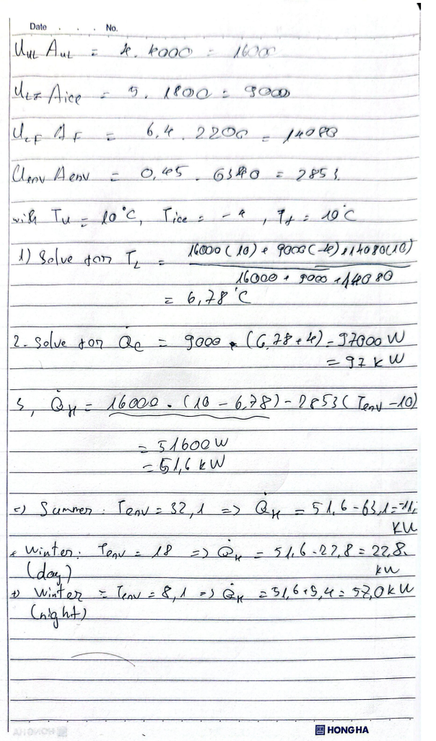
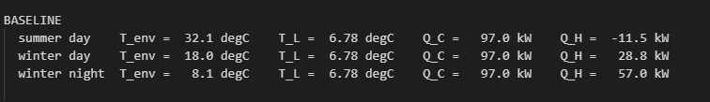
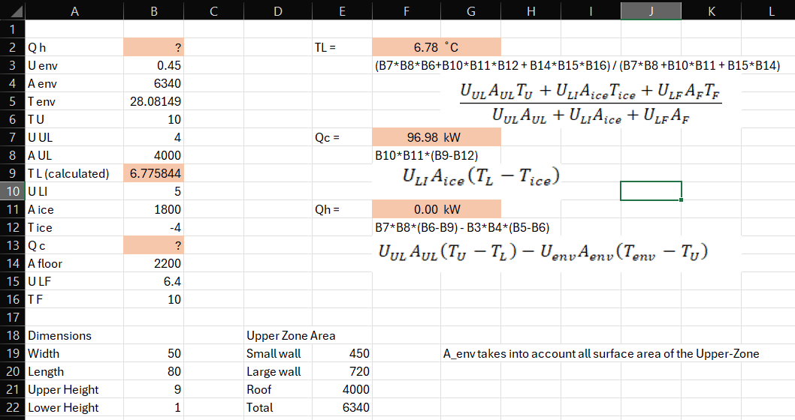
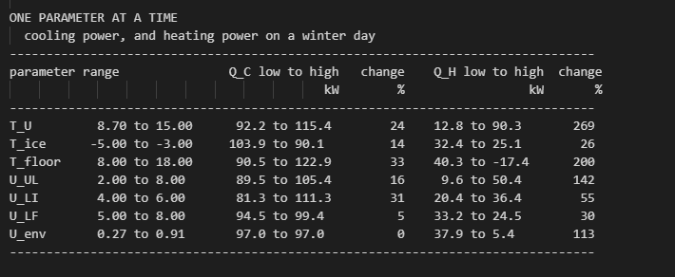
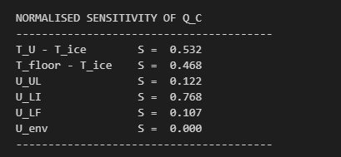
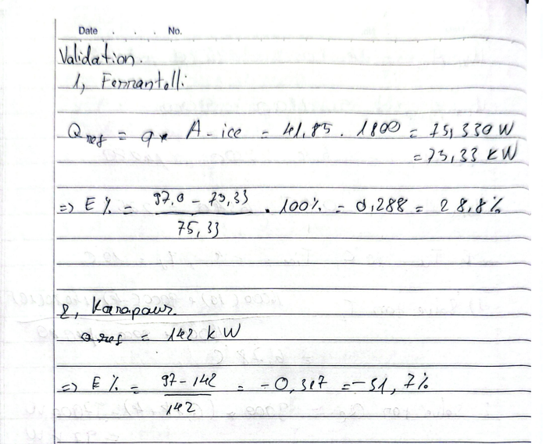

Python Code:

1. Sensitivity Analysis

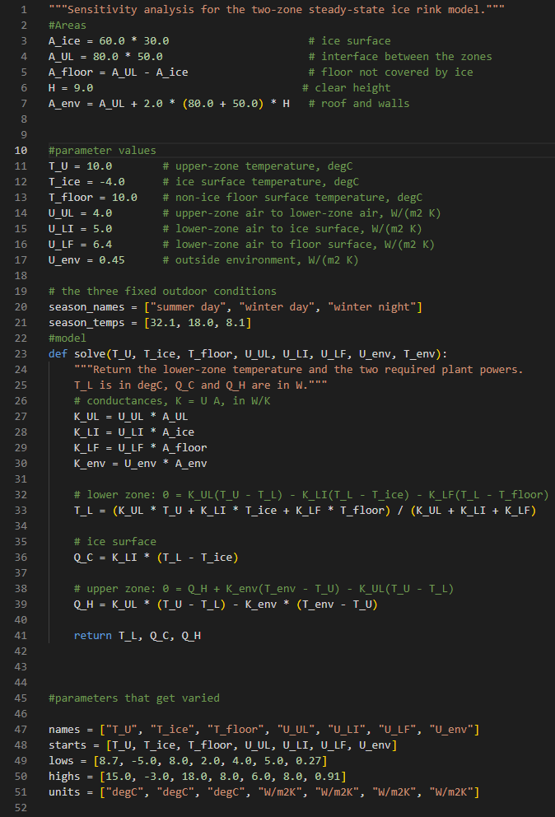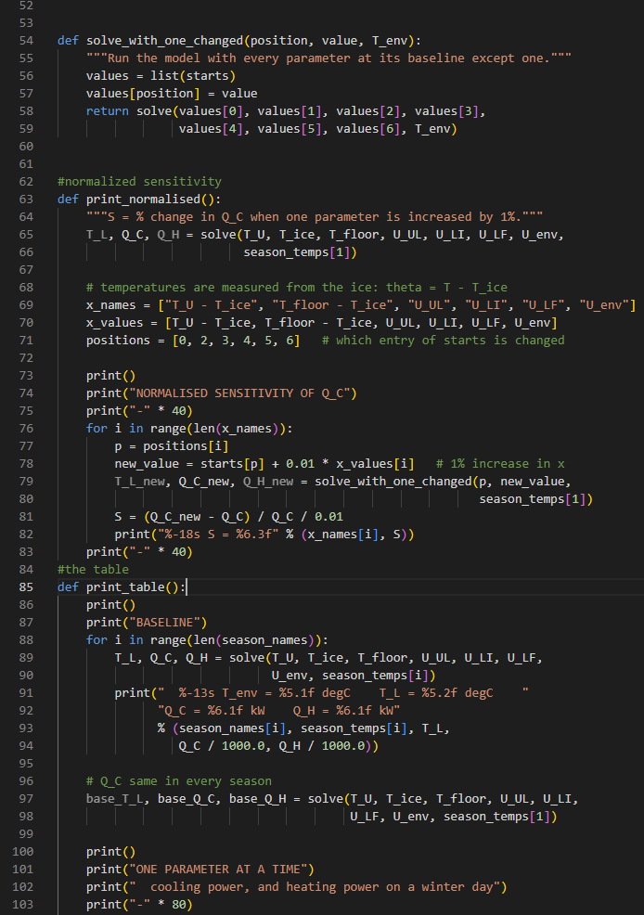

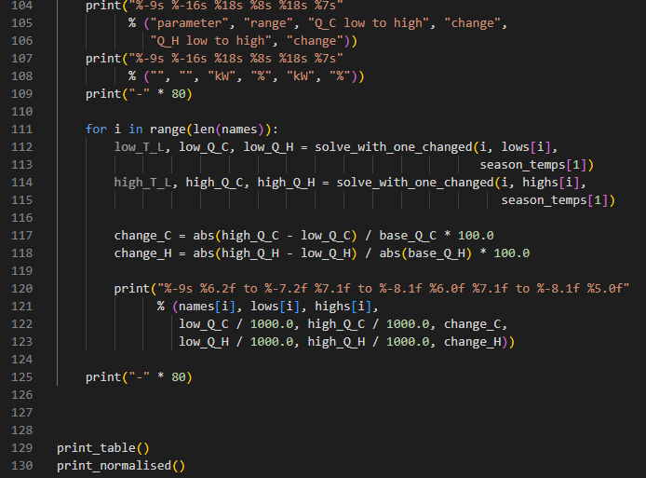

2. Network Diagram
