BÁO CÁO THỰC HÀNH LAB 1  
LẬP TRÌNH HƯỚNG ĐỐI TƯỢNG

# The Very First Java Programs

## *2.2.1* Write, compile the first Java application:

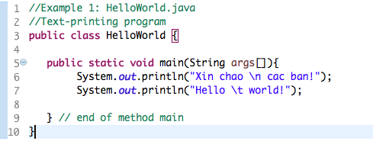

*Kết quả*

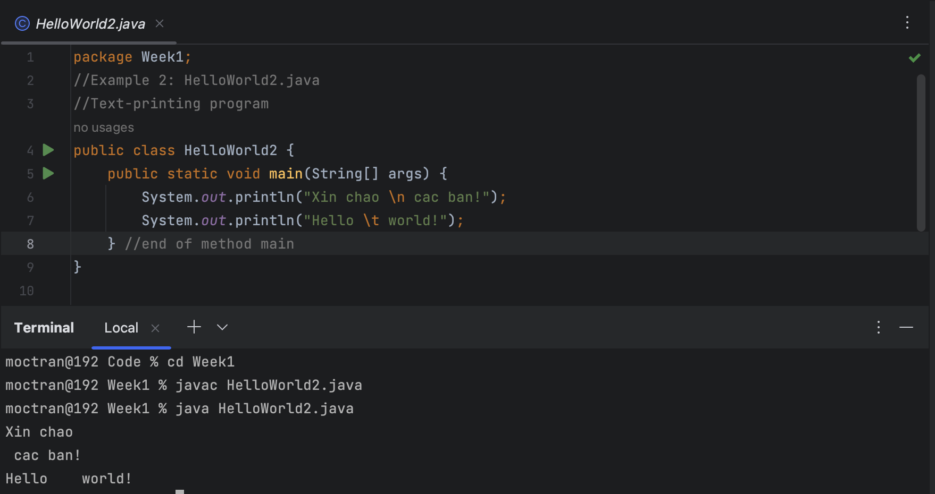

## 2.2.2 Write, compile the first dialog Java program

### Screen Shot 2019-02-12 at 12

## 2.2.3 Write, compile the first input dialog Java application

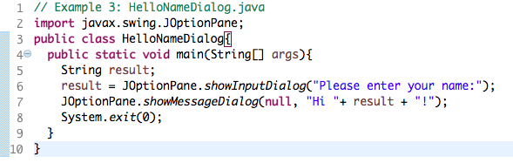

## 2.2.4 Write, compile, and run the following example:

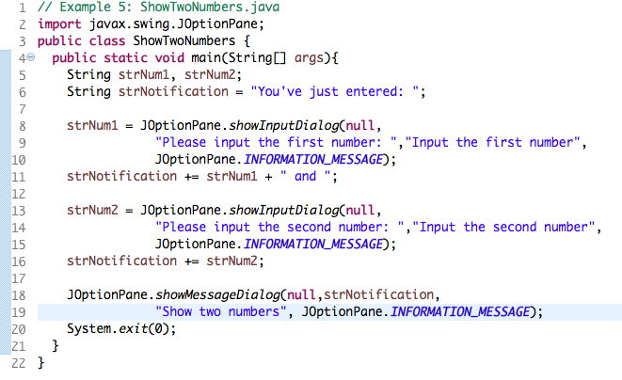

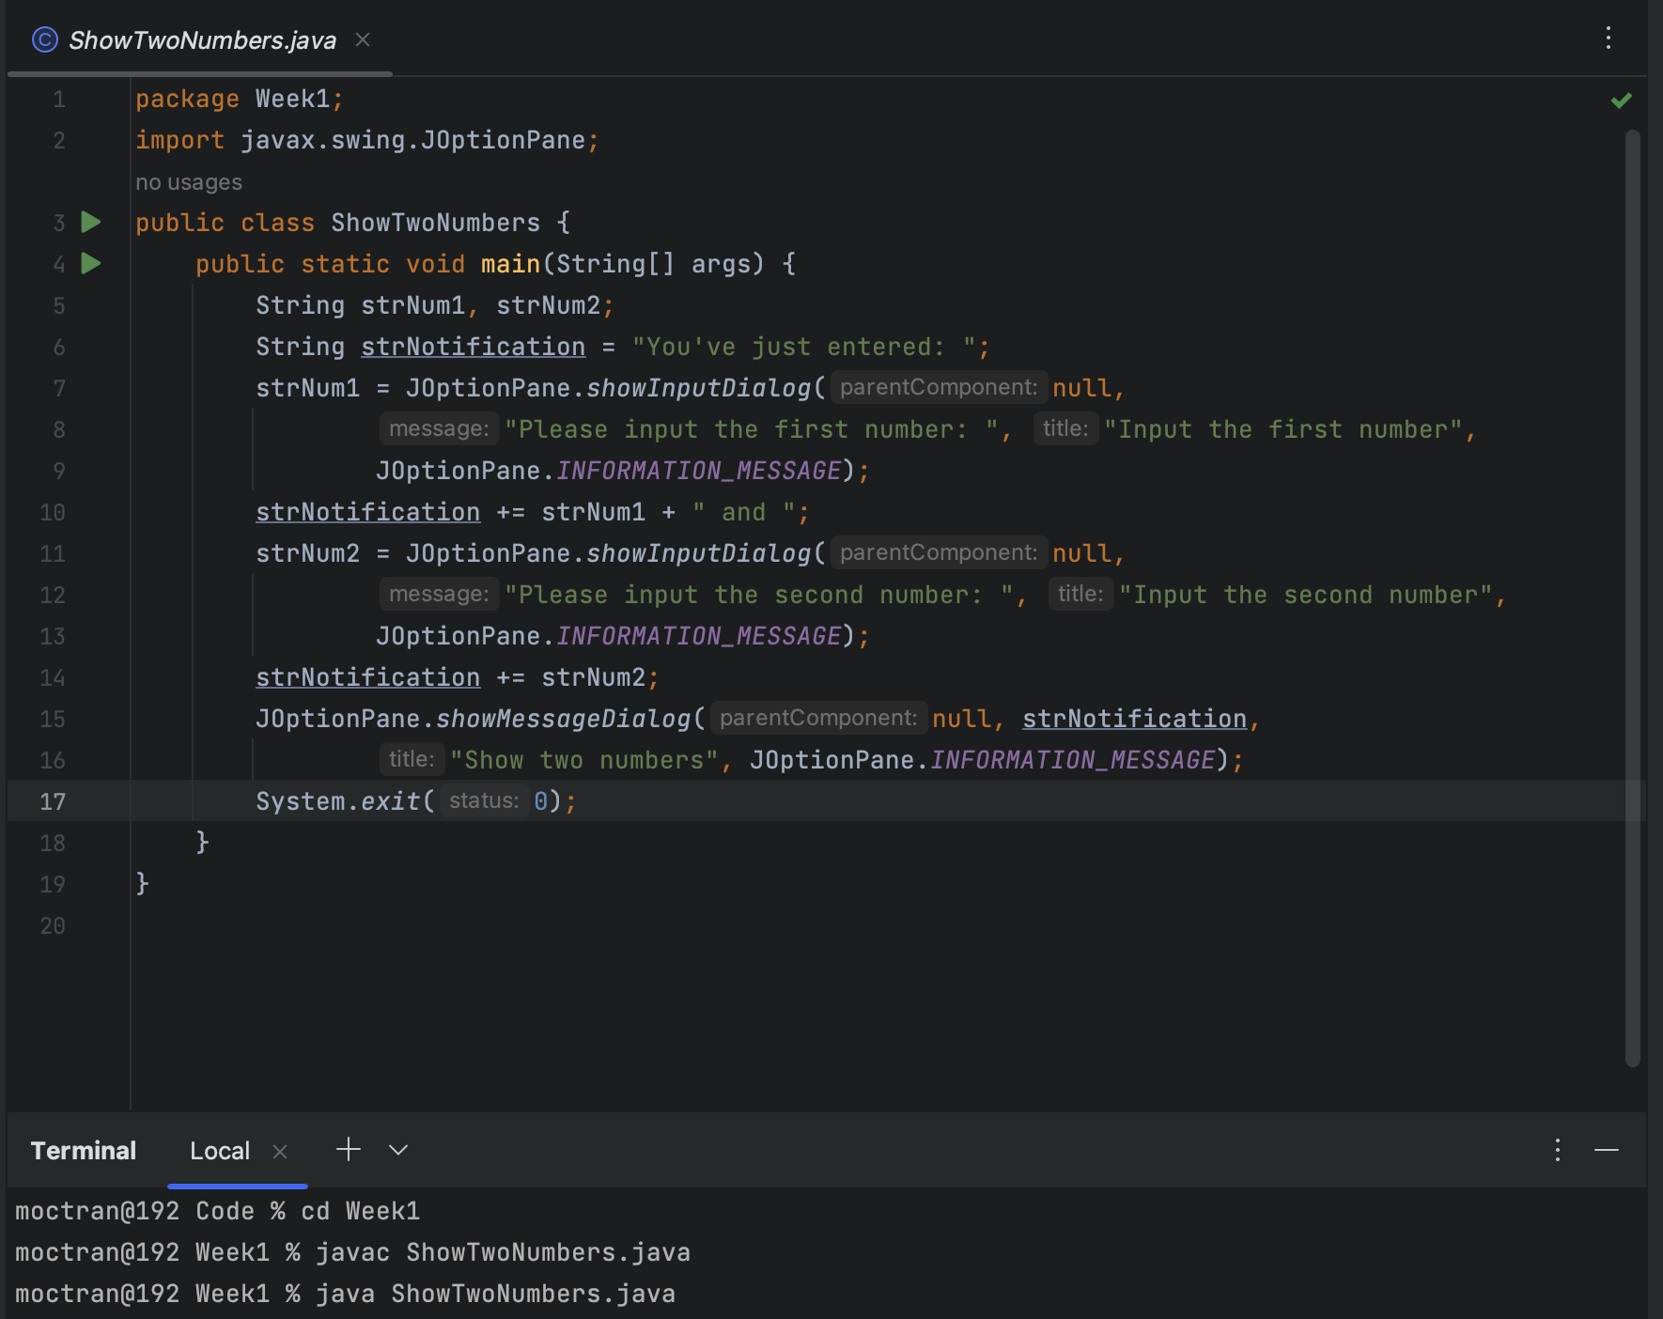

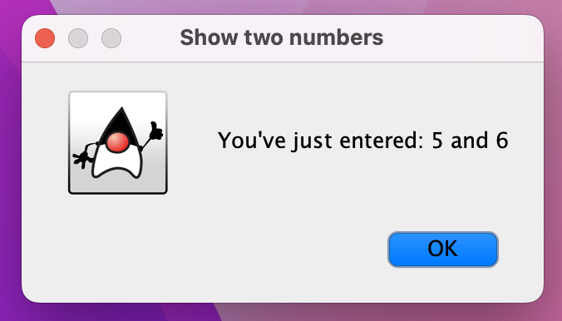

## 2.2.5 Write a program to calculate sum, difference, product, and quotient of 2 double numbers which are entered by users.

## 2.2.6

The first-degree equation

The system of first-degree equations with two variables

The second-degree equation with one variable

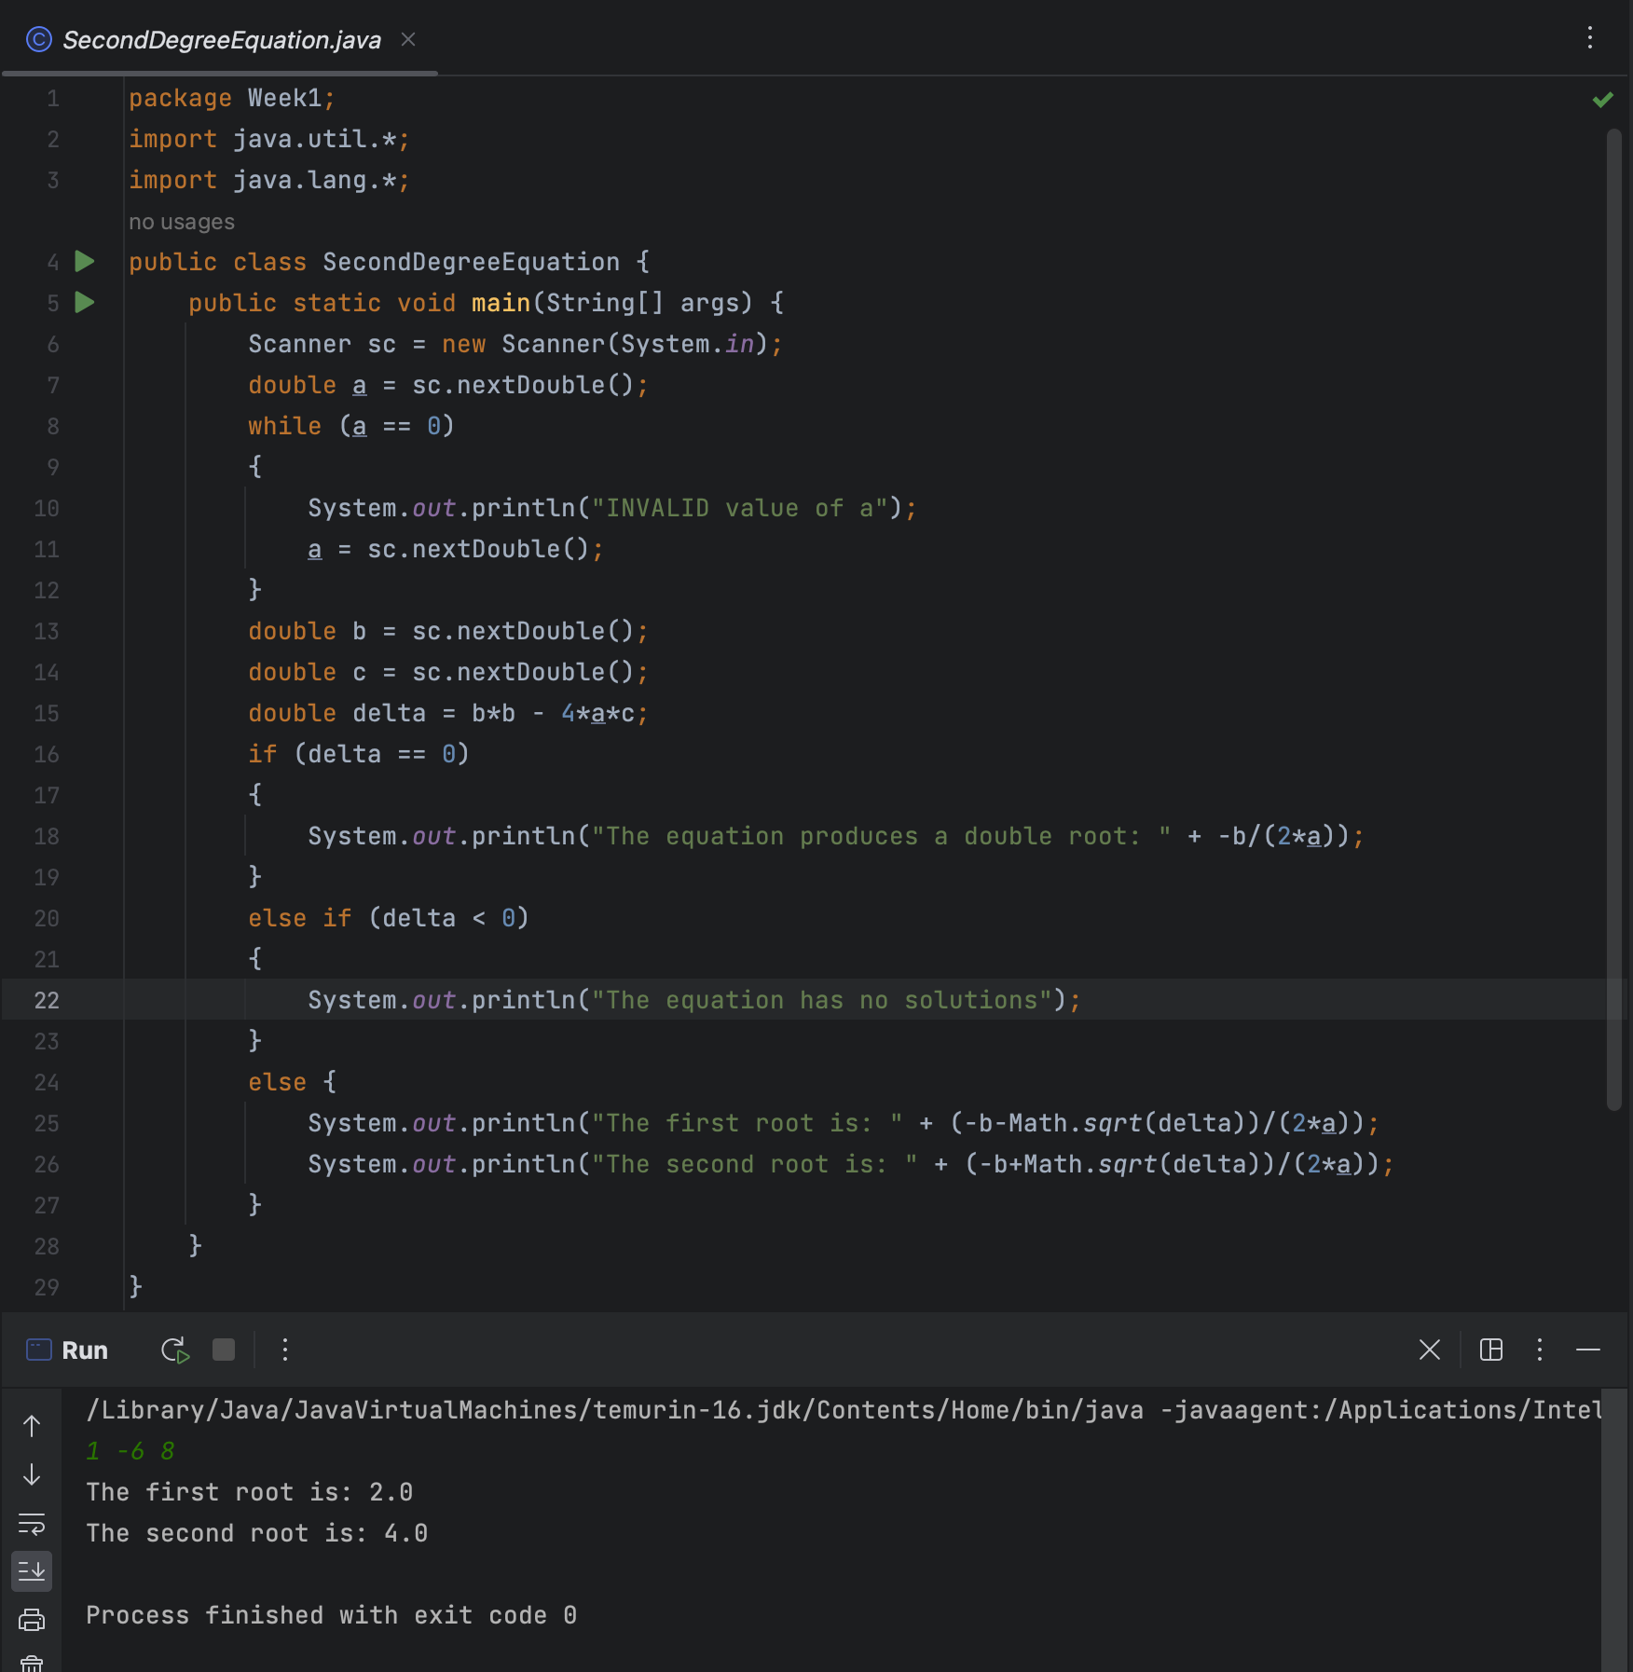

## *6.1 Write, compile, and run the ChoosingOption program:*

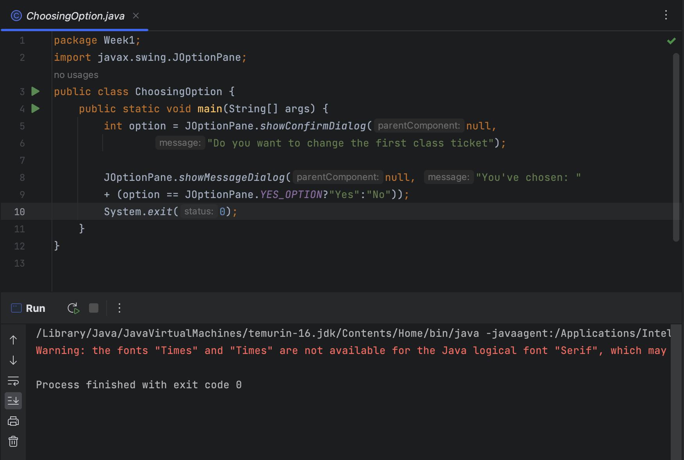

* If the users choose “Cancel”, the dialog box will appear: “You've chosen: No”
* You can customize the options that are presented to the user by changing the values in the **new Object[] {...}** array.

## *6.2 Write a program for input/output from keyboard:*

## *6.3 Write a program to display a triangle with a height of n stars:*

## *6.4 Write a program to display the number of days of a month:*

package Week1;  
import java.util.*;  
public class DaysOfAMonth {  
 public static void main(String[] args) {  
 Scanner input = new Scanner(System.*in*);  
  
 // Prompt the user to enter the month and year  
 System.*out*.print("Enter the month (e.g. January, Jan., Jan, 1): ");  
 String monthString = input.nextLine().toLowerCase();  
 System.*out*.print("Enter the year (e.g. 1999): ");  
 int year = input.nextInt();  
 int days = 0;  
 // Validate the user input for the year  
 while (year < 0) {  
 System.*out*.print("Invalid input. Please enter a non-negative number for the year: ");  
 year = input.nextInt();  
 }  
  
 // Determine the month number based on the user input  
 int month = 0;  
 if (monthString.equals("january") || monthString.equals("jan.") || monthString.equals("jan") || monthString.equals("1")) {  
 month = 1;  
 } else if (monthString.equals("february") || monthString.equals("feb.") || monthString.equals("feb") || monthString.equals("2")) {  
 month = 2;  
 } else if (monthString.equals("march") || monthString.equals("mar.") || monthString.equals("mar") || monthString.equals("3")) {  
 month = 3;  
 } else if (monthString.equals("april") || monthString.equals("apr.") || monthString.equals("apr") || monthString.equals("4")) {  
 month = 4;  
 } else if (monthString.equals("may") || monthString.equals("5")) {  
 month = 5;  
 } else if (monthString.equals("june") || monthString.equals("jun") || monthString.equals("6")) {  
 month = 6;  
 } else if (monthString.equals("july") || monthString.equals("jul") || monthString.equals("7")) {  
 month = 7;  
 } else if (monthString.equals("august") || monthString.equals("aug.") || monthString.equals("aug") || monthString.equals("8")) {  
 month = 8;  
 } else if (monthString.equals("september") || monthString.equals("sep.") || monthString.equals("sep") || monthString.equals("9")) {  
 month = 9;  
 } else if (monthString.equals("october") || monthString.equals("oct.") || monthString.equals("oct") || monthString.equals("10")) {  
 month = 10;  
 } else if (monthString.equals("november") || monthString.equals("nov.") || monthString.equals("nov") || monthString.equals("11")) {  
 month = 11;  
 } else if (monthString.equals("december") || monthString.equals("dec.") || monthString.equals("dec") || monthString.equals("12")) {  
 month = 12;  
 }  
 switch (month) {  
 case 2:  
 if (year % 4 == 0 && (year % 100 != 0 || year % 400 == 0)) {  
 days = 29;  
 } else {  
 days = 28;  
 }  
 break;  
 case 4:  
 case 6:  
 case 9:  
 case 11:  
 days = 30;  
 break;  
 default:  
 days = 31;  
 break;  
 }  
 System.*out*.println(days);  
 }  
}

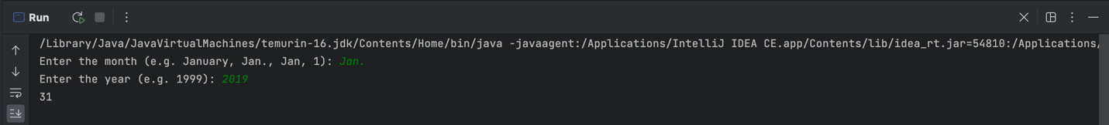

## *6.5 Write a program sort a numeric array, calculate the sum and average value:*

## *6.6 Write a program to add two matrices of the same size:*

package Week1;  
import java.sql.SQLOutput;  
import java.util.*;  
public class AddTwoArrays {  
 public static void main(String[] args) {  
 Scanner sc = new Scanner(System.*in*);  
 System.*out*.print("Enter the size of the matrices: ");  
 int n = sc.nextInt();  
 int[][] a = new int[n][n];  
 int[][] b = new int[n][n];  
 System.*out*.println("Enter the elements of the first array: ");  
 for (int i = 0; i < n; i++) {  
 for (int j = 0; j < n; j++)  
 a[i][j] = sc.nextInt();  
 }  
 System.*out*.println("Enter the elements of the second array: ");  
 for (int i = 0; i < n; i++)  
 {  
 for (int j = 0; j < n; j++)  
 b[i][j] = sc.nextInt();  
 }  
 int[][] sum = new int[n][n];  
 for (int i = 0; i < n; i++)  
 {  
 for (int j = 0; j < n; j++)  
 sum[i][j] = a[i][j]+b[i][j];  
 }  
 System.*out*.println("The sum array: ");  
 for (int i = 0; i < n; i++)  
 {  
 for (int j = 0 ; j < n; j++)  
 {  
 System.*out*.print(sum[i][j] + " ");  
 }  
 System.*out*.printf("\n");  
 }  
 }  
}

