Contents

Use of the E-Health application 2

1 Introduction 2

2 E-Health Web Services application 2

3 E-Health Web GUI application 3

Web GUI 3

Patients menu 5

Patient data page 5

Content management 6

Other features 7

4. E-Health desktop client application 7

Screenshots 7

# Use of the E-Health application

## 1 Introduction

In this appendix, the web components already deployed in a PaaS provider will be presented. These are the components that are currently running in Cloud Foundry and Pivotal, and that will be deployed later in another PaaS provider using the MODAClouds tools, as soon as the models and scripts are ready. This task will be done before month 24. This brief description of the web components also serves as a short manual.

The client desktop application that uses the web services component will also be briefly described.

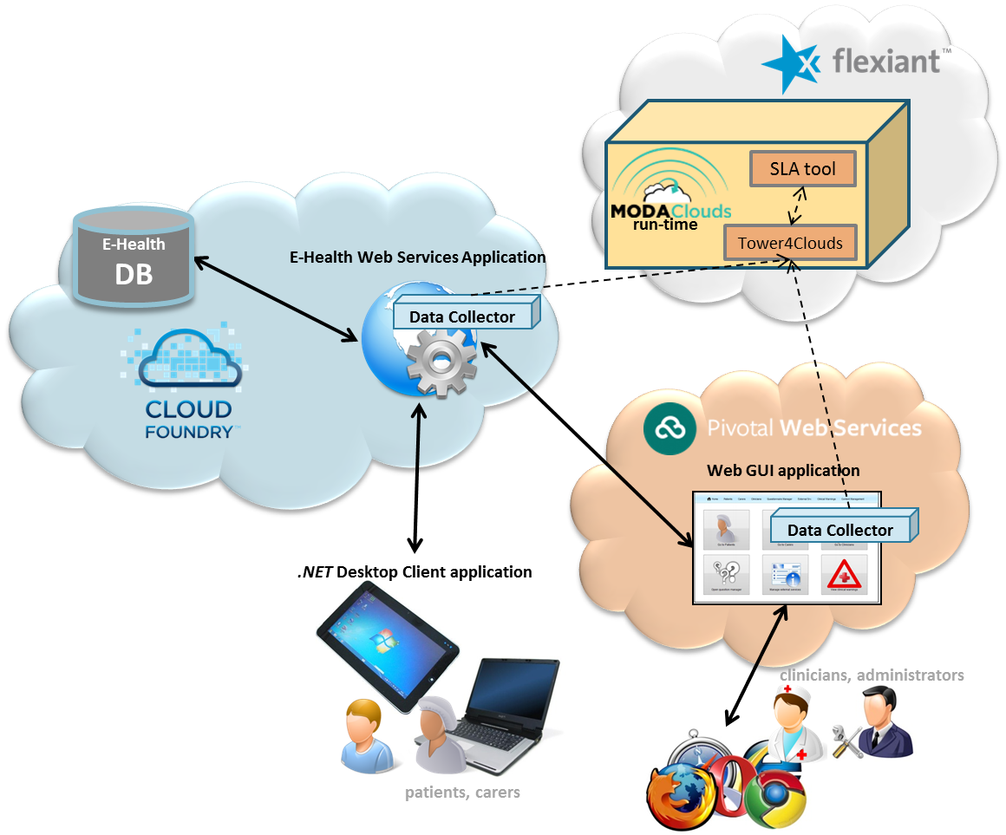

**FigureA.1.1: E-Health architecture - components deployed in Cloud Foundry & Pivotal**

Right now, the database used by these components that is hosted in a private server is a MySQL database service offered by the platform as an add-on.

## 2 E-Health Web Services application

This component has the main logic of the ATOS Healthcare solution. This application provides a set of services (SOAP) that are used by the other components of the solution, like the web GUI application and the desktop client application. This is also the component that handles the connections with the database and other services or applications, like the ones provided by the selected PaaS.

This web application has been deployed in a private Cloud Foundry instance container as a standalone java web application.

* Link to e-Health Web Services applications:
  + <http://ehealthws.95.211.172.243.xip.io/StorageComponent?wsdl>

#### Screenshots

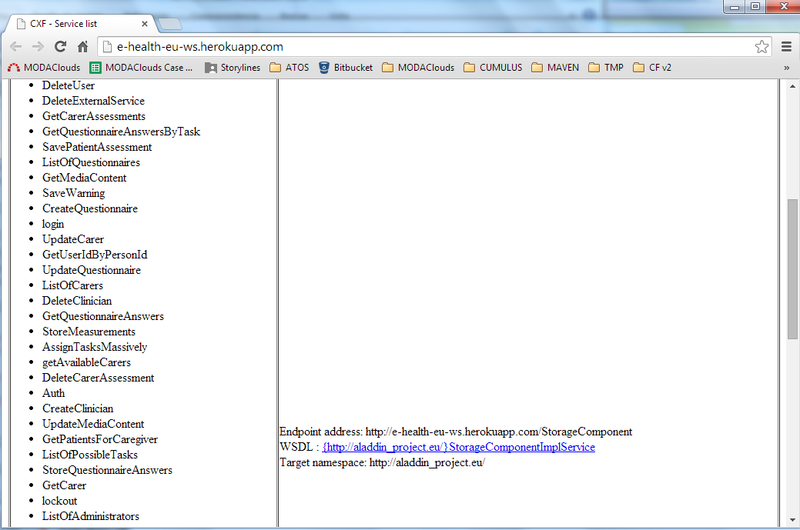

**FigureA.2.1: Web services application**

## 3 E-Health Web GUI application

This component is the main interface for the clinicians and administrators of the E-Health solution. This is a web application that uses the services offered by the E-Health Web Services application. Its main purpose is to manage the users of the solution, and also to do the follow-up of the patients. There are two different roles or users that can access this application, the administrators and the clinicians. The first ones are responsible of the management of the users of the system. On the other hand, the clinicians are the responsible of the management of the patients. This includes the content (videos, games, links used by the desktop application) management, the patients tasks management and also the follow up of these patients.

This application has also been deployed as a standalone java web application in two different PaaS providers.

* link to e-Health Web GUI application:
  + <http://ehealth-modaclouds-gui.95.211.172.243.xip.io/>
  + <http://ehealth-gui-bursting1.cfapps.io/>
* User / password / role:

- admin / admin123 / administrator

- house / password123 / clinician

### Web GUI

Before starting to work with the applications some considerations have to be taken into account:

1. This is a first version of the application. It may have some errors.

2. Only administrators can create clinicians.

3. Both administrators and clinicians can create patients and caregivers.

4. Only the clinician users can manage the patients.

5. In order to create a patient, you have to create first a caregiver (carers menu).

6. The questionnaire manager is not ready. There are other features not ready yet.

In order to work with the application enter a valid **Username and Password** assigned to you and click on the **Sign In** button.

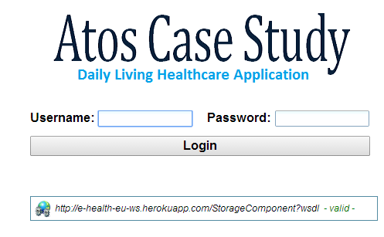

**FigureA.3.1: Web application – login screen**

After a valid user is logged in, the following menu screen will be displayed:

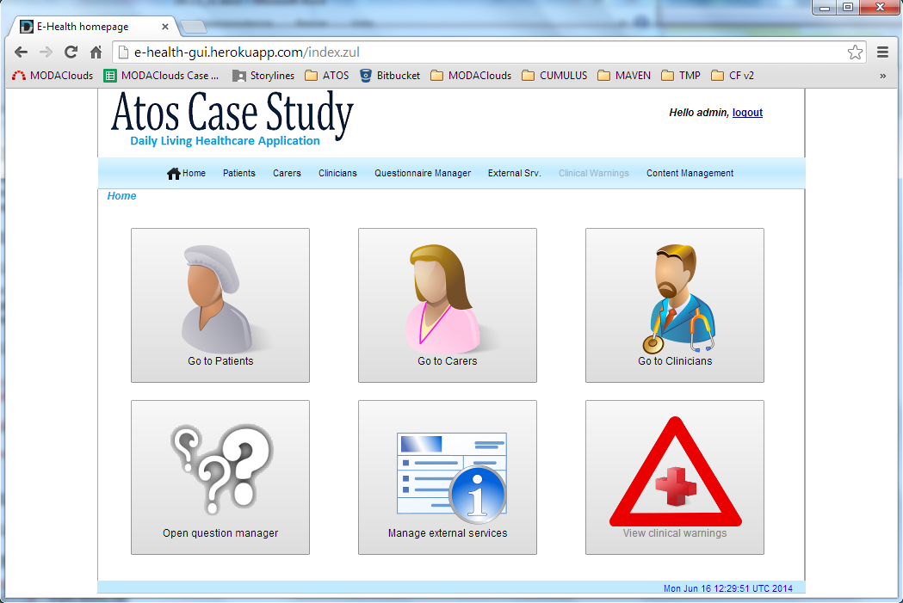

**FigureA.3.2: Web application – main menu**

Once a user successfully logged in Web GUI Portal, it can access seven navigable sections:

1. Patients menu action: to manage patients’ accounts, data, tasks and tasks for carers
2. Carers menu action: to manage carers’ accounts and data
3. Clinicians menu action: to manage accounts of administrators (accessible only by administrators)
4. Questionnaire Manager: to manage questionnaires
5. External Services: to manage external services, which can be used in tasks assigned to patients
6. Clinicians warnings: to view the list of received warnings
7. Content Management: to manage external resources (games, video, exercises, etc.) accessible by all patients and carers

### Patients menu

From the main menu page, clicking on the “Patients” tab or on the “Go to Patients” picture (see the picture below), clinicians can list the patients beyond its responsibility and access to a patient menu action page that provides functionalities to manage patient’s data, assign tasks, manage assessment and monitor the status.

|  |  |  |  |
| --- | --- | --- | --- |
| **1) Add Patient data** | **2) Access Patient data** | **3) Modify Patient data** | **4) Delete Patient data** |

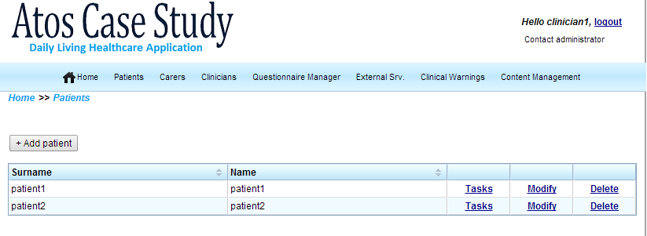

**FigureA.3.3: Web application – patients menu**

### Patient data page

Clinicians through the “Patient data page” (*Tasks* link) are able to manage their patients’ data. For each patient the E-Health system offers a detailed overview of the patient status. The main actions clinicians can perform are:

* Show/Hide or modify patient personal data;
* Interact with the patient calendar (calendar functionalities);
* Manage patient tasks: view status task, assign new tasks, remove task, remove massively tasks;
* View measurement charts (weight and bloody pressure);
* Manage patient assessment;

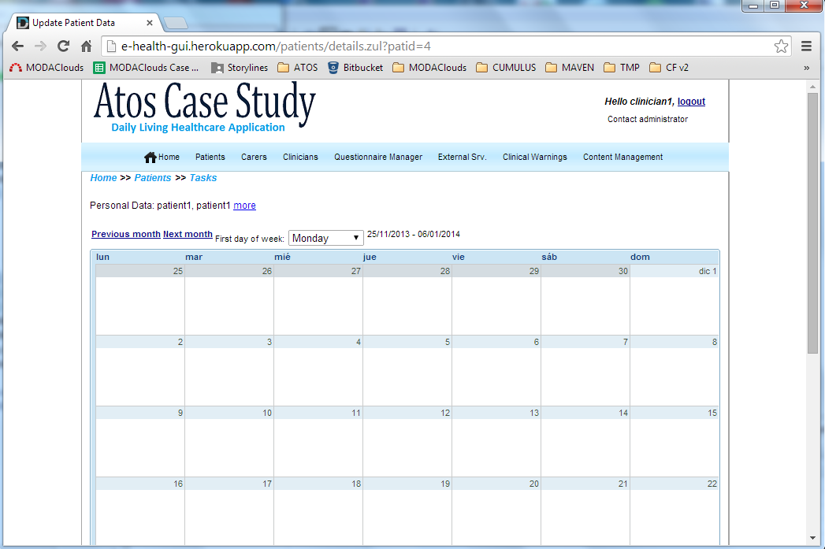

**FigureA.3.4: Web application – patient calendar**

### Content management

The content that can be accessed (desktop application) by the end users, like the patients or their caregivers, is managed in this menu screen.

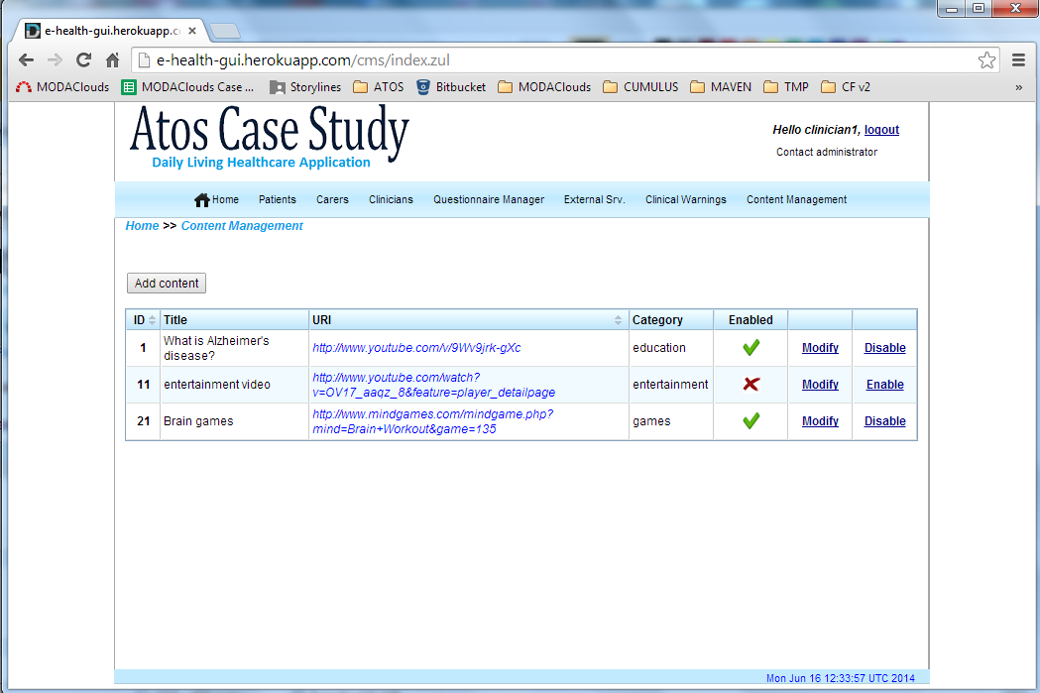

**FigureA.3.5: Web application – content management**

The clinicians can specify the videos, games or other kind of content that patients can access.

### Other features

The external services menu, the clinical warnings menu and the questionnaire manager are not ready or don’t work properly.

## 4. E-Health desktop client application

This desktop application will be used by the patients and their caregivers in order to collect all the patients’ measurements and parameter data that will be sent later to the server (e-Health Web Services application). This is also the application where the end users can access all the multimedia content provided by the clinicians.

This is a first version of the application and it may have some errors. But right now, the application has the following features ready and available:

- Blood pressure, weight and activity measurements

- Access to videos and other kind of contents

* User / password / role:

- felo / password123 / caregiver

### Screenshots

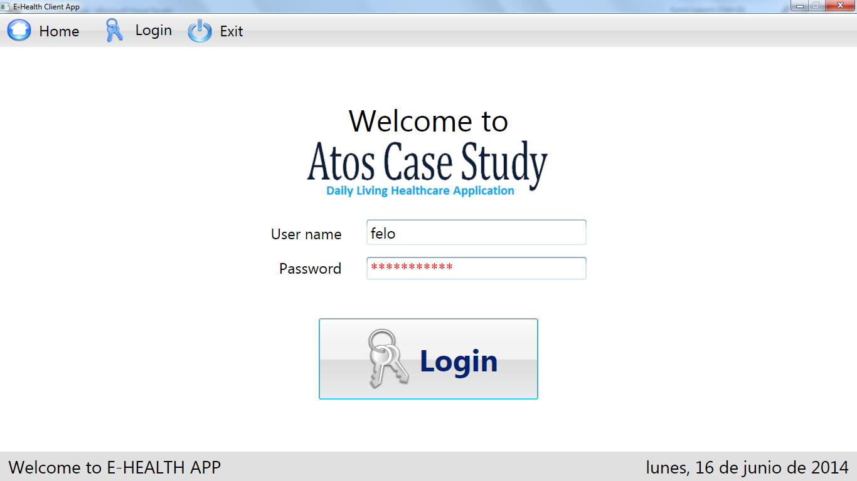

**FigureA.4.1: Desktop application – login screen**

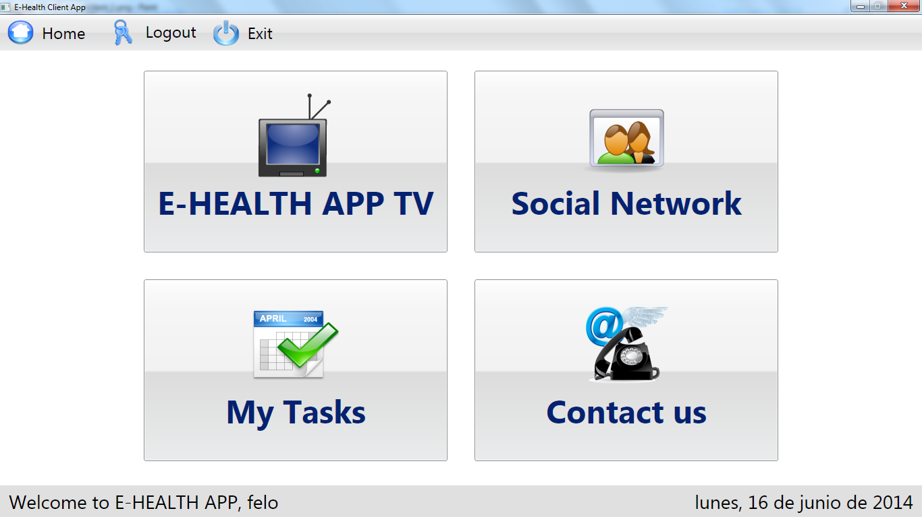

**FigureA.4.2: Desktop application – main menu**

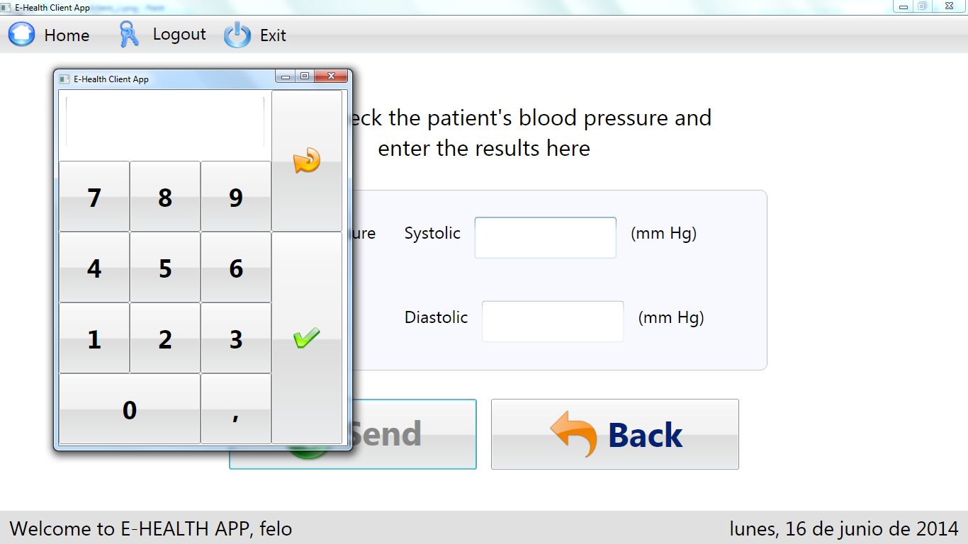

**FigureA.4.3: Desktop application – blood pressure measurement screen**