**CompanyLocker Specification Document**

**Project Detail**

Project Name: CompanyLocker

**Project Version: 1.0**

**GitHub repository link:** [**https://github.com/modakajit58/Simplilearn_CompanyLockerProject_Phase1/tree/main/CompanyLockerCode**](https://github.com/modakajit58/Simplilearn_CompanyLockerProject_Phase1/tree/main/CompanyLockerCode)

**Project Details:** Prototype of file management system. This application has the features to add, delete and search a file from specific directory.

**Objective**: Application Need to be presented to relevant stack holder for the budget approval

**Developer Detail**

Name: Ajit Nivrutti Modak

Simplilearn user ID: [modakajit58@gmail](mailto:modakajit58@gmail.com)

Batch: MS FSD June 2022 Cohort 1

**Functionality Detail of the Application:**

**Welcome Screen:**

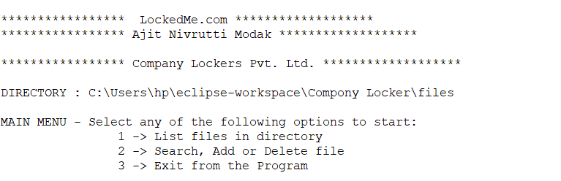

**Main Screen:**

This screen heaving the welcome screen and the user interface detail where user need to select any of one options

“

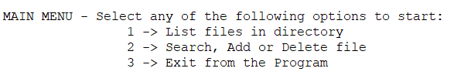

**“**

**List files in the directory:** This option provides the list of files in current directory.

**Search, Add or Delete file:** This option takes the user to secondary menu. (More details are provided in the secondary menu section of this document).

**Exit from the programme**: Close the Application.

**Secondary Menu:**

This Section has the options for the file operation and one option for the going back to main screen. By selecting the file operation a, b, or c user can perform specific Task.

“

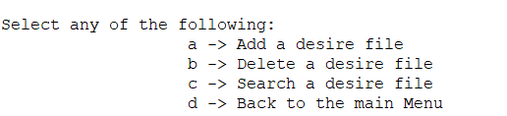

“

**Add a desire file**: when user select this option it asks for the file name first. When user enters the file name it will adds new file in the directory.

**Delete a desire file:** when user select this option it asks for the file name first. When user enters the file name it will Delete the file form directory

**Search file**: when users select these options it searches the files in the directory and shows the search result.

**Back to the main menu**: it takes bake the user to main menu option.

**Flow Chart:**

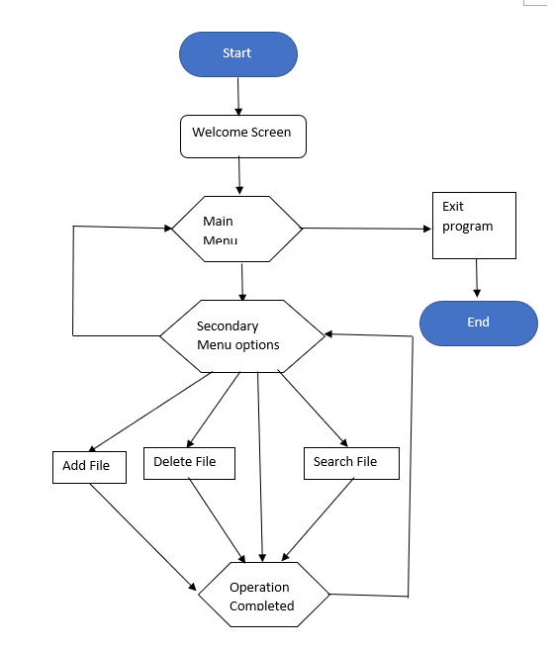

**Sprint Plan:**

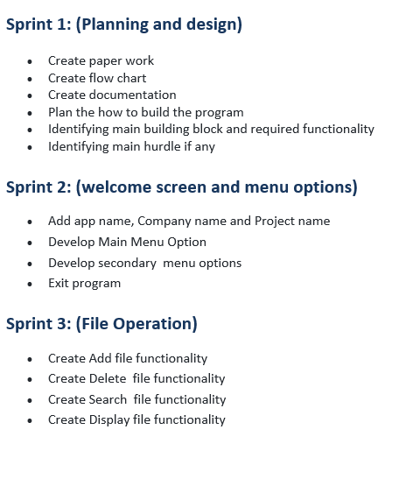

**Classes and functions used in the programme:**

|  |  |  |  |
| --- | --- | --- | --- |
| Sr. No. | Name | Class/functions | Remarks |
| 1 | CompanyLocker | Class | Class for the file operations |
| 2 | showPrimaryMenu | Function | For showing primary menu |
| 3 | showFiles | Function | For listing and sorting the files |
| 4 | showSecondaryMenu | Function | For showing secondary menu |
| 5 | addFile | Function | For adding files |
| 6 | deleteFile | Function | For deleting file |
| 7 | searchFile | Function | For searching files |
|  |  |  |  |

**Concept used in this programme:**

1. Classes
2. Objects
3. Constructor
4. Encapsulation
5. Inheritance
6. Exception Handling
7. File handling
8. Flow control
9. Methods
10. Variable
11. Access Modifier
12. List
13. String
14. Array
15. Searching and Sorting

**Conclusion:**

There is lot of scope to improve this program. Using File management system, we can manage the files through program. This is a prototyped application, the user interaction will be via a command line.