Contents

1. Create a GitHub repository with project code 2

2. Use image repository to store Docker images 4

3. Execute linting step in code pipeline 5

4. Build a Docker container in a pipeline 8

5. The Docker container is deployed to a Kubernetes cluster 9

6. The Docker container is deployed to a Kubernetes cluster 11

7. Use a Rolling Deployment successfully 12

# Create a GitHub repository with project code

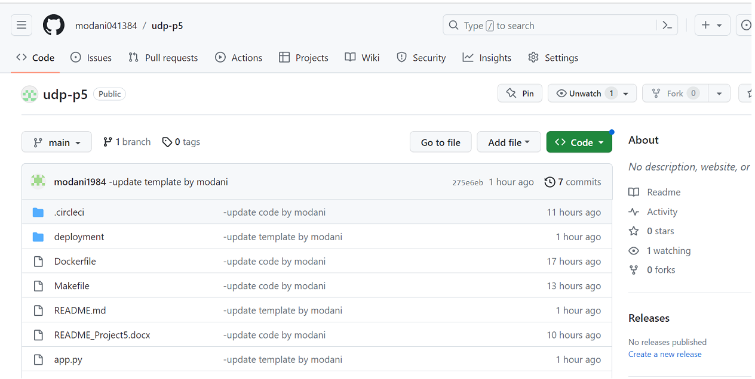

URL our Github is: <https://github.com/modani041384/udp-p5.git>

* Create EC2 Instance

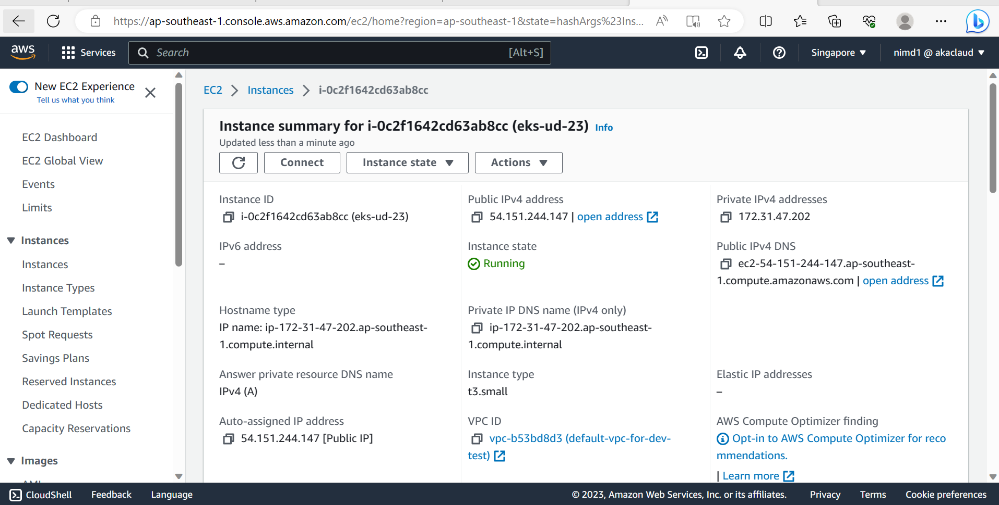

* Install infra
* Get resource from git by: git clone <https://github.com/modani041384/udp-p5.git>

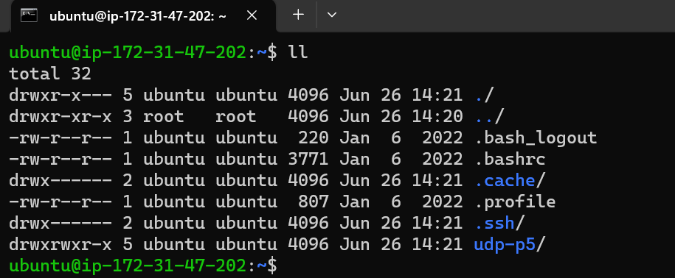

* Install python3.7

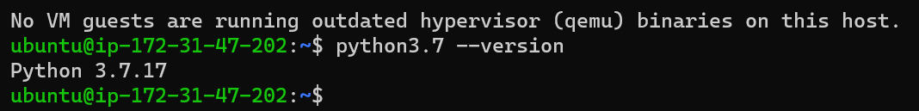

* Install docker

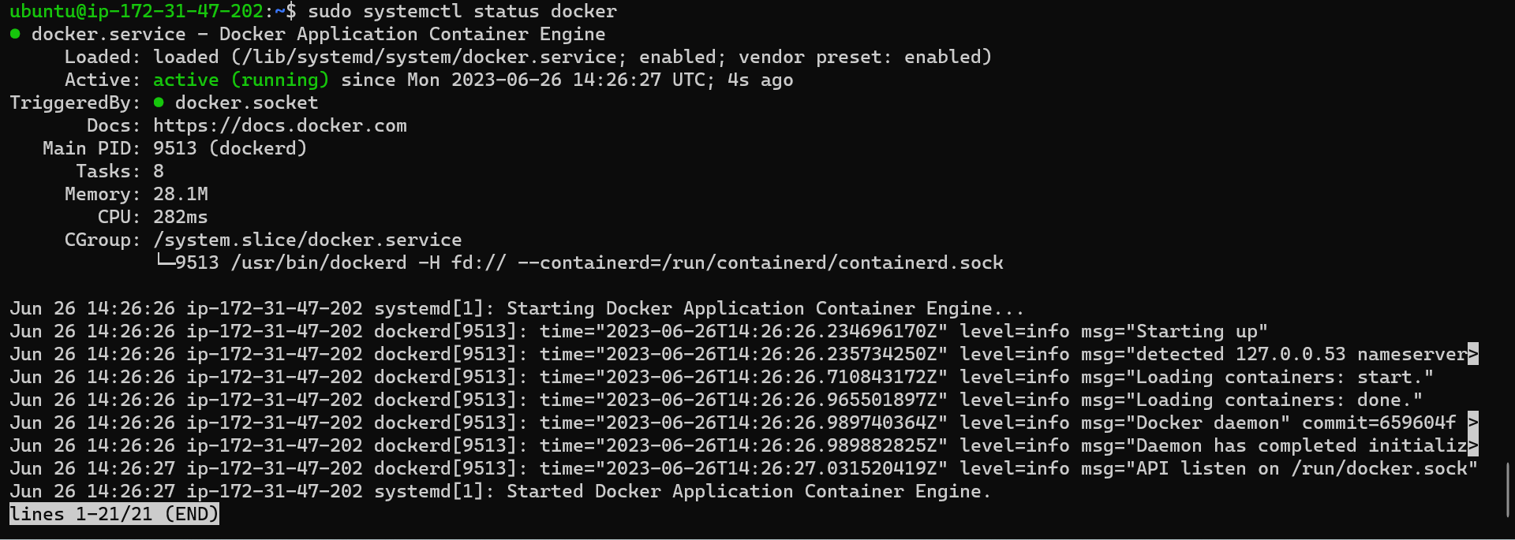

* Install kubectl



* install AWS CLI



* install eksctl



# Use image repository to store Docker images

* Run docker

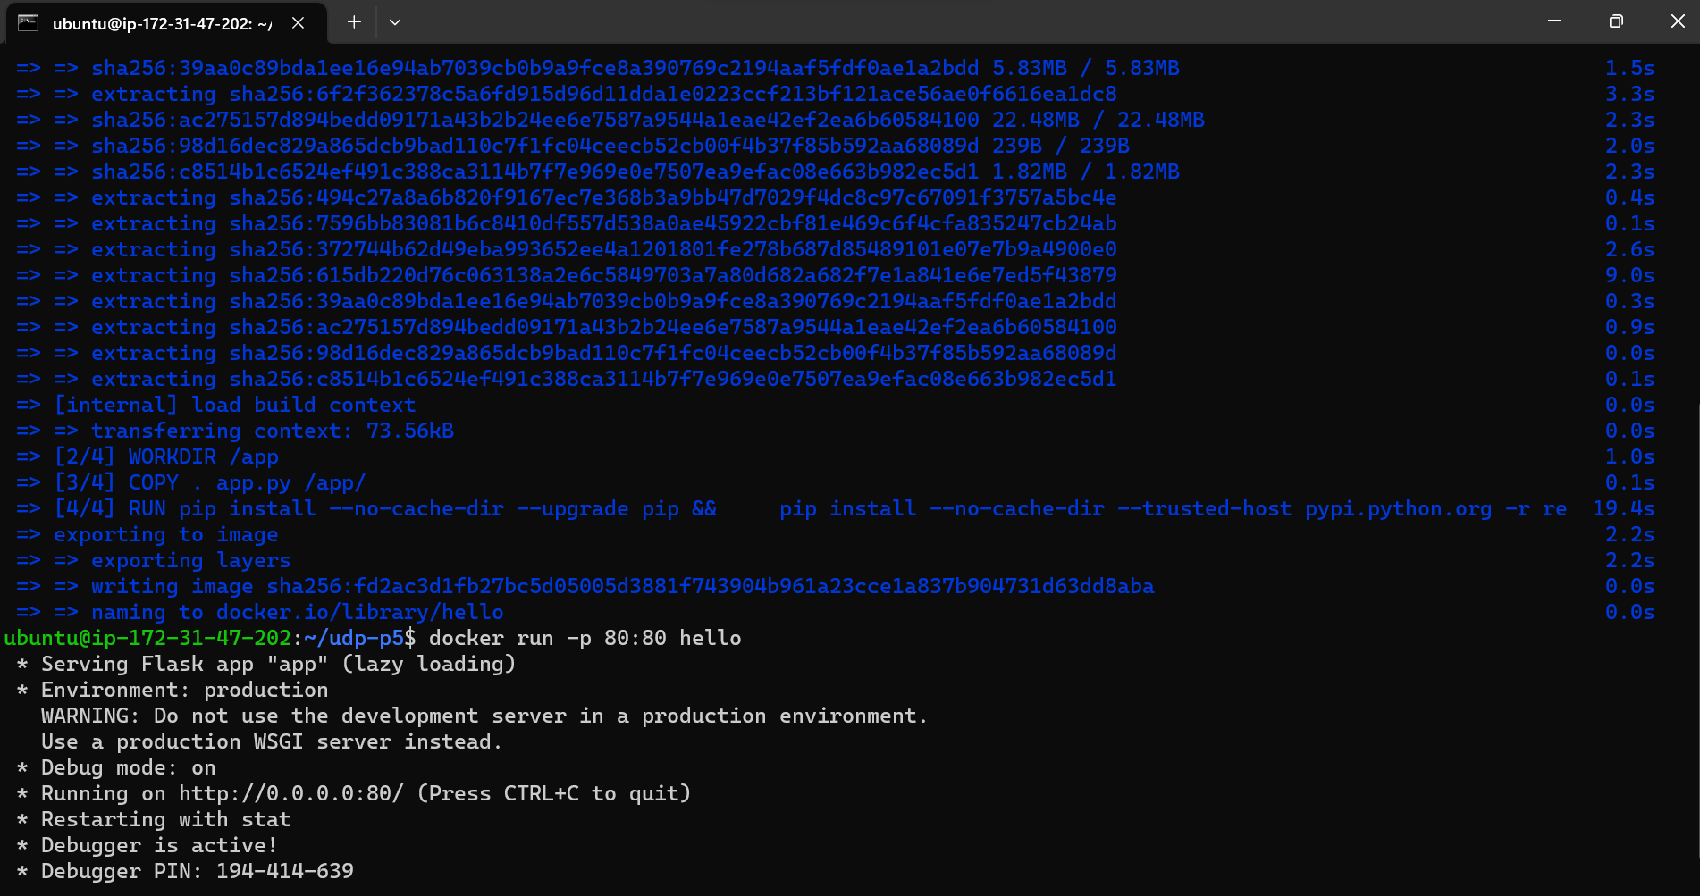



* Update docker images

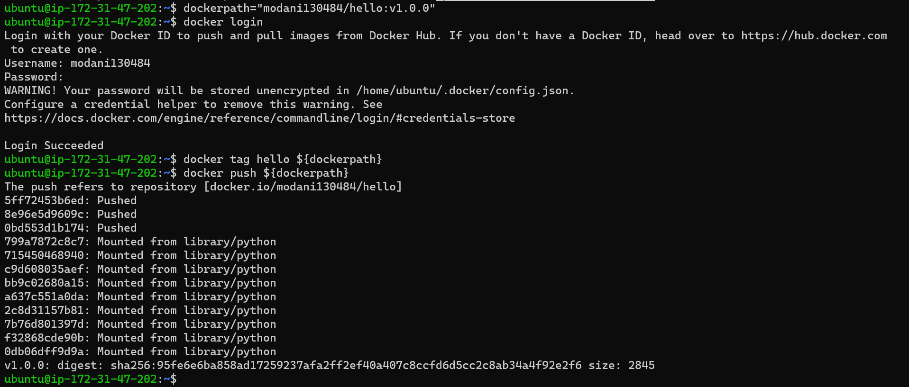

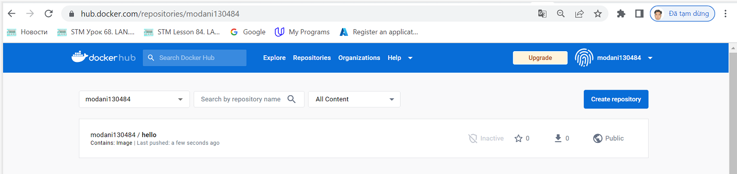

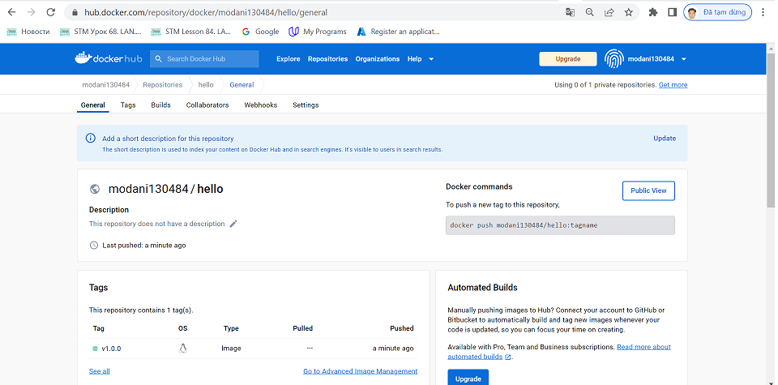

# Execute linting step in code pipeline

sudo apt install python3.7-venv

python3.7 -m venv ~/.devops

source ~/.devops/bin/activate



sudo apt install make

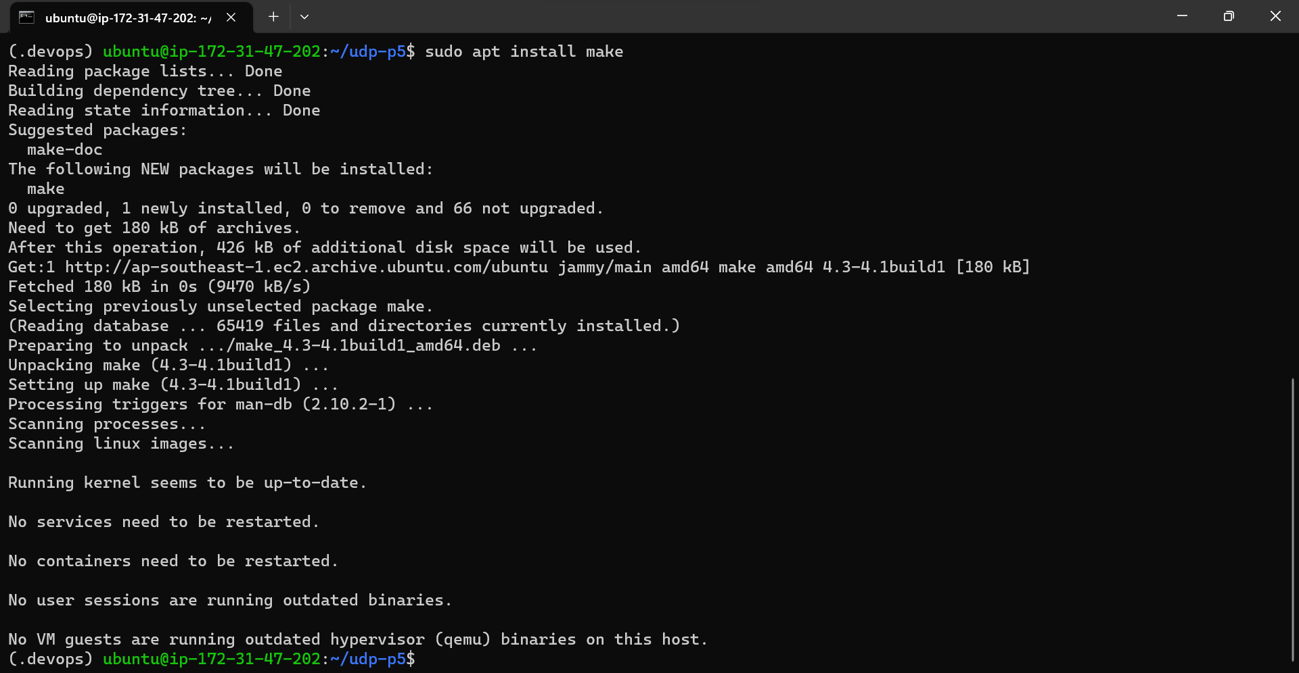

Then, we can run: **make install**

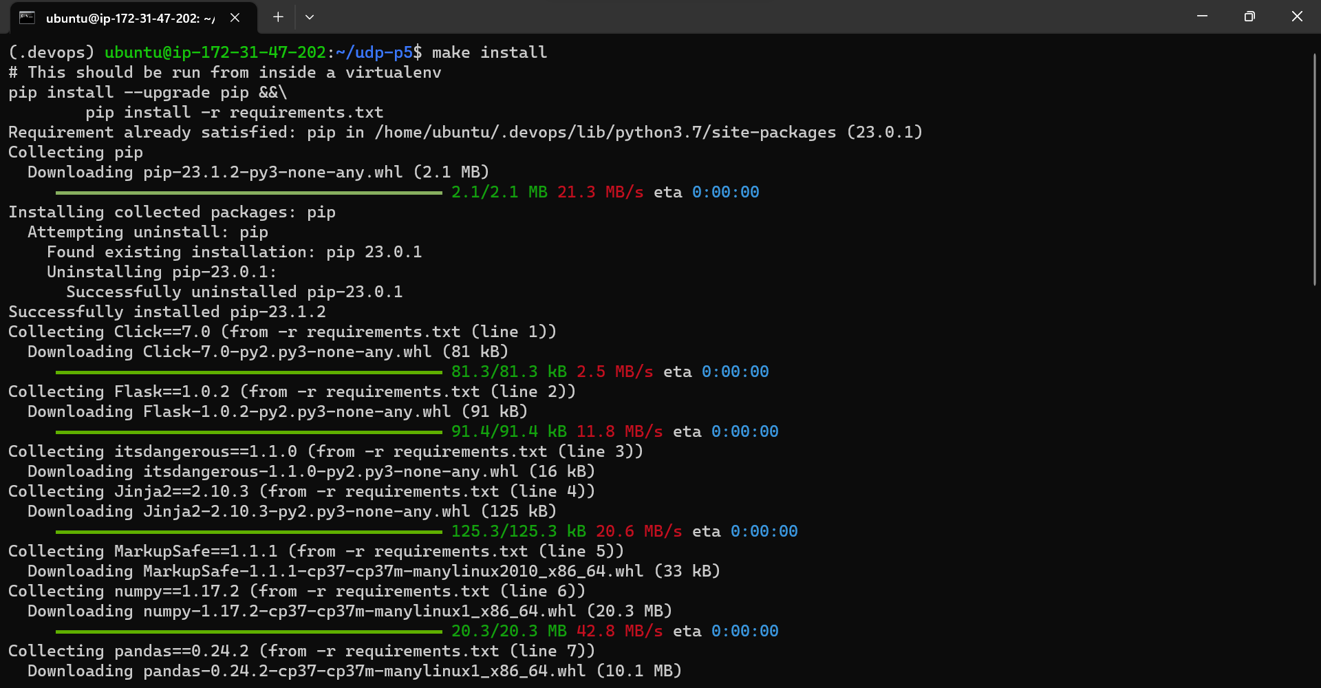

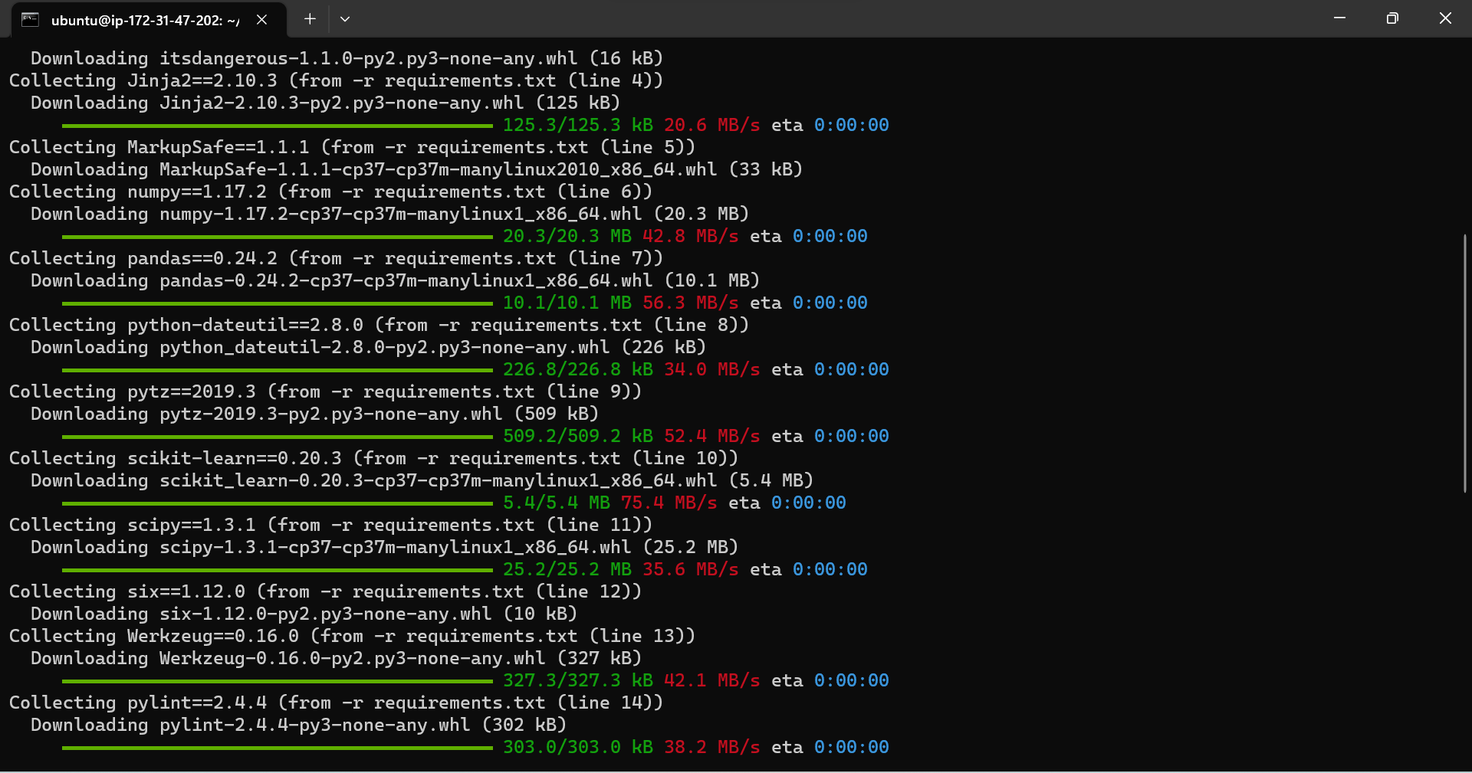

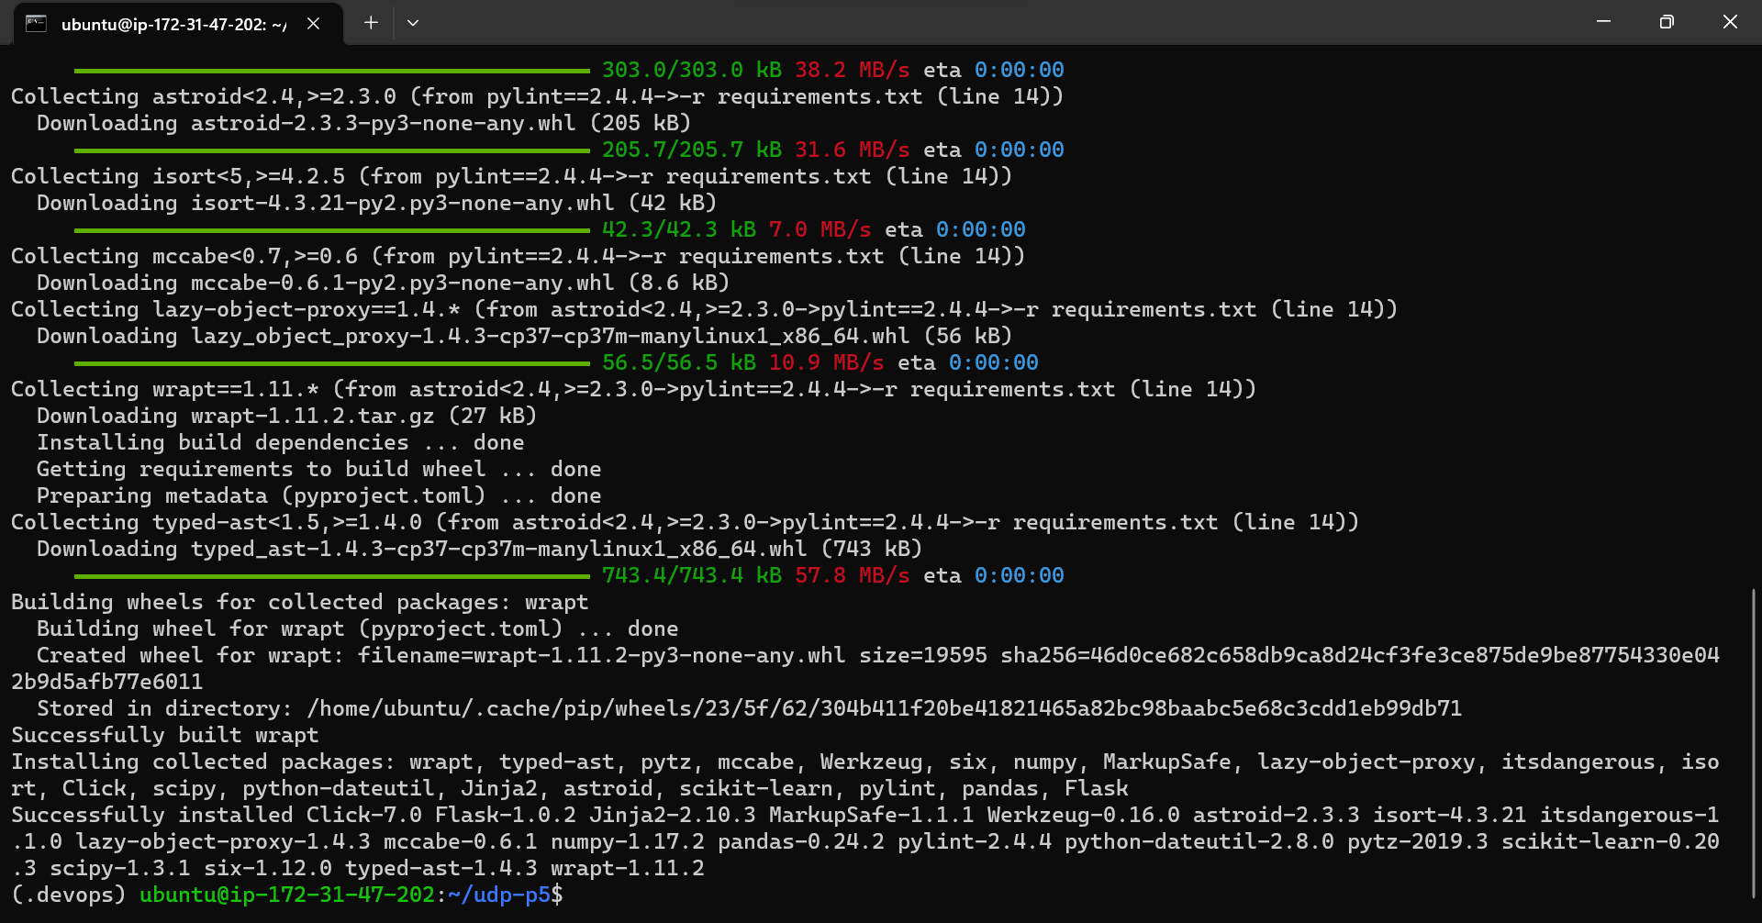

Then, we install hadolint

wget -O /bin/hadolint https://github.com/hadolint/hadolint/releases/download/v1.16.3/hadolint-Linux-x86_64 &&\

chmod +x /bin/hadolint

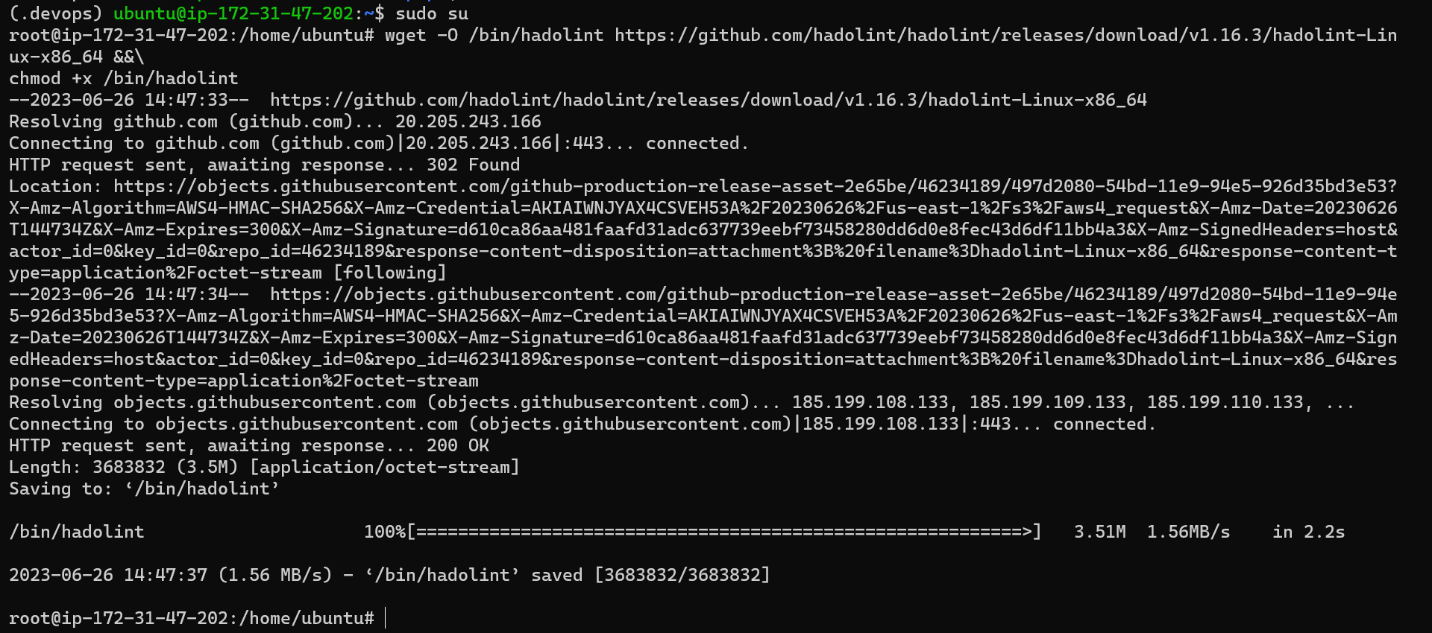

Then, we can run **make lint**

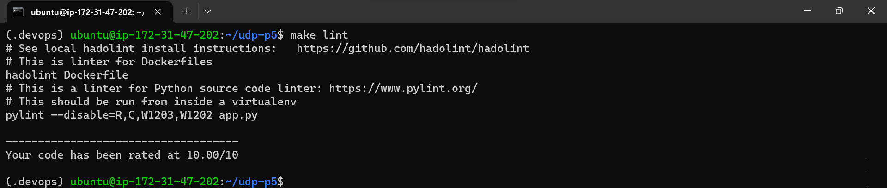

# Build a Docker container in a pipeline

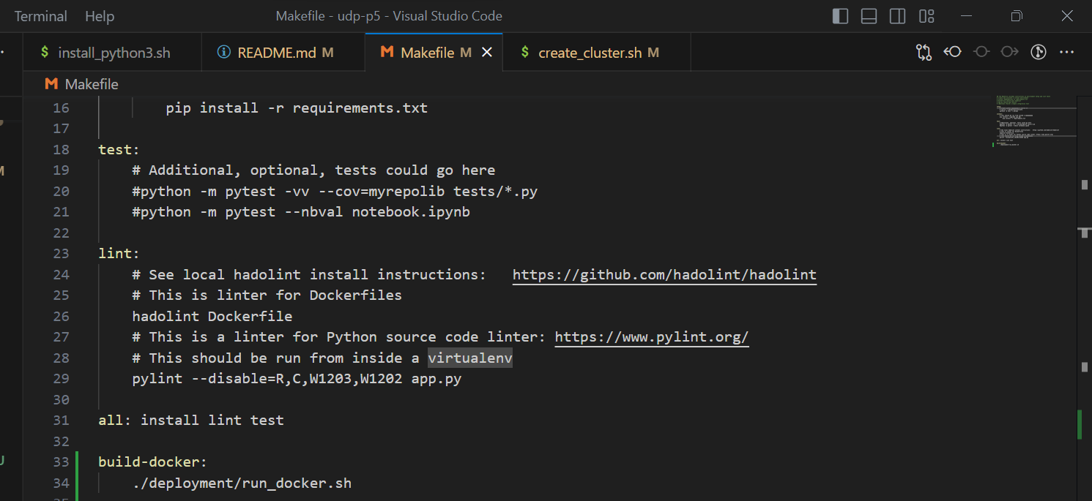

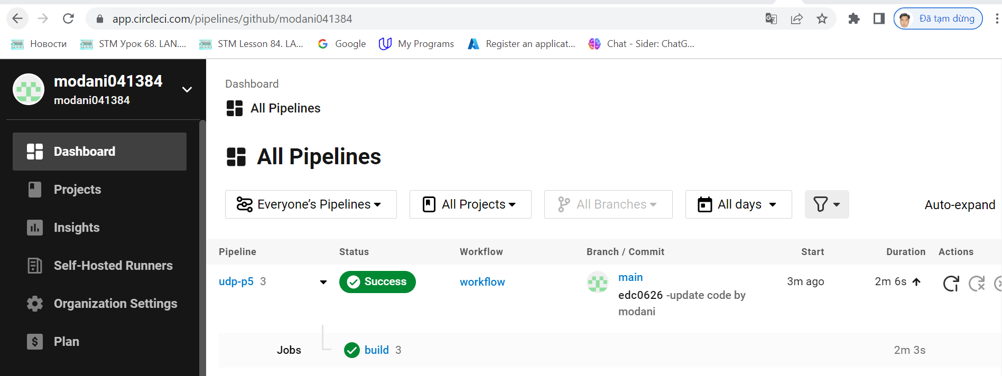

# The Docker container is deployed to a Kubernetes cluster

* aws configure



* Create cluster

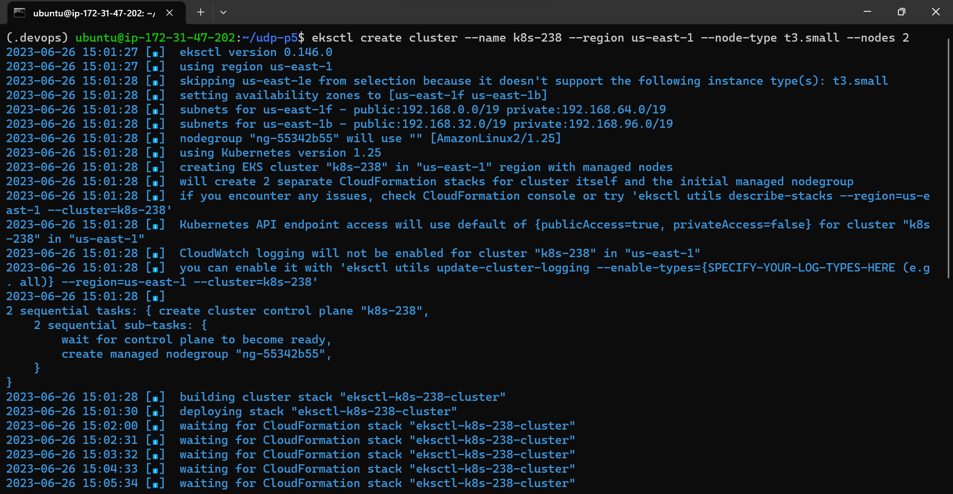

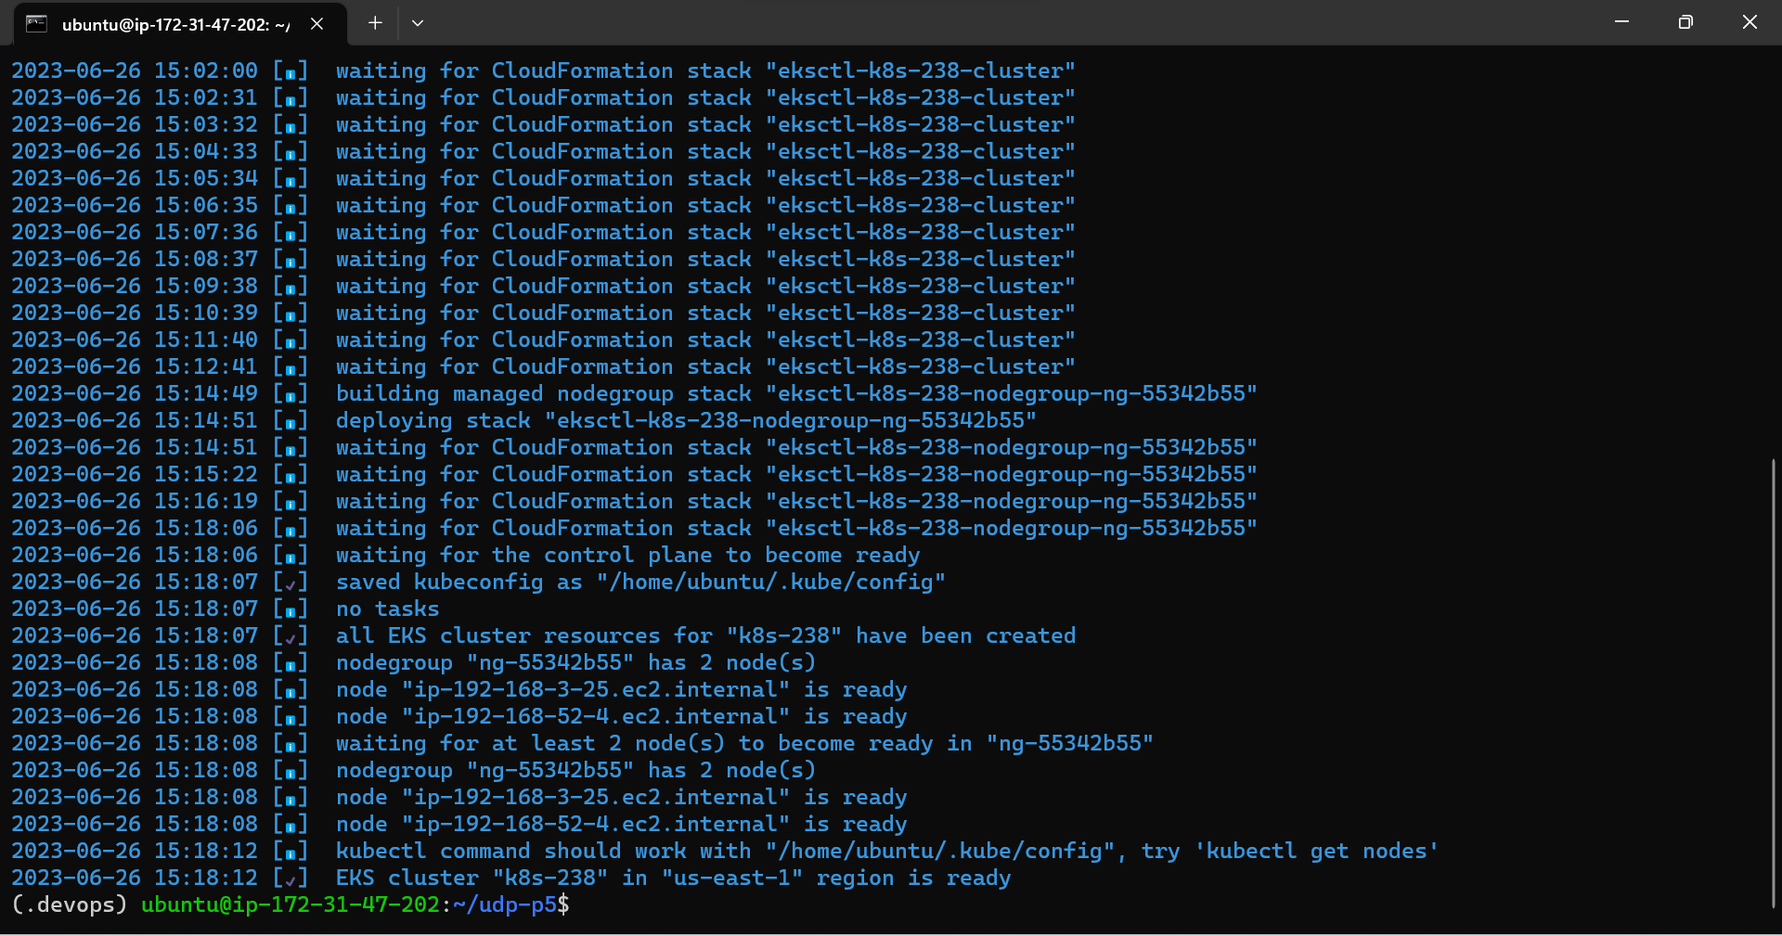

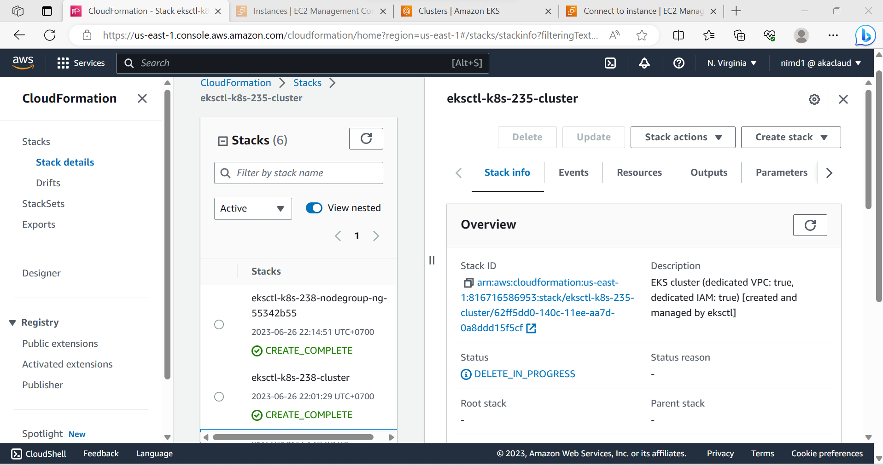

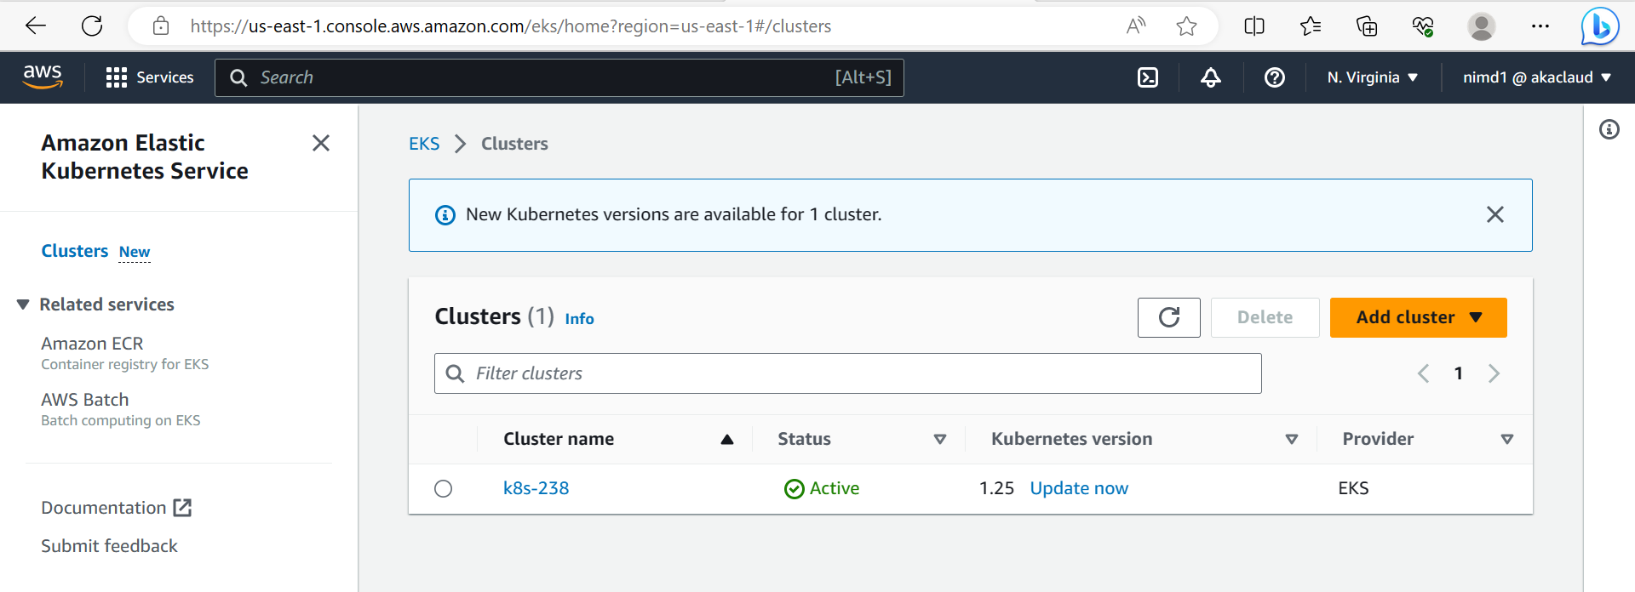

* get list clusters

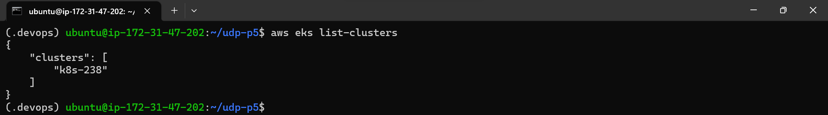

# The Docker container is deployed to a Kubernetes cluster

* deployement kubernet

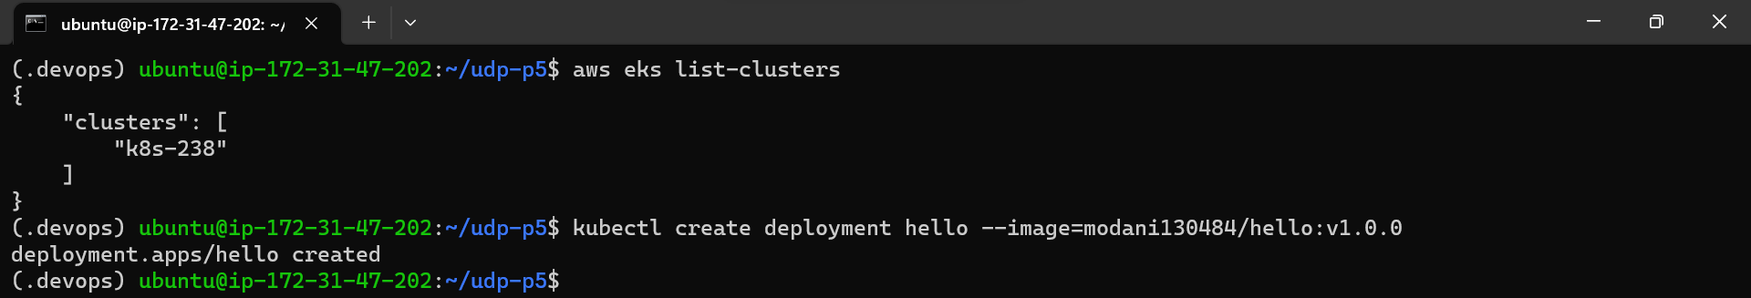

* get status after deployment



* expose deployment

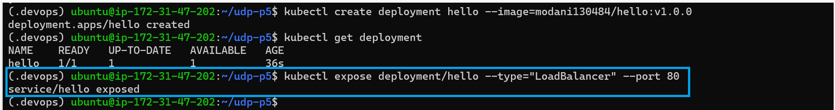

* get information after expose deployment

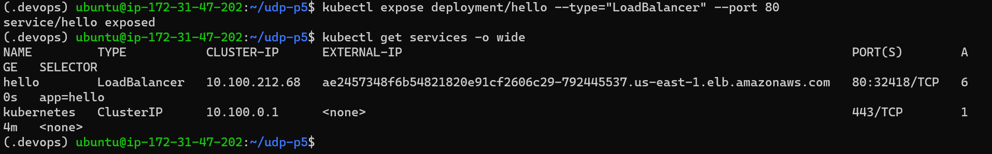

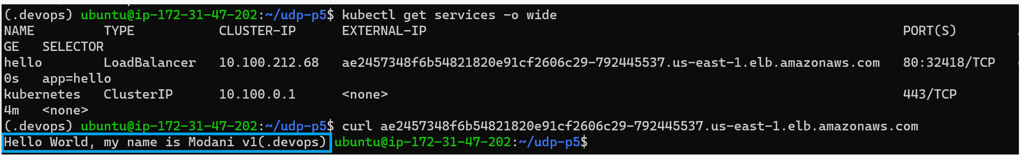



URL: http://ae2457348f6b54821820e91cf2606c29-792445537.us-east-1.elb.amazonaws.com/

# Use a Rolling Deployment successfully

* rolling-update

First, we update the new version of the application to docker containers

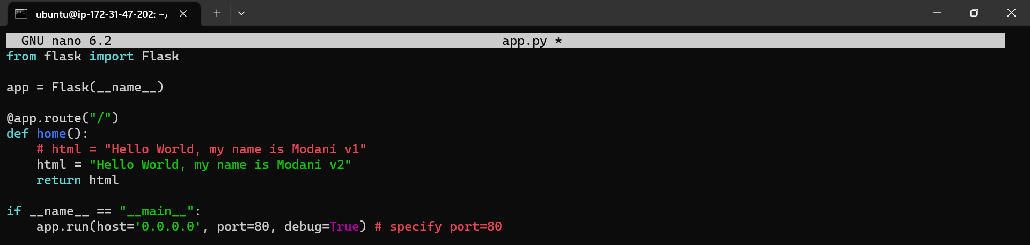

* Then, we can update the again pod with the command line

kubectl set image deployment <deployment-name> <container-name>=<new-image>



* get status after rolling-update



* Then, we have



* Rollback version before
* check version app that we have

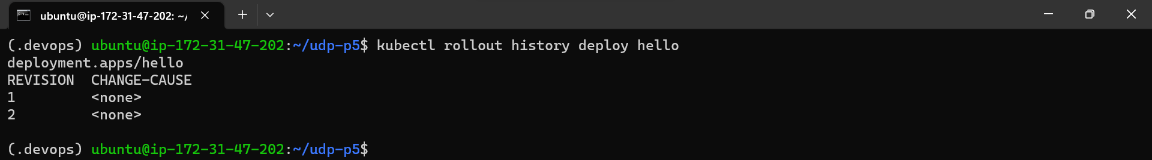

* Then, we choose the version that want to rollback (Example 1)

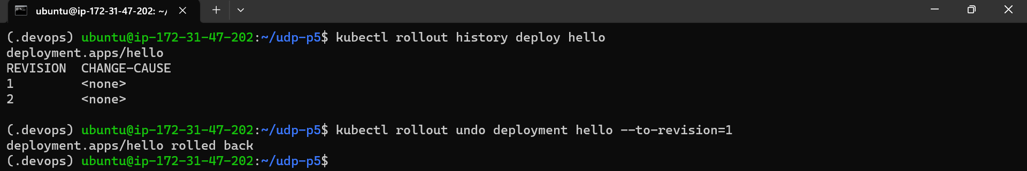

Check status



Then, we have

