Assignment #2

1. You need to build a page called Calculator.html. This page contains at least the following functionalities:

* Add
* subtract
* Multiply
* Divide
* Clear All

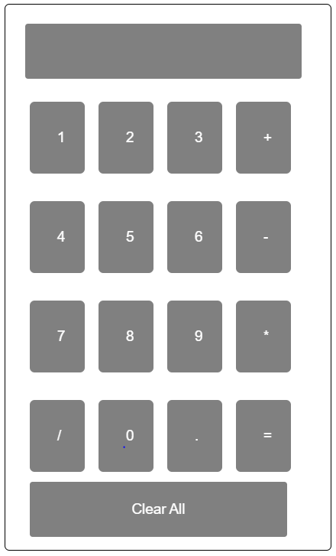

1. Hints:

* Use Html, CSS, and JavaScript.
* Every function must return a value

(3 grades)

1. You need to build a web application **containing one page**

(Home.html) This page contains 2 divs

* **1 First div is**



* **The second div is**



**Requirements:**

The content of Learn more is in another file attached in the assignment folder called learn.html “What you need is to extract data from learn.html and put it in the suitable place in home.html using ajax when pressing on button **learn More**

**Final page must be like this:**



**Notes:**

1. Name your project “YourGroup_YourID_WT_Ass2”
2. Compress the project then upload it on the blackboard based on your group number
3. This assignment will be done individually
4. No late submissions will be accepted
5. Cheaters and copies will be graded by negative
6. Deadline for this assignment will be Thursday 3-6-2021 maximum by 11:59 pm