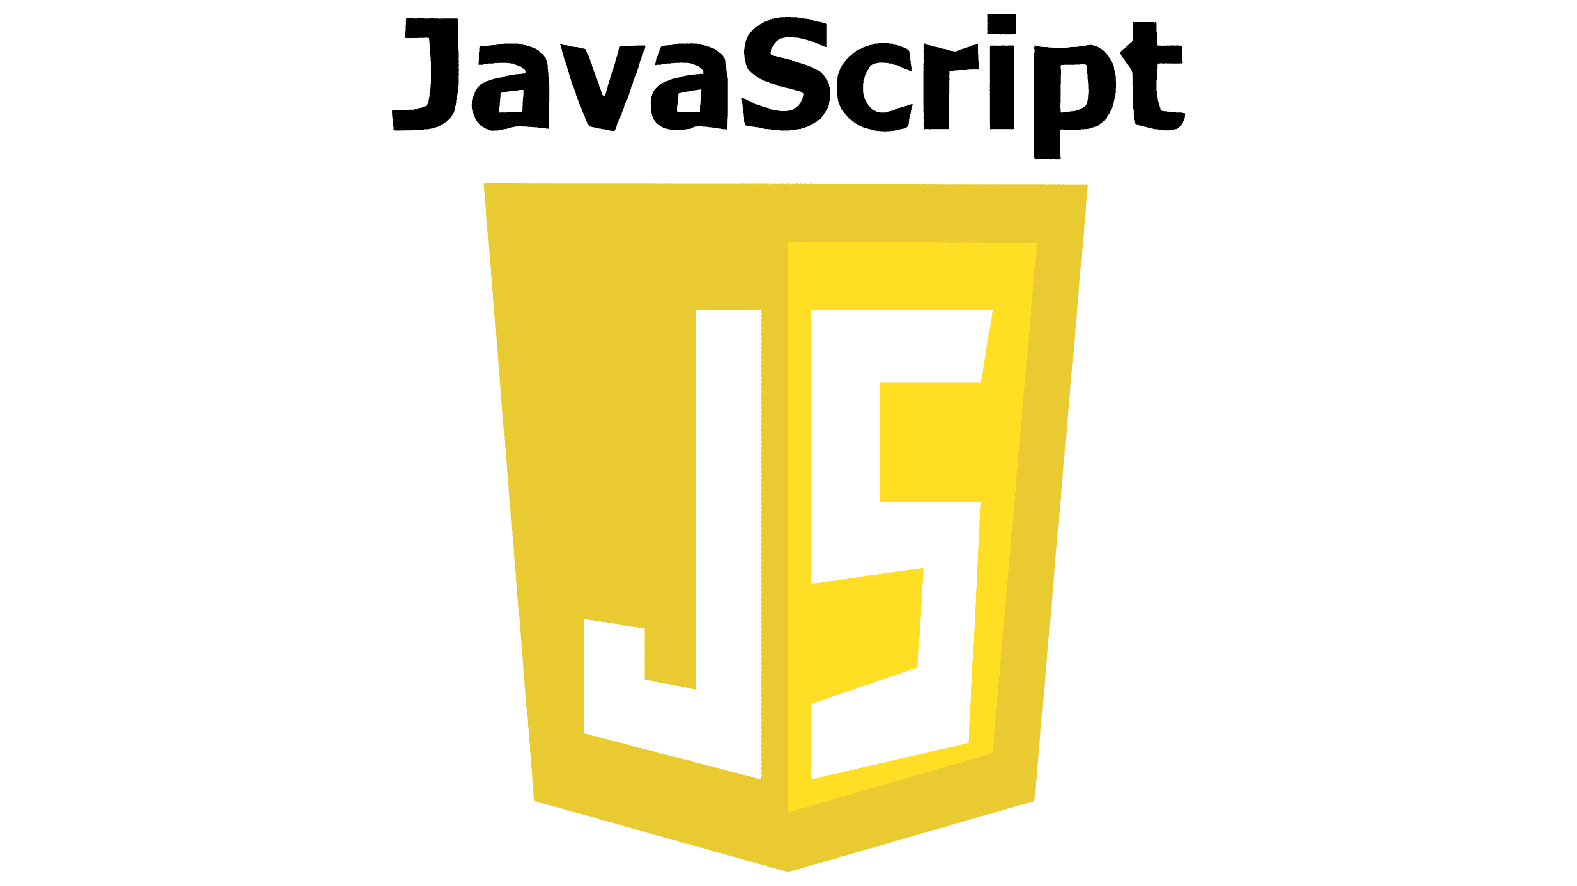

Book 5
ES6 and Beyond
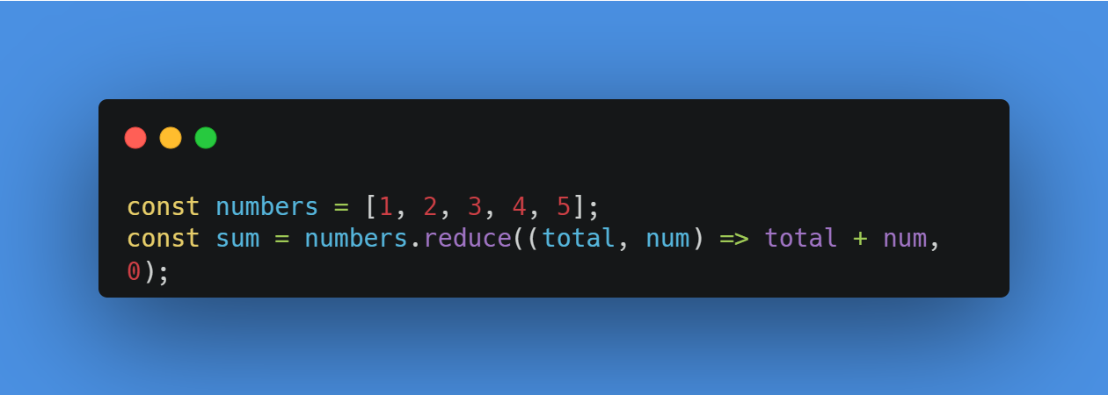
https://github.com/modcomlearning/Javascript
Table of Contents
Introduction to JavaScript: From Basics to Advanced 4
Why Learn JavaScript? 4
What Will You Learn in This Book? 4
1. Getting Started with the Basics 4
2. Core Concepts 5
3. Intermediate Features 5
4. Advanced Topics 5
5. Real-world Applications 5
How This Book Works 6
Who Is This Book For? 6
Let’s Get Started! 6
Introduction to Javascript 8
Why Learn JavaScript? 8
Hello World in JavaScript 8
Explanation: 9
JavaScript Variables and Data Types 10
JavaScript Variables 10
Declaring Variables 10
Variable Rules 11
Summary: 12
Variable Assignment and Reassignment 13
Data Types: 14
String (string): 14
2. Number (number): 14
3. Boolean (boolean): 15
4. Undefined (undefined): 15
5. Null (null): 16
Objects and Arrays (Complex Data Types) 16
Object (object): 16
Array (array): 17
Summary 18
Javascript Operators 18
1. Arithmetic Operators 19
2. Assignment Operators 19
3. Comparison Operators 20
4. Logical Operators 20
Control Statements in JavaScript 21
1. Conditional Statements 21
if Statement 21
Example 22
if-else Statement 23
else if Statement 24
Summary 26
Task Todo 26
Task: 26
Iterative/Looping Statements 27
for Loop 27
Tasks 28
While loop 28
Summary 29
Tasks 29
Javascript Functions 30
Basic Function Without Parameters 30
Function with Parameters 32
Arrow Functions 34
Arrow Function without Parameters: 34
Arrow Function with Parameters: 36
Brief Explanation: 37
Summary: 38
Task ToDo 38
Understanding JavaScript Imports, Exports 39
1. What are Imports and Exports? 39
Practice Questions 41
Appendix 1 43
Useful Links 44

Introduction to JavaScript: From Basics to Advanced
Welcome to Book 5 – your comprehensive guide to mastering JavaScript! Whether you’re just starting out with programming or you’re looking to level up your JavaScript skills, this book will take you on an exciting journey, covering everything from the foundations of JavaScript to its most advanced features.

Why Learn JavaScript?
JavaScript is the backbone of modern web development. It powers dynamic websites, mobile apps, and even server-side applications through Node.js. Mastering JavaScript means gaining the skills to create interactive web pages, perform asynchronous operations, manipulate data, and build full-fledged applications. Whether you want to work on the front-end with frameworks like React, Vue, or Angular, or dive into back-end development with Node.js, JavaScript is the language that opens countless opportunities.

What Will You Learn in This Book?
This book is designed to take you step by step, progressing from the basics of JavaScript to its most advanced concepts, in a structured way. ES6, also known as ECMAScript 2015, is the sixth version of the ECMAScript standard, which is the specification that JavaScript follows. Here's how we’ll guide you:

1. Getting Started with the Basics
- Syntax: Learn how to write JavaScript code with proper syntax, variables, and basic operations.
- Data Types: Understand how JavaScript handles different types of data (strings, numbers, arrays, objects).
- Control Flow: Master loops, conditionals, and basic logic to control how your code behaves.

2. Core Concepts
- Functions: Understand how to create and work with functions, including function expressions, parameters, and return values.
- Objects & Arrays: Learn about these powerful structures, how to manipulate them, and store data.

3. Intermediate Features
- Error Handling: Master how to handle errors in JavaScript to make your applications more robust.
- Event Handling: Understand how to interact with user events (like clicks, key presses) to make dynamic applications.

4. Advanced Topics
- Advanced Functions: Get to grips with higher-order functions, arrow functions, and functional programming techniques.
- Performance & Optimization: Explore how to write efficient, performance JavaScript code, and optimize applications for better user experiences.

5. Real-world Applications
- Frameworks & Libraries: Dive into the basics of popular frameworks like React JS.
- APIs & Web Requests: Learn how to interact with third-party APIs to create powerful applications.

How This Book Works
This book is structured to take you on a progressive learning path, starting from the ground up. Each chapter builds on the previous one, with clear examples, exercises, and challenges to help you solidify your understanding. You’ll find:
- Practical Examples: Real-world scenarios to demonstrate concepts.
- Interactive Exercises: Engaging challenges at the end of each chapter to practice what you’ve learned.
- Key Takeaways: Quick summaries of the most important concepts to remember.
By the end of this book, you will not only understand JavaScript but be able to write clean, efficient, and sophisticated applications. You’ll have the skills to tackle complex problems, debug code effectively, and build amazing things on the web.

Who Is This Book For?
This book is perfect for:
- Beginners: If you’ve never written JavaScript before, don’t worry! We’ll start from the very basics.
- Intermediate Developers: If you already know some JavaScript but want to deepen your knowledge, we cover intermediate and advanced concepts in detail.
- Aspiring Web Developers: JavaScript is the language of the web, and learning it is essential if you want to build websites, applications, and APIs.

Let’s Get Started!
Ready to take your JavaScript skills to the next level? Let’s start by understanding the basic syntax and building your first JavaScript program.
To start working with Javascript we need to install VS Code Editor from https://code.visualstudio.com/

Node.js is a JavaScript runtime environment that allows you to run JavaScript code outside of a web browser.

We will be using Nodejs to run our JS Files.

Install Node JS from https://nodejs.org/en/learn/getting-started/how-to-install-nodejs or https://www.geeksforgeeks.org/install-node-js-on-windows/

Introduction to Javascript
JavaScript is one of the most popular and powerful programming languages used in web development. It's primarily used to make websites interactive and dynamic. Originally created to run in web browsers, JavaScript has since evolved into a language that can be used for full-stack development, mobile app development, and even desktop applications.
JavaScript is a high-level, interpreted language, meaning that you don’t need to compile it, and it is executed directly by the browser or a runtime environment (like Node.js). It can interact with HTML and CSS, making it the heart of modern web development.

Why Learn JavaScript?
- Interactivity: JavaScript allows you to add interactivity to websites, such as handling user input, animations, and updates without reloading the page.
- Versatility: JavaScript is used for both client-side (in the browser) and server-side (with Node.js) development, making it a full-stack language.
- Widely Used: JavaScript is the most used programming language on the web, powering interactive websites, web applications, mobile apps, and even games.

Hello World in JavaScript
The "Hello, World!" program is the simplest example of any programming language, and it’s a great way to start your journey in coding. It simply prints the message "Hello, World!" to the screen.
Here is the Hello, World! code in JavaScript:

In VS code Create a File named Lesson1a.py and write below code.
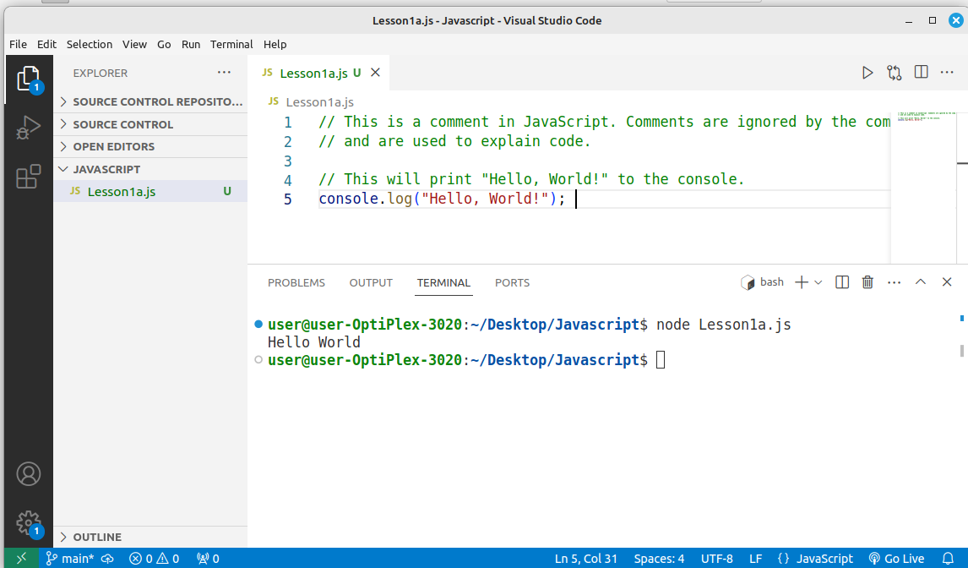
To run Your code use this command in terminal as shown above.

node Lesson1a.js
Task: Students ToDo 3 more console.log(); Print your own messages

Explanation:
- console.log() is a built-in JavaScript function that outputs whatever is inside the parentheses to the console. The console is a tool that developers use to log messages, check errors, and test small snippets of code.
- "Hello, World!" is a string. In JavaScript, text is enclosed in double or single quotes.
- The // syntax is used for writing comments in JavaScript. Everything after // on that line is ignored by the program, and it’s just there to explain or clarify the code.

JavaScript Variables and Data Types
In JavaScript, variables and data types are essential concepts that you'll encounter frequently as you begin writing code. Let’s explore both of these concepts in detail.

JavaScript Variables
A variable is a container used to store data values. In JavaScript, variables are used to hold various types of data, such as numbers, strings, booleans, and more. Once a variable is declared, you can use it to store, modify, and access the data.

Example


Declaring Variables
You can declare variables using one of the following keywords:
- var: An older way to declare variables, typically used in the past. It has function-level scope and can lead to unexpected behavior in modern JavaScript.
- let: The modern and preferred way to declare variables. It has block-level scope, which means it is limited to the block (like a function or a loop) where it is declared.
- const: Declares a constant value. Once assigned, a const variable cannot be reassigned. However, if the value is an object or array, the contents of the object can still be modified.

Variable Rules
In JavaScript, there are specific rules and best practices for declaring variables. Understanding these rules is important to avoid errors and write efficient code. Here are the key rules for declaring a variable in JavaScript:

1. Variable Declaration with let, const, and var:
- let and const are used to declare variables with block scope, while var is function-scoped.
- const is used to declare a constant, i.e., a variable whose value cannot be reassigned after initialization.
2. Variable Names (Identifiers) Rules:
- Must start with a letter, underscore (_), or dollar sign ($).
  - Valid: let name;, let _age;, let $price;
  - Invalid: let 1name; (cannot start with a number).
- Can contain letters, numbers, underscores, or dollar signs.
  - Valid: let user1;, let _value;, let $score;
- Cannot use JavaScript reserved keywords (Check Appendix 1) (such as let, class, return, etc.) as variable names.
  - Invalid: let for;, let function;
- Case-sensitive: JavaScript is case-sensitive, so age and Age are considered different variables.
  - Example: let age; and let Age; are two separate variables.
3. Naming Conventions:
- Camel case is generally used for variable names in JavaScript, where the first word is lowercase and each subsequent word is capitalized.
  - Example: let userAge = 25;
- Avoid using all uppercase letters for variable names, as that is usually reserved for constants.
  - Example: const MAX_LENGTH = 100;

Summary:
- Variables can be declared with let, const, or var.
- Variable names must start with a letter, underscore, or dollar sign and can contain letters, numbers, underscores, or dollar signs.
- You cannot use JavaScript reserved keywords as variable names.
- let and const have block-level scope, while var has function-level scope.
- Variables declared with let and const cannot be redeclared in the same scope.
- const must be initialized at the time of declaration.
- JavaScript variables are case-sensitive.

Next - Example of declaring variables - Lesson1b.js
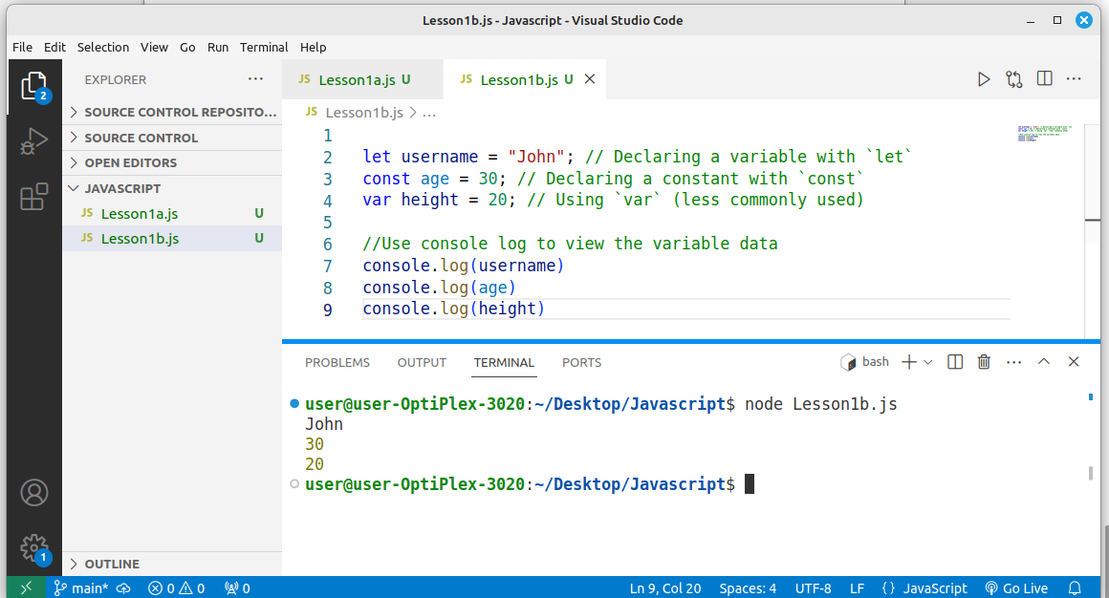

Variable Assignment and Reassignment
- let allows you to declare variables that can be reassigned to new values.
- const does not allow reassignment of the variable once a value has been assigned.
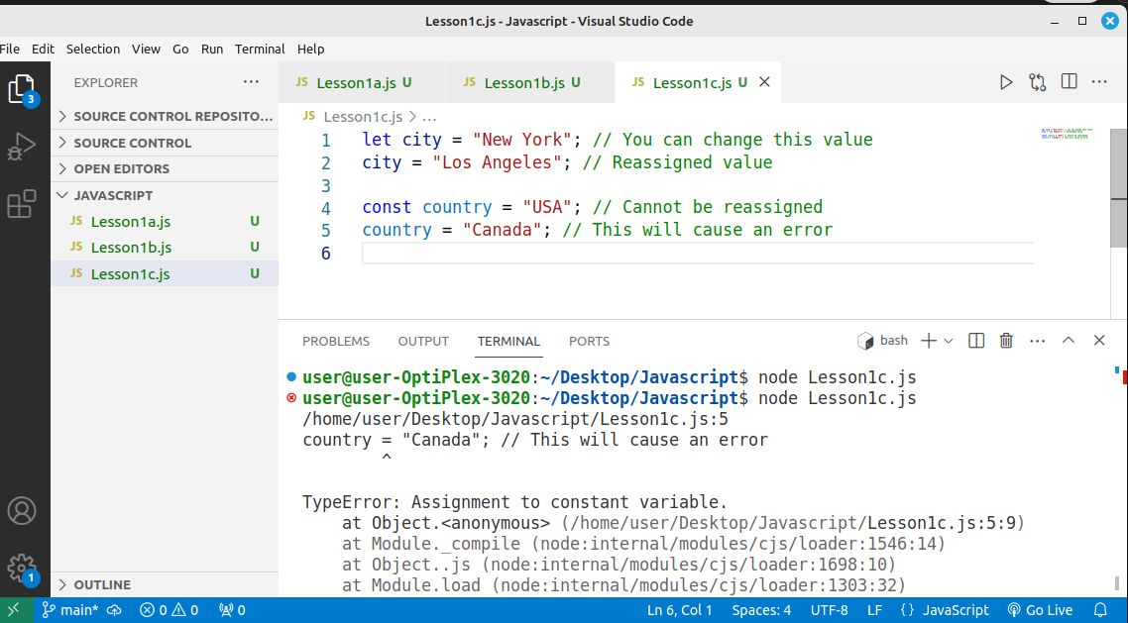

Data Types:
Data types are simple values that are directly assigned and used in the program.

String (string):
  - Represents a sequence of characters (text).
  - Strings are enclosed in either single quotes (' ') or double quotes (" ").
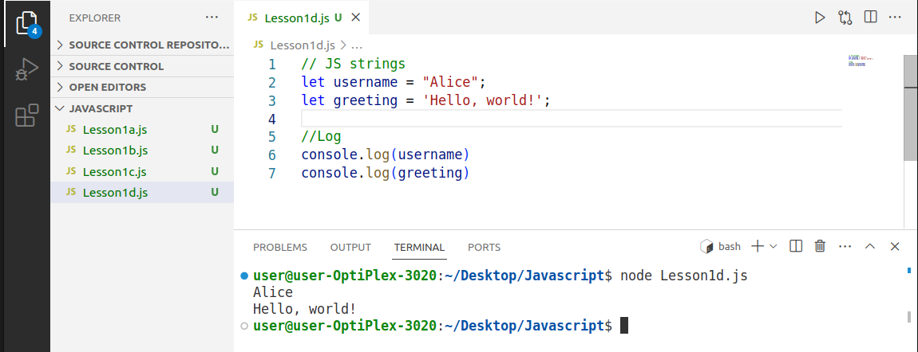

2. Number (number):
- Represents numeric values, both integers and floating-point numbers.
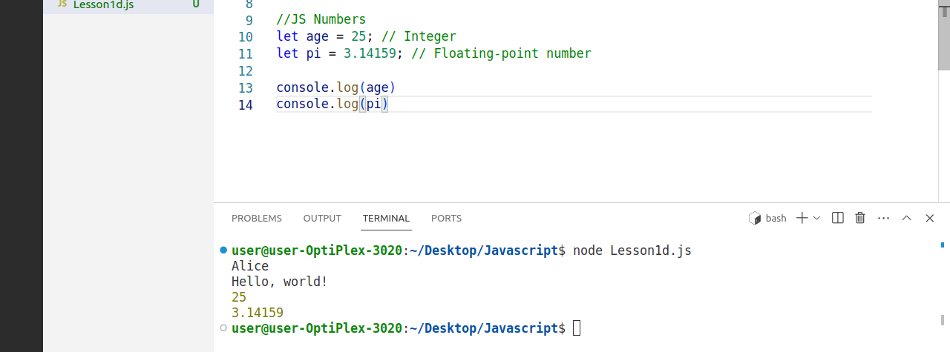

3. Boolean (boolean):
- Represents a truth value: either true or false.
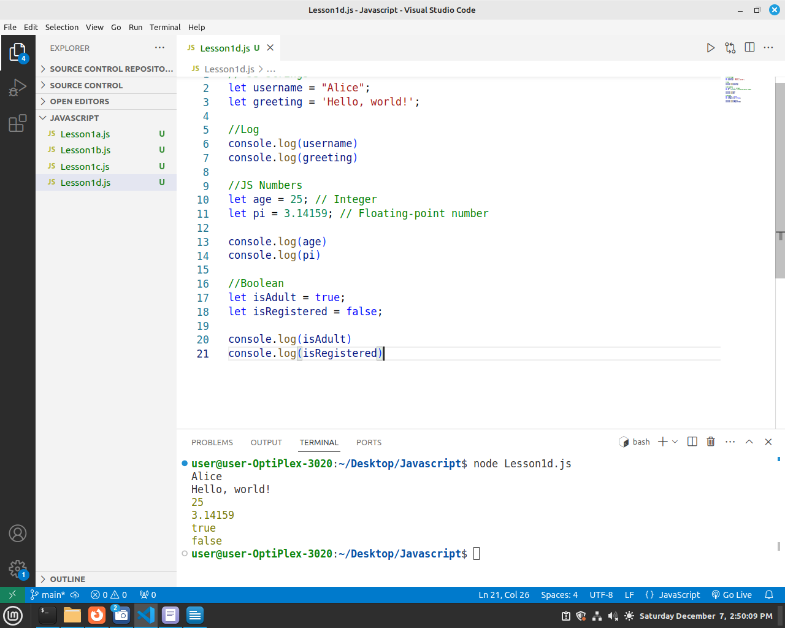

4. Undefined (undefined):
- A variable that has been declared but not assigned a value is automatically given the value undefined.
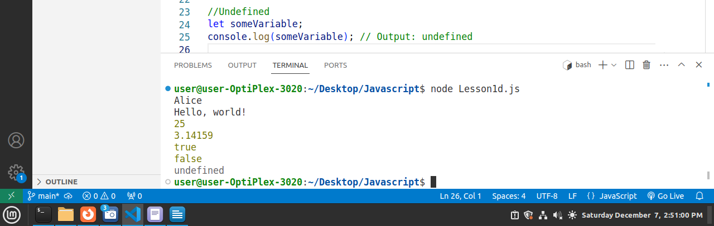

5. Null (null):
- Represents the intentional absence of any object value. It's a special value that represents "nothing."
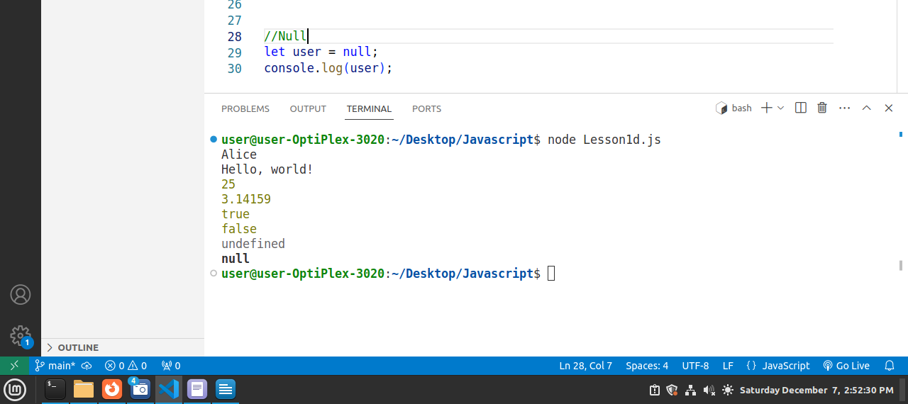

Objects and Arrays (Complex Data Types)
Besides the data types, JavaScript also has objects and Arrays, which are more complex data structures.

Object (object):
  - An object is a collection of key-value pairs where each key (also called a property) is associated with a value. The value can be any valid JavaScript data type.
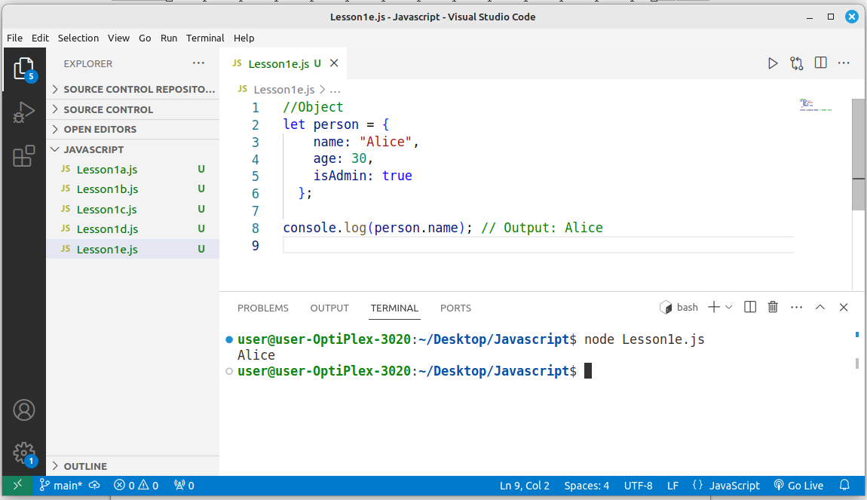

Array (array):
- An array is a special type of object used to store a list of values in an ordered manner. Arrays are indexed by numbers starting from 0.
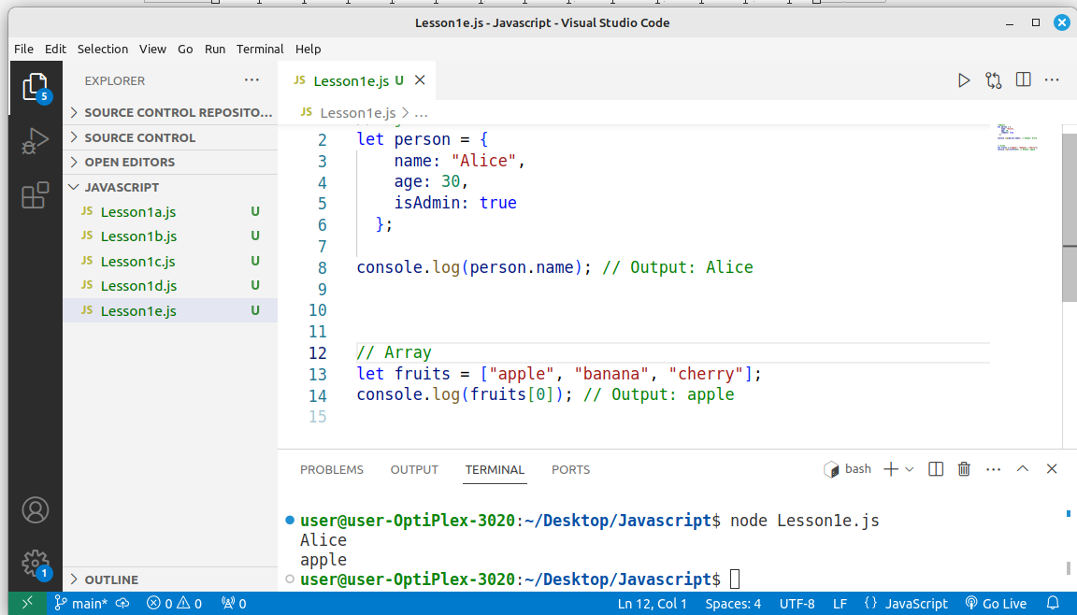

In JavaScript, the typeof operator is used to determine the type of a variable or expression. It returns a string indicating the type of the operand.

let num = 10;
console.log(typeof num); // Output: "number"

Summary
- Variables in JavaScript store data values and can be declared with var, let, or const.
- Data types include:
  - string: Text data.
  - number: Numeric values (integers and floats).
  - boolean: Logical values (true or false).
  - undefined: Variables declared but not assigned a value.
  - null: An intentional absence of a value.
- Complex data types like objects and arrays store collections of data.
By understanding how to declare variables and work with different data types, you can start writing more powerful and dynamic JavaScript code.

Javascript Operators
Operators are the same in all Programming Languages but the way of writing code or using the operators are different.
JavaScript operators are special symbols or keywords used to perform operations on values (known as operands). Operators can be used for mathematical calculations, comparisons, logical evaluations, assignment, and more.
Below are Javascript operators

1. Arithmetic Operators
These operators are used to perform mathematical operations like addition, subtraction, multiplication, etc.
Operator | Description | Example | Result
+ | Addition | 5 + 3 | 8
- | Subtraction | 5 - 3 | 2
* | Multiplication | 5 * 3 | 15
/ | Division | 6 / 3 | 2
% | Modulus (remainder) | 5 % 3 | 2
** | Exponentiation (ES6+) | 2 ** 3 | 8

2. Assignment Operators
Assignment operators are used to assign values to variables.
Operator | Description | Example | Result
= | Assignment | let x = 5; | x = 5
+= | Addition Assignment | x += 3; | x = x + 3 (i.e., x = 8)
-= | Subtraction Assignment | x -= 2; | x = x - 2
*= | Multiplication Assignment | x *= 4; | x = x * 4
/= | Division Assignment | x /= 2; | x = x / 2
%= | Modulus Assignment | x %= 3; | x = x % 3

3. Comparison Operators
These operators are used to compare two values and return a Boolean result (true or false).
Operator | Description | Example | Result
== | Equal to (value) | 5 == 5 | true
!= | Not equal to (value) | 5 != 3 | true
> | Greater than | 5 > 3 | true
< | Less than | 5 < 8 | true
>= | Greater than or equal to | 5 >= 5 | true
<= | Less than or equal to | 3 <= 4 | true

4. Logical Operators
These operators are used to perform logical operations, typically with Boolean values.
Operator | Description | Example | Result
&& | Logical AND | true && false | false
|| | Logical OR | true || false | Logical OR
! | Logical NOT | !true | false

Control Statements in JavaScript
Control statements in JavaScript allow you to control the flow of your program. They let you make decisions, loop through data, and handle different situations. The three main categories of control statements are:
- Conditional Statements – Making decisions in your code based on conditions.
- Looping Statements – Repeating a block of code a number of times.
- Jump Statements – Controlling the flow of the program based on certain conditions.

1. Conditional Statements
Conditional statements help your program to decide between different courses of action based on whether a condition is true or false.

if Statement
The if statement is used to execute a block of code only if a specific condition is true.
Syntax:
if (condition)
{
// code to be executed if the condition is true
}

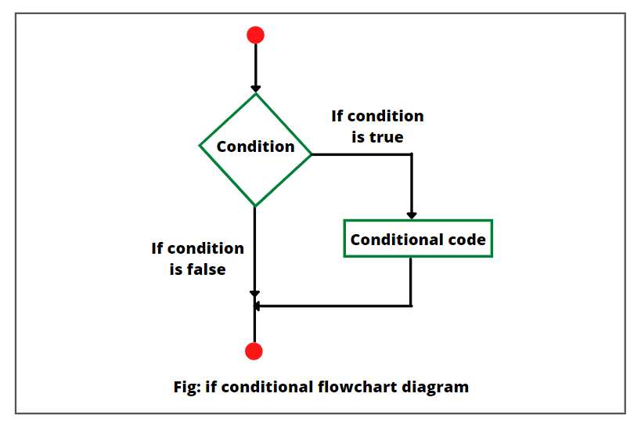
If Statement Flowchart

Example
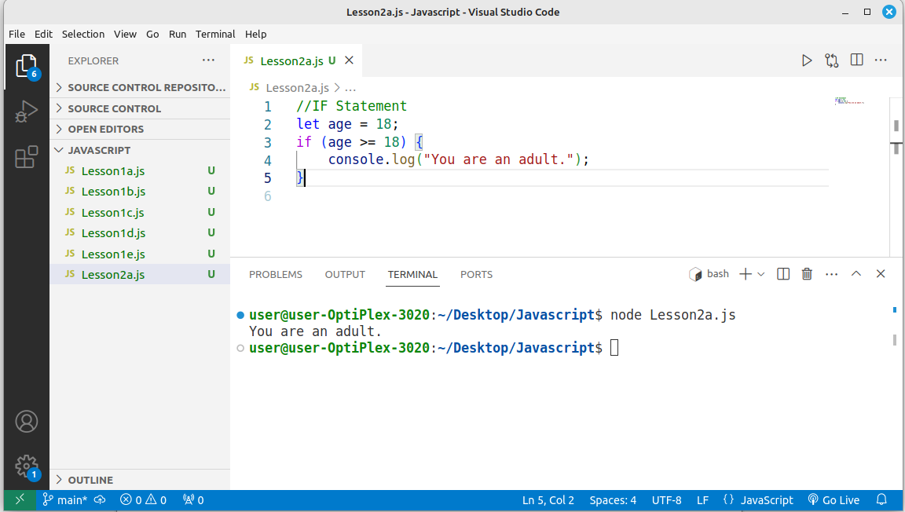

if-else Statement
The if-else statement allows you to specify a block of code to run if the condition is true and another block of code to run if the condition is false.
Syntax:
if (condition) {
// code to be executed if the condition is true
} else {
// code to be executed if the condition is false
}
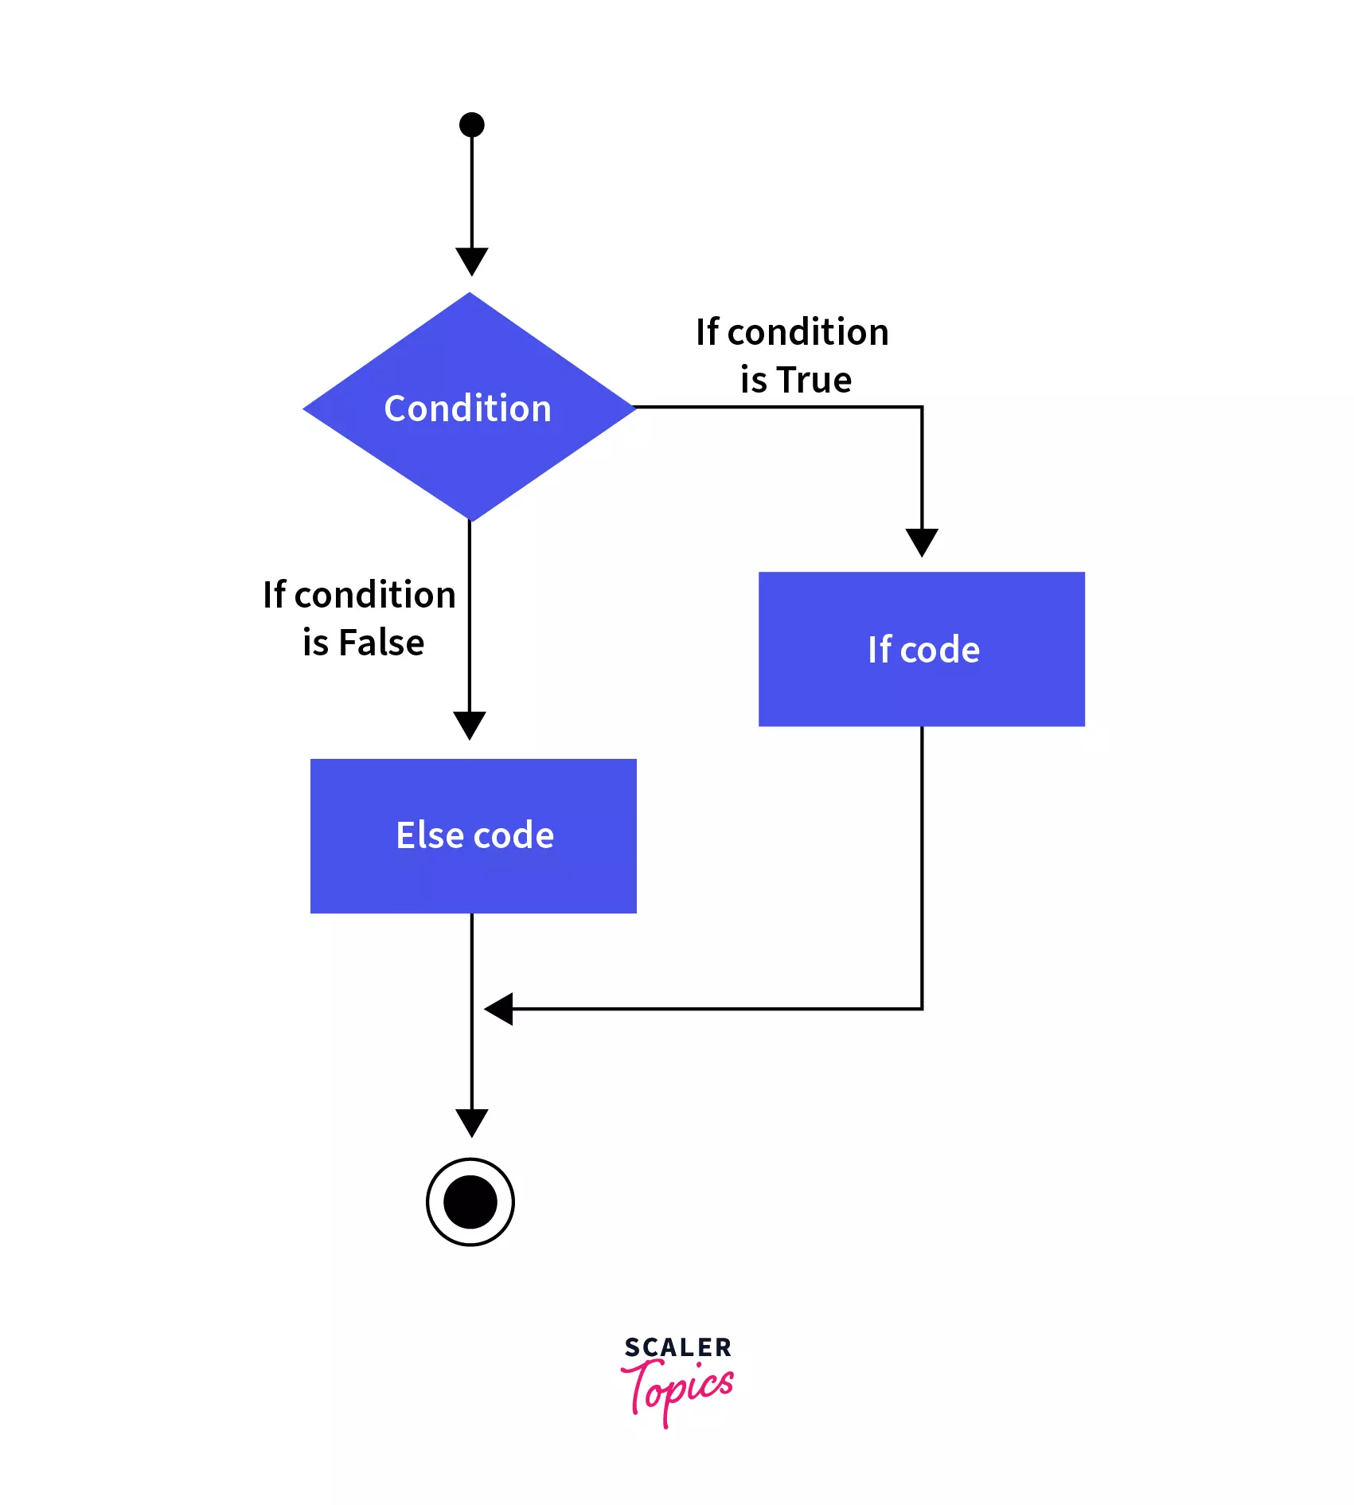
If Else Flowchart
Example

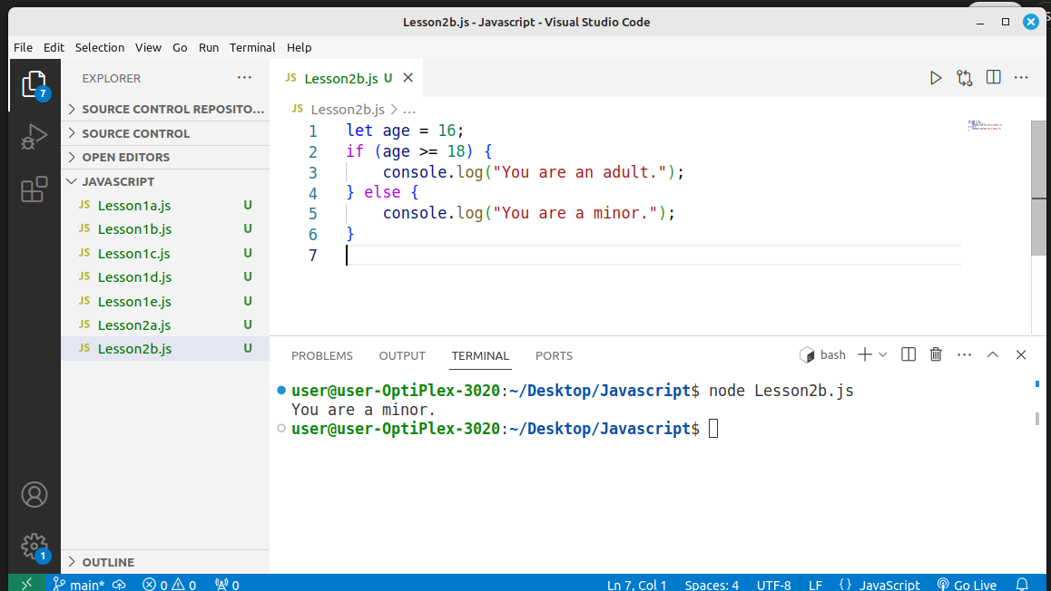
else if Statement
The else if statement is used to check multiple conditions if the first if condition is false. You can chain multiple else if statements to check for different conditions.
Syntax:
if (condition1) {
// code to be executed if condition1 is true
} else if (condition2) {
// code to be executed if condition2 is true
} else {
// code to be executed if none of the conditions are true
}

If Else – Else IF Flowchart

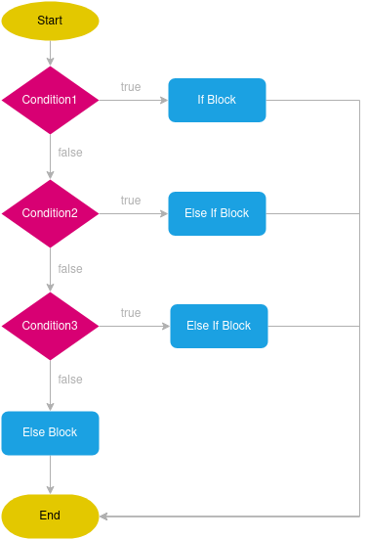

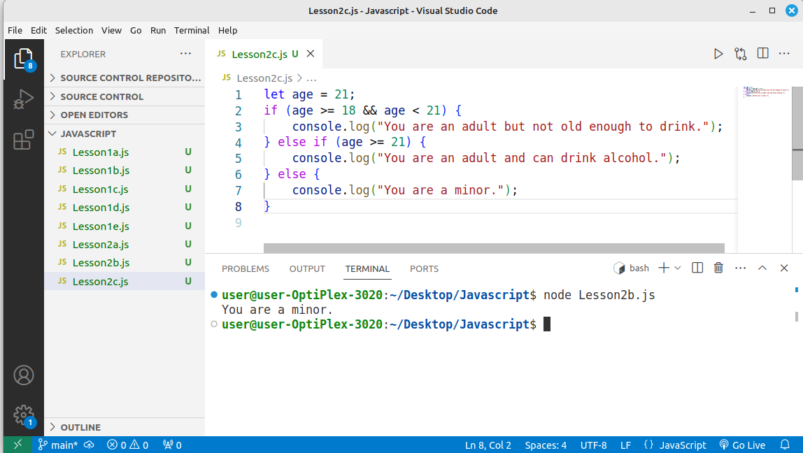
Example

Summary
- if: Executes code if a condition is true.
- if-else: Executes one block of code if a condition is true, and another if it is false.
- else-if: Checks multiple conditions in sequence if the previous conditions were false.
These conditional statements are essential for controlling the flow of a program based on dynamic conditions. Let me know if you need further examples or explanations!

Task Todo
Example Scenario:
Assume you have the following tax brackets:
Tax Table:
Salary Range | Tax Rate
$0 - $30000 | 10%
$30001 - $60000 | 15%
$60001 - $100000 | 20%
$100001 and above | 25%

Task:
The students will write a JS program that uses an if-else if- else statement to calculate the tax based on the provided salary.

Iterative/Looping Statements
Looping statements are used to repeat a block of code multiple times based on a condition or a fixed number of iterations.

for Loop
The for loop is typically used when you know beforehand how many times you want to repeat the block of code. Below Is the Syntax for for loop:
for (initialization; condition; increment) {
// code to be executed
}
- Initialization: Executed before the loop starts
- Condition: Checked before each iteration. If true, the loop continues; if false, the loop stops.
- Increment: Executed after each iteration.
Example
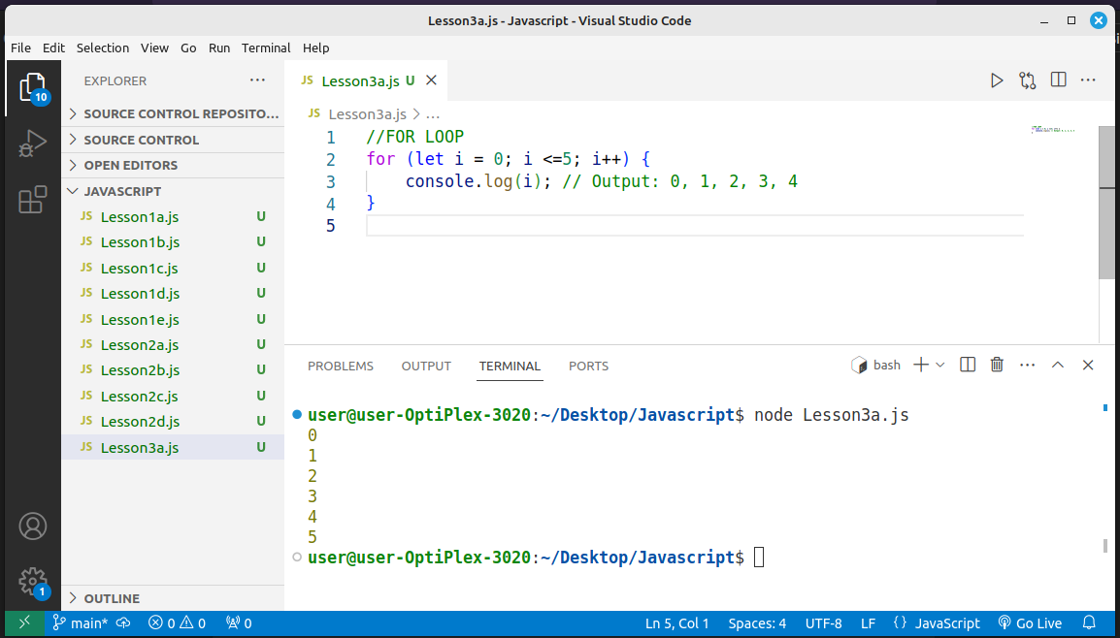

Tasks
Task: Write a for loop to print all odd numbers from 1 to 19.
Task: Write a for loop to count down from 10 to 1 and print the numbers in the console.
Task: Write a for loop to find the largest number in the array: [10, 20, 4, 45, 99, 1].
Task: Write a for loop to print the multiplication table of 5 from 5 x 1 to 5 x 10.

While loop
The while loop runs as long as the given condition evaluates to true.
Syntax:
while (condition) {
// code to be executed
} Example
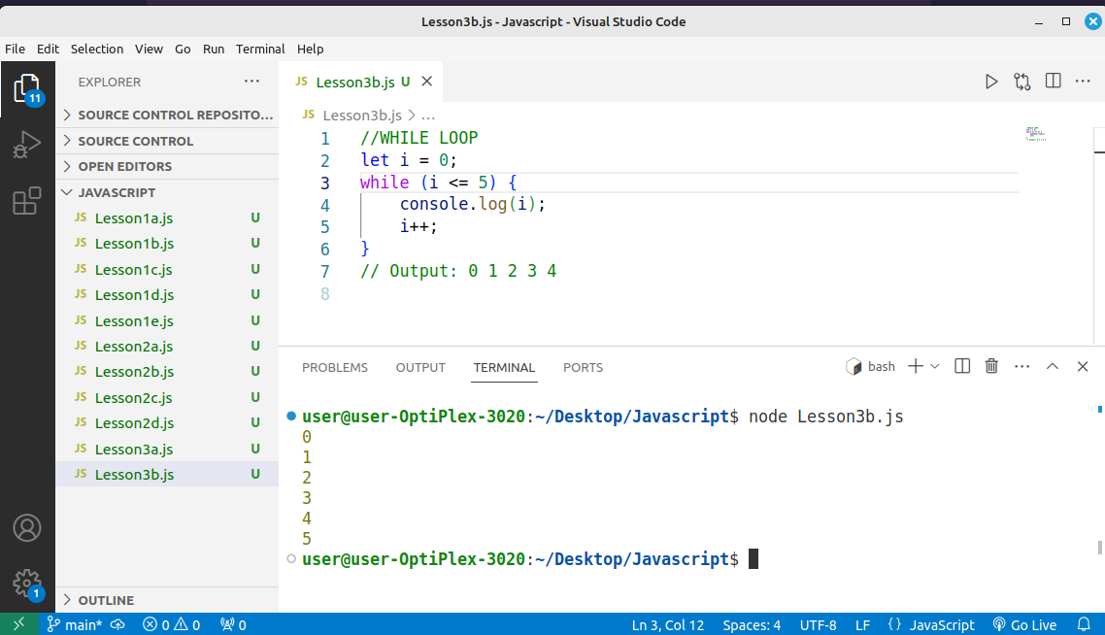

Summary
- for loop: Best when the number of iterations is known in advance, and you can manage all the loop control logic (initialization, condition, and increment) in one place.
- while loop: Best when the number of iterations is unknown, and the loop should continue until a certain condition is no longer true.

Tasks
Task: Write a for loop to print all odd numbers from 1 to 19.
Task: Write a for loop to count down from 10 to 1 and print the numbers in the console.

Javascript Functions
In JavaScript, functions are blocks of reusable code designed to perform a specific task. Functions allow you to group code into modular units, making your code more readable, maintainable, and reusable. Here's a comprehensive guide on how functions work in JavaScript:

Basic Function Without Parameters
A simple function can be created using the function keyword. This function doesn't accept any parameters and just performs a task, like printing something to the console.
Example:
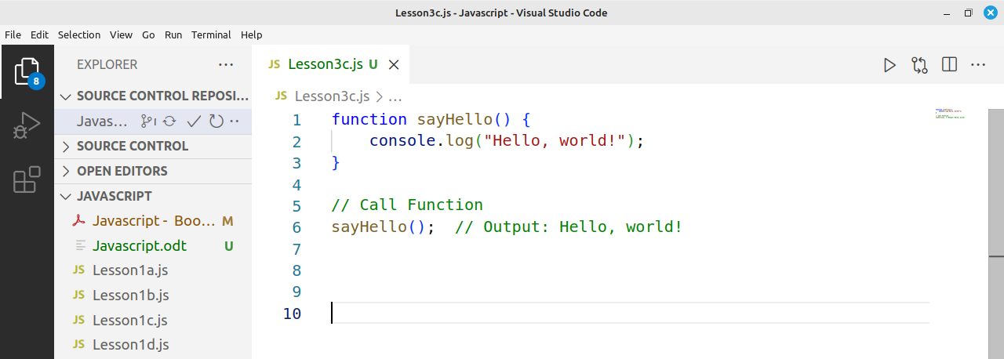
In above example:
- The function sayHello doesn't take any parameters.
- When called, it prints "Hello, world!" to the console.

Below we add another function to add two numbers
In Lesson3c.js, Add another Function named sum()
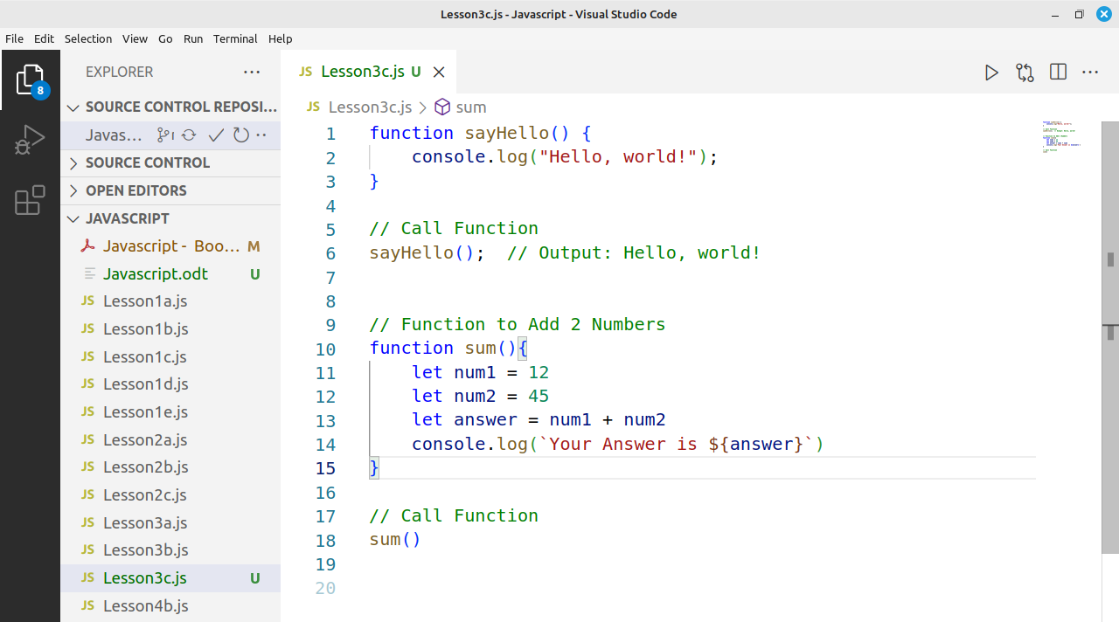
Here's a brief explanation in points:
- Function Definition: function sum() defines a function named sum.
- Variable Declaration: let num1 = 12 and let num2 = 45 initialize two variables with values 12 and 45.
- Addition: let answer = num1 + num2 adds the two numbers and stores the result (57) in answer.
- Output: console.log(\Your Answer is ${answer}`)` prints the result to the console using a template literal.
- Function Call: sum() calls the function to execute the code inside it, resulting in Your Answer is 57 being printed in the console.
Task: Students to Attempt do a Multiplication Function named ‘multiply()’ and Multiply 2 Numbers

Function with Parameters
A function can accept parameters, which are variables you pass when calling the function. These parameters can be used inside the function to perform tasks dynamically.
Example:
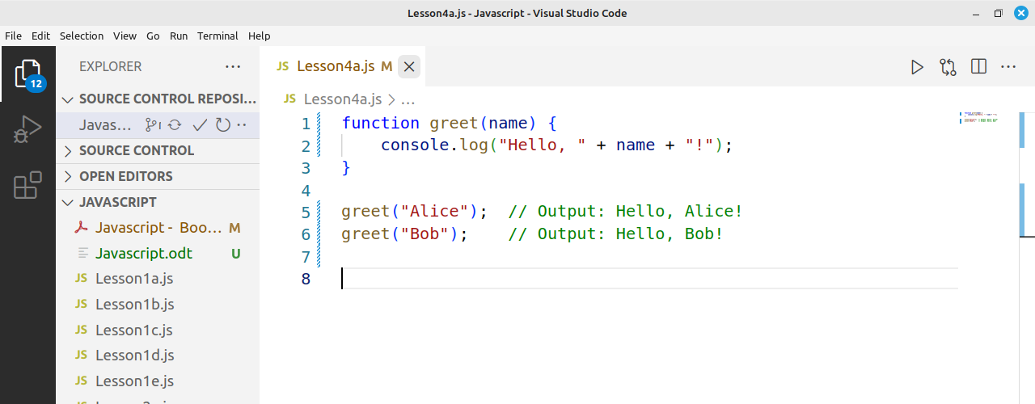
In this example:
- The function greet takes a parameter name.
- When called with an argument like "Alice", it prints "Hello, Alice!".

Lets redo the sum example with Parameters , Add sum() function.
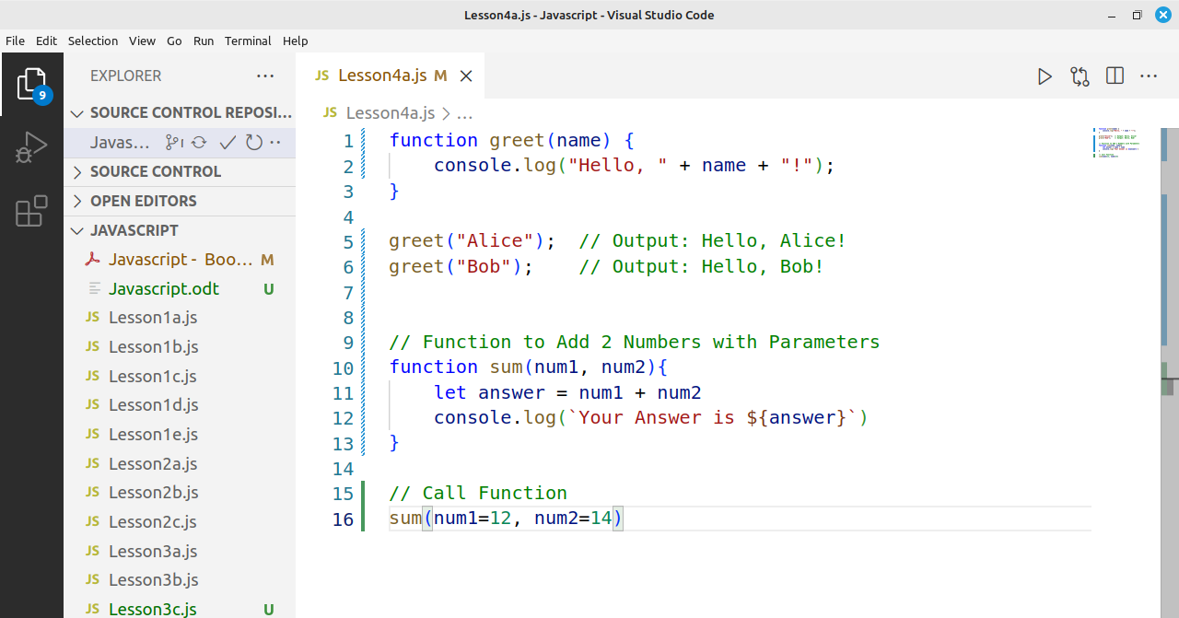
Here's a brief explanation of the updated code:
- Function with Parameters: function sum(num1, num2) defines a function that takes two parameters, num1 and num2.
- Addition: let answer = num1 + num2 adds the values of num1 and num2 and stores the result in answer.
- Output: console.log(\Your Answer is ${answer}`)` prints the result to the console using string interpolation.
- Function Call: sum(num1=12, num2=14) calls the function and passes 12 as num1 and 14 as num2, resulting in the output Your Answer is 26.
Task: Students to do subtraction of two numbers using Arrow function

Arrow Functions
Arrow functions, introduced in ES6, provide a more concise syntax for writing functions. Arrow functions are especially useful in callback functions and allow you to write functions in a more compact way.

Arrow Function without Parameters:
An arrow function without parameters can be written as follows:
Example:
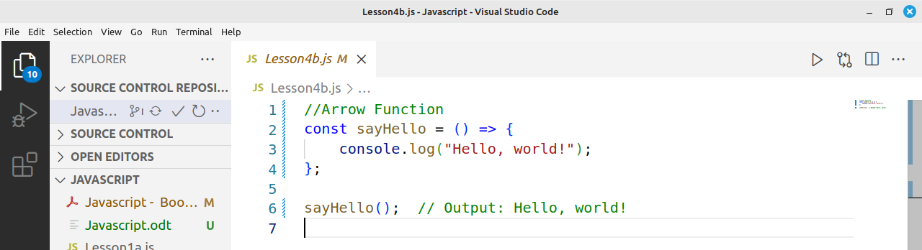
In this case:
- sayHello is assigned an arrow function.
- The function doesn't take any parameters, and it performs the same task as the first example: printing "Hello, world!".

- To compare above arrow function with older functions we did in Lesson3c.js, the difference is the function definition.
function sayHello() {
console.log("Hello, world!");
}
Below is the Converted to Arrow function and looks like below. NB: Only the function definition is Changed
const sayHello = () => {
console.log("Hello, world!");
}

Lets now try to add 2 Numbers with Arrow function Approach.
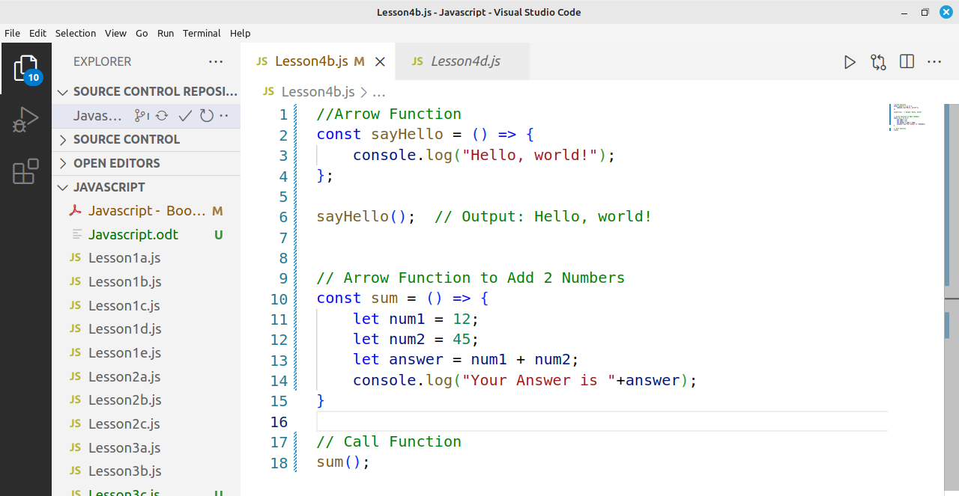

Arrow Function with Parameters:
An arrow function with parameters follows a similar pattern but allows for dynamic input.

Next - Example:
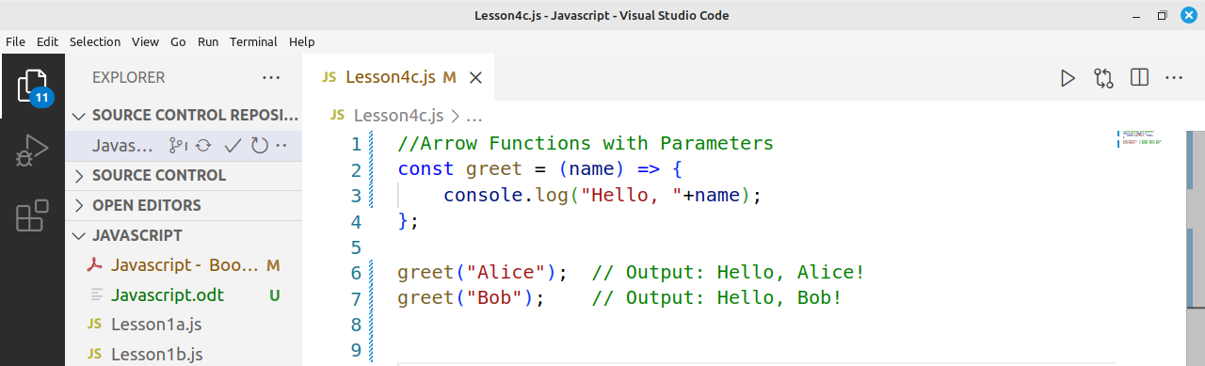
In this case:
- The arrow function greet takes one parameter, name, and prints "Hello, <name>!".
Example:
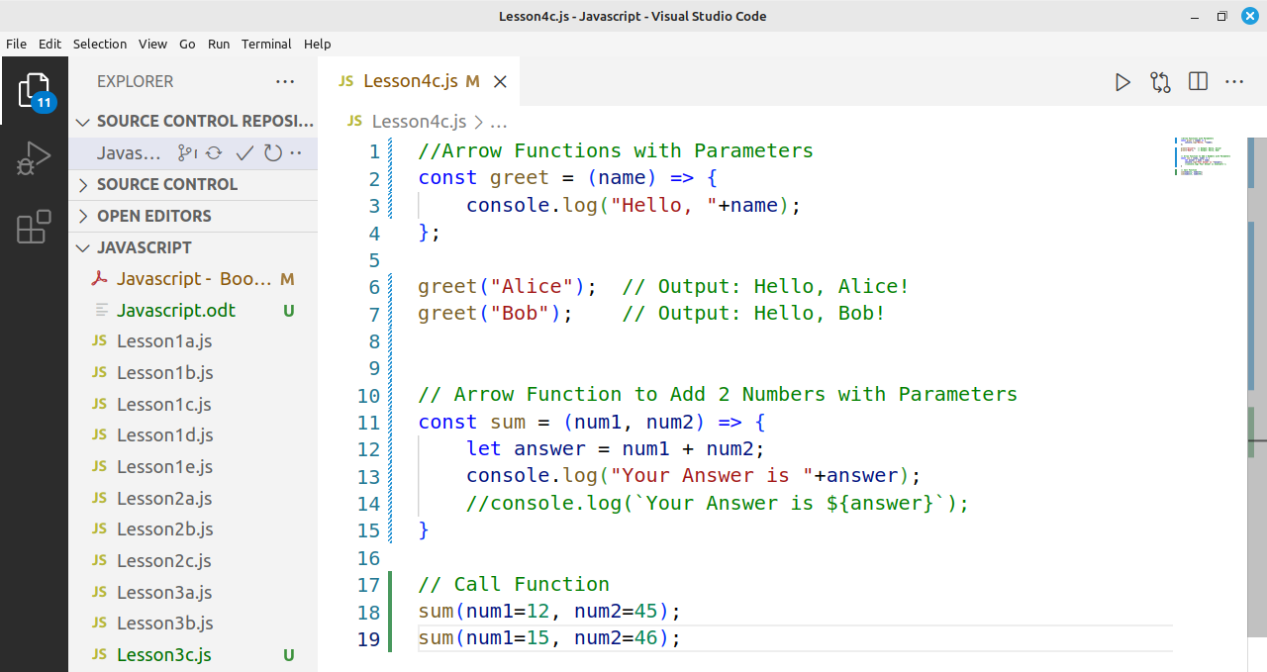

Brief Explanation:
- Arrow Function: The function is defined as an arrow function: const sum = (num1, num2) => { ... }.
- Parameters: num1 and num2 are passed as parameters to the function, allowing dynamic input values.
- Addition: The sum of num1 and num2 is calculated and stored in answer.
- Output: The result is printed to the console using template literals (console.log(\Your Answer is ${answer}`)`).
- Function Call: sum(12, 45) calls the function with 12 as num1 and 45 as num2, and prints Your Answer is 57.

Example – Finding Body Mass Index – Arrow Function
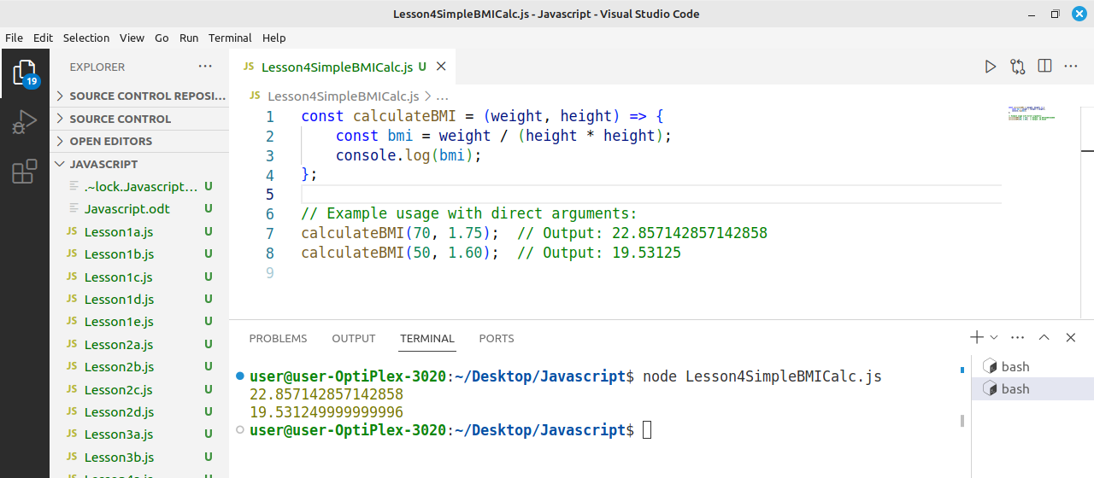

Summary:
- Basic Function (no parameters): A function that doesn't take any input.
- Function with Parameters: A function that accepts parameters to be used inside its body.
- Arrow Function (no parameters): A more concise way to write functions without parameters.
- Arrow Function with Parameters: A concise function syntax that also accepts parameters.

Task ToDo
Task: Write an arrow function calculateSimpleInterest that calculates the simple interest based on the given principal amount, rate of interest, and time period. The function should take three parameters:
- p: The initial amount of money (in dollars).
- r: The rate of interest (in percentage).
- t: The time period for which the interest is calculated (in years).
The formula for calculating simple interest is:
Simple Interest (SI) = (Principal * Rate * Time) / 100
Requirements:
- The function should return the calculated simple interest.
- Use arrow function syntax.
- Ensure the function is flexible and accepts different values for the parameters.

Understanding JavaScript Imports, Exports
In modern JavaScript development, modular programming has become a key practice to write clean, maintainable, and reusable code. One of the most powerful features of JavaScript for modularity is imports and exports. In this chapter, we'll explore how to import different kinds of files and modules in JavaScript.

1. What are Imports and Exports?
Before diving into how to import files, it's important to understand exports. In JavaScript, the export keyword is used to make functions, objects, or variables available for other files to use.
The import keyword is used in other JavaScript files to bring these exports into their own scope.
The import keyword is used in other JavaScript files to bring the exported Files into another File.
Create a File named myModule.js and write below code.
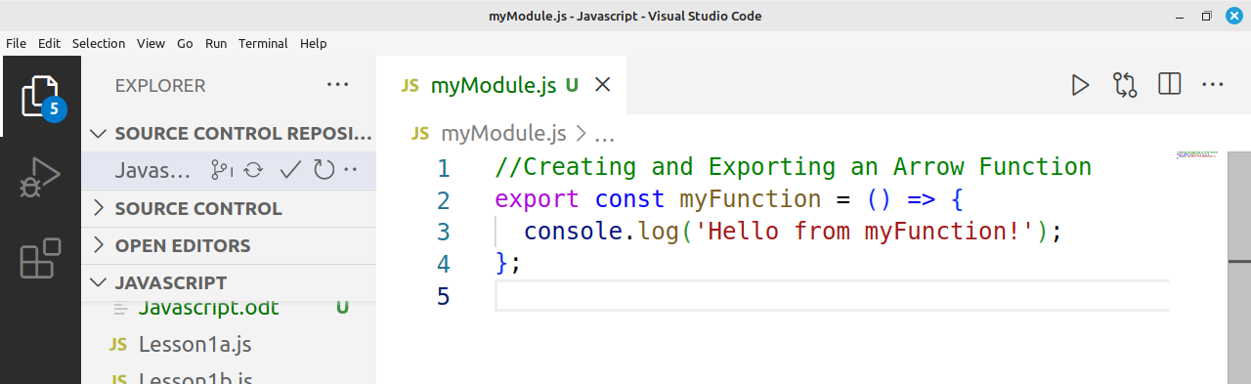

In this example, the function myFunction is exported from a file called myModule.js, Now we can import it in another File.
myModule.js is known as a module as it contains JS functions
Next, Create another File and named it Lesson5a.js and import the myFunction from myModule.js File
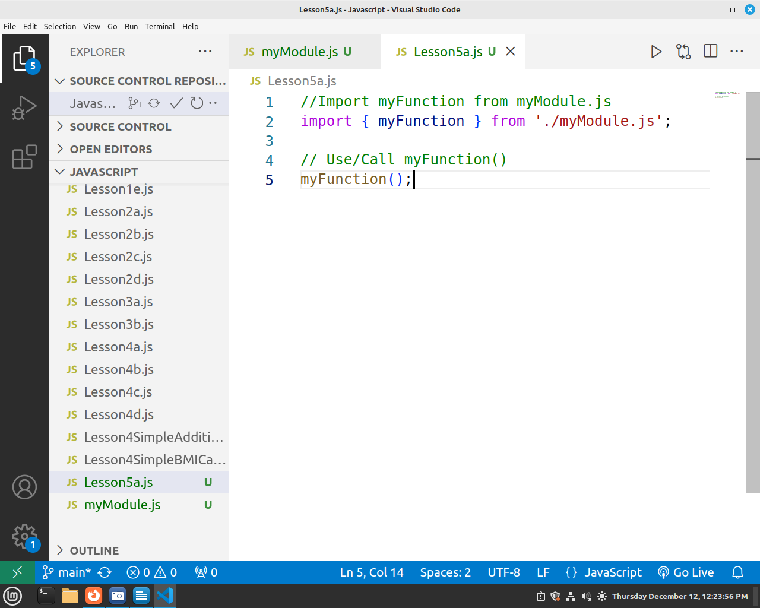

Practice Questions
1. What is a variable in JavaScript, and how do you declare one?
2. What is the difference between var, let, and const in JavaScript?
3. What is the difference between undefined and null in JavaScript?
4. What is the purpose of the console.log() method in JavaScript?
5. What will be the result of declaring a variable without initializing it?
6. How do you declare a constant in JavaScript?
7. What does const do in JavaScript, and when can it be used?
8. What will be the output of the following code?
let a = 10;
let b = a;
b = 20;
console.log(a);
console.log(b);
9. What does the typeof operator do in JavaScript?
10. Why are comments used, and how can you make a comment in JavaScript?
11. What are the different types of data types in JavaScript?
12. What happens when you declare a variable with var in a loop, and why does it behave differently than let?
13. How do you access the first element of an array?
14. What is a Boolean in JavaScript, and what values can it have?
15. What is the difference between a for loop and a while loop?
16. What is the difference between an object and an array in JavaScript?
17. How can you add two numbers in JavaScript?
18. How do you create an object Type in JavaScript?
19. Write an arrow function square that takes a number as a parameter and logs its square
20. Create an arrow function isEven that takes a number as a parameter and logs a message if number id ODD or EVEN
21. Write an arrow function celsiusToFahrenheit that takes a temperature in 22. Celsius as a parameter and converts it to Fahrenheit. Use the formula:
Fahrenheit = (Celsius * 9/5) + 32.

Appendix 1
Reserved keywords in JavaScript
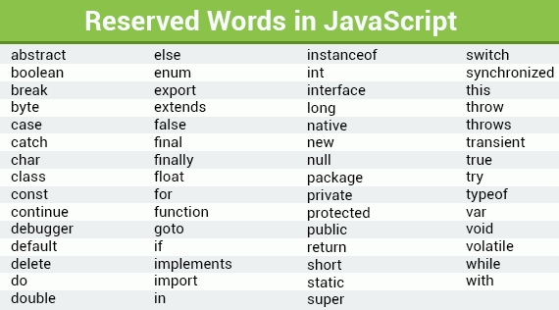

Useful Links
https://www.w3schools.com/js/
https://www.microverse.org/blog/introduction-to-javascript-a-guide-for-beginners
https://careerfoundry.com/en/tutorials/web-development-for-beginners/an-introduction-to-javascript

