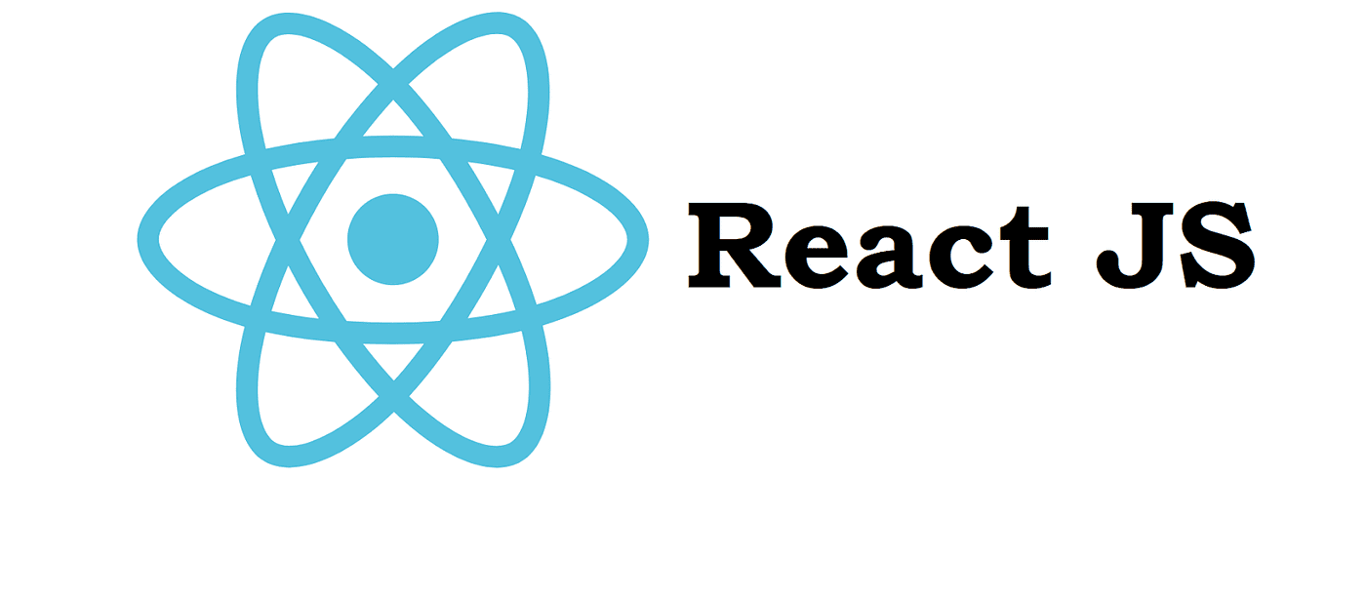 # Getting Started with Create React App
In this github repo, we will create a eCommerce Frontend web application, ReactJS will be used as the frontend framework. The frontend will interact with the backend API to handle: ✅ User Signup ✅ User Signin ✅ Add Product ✅ Get Products ✅ Make Payment - LIPA NA MPESA
Please check the Backend API Implementation here. https://github.com/modcomlearning/BackendAPI
By the end of this repo, you will create an eCommerce web application similar to https://sokogarden.vercel.app/

Step 1 : Create React App, File Structure, Run App.
This project was bootstrapped with Create React App.
In your class Main folder, create a react app using below command
npx create-react-app sokogarden
Below is the App Structure Explained
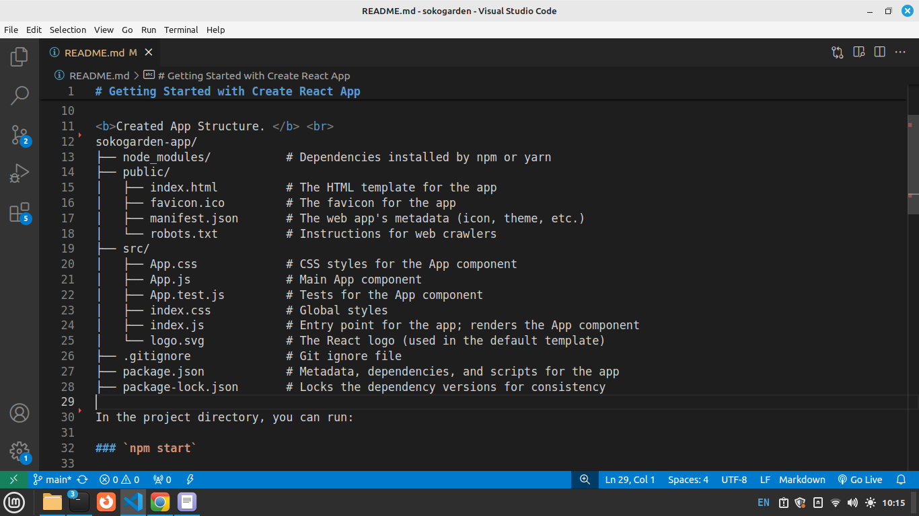
alt text
Runs the app in the development mode.
Open http://localhost:3000 to view it in your browser.
The page will reload when you make changes.
You may also see any lint errors in the console.
Your React App runs as below on the browser.
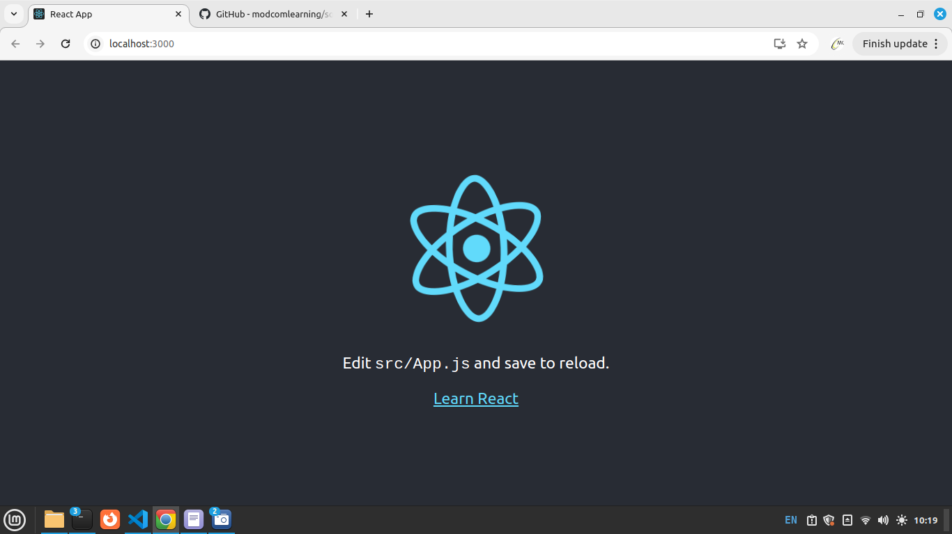
alt text
Lets Edit our App. in src Folder open App.js and remove the higlighted code(remove everything Inside header tags) in below screen.
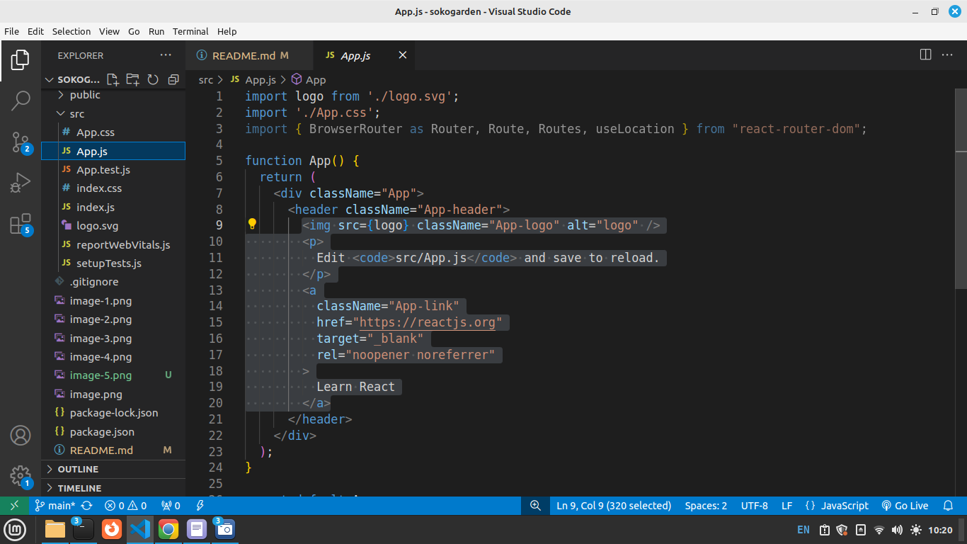
alt text
Replace the code you removed with a heading and as shown below. 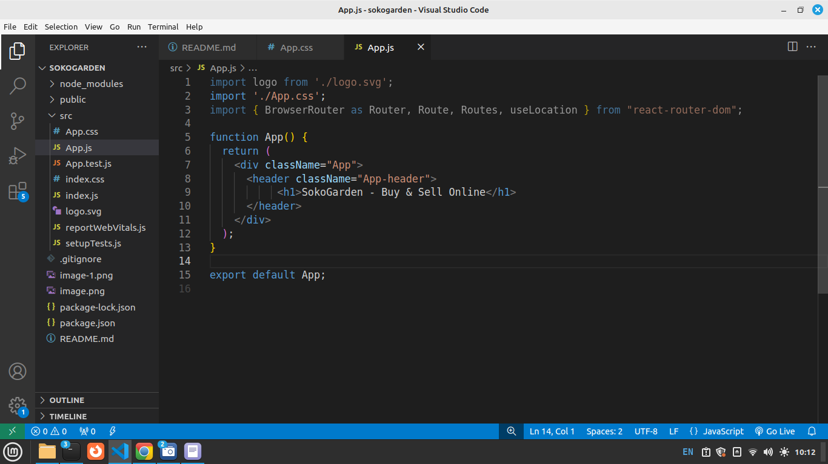
Run your App Runs the app in the development mode.
Open http://localhost:3000 to view it in your browser.
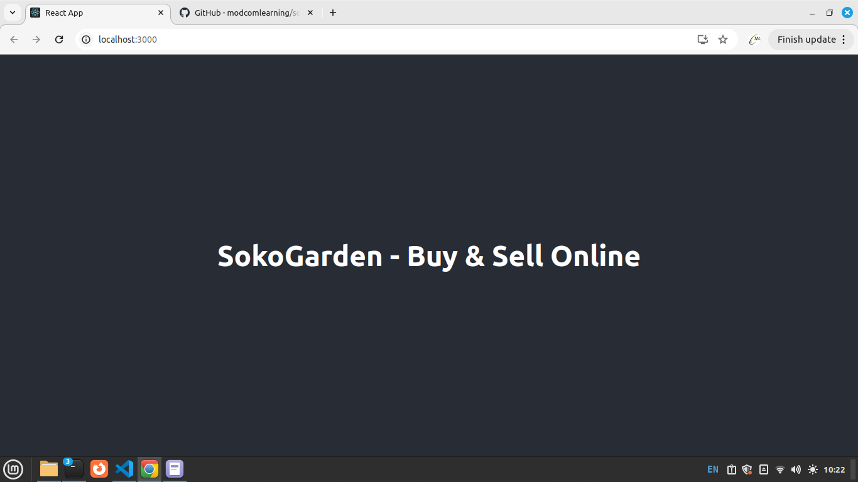 Install React Router
npm install react-router-dom
npm install bootstrap
npm install axios
React Router will be used to create navigation in our App. Bootstrap will provide CSS Classes for styling. Axios will be used in Accessing our Backend APIs created earlier
in App.js add below import to make bootstrap available in your App.
import 'bootstrap/dist/css/bootstrap.min.css';
In App.css, Please change the min-height to 20vh, see below, This reduces the height of the Main App.js component display.
.App-header {
background-color: #282c34;
min-height: 20vh;
display: flex;
flex-direction: column;
align-items: center;
justify-content: center;
font-size: calc(10px + 2vmin);
color: white;
}
Run your App Runs the app in the development mode.
Open http://localhost:3000 to view it in your browser.
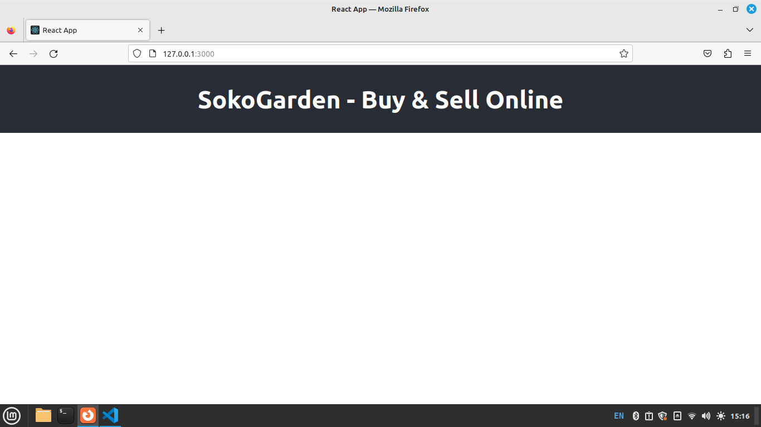
alt text

Step 2: Components Creation
In this Project we will have Components to represent different user interfaces. i.e Signup, Signin, GetProducts, Addproducts, MakePayment, Navbar, Footer etc
Above components MUST be created inside the src Folder, in src Folder, create a subfolder named components.
Right Click on components folder you created above - Select New File - File name Enter - Signup.js.
Inside Signup.js type below code.
const Signup = () => {
return (
<div>
<h1>Welcome to Signup Component</h1>
</div>
);
}
export default Signup;
Right Click on components folder - Select New File - File name Enter - Signin.js.
Inside Signin.js type below code.
const Signin = () => {
return (
<div>
<h1>Welcome to Signup Component</h1>
</div>
);
}
export default Signin;
Right Click on components folder - Select New File - File name Enter - Addproduct.js.
Inside Addproduct.js type below code.
const Addproduct = () => {
return (
<div>
<h1>Welcome to Add Products Component</h1>
</div>
);
}
export default Addproduct;
Right Click on components folder - Select New File - File name Enter - Getproducts.js.
Inside Getproducts.js type below code.
const Getproducts = () => {
return (
<div>
<h1>Welcome to Get Products Components</h1>
</div>
);
}
export default Getproducts;
We now have 4 different Components. We need to create routing/navigation for them.This means how do we access them on the browser.

Step 3: Routing
In this Step we will create Router for our App. in App.js add below import for routing capabilities javascript import { BrowserRouter, Route, Routes} from "react-router-dom"; Then inside the App.js, under the JSX code, wrap the ‘DIV’ with a Router
import logo from './logo.svg';
import './App.css';
import { BrowserRouter, Route, Routes, useLocation } from "react-router-dom";
function App() {
return (
<Router>
<div className="App">
<header className="App-header">
<h1>SokoGarden - Buy & Sell Online</h1>
</header>
</div>
</Router>
);
}
export default App;
Below the header tag add below routes.
<Routes>
<Route path="/signup" element={<Signup />} />
<Route path="/signin" element={<Signin />} />
<Route path="/addproduct" element={<Addproduct />} />
{/* This is the default component */}
<Route path="/" element={<Getproducts/>} />
</Routes>
This code defines client-side routing in a React application using React Router. Here’s a breakdown:
<Routes>: A wrapper that holds multiple <Route> components and ensures only one matching route is rendered at a time.
<Route path="/signup" element={<Signup/>} />: When the URL is /signup, the Signup component is rendered.
<Route path="/signin" element={<Signin />} />: When the URL is /signin, the Signin component is rendered.
<Route path="/addproduct" element={<Addproduct />} />: When the URL is /addproduct, the Addproduct component is rendered.
<Route path="/" element={<Getproducts/>} />: Acts as the default (home) route, rendering Getproducts when the path is /.<br><br>
Your Full App.js Code after adding the Router Code
import logo from './logo.svg';
import './App.css';
import { BrowserRouter, Route, Routes, useLocation } from "react-router-dom";
import Signup from './components/Signup';
import Signin from './components/Signin';
import Addproduct from './components/Addproduct';
import Getproducts from './components/Getproducts';
function App() {
return (
<BrowserRouter>
<div className="App">
<header className="App-header">
<h1>SokoGarden - Buy & Sell Online</h1>
</header>
<Routes>
<Route path="/signup" element={<Signup />} />
<Route path="/signin" element={<Signin />} />
<Route path="/addproduct" element={<Addproduct />} />
{/* This is the default component */}
<Route path="/" element={<Getproducts/>} />
</Routes>
</div>
</BrowserRouter>
);
}
export default App;
Test Your Routes in the Browser. Signup use: http://127.0.0.1:3000/signup Signin use: http://127.0.0.1:3000/signin Add Products use: http://127.0.0.1:3000/addproducts Get products use: http://127.0.0.1:3000/

Step 4a: Signup
In this Step we will work on Signup component, This component connect to the backend through the signup API created in https://github.com/modcomlearning/BackendAPI(Step4) NB: Please check Full component code at the end of this Step. Open Signup.js Component and import below modules to be used in our code. Put them before the arrow function
import { useState } from "react"; // for state management
import { Link } from "react-router-dom"; //for routing
import axios from "axios"; //For backend API access
Next, we create a signup form in JSX. the form has username, email, password, phone input Fields. Updated Signup.js Code.
import { useState } from "react"; //used for state management
import { Link} from "react-router-dom"; //used for routing
import axios from "axios"; //used for API access
//Arrow function
const Signup = () => {
return (
<div className="row justify-content-center mt-4">
<div className="col-md-6 card shadow p-4">
<h2>Sign Up</h2>
<form>
<input
type="text"
className="form-control"
placeholder="Enter Username"
required
/> <br />
<input
type="email"
className="form-control"
placeholder="Enter Email"
required /> <br />
<input
type="password"
className="form-control"
placeholder="Enter Password"
required
/> <br />
<input
type="text"
className="form-control"
placeholder="Enter Phone"
required
/> <br />
<button type="submit" className="btn btn-primary">
Sign Up
</button>
</form>
Already have an account? <Link to="/signin">Sign In</Link>
</div>
</div>
);
};
export default Signup;
Run your App Runs the app in the development mode.
Open http://localhost:3000/signup to view it in your browser.
Output - A Signup Form.
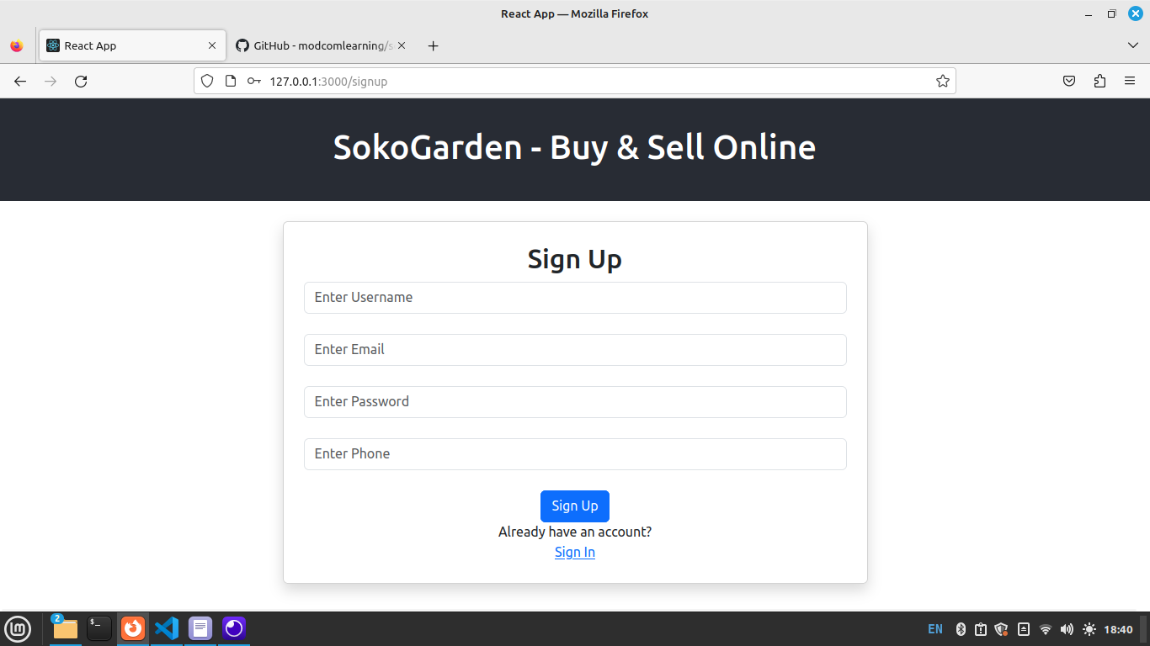
alt text
Then inside the Arrow function, Create below hooks.
//Below hooks are set to "" since the variables hold no data/strings
//The hooks will be updated later in this Program
const [username, setUsername] = useState("");
const [email, setEmail] = useState("");
const [password, setPassword] = useState("");
const [phone, setPhone] = useState("");
In JSX Part update your form. Please Note in below input we update the Hooks defined above using onChange onChange function is called when user enter an input. i.e username onChange calls the hooks updater function i.e setUsername().
return (
<div className="row justify-content-center mt-4">
<div className="col-md-6 card shadow p-4">
<h2>Sign Up</h2>
<form>
<input
type="text"
className="form-control"
placeholder="Enter Username"
value={username}
onChange={(e) => setUsername(e.target.value)}
required
/> <br />
{/* Below for testing onChange() concept */}
{username}
<input
type="email"
className="form-control"
placeholder="Enter Email"
value={email}
onChange={(e) => setEmail(e.target.value)}
required /> <br />
<input
type="password"
className="form-control"
placeholder="Enter Password"
value={password}
onChange={(e) => setPassword(e.target.value)}
required
/> <br />
<input
type="text"
className="form-control"
placeholder="Enter Phone"
value={phone}
onChange={(e) => setPhone(e.target.value)}
required
/> <br />
<button type="submit" className="btn btn-primary">
Sign Up
</button>
</form>
Already have an account? <Link to="/signin">Sign In</Link>
</div>
</div>
);
NB: In above code, for simplicity, you can do each hook at a time. i.e initialize the username hook, then bind it in the username input and do the onChange(). Then repeat the same for other inputs.
Run your App Runs the app in the development mode.
Open http://localhost:3000/signup to view it in your browser. Type username and observe how the username hook updates as you type.
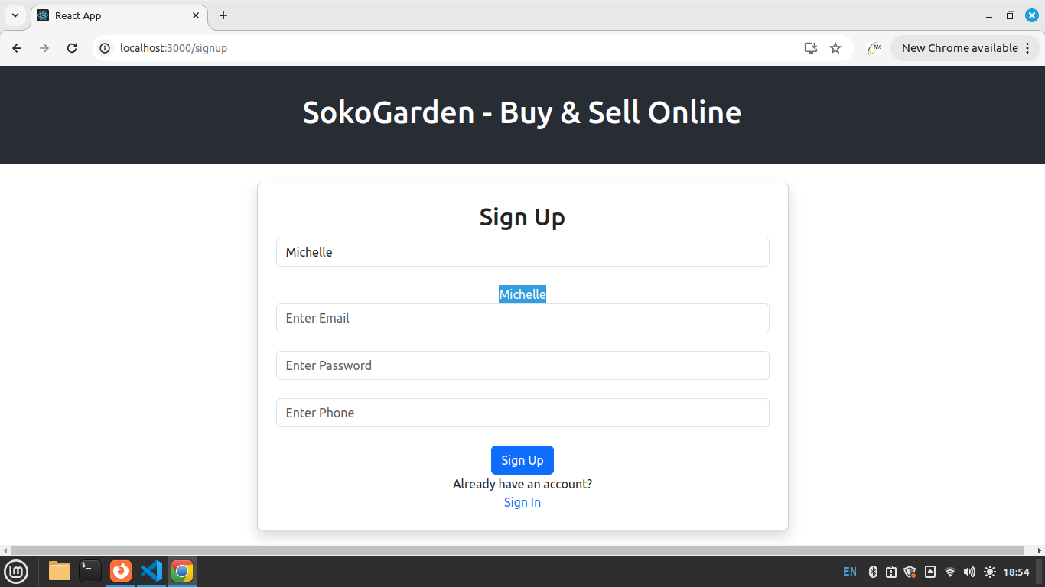
alt text
Above, we typed username “Michelle” and it displays/binds it in realtime. This shows that the username Hook variable updates as you type (onChange)
Here we explain what is happening on the inputs, we use username input in our explanation
<input type=“text” />: This is an HTML input element where the user can type text (in this case, a username).
className=“form-control”: This is a CSS class that likely styles the input field. In React, we use className instead of class for applying styles.
placeholder=“Enter Username”: This is the text that appears inside the input field when it’s empty. It gives a hint to the user about what to type, in this case, a username.
value={username}: This links the value of the input field to a state variable called username. This means the input field will display whatever value is stored in the username state.
onChange={(e) => setUsername(e.target.value)}: This defines what happens when the user types into the input field. It updates the username state with whatever the user types, so the value in the input is always in sync with the state.
required: This makes the input field mandatory, meaning the user must fill it out before submitting a form.
<br /> : This just adds a line break (an empty space) after the input field.

Step 4b: Signup
Now we’ve created Hooks, a form that updates the hooks on input change(onChange).
In Signup.jsx, create below hooks for loading, success and error messages. We set below hooks to empty strings, to be updated later in this program.
const [success, setSuccess] = useState("");
const [error, setError] = useState("");
const [loading, setLoading] = useState("");
Next, we need to create a function to submit the data to our API. inside the arrow function of Signup.js, add below function. This function will collect updated input data(Stored in Hooks) and post to our Backend API
//create function
const submit = async (e) => {
// Prevents JS default actions as we need to do our own action below
e.preventDefault();
//set loading hook variable to true, show loading message
setLoading("Please wait as we upload your data!");
try {
//append updated hooks variables into data varaible
const data = new FormData();
data.append("username", username);
data.append("email", email);
data.append("password", password);
data.append("phone", phone);
//use axios to post above data to our Backend API
const response = await axios.post(
"https://modcom2.pythonanywhere.com/api/signup",
data
);
//Set loading variable to empty string.
setLoading("");
//Update success message upon successful data submission/post
setSuccess(response.data.message);
// Clear form fields
setUsername("");
setEmail("");
setPassword("");
setPhone("");
//Catch errora/Exeptions
} catch (error) {
setLoading("");
setError(error.message);
}
};
Next, go back to your form opening tag and add a onSubmit attribute to call the submit function you created above.
<form onSubmit={submit}>
After calling the submit function we need to bind loading, success and error hooks inside the form. These will show loading, success and error messages.
So, add below inside the form tag
{loading}
{success}
{error}
Done.
Full Signup.js Code.
import { useState } from "react"; //used for state management
import { Link} from "react-router-dom"; //used for routing
import axios from "axios"; //used for API access
//Arrow function
const Signup = () => {
//Initialize Hooks
const [username, setUsername] = useState("");
const [email, setEmail] = useState("");
const [password, setPassword] = useState("");
const [phone, setPhone] = useState("");
const [success, setSuccess] = useState("");
const [error, setError] = useState("");
const [loading, setLoading] = useState("");
//submit function
const submit = async (e) => {
e.preventDefault(); // prebent default JS actions
//Update loading Hook with a message
setLoading("Please wait as we upload your data!");
try {
// Put updated hooksin data variable
const data = new FormData();
data.append("username", username);
data.append("email", email);
data.append("password", password);
data.append("phone", phone);
//post your data to your Backend API
const response = await axios.post(
"https://modcom2.pythonanywhere.com/api/signup",
data
);
//After data has been posted, set success hook variable to empty
setLoading("");
//Update success hook with a success message
setSuccess(response.data.message);
// Clear form fields
setUsername("");
setEmail("");
setPassword("");
setPhone("");
//Catch any errors/exceptions
} catch (error) {
setLoading("");//Update loading hook variable to empty
setError(error.message);
}
};
return (
<div className="row justify-content-center mt-4">
<div className="col-md-6 card shadow p-4">
<h2>Sign Up</h2>
<form onSubmit={submit}>
{loading}
{success}
{error}
<input
type="text"
className="form-control"
placeholder="Enter Username"
value={username}
onChange={(e) => setUsername(e.target.value)}
required
/> <br />
{username}
<input
type="email"
className="form-control"
placeholder="Enter Email"
value={email}
onChange={(e) => setEmail(e.target.value)}
required /> <br />
<input
type="password"
className="form-control"
placeholder="Enter Password"
value={password}
onChange={(e) => setPassword(e.target.value)}
required
/> <br />
<input
type="text"
className="form-control"
placeholder="Enter Phone"
value={phone}
onChange={(e) => setPhone(e.target.value)}
required
/> <br />
<button type="submit" className="btn btn-primary">
Sign Up
</button>
</form>
Already have an account? <Link to="/signin">Sign In</Link>
</div>
</div>
);
};
export default Signup;
Run your App Runs the app in the development mode.
Open http://localhost:3000/signup to view it in your browser.
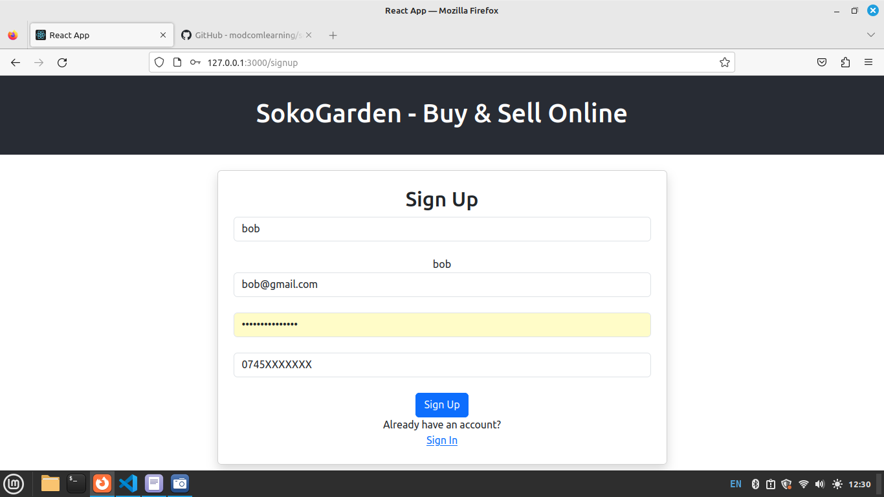 Fill in the Details in the form and click sign up.

Step 5a: Signin
In this step, we create a login form. This form will communicate with API created in https://github.com/modcomlearning/BackendAPI(Step5).
Open Signin.js Create below form
import React, { useState } from "react"; //for state management
import { Link, useNavigate } from "react-router-dom"; //for routing/navigation
import axios from "axios"; //for API Access
const Signin = () => {
// We create a Login form
return (
<div className="row justify-content-center mt-5">
<div className="col-md-6 card shadow p-4">
<h2>Sign In</h2>
<form>
<input
type="email"
className="form-control mb-3"
placeholder="Email"
required
/>
<input
type="password"
className="form-control mb-3"
placeholder="Password"
required
/>
<button type="submit" className="btn btn-primary w-100">
Sign In
</button>
</form>
Don't have an account? <Link to="/signup">Sign Up</Link>
</div>
</div>
);
};
export default Signin;
Run your App Runs the app in the development mode.
Open http://localhost:3000/signin to view it in your browser.
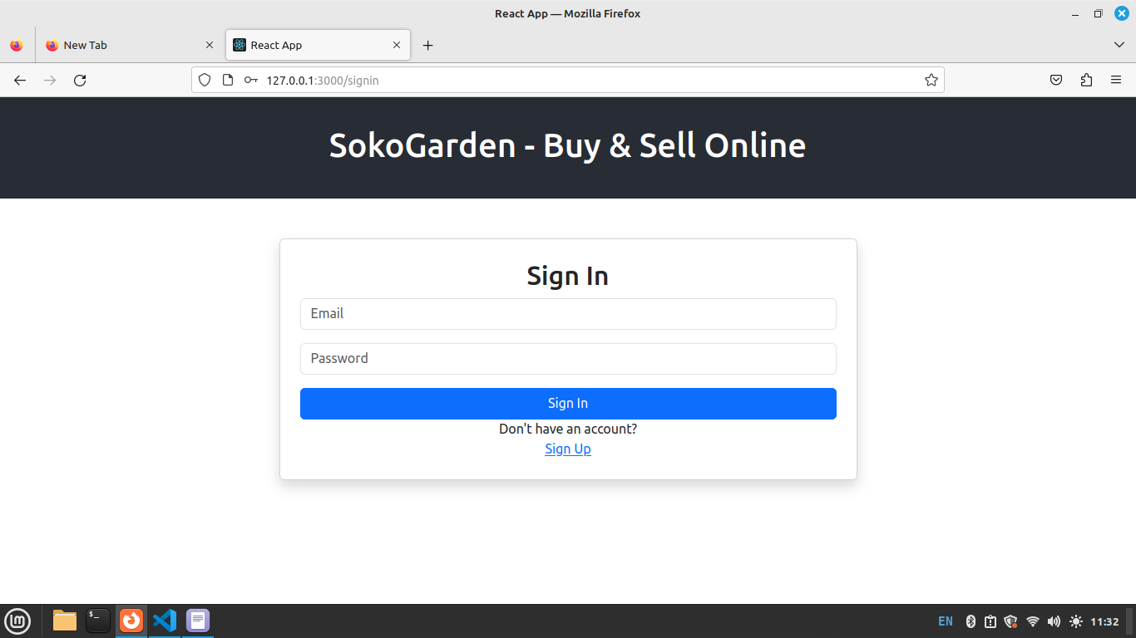
alt text
In your Signin Arrow function, initialize below hooks
const [email, setEmail] = useState(""); //email hook variable
const [password, setPassword] = useState(""); //password hook variable
const [loading, setLoading] = useState(""); //loading hook variable
const [error, setError] = useState(""); //error hook variable
const navigate = useNavigate(); // For redirection
Next, Update your hooks in the input tags using onChange atribute, see below.
import React, { useState } from "react"; //for state management
import { Link, useNavigate } from "react-router-dom"; //for routing/navigation
import axios from "axios"; //for Backend API Access
const Signin = () => {
// We create a Login form
const [email, setEmail] = useState("");//email hook variable
const [password, setPassword] = useState(""); //password hook variable
const [loading, setLoading] = useState("");//loading hook variable
const [error, setError] = useState("");//error hook variable
const navigate = useNavigate(); // For redirection to another Component
return (
<div className="row justify-content-center mt-5">
<div className="col-md-6 card shadow p-4">
<h2>Sign In</h2>
<form>
<input
type="email"
className="form-control mb-3"
placeholder="Email"
value={email}
onChange={(e) => setEmail(e.target.value)}
required
/>
<input
type="password"
className="form-control mb-3"
placeholder="Password"
value={password}
onChange={(e) => setPassword(e.target.value)}
required
/>
<button type="submit" className="btn btn-primary w-100">
Sign In
</button>
</form>
Don't have an account? <Link to="/signup">Sign Up</Link>
</div>
</div>
);
};
export default Signin;

Step 5b: Signin
Next, In your Arrow function, Create a submit function to handle data submission to Backend API.
//Function to submit data to API
const submit = async (e) => {
e.preventDefault();//Prevent default actions
setLoading("Please wait as we log you in");//set progress message
//Add data to form data object
try {
const data = new FormData();
data.append("email", email);
data.append("password", password);
//Post above data to Backend API
const response = await axios.post(
"https://modcom2.pythonanywhere.com/api/signin",
data);
setLoading(""); //After successful posting, Clear the loading message
// Check if the response has user item,
if (response.data.user) {
// If user is Found, Store user details in localStorage
localStorage.setItem("user", JSON.stringify(response.data.user));
// Redirect to /getproducts Component
navigate("/");
}
else {
//User Not Found, Show Error message
setError(response.data.message);
}
//If there was an Error, Clear Loading
} catch (error) {
setLoading("");
setError(error.response.data.message);
}
};
Finally, We need to Call submit function created above when a user clicks a the signin button. In your Form openning tag, add an onSubmit attribute and Call the submit function.
In addition, we need to see the loading and error messages in our Form, Bind/Fix the loading and error hooks inside your form tag. See below code snippet.
<form onSubmit={submit}>
{loading}
{error}
....
Full Code for Signin.js
import { useState } from "react"; //for state management
import { Link, useNavigate } from "react-router-dom"; //for routing/navigation
import axios from "axios"; //for API Access
const Signin = () => {
// Initialize hooks to be used in this component.
const [email, setEmail] = useState(""); //email hook
const [password, setPassword] = useState(""); //password hook
const [loading, setLoading] = useState(""); //laoding hook
const [error, setError] = useState(""); //error hook
const navigate = useNavigate() //hook for navigating to a new component
//Function to submit data to API
const submit = async (e) => {
e.preventDefault();//Prevent default actions
setLoading("Please wait as we log you in");//set progress message
//Add data to form data object
try {
const data = new FormData();
data.append("email", email);
data.append("password", password);
//Post above data to Backend API
const response = await axios.post(
"https://modcom2.pythonanywhere.com/api/signin",
data);
setLoading(""); //After successful posting, Clear the loading message
// Check if the response has user item,
if (response.data.user) {
// If user is Found, Store user details in localStorage
localStorage.setItem("user", JSON.stringify(response.data.user));
// Redirect to /getproducts Component
navigate("/");
}
else {
//User Not Found, Show Error message
setError(response.data.message);
}
//If there was an Error, Clear Loading
} catch (error) {
setLoading("");
setError(error.data.message);
}
};
return (
<div className="row justify-content-center mt-5">
<div className="col-md-6 card shadow p-4">
<h2>Sign In</h2>
<form onSubmit={submit}>
{loading}
{error}
<input
type="email"
className="form-control mb-3"
placeholder="Email"
value={email}
onChange={(e) => setEmail(e.target.value)}
required
/>Detials
<input
type="password"
className="form-control mb-3"
placeholder="Password"
value={password}
onChange={(e) => setPassword(e.target.value)}
required
/>
<button type="submit" className="btn btn-primary w-100">
Sign In
</button>
</form>
Don't have an account? <Link to="/signup">Sign Up</Link>
</div>
</div>
);
};
export default Signin;
Run your App Runs the app in the development mode.
Open http://localhost:3000/signin to view it in your browser.
Fill in the Details in the form and click sign in. If user credenatials provided are wrong, You will get an error saying Login Failed, else if user credentials are right, it will navigate to getproducts Component. See below screenshot for wrong credentials.
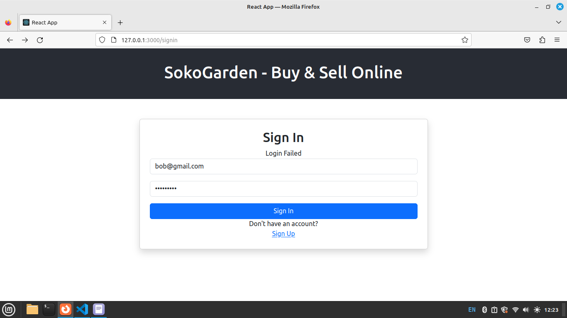
alt text

Step 6a: Add/Upload Product - Form, Hooks
In this step we will be Uploading/Adding product to our API created in https://github.com/modcomlearning/BackendAPI (Step 6). Add_product API Demo.
Next, create a HTML form for product upload. In your React App Open Addproduct.js and import below modules.
import { useState } from "react"; // for variable state mangement
import axios from "axios"; //for API Access
import { Link } from "react-router-dom"; //for components linking
Next, Create the Upload HTML Form in JSX
//Imports
import { useState } from "react";// for variable state mangement
import axios from "axios";//for API Access
import { Link } from "react-router-dom"; //for components linking
const Addproduct = () => {
// Do HTML product Upload Form
return (
<div className="row justify-content-center mt-4">
<div className="col-md-6 card shadow p-4">
<form>
<h3>Upload Products</h3>
{/* Call setProductName onChange to update produce name Hook */}
<input
type="text"
placeholder="Enter Product Name"
className="form-control"
required
/>
<br />
{/* Call setProductDescription onChange to update produce description Hook */}
<textarea
className="form-control"
placeholder="Describe your Product"
required
></textarea>
<br />
{/* Call setProductCost onChange to update produce cost Hook */}
<input
type="number"
placeholder="Enter Product Cost"
className="form-control"
required
/>
<br />
{/* Call setProductPhoto onChange to update produce photo Hook */}
<b>Browse/Upload Product Image</b>
<input
type="file"
className="form-control"
accept="image/*"
required
/>
<br />
<button type="submit" className="btn btn-primary">
Upload Product
</button>
</form>
</div>
</div>
);
};
export default Addproduct;

Run your App Runs the app in the development mode.
Open http://localhost:3000/add_product to view it in your browser.
Output.
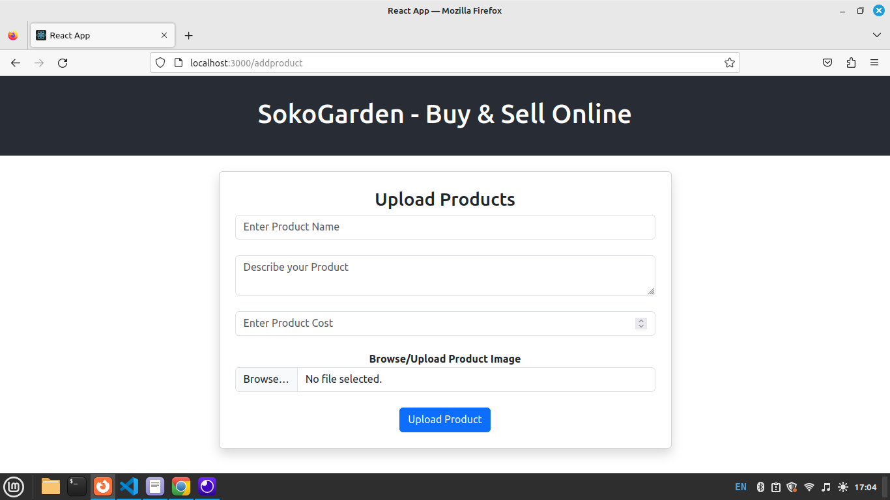
alt text

Next, Initialize below Hooks that will hold our input values,The hooks are initialized to empty strings, meaning they hold no value. They will be updated when the user types values on the input using onChange().
Below is the updated Code with Hooks initialized and Updated onChange() of inputs.
//Initialize product details hooks
const [product_name, setProductName] = useState("");
const [product_description, setProductDescription] = useState("");
const [product_cost, setProductCost] = useState("");
const [product_photo, setProductPhoto] = useState("");
Below is the Code with Hooks
//Imports
import { useState } from "react";// for variable state mangement
import axios from "axios";//for API Access
import { Link } from "react-router-dom"; //for components linking
const Addproduct = () => {
//Initialize below Hooks
const [product_name, setProductName] = useState("");
const [product_description, setProductDescription] = useState("");
const [product_cost, setProductCost] = useState("");
const [product_photo, setProductPhoto] = useState("");
// Do HTML product Upload Form
return (
<div className="row justify-content-center mt-4">
<div className="col-md-6 card shadow p-4">
<form>
<h3>Upload Products</h3>
{/* Call setProductName onChange to update produce name Hook */}
<input
type="text"
placeholder="Enter Product Name"
className="form-control"
value={product_name}
onChange={(e) => setProductName(e.target.value)}
required
/>
<br />
{/* Call setProductDescription onChange to update produce description Hook */}
<textarea
className="form-control"
placeholder="Describe your Product"
value={product_description}
onChange={(e) => setProductDescription(e.target.value)}
required
></textarea>
<br />
{/* Call setProductCost onChange to update produce cost Hook */}
<input
type="number"
placeholder="Enter Product Cost"
className="form-control"
value={product_cost}
onChange={(e) => setProductCost(e.target.value)}
required
/>
<br />
{/* Call setProductPhoto onChange to update produce photo Hook */}
<b>Browse/Upload Product Image</b>
<input
type="file"
className="form-control"
accept="image/*"
onChange={(e) => setProductPhoto(e.target.files[0])}
required
/>
<br />
<button type="submit" className="btn btn-primary">
Upload Product
</button>
</form>
</div>
</div>
);
};
export default Addproduct;
Run your App Runs the app in the development mode.
Open http://localhost:3000/addproduct to view it in your browser. NB: we can bind Hooks on UI to find out they are being updated as the user types.

Step 6b: Add/Upload Product - Submit to API
In Step 6a, we created a Product Upload form and Set up the Hooks to be used. Next, We do a submit function, This function will collect data from updated Hooks and submit to add_product Backend API.
First initialize below hooks that used to Handle loading, success and Error messages(information messages)
// Hooks for information messages
const [loading, setLoading] = useState("");
const [message, setMessage] = useState("");
const [error, setError] = useState("");
Next, Inside Addproduct Arrow Function (Below the Hooks Initialization) create below submit Arrow function.
const submit = async (e) => {
//TODO
}
Next is submit function Logic This will include capturing product data in updated hooks and POST to our add_product Backend API.
Below is the submit function implementation.
//Submit Function
const submit = async (e) => {
//Prevent default actions
e.preventDefault();
//update loading hook to show progress
setLoading("Please wait ... ");
//add all updated hooks to data variable
const data = new FormData();
data.append("product_name", product_name);
data.append("product_description", product_description);
data.append("product_cost", product_cost);
data.append("product_photo", product_photo);
//Post data to Backend API
try {
const response = await axios.post(
"https://modcom2.pythonanywhere.com/api/add_product",
data
);
//Set loding message to empty, after a successful POST to API
setLoading("")
//Update message hook to successfully Added to notify the user.
setMessage("Product Added successfully!");
// setMessage(response.data.success);
// reset the input fields
setProductName("");
setProductDescription("");
setProductCost("");
setProductPhoto("");
//Catch Any server error, i.e internet issues , server errors
} catch (error) {
setError("Failed to add product. Please try again.");
}
};
Here’s the function with the explanation broken down line by line: Prevent the default form submission behavior:
e.preventDefault();
Displays a loading message while processing the request:
setLoading("Please wait ... ");
Collects data from the input fields and appends them to a FormData object:
const data = new FormData();
data.append("product_name", product_name);
data.append("product_description", product_description);
data.append("product_cost", product_cost);
data.append("product_photo", product_photo);
Sends the collected data to the backend API using a POST request:
const response = await axios.post(
"https://modcom2.pythonanywhere.com/api/add_product",
data
);
If the submission is successful, Clears the loading message so that its stops to display. Update the loading Hook
setLoading("");
Update message Hook, Displays a success message:
setMessage("Product Added successfully!");
Resets the input fields to be empty for the next submission:
setProductName("");
setProductDescription("");
setProductCost("");
setProductPhoto("");
If there is an error (e.g., network issue or server error), it displays an error message:
setError("Failed to add product. Please try again.");
This approach ensures that the process of adding a product to the backend is managed smoothly, with clear feedback to the user for both success and failure scenarios. Finally, Call the submit() Function onSubmit of the form as shown below and Bind the loading, messages and error hooks in the form to show the user loading, messages and error messages Inside your form tag add below code.
{/* Bind user loding, success, error messages */}
<form onSubmit={submit}>
{loading}
{message}
{error}
....
Full Addproduct.js Code.
import { useState } from "react"; // for state management
import axios from "axios"; //For API Access
import { Link } from "react-router-dom"; ////For link to other component
const Addproduct = () => {
//Initialize product details hooks
const [product_name, setProductName] = useState("");
const [product_description, setProductDescription] = useState("");
const [product_cost, setProductCost] = useState("");
const [product_photo, setProductPhoto] = useState("");
// Hooks for information messages
const [loading, setLoading] = useState("");
const [message, setMessage] = useState("");
const [error, setError] = useState("");
//Submit Function
const submit = async (e) => {
//Prevent default actions
e.preventDefault();
//update loading hook to show progress
setLoading("Please wait ... ");
//add all updated hooks to data variable
const data = new FormData();
data.append("product_name", product_name);
data.append("product_description", product_description);
data.append("product_cost", product_cost);
data.append("product_photo", product_photo);
//Post data to Backend API
try {
const response = await axios.post(
"https://modcom2.pythonanywhere.com/api/add_product",
data
);
//Set loding message to empty, after a successful POST to API
setLoading("")
//Update message hook to successfully Added to notify the user.
setMessage("Product Added successfully!");
// setMessage(response.data.success);
// reset the input fields
setProductName("");
setProductDescription("");
setProductCost("");
setProductPhoto("");
//Catch Any server error, i.e internet issues , server errors
} catch (error) {
setError("Failed to add product. Please try again.");
}
};
return (
<div className="row justify-content-center mt-4">
<div className="col-md-6 card shadow p-4">
<form onSubmit={submit}>
{/* Bind user loding, success, error messages */}
{loading}
{message}
{error}
<h3>Upload Products</h3>
{/* Call setProductName onChange to update produce name Hook */}
<input
type="text"
placeholder="Enter Product Name"
className="form-control"
value={product_name}
onChange={(e) => setProductName(e.target.value)}
required
/> <br />
{/* Call setProductDescription onChange to update produce description Hook */}
<textarea
className="form-control"
placeholder="Describe your Product"
value={product_description}
onChange={(e) => setProductDescription(e.target.value)}
required
></textarea>
<br />
{/* Call setProductCost onChange to update produce cost Hook */}
<input
type="number"
placeholder="Enter Product Cost"
className="form-control"
value={product_cost}
onChange={(e) => setProductCost(e.target.value)}
required
/>
<br />
{/* Call setProductPhoto onChange to update produce photo Hook */}
<b>Browse/Upload Product Image</b>
<input
type="file"
className="form-control"
accept="image/*"
onChange={(e) => setProductPhoto(e.target.files[0])}
required
/>
<br />
{/* submit button */}
<button type="submit" className="btn btn-primary">
Upload Product
</button>
</form>
</div>
</div>
);
};
export default Addproduct;
Run your App Runs the app in the development mode.
Open http://localhost:3000/addproduct to view it in your browser. Fill in product details, browse image from computer and press Upload Product button. The data sent to the add_product API and you get a success message.
Output.

alt text

Step 7a: Get Products
In this step we will be getting all products posted on the API. The get products Backend API implementation can be accessed at https://github.com/modcomlearning/BackendAPI(Step7)
In your React App Open Getproducts.js
const Getproducts = () => {
return (
<div>
<h1>Welcome to Get Products Components</h1>
</div>
);
}
export default Getproducts;
Create a Card to demonstrate how a single product will display, Update the HTML code as follows
const Getproducts = () => {
return (
<div className="row">
<h3 className="mt-5">Available Products</h3>
<div className="col-md-3 justify-content-center mb-4">
{/* Card with equal size */}
<div className="card shadow card-margin">
<img
className=" product_img mt-4"
src="logo.png"
/>
{/* Card Body with a dummy Product */}
<div className="card-body">
<h5 className="mt-2">Unga</h5>
<p className="text-muted">This is Nice Soft Ugali</p>
<b className="text-warning">200 KES</b> <br />
</div>
</div>
</div>
</div>
);
}
export default Getproducts;
Run your App Runs the app in the development mode.
Open http://localhost:3000/ to view it in your browser.
Output Below shows a Card View of how a Product will be displayed This a Dummy/Example Product, Not the ones from the Database
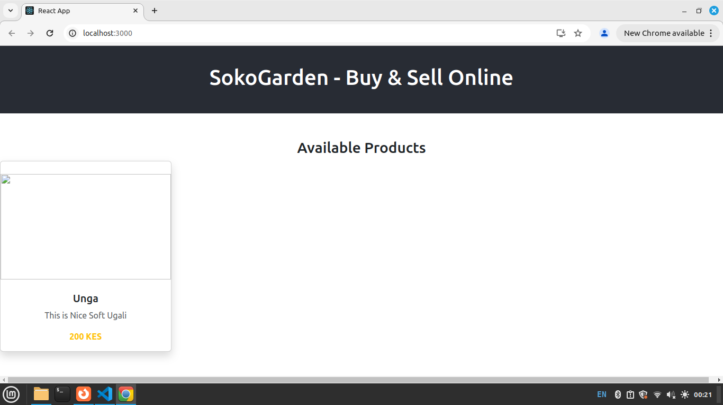
alt text
Next, we need to fetch/get all products from our getproducts Backend API and display in the Card we’ve just seen
Import the required modules
import { useState, useEffect } from "react"; // for state management
import axios from "axios"; //For API Access
import { Link, useNavigate } from "react-router-dom"; // For link/navigate to other component
Initialize below Hooks
// Initialize Hooks
const [products, setProducts] = useState([]); // Default to empty array instead of a string
const [loading, setLoading] = useState(""); //For loading message
const [error, setError] = useState(""); //error message hook
const navigate = useNavigate();
Specify the image location URL, this is where the image image files were saved in pythonanywhere..
//Specify image location URL
const img_url = "https://modcom2.pythonanywhere.com/static/images/"
Next, write below code snippet to get all records from get_product_details Backend API. First, Create an Arrow Function named getproducts() and write below code
const getproducts = async()=>{
setLoading("Please wait, We are retrieving the products .."); // Set loading message when fetching starts
try {
const response = await axios.get("https://modcom2.pythonanywhere.com/api/get_product_details")
setProducts(response.data)
setLoading("")
}
catch(error){
setLoading("")
setError("There was an Error")
}
}//end function
Call Above Functions inside useEffect()
useEffect(() => {
getproducts();
}, []); // empty dependency array ensures this runs only once when the component mounts
Here’s a simple breakdown of what the useEffect hook does:
Loading State: setLoading(“Please wait, We are retrieving the products ..”); sets a loading message while the data is being fetched. API Call: The axios.get(“https://modcom2.pythonanywhere.com/api/get_product_details”) makes a GET request to the provided API URL to retrieve product details. Response Handling: On try block, The response variable containes the products details and set into the products state using setProducts(response.data). The loading message is cleared with setLoading("“). Error Handling: On error (.catch), an error message is set into the error state with setError(”There was an Error“). The loading message is cleared with setLoading(”").
Triggering Fetch on Mount: - useEffect() The useEffect hook is used to run a function when the component loads. In this case, it runs the API call to fetch product details when the component first loads. useEffect runs after the component renders. If you include variables in the array[], useEffect will run whenever those variables change. In our the code inside useEffect run only once when Page loads.
Inside use Effect, we Call getproducts() function to fetch all products.
Summary: 1. The hook fetches data when the component mounts. 2. It shows a loading message while the data is being fetched. 3. It updates the state with fetched data or shows an error if something goes wrong.
in JSX that we had done earlier, we loop/map through the products from the API and display them in the Card, Update the Card by Removing the Dummy/Example product and bind with the products from your database. Do below code.
return (
<div className="row">
<h3 className="mt-5">Available Products</h3>
{/* Bind Error Messages */}
{loading}
{error}
{/* Map over products and display them */}
{products.length > 0 && products.map((product) => (
<div className="col-md-3 justify-content-center mb-4">
{/* Card with equal size */}
<div className="card shadow card-margin">
<img
className=" product_img mt-4"
src={img_url + product.product_photo}
/>
<div className="card-body">
<h5 className="mt-2">{product.product_name}</h5>
<p className="text-muted">{product.product_description}</p>
<b className="text-warning">{product.product_cost} KES</b> <br />
<button className="btn btn-dark mt-2 w-100">Purchase Now</button>
</div>
</div>
</div>
))}
</div>
);
In App.css add below css class to style the image
.product_img {
object-fit: contain;
width: 100%;
height: 200px;
}
Full Getproducts.js Code
import { useState, useEffect } from "react"; // for state management
import axios from "axios"; //For API Access
import { Link } from "react-router-dom"; // For link to other component
const Getproducts = () => {
// Initialize Hooks
const [products, setProducts] = useState([]); // Default to empty array instead of a string
const [loading, setLoading] = useState(""); //For loading message
const [error, setError] = useState(""); //error message hook
//Specify image location URL
const img_url = "https://modcom2.pythonanywhere.com/static/images/"
const getproducts = async()=>{
setLoading("Please wait, We are retrieving the products .."); // Set loading message when fetching starts
try {
const response = await axios.get("https://modcom2.pythonanywhere.com/api/get_product_details")
setProducts(response.data)
setLoading("")
}
catch(error){
setLoading("")
setError("There was an Error")
}
}//end function
// Call getproducts on Use Effect
useEffect(() => {
getproducts()
}, []); // empty dependency array ensures this runs only once when the component mounts
return (
<div className="row">
<h3 className="mt-5">Available Products</h3>
{/* Bind Error Messages */}
{loading}
{error}
{/* Map over products and display them */}
{products.map((product) => (
<div className="col-md-3 justify-content-center mb-4">
{/* Card with equal size */}
<div className="card shadow card-margin">
<img
className=" product_img mt-4"
src={img_url + product.product_photo}
/>
<div className="card-body">
<h5 className="mt-2">{product.product_name}</h5>
<p className="text-muted">{product.product_description}</p>
<b className="text-warning">{product.product_cost} KES</b> <br />
<button className="btn btn-dark mt-2 w-100">Purchase Now</button>
</div>
</div>
</div>
))}
</div>
);
}
export default Getproducts;
Run your App Runs the app in the development mode.
Open http://localhost:3000/ to view it in your browser. Output
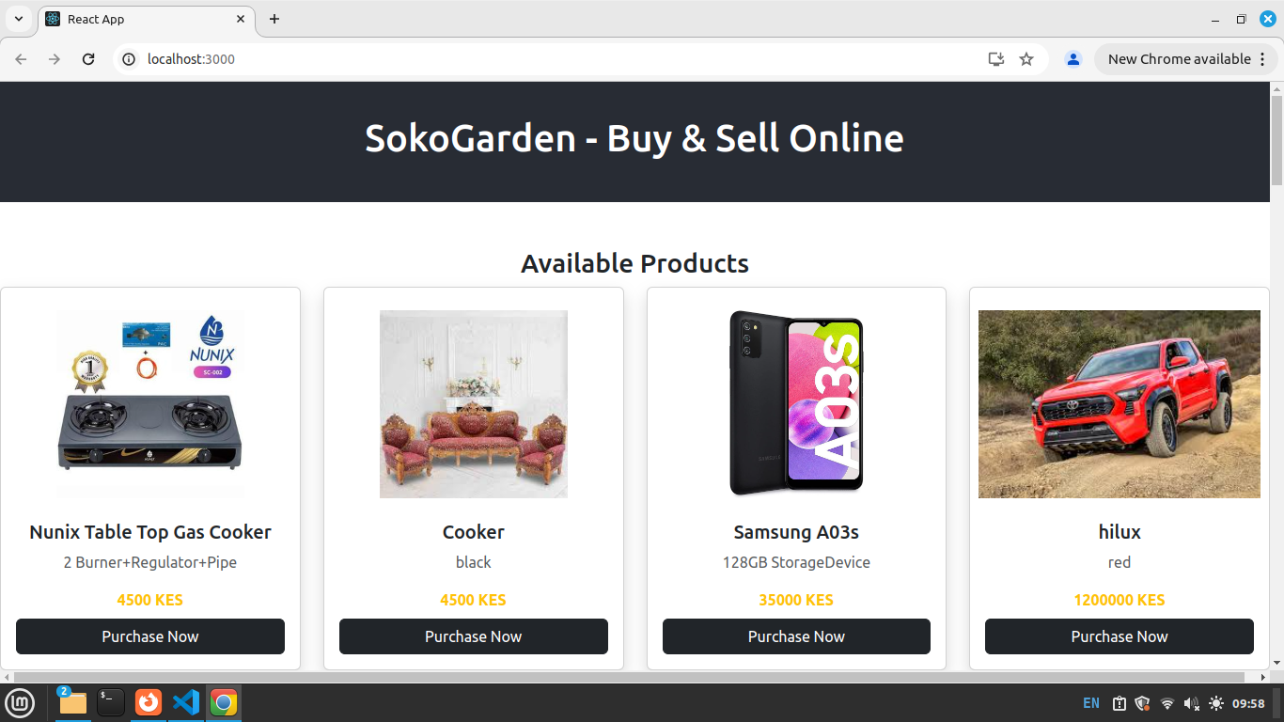
alt text

Step 8: Make Payment - Payment Integration.

In this Step, we implement LIPA NA MPESA, this allows customers to pay for products using MPESA. We will be interacting with our Backend API created in https://github.com/modcomlearning/BackendAPI (Step 8) API Demo
In Your React App, Right Click on Components Folder,
Create a Component named Makepayment.js.
Inside Create the Component Arrow Function and Return JSX Code.
Makepayment.js
const Makepayment = ()=> {
return(
<div>
<h1>Make Payment - Lipa NA MPESA</h1>
</div>
)
}
export default Makepayment;
In App.js add a Route to Makepayment.js Component, Open App.js and add the Route as shown below.
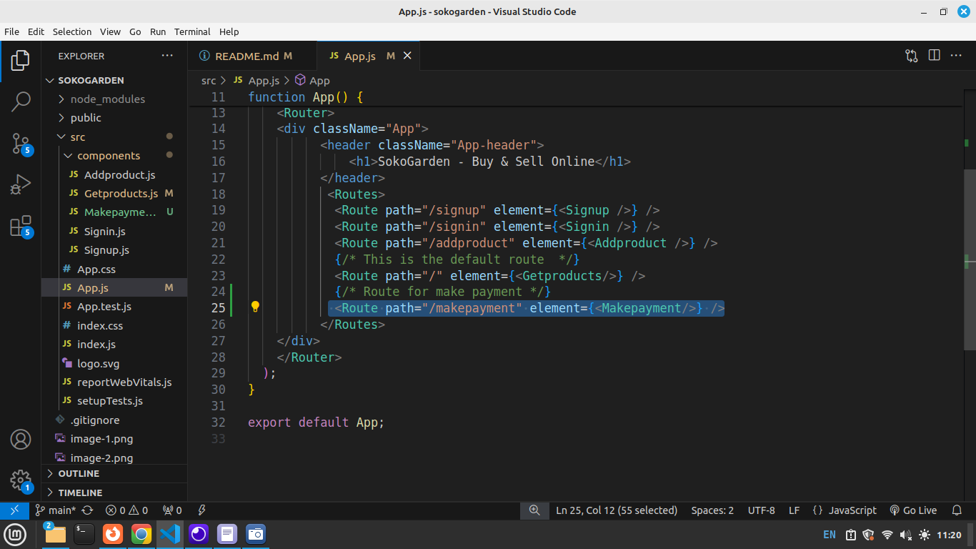
alt text
Test the route Run your App Runs the app in the development mode.
Open http://localhost:3000/makepayment to view it in your browser. Output
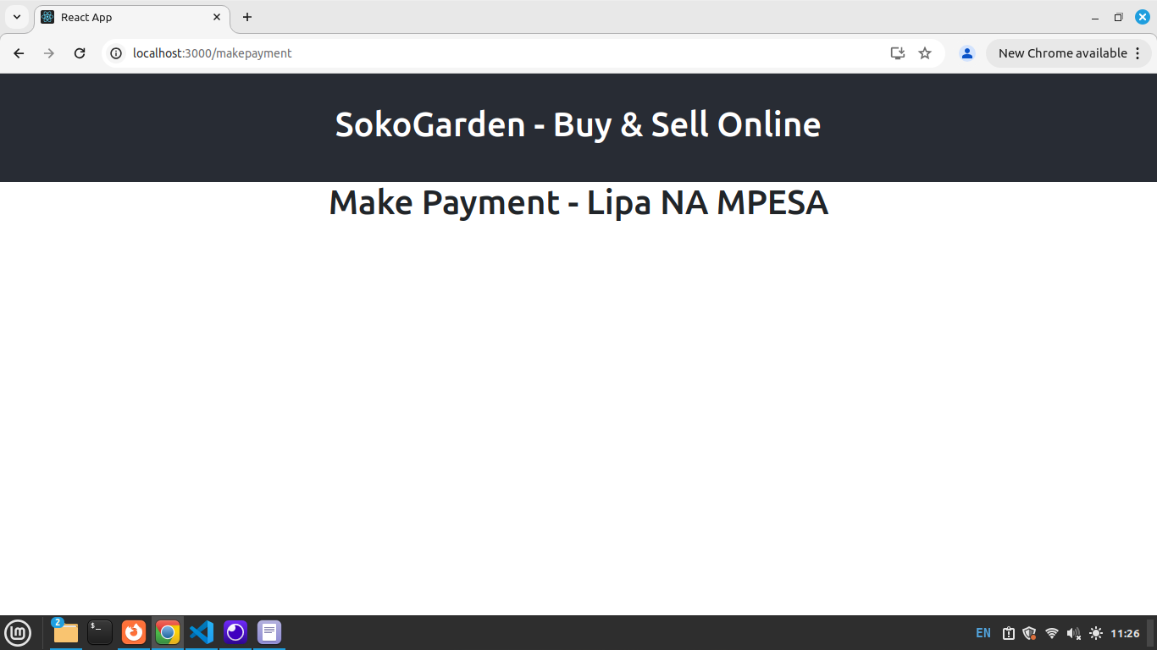
alt text
Implementing the LIPA NA MPESA Logic To make our App have MPESA Integration, First we need to add some code in Getproducts.js
Open Getproducts.js and locate the ‘Purchase Now’ Button in JSX. Currently our Button looks like below
<button className="btn btn-dark mt-2 w-100">Purchase Now</button>
Update above Code to;
<button
className="btn btn-dark mt-2 w-100"
onClick={() => navigate('/makepayment', { state: { product } })}>
Purchase Now
</button>
Above, onClick ‘Purchase Now’ Button, we navigate to /makepayment, as we navigate we carry/parse the all the details of the current product that was clicked. we use { state: { product } }
Open Makepayment.js
Import required modules
import { useState } from 'react';
import {Link, useLocation} from 'react-router-dom'
Receive the product parsed from Getproducts Component, using the Purchase Now Button.
Here, we make use of useLocation() Hook.
//We Receive the product in Makepayment
//We use useLocation to receive the product
const {product} = useLocation().state || {};
//console.log("Res: "+product.product_name)
seLocation() The useLocation() hook is a feature from React Router that helps you access information about the current URL in your app. It allows you to read the URL’s path, search variables in a component.
using useLocation(), we are able to retrieve ‘product’ in Makepayment Component.
In JSX Code, Bind the product_name and product_cost in JSX
return(
<div>
<h1>LIPA NA MPESA</h1>
{/* Bind product name and Cost */}
<p>Product NAME: {product.product_name}</p>
<p>Product Cost: {product.product_cost}</p>
</div>
)
Run your App Open http://localhost:3000/makepayment to view it in your browser. Output
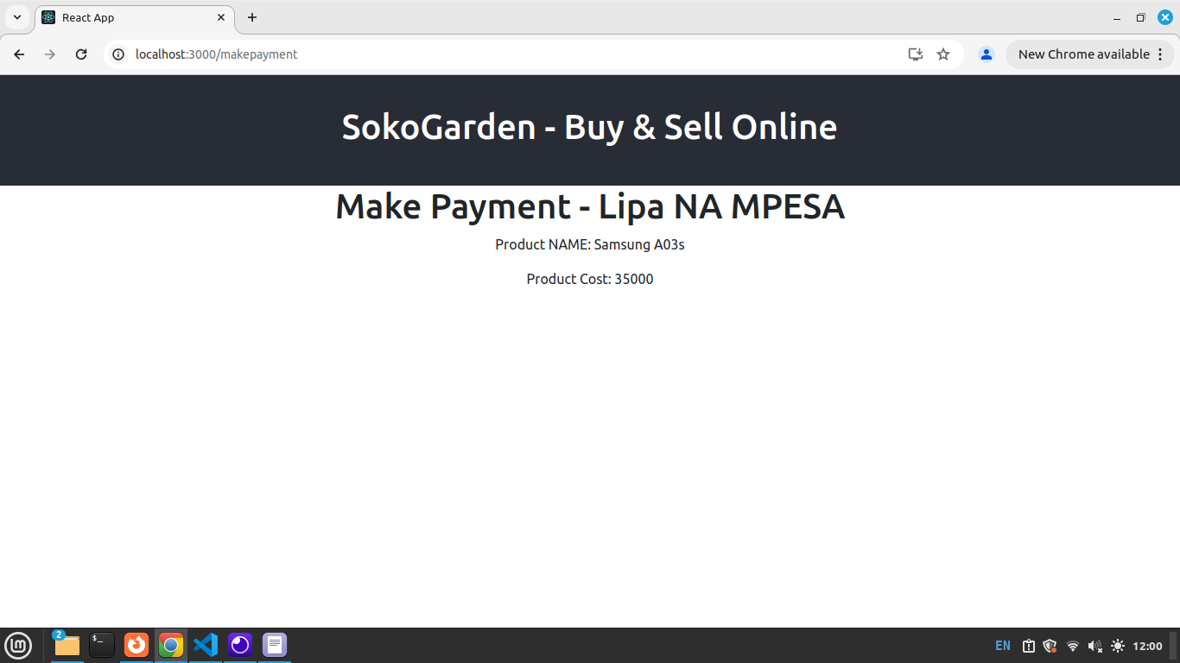
alt text
Next, Create below hooks states to hold the phone number and a success message
//Hooks to Hold Phone Number and success Message
const [phone, setPhone] = useState("")
const [message, setMessage] = useState("")
In JSX, Add Form that will request for user Phone Number, this is the Phone Number number used in Payment. In below form as user types we update the phone Hook using the setPhone() updater function.
return(
<div>
<h1>LIPA NA MPESA</h1>
<p>Product NAME: {product.product_name}</p>
<p>Product Cost: {product.product_cost}</p>
<form>
<input
type="text"
placeholder='Enter Phone Number'
value={phone}
onChange={(e)=>setPhone(e.target.value)}/> <br /><br />
<button className='btn btn-dark'>
Make Payment
</button>
</form>
</div>
)
Run your App Open http://localhost:3000/makepayment to view it in your browser. Output
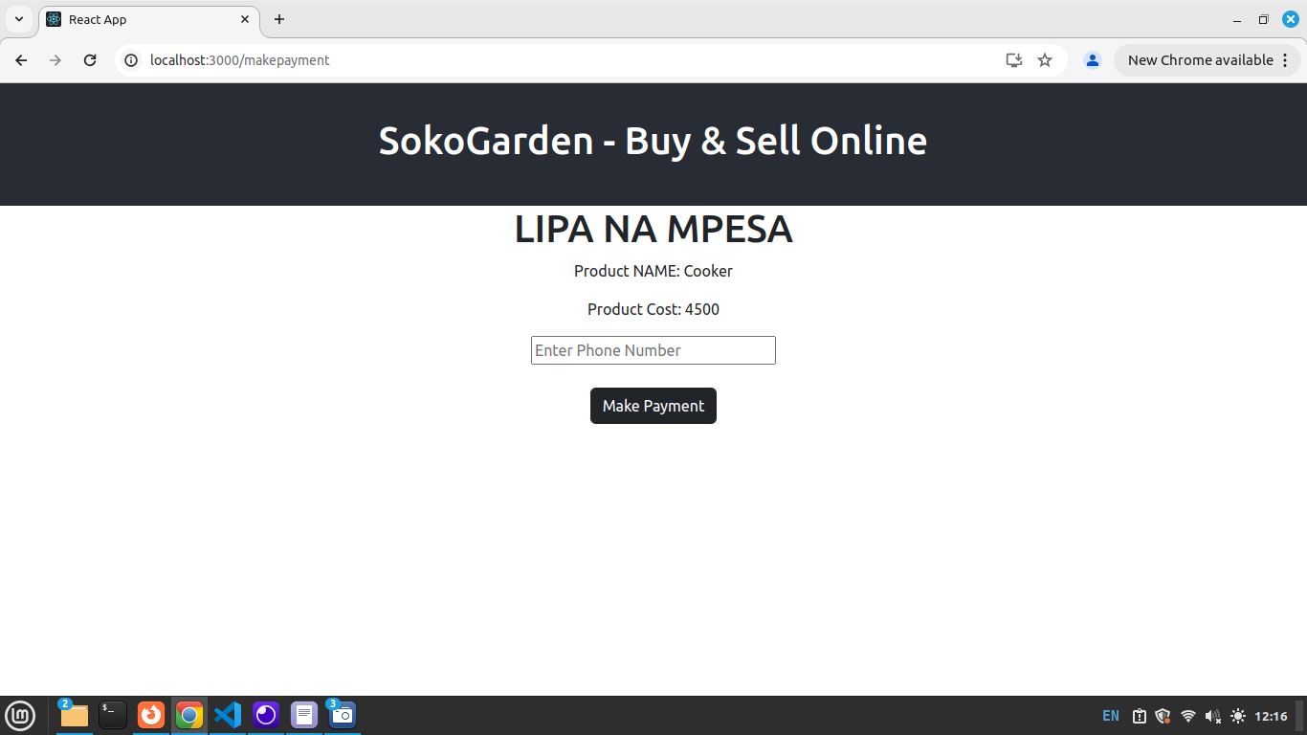
alt text
Create a submit function to send phone and amount to our Backend Payment API.
//Create a submit Function
const submit = async(e) =>{
e.preventDefault(); // prebent default JS actions
//Update loading Hook with a message
setMessage("Please wait as we Processs!");
// Put updated hooks in data variable
const data = new FormData();
data.append("phone", phone);
// Direcly parse the amount from product variable.
// We use product.product_cost
data.append("amount", product.product_cost);
//post your data to your Payment Backend API
const response = await axios.post(
"https://modcom2.pythonanywhere.com/api/mpesa_payment",
data
);
//Update message Hook with a new message
setMessage("Please Complete Payment on Your Phone")
}
Finally, in the Form opening tag Call the submit Function and bind the message Hook for status messages
<form onSubmit={submit}>
{message}
....

Full Makepayment.js Code
import { useState } from 'react';
import {useLocation} from 'react-router-dom'
import axios from 'axios';
const Makepayment = ()=> {
// Extract the received product using useLocation()
const { product } = useLocation().state || {};
//Hook to Hold Phone Number
const [phone, setPhone] = useState("")
const [message, setMessage] = useState("")
//Create a submit Function
const submit = async(e) =>{
e.preventDefault(); // prebent default JS actions
//Update loading Hook with a message
setMessage("Please wait as we Processs!");
// Put updated hooks in data variable
const data = new FormData();
data.append("phone", phone);
data.append("amount", product.product_cost);
//post your data to your Backend API
const response = await axios.post(
"https://modcom2.pythonanywhere.com/api/mpesa_payment",
data
);
setMessage("Please Complete Payment on Your Phone")
}
return(
<div>
<h1>LIPA NA MPESA</h1>
<p>Product NAME: {product.product_name}</p>
<p>Product Cost: {product.product_cost}</p>
<form onSubmit={submit}>
{message}
<input
type="text"
placeholder='Enter Phone Number'
value={phone}
onChange={(e)=>setPhone(e.target.value)}/> <br /><br />
<button className='btn btn-dark'>
Make Payment
</button>
</form>
</div>
)
}
export default Makepayment;
Summary In above Step 8; 1. We click ‘Purchase Now’ Button from Getproducts.js Component. 2. Parse the product details to Makepayment.js. 3. In Makepayment.js, the parsed product is received using useLocation() 4. The received product details are extracted and binded in JSX 5. We create a Form to request user Phone Nuumber, Update Hooks and Submit data to our Backend API.
Run your App Open http://localhost:3000/ to view it in your browser. Output
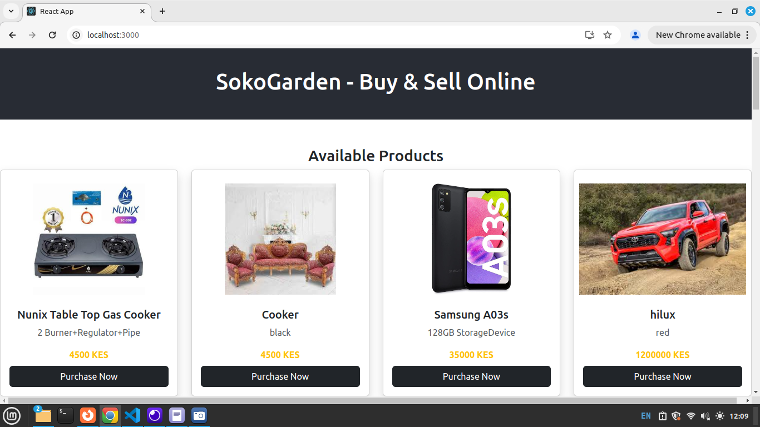
alt text
All products are displayed above.
Click on ‘Purchase Now’ Button. Below Screen Shows. Observe that the product you clicked is displayed in below screen. Showing the name and Cost. Type phone number and Makepayment.
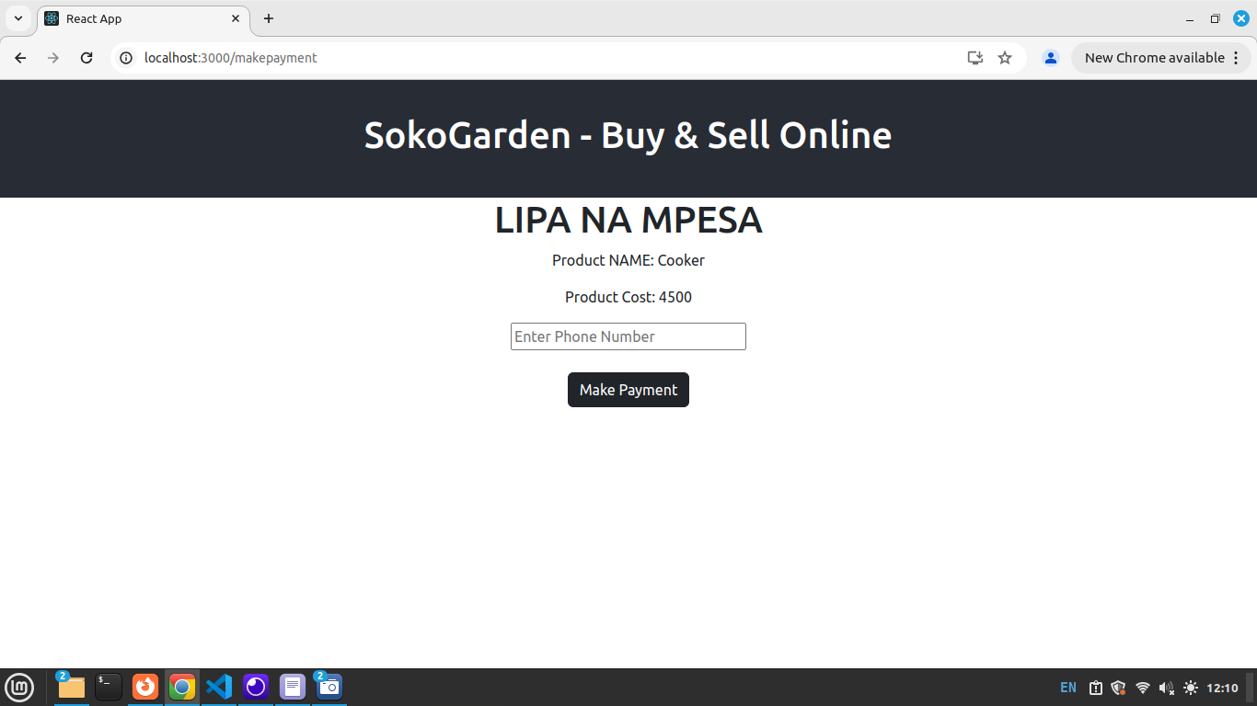
alt text
An MPESA prompt - STK PUSH is sent to Your Phone. Enter PIN and Make a Purchase.

Step 9: Navigation/Navbar
In this step, we create a navigation within the App. 1. Navigate from Get Products to Add Product. Open Getproducts.js and add below navbar Add this code inside the root Div.
<nav className="m-4">
<Link to='/addproduct' className="btn btn-dark mx-2">UPLOAD PRODUCTS</Link>
<Link to='/signin' className="btn btn-dark mx-2">Sign In</Link>
<Link to='/signup' className="btn btn-dark mx-2">Sign Up</Link>
</nav>
Above makes users Navigate from Get Products to Upload Products, Signin and Signup.
- Navigate from Add Product to Get Products. Open Addproduct.js and add below navbar Add this code inside the root Div.
<nav className="m-4">
<Link to='/' className="btn btn-dark">GET ALL PRODUCTS</Link>
</nav>
Run your App Open http://localhost:3000/ to view it in your browser. Output 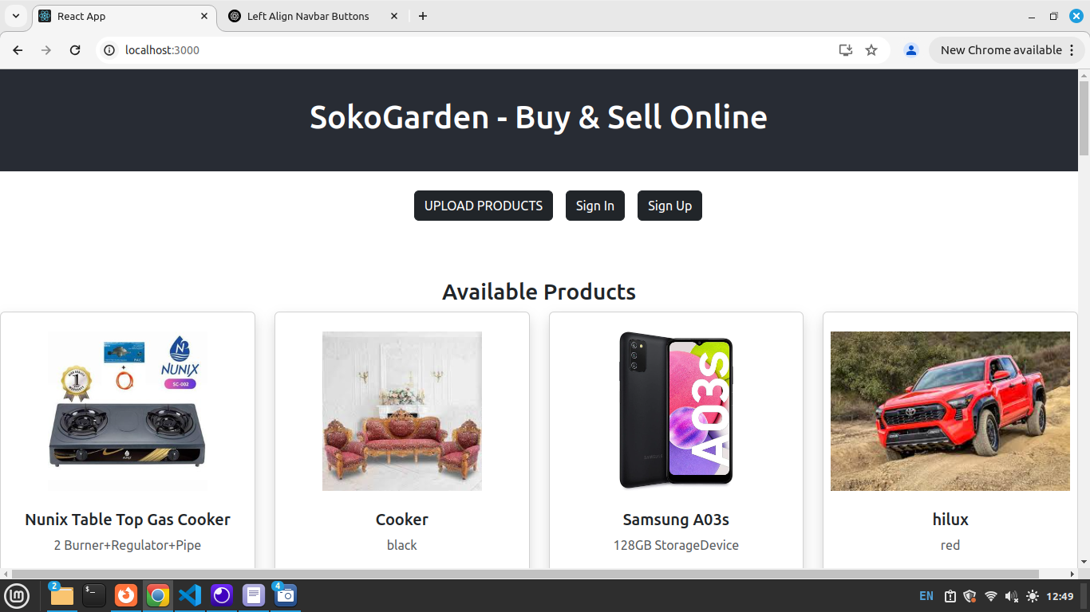
Users can now navigate from; 1. Getproducts to Addproducts, Signin and Signup. 2. Addproduct to Getproducts.

Conclusion
Throughout this Full Stack Development module, we successfully built a complete Full Stack application—SokoGarden. The frontend was developed using JavaScript and React.js, while the backend was powered by Python Flask Framework with an SQL Database. API testing was conducted using Insomnia (https://insomnia.rest/), and the API was hosted on PythonAnywhere..
This project provided hands-on experience in integrating frontend and backend technologies, API development and testing, database management, and deployment. By working on SokoGarden, students have gained proficiency in building, testing, and deploying Full Stack applications—a crucial skill set for real-world software development. You can explore the project further using the links below: 🔹 Frontend Repository:SokoGarden Frontend: https://github.com/modcomlearning/sokogarden 🔹 Backend Repository: SokoGarden Backend API: https://github.com/modcomlearning/BackendAPI 🔹 App Link : https://sokogarden.vercel.app/
Well done on reaching this milestone! Keep building, keep learning, and happy coding! Note: Before Proceeding to the Next Module - Android Apps Development, we need to create Full Stack Application Projects .

Next, Steps.
Now that you’ve successfully completed the SokoGarden project, it’s time to take your skills to the next level!
✅ Challenge: Build upon the foundation of SokoGarden by coming up with a new eCommerce concept.
#### Guideline Students’ must 🔹 Apply what they have learned in a real-world project. 🔹 Come up with an idea. 🔹 Identify what specific Products/Services your application is dealing with. 🔹 Customize the frontend and backend to fit your Concept. 🔹 Enhance the Frontend User Interface - Look and Feel. 🔹 Come up with any new features 🔹 New Features i.e Carousel, Footers, About Us, Share Products,Filter, Delete etc 🔹 Demonstrate understanding of Full Stack Development Concept - Frontend-Backend.

Notes
Building upon the SokoGarden project offers students a comprehensive understanding the CONCEPT of Full Stack Development. This experience enables them to grasp the essential components of full-stack applications, including:
Frontend Development: Crafting user interfaces using technologies like HTML, CSS, and JavaScript frameworks such as React.js. Backend Development: Implementing server-side logic with languages like Python and frameworks such as Flask. Database Management: Handling data storage and retrieval using SQL databases.
Engaging in this project equips students with the versatility to tackle various applications in the industry. The foundational concepts learned are transferable across different projects, as full-stack development principles remain consistent. This adaptability ensures that students are well-prepared to meet diverse market demands. 🚀 Get creative and start building! 💡💻
Credits The successful completion of the SokoGarden project was made possible through the dedicated efforts and unwavering support of the MODCOM Institute trainers and management. Their commitment to providing software training and hands-on experience has been instrumental in guiding students through this comprehensive full-stack development journey. Stay updated with our latest news and events by following us on X @ModcomKenya Website : https://modcom.co.ke Thank you all for making this project a success!.

