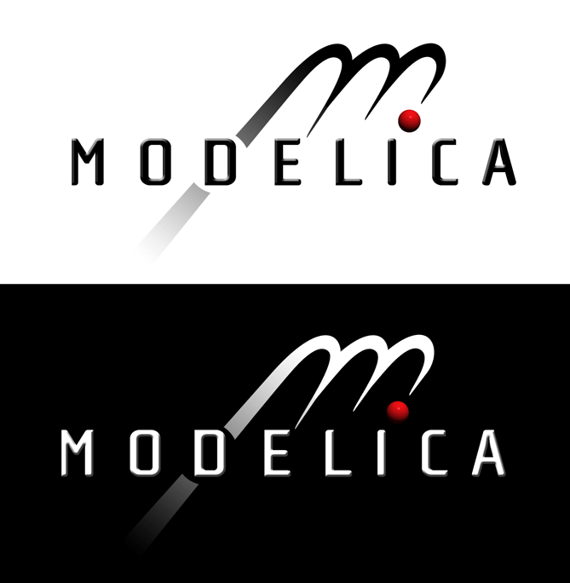

Modelica Standard Library

Version 2.2.2

August 2007

Tutorial and Reference

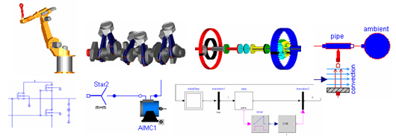

Modelica Association
http://www.Modelica.org
Copyright © 1998-2007, Modelica Association (http://www.Modelica.org)

This manual can be freely distributed according to the MIT License:
Permission is hereby granted, free of charge, to any person obtaining a copy of this manual to deal without restriction, including without limitation the rights to use, copy, modify, merge, publish, distribute, sublicense, and/or sell copies of this manual, and to permit persons to whom the manual is furnished to do so, subject to the following conditions:
The above copyright notice and this permission notice shall be included in all copies or substantial portions of the manual.
THIS MANUAL IS PROVIDED "AS IS", WITHOUT WARRANTY OF ANY KIND, EXPRESS OR IMPLIED, INCLUDING BUT NOT LIMITED TO THE WARRANTIES OF MERCHANTABILITY, FITNESS FOR A PARTICULAR PURPOSE AND NONINFRINGEMENT. IN NO EVENT SHALL THE AUTHORS OR COPYRIGHT HOLDERS BE LIABLE FOR ANY CLAIM, DAMAGES OR OTHER LIABILITY, WHETHER IN AN ACTION OF CONTRACT, TORT OR OTHERWISE, ARISING FROM, OUT OF OR IN CONNECTION WITH THIS MANUAL OR THE USE OR OTHER DEALINGS IN THE MANUAL.

Modelica is a freely available, object-oriented language for modeling of large, complex, and heterogeneous physical systems. It is suited for multi-domain modeling, for example, mechatronic models in robotics, automotive and aerospace applications involving mechanical, electrical, hydraulic and control subsystems, process oriented applications and generation and distribution of electric power. Models in Modelica are mathematically described by differential, algebraic and discrete equations. No particular variable needs to be solved for manually. A Modelica tool will have enough information to decide that automatically. Modelica is designed such that available, specialized algorithms can be utilized to enable efficient handling of large models having more than one hundred thousand equations. Modelica is suited and used for hardware-in-the-loop simulations and for embedded control systems.
Modelica is developed by the Modelica Association, a non-profit organization with seat in Linköping, Sweden. The Modelica Association also develops the free Modelica Standard Library containing model components in many domains that are based on standardized interface definitions. This Manual was automatically produced from the documentation included in the Modelica Standard Library. The source code of the Modelica Standard Library, as well as this manual, is available at http://www.modelica.org/libraries/Modelica

Contents

Index 5

Include File here with “insert file”

Index
Fehler! Keine Indexeinträge gefunden.

The MIT license text was modifed by replacing SOFTWARE with MANUAL.
Modelica® is a registered trademark of the Modelica Association.

